TASK 1
Objective: The objective of this task is to implement secure password-based authentication using email-based usernames, bcrypt salted hashing, input validation, failed-login tracking, account lockout, login logging, and SHA-256 integrity verification.
Scenario 1: User registration with email validation and secure password hashing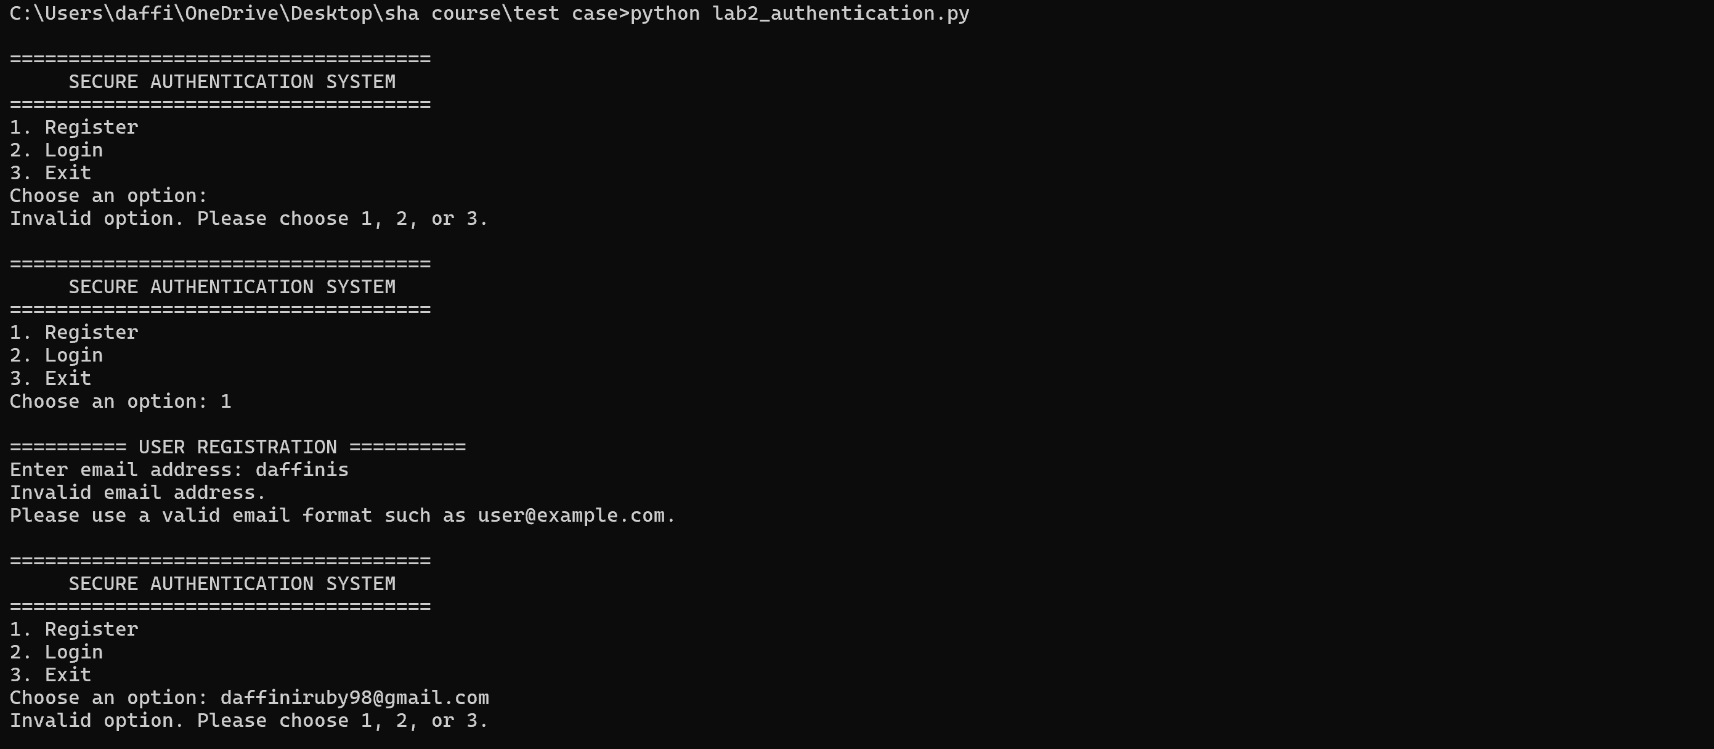
Scenario 2: Login attempt with an incorrect password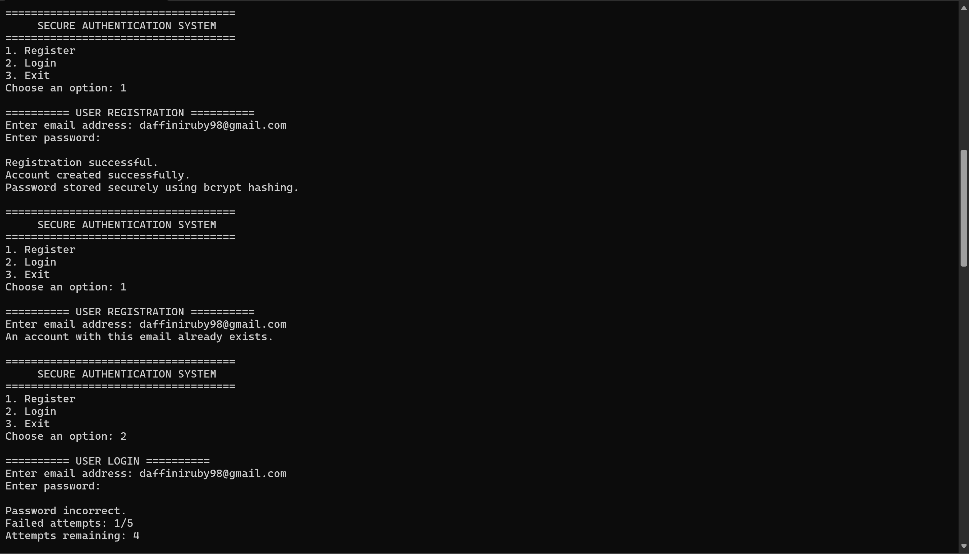

Scenario 3: After 5 incorrect password attempts, the account is locked.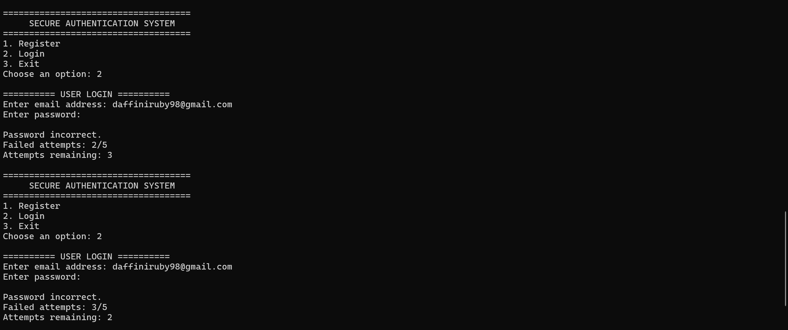
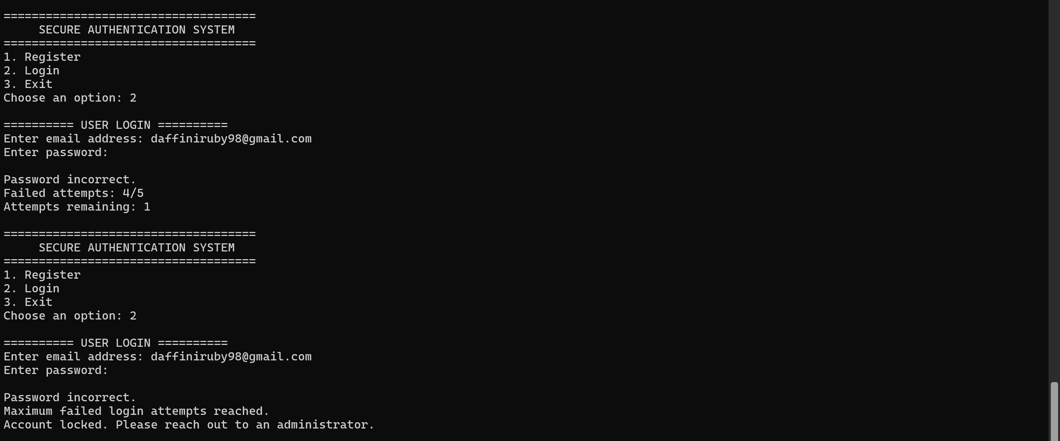
Scenario 4: After the account is locked, further login attempts are denied even when the correct password is entered.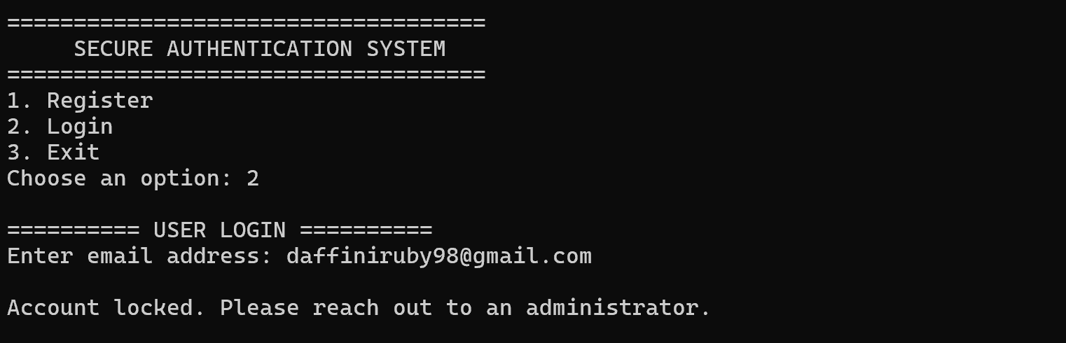

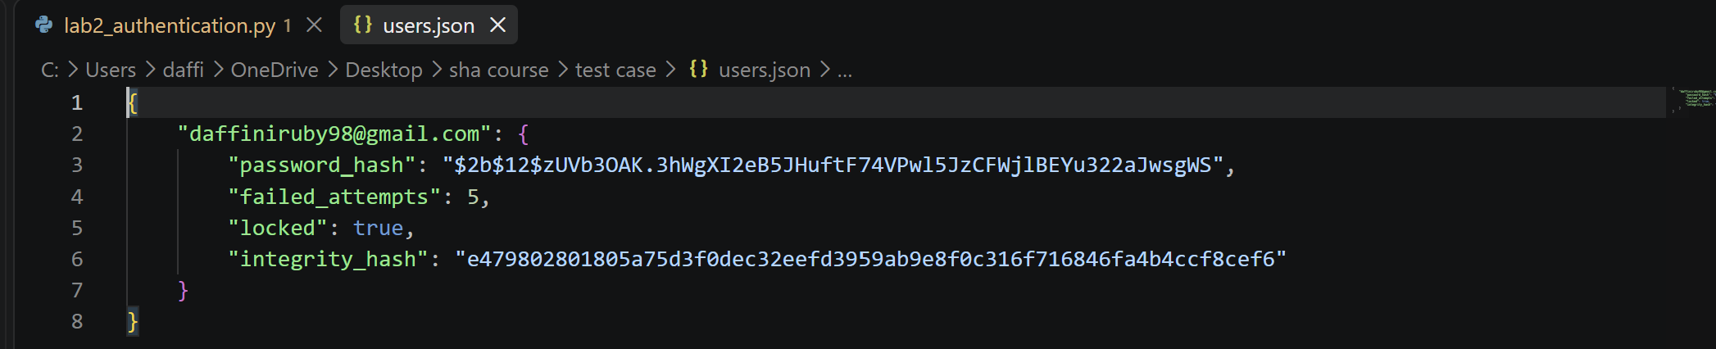

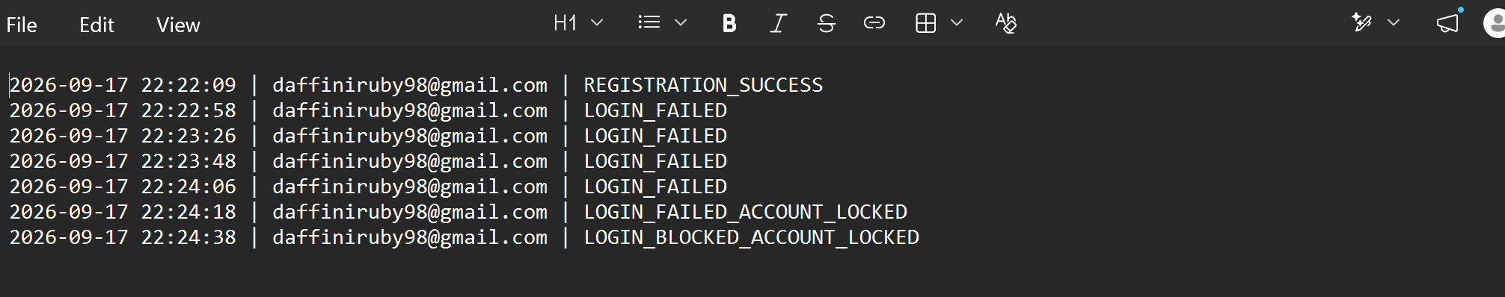
Security Implementation: Passwords are not stored in plaintext. Bcrypt is used to generate a salted password hash for secure password storage and verification. The system accepts only valid email addresses as usernames and rejects invalid input. Failed login attempts are tracked, and the account is permanently locked after five incorrect password attempts. Subsequent login attempts are denied even when the correct password is provided. Login events are recorded in a log file, and a SHA-256 integrity hash is used to detect unauthorized modification of the stored user record.

TASK 2:
Scenario 1 — OTP expiration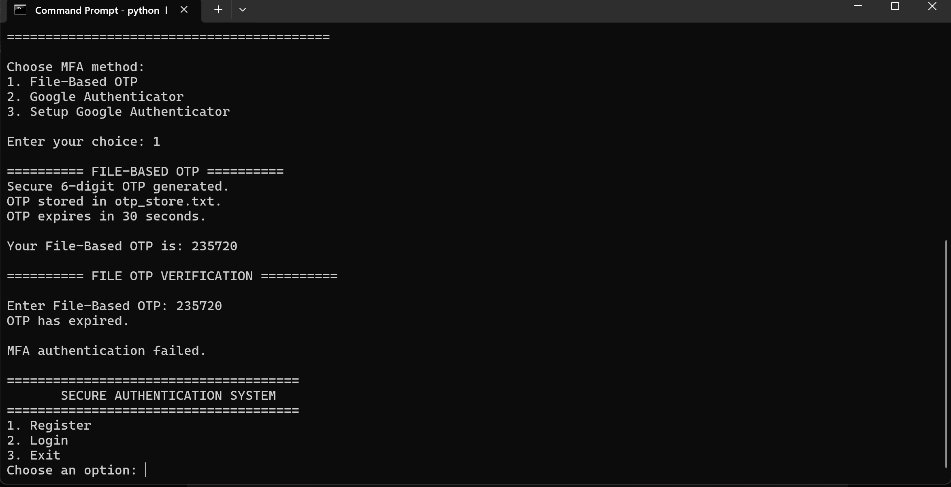
Scenario 2 — Successful OTP verification
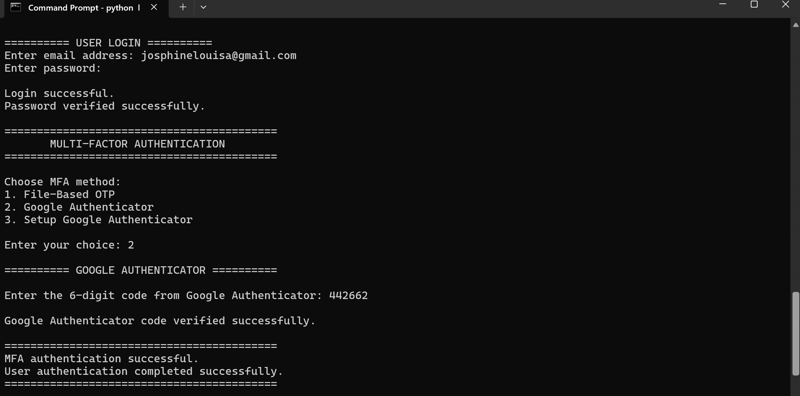
Scenario 3 — Maximum 3 incorrect attempts
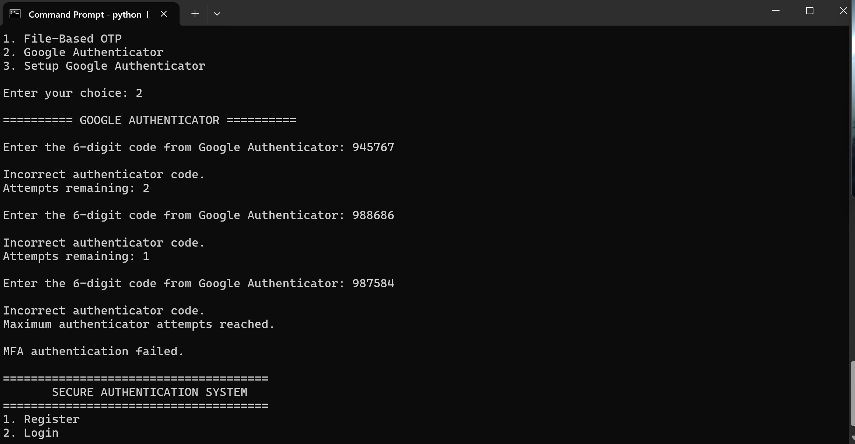

TASK 3:
Scenario 1: JWT generated after successful MFA
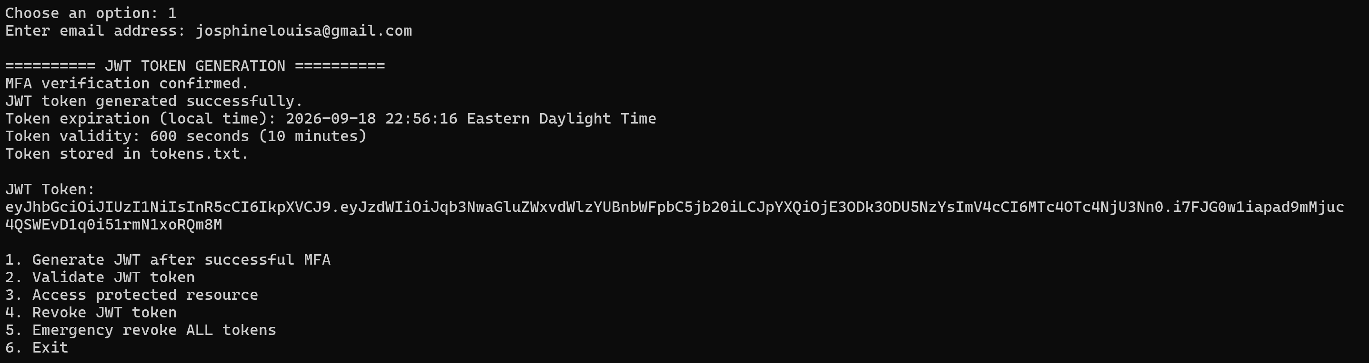
Scenario 2: Valid JWT validation / access granted
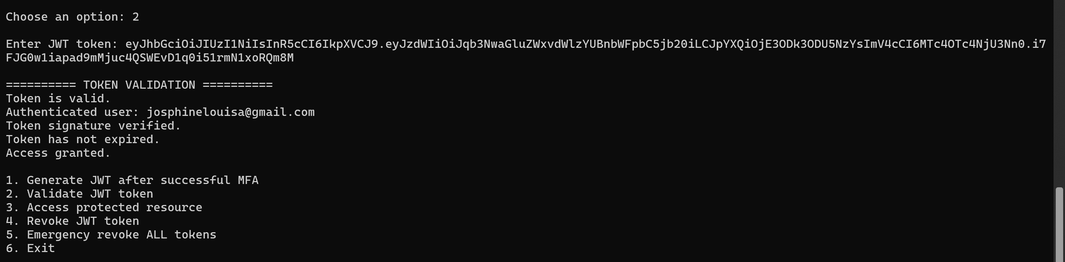
Scenario 3: Token Expired and Access Denied

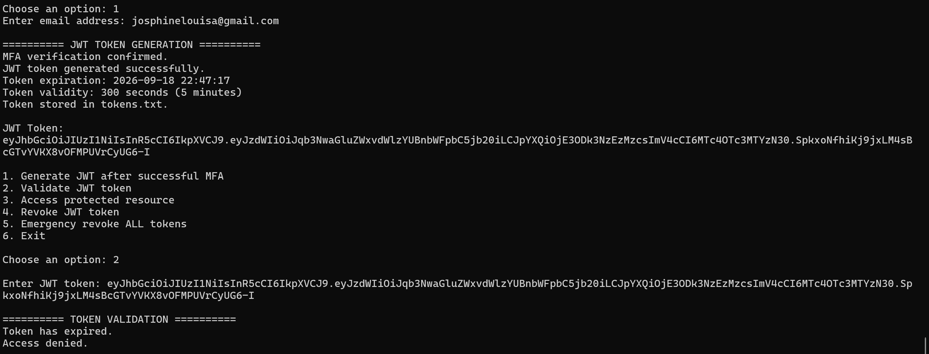
Scenario 4: Emergency revocation of all tokens
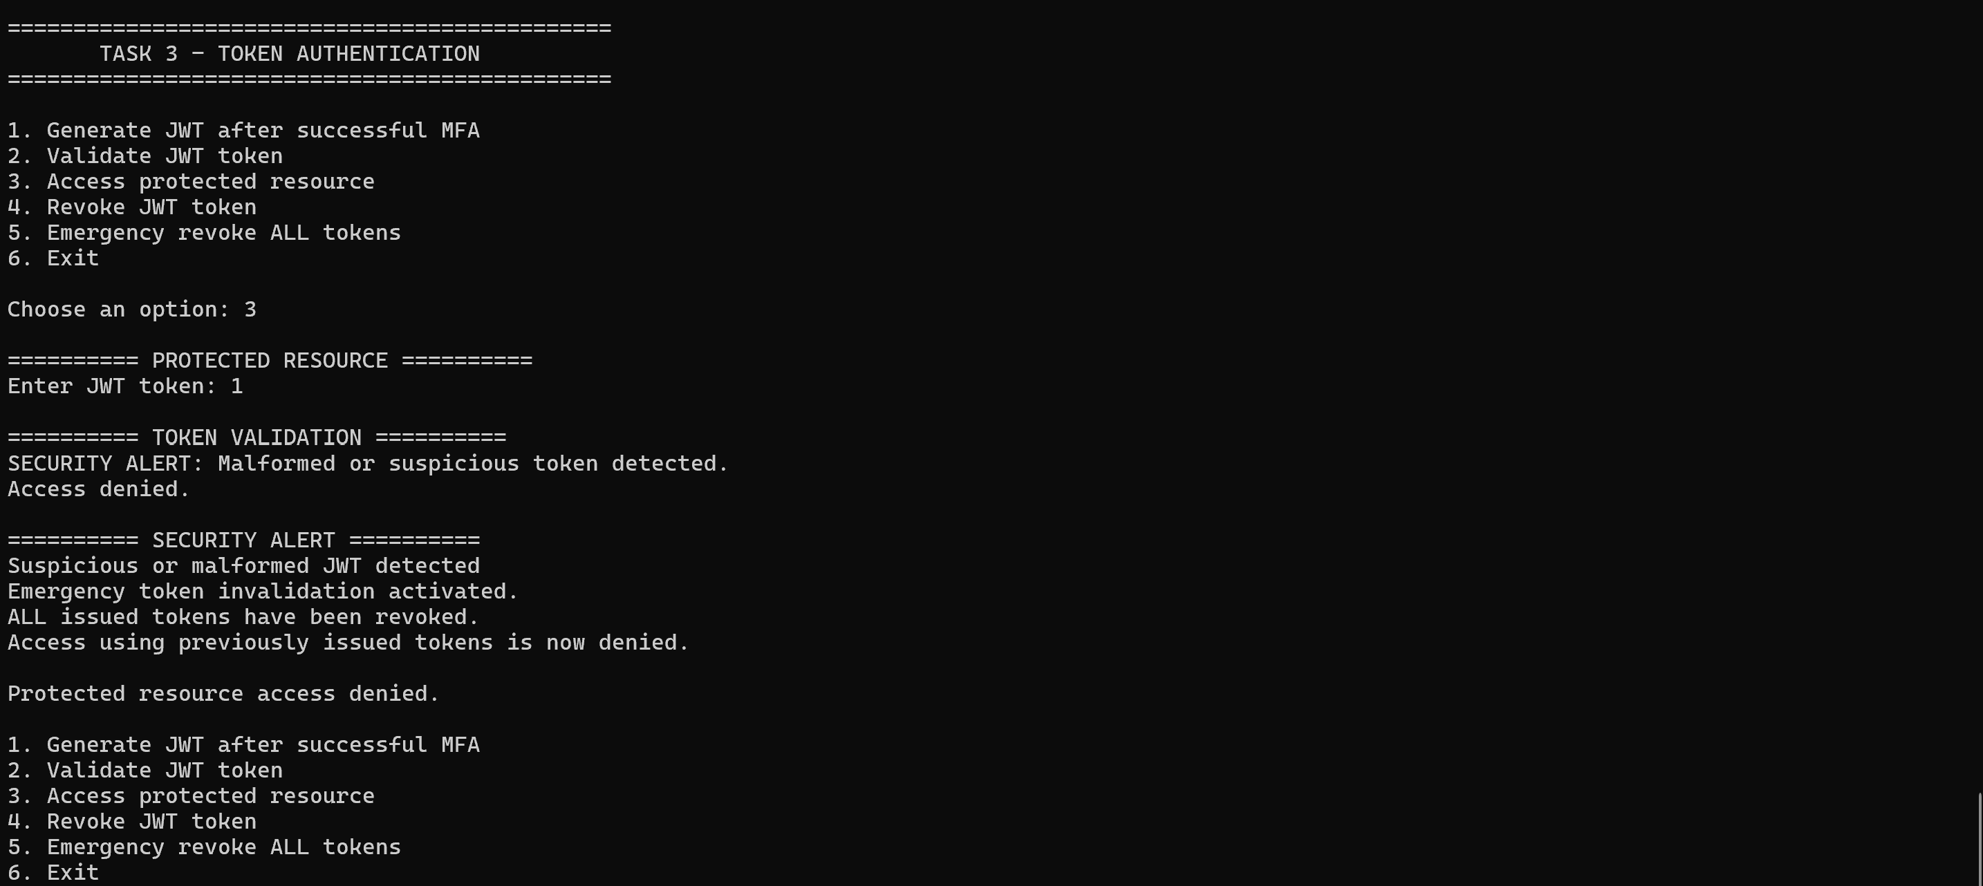
Scenario 5: Protected resource successfully accessed
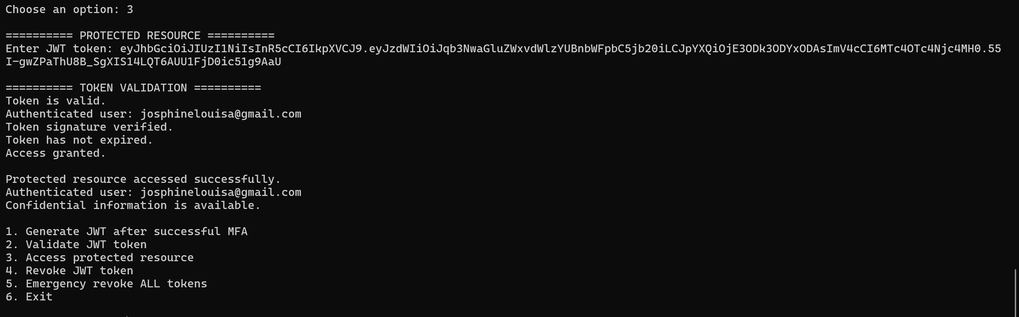
Scenario 6: Individual JWT revocation
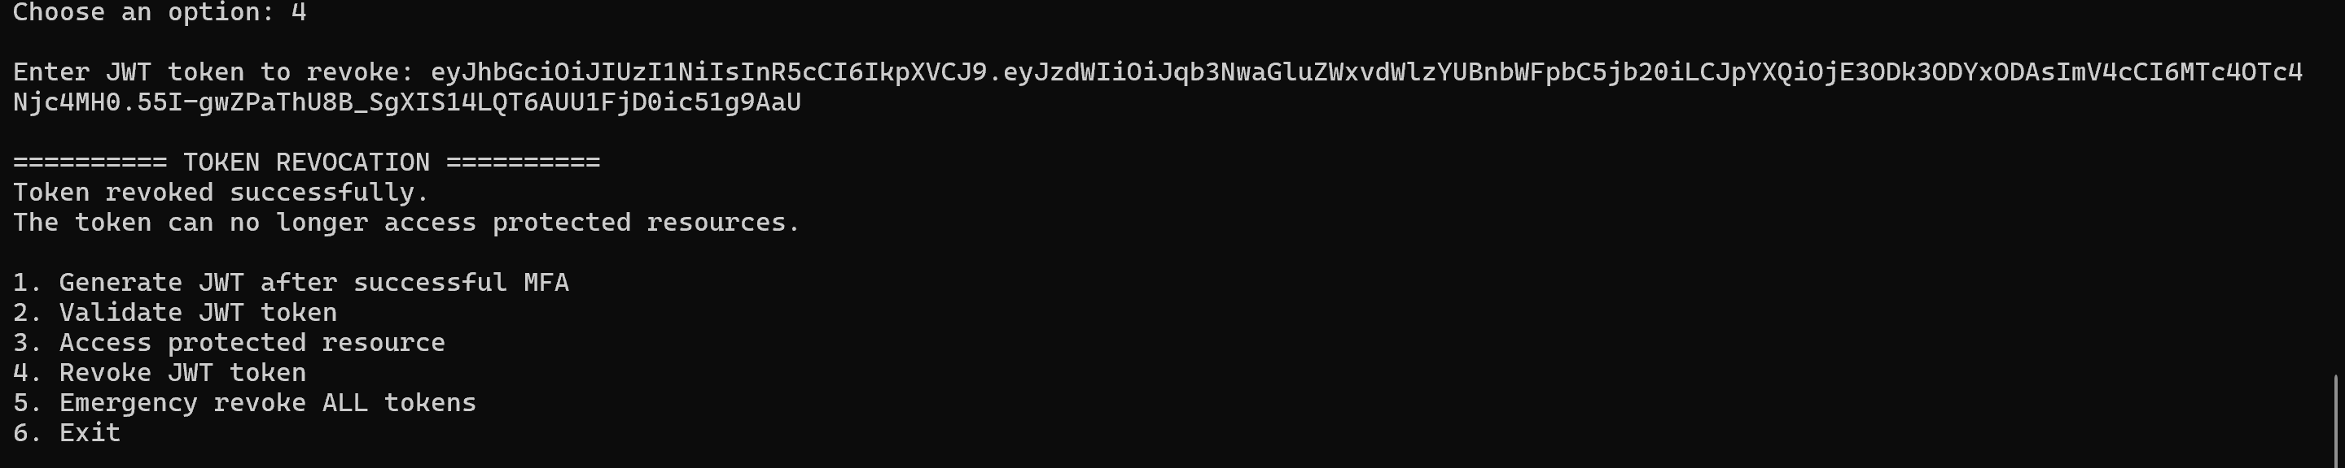

TASK 4: THREAT ANALYSIS AND MITIGATION
While developing the authentication system, I came across a few security issues that could affect the application if an attacker tries to bypass the authentication process. I focused mainly on OTP attacks, JWT attacks, and password-based attacks.
1. OTP Interception and Reuse
One possible risk is that an attacker could obtain a user's OTP and try to use it before it expires. This could happen through phishing, malware, or other methods of intercepting authentication information.
Mitigation implemented in my project
In my project, the file-based OTP is a six-digit code that is valid for only 30 seconds. The system checks both the OTP and its expiry time before accepting it. The number of incorrect attempts is also limited. This gives an attacker only a short period in which a stolen OTP could potentially be used.
Future implementation / recommended mitigation
As a future improvement, I could bind the OTP to the user's login session so that the same OTP cannot easily be used in another session. The research paper I reviewed also discusses using information such as the user, session, and time of OTP generation for this purpose. Another possible improvement would be risk-based authentication, where factors such as the device, IP address, login time, and previous login behaviour are considered before deciding whether additional verification is required.
2. JWT Forgery and Replay — Real-World Attack Scenario
API Exploitation
An attacker who gets hold of a valid JWT, or manages to create a forged one, could try to use it in API requests to access protected information. For example, if the application does not properly check the token signature, expiry, or user permissions, the attacker could potentially access information they should not have access to.
Mitigation implemented in my project
In my implementation, the JWT signature is checked before the protected resource is accessed. The token expiry is also checked, so expired tokens are rejected. I also added individual token revocation and an emergency option to revoke all issued tokens if suspicious activity is noticed.
Future implementation / recommended mitigation
If this system were developed further, I would store the JWT signing secret more securely and use shorter-lived access tokens. I would also validate claims such as the issuer and audience and add stronger authorization checks. HTTPS and better session invalidation after logout or password changes could provide additional protection against token theft and replay attacks.
3. Weak Password Policies — Real-World Attack Scenario
Brute-Force and Password Guessing
Another common risk is password guessing. An attacker could repeatedly try different passwords, especially if a user has chosen a weak or commonly used password.
Mitigation implemented in my project
In my project, passwords are stored using bcrypt salted hashing rather than as plain text. Failed login attempts are tracked, and the account is locked after repeated incorrect attempts. Login activities are also recorded in the log file. These controls make repeated password-guessing attempts more difficult.
Future implementation / recommended mitigation
As a future improvement, I could add stronger password requirements, login rate limiting, and checks for commonly compromised passwords. Additional monitoring and MFA could also provide another layer of protection if a password is successfully guessed.
References
[1] I. Kim, “Adaptive OTP Generation Using AI-Based Risk Assessment for Context-Aware Two-Factor Authentication Systems,” Journal of Communications and Networks, vol. 28, no. 2, p. 147, Apr. 2026.

