Lab 4 Applied Research Report
Input Validation, Secure Randomness & Injection Attack Prevention in a Healthcare Data Portal
Cybersecurity Architecture, Design, and Secure Software Development | Name: ____________ Student ID: ________ Date: ________
Summary. A penetration test of a healthcare portal found SQL injection, XSS, weak input validation and predictable tokens. I built a Python module (secure_input_module.py) that validates emails, filenames and paths, uses parameterized SQL, encodes output against XSS, and issues session/reset tokens with the secrets module. Each attack was run against a vulnerable and a fixed version; results quoted below come from that run (demo_output.txt).

Section A: Validation Strategy
Validation decides whether input is acceptable before the program uses it. Three styles exist, and they differ in how they fail:
Approach | How it works | Strength | Weakness
Blacklist | Reject inputs containing known bad strings ("<script>", "../", "OR"). | Quick to write. | Attacker only needs one variant you forgot (case, encoding, nesting). Never complete.
Whitelist | Accept only input that fits a strictly defined good shape; reject everything else. | Unknown attacks are rejected by default (default-deny). | Must be designed carefully or it blocks legitimate users.
Regex | A pattern language, not a strategy. It is the tool used to express a whitelist (or a blacklist). | Compact, testable, exact. | Sloppy patterns (match instead of fullmatch, '$' accepting a trailing newline, catastrophic backtracking) create bypasses or DoS.

Design used in the lab. All validators are regex-based whitelists using fullmatch. Email: a limited username character set, a domain of letters/digits/hyphen labels, and an alphabetic TLD, with length caps (254/64) and explicit rejection of quotes, angle brackets and control characters. This rejected "<script>alert(1)</script>@evil.com", "user@localhost", "user@-bad-.com" and "a..b@site.com" but accepted "john.doe@hospital.com". Filename: first character must be a letter, digit or underscore (which blocks hidden files such as .env), the rest only letters, digits, "_" and ".", no ".." anywhere and at most 100 characters. Path: join the user value to a fixed base directory, normalize, resolve symlinks with realpath, then require the result to remain inside the base (commonpath check); absolute paths and null bytes are rejected. "../../../../etc/passwd" resolved to /etc/passwd and was rejected, while "sub/../report.txt" was correctly accepted because it stays inside the base.
Principles: validate on the server (client checks are cosmetic), canonicalize before checking, validate for meaning and format, and remember that validation is only one layer. It does not replace parameterized queries or output encoding.

Section B: Attack Analysis
Attack | How it works | Why the naive defence fails | Fix implemented
SQL injection | User text is concatenated into the SQL string, so quotes let the attacker change the query's structure. Input ' OR '1'='1 made the WHERE clause always true and returned all 4 users; admin'-- commented out the password check and logged in without it; a UNION payload dumped every password. | Removing the word "OR" is case-sensitive: "oR" still returned 4 rows. Escaping quotes by hand misses encodings, numeric contexts and other dialect tricks. | Parameterized query (WHERE username = ?). The same three payloads returned 0 rows, False and an empty list: input is only ever data, never SQL code.
Cross-site scripting | Unescaped user text is written into a page, so the browser runs it as code, e.g. <script>alert('Hacked')</script> or a script that sends document.cookie to an attacker's server. Stored XSS hits every later visitor, including doctors. | Deleting "<script>" once fails on <SCRIPT> (case) and <scr<script>ipt> (nesting rebuilds the tag). Other tags such as <img onerror=...> need no script tag at all. | html.escape at output turns < > & " ' into harmless entities (&lt;script&gt;...), plus input sanitization (length cap, control-character and tag stripping) as a second layer.
Path traversal | "../" sequences climb out of the intended folder: base + ../../../../etc/passwd resolves to /etc/passwd, exposing files never meant to be served. | Removing "../" once turns "....//" into "../" (the filter itself creates the attack). URL-encoded and backslash variants add more bypasses. | Resolve first, then check containment with realpath/commonpath. The filtered value was rejected too, so even a bad upstream filter cannot cause a leak.
Format string / buffer overflow | printf(user_input) lets the attacker supply %x conversions and read stack memory (the C demo leaked fde30810.0.0.c9e03b20). strcpy into an 8-byte buffer with 32 bytes overwrites adjacent memory, which can corrupt data or hijack control flow; the compiler's stack protector aborted the run ("stack smashing detected"). | Filtering "%" characters is fragile; length checks written by hand are easy to get wrong by one byte. | printf("%s", input) treats input as data; snprintf(buf, sizeof buf, ...) bounds every copy. Compiler protections (stack canaries, ASLR, DEP) reduce, but do not remove, the risk.

Why buffer overflows happen and why Python is safer. In C the programmer manages memory; functions such as strcpy and gets copy until they see a terminator and never check that the destination is large enough, so extra bytes spill over neighbouring variables, saved registers or the return address. Python strings and lists are bounds-checked objects that resize automatically, so plain Python raises an exception instead of corrupting memory. It is not immune: C extensions and ctypes can overflow buffers; unsafe str.format/eval on user input leaks data (the Python demo leaked SECRET_KEY through "{app.SECRET_KEY}", the analogue of printf(user_input)); and giant inputs can still cause denial of service. The lesson is the same everywhere: never let user data act as code or as a format specification.

Section C: Randomness & Entropy
Why random is insecure. Python's random module uses the Mersenne Twister, a deterministic algorithm designed for simulations. Its whole future output follows from its seed, and after observing 624 consecutive 32-bit outputs its internal state can be reconstructed. Programs often seed it with the clock, which an attacker can guess closely. secrets uses the operating system's cryptographically secure generator (fed by hardware and kernel entropy), built so that past outputs reveal nothing about future ones.
Entropy is the amount of real uncertainty in a value, measured in bits: n bits of entropy means an attacker faces 2^n equally likely possibilities. Predictable randomness is dangerous because the effective entropy is far below the token's length: a 16-hex-character token looks like 64 bits, but if it comes from a clock-seeded generator the attacker only needs to search the possible seeds.
Secret | Entropy (bits) | Guesses to exhaust | Practical meaning
Token from time-seeded random (24 h window) | 16.4 | 8.6 × 10^4 | Broken in 0.043 s (5,232 guesses)
Random 4-digit PIN | 13.3 | 1.0 × 10^4 | Needs lockout / rate limiting
secrets.token_hex(16) | 128 | 3.4 × 10^38 | Infeasible to brute force
secrets.token_urlsafe(32) | 256 | 1.2 × 10^77 | Used for session and reset tokens

Distribution analysis (1000 values each). random.randint(1,100) gave a chi-square of 113.8 and secrets.randbelow(100)+1 gave 71.6; both are below the 5% critical value of 123.2 (df = 99), so both look uniform (figure). This is the key finding: statistical uniformity does not imply unpredictability. Only entropy and secrecy of the generator state determine security, which is why the attack below still works against the "uniform" generator.
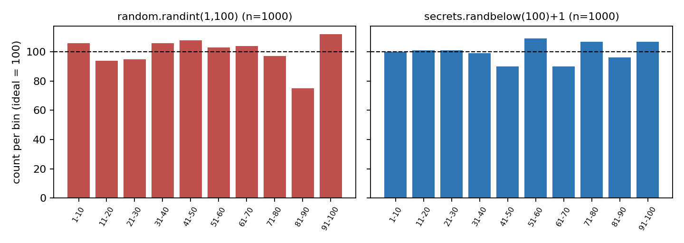
Figure 1. Ten-bin histograms; the dashed line marks the ideal count of 100.
Attack scenarios. (1) Token prediction: the server seeds random with its boot time. The attacker registers, receives one token, tries every boot second of the last 24 hours (86,400 candidates) and finds the seed after 5,232 guesses in 0.043 s. (2) Session hijacking: with the seed recovered, the attacker asks the reproduced generator for the next output and obtains the victim's session token exactly (predicted f0938f5453ba69a6 = actual, True), then presents it as a cookie to read the victim's patient records without a password. (3) Password-reset takeover: the same method predicts the reset link sent to a victim's email and lets the attacker set a new password. With secrets there is no seed to recover; exhausting 2^256 possibilities at 10^12 guesses per second would take about 10^57 years.
Recommendations. Whitelist-validate every input on the server; use parameterized queries everywhere; encode output for its context (HTML, attribute, JavaScript, URL); confine file access to a resolved base directory; use secrets (at least 128 bits) for every token, key and reset link; expire tokens and rotate session IDs at login; and treat filters and validation as layers of defence in depth rather than a single wall.

