Course: Cybersecurity Arch,Design&SSD - MCSC-6002-0NB
Name: Daffiniruby Peter Arockiasamy

The HTML server
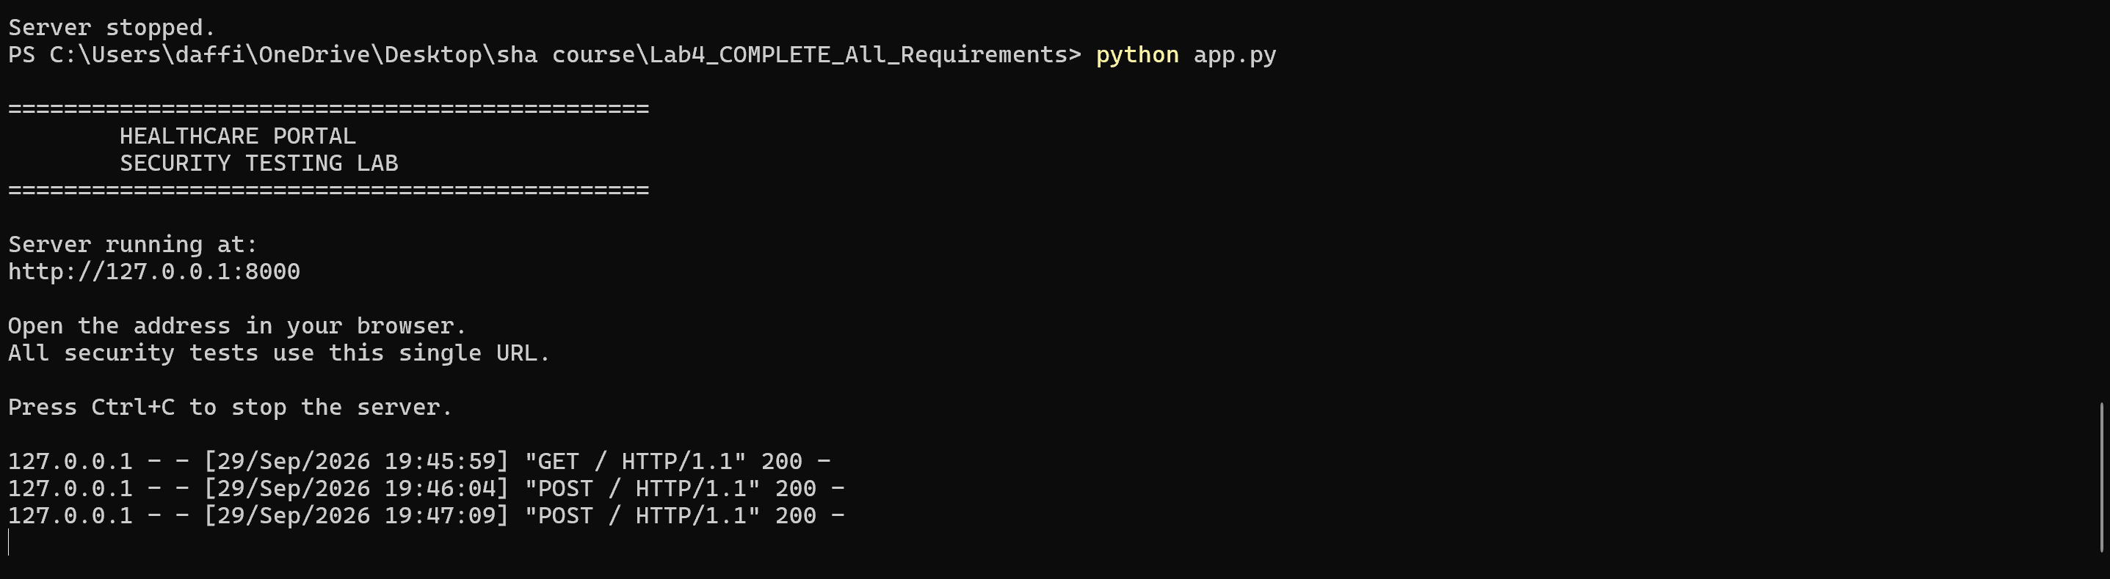

Figure 1: Live Password Validation During Account Registration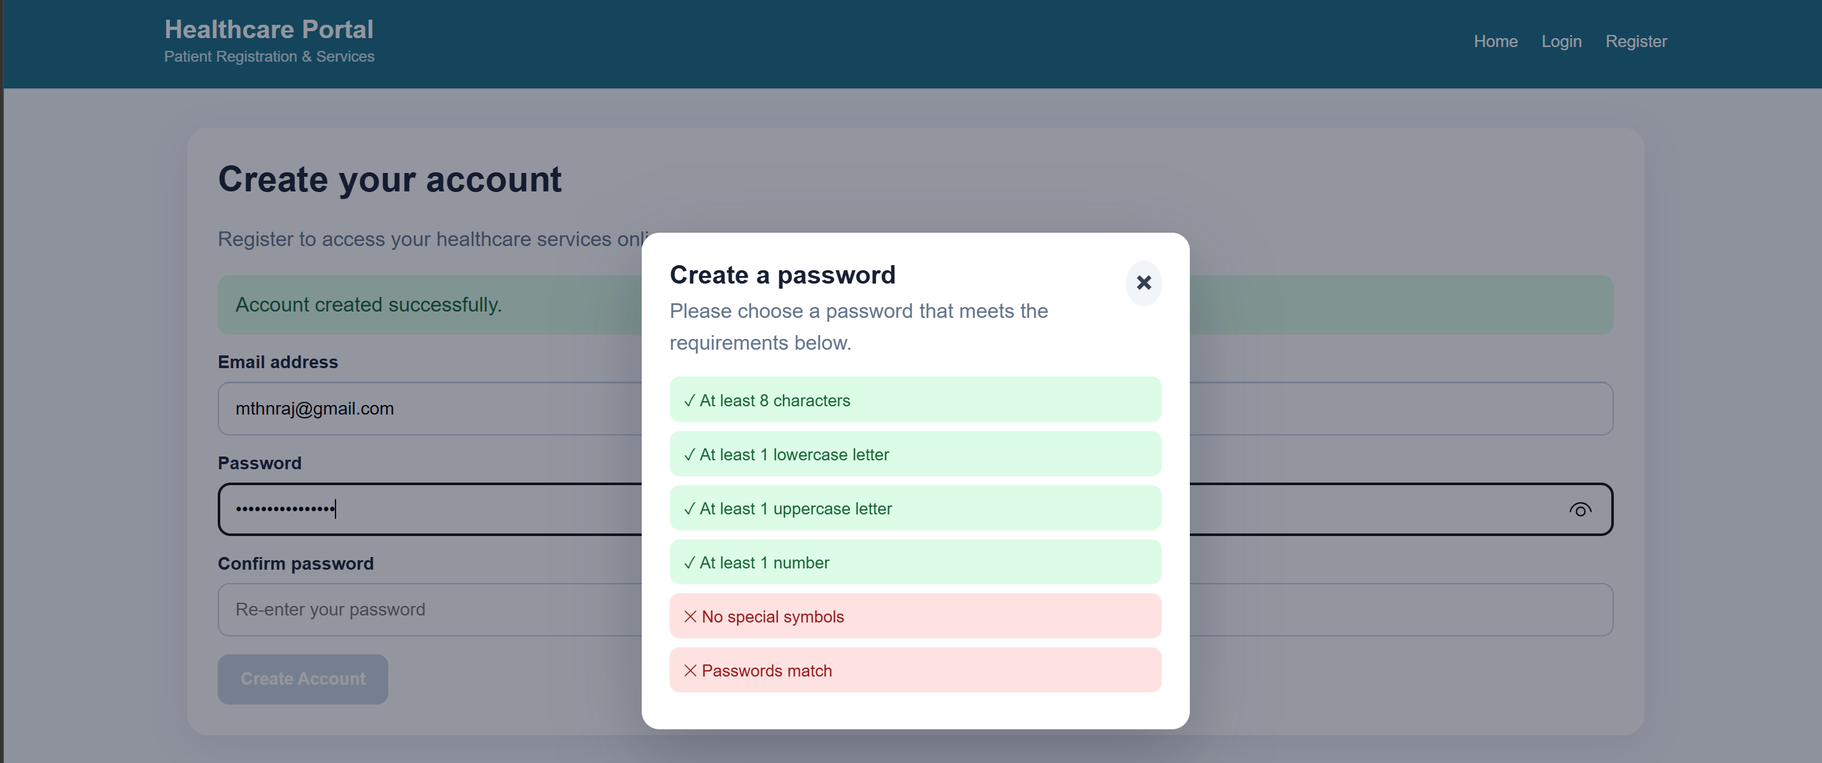
Figure 2: Login Authentication — Invalid Credentials
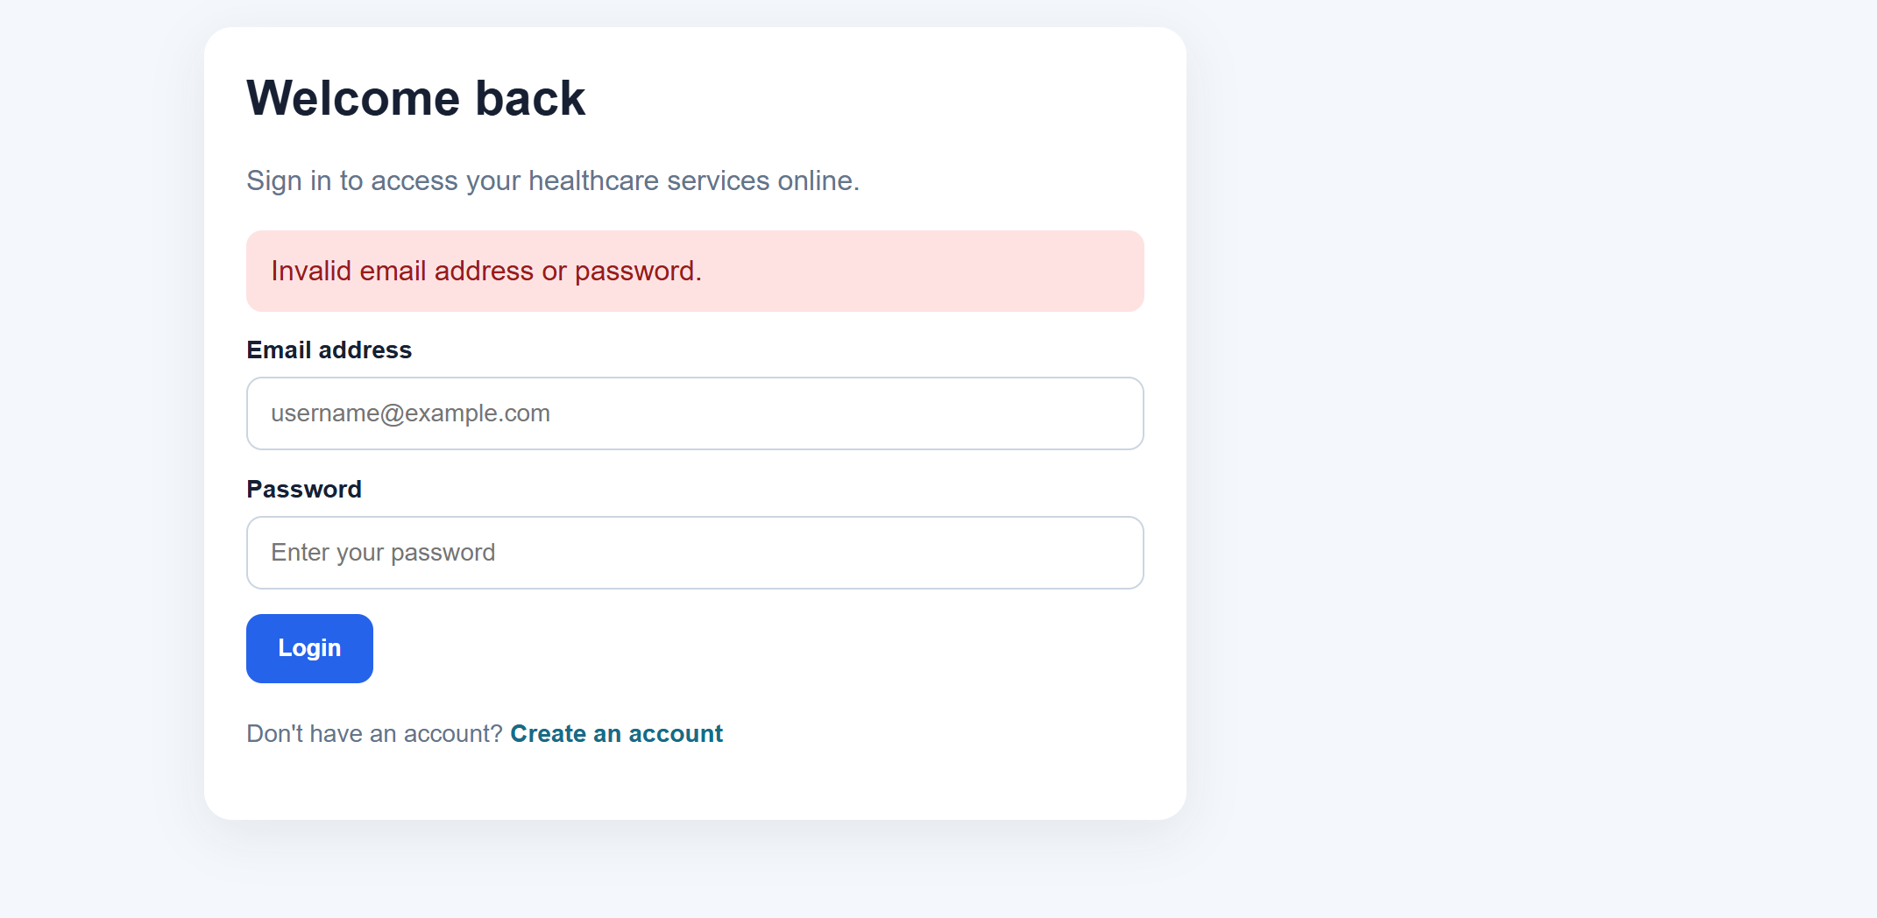
Figure 3— Successful Email Validation
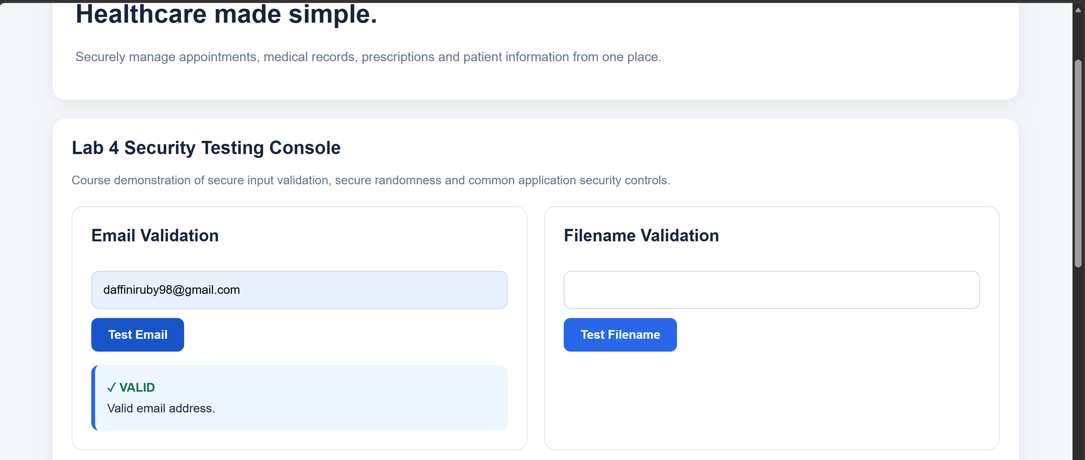
Figure 4 — File Path Validation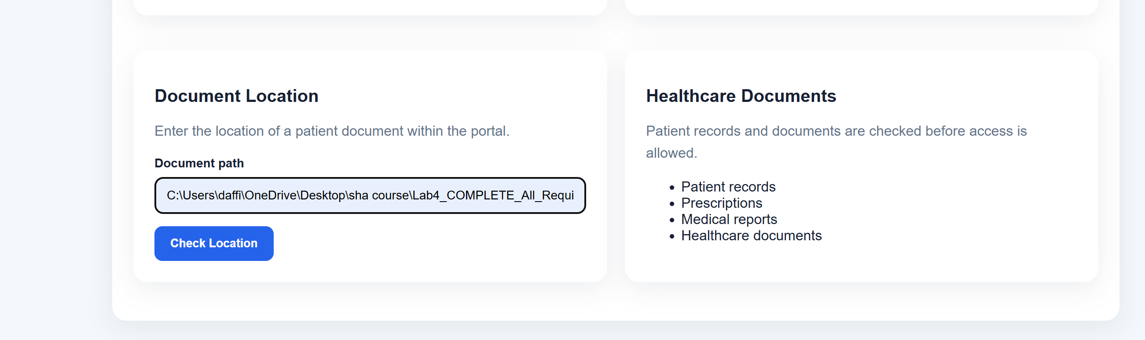
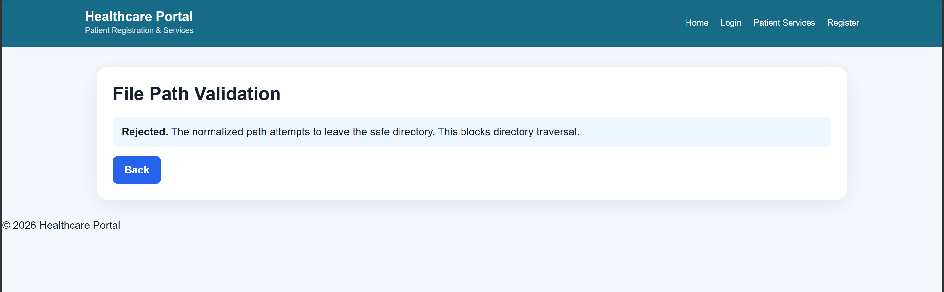
Valid file path accepted after normalization
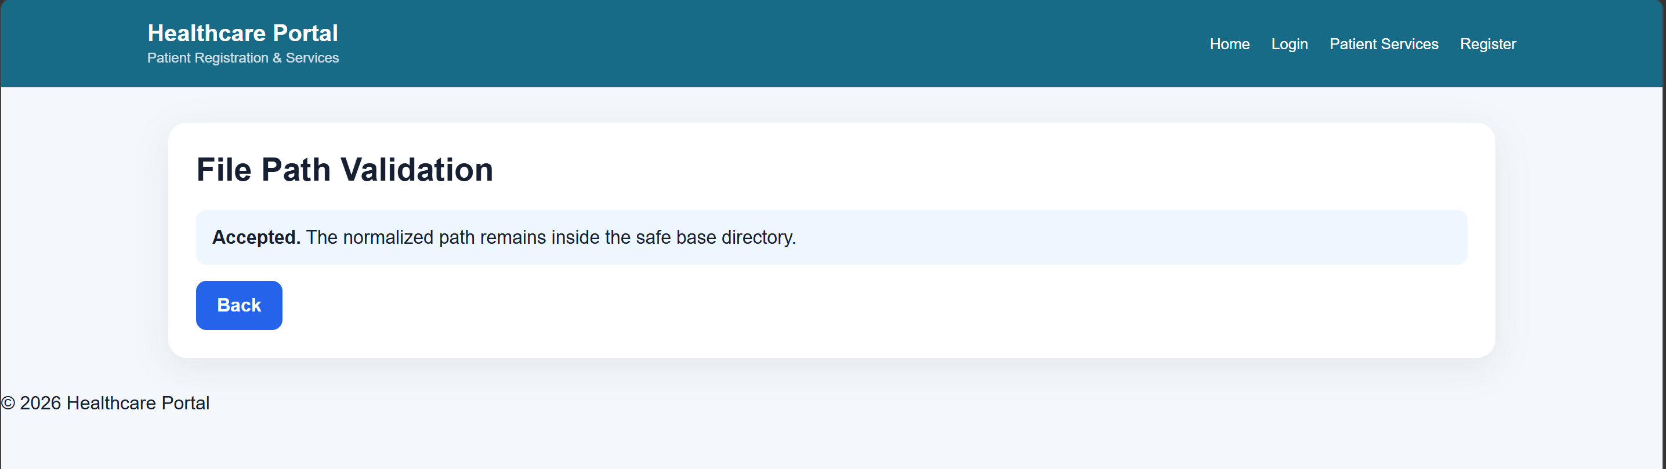
Figure 5— Filename Validation
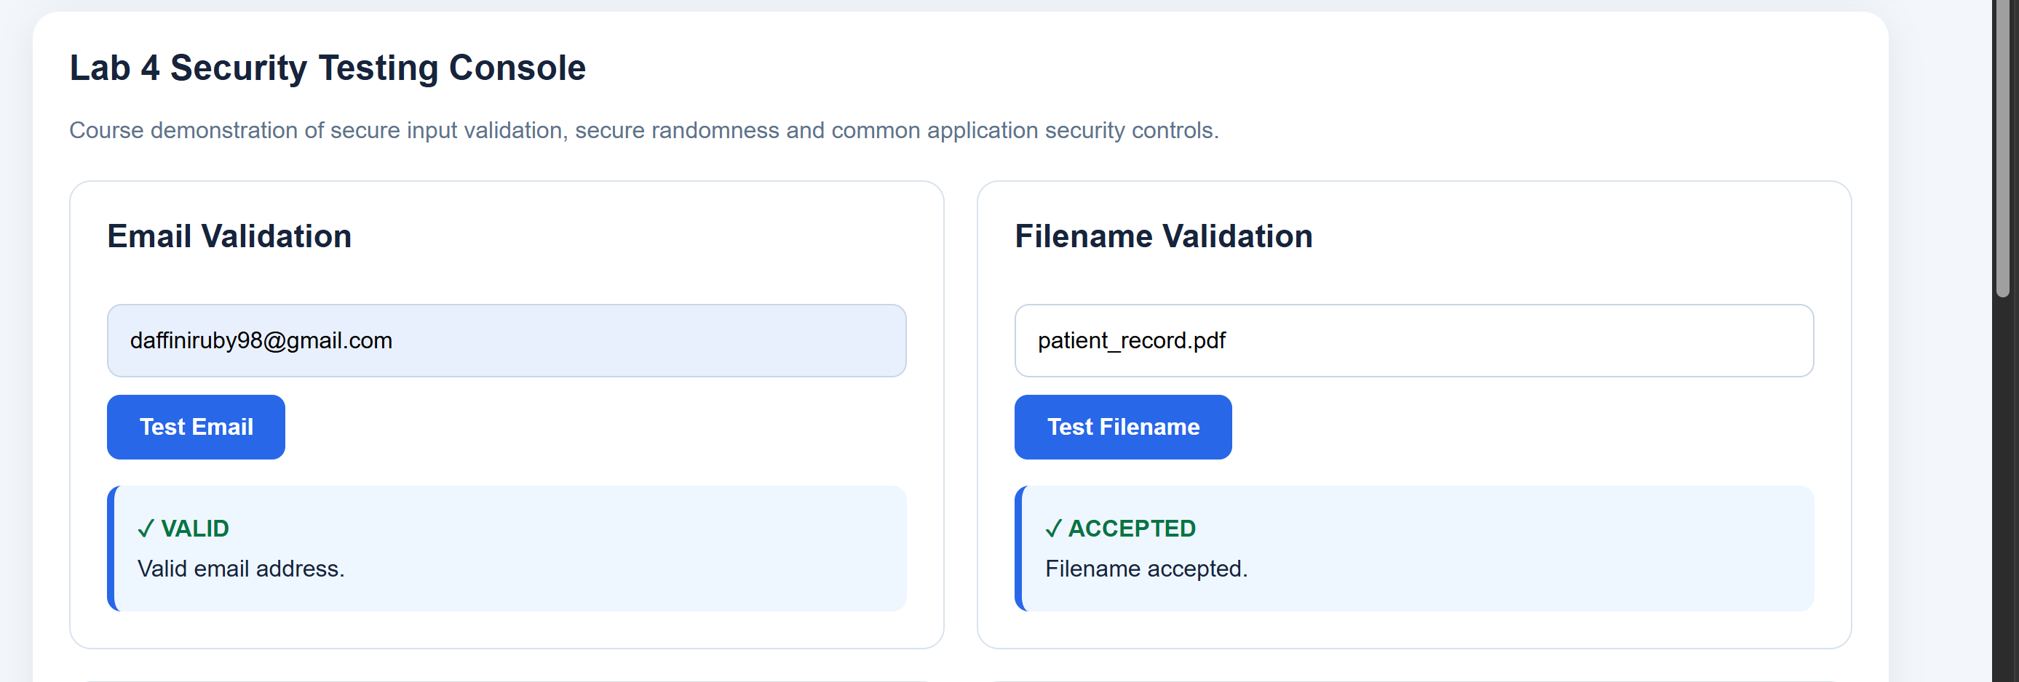
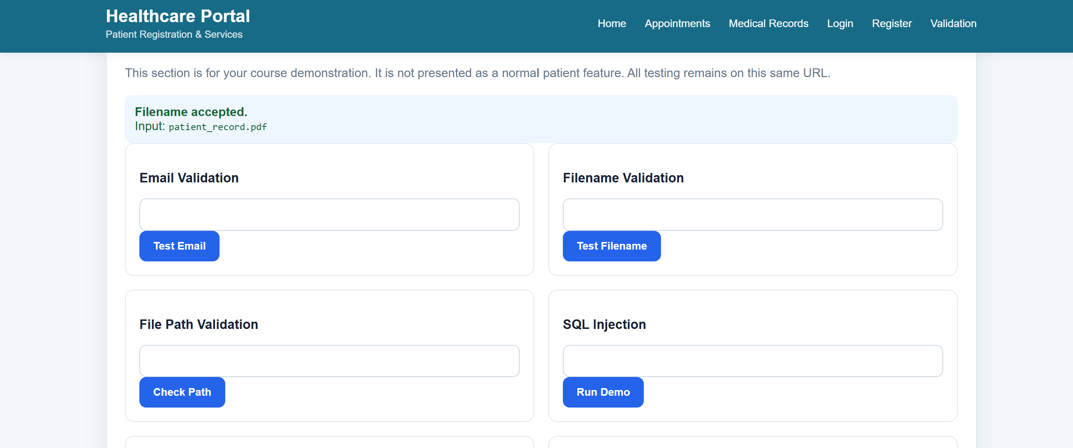
Figure 6 —Filename Validation — Rejected Invalid Filename
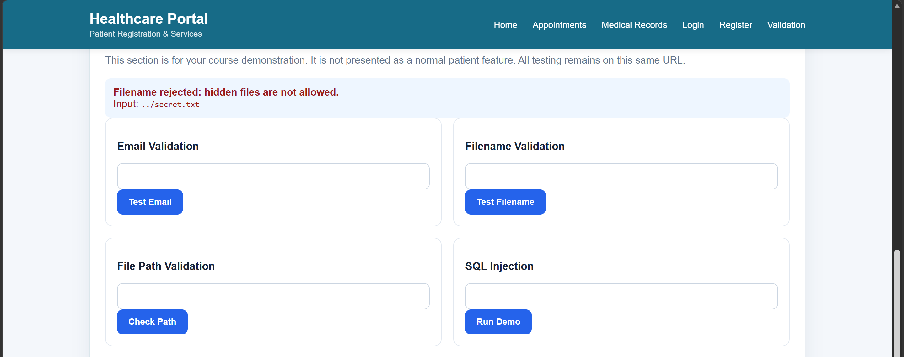
Figure 7 — Valid File Path Accepted
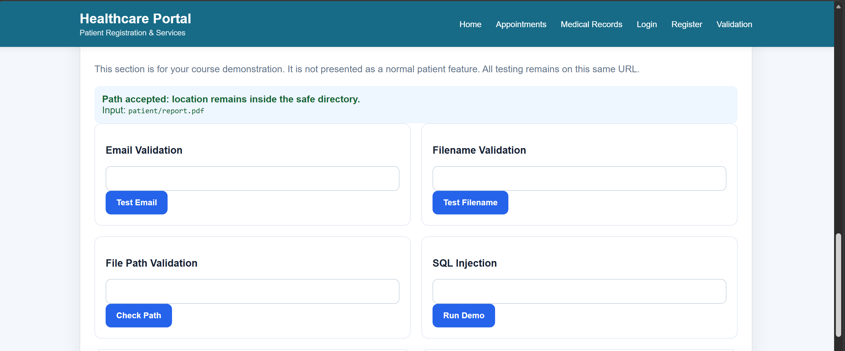
Figure 8 — Directory Traversal Attempt Rejected
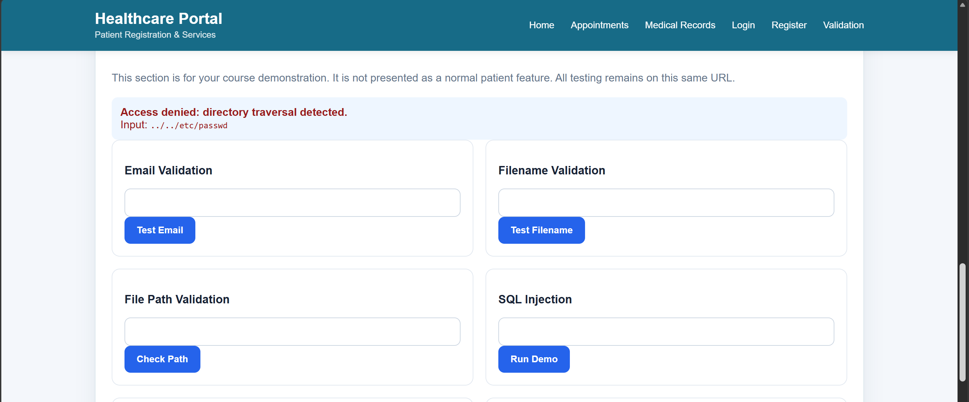
Figure 9- Secure Random Number Generation
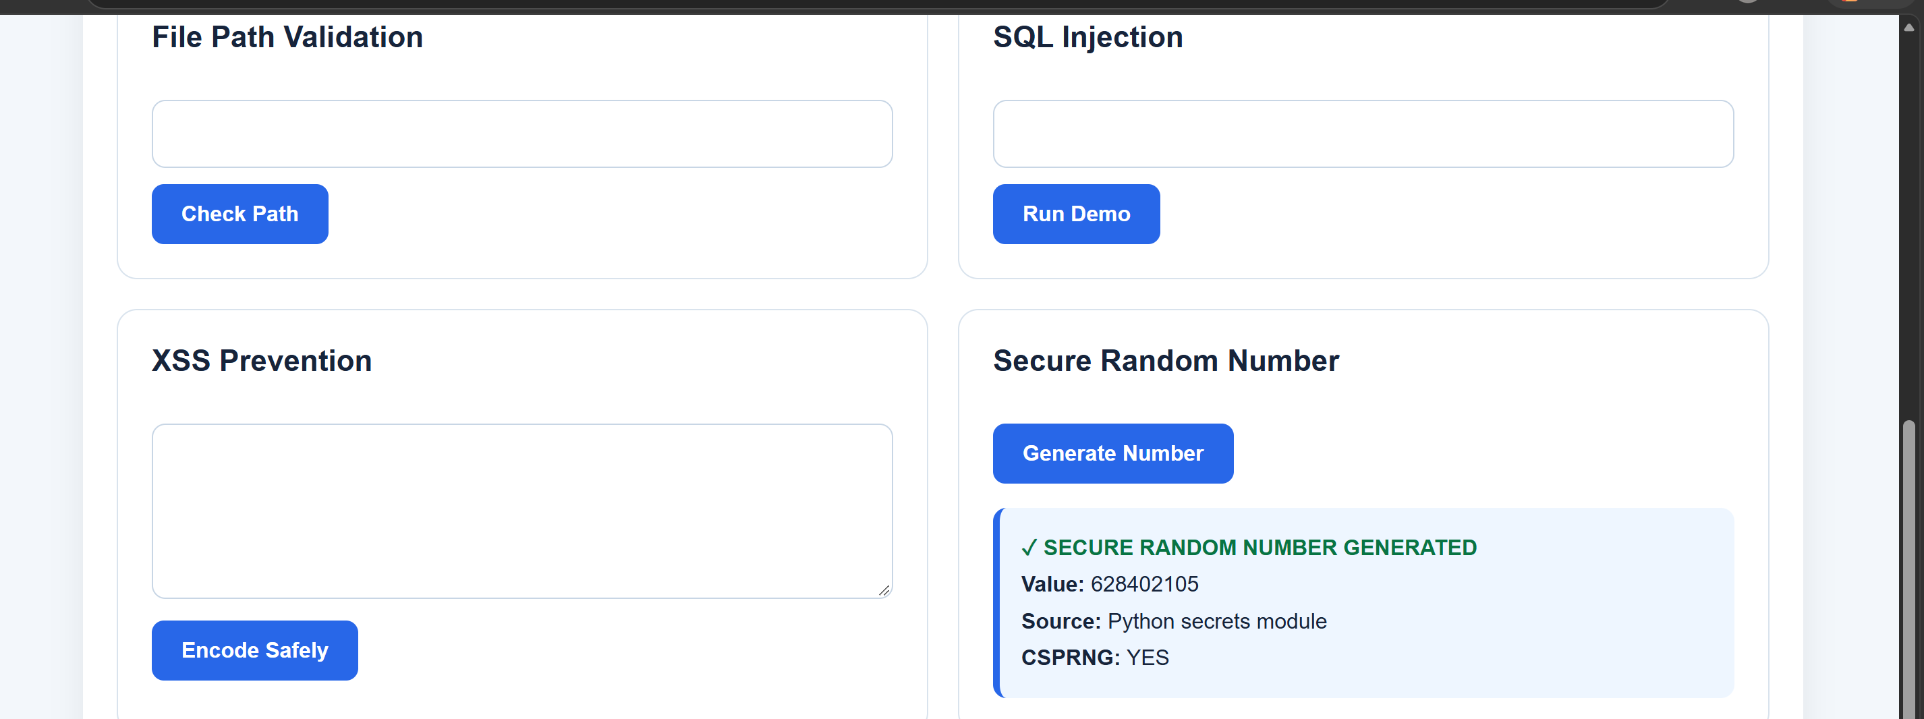

Figure 10— Weak Seed vs CSPRNG Comparison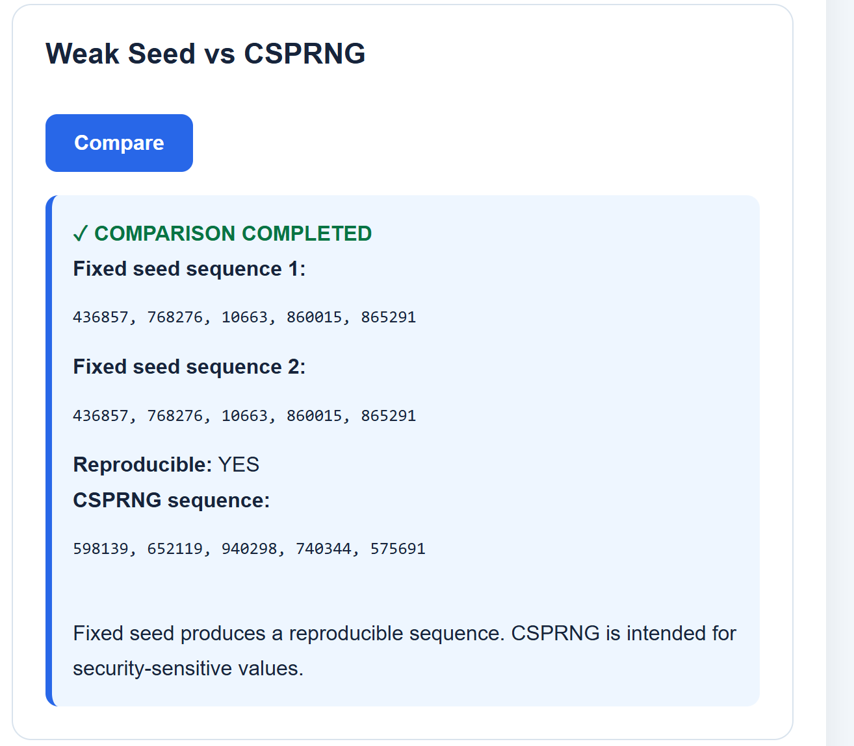Figure 11— Randomness and Entropy Analysis
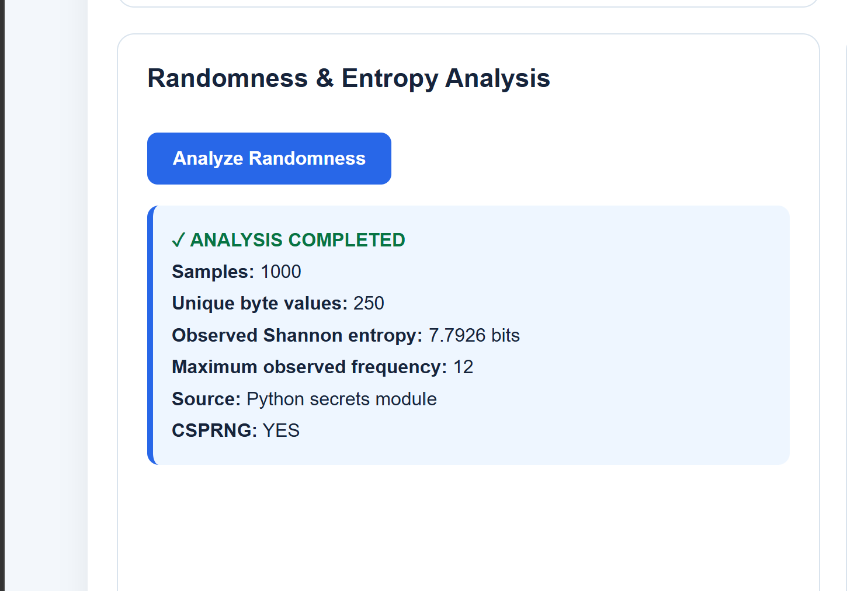

Figure 12— Formatting / Buffer Overflow Awareness
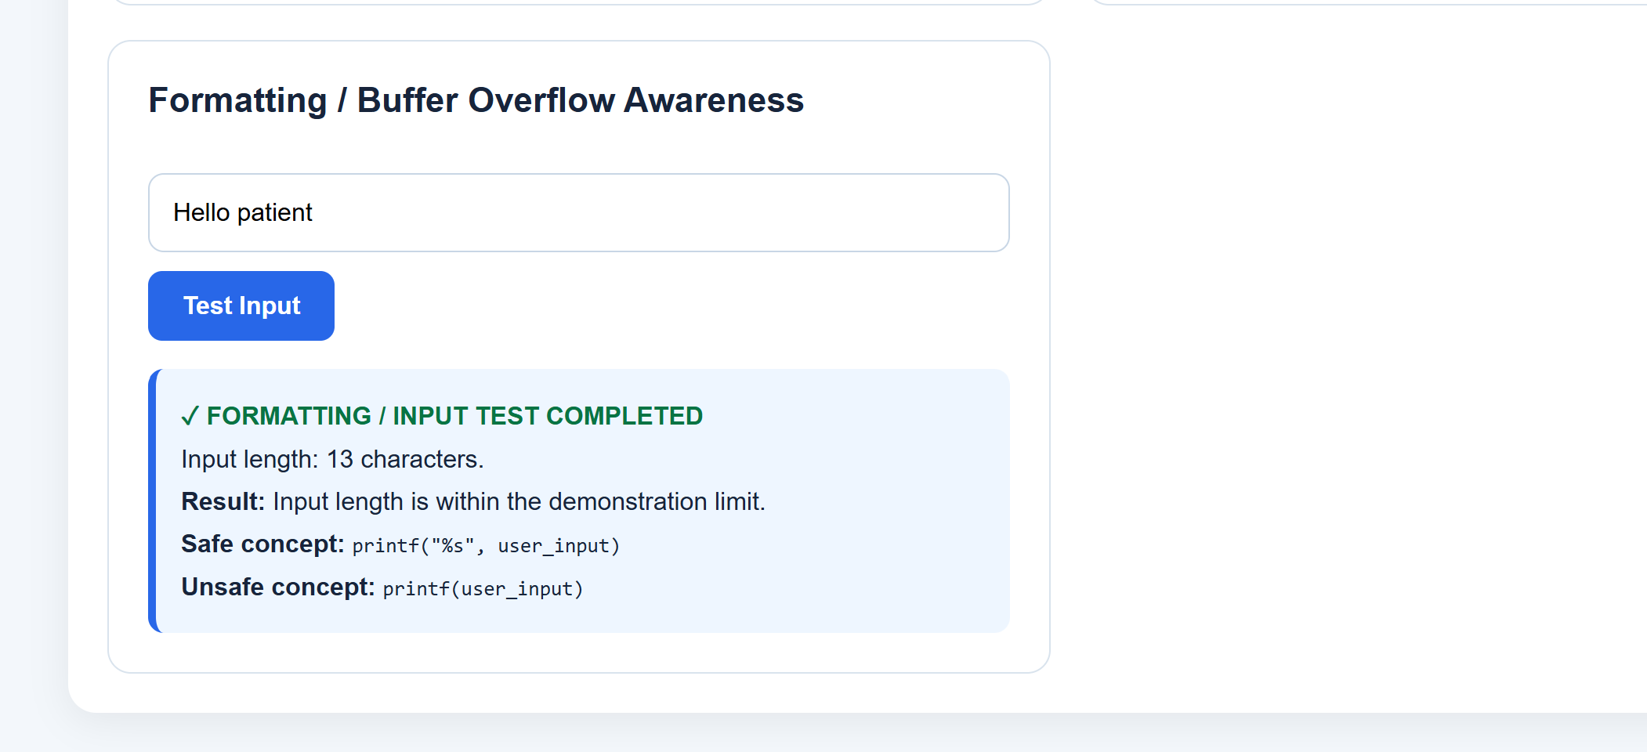

Figure 13— Oversized Input Test Rejected
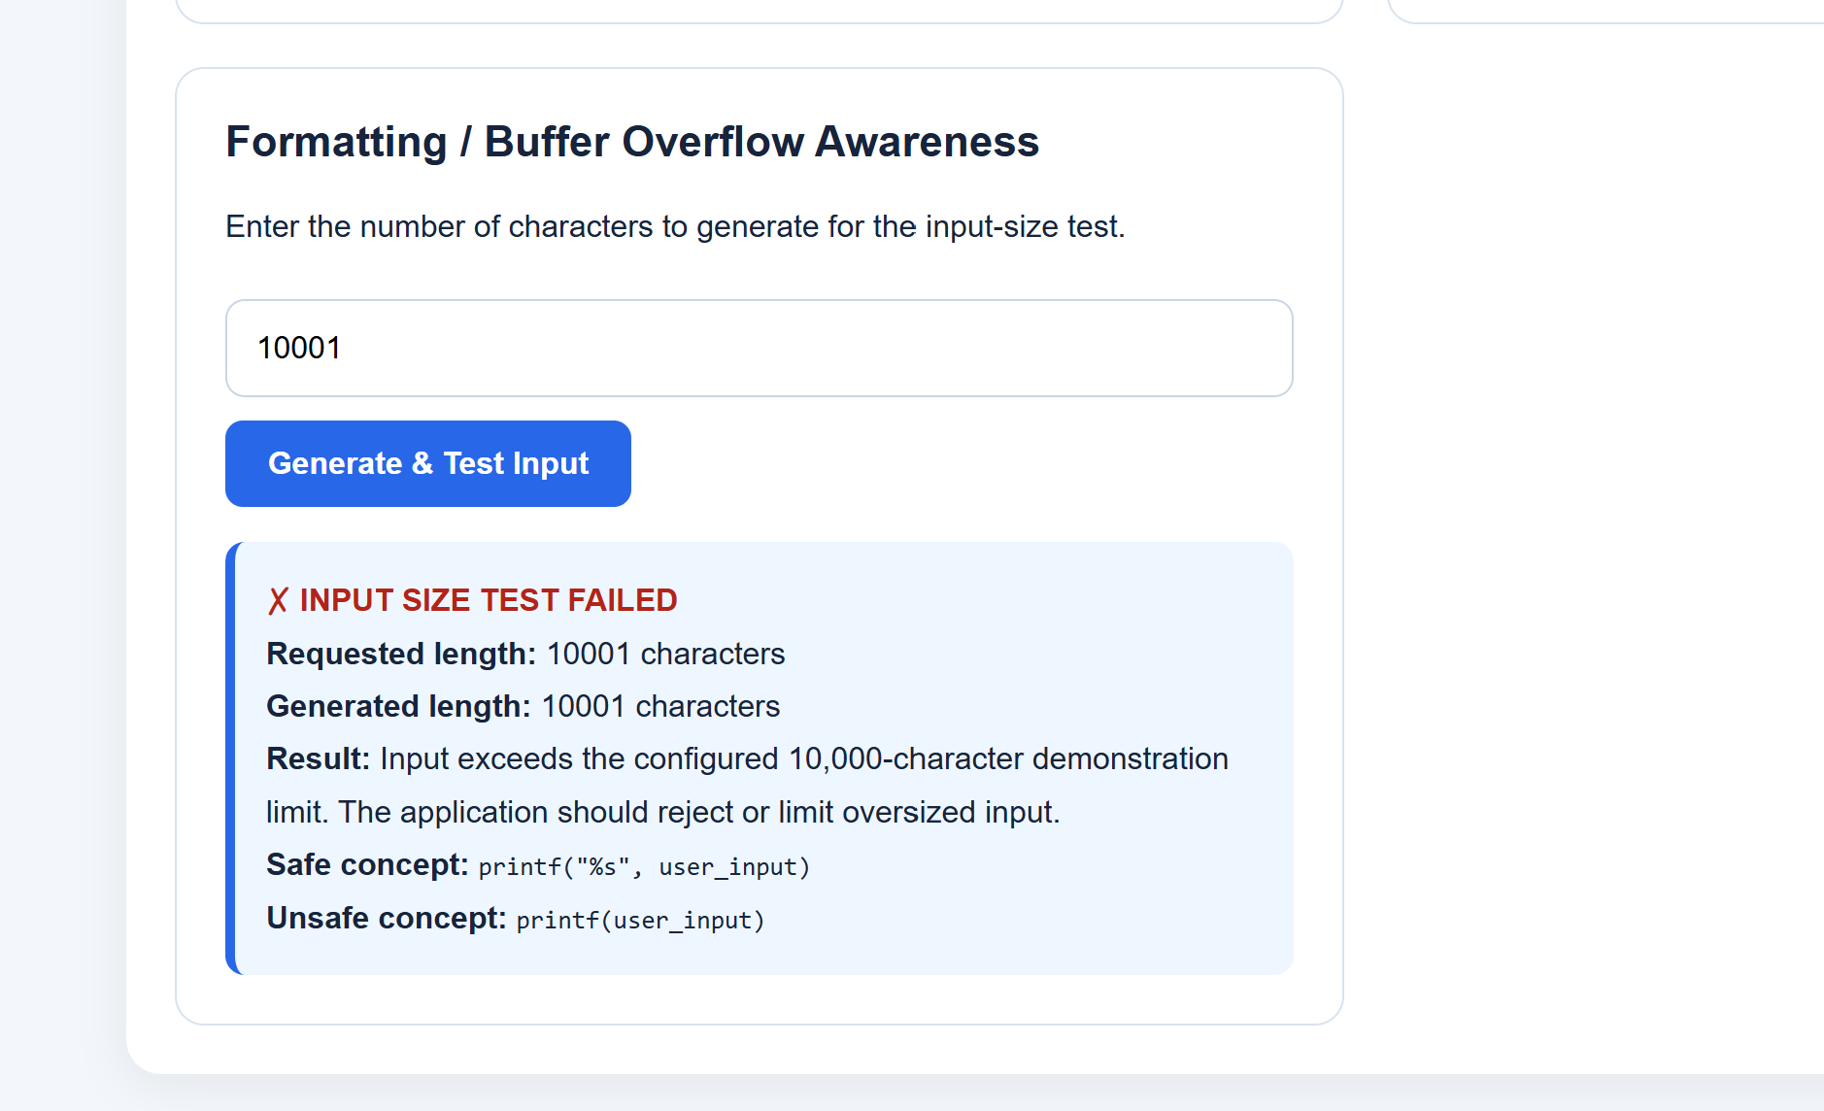

Figure 14— SQL Injection Attempt Blocked
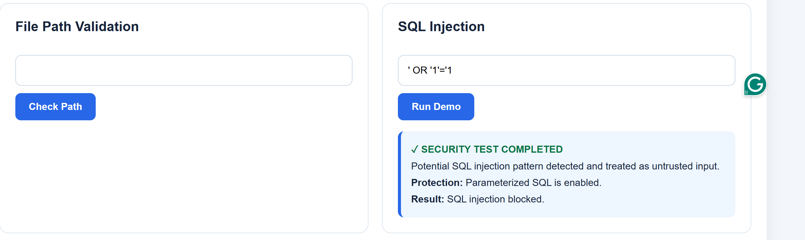
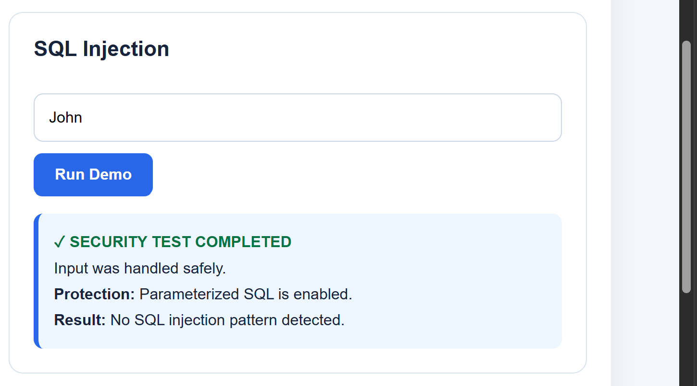
Figure 15— XSS Prevention with Normal Input
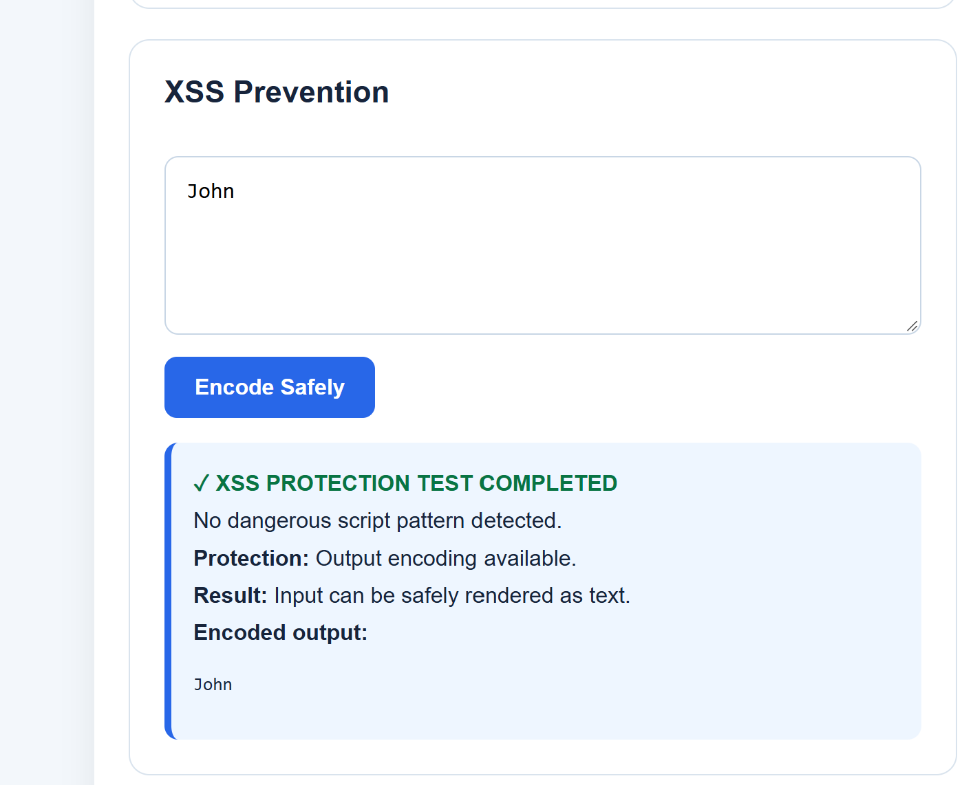

Figure 16 - XSS Attack Detected and Safely Encoded
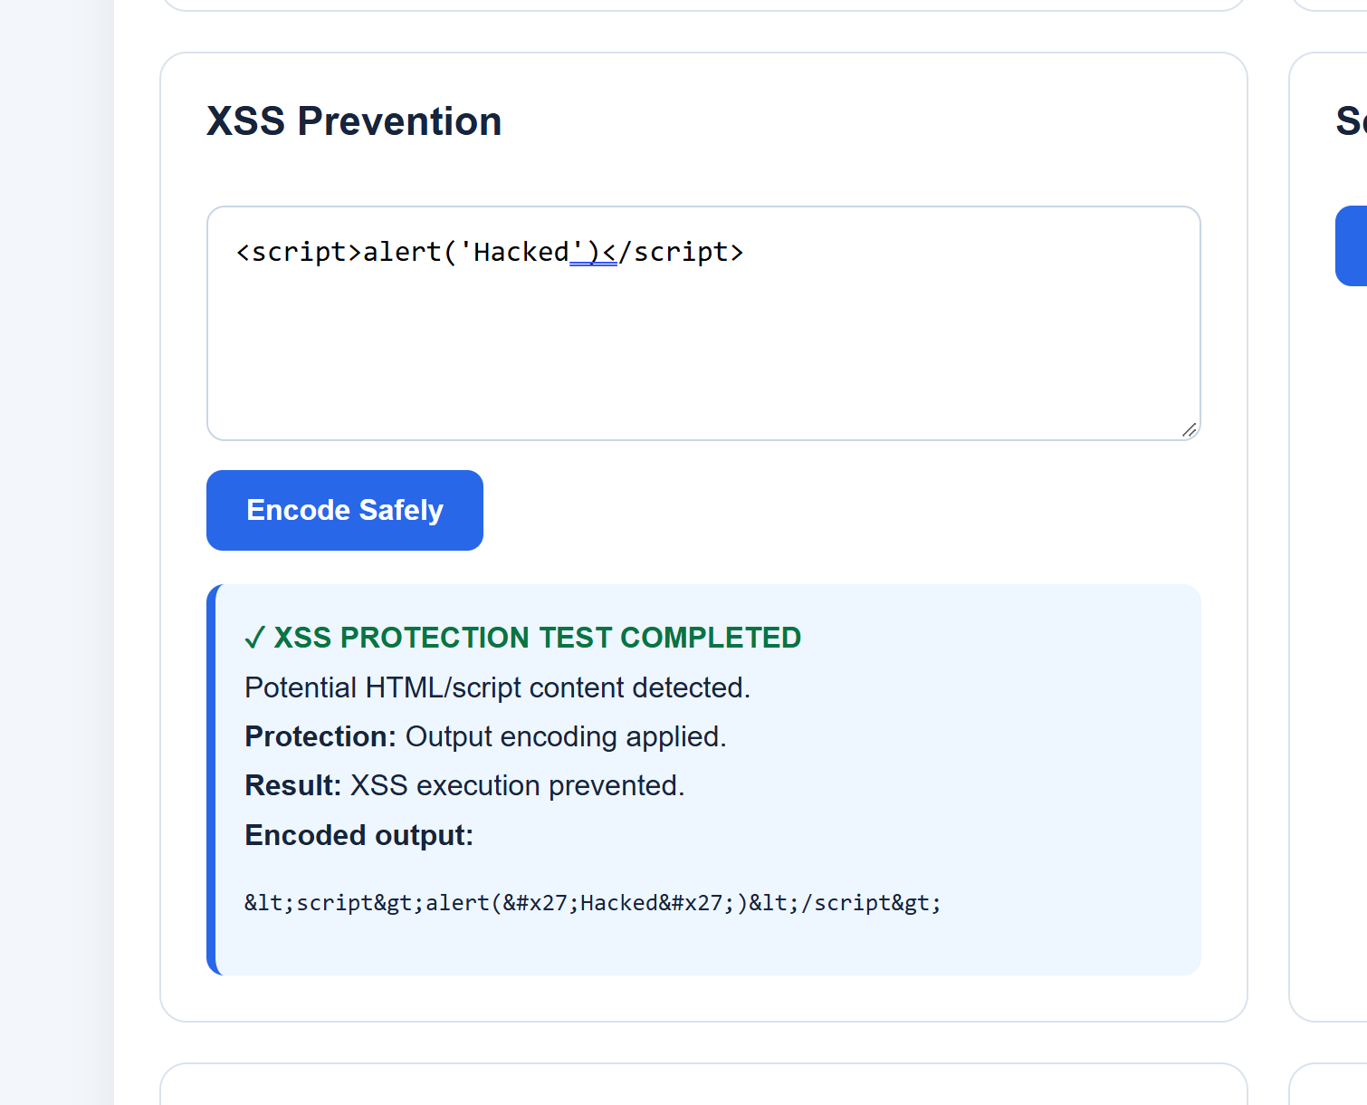

Section A: Validation Strategy
Regex vs Whitelist vs Blacklist
Input validation is an important part of secure application development because the application should not automatically trust information entered by users. In my healthcare portal project, I used different validation techniques depending on the type of input. The main techniques considered in this lab are regular expressions (Regex), whitelist validation and blacklist validation.
Regex Validation
Regular expressions also called Regex are used to check whether an input follows a specific pattern. This is useful when the input has a known structure. For example, an email address normally follows a format such as:
username@domain.com
In my project, Regex is used for email validation. The application checks whether the entered email follows the expected format before accepting it. This helps reject invalid values and reduces the possibility of unexpected input being processed.
Regex is useful when there are clear rules for what the input should look like. However, Regex should not be treated as a complete security solution for every type of input. Different inputs require different validation methods. The lab specifically requires email validation and checking for invalid or unwanted input.
Whitelist Validation
Whitelist validation means defining what is allowed and rejecting everything outside that list. I used this approach for filename validation.
For example, my application allows:
A-Z
a-z
0-9
_
.
Therefore, a filename such as:
patient_record.pdf
On the other hand, filenames containing path separators or traversal characters should not be accepted. The lab specifically requires filenames to allow alphanumeric characters, _, and while rejecting path traversal such as ../ and hidden files such as. env.
Whitelist validation is useful because it starts from a safer approach: instead of trying to identify every possible bad input, the application defines the small set of input that is expected.
Blacklist Validation
Blacklist validation works in the opposite way. It identifies known dangerous patterns and rejects them. For example, during my XSS test, the application checks for patterns related to HTML or JavaScript such as <script>, javascript:, onerror= and similar content.
For the XSS demonstration, I entered:
<script>alert('Hacked')</script>
The application detected potential HTML/script content and encoded the input rather than allowing it to execute. This satisfies the lab requirement to accept user input while preventing script execution using output encoding and sanitization.
However, blacklist validation has a limitation. It is difficult to create a blacklist containing every possible malicious input. An attacker may use another pattern or representation that is not included in the blacklist. Therefore, blacklist checking should not be the only security control.
Overall, I used the validation method according to the input type. Regex is useful for structured data such as email addresses. Whitelist validation is suitable for filenames and dangerous-pattern detection combined with output encoding is used for XSS.
Section B: Attack Analysis
How Each Attack Works
The main attacks considered in this lab are SQL Injection, Cross-Site Scripting (XSS), and Directory Traversal. These attacks are related to improper handling of user-controlled input.
1. SQL Injection
SQL Injection occurs when an application directly adds user input into an SQL query without properly separating the input from the SQL command.
A vulnerable query looks like:
query = "SELECT * FROM users WHERE username = '" + user_input + "'"
The problem is that the user's input becomes part of the SQL statement. An attacker can provide specially constructed input that changes how the database interprets the query.
For my demonstration, I tested SQL injection using an input such as:
' OR '1'='1
The application identifies the suspicious input and reports that the SQL injection was blocked.
The secure solution is a parameterized query:
query = "SELECT * FROM users WHERE username = ?"
connection.execute(query, (user_input,))
Here, the SQL command and the user input are handled separately. The database treats the supplied value as data instead of interpreting it as part of the SQL syntax. The lab specifically requires both a vulnerable query for demonstration and a secure parameterized query.
2. Cross-Site Scripting
XSS happens when an application accepts user input and displays it in a web page without properly handling HTML or JavaScript content.
For example, the attack input used in my test was:
<script>alert('Hacked')</script>
If this type of input is inserted into a page without protection, the browser may interpret it as JavaScript instead of normal text.
In my application, the input is checked for potentially dangerous HTML/script patterns.
My test produced:
Potential HTML/script content detected.
Protection: Output encoding applied.
Result: XSS execution prevented.
The encoded output converts characters such as < and > into HTML entities. This demonstrates that the application detected malicious input and prevented it from being executed. The lab specifically requires output encoding using techniques such as html.escape().
3. Directory Traversal
Directory traversal is an attack where an attacker attempts to access files outside the directory that the application is supposed to allow.
The ../ represents the parent directory. If an application directly accepts a user-controlled path, an attacker could try to move outside the intended directory and access other files.
In my project, I use path normalization and then check whether the resulting path remains inside the configured safe base directory. If the normalized path is outside the allowed directory, the application rejects it.
For example, my testing includes both a valid path and a directory traversal attempt. The valid path is accepted when it remains inside the safe directory, while the traversal attempt is rejected.
Why Naive Defences Fail
Naive security defenses fail because they normally focus on only a small number of known attack patterns instead of properly controlling the input or separating data from executable instructions.
For example, a simple SQL blacklist may search for words such as SELECT, OR, or other SQL keywords. This is not a reliable solution because SQL injection can be represented in different ways. The better approach is to use parameterized SQL queries so that user input is always treated as data.
Similarly, using a small blacklist for XSS is not enough because there can be different HTML and JavaScript patterns. In my project, pattern detection is combined with output encoding. This provides a stronger defense because the browser receives encoded content rather than executable HTML.
For directory traversal, simply checking whether the input contains ../ is also not enough. The application should normalize the complete path and then verify that the final location remains inside the permitted directory.
Therefore, security controls should be applied according to the type of attack. Parameterized queries should be used for SQL, output encoding should be used for HTML output, and canonicalization plus safe-base checking should be used for file paths.
Section C: Randomness & Entropy
Why is random Insecure?
Randomness is important in cybersecurity for generating values such as session tokens and password-reset tokens. However, not every random-number generator is suitable for security purposes.
Python provides the random module for general-purpose pseudo-random number generation. For example:
import random
random.randint(1, 100)
This is useful for normal applications, simulations, and similar tasks, but it should not be used for security-sensitive tokens.
One important issue is predictability. Pseudo-random generators use an internal algorithm and can produce a reproducible sequence when a known seed is used.
For example:
random.seed(12345)
If the same seed and algorithm are used, the sequence can be reproduced. My project demonstrates this using the Weak Seed vs CSPRNG comparison. The same fixed seed produces the same sequence, showing that the values are reproducible.
This is a security problem if the same type of predictable randomness is used to generate session tokens or password-reset tokens. If an attacker can determine or predict the generator state, they may be able to predict future security-sensitive values.
The lab therefore asks us to compare weak seed-based randomness with cryptographic randomness and specifically discusses token prediction and session hijacking as possible attack scenarios.
Using secrets for Security
For security-sensitive values, my project uses Python's secrets module.
For example:
import secrets
value = secrets.randbelow(100)
The lab specifically gives secrets.randbelow() as the secure alternative to random.randint() and requires secure session and password-reset token generation.
My application also generates 1,000 secure random values and performs a distribution and entropy analysis. This allows the randomness to be evaluated rather than simply generating one value and assuming that it is secure.
Importance of Entropy in Cryptography
Entropy represents the amount of uncertainty or unpredictability in a value. In cryptography, unpredictability is extremely important because attackers should not be able to easily guess security-sensitive values.
For example, consider a session token. If the token is generated from a predictable sequence, an attacker may be able to guess another valid token. If the token has strong unpredictability, guessing a valid value becomes much more difficult.
The same principle applies to password-reset tokens. A password-reset token should not be based on a predictable sequence because an attacker who can predict the token could potentially interfere with the password-reset process.
Entropy is therefore important for:
- Session tokens
- Password-reset tokens
- Authentication-related values
- Cryptographic keys
- Other security-sensitive random values
The randomness analysis generates 1,000 values and calculates the Shannon entropy of the observed distribution. The purpose is to understand how the generated values are distributed and to demonstrate that the application is using the Python secrets module for security-sensitive randomness.

