Lab 5: Hashes & Anti-Tampering Mechanisms
Cybersecurity Architecture, Design, and Secure Software Development
Name: Daffiniruby Peter Arockiasamy

Implementation Summary:
In this lab, I developed an interactive Python-based integrity and anti-tampering application. I implemented SHA-256 hashing for data fingerprints, HMAC-SHA256 for message authentication, cryptographically random secret-key generation and a NONCE mechanism to prevent replay of previously accepted requests. I also implemented file tampering detection by storing a trusted SHA-256 hash and comparing it with newly calculated hash during verification.
The python code uses real- time user input instead of fixed demonstration values. For HMAC, a new 256-bit secret key is generated for each newly protected message. For replay protection, a fresh random NONCE is generated for each new request and previously accepted NONCE values are stored. For file integrity, the program reports an explicit alert when the current hash differs from the trusted hash.

Task 1 — Hashing of Strings
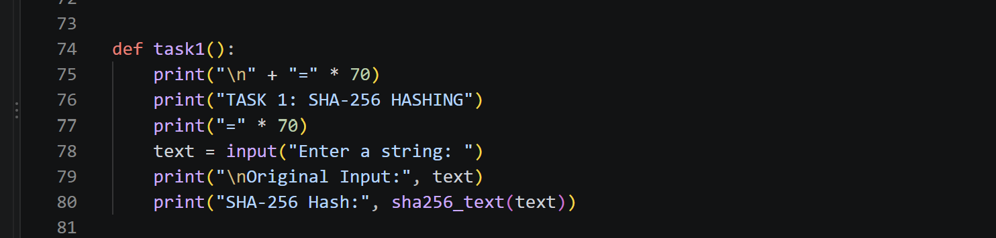
Output:
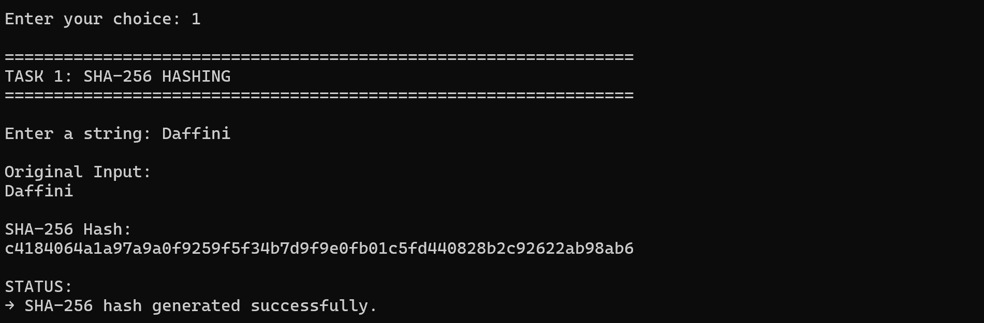
I entered a message and generated its SHA-256 hash using Python's hashlib library.
I displayed the original input and its hash to demonstrate data integrity and fingerprinting.
Task 2: Message Authentication Code (MAC)

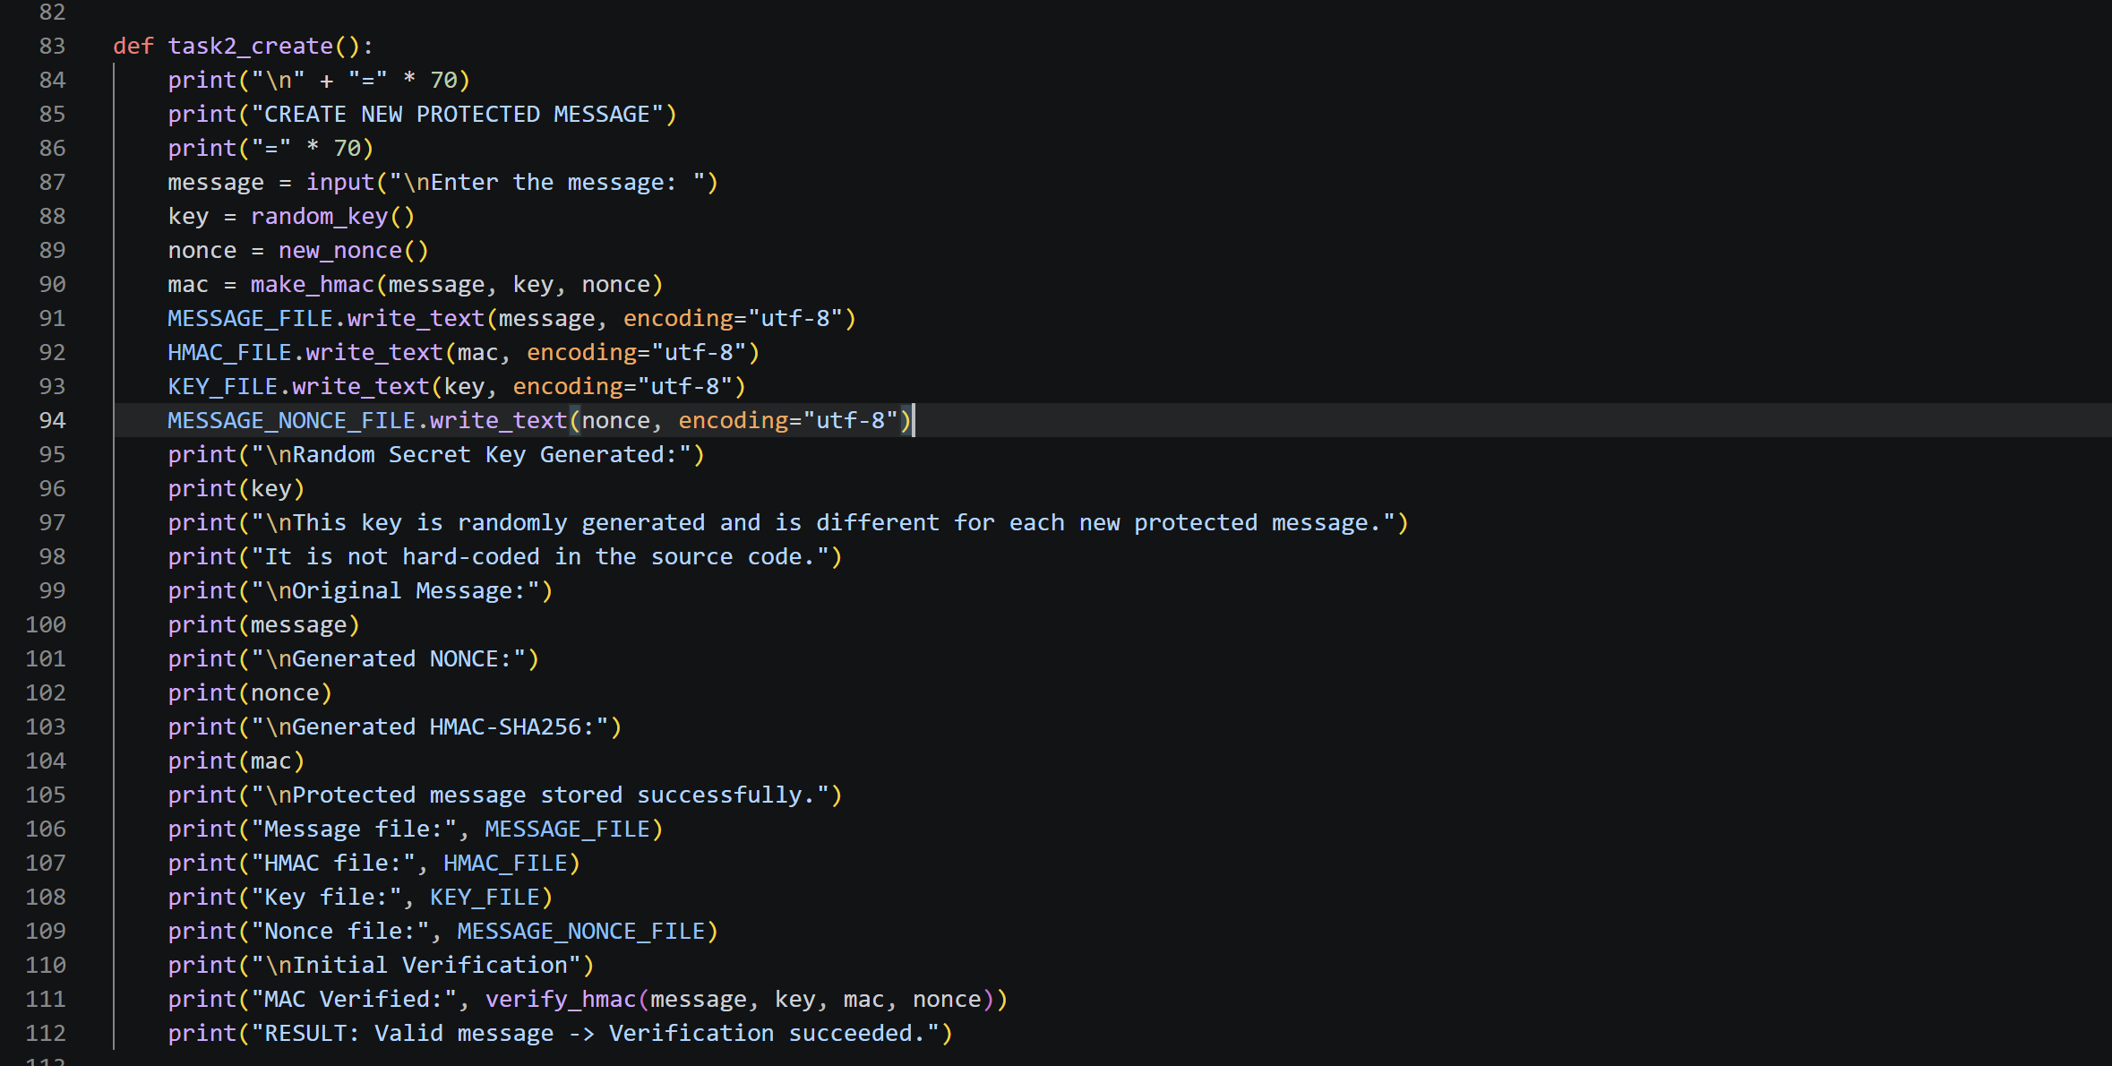

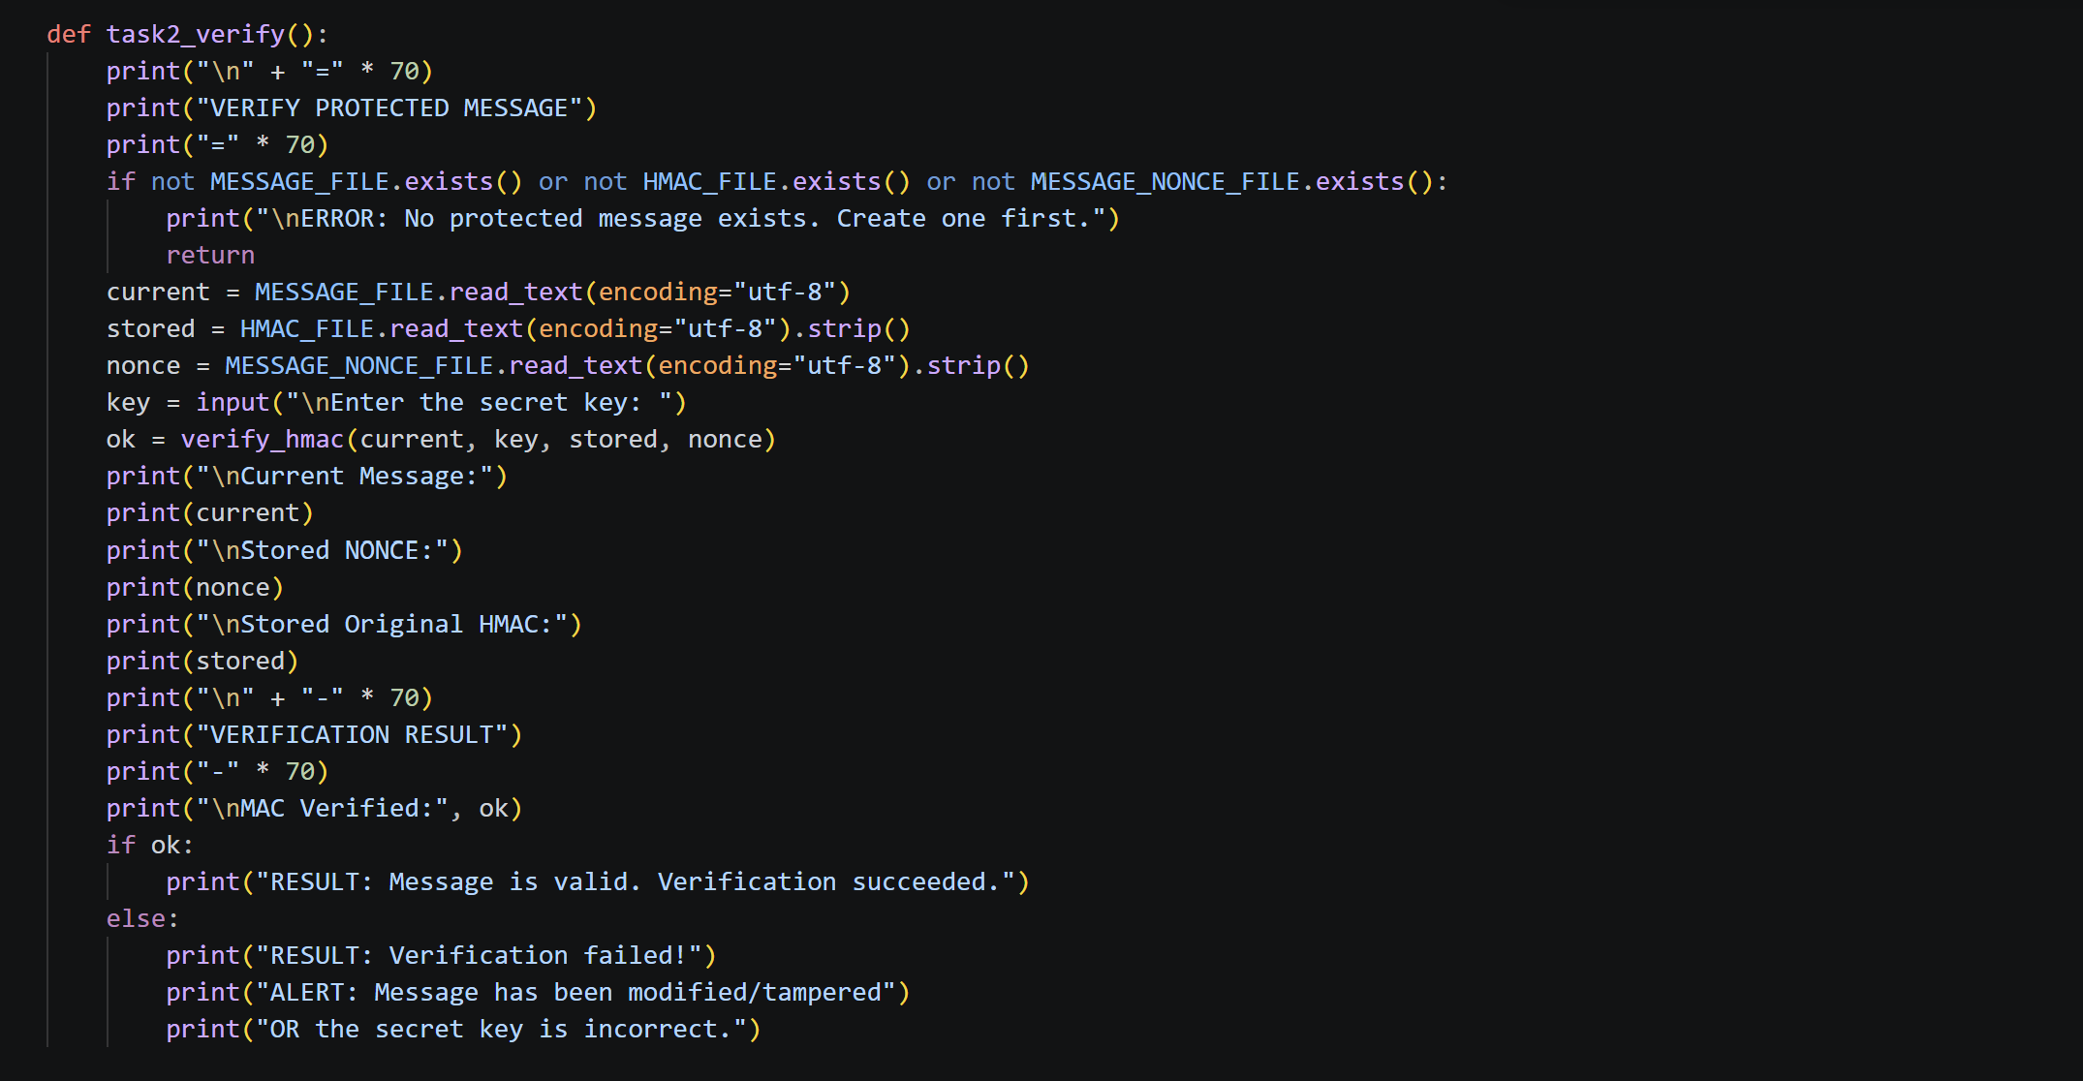
Output: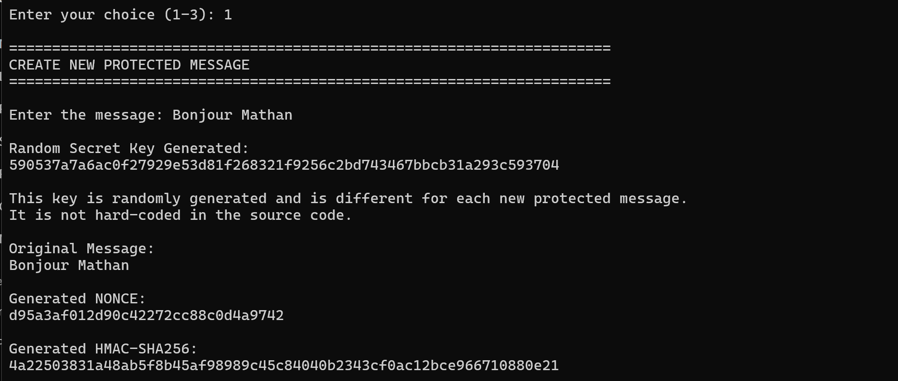
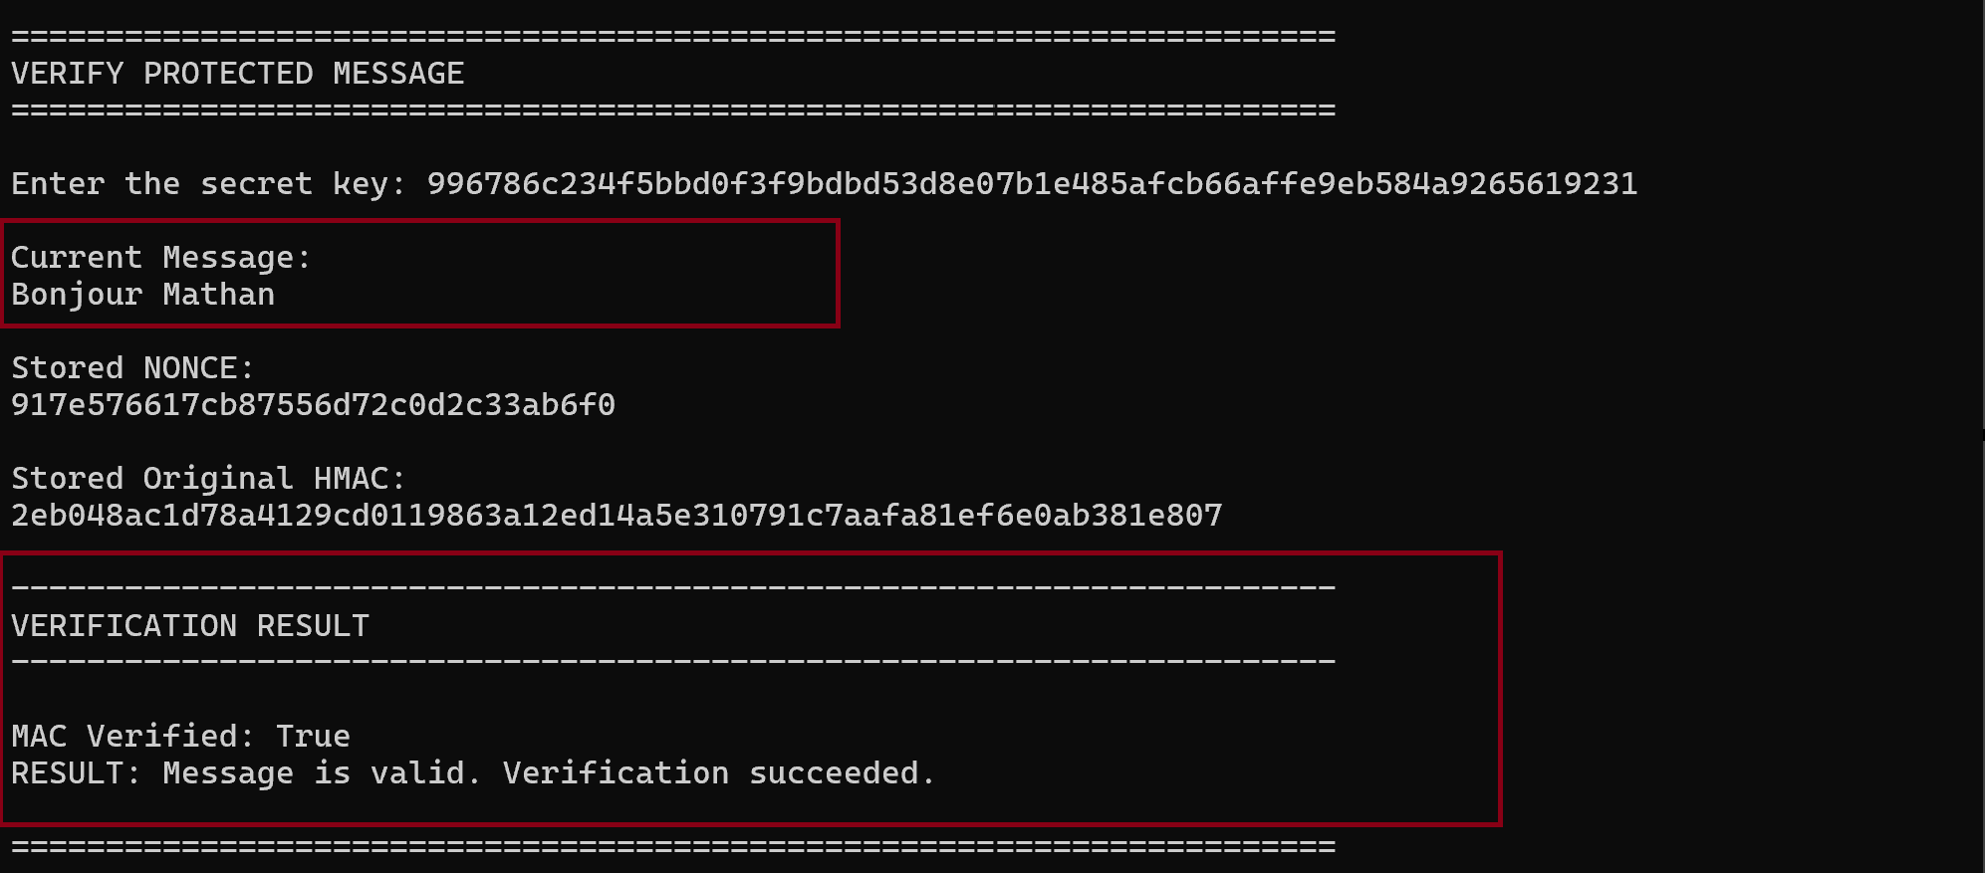

I generated a new random 256-bit secret key and used it with HMAC-SHA256 to authenticate the message.
I verified the HMAC by recalculating it and comparing it with the stored value to detect message modification.

4.3 Task 3: NONCE for Replay Protection

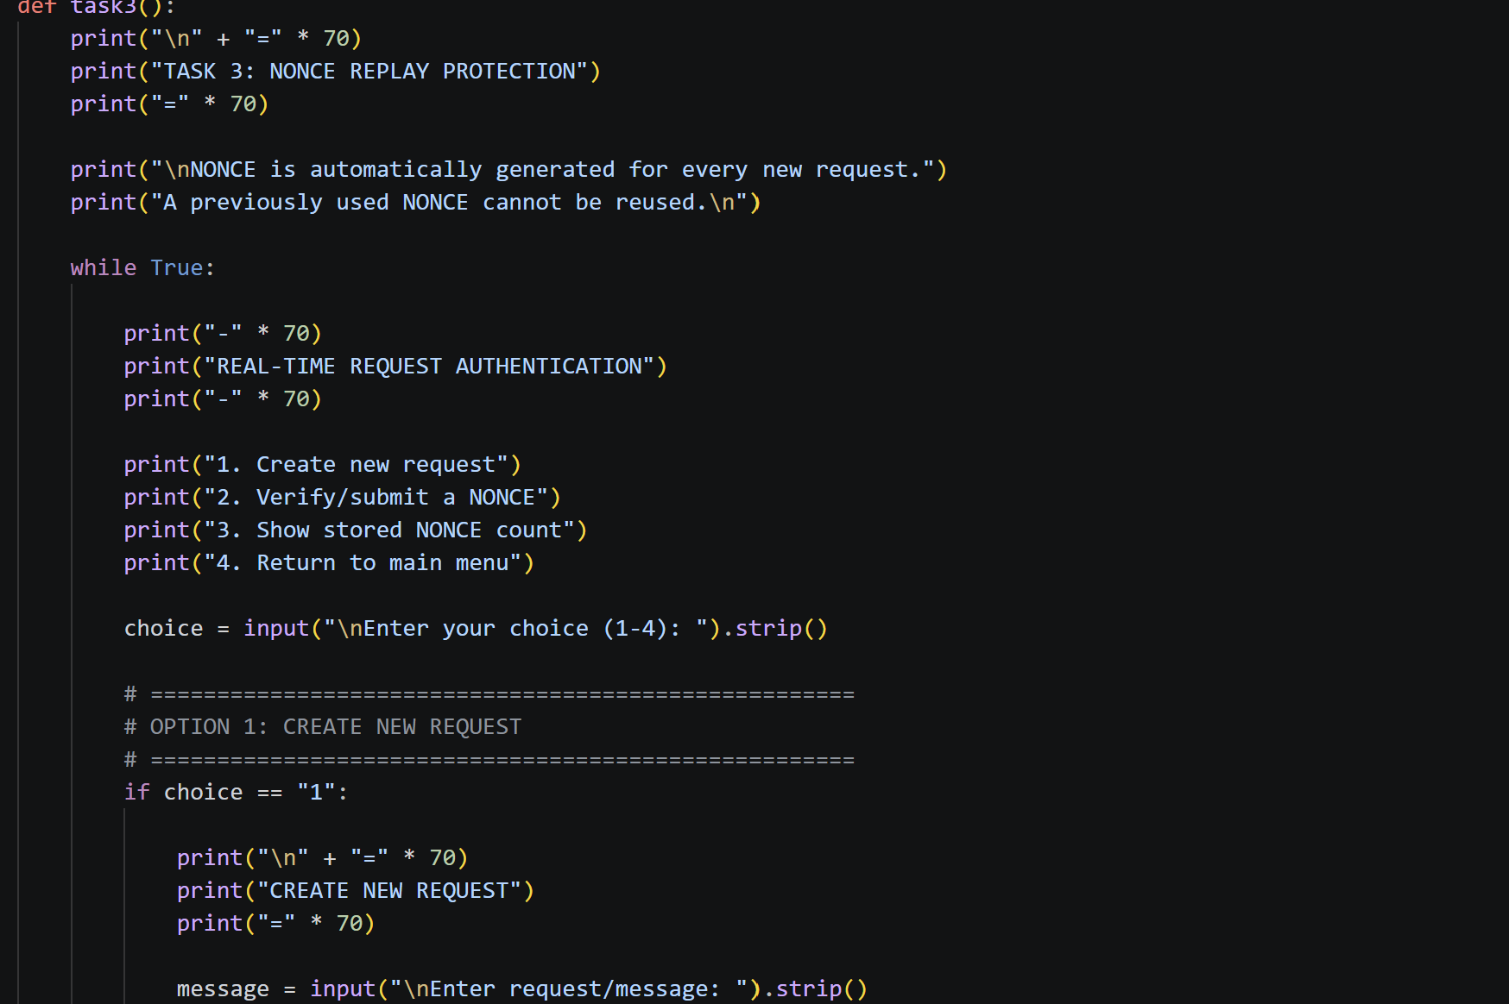

Output:
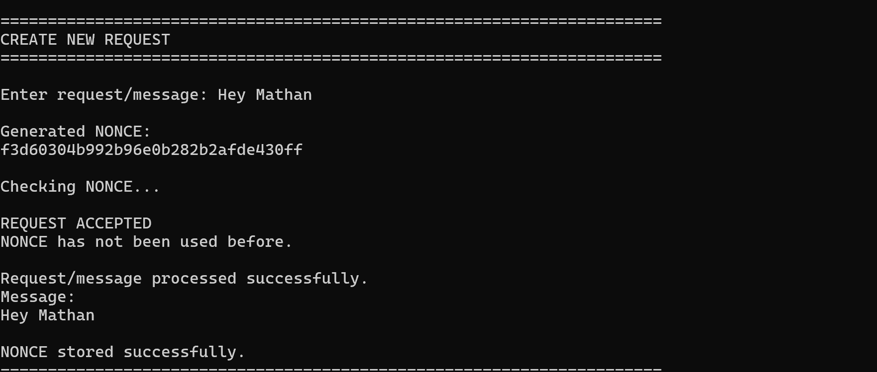

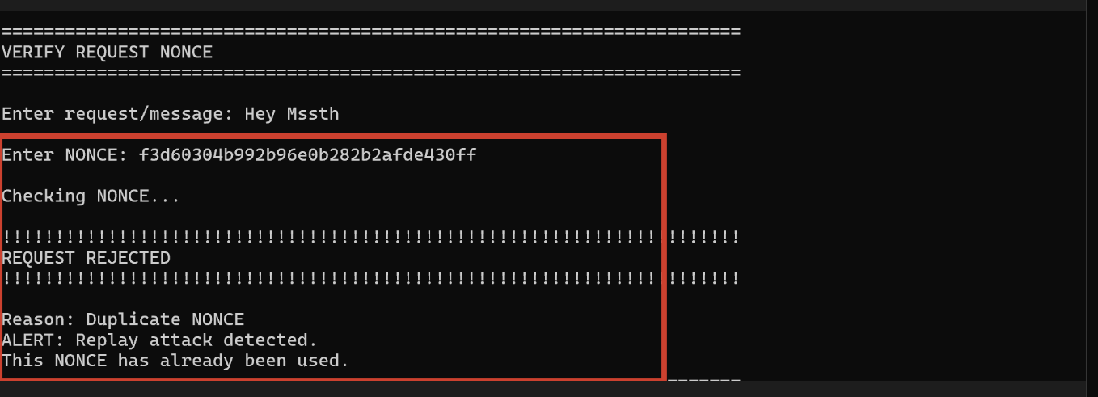
I generated a fresh random NONCE for each request and stored previously accepted NONCE values.
I rejected a request when the same NONCE was submitted again, demonstrating protection against replay attacks.

Task 4: File / Software Tampering Detection

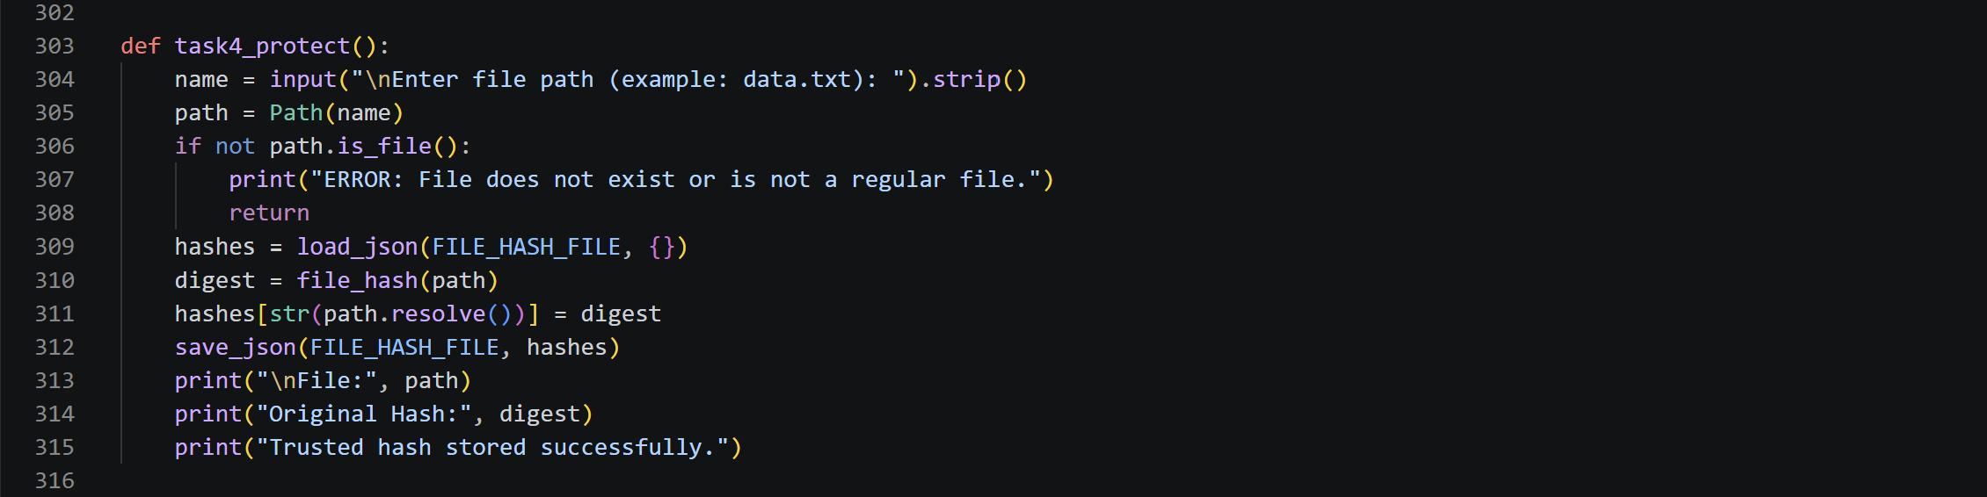Output:
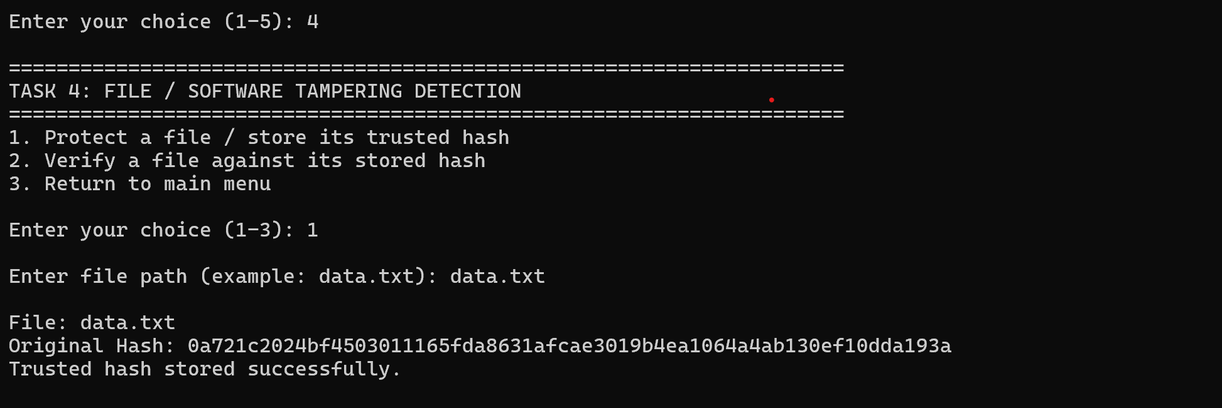

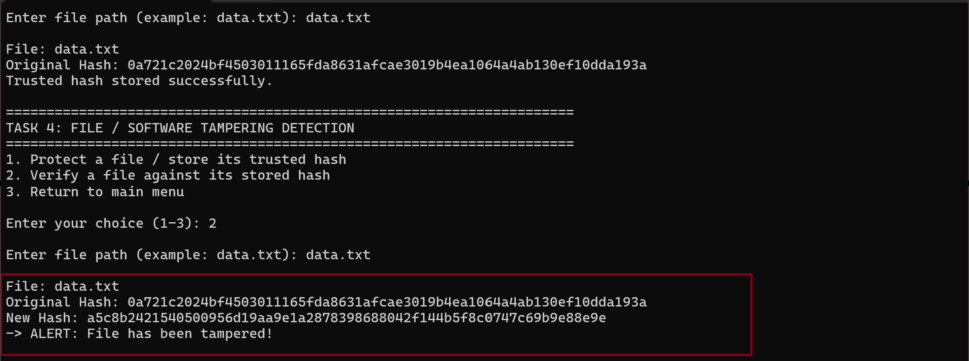

I generated and stored a trusted SHA-256 hash for the selected file.
I calculated the file hash again during verification and detected tampering when the new hash did not match the stored hash.

