Secure Healthcare File System: Role-Based Access Control and Data Integrity Protection
Name: Daffini Ruby Peter Arockiasamy
Introduction:
This lab implements a secure healthcare file system using Python to demonstrate authentication, role-based access control, secure prescription management, patient record management, and data integrity verification. The system supports four user roles: Administrator, Doctor, Nurse, and Patient. Each role is assigned specific permissions according to its responsibilities. SHA-256 hashing is used to detect unauthorized modification of prescription records.
Figure 1: Patient registration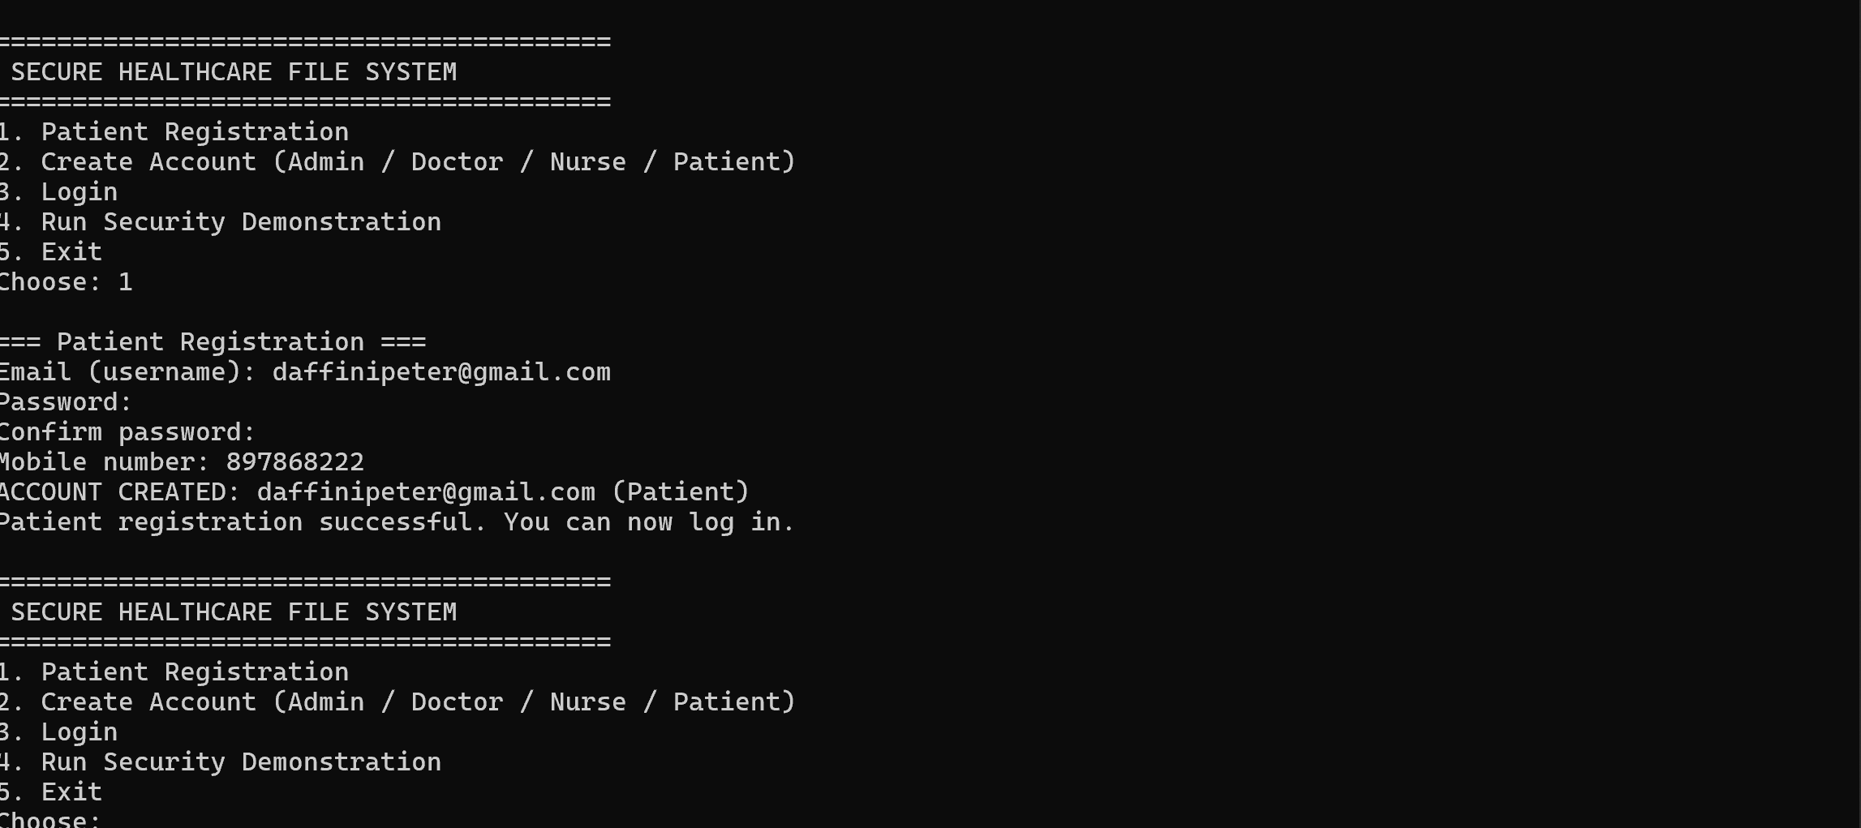
Figure 2: Admin/Doctor/Nurse account creation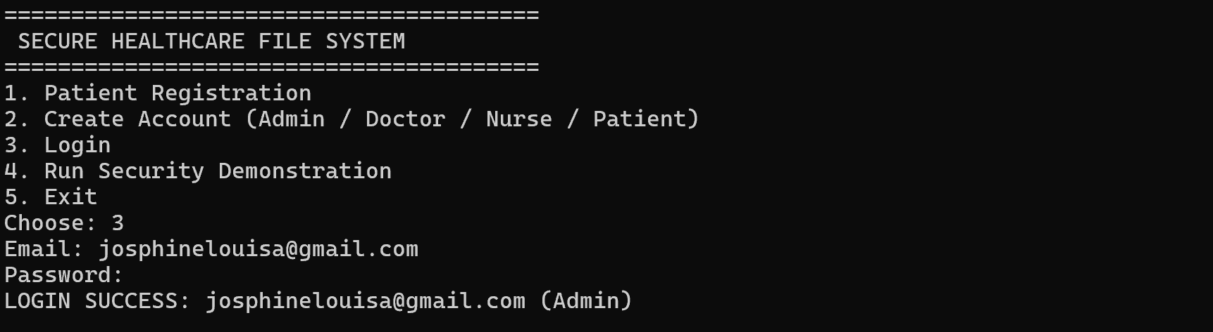
a) Admin account creation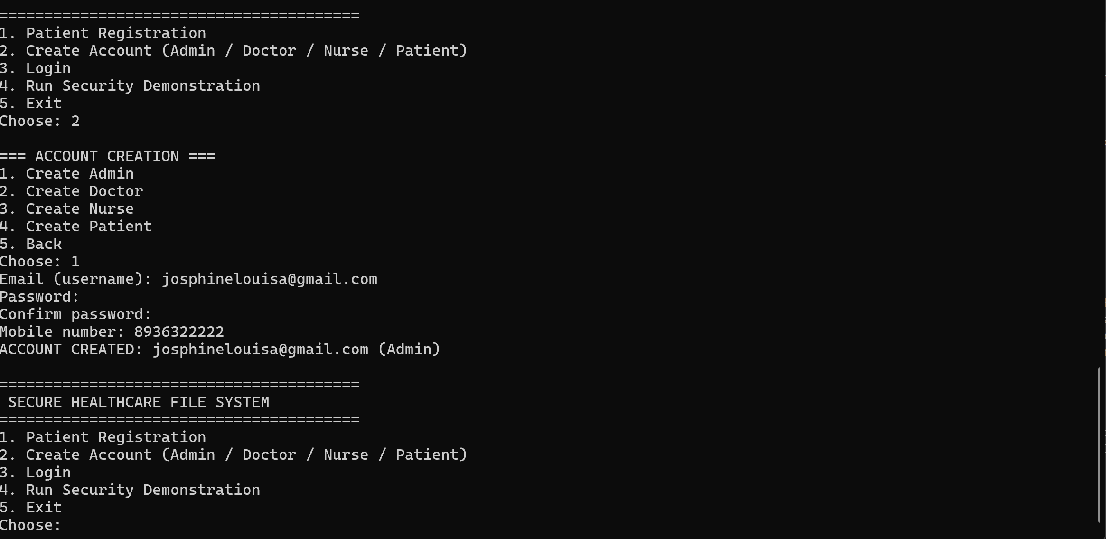
b) Doctor account creation:
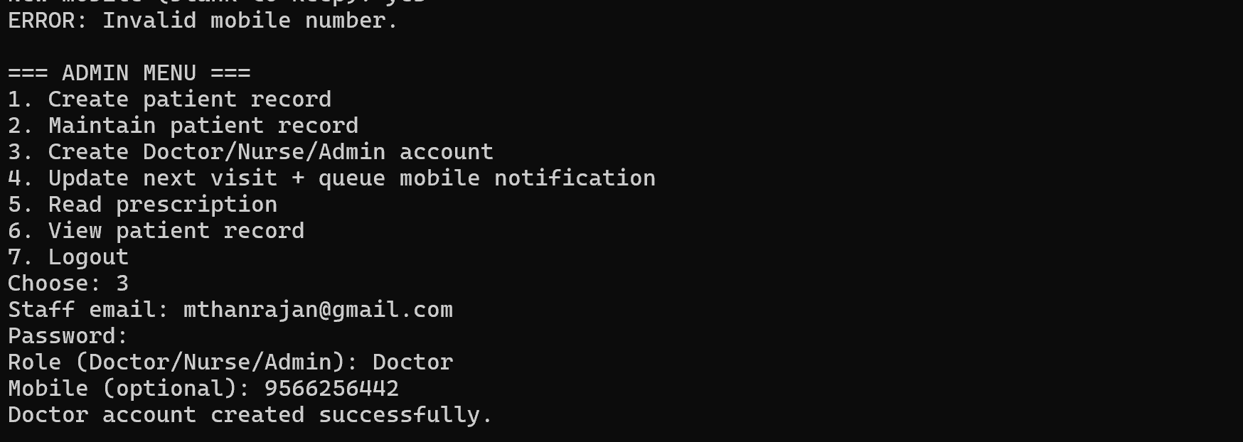
c) Nurse account creation:
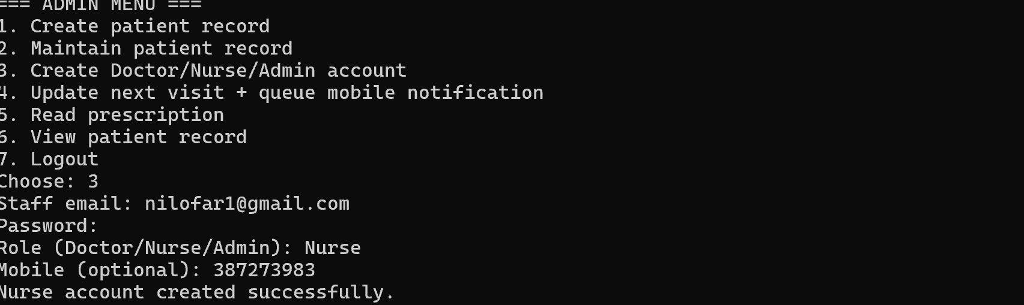

Figure 3: Nurse Account Creation and Patient Record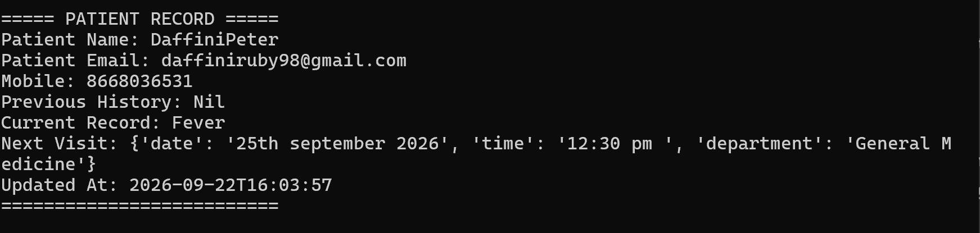
Figure 4: Doctor creates/updates prescription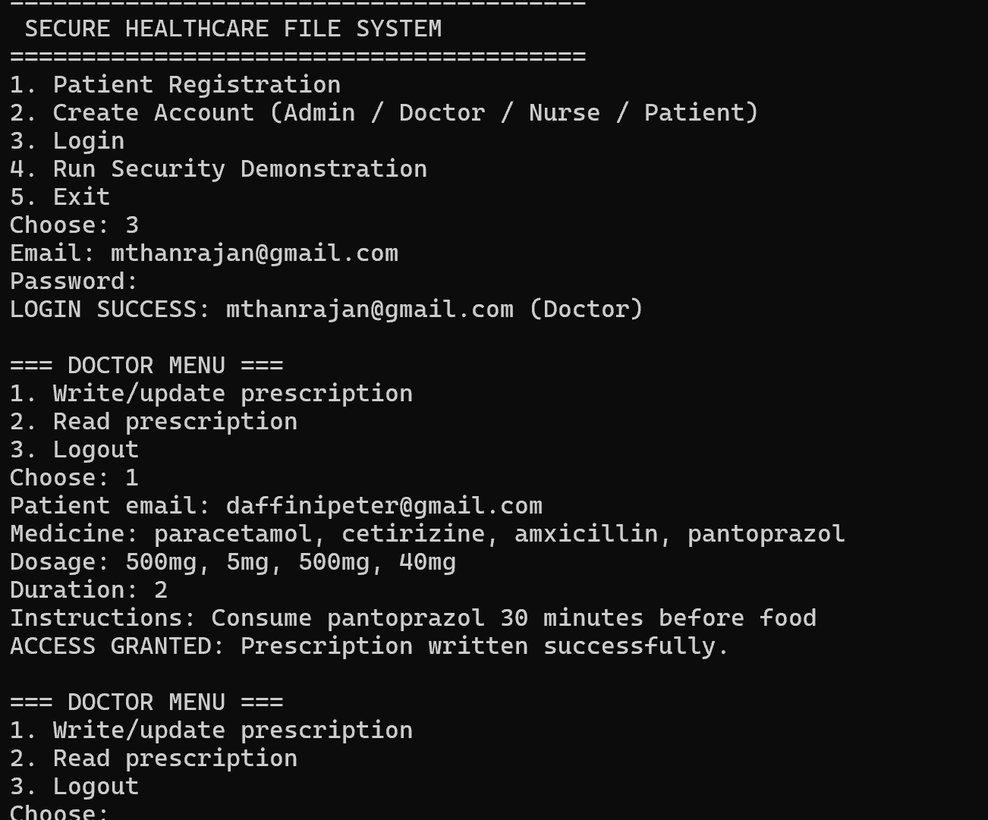
Figure 5: Doctor reads prescription
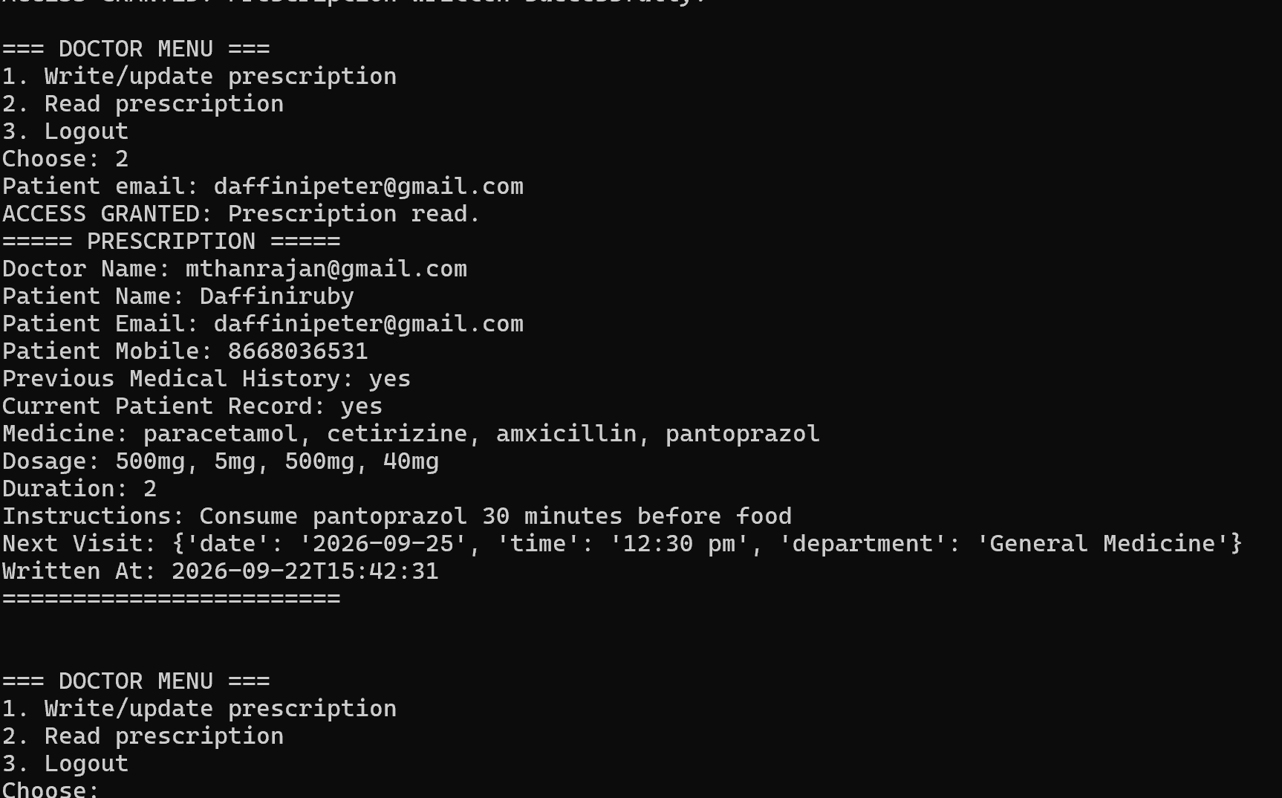
Figure 6: Nurse reads prescription
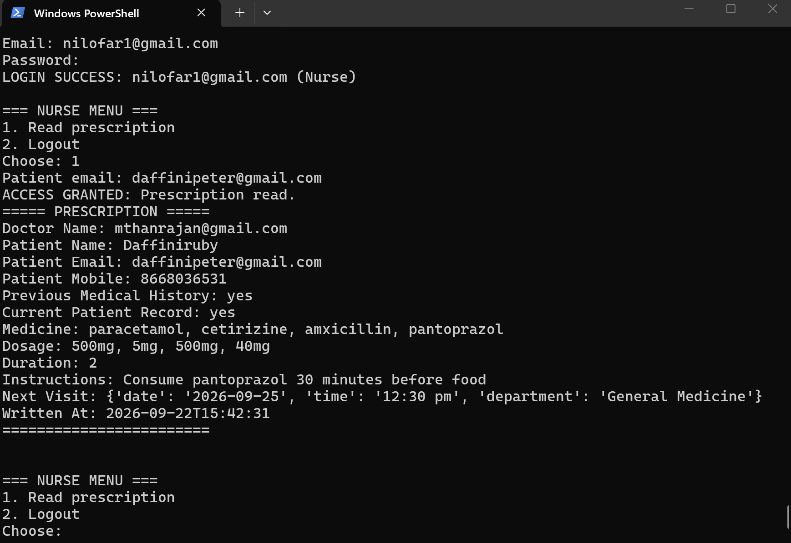
Figure 7: Admin updates patient record and next visit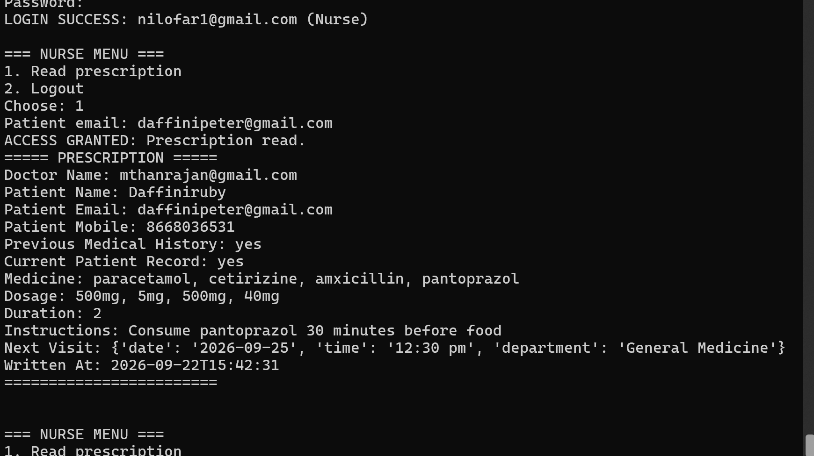
Figure 8: Unauthorized Prescription Modification Attempt by Nurse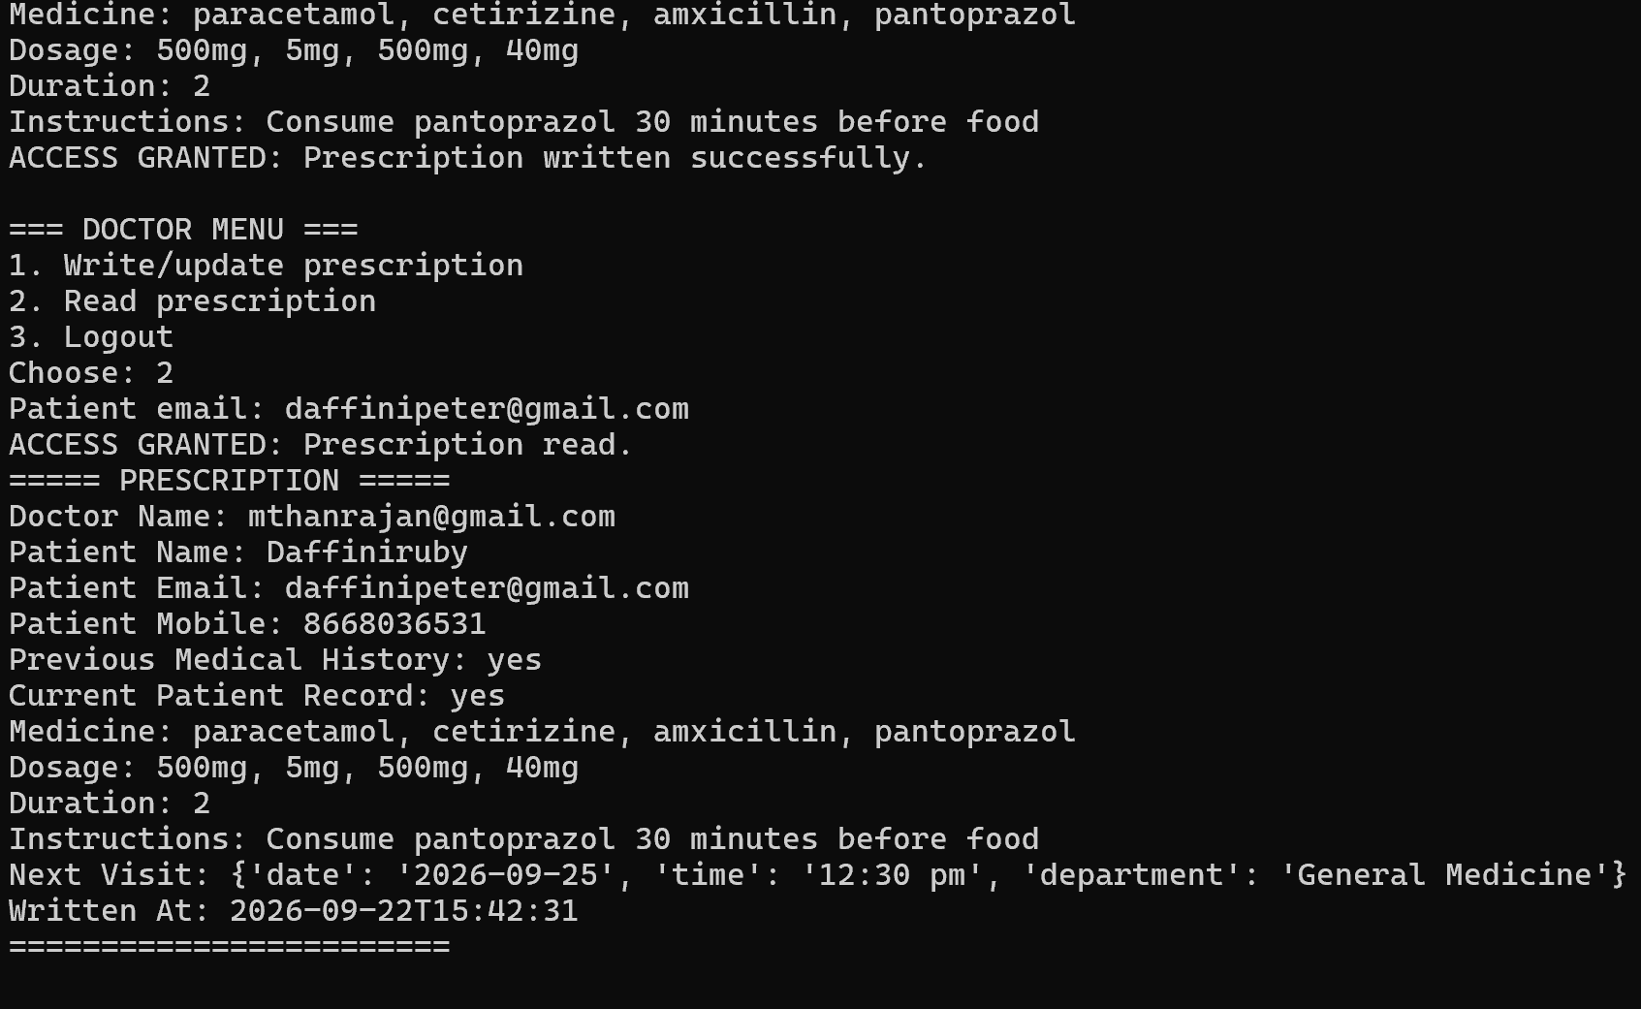

Figure 9: Detection of Unauthorized Prescription Tampering Using SHA-256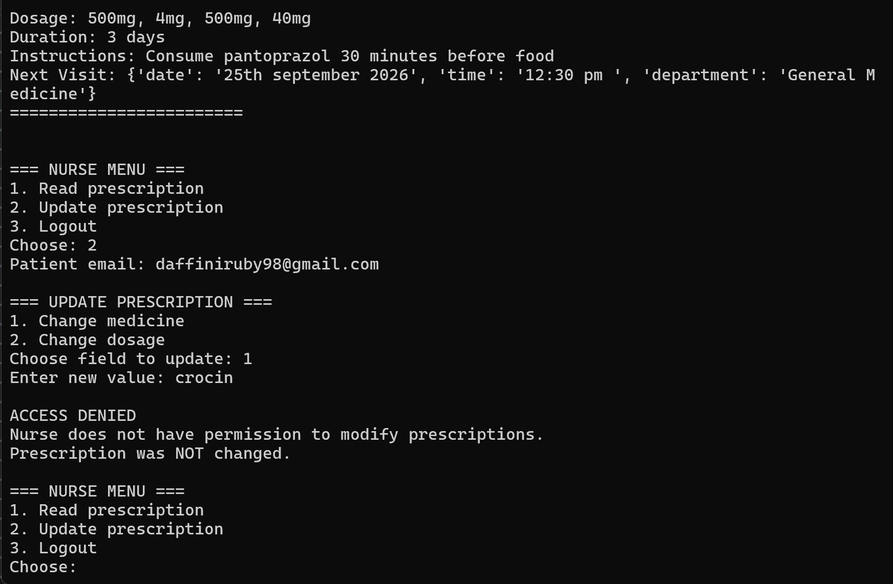
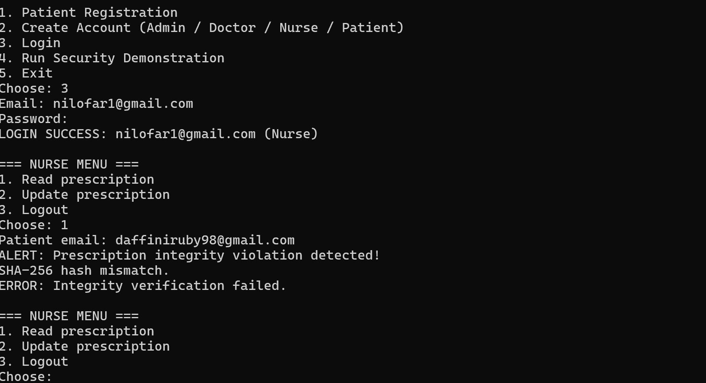

Figure 9: Secure file deletion
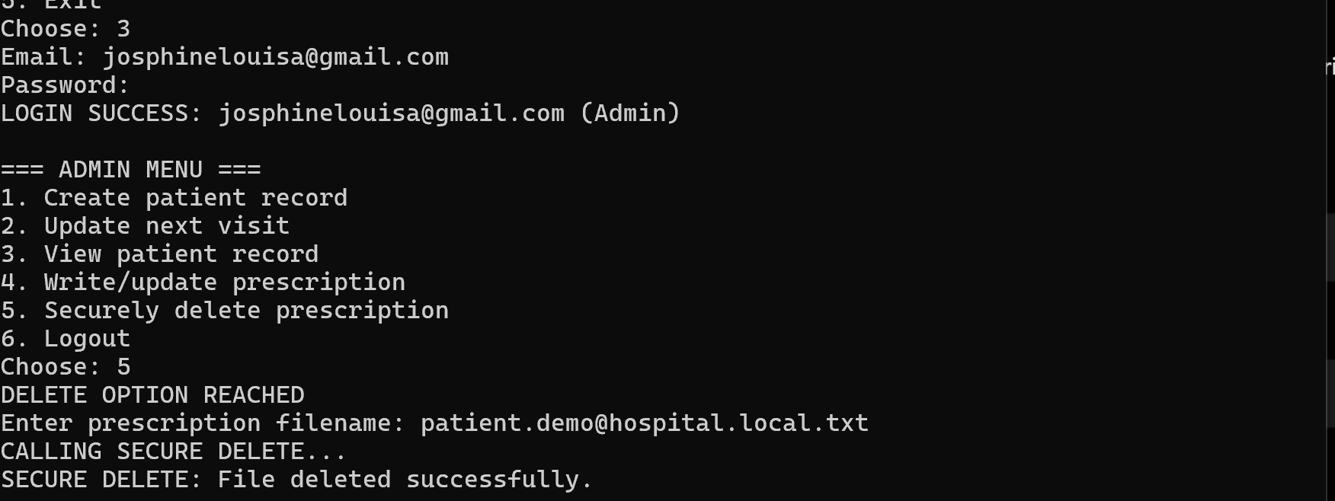
Security Controls Demonstrated
Security Control | Implementation
Authentication | Users authenticate using their account credentials
Role-Based Access Control | Admin, Doctor, Nurse and Patient have different permissions
Least Privilege | Nurse has read-only access to prescriptions
Prescription Authorization | Doctor can create/update prescriptions
Data Integrity | SHA-256 hash verification detects unauthorized changes
Tampering Detection | Hash mismatch generates an integrity violation alert

Section A: Design Justification
1. RBAC vs ABAC
Role-Based Access Control (RBAC)
Role-Based Access Control (RBAC) grants permissions according to predefined roles. Instead of assigning permissions separately to every user, the system creates roles such as Admin, Doctor, Nurse, and Guest, and each role receives a defined set of permissions.
For example, in the healthcare file system:
- Admin → administrative and file-management permissions
- Doctor → create and modify prescriptions
- Nurse → read prescriptions
- Guest → limited access
When a user requests an operation, the system checks the user's assigned role and determines whether that role has permission to perform the requested operation. NIST describes RBAC as a model where predefined roles carry specific privileges and users obtain those privileges through their assigned roles.
2. Attribute-Based Access Control (ABAC)
Attribute-Based Access Control (ABAC) makes access decisions using attributes associated with the user, resource, requested operation, and environment. NIST defines ABAC as an authorization methodology in which these attributes are evaluated against policies to determine whether an operation should be permitted.
For example, an ABAC policy for a healthcare system could be:
A Doctor can read a patient's medical record only during working hours, from an authorized hospital device, and when the doctor's clearance level is sufficient.
Therefore, simply having the Doctor role would not necessarily be enough. The system could also evaluate:
- User role
- Department
- Security clearance
- Patient data sensitivity
- Device status
- Location
- Time
- Requested operation
2. Why SHA-256?
SHA-256 (Secure Hash Algorithm 256-bit) is a cryptographic hash function belonging to the SHA-2 family. It converts data of any size into a fixed-length 256-bit hash value. Even a minor change in the original data produces a significantly different hash, making it useful for detecting unauthorized modification and verifying data integrity.
In this healthcare file system, SHA-256 is generated when a prescription is created or modified and stored as integrity metadata. During every read operation, the system recalculates the hash and compares it with the stored value. If the values do not match, the system identifies a possible tampering or integrity violation and generates an alert. This directly satisfies the lab requirement for hash generation and integrity verification.
1. Strong integrity verification – It allows the system to detect whether a prescription has been modified.
2. 256-bit output – It provides a large hash space and strong security properties.
3. Avalanche effect – A small input change results in a substantially different digest.
4. Resistance to cryptographic attacks – It provides strong resistance against practical collision, preimage, and second-preimage attacks.
5. Efficient processing – Hashes can be generated and verified efficiently during file operations.
6. Suitable for healthcare data integrity – It provides a practical mechanism for identifying unauthorized modification of sensitive patient records.
7. Modern cryptographic standard – SHA-256 belongs to the SHA-2 family and is preferable to deprecated/legacy SHA-1 for modern integrity applications.
8. Works with other security controls – SHA-256 complements RBAC, authentication, permission checking, and audit logging rather than replacing them.
9. Supports tamper detection – A mismatch between the stored and recalculated hash can trigger an integrity alert.
10. Future security consideration – Although SHA-256 provides strong classical security, the system should remain cryptographically agile because it is not specifically designed as a post-quantum hash.
SECTION B - Security Analysis
1. Insider Threats: Legitimate healthcare users may misuse their authorized access to sensitive patient information. RBAC reduces unnecessary privileges but cannot completely prevent misuse by trusted users. Least privilege, access reviews, separation of duties, and monitoring can reduce this risk.
2. Log Tampering: Audit events are stored in a local log file. An attacker who compromises with the host could modify or delete log entries to conceal malicious activity. Centralized, tamper-resistant logging through a SIEM should be used in a production environment.
3. Privilege Escalation: If authentication or role-management controls are compromised, an attacker could attempt to obtain a higher-privileged account. Administrative role assignments should require authorization, MFA, separation of duties, and monitoring.
4. Integrity Metadata Tampering: SHA-256 detects unauthorized file modification only when the trusted hash remains protected. If an attacker can modify both the prescription and its stored hash, the basic comparison could potentially be bypassed. HMAC-based integrity protection and separate key storage would strengthen the design.
5. Account Lockout Bypass: Failed-login counters and lockout state should be persisted rather than maintained only in application memory. Otherwise, restarting the application could reset the protection and provide additional authentication attempts.
3. SECTION C: Enhancements
1. Implement Complete Unix-Style Permissions
The current system uses role-based read/write permissions, but a stronger implementation would provide explicit owner, group, and read/write/execute (r/w/x) permissions for each file. This would provide more granular control over file operations.
2. Strengthen Audit Logging
The current application stores audit information locally. A production system should forward logs to a centralized SIEM or tamper-resistant logging system. Log integrity protection, restricted access, retention policies, and monitoring should also be implemented.
3. Implement Multi-Factor Authentication
Password authentication should be supplemented with MFA, particularly for Admin and other privileged accounts. This would reduce the risk of account takeover caused by stolen or compromised passwords.
4. Backup and Recovery
Regular encrypted backups and recovery procedures should be implemented to protect against accidental deletion, ransomware, corruption, or system failure.
5. Strengthen Access Control with ABAC
For a larger healthcare environment, RBAC could be combined with ABAC to consider additional attributes such as department, patient assignment, device, location, or time. This would provide more context-aware authorization while retaining the simplicity of role-based permissions.

FLOW DIAGRAM:
START
↓
Login as Nurse: nurse1
↓
Authentication Successful
↓
Attempt: Read patient_record.txt
↓
RBAC / File Permission Check
↓
Decision: Does Nurse have Read Permission?
↓
YES
↓
ACCESS GRANTED
↓
patient_record.txt is Read Successfully
↓
Attempt: Write patient_record.txt
↓
RBAC / File Permission Check
↓
Decision: Does Nurse have Write Permission?
↓
NO
↓
ACCESS DENIED
"Insufficient Permission"
↓
patient_record.txt is NOT Changed
↓
Tampering Detected in File
↓
Calculate SHA-256 Hash
↓
Compare Current Hash with Stored Hash
↓
Decision: Do the Hashes Match?
↓
NO
↓
ALERT: Integrity Violation
↓
SHA-256 Hash Mismatch
↓
Read Operation Stopped
↓
Log Updated
↓
END

