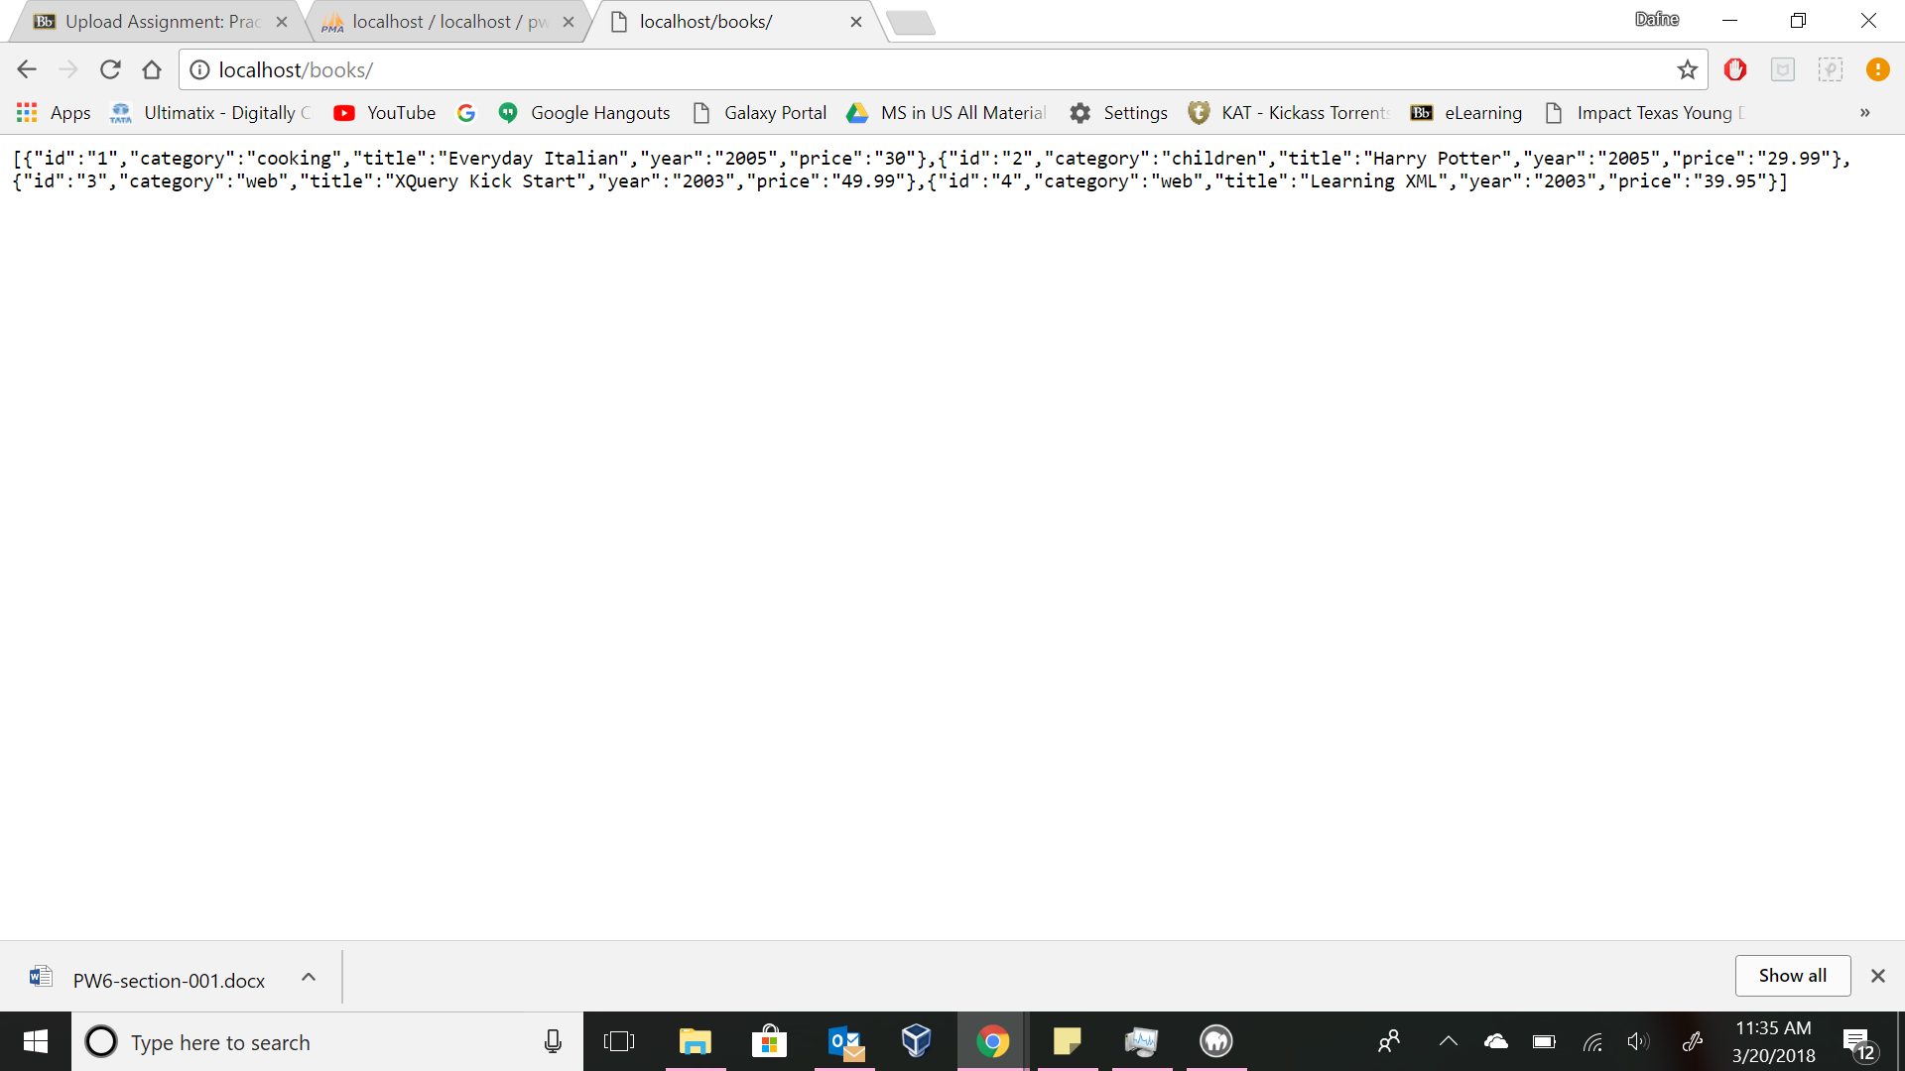

Result :

[{"id":"1","category":"cooking","title":"Everyday Italian","year":"2005","price":"30"},{"id":"2","category":"children","title":"Harry Potter","year":"2005","price":"29.99"},{"id":"3","category":"web","title":"XQuery Kick Start","year":"2003","price":"49.99"},{"id":"4","category":"web","title":"Learning XML","year":"2003","price":"39.95"}]