

**4**

**Github link :**



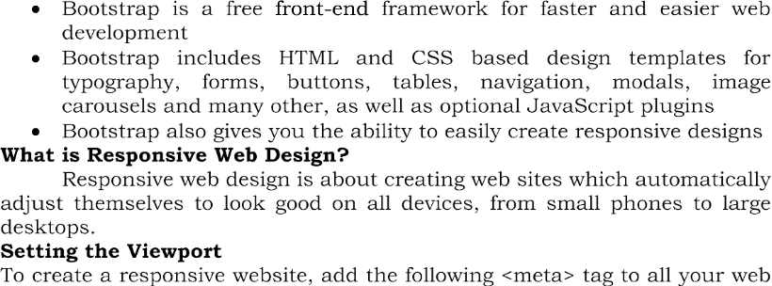

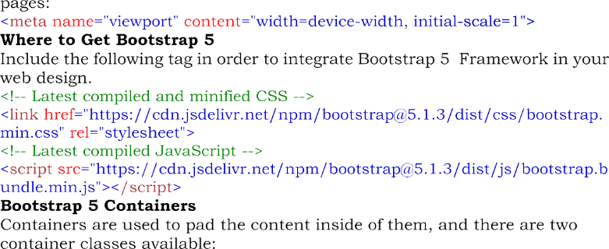

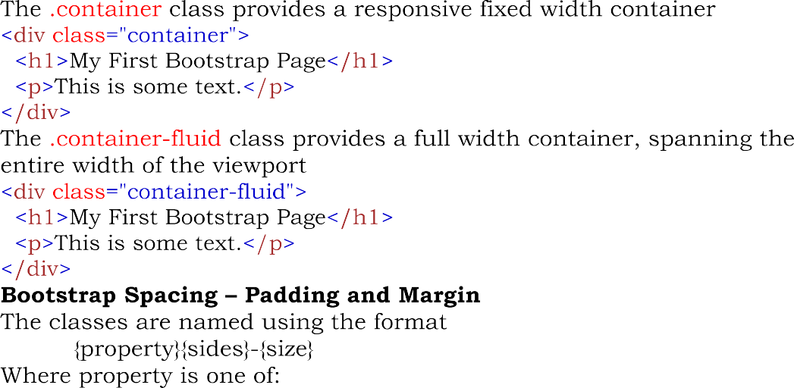

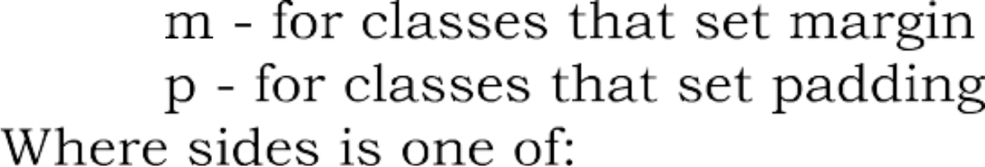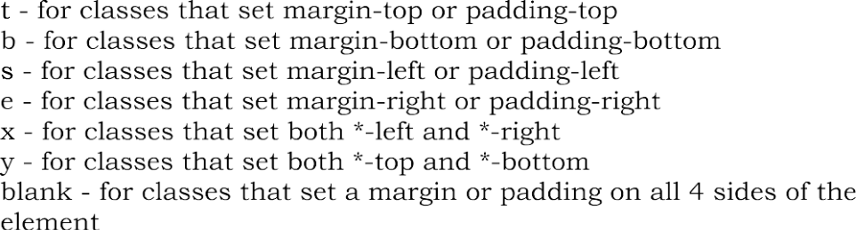

**Code:**

<!DOCTYPE html>

<head>

<meta name="viewport" content="width=device-width, initial-scale=1" />

<link

href="https://cdn.jsdelivr.net/npm/bootstrap@5.1.3/dist/css/bootstrap. min.css"

rel="stylesheet"

/>

<script src="https://cdn.jsdelivr.net/npm/bootstrap@5.1.3/dist/js/bootstrap.b undle.min.js"></script>

<meta charset="utf-8">

<meta name="viewport" content="width=device-width, initial-scale=1">

<link rel="stylesheet" href="https://cdn.jsdelivr.net/npm/bootstrap@4.6.1/dist/css/bootstrap.min.css">

<script src="https://cdn.jsdelivr.net/npm/jquery@3.6.0/dist/jquery.slim.min.js"></script>

<script src="https://cdn.jsdelivr.net/npm/popper.js@1.16.1/dist/umd/popper.min.js"></script>

<script src="https://cdn.jsdelivr.net/npm/bootstrap@4.6.1/dist/js/bootstrap.bundle.min.js"></script>

<style>

ul li {

display: inline-block;

word-spacing: 30px;

padding-left: 400px;

}

.carousel-inner img {

width: 100%;

height: 500px;

}

.reg{

border:2px solid blue;

/* width: 50%;

padding: 10px; */

}

/* .table{

width:50%;

height: 50%px;

float:right;

margin-bottom: 600px;

} */

</style>

</head>

<body>

<img

src="https://encrypted-tbn0.gstatic.com/images?q=tbn:ANd9GcSeuXftADuVvua0OF8j6cLO-edmDAPzO4Q2OA&usqp=CAU"

width="250px" height="50px" style="float: left;"

/>

<nav>

</div>

<nav>

<div class="a">

<ul>

<li style="color:blue;">Home Services Clients ContactUs Login/SignUp <input type="text" placeholder="Search.."><input type="Submit" value="submit" style="background-color:rgb(0, 183, 255) ;color:aliceblue;"></li>

</ul>

</div>

</nav>

<div id="demo" class="carousel slide" data-ride="carousel">

<!-- Indicators -->

<ul class="carousel-indicators">

<li data-target="#demo" data-slide-to="0" class="active" width="5%;"></li>

<li data-target="#demo" data-slide-to="1" width="5px;"></li>

<li data-target="#demo" data-slide-to="2" width="5px;"></li>

</ul>

<!-- The slideshow -->

<div class="carousel-inner">

<div class="carousel-item active">

<img src="https://tse4.mm.bing.net/th?id=OIP.lEt31m2OcsdIXARkmk6DeQHaFj&pid=Api&P=0" width=50>

</div>

<div class="carousel-item">

<img src="https://wdmarchitects.com/wp-content/uploads/2018/05/CapFed_FoxRidge_interior3-scaled.jpg" alt="Chicago">

</div>

<div class="carousel-item">

<img src="https://tse1.mm.bing.net/th?id=OIP.3pEoLnykDEQd7I_ycq_uWgHaE9&pid=Api&P=0" alt="New York">

</div>

</div>

<!-- Left and right controls -->

<a class="carousel-control-prev" href="#demo" data-slide="prev">

<span class="carousel-control-prev-icon"></span>

</a>

<a class="carousel-control-next" href="#demo" data-slide="next">

<span class="carousel-control-next-icon"></span>

</a>

</div>

<section id="services" class="form-table">

<div class="container-fluid">

<div class="row">

<div class="col-md-6">

<form class="row g-3 form">

<div class="col-md-6">

<label for="inputEmail4" class="form-label">Email</label>

<input type="email" class="form-control" id="inputEmail4" />

</div>

<div class="col-md-6">

<label for="inputPassword4" class="form-label">Password</label>

<input

type="password"

class="form-control"

id="inputPassword4"

/>

</div>

<div class="col-12">

<label for="inputAddress" class="form-label">Address</label>

<input

type="text"

class="form-control"

id="inputAddress"

placeholder="1234 Main St"

/>

</div>

<div class="col-12">

<label for="inputAddress2" class="form-label">Address 2</label>

<input

type="text"

class="form-control"

id="inputAddress2"

placeholder="Apartment, studio, or floor"

/>

</div>

<div class="col-md-6">

<label for="inputCity" class="form-label">City</label>

<input type="text" class="form-control" id="inputCity" />

</div>

<div class="col-md-4">

<label for="inputState" class="form-label">State</label>

<select id="inputState" class="form-select">

<option selected>Choose...</option>

<option>...</option>

</select>

</div>

<div class="col-md-2">

<label for="inputZip" class="form-label">Zip</label>

<input type="text" class="form-control" id="inputZip" />

</div>

<div class="col-12">

<div class="form-check">

<input

class="form-check-input"

type="checkbox"

id="gridCheck"

/>

<label class="form-check-label" for="gridCheck">

Check me out

</label>

</div>

</div>

<div class="col-12">

<button type="submit" class="btn btn-primary">Sign in</button>

</div>

</div>

</form>

<div class="col-md-6">

<table class="table table-bordered">

<thead class="bg-primary" style="color: white">

<tr>

<th scope="col">S.No</th>

<th scope="col">Reg.No</th>

<th scope="col">Name of the Participant</th>

<th scope="col">Collaborative activity</th>

<th scope="col">Collaborating Agency</th>

</tr>

</thead>

<tbody>

<tr>

<th scope="row">1</th>

<td>URK16AE001</td>

<td>ANIT ANU JOHN</td>

<td>Product Design and Analysis</td>

<td>CADD Centre</td>

</tr>

<tr>

<th scope="row">2</th>

<td>URK16AE011</td>

<td>VASANTHA KANESH M</td>

<td>Product Design and Analysis</td>

<td>CADD Centre</td>

</tr>

<tr>

<th scope="row">3</th>

<td>URK16AE013</td>

<td>ABIJITH J</td>

<td>Product Design and Analysis</td>

<td>CADD Centre</td>

</tr>

<tr>

<th scope="row">4</th>

<td>URK16AE015</td>

<td>JEBIN JOHN J</td>

<td>Product Design and Analysis</td>

<td>CADD Centre</td>

</tr>

<tr>

<th scope="row">5</th>

<td>URK16AE018</td>

<td>JOSHI K J</td>

<td>Product Design and Analysis</td>

<td>CADD Centre</td>

</tr>

<tr>

<th scope="row">6</th>

<td>URK16AE020</td>

<td>J P GOKUL</td>

<td>Product Design and Analysis</td>

<td>CADD Centre</td>

</tr>

<tr>

<th scope="row">7</th>

<td>URK16AE021</td>

<td>JEROME</td>

<td>Product Design and Analysis</td>

<td>CADD Centre</td>

</tr>

<tr>

<th scope="row">8</th>

<td>URK16AE022</td>

<td>AFNAN M. ARIEF</td>

<td>Product Design and Analysis</td>

<td>CADD Centre</td>

</tr>

</tbody>

</table>

</div>

</div>

</div>

</section>

<!-- Popper JS -->

<script

src="https://cdn.jsdelivr.net/npm/@popperjs/core@2.11.5/dist/umd/popper.min.js"

integrity="sha384-Xe+8cL9oJa6tN/veChSP7q+mnSPaj5Bcu9mPX5F5xIGE0DVittaqT5lorf0EI7Vk"

crossorigin="anonymous"

></script>

<!-- Bootstrap JS -->

<script

src="https://cdn.jsdelivr.net/npm/bootstrap@5.2.0/dist/js/bootstrap.min.js"

integrity="sha384-ODmDIVzN+pFdexxHEHFBQH3/9/vQ9uori45z4JjnFsRydbmQbmL5t1tQ0culUzyK"

crossorigin="anonymous"

></script>

<!-- <div class="bottom">

<div class="reg">

<div class="container-fluid">

<h5 style=" color:rgba(0, 255, 255, 0.774); text-align:center">Registration Form</h5>

<form class="form-inline">

<label class="mb-6 p-2">Email</label>

<input type="email" class="form-control mb-2">

<label class="mb-6 p-2">password</label>

<input type="password" class="form-control mb-2">

</div>

<label class="mb-2">Adress</label>

<input type="text" class="form-control mb-2" placeholder="Enter your Address">

<label class="mb-2">Adress 2</label>

<input type="text" class="form-control mb-2" placeholder="Enter your Address">

<div class="form-inline">

<label class="mb-3 p-2">city</label>

<input type="text" >

<label class="mb-2 p-3">Zip</label>

<input type="number">

</div>

<input type="checkbox">Check me out</input><br><br>

<input type="submit" class="btn btn-primary mb-2" value="submit">

</form>

</div>

<table class="table table-bordered">

<th>

<tr class ="bg-primary text-white">

<th>S.no</th>

<th>Reg.no</th>

<th>Name of the participant</th>

<th>Collabarative activity</th>

<th>Collaborating Agency</th>

</tr>

</th>

<tr>

<td>1</td>

<td>UR16AE001</td>

<td>ANIT ANU JOHN</td>

<td>Product design and analysit</td>

<td>CABB Center</td>

</tr>

<tr>

<td>2</td>

<td>UR16AE011</td>

<td>VASANTHA</td>

<td>Product design and analysit</td>

<td>CABB Center</td>

</tr>

<tr>

<td>3</td>

<td>UR16AE003</td>

<td>ABIJITH</td>

<td>Product design and analysit</td>

<td>CABB Center</td>

</tr>

<tr>

<td>4</td>

<td>UR16AE005</td>

<td>JEBIN JOHN</td>

<td>Product design and analysit</td>

<td>CABB Center</td>

</tr>

<tr>

<td>5</td>

<td>UR16AE012</td>

<td>JOSHI K</td>

<td>Product design and analysit</td>

<td>CABB Center</td>

</tr>

<tr>

<td>6</td>

<td>UR16AE021</td>

<td>J B GOKUL</td>

<td>Product design and analysit</td>

<td>CABB Center</td>

</tr>

<tr>

<td>7</td>

<td>UR16AE051</td>

<td>JEROME</td>

<td>Product design and analysit</td>

<td>CABB Center</td>

</tr>

<tr>

<td>8</td>

<td>UR16AE056</td>

<td>AFNAN M. ARIEF</td>

<td>Product design and analysit</td>

<td>CABB Center</td>

</tr>

</table>

</div>

-->

</body>

**Output:**

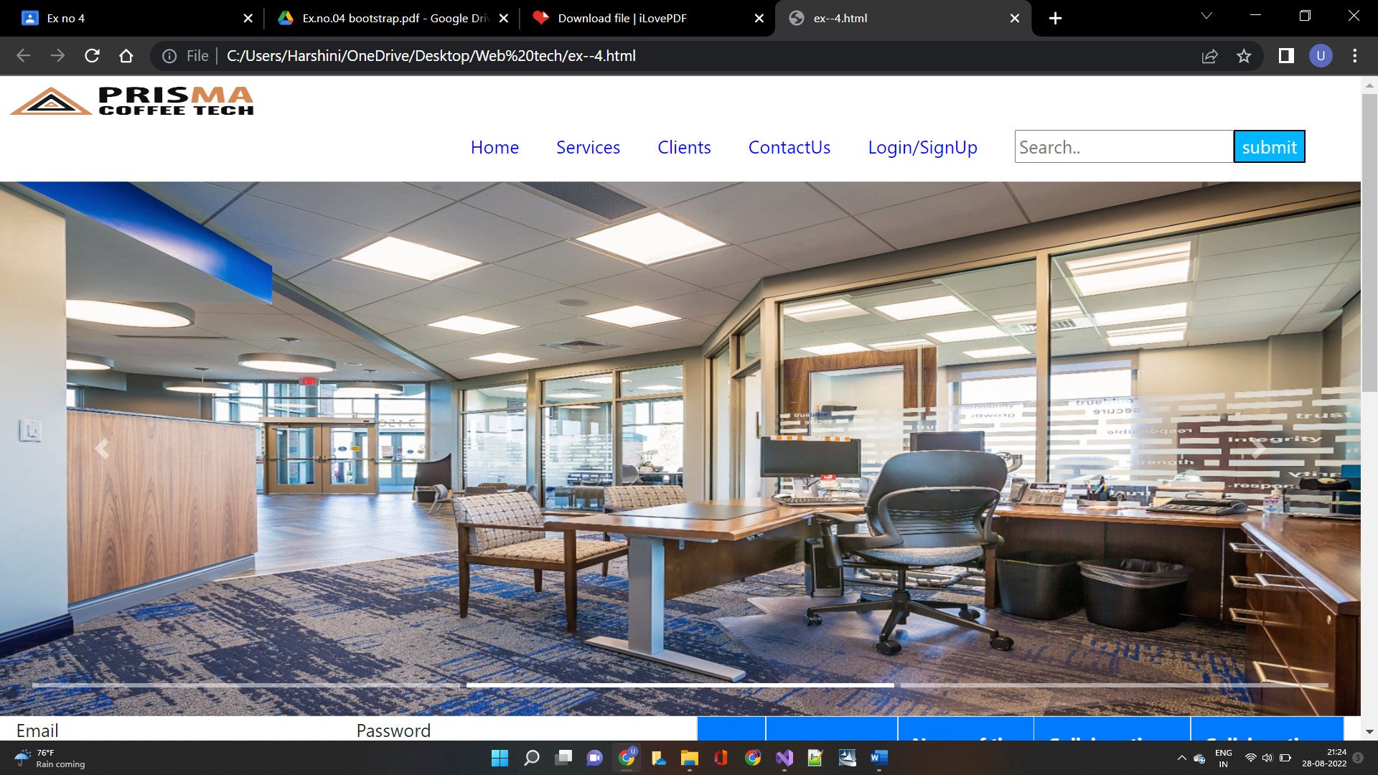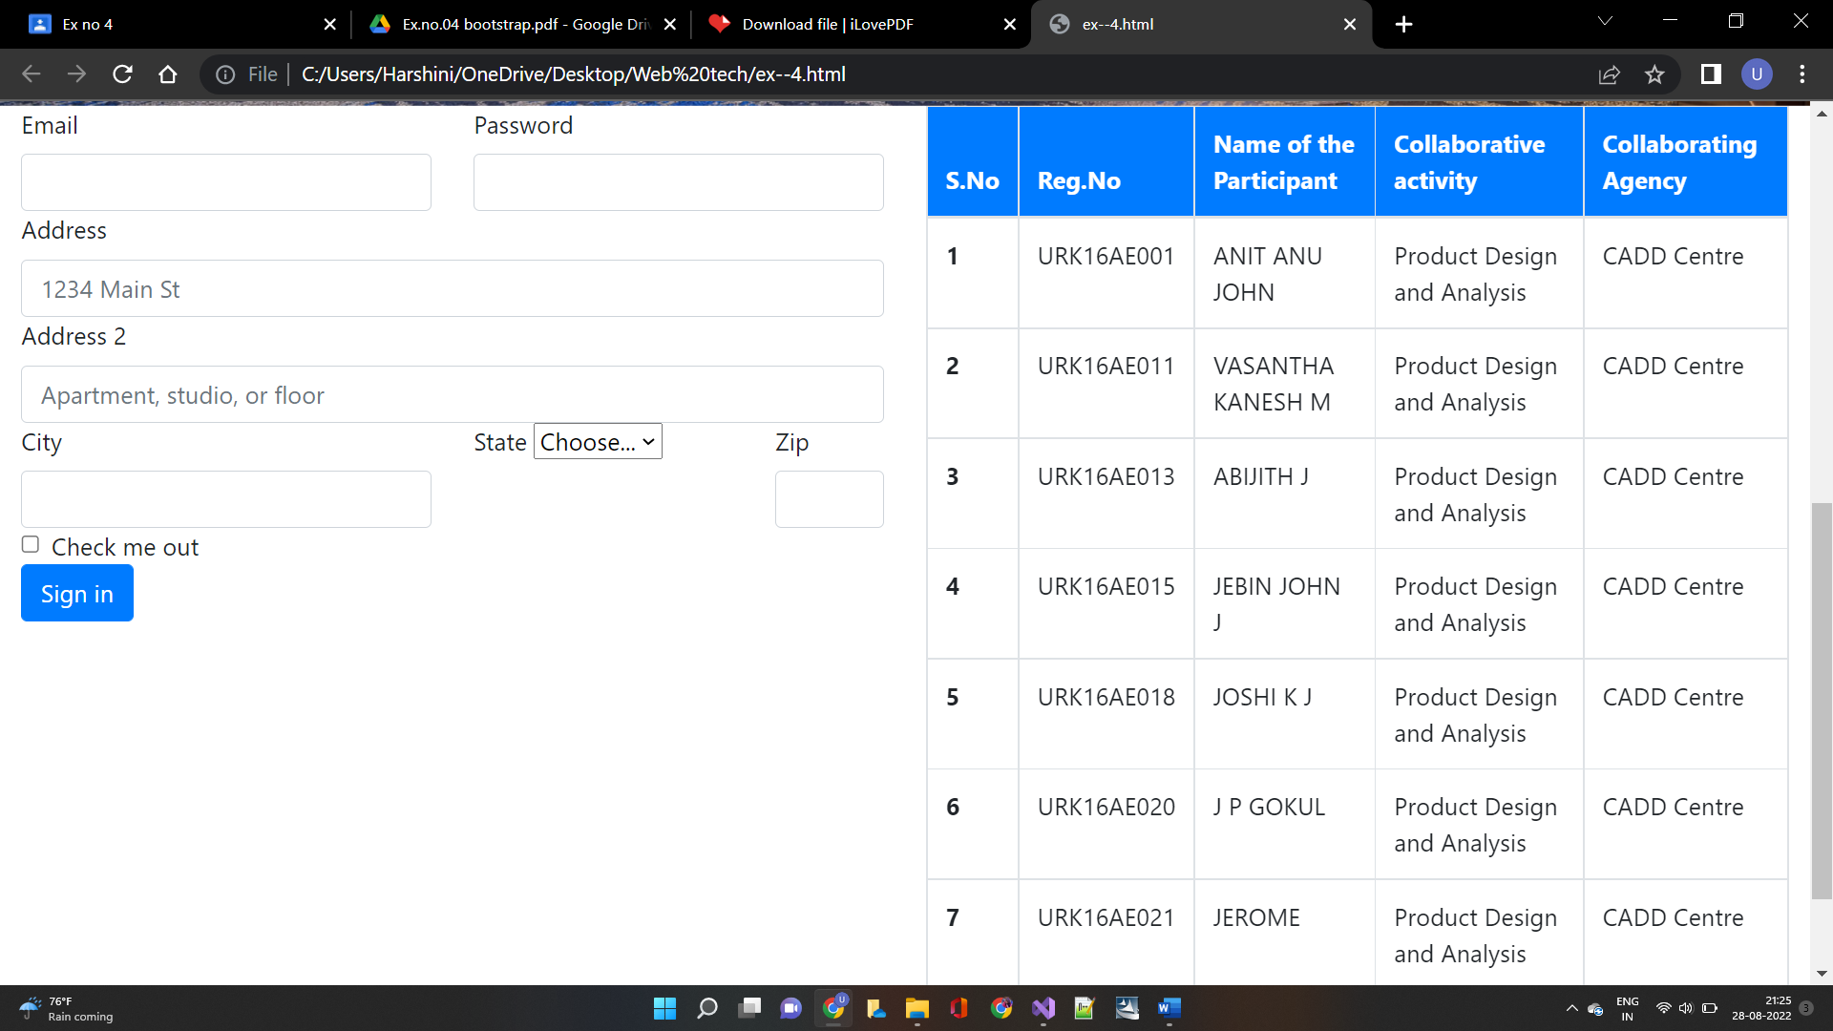

**Result:**

Hence to create a responsive web design using bootstrap UI framework is done successfully.