# Digital Design and Computer Organisation Laboratory

**UE21CS251A**

# 3rd Semester, Academic Year 2022-23

## Date:

|  |  |  |
| --- | --- | --- |
| **Name:** Pranav Ajay Desai | **SRN:** PES2UG21CS385 | **Section:**  G |

Week# 7

## Program Number: 1

## TITLE:

**WRITE A VERILOG PROGRAM TO MODEL Control Logic .**

**GENERATE THE VVP OUTPUT AND SIMULATION WAVEFORM USING**

**GTKWAVE. VERIFY THE OUTPUT AND WAVEFORM WITH THE TRUTH TABLE**

## Verilog Code Screenshot

lib.v

module invert ( input wire i, output wire o

);

assign o = !i; endmodule

module and2 (

input wire i0, i1,

output wire o

);

assign o = i0 & i1; endmodule

module or2 (

input wire i0, i1,

output wire o

);

assign o = i0 | i1; endmodule

module xor2 (

input wire i0, i1,

output wire o

);

assign o = i0 ^ i1; endmodule

module nand2 ( input wire i0, i1,

output wire o

);

wire t;

and2 and2_0 (

i0,

i1, t

);

invert invert_0 ( t,

o

);

endmodule

module nor2 (

input wire i0, i1,

output wire o

);

wire t; or2 or2_0 (

i0,

i1, t

);

invert invert_0 ( t,

o

);

endmodule

module xnor2 ( input wire i0, i1,

output wire o

);

wire t;

xor2 xor2_0 (

i0,

i1, t

);

invert invert_0 ( t,

o

);

endmodule

module and3 (

input wire i0, i1,

i2,

output wire o

);

wire t;

and2 and2_0 (

i0,

i1, t

);

and2 and2_1 (

i2,

t, o

);

endmodule

module or3 (

input wire i0, i1,

i2,

output wire o

);

wire t; or2 or2_0 (

i0,

i1, t

);

or2 or2_1 ( i2,

t, o

);

endmodule

module nor3 (

input wire i0, i1,

i2,

output wire o

);

wire t; or2 or2_0 (

i0,

i1, t

);

nor2 nor2_0 (

i2,

t, o

);

endmodule

module nand3 ( input wire i0, i1,

i2,

output wire o

);

wire t;

and2 and2_0 (

i0,

i1, t

);

nand2 nand2_1 ( i2,

t, o

);

endmodule

module xor3 (

input wire i0, i1,

i2,

output wire o

);

wire t;

xor2 xor2_0 (

i0,

i1, t

);

xor2 xor2_1 (

i2,

t, o

);

endmodule

module xnor3 ( input wire i0, i1,

i2,

output wire o

);

wire t;

xor2 xor2_0 (

i0,

i1,

t

);

xnor2 xnor2_0 ( i2,

t, o

);

endmodule

module mux2 (

input wire i0, i1,

j,

output wire o

);

assign o = (j == 0) ? i0 : i1; endmodule

module mux4 (

input wire [0:3] i, input wire j1,

j0,

output wire o

);

wire t0, t1; mux2 mux2_0 ( i[0],

i[1],

j1, t0

);

mux2 mux2_1 ( i[2],

i[3],

j1, t1

);

mux2 mux2_2 (

t0,

t1,

j0, o

);

endmodule

module mux8 (

input wire [0:7] i, input wire j2,

j1,

j0,

output wire o

);

wire t0, t1; mux4 mux4_0 (

i[0:3],

j2,

j1, t0

);

mux4 mux4_1 (

i[4:7],

j2,

j1, t1

);

mux2 mux2_0 (

t0,

t1,

j0, o

);

endmodule

module demux2 ( input wire i, j,

output wire o0, o1

);

assign o0 = (j == 0) ? i : 1'b0; assign o1 = (j == 1) ? i : 1'b0;

endmodule

module demux4 ( input wire i, j1,

j0,

output wire [0:3] o

);

wire t0, t1; demux2 demux2_0 (

i,

j1,

t0, t1

);

demux2 demux2_1 ( t0,

j0, o[0], o[1]

);

demux2 demux2_2 ( t1,

j0, o[2], o[3]

);

endmodule

module demux8 ( input wire i, j2,

j1,

j0,

output wire [0:7] o

);

wire t0, t1; demux2 demux2_0 (

i,

j2,

t0, t1

);

demux4 demux4_0 ( t0,

j1,

j0, o[0:3]

);

demux4 demux4_1 ( t1,

j1,

j0, o[4:7]

);

endmodule

module df (

input wire clk, in,

output wire out

);

reg df_out;

always @(posedge clk) df_out <= in; assign out = df_out;

endmodule

module dfr (

input wire clk, reset,

in,

output wire out

);

wire reset_, df_in; invert invert_0 (

reset, reset_

);

and2 and2_0 (

in, reset_, df_in

);

df df_0 (

clk, df_in, out

);

endmodule

module dfrl (

input wire clk, reset,

load, in,

output wire out

);

wire _in; mux2 mux2_0 (

out, in, load,

_in

);

dfr dfr_1 ( clk, reset,

_in, out

);

endmodule

module dfs (

input wire clk,

set, in,

output wire out

);

wire dfr_in, dfr_out; invert invert_0 (

in, dfr_in

);

invert invert_1 ( dfr_out,

out

);

dfr dfr_2 ( clk, set, dfr_in, dfr_out

);

endmodule

module dfsl (

input wire clk, set,

load, in,

output wire out

);

wire _in; mux2 mux2_0 (

out, in, load,

_in

);

dfs dfs_1 ( clk, set,

_in,

out

);

endmodule

## alu.v

module fa (

input wire i0, i1,

cin,

output wire sum, cout

);

wire t0, t1, t2; xor3 _i0 (

i0,

i1, cin, sum

);

and2 _i1 ( i0,

i1, t0

);

and2 _i2 ( i1, cin, t1

);

and2 _i3 (

cin, i0, t2

);

or3 _i4 (

t0,

t1,

t2, cout

);

endmodule

module addsub (

input wire addsub, i0,

i1, cin,

output wire sumdiff, cout

);

wire t; fa _i0 (

i0,

t, cin,

sumdiff, cout

);

xor2 _i1 ( i1, addsub, t

);

endmodule

module alu_slice (

input wire [1:0] op, input wire i0,

i1, cin,

output wire o, cout

);

wire t_sumdiff, t_and, t_or, t_andor; addsub _i0 (

op[0], i0,

i1, cin,

t_sumdiff, cout

);

and2 _i1 ( i0,

i1, t_and

);

or2 _i2 (

i0,

i1, t_or

);

mux2 _i3 (

t_and, t_or, op[0], t_andor

);

mux2 _i4 (

t_sumdiff, t_andor, op[1],

o

);

endmodule

module alu (

input wire [1:0] op, input wire [15:0] i0, i1,

output wire [15:0] o, output wire cout

);

wire [14:0] c;

|  |  |
| --- | --- |
| alu_slice _i0  op, | ( |
| i0[0], |  |
| i1[0], |  |
| op[0], |  |
| o[0], |  |
| c[0] |  |
| ); |  |
| alu_slice _i1 | ( |
| op, |  |
| i0[1], |  |
| i1[1], |  |
| c[0], |  |
| o[1], |  |
| c[1] |  |
| ); |  |
| alu_slice _i2 | ( |
| op, |  |
| i0[2], |  |
| i1[2], |  |
| c[1], |  |
| o[2], |  |
| c[2] |  |
| ); |  |
| alu_slice _i3 | ( |
| op, |  |
| i0[3], |  |
| i1[3], |  |
| c[2], |  |
| o[3], |  |
| c[3] |  |
| ); |  |
| alu_slice _i4 | ( |
| op, |  |
| i0[4], |  |
| i1[4], |  |
| c[3], |  |
| o[4], |  |
| c[4] |  |

|  |  |
| --- | --- |
| ); |  |
| alu_slice _i5 | ( |
| op, |  |
| i0[5], |  |
| i1[5], |  |
| c[4], |  |
| o[5], |  |
| c[5] |  |
| ); |  |
| alu_slice _i6 | ( |
| op, |  |
| i0[6], |  |
| i1[6], |  |
| c[5], |  |
| o[6], |  |
| c[6] |  |
| ); |  |
| alu_slice _i7 | ( |
| op, |  |
| i0[7], |  |
| i1[7], |  |
| c[6], |  |
| o[7], |  |
| c[7] |  |
| ); |  |
| alu_slice _i8 | ( |
| op, |  |
| i0[8], |  |
| i1[8], |  |
| c[7], |  |
| o[8], |  |
| c[8] |  |
| ); |  |
| alu_slice _i9 | ( |
| op, |  |
| i0[9], |  |
| i1[9], |  |
| c[8], |  |
| o[9], |  |

|  |  |
| --- | --- |
| c[9] | |
| ); |  |
| alu_slice _i10 | ( |
| op, |  |
| i0[10], |  |
| i1[10], |  |
| c[9], |  |
| o[10], |  |
| c[10] |  |
| ); |  |
| alu_slice _i11 | ( |
| op, |  |
| i0[11], |  |
| i1[11], |  |
| c[10], |  |
| o[11], |  |
| c[11] |  |
| ); |  |
| alu_slice _i12 | ( |
| op, |  |
| i0[12], |  |
| i1[12], |  |
| c[11], |  |
| o[12], |  |
| c[12] |  |
| ); |  |
| alu_slice _i13 | ( |
| op, |  |
| i0[13], |  |
| i1[13], |  |
| c[12], |  |
| o[13], |  |
| c[13] |  |
| ); |  |
| alu_slice _i14 | ( |
| op, |  |
| i0[14], |  |
| i1[14], |  |
| c[13], |  |

o[14], c[14]

);

alu_slice _i15 ( op,

i0[15],

i1[15],

c[14],

o[15],

cout

);

endmodule

## mproc_mem.v

module ram_128_16 ( input wire clk, reset,

wr,

input wire [6:0] addr, input wire [15:0] din, output wire [15:0] dout

);

reg [0:127] ram[15:0];

initial begin

ram[0] = 16'o000100; ram[1] = 16'o001201; ram[2] = 16'o002321; ram[3] = 16'o003432;

end

always @(wr) ram[addr] = din; assign dout = ram[addr];

endmodule

module mproc_mem ( input wire clk, reset

);

wire [15:0] addr;

wire [15:0] ins;

ram_128_16 ram_128_16_0 ( clk,

reset, 1'b0,

addr[6:0], 16'b0,

ins

);

mproc mproc_0 ( clk, reset, ins,

addr

);

endmodule

mproc.v

module ir (

input wire clk, reset,

load,

input wire [15:0] din, output wire [15:0] dout

);

dfrl dfrl_0 ( clk, reset, load, din['h0],

dout['h0]

);

dfrl dfrl_1 ( clk,

reset,

load, din['h1],

dout['h1]

);

dfrl dfrl_2 ( clk, reset, load, din['h2],

dout['h2]

);

dfrl dfrl_3 ( clk, reset, load, din['h3],

dout['h3]

);

dfrl dfrl_4 ( clk, reset, load, din['h4],

dout['h4]

);

dfrl dfrl_5 ( clk, reset, load, din['h5],

dout['h5]

);

dfrl dfrl_6 ( clk,

reset, load, din['h6],

dout['h6]

);

dfrl dfrl_7 ( clk, reset, load, din['h7],

dout['h7]

);

dfrl dfrl_8 ( clk, reset, load, din['h8],

dout['h8]

);

dfrl dfrl_9 ( clk, reset, load, din['h9],

dout['h9]

);

dfrl dfrl_a ( clk, reset, load, din['ha],

dout['ha]

);

dfrl dfrl_b (

clk, reset, load, din['hb],

dout['hb]

);

dfrl dfrl_c ( clk, reset, load, din['hc],

dout['hc]

);

dfrl dfrl_d ( clk, reset, load, din['hd],

dout['hd]

);

dfrl dfrl_e ( clk, reset, load, din['he],

dout['he]

);

dfrl dfrl_f ( clk, reset, load, din['hf],

dout['hf]

);

endmodule

module nor5 (

input wire [0:4] i, output wire o

);

wire t;

or3 or3_0 (

i[0],

i[1],

i[2],

t

);

nor3 nor3_0 (

t, i[3],

i[4],

o

);

endmodule

module control_logic ( input wire clk, reset,

input wire [15:0] cur_ins, output wire [2:0] rd_addr_a, rd_addr_b,

wr_addr,

output wire [1:0] op, output wire pc_inc, load_ir,

wr_reg

);

wire t, alu_ins;

dfsl fetch ( clk, reset, 1'b1,

wr_reg, pc_inc

);

assign load_ir = pc_inc;

dfrl dec_exec ( clk, reset, 1'b1,

load_ir, t

);

nor5 nor5_0 (

cur_ins[15:11], alu_ins

);

and2 and2_0 (

t, alu_ins, wr_reg

);

assign rd_addr_a = cur_ins[2:0];

assign rd_addr_b = cur_ins[5:3];

assign wr_addr = cur_ins[8:6];

assign op = cur_ins[10:9];

endmodule

module mproc ( input wire clk, reset,

input wire [15:0] ins, output wire [15:0] addr

);

wire pc_inc, cout;

wire [2:0] rd_addr_a, rd_addr_b, wr_addr; wire [1:0] op;

wire [15:0] cur_ins, d_out_a, d_out_b;

pc pc_0 (

clk, reset, pc_inc, 1'b0,

1'b0,

16'b0,

addr

);

ir ir_0 (

clk, reset, load_ir, ins, cur_ins

);

control_logic control_logic_0 ( clk,

reset, cur_ins,

rd_addr_a, rd_addr_b, wr_addr, op, pc_inc, load_ir, wr_reg

);

reg_alu reg_alu_0 ( clk,

reset, 1'b1,

wr_reg, op, rd_addr_a, rd_addr_b, wr_addr, 16'b0,

d_out_a, d_out_b, cout

);

endmodule

## pc.v

module pc_slice ( input wire clk, reset,

cin, load, inc, sub, offset,

output wire cout, pc

);

wire in, inc_; invert invert_0 (

inc, inc_

);

and2 and2_0 (

offset, inc_,

t

);

addsub addsub_0 ( sub,

pc,

t, cin, in, cout

);

dfrl dfrl_0 ( clk, reset, load, in,

pc

);

endmodule

module pc_slice0 ( input wire clk, reset,

cin, load, inc, sub, offset,

output wire cout, pc

);

wire in; or2 or2_0 (

offset,

inc, t

);

addsub addsub_0 ( sub,

pc,

t, cin, in, cout

);

dfrl dfrl_0 ( clk, reset, load, in,

pc

);

endmodule

module pc (

input wire clk, reset,

inc, add, sub,

input wire [15:0] offset, output wire [15:0] pc

);

input wire load; input wire [15:0] c; or3 or3_0 (

inc, add, sub, load

);

pc_slice0 pc_slice_0 ( clk,

reset, sub, load, inc, sub,

offset[0], c[0],

pc[0]

);

pc_slice pc_slice_1 ( clk,

reset, c[0],

load, inc, sub,

offset[1], c[1],

pc[1]

);

pc_slice pc_slice_2 ( clk,

reset, c[1],

load, inc, sub,

offset[2], c[2],

pc[2]

);

pc_slice pc_slice_3 ( clk,

reset, c[2],

load, inc, sub,

offset[3],

|  |  |
| --- | --- |
| c[3],  pc[3] | |
| ); |  |
| pc_slice pc_slice_4 | ( |
| clk, |  |
| reset, |  |
| c[3], |  |
| load, |  |
| inc, |  |
| sub, |  |
| offset[4], |  |
| c[4], |  |
| pc[4] |  |
| ); |  |
| pc_slice pc_slice_5 | ( |
| clk, |  |
| reset, |  |
| c[4], |  |
| load, |  |
| inc, |  |
| sub, |  |
| offset[5], |  |
| c[5], |  |
| pc[5] |  |
| ); |  |
| pc_slice pc_slice_6 | ( |
| clk, |  |
| reset, |  |
| c[5], |  |
| load, |  |
| inc, |  |
| sub, |  |
| offset[6], |  |
| c[6], |  |
| pc[6] |  |
| ); |  |
| pc_slice pc_slice_7 | ( |
| clk, |  |
| reset, |  |

c[6],

load, inc, sub,

offset[7], c[7],

pc[7]

);

pc_slice pc_slice_8 ( clk,

reset, c[7],

load, inc, sub,

offset[8], c[8],

pc[8]

);

pc_slice pc_slice_9 ( clk,

reset, c[8],

load, inc, sub,

offset[9], c[9],

pc[9]

);

pc_slice pc_slice_10 ( clk,

reset, c[9],

load, inc, sub,

offset[10], c[10],

|  |  |
| --- | --- |
| pc[10] | |
| ); |  |
| pc_slice pc_slice_11 | ( |
| clk, |  |
| reset, |  |
| c[10], |  |
| load, |  |
| inc, |  |
| sub, |  |
| offset[11], |  |
| c[11], |  |
| pc[11] |  |
| ); |  |
| pc_slice pc_slice_12 | ( |
| clk, |  |
| reset, |  |
| c[11], |  |
| load, |  |
| inc, |  |
| sub, |  |
| offset[12], |  |
| c[12], |  |
| pc[12] |  |
| ); |  |
| pc_slice pc_slice_13 | ( |
| clk, |  |
| reset, |  |
| c[12], |  |
| load, |  |
| inc, |  |
| sub, |  |
| offset[13], |  |
| c[13], |  |
| pc[13] |  |
| ); |  |
| pc_slice pc_slice_14 | ( |
| clk, |  |
| reset, |  |
| c[13], |  |

load, inc, sub,

offset[14], c[14],

pc[14]

);

pc_slice pc_slice_15 ( clk,

reset, c[14],

load, inc, sub,

offset[15], c[15],

pc[15]

);

endmodule

## reg_alu.v

module reg_file_2_1 ( input wire clk, reset,

wr, rd_addr_a, rd_addr_b, wr_addr, d_in,

output wire d_out_a, d_out_b

);

wire l0, l1, o0, o1; dfrl dfrl_0 (

clk, reset, l0,

d_in,

o0

);

dfrl dfrl_1 ( clk, reset, l1, d_in,

o1

);

mux2 mux2_a (

o0,

o1, rd_addr_a, d_out_a

);

mux2 mux2_b (

o0,

o1, rd_addr_b, d_out_b

);

demux2 demux2_0 ( wr,

wr_addr, l0,

l1

);

endmodule

module _reg_file_2_1 ( input wire clk, reset,

wr, rd_addr_a, rd_addr_b, wr_addr, d_in,

output wire d_out_a, d_out_b

);

wire l0, l1, o0, o1; dfsl dfsl_0 (

clk, reset, l0, d_in, o0

);

dfrl dfrl_1 ( clk, reset, l1,

d_in, o1

);

mux2 mux2_a (

o0,

o1, rd_addr_a, d_out_a

);

mux2 mux2_b (

o0,

o1, rd_addr_b, d_out_b

);

demux2 demux2_0 ( wr,

wr_addr, l0,

l1

);

endmodule

module _reg_file_4_1 ( input wire clk, reset,

wr,

input wire [1:0] rd_addr_a, rd_addr_b,

wr_addr,

input wire d_in, output wire d_out_a, d_out_b

);

wire wr0, wr1, o0_a, o0_b, o1_a, o1_b;

_reg_file_2_1 reg_file_2_1_0 ( clk,

reset, wr0,

rd_addr_a[0], rd_addr_b[0], wr_addr[0], d_in,

o0_a, o0_b

);

reg_file_2_1 reg_file_2_1_1 ( clk,

reset, wr1,

rd_addr_a[0], rd_addr_b[0], wr_addr[0], d_in,

o1_a, o1_b

);

mux2 mux2_a ( o0_a, o1_a,

rd_addr_a[1], d_out_a

);

mux2 mux2_b ( o0_b,

o1_b, rd_addr_b[1], d_out_b

);

demux2 demux2_0 ( wr, wr_addr[1], wr0,

wr1

);

endmodule

module reg_file_4_1 ( input wire clk, reset,

wr,

input wire [1:0] rd_addr_a, rd_addr_b,

wr_addr,

input wire d_in, output wire d_out_a, d_out_b

);

wire wr0, wr1, o0_a, o0_b, o1_a, o1_b; reg_file_2_1 reg_file_2_1_0 (

clk, reset, wr0,

rd_addr_a[0], rd_addr_b[0], wr_addr[0], d_in,

o0_a, o0_b

);

reg_file_2_1 reg_file_2_1_1 ( clk,

reset, wr1,

rd_addr_a[0], rd_addr_b[0], wr_addr[0], d_in,

o1_a, o1_b

);

mux2 mux2_a ( o0_a, o1_a,

rd_addr_a[1], d_out_a

);

mux2 mux2_b ( o0_b, o1_b,

rd_addr_b[1], d_out_b

);

demux2 demux2_0 ( wr, wr_addr[1], wr0,

wr1

);

endmodule

module reg_file_8_1 ( input wire clk, reset,

wr,

input wire [2:0] rd_addr_a, rd_addr_b,

wr_addr,

input wire d_in, output wire d_out_a, d_out_b

);

wire wr0, wr1, o0_a, o0_b, o1_a, o1_b;

_reg_file_4_1 reg_file_4_1_0 ( clk,

reset, wr0,

rd_addr_a[1:0], rd_addr_b[1:0], wr_addr[1:0], d_in,

o0_a, o0_b

);

reg_file_4_1 reg_file_4_1_1 ( clk,

reset, wr1,

rd_addr_a[1:0], rd_addr_b[1:0], wr_addr[1:0], d_in,

o1_a, o1_b

);

mux2 mux2_a ( o0_a, o1_a,

rd_addr_a[2], d_out_a

);

mux2 mux2_b ( o0_b, o1_b,

rd_addr_b[2], d_out_b

);

demux2 demux2_0 ( wr, wr_addr[2], wr0,

wr1

);

endmodule

module reg_file_8_4 ( input wire clk, reset,

wr,

input wire [2:0] rd_addr_a, rd_addr_b,

wr_addr,

input wire [3:0] d_in, output wire [3:0] d_out_a, d_out_b

);

reg_file_8_1 reg_file_8_1_0 ( clk,

reset, wr,

rd_addr_a, rd_addr_b, wr_addr, d_in[0], d_out_a[0], d_out_b[0]

);

reg_file_8_1 reg_file_8_1_1 ( clk,

reset, wr,

rd_addr_a, rd_addr_b, wr_addr, d_in[1], d_out_a[1], d_out_b[1]

);

reg_file_8_1 reg_file_8_1_2 ( clk,

reset,

wr, rd_addr_a, rd_addr_b, wr_addr, d_in[2], d_out_a[2], d_out_b[2]

);

reg_file_8_1 reg_file_8_1_3 ( clk,

reset, wr,

rd_addr_a, rd_addr_b, wr_addr, d_in[3], d_out_a[3], d_out_b[3]

);

endmodule

module reg_file ( input wire clk, reset,

wr,

input wire [2:0] rd_addr_a, rd_addr_b,

wr_addr,

input wire [15:0] d_in, output wire [15:0] d_out_a, d_out_b

);

reg_file_8_4 reg_file_8_4_0 ( clk,

reset, wr,

rd_addr_a, rd_addr_b, wr_addr,

d_in[3:0],

d_out_a[3:0], d_out_b[3:0]

);

reg_file_8_4 reg_file_8_4_1 ( clk,

reset, wr,

rd_addr_a, rd_addr_b, wr_addr, d_in[7:4],

d_out_a[7:4], d_out_b[7:4]

);

reg_file_8_4 reg_file_8_4_2 ( clk,

reset, wr,

rd_addr_a, rd_addr_b, wr_addr, d_in[11:8], d_out_a[11:8], d_out_b[11:8]

);

reg_file_8_4 reg_file_8_4_3 ( clk,

reset, wr,

rd_addr_a, rd_addr_b, wr_addr, d_in[15:12], d_out_a[15:12], d_out_b[15:12]

);

endmodule

module mux2_4 (

input wire [3:0] i0, i1,

input wire j, output wire [3:0] o

);

mux2 mux2_0 ( i0[0],

i1[0],

j, o[0]

);

mux2 mux2_1 ( i0[1],

i1[1],

j, o[1]

);

mux2 mux2_2 ( i0[2],

i1[2],

j, o[2]

);

mux2 mux2_3 ( i0[3],

i1[3],

j, o[3]

);

endmodule

module mux2_16 (

input wire [15:0] i0, i1,

input wire j,

output wire [15:0] o

);

mux2_4 mux2_4_0 (

i0[3:0],

i1[3:0],

j, o[3:0]

);

mux2_4 mux2_4_1 ( i0[7:4],

i1[7:4],

j, o[7:4]

);

mux2_4 mux2_4_2 ( i0[11:8],

i1[11:8],

j, o[11:8]

);

mux2_4 mux2_4_3 ( i0[15:12],

i1[15:12],

j, o[15:12]

);

endmodule

module reg_alu ( input wire clk, reset,

sel, wr,

input wire [1:0] op,

input wire [2:0] rd_addr_a, rd_addr_b,

wr_addr,

input wire [15:0] d_in, output wire [15:0] d_out_a, d_out_b,

output wire cout

);

wire [15:0] d_in_alu, d_in_reg; wire cout_0;

alu alu_0 ( op, d_out_a, d_out_b, d_in_alu, cout_0

);

reg_file reg_file_0 ( clk,

reset, wr,

rd_addr_a, rd_addr_b, wr_addr, d_in_reg, d_out_a, d_out_b

);

mux2_16 mux2_16_0 ( d_in,

d_in_alu, sel, d_in_reg

);

dfr dfr_0 ( clk, reset, cout_0, cout

);

endmodule

## tb_mproc_mem.v

`timescale 1 ns / 100 ps

`define TESTVECS 4

module tb;

reg clk, reset;

integer i;

initial begin

$dumpfile("tb_mproc_mem.vcd");

$dumpvars(0, tb); end

initial begin reset = 1'b1;

#12.5 reset = 1'b0; end

initial clk = 1'b0; always #5 clk = ~clk;

mproc_mem mproc_mem_0 ( clk,

reset

);

initial begin

#6

for (i = 0; i < `TESTVECS; i = i + 1) begin #10;

end

#100 $finish;

end endmodule

## Verilog VVP Output Screen Shot

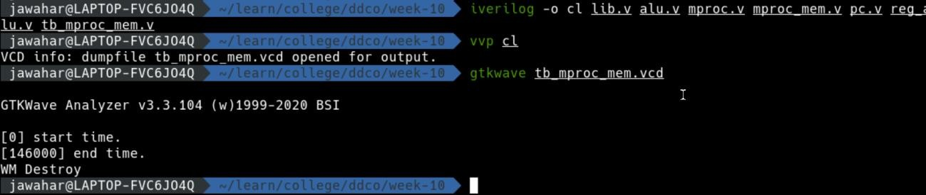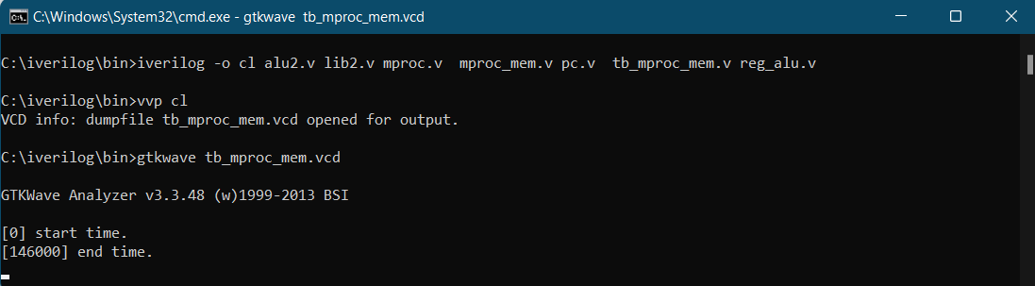

1. 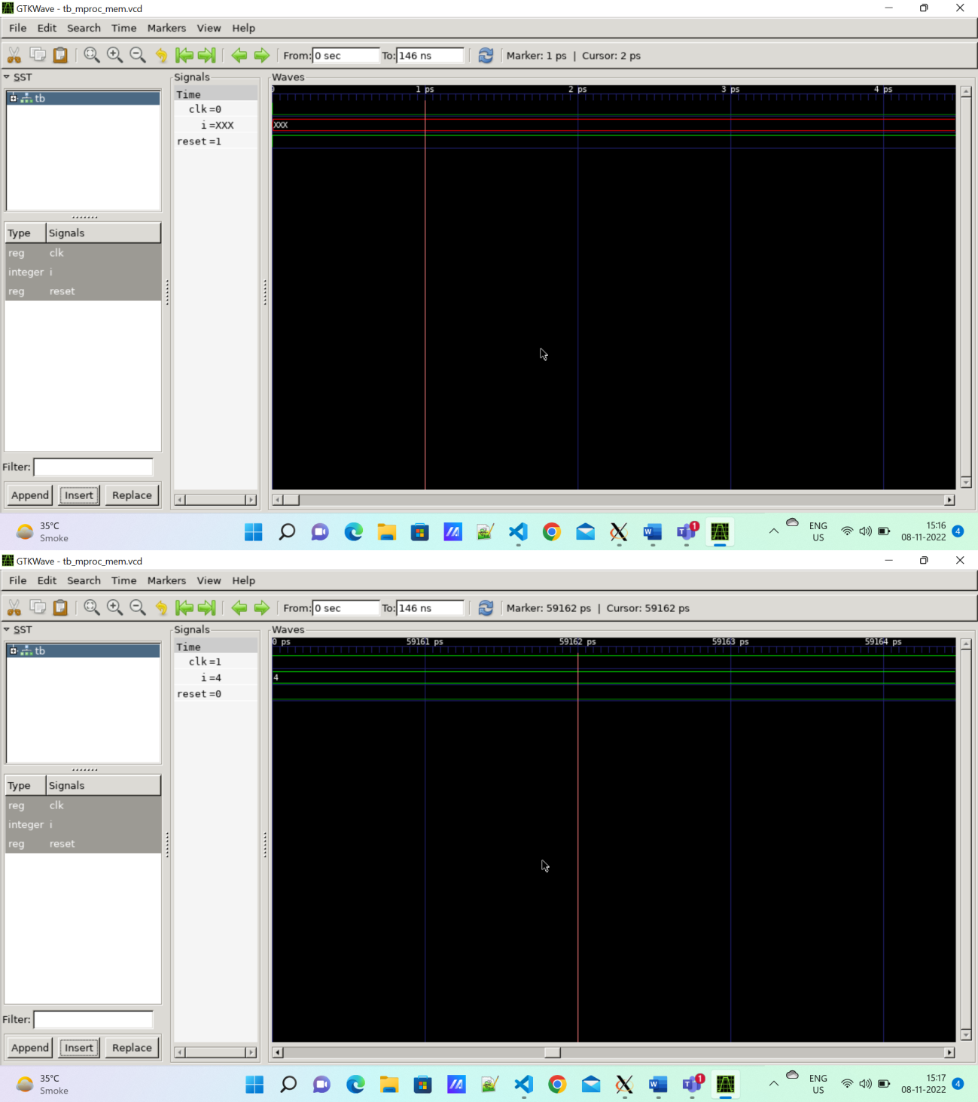GTKWAVE Screenshot



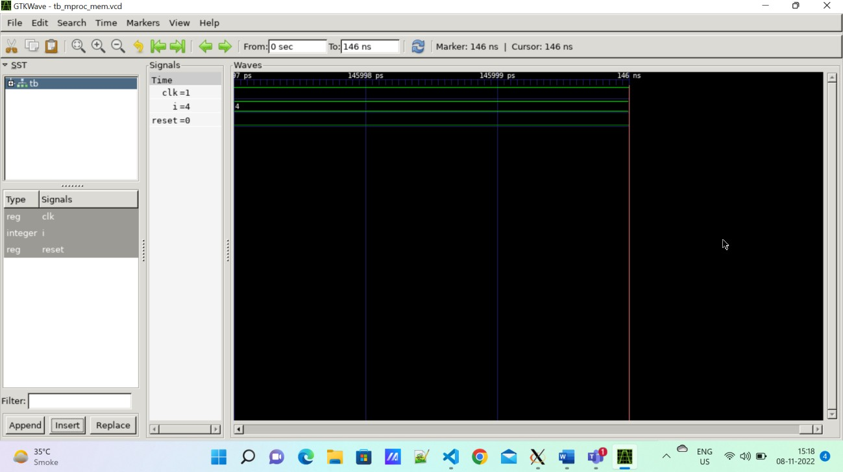

xxx

# Disclaimer:

## The programs and output submitted is duly written, verified and executed by me.

* I have not copied from any of my peers nor from the external resource such as internet.

## If found plagiarized, I will abide with the disciplinary action of the University.

Signature:



Name:HEEMAJ YADAV

SRN: PES2UG21CS198

Date:15-11-2022