NS3 with Cmake linux

Before Building ……………………………………………………………………………………… 2

Cached Files ……………………………………………………………………………………… 2

Dependency options ………………………………………………………………………………… 3

Build Support …………………………………………………………………………………….. 5

Adding Dependencies …...………………………………………………………………………… 5

Building Modules/Libraries …………………………………………………………………………. 6

Building Examples ………………………………………………………………………………….. 6

General Notes ...………………………………………………………………………………….. 13

Common Errors …………………….……………………………………………………………... 13

Before building:

sudo apt-get update
sudo apt-get install gcc g++ python python-dev mercurial python-setuptools git autoconf cvs bzr unrar cmake make p7zip-full unzip
sudo apt-get install python-dev python-graphviz python-kiwi python-gnome2 ipython
sudo apt-get install python-cairo-dev
sudo apt-get install python-gtk2 python-gtk2-dev
sudo apt-get install libboost-all-dev
sudo apt-get install libxml2-dev
sudo apt-get install libgsl0-dev
export LIB_BOOST=/usr/include/boost

download vscode

In order to build with cmake, there are 2 options, building out of source and build(with vscode).

If you open the root directory(NS3) In vscode, it will automatically configure the project and you will be able to build from the build button located on the bottom ribbon.

If you build from the terminal, you must create a new directory in your root directory. Then cd into your new directory and run “cmake ..” this will create configure the cmake project. In order to build, you must run “make”

I recommend running “make -i” (ignore errors)

Built files in the scratch folder or examples will be place the in the bin directory of the build.

Cached Files

**If you reconfigure the project through an out of source directory, you may need to run “cmake .” in the build directory in order to receive new changes.

If you create a add a new header or .cc file, be sure to include it in the CmakeLists file of that directory, or it will not become part of the build.

You must then clear your cache as mentioned above

Dependency options:

The CmakeLists.txt file located in the top directory of the project has the list of all properties/dependencies. It is also used to set which compiler is used to build the project, as well as the sub directories that are to be included in the build. Specific libraries can also be selected to be built or not built, which are preceded with a #. The process_options command will process the list of selected dependencies set to ON by calling a function located in buildsupport/macros_and_definitions.cmake

NS3 to set to version 3.29. Debug mode is set to OFF and will not be configured.

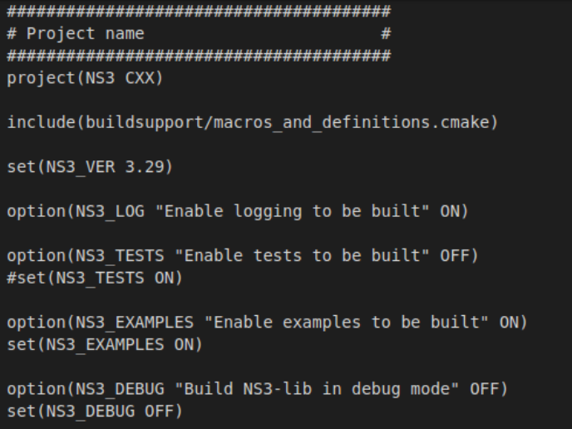

All the following libraries except for click will be built

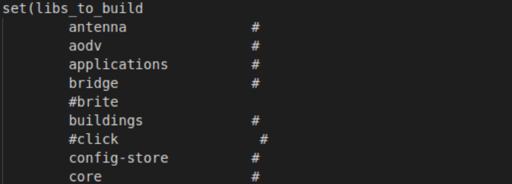
process_options() is called and the following sub directories will be built

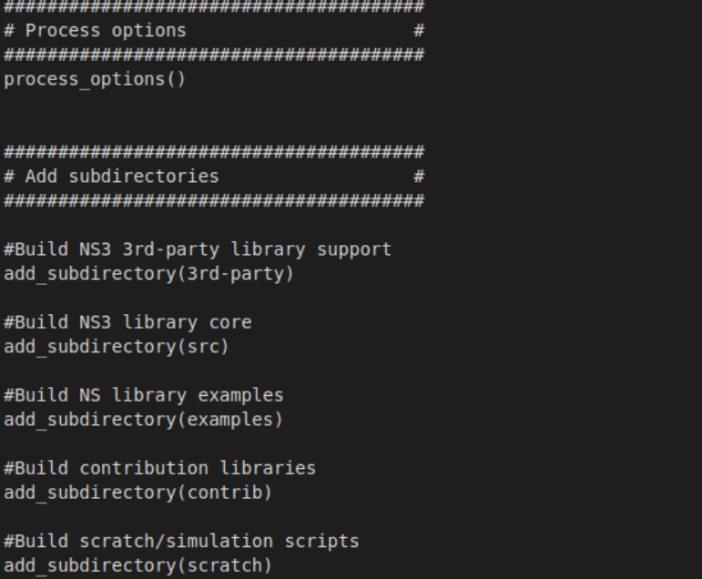
Build support:

The following will be located in the buildsupport directory:
CMakeChecksCache/
custom_modules/
check_dependencies.cmake
contributions.cmake
GitUtils.cmake
macros_and_defintions.cmake
vcpkg_hunter.cmake

The CmakeChecksCache folder provides functions that will cache your builds in order to save time on building after minor changes.

The custom_modules contains a function to locate the PCRE headers(for windows users). This contains header files such as regex.h

Adding dependencies:

In order to add a dependency such as Armadillo, navigate to the macros_and_defintions.cmake file. Under the macro labeled, process_options, follow the proper pattern to input a new dependency such as:
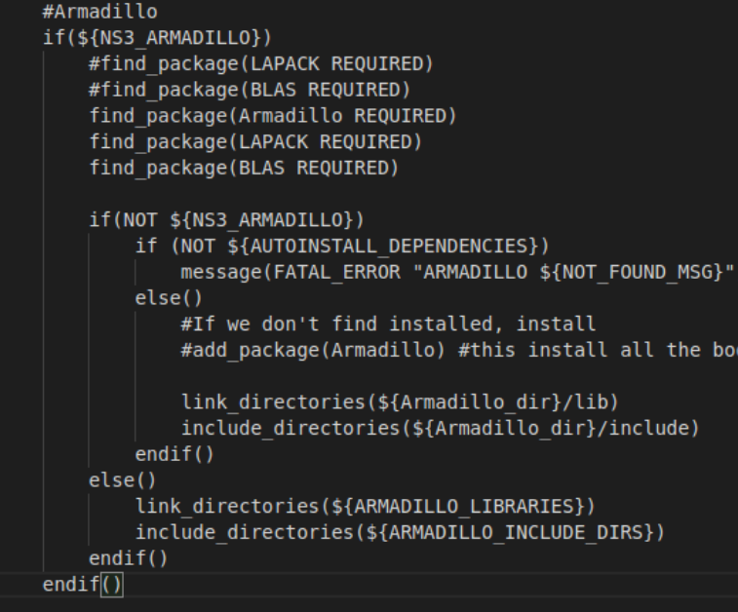

Next, you must navigate to the CmakeLists file in the root directory and add an option for the new dependency such as:

option(NS3_ARMADILLO "Build with Armadillo support" ON)
set(NS3_ARMADILLO ON)

Building modules/libraries:

When adding a new test to a module in the src directory, The CMakeLists.txt file in the corresponding sub-directory must be edited to include the added file.

For example: the antenna directory contains the following list.

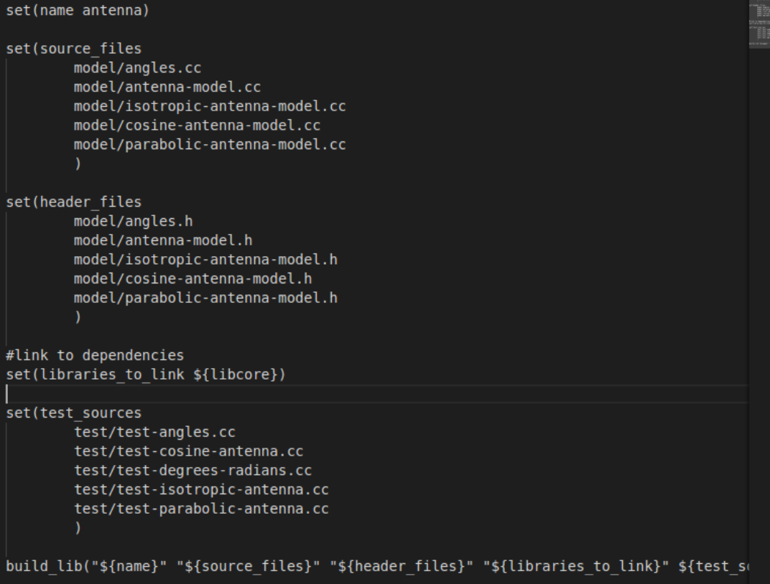
The build_lib definition can be found in macros_and_definitions.cmake
In order to link another library in order to build the current library, the name of the library will be in the following format ${ lib + (name of directory desired to link) }

source_files files should include every .cc file in the model directory. header_files should include every .h file in the model directory. Any test_sources will be locate din the test directory.

Building examples:

Building examples is very similar to building a library. You must set the necessary fields and link the proper libraries in order for it to build.

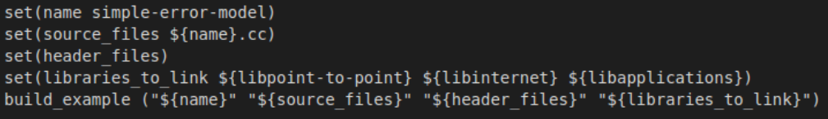

Adding Contributing Libraries:

Adding a contributing Library is similar to add an ns3 module. A contributing library is a library under the contrib directory.
Sample CmakeLists.txt in the contrib folder

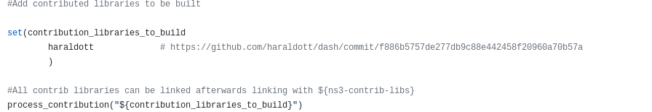
Inside the haraldott folder contains a folder called dash and the following CmakeLists.txt file
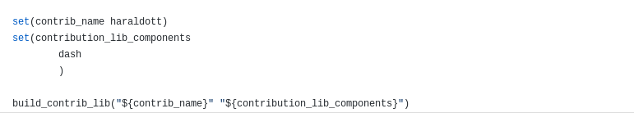
Inside the dash folder contains the following CmakeLists.txt file:

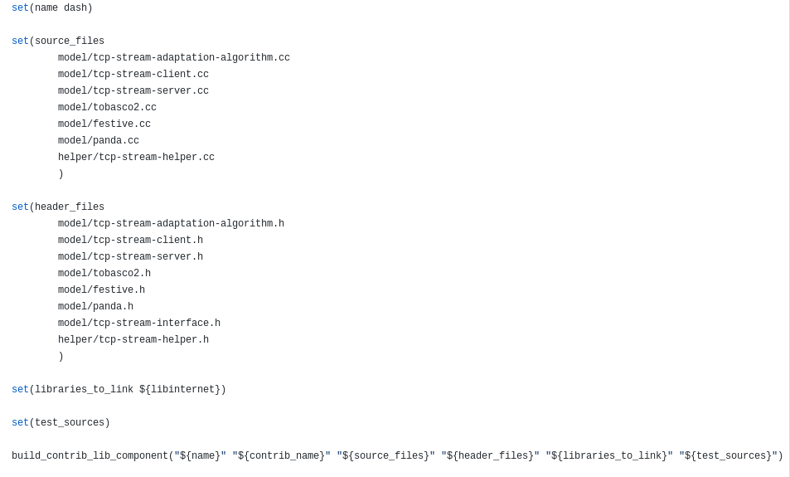
The folder also contains an examples, helper and model folder, similar to a library in the src directory.

The following commands can be found within the contributions.cmake file under the buildsupport directory.

process_contribution(contribution_list)

- Creates library names to solve dependency problems with macros that will be called at each lib subdirectory. It will also create handles for the libraries and create a list of each contributing library to be built. It will also recurse each folder’s sub directories and copy any header files in to the ns3 header output directory.

build_contrib_lib_component(name contrib source_files header_files libraries_to_link test_sources)

- Creates a shared library with the sources and headers. If NS3_TESTS are enabled, A shared library will be built and linked to the library module with the listed test sources. If NS_EXAMPLES is enabled, the listed examples will be built and placed in the build directory under bin/examples

build_contrib_example(name contrib source_files header_files libraries_to_link files_to_copy)

- Creates a shared library with sources and headers. Creates an executable linked with the listed input libraries. Also creates a copy of the files_to_copy and places it in the contrib/libname/examples folder in the build directory

build_contrib_lib(contrib_name components)
- Creates the name of the to be built shared object using contrib_name. Creates a library from its sub components and links the library with any NS3 modules. Also creates a module header that contains all headers in its components.

macros_and_definitions.cmake

Macros and Definitions contains macros that are used to build modules, find and enable dependencies, configure python bindings, and create the appropriate output structure for the finished build. It includes Windows dependent features as well. It also includes the contributions.cmake file as well, so it will not have to be included elsewhere.

It all defines the following folders as output folders for the build:

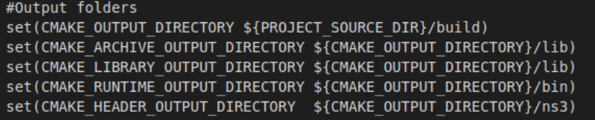

It contains the following macros:

process_options()

-This macro will process all the options passed in the root CmakeLists.txt . It will copy every single header file to into the header output directory. If any custom modules are defined, they will be set to be built as well. If an option is set to OFF in the root CmakeLists.txt, it will not be built. If it is set to ON, it will be built. Cmake will call find_package() to find the desired library. If it is not installed, it will try and install the package, or it will just fail the build. After each dependency is found, its libraries to linked globally. If Debug is set to true, it will built the debug libraries instead of the regular release libraries.

Additional dependencies are to be added in this macro. See Adding Dependencies.

Each library shared object’s name is set to ns${NS3_VER}-${libname}-${build_type}

Configuring Python and its ns3 bindings

In order for python code to properly be compiled and linked to other targets, python must be discovered by ns3. Typically, find_package(Python2) should target your environment's python 2.7. However, with newer versions of cmake, the correct call is now find_package(PythonLibs). In this case, please substitute Python2 in the following code with PythonLibs. For more information on this, please visit: https://cmake.org/cmake/help/v3.0/module/FindPythonLibs.html

The following is found within macros_and_definitions.cmake

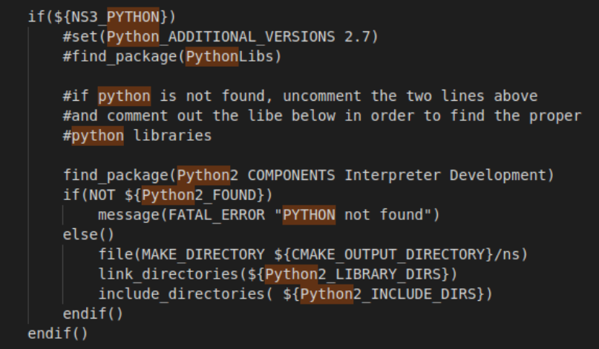
In order to configure python bindings for each module, each module’s ns3module.cc and ns3module.h must targeted. Currently the modules are targeted in the build directory. The option to configure either the gcc_ILP32 or gcc_LP64 versions are available. Both can be configured if desired by setting a new modulegen_arch_command with the other version name, and calling the new command in execute_process.

If the ns3module.cc and ns3module.h files arcmakee not in the build directory, you can add a file copy when traversing the module in the src directory to copy it to the build directory with file(COPY files DESTINATION destination)

The following code will execute each module’s ns3module.cc main function and configure its python bindings, saving them in the build/lib folder as shared objects.

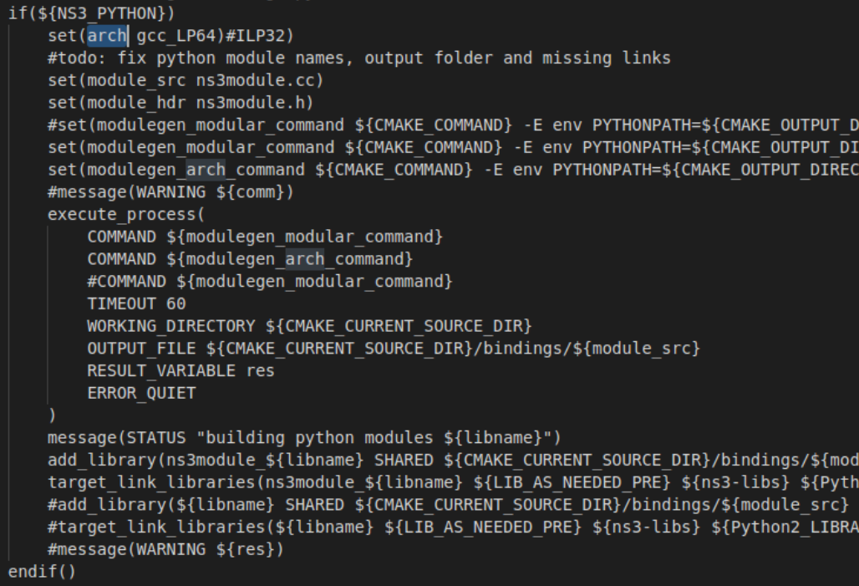
Note: If a module like netanim does not contain bindings, it may cause an error on compiling which can be bypassed with make -i, or an arbitrary ns3module.cc and ns3module.h may be added to the folder, in which its output would be insignificant.

Note: I recommend enabling dependencies such as GTK in the root CmakeLists.txt in order to properly build all modules properly

write_module_header(name header_files)

- writes include directives for each header file required for a module to the desired file

build_lib(libname source_files header_files libraries_to_link test_sources)

- creates a shared library with the sources and header files presented. It will link the new library with any of the libraries passed into the parameters. It will call write_module_header to include all headers from that module. If tests are enabled, it will build the test libraries. If examples are enabled, then examples will be built into the build directory’s bin. Python bindings for the newly added library will also be built.

buiild_example(name source_files header_files libraries_to_link)

- It will build an executable for the example passed in and output it to the build/bin directory.

build_lib_example(name source_files header_files libraries_to_link files_to_copy)

- Builds an example with the current library also linked.

vcpkg_hunter.cmake

-Will download and setup if not already installed vcpkg, which helps manage C and C++ libraries.

function(add_package package_name)

Adds the desired package from its name by running the VCPKG.execwith the package_name as parameters

General Notes:

Each Directory that wishes to be included in the final build will require a CMakeLists.txt file.

Any additional commands are located in CMAKE_SOURCE_DIRECTORY/buildsupport/macros_and_defintions.cmake

The build output is currently set to CMAKE_SOURCE_DIRECTORY/build/bin

python bindings will configure as long as a ns3module.cc and ns3module.h are located in the src directory of the respective built module.

No two dynamically linked libraries may share the same name.

Comments in cmake scripts begin with #

add_subdirectory(name_of_sub_directory) will add the sub directory to the cmake script, allowing it to compile later on. Due to this, Cmake builds like a tree.

Common Errors:

If a dependency doesn’t compile properly, you may skip it using “make -i”

You can also run multiple make jobs at once with “make -j N” where N is the amount of desired jobs

In macros_and_defintions.cmake, if python2 cannot be found please try and declare
find_package(PythonLibs), this should find Python2 libraries in order to compile NS3 python bindings

"Log component "Time" has already been registered once.” - Unsolved visualizer issue

Current Work in Progress

In order for the python bindings to properly function, they must be named after each module. Ex. The visualizer module must be named (visualizer.so) once configured, due to the way they were written. Currently the python bindings are configured under the name libns3module_(module), due to conflicting naming issues. The current process of configuring and building the python bindings is located in macros_and_defintions.cmake at the end of the build_lib macro.

After creating the new python configured so file named ${module}.so the following error occur when trying to dynamically link the module to a python script upon execution.

File "first.py", line 16, in <module>
import ns.applications
ImportError: dynamic module does not define init function (initapplications)

***The above issue is the result of not properly configuring the python bindings, leaving an empty shared object file.

Due to the python bindings not properly being named, this creates the issue of not being able to use the visualizer. Due to this, the visualizer does not work.

