Lab - Configure IPv6 Addresses on Network Devices

Topology

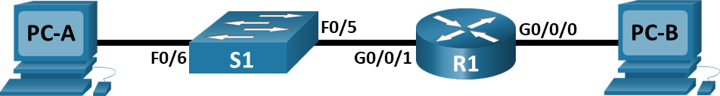

# Addressing Table

|  |  |  |  |  |
| --- | --- | --- | --- | --- |
| Device | Interface | IPv6 Address | Prefix Length | Default Gateway |
| R1 | G0/0/0 | 2001:db8:acad:a::1 | 64 | N/A |
| R1 | G0/0/1 | 2001:db8:acad:1::1 | 64 | N/A |
| S1 | VLAN 1 | 2001:db8:acad:1::b | 64 | N/A |
| PC-A | NIC | 2001:db8:acad:1::3 | 64 | fe80::1 |
| PC-B | NIC | 2001:db8:acad:a::3 | 64 | fe80::1 |

# Objectives

Part 1: Set Up Topology and Configure Basic Router and Switch Settings

Part 2: Configure IPv6 Addresses Manually

Part 3: Verify End-to-End Connectivity

# Background / Scenario

In this lab, you will configure hosts and device interfaces with IPv6 addresses. You will issue **show** commands to view IPv6 unicast addresses. You will also verify end-to-end connectivity using **ping** and **traceroute** commands.

**Note**: The routers used with CCNA hands-on labs are Cisco 4221 with Cisco IOS XE Release 16.9.4 (universalk9 image). The switches used in the labs are Cisco Catalyst 2960s with Cisco IOS Release 15.2(2) (lanbasek9 image). Other routers, switches, and Cisco IOS versions can be used. Depending on the model and Cisco IOS version, the commands available and the output produced might vary from what is shown in the labs. Refer to the Router Interface Summary Table at the end of the lab for the correct interface identifiers.

**Note**: Make sure that the routers and switches have been erased and have no startup configurations. If you are unsure, contact your instructor.

**Note**: The default 2960 Switch Database Manager (SDM) template does not support IPv6. It may be necessary to issue the command **sdm prefer dual-ipv4-and-ipv6 default** to enable IPv6 addressing before applying an IPv6 address to the VLAN 1 SVI.

**Note**: The **default bias** template used by the Switch Database Manager (SDM) does not provide IPv6 address capabilities. Verify that SDM is using either the **dual-ipv4-and-ipv6** template or the **lanbase-routing** template. The new template will be used after reboot.

S1# **show sdm prefer**

Follow these steps to assign the dual-ipv4-and-ipv6 template as the default SDM template:

S1# **configure terminal**

S1(config)# **sdm prefer dual-ipv4-and-ipv6 default**

S1(config)# **end**

S1# **reload**

# Required Resources

* 1 Router (Cisco 4221 with Cisco IOS XE Release 16.9.4 universal image or comparable)
* 1 Switch (Cisco 2960 with Cisco IOS Release 15.2(2) lanbasek9 image or comparable)
* 2 PCs (Windows with terminal emulation program, such as Tera Term)
* Console cables to configure the Cisco IOS devices via the console ports
* Ethernet cables as shown in the topology

**Note**: The Gigabit Ethernet interfaces on Cisco 4221 routers are autosensing and an Ethernet straight-through cable may be used between the router and PC-B. If using another model Cisco router, it may be necessary to use an Ethernet crossover cable.

# Instructions

## Cable the Network and Configure Basic Router and Switch Settings

After cabling the network, initializing and reloading the router and switch, complete the following:

### Configure the router.

Assign the hostname and configure basic device settings.

### Configure the switch.

Assign the hostname and configure basic device settings.

## Configure IPv6 Addresses Manually

### Assign the IPv6 addresses to Ethernet interfaces on R1.

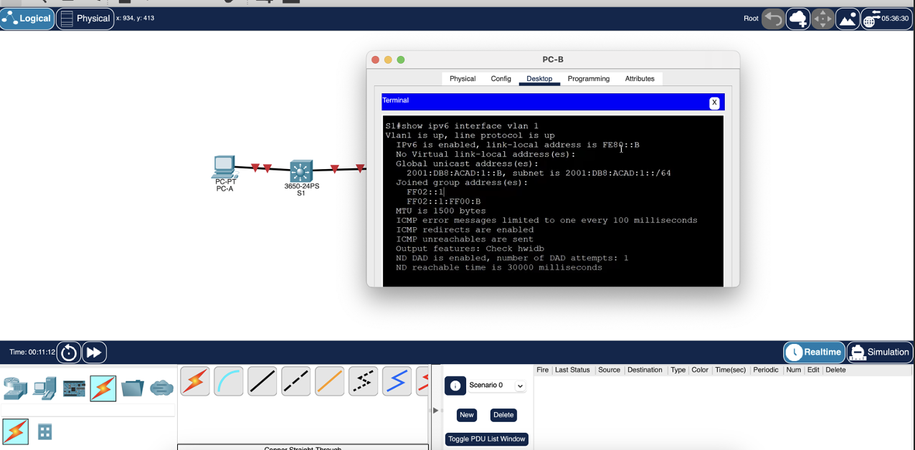

### Enable IPv6 routing on R1.

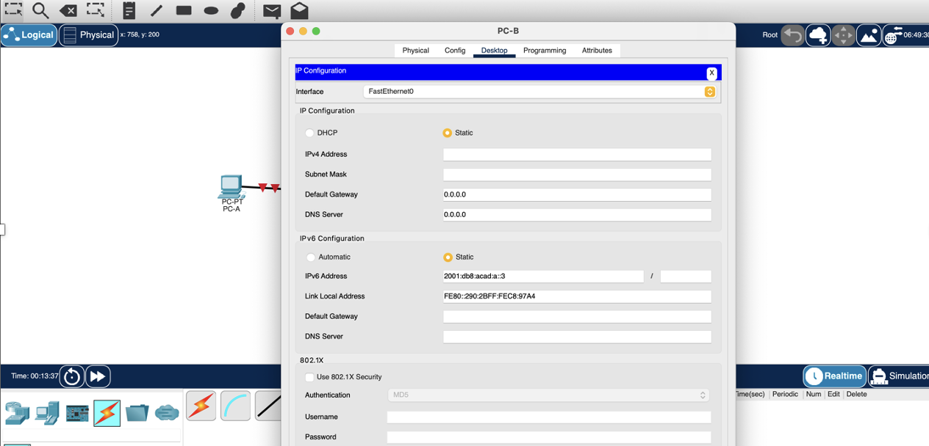

### Assign IPv6 addresses to the management interface (SVI) on S1.

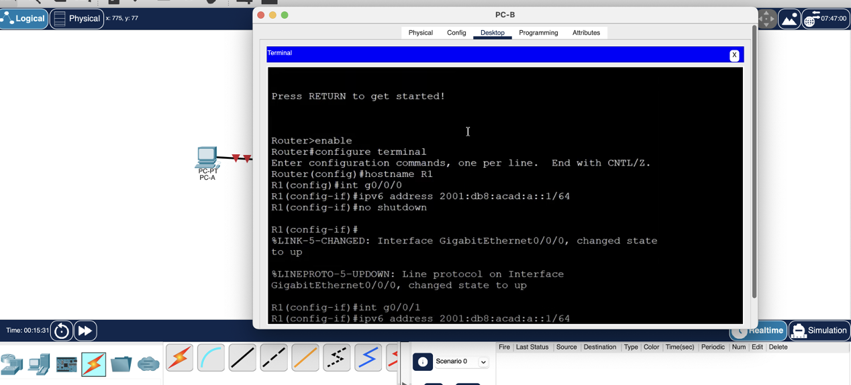

### Assign static IPv6 addresses to the PCs.

# Reflection Questions

* 1. Why can the same link-local address, fe80::1, be assigned to both Ethernet interfaces on R1?

Link-local packets are designed to limit their distribution within a local network, which allows using the same local address of the communication channel on different interfaces connected to different local networks.

* 1. What is the Subnet ID of the IPv6 unicast address 2001:db8:acad::aaaa:1234/64?

In this example, the fourth value of an IPv6 address with the prefix /64 consists only of zeros (either 0 or 0000), which represent the subnet identifier. Following the rule "IPv6 skips the entire segment 0", in an IPv6 address, a double colon (::) is used to replace consecutive blocks of zeros. As a result, the address 2001:acad::aaaa:1234/64 can be written as 2001:db8:abcd::/64, where a double colon (::) replaces consecutive zeros in the subnet identifier and the first two characters of the interface identifier.

# Router Interface Summary Table

| Router Model | Ethernet Interface #1 | Ethernet Interface #2 | Serial Interface #1 | Serial Interface #2 |
| --- | --- | --- | --- | --- |
| 1800 | Fast Ethernet 0/0 (F0/0) | Fast Ethernet 0/1 (F0/1) | Serial 0/0/0 (S0/0/0) | Serial 0/0/1 (S0/0/1) |
| 1900 | Gigabit Ethernet 0/0 (G0/0) | Gigabit Ethernet 0/1 (G0/1) | Serial 0/0/0 (S0/0/0) | Serial 0/0/1 (S0/0/1) |
| 2801 | Fast Ethernet 0/0 (F0/0) | Fast Ethernet 0/1 (F0/1) | Serial 0/1/0 (S0/1/0) | Serial 0/1/1 (S0/1/1) |
| 2811 | Fast Ethernet 0/0 (F0/0) | Fast Ethernet 0/1 (F0/1) | Serial 0/0/0 (S0/0/0) | Serial 0/0/1 (S0/0/1) |
| 2900 | Gigabit Ethernet 0/0 (G0/0) | Gigabit Ethernet 0/1 (G0/1) | Serial 0/0/0 (S0/0/0) | Serial 0/0/1 (S0/0/1) |
| 4221 | Gigabit Ethernet 0/0/0 (G0/0/0) | Gigabit Ethernet 0/0/1 (G0/0/1) | Serial 0/1/0 (S0/1/0) | Serial 0/1/1 (S0/1/1) |
| 4300 | Gigabit Ethernet 0/0/0 (G0/0/0) | Gigabit Ethernet 0/0/1 (G0/0/1) | Serial 0/1/0 (S0/1/0) | Serial 0/1/1 (S0/1/1) |

**Note**: To find out how the router is configured, look at the interfaces to identify the type of router and how many interfaces the router has. There is no way to effectively list all the combinations of configurations for each router class. This table includes identifiers for the possible combinations of Ethernet and Serial interfaces in the device. The table does not include any other type of interface, even though a specific router may contain one. An example of this might be an ISDN BRI interface. The string in parenthesis is the legal abbreviation that can be used in Cisco IOS commands to represent the interface.

End of document