Lab - Use Ping and Traceroute to Test Network Connectivity Topology

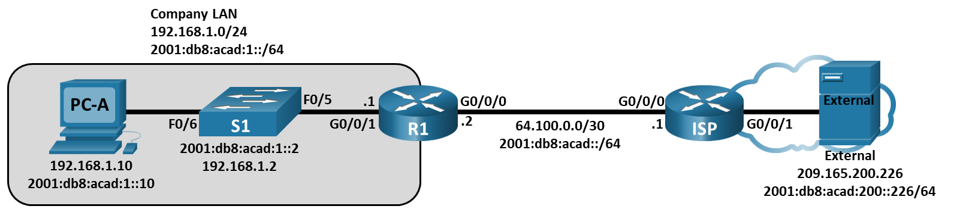

# Addressing Table

| Device | Interface | IP Address / Prefix | Default Gateway |
| --- | --- | --- | --- |
| R1 | G0/0/0 | 64.100.0.2 /30 | N/A |
| R1 | G0/0/0 | 2001:db8:acad::2 /64 | N/A |
| R1 | G0/0/0 | fe80::2 | N/A |
| R1 | G0/0/1 | 192.168.1.1 /24 | N/A |
| R1 | G0/0/1 | 2001:db8:acad:1::1 /64 | N/A |
| R1 | G0/0/1 | fe80::1 | N/A |
| ISP | G0/0/0 | 64.100.0.1 /30 | N/A |
| ISP | G0/0/0 | 2001:db8:acad::1 /64 | N/A |
| ISP | G0/0/0 | fe80::1 | N/A |
| ISP | G0/0/1 | 209.165.200.225 /27 | N/A |
| ISP | G0/0/1 | 2001:db8:acad:200::225 /64 | N/A |
| ISP | G0/0/1 | fe80::225 | N/A |
| S1 | VLAN 1 | 192.168.1.2 /24 | 192.168.1.1 |
| S1 | VLAN 1 | 2001:db8:acad:1::2 /64 | fe80::1 |
| S1 | VLAN 1 | fe80::2 | fe80::1 |
| PC-A | NIC | 2001:db8:acad:1::10 /64 | fe80::1 |
| PC-A | NIC | 192.168.1.10 /24 | 192.168.1.1 |
| External | NIC | 209.165.200.226 /27 | 209.165.200.225 |
| External | NIC | 2001:db8:acad:200::226 /64 | fe80::225 |

# Objectives

Part 1: Build and Configure the Network

Part 2: Use Ping Command for Basic Network Testing

Part 3: Use Tracert and Traceroute Commands for Basic Network Testing

Part 4: Troubleshoot the Topology

# Background / Scenario

Ping and traceroute are two tools that are indispensable when testing TCP/IP network connectivity. Ping is a network administration utility used to test the reachability of a device on an IP network. This utility also measures the round-trip time for messages sent from the originating host to a destination computer. The ping utility is available on Windows, Unix-like operating systems (OS), and the Cisco Internetwork Operating System (IOS).

The traceroute utility is a network diagnostic tool for displaying the path or route and measuring the transit delays of packets travelling an IP network. The tracert utility is available on Windows, and a similar utility, traceroute, is available on Unix-like OS and Cisco IOS.

In this lab, the **ping** and **traceroute** commands are examined and command options are explored to modify the command behavior. Cisco devices and PCs are used in this lab for command exploration. The necessary Cisco device configurations are provided in this lab.

**Note**: The routers used with CCNA hands-on labs are Cisco 4221 with Cisco IOS XE Release 16.9.4 (universalk9 image). The switches used in the labs are Cisco Catalyst 2960s with Cisco IOS Release 15.2(2) (lanbasek9 image). Other routers, switches, and Cisco IOS versions can be used. Depending on the model and Cisco IOS version, the commands available and the output produced might vary from what is shown in the labs. Refer to the Router Interface Summary Table at the end of the lab for the correct interface identifiers.

**Note**: Make sure that the routers and switches have been erased and have no startup configurations. If you are unsure, contact your instructor.

The **default bias** template used by the Switch Database Manager (SDM) does not provide IPv6 address capabilities. Verify that SDM is using either the **dual-ipv4-and-ipv6** template or the **lanbase-routing** template. The new template will be used after reboot even if the configuration is not saved.

S1# **show sdm prefer**

Use the following commands to assign the **dual-ipv4-and-ipv6** template as the default SDM template.

S1# **configure terminal**

S1(config)# **sdm prefer dual-ipv4-and-ipv6 default**

S1(config)# **end**

S1# **reload**

# Required Resources

* 2 Routers (Cisco 4221 with Cisco IOS XE Release 16.9.4 universal image or comparable)
* 1 Switch (Cisco 2960 with Cisco IOS Release 15.2(2) lanbasek9 image or comparable)
* 2 PCs (Windows with terminal emulation program, such as Tera Term)
* Console cables to configure the Cisco IOS devices via the console ports
* Ethernet and serial cables as shown in the topology

# Instructions

## Build and Configure the Network

In Part 1, you will set up the network in the topology and configure the PCs and Cisco devices. The initial configurations for the routers and switches are provided for your reference. In this topology, static routing is used to route packets between networks.

### Cable the network as shown in the topology.

### Erase the configurations on the routers and switches, and reload the devices.

### Configure PC IP addresses and default gateways according to the Addressing Table.

### Configure the R1 and ISP routers and S1 switch using the initial configurations provided below.

At the switch or router global configuration mode prompt, copy and paste the configuration for each device. Save the configuration to startup-config.

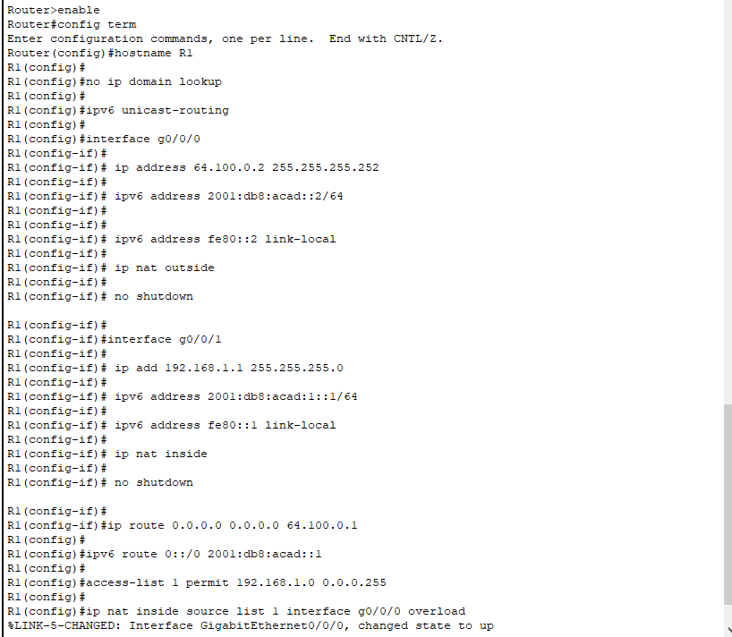

### Configure an IP host table on the R1 router.

The IP host table allows you to use a hostname to connect to a remote device rather than an IP address. The host table provides name resolution for the device with the following configurations. Copy and paste the following configurations for the R1 router. The configurations will allow you to use the hostnames for **ping** and **traceroute** commands on the R1 router.

## Use Ping Command for Basic Network Testing

In Part 2 of this lab, use the **ping** command to verify end-to-end connectivity. Ping operates by sending Internet Control Message Protocol (ICMP) echo request packets to the target host and then waiting for an ICMP response. It can record the round trip time and any packet loss or routing loops.

IP packets have a limited lifetime on the network. IP packets use an 8 bit Time to Live (IPv4) or Hop Limit (IPv6) header field value which specifies the maximum number of layer three hops that can be traversed on the path to their destination. Hosts on a network will set its own 8 bit value with a maximum value of 255.

So each time an IP packet arrives at a layer three network device this value is reduced by one before it is forwarded to its destination. So if this value eventually reaches zero the IP packet is discarded.

You will examine the results with the **ping** command and the additional ping options that are available on Windows-based PCs and Cisco devices.

### Test network connectivity from the R1 network using PC-A.

All the pings from PC-A to other devices in the topology should be successful. If they are not, check the topology and the cabling, as well as the configuration of the Cisco devices and the PCs.

* + - 1. Ping from PC-A to its default gateway using the IPv4 address (R1’s GigabitEthernet 0/0/1 interface).

Open command prompt

In this example, four (4) ICMP requests, 32 bytes each, were sent and the responses were received in less than one millisecond with no packet loss. The transmission and reply time can increase as the ICMP requests and responses are processed by more devices during the journey to and from the final destination.

This can also be done using the IPv6 address of the default gateway (R1’s GigabitEthernet 0/0/1 interface).

* + - 1. From PC-A, ping the addresses listed in the following table and record the average round trip time and IPv4 Time to Live (TTL) or IPv6 Hop Limit. **Optional**: Use WireShark to see the IPv6 Hop Limit value.

| Destination | Average Round Trip Time (ms) | TTL / Hop Limit |
| --- | --- | --- |
| 192.168.1.10 | 5 | 128 |
| 2001:db8:acad:1::10 | 2 | 128 |
| 192.168.1.1 (R1) | <1 | 255 |
| 2001:db8:acad:1::1 (R1) | <1 | 255 |
| 192.168.1.2 (S1) | <1 | 255 |
| 2001:db8:acad:1::2(S1) | <1 | 255 |
| 64.100.0.2 (R1) | <1 | 255 |
| 2001:db8:acad::2 (R1) | <1 | 255 |
| 64.100.0.1 (ISP) | <1 | 254 |
| 2001:db8:acad::1 (ISP) | <1 | 254 |
| 209.165.200.225 (ISP G0/0/1) | <1 | 254 |
| 2001:db8:acad:200::225 (ISP G0/0/1) | <1 | 254 |
| 209.165.200.226 (External) | <1 | 126 |
| 2001:db8:acad:200::226 (External) | <1 | 126 |

### Use extended ping commands on PC-A.

The default **ping** command sends four requests at 32 bytes each. It waits 4,000 milliseconds (4 seconds) for each response to be returned before displaying the “Request timed out” message. The **ping** command can be fine-tuned for troubleshooting a network.

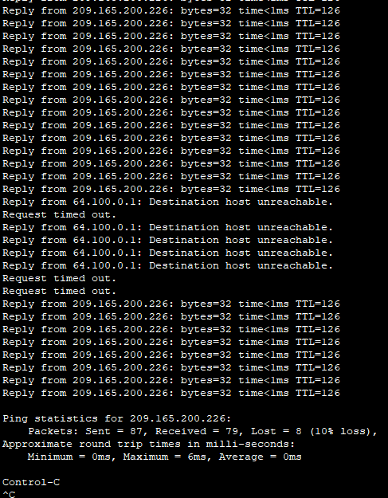

#### Question:

What ICMP error messages did you receive?

The request cannot be executed due to the unavailability of the destination node and the timeout.

### Test network connectivity from the R1 network using Cisco devices.

The **ping** command is also available on Cisco devices. In this step, the **ping** command is examined using the R1 router and the S1 switch.

What is the IP address used?

209.165.200.226

## Use Tracert and Traceroute Commands for Basic Network Testing

The commands for tracing routes can be found on PCs and network devices. For a Windows-based PC, the **tracert** command uses ICMP messages to trace the path to the final destination. The **traceroute** command utilizes the User Datagram Protocol (UDP) datagrams for tracing routes to the final destination for Cisco devices and other Unix-like PCs.

In Part 3, you will examine the traceroute commands and determine the path that a packet travels to its final destination. You will use the **tracert** command from the Windows PCs and the **traceroute** command from the Cisco devices. You will also examine the options that are available for fine tuning the traceroute results.

### Use the tracert command from PC-A to EXTERNAL.

* + - 1. At the command prompt, type **tracert 209.165.200.226**.

Open a command prompt

The tracert results indicates the path from PC-A to EXTERNAL is from PC-A to R1 to ISP to EXTERNAL. The path to EXTERNAL traveled through two router hops to the final destination of EXTERNAL.

### Explore additional options for the tracert command.

* + - 1. At the command prompt, type **tracert** and press Enter to see the available options.
      2. Use the **-d** option. Notice that the IP address of 209.165.200.226 is not resolved as EXTERNAL.

### Use the traceroute command from the R1 router to External.

At the command prompt, type **traceroute 209.165.200.226** or **traceroute 2001:db8:acad:200::226** on the R1 router. The hostnames are resolved because a local IP host table was configured on the R1 router.

### Use the traceroute command from the S1 switch to External.

On the S1 switch, type **traceroute 209.165.200.226** or **traceroute 2001:db8:acad:200::226**. The hostnames are not displayed in the traceroute results because a local IP host table was not configured on this switch.

Open a configuration window

Close configuration window

The **traceroute** command has additional options. You can use the **?** or just press Enter after typing **traceroute** at the prompt to explore these options.

The following link provides more information regarding the **ping** and **traceroute** commands for a Cisco device:

<http://www.cisco.com/en/US/products/sw/iosswrel/ps1831/products_tech_note09186a00800a6057.shtml>

## Troubleshoot the Topology

### Copy and paste the following configuration into the ISP router.

### From the R1 network, use ping and tracert or traceroute commands to troubleshoot and correct the problem on the ISP network.

* + - 1. Use the **ping** and **tracert** commands from PC-A.

You can use the **tracert** command to determine end-to-end network connectivity. This tracert result indicates that PC-A can reach its default gateway of 192.168.1.1, but PC-A does not have network connectivity with External.

Open command prompt

One way to locate the network issue is to ping each hop in the network to EXTERNAL. First determine if PC-A can reach the ISP router g0/0/0 interface with an IP address of 64.100.0.1.

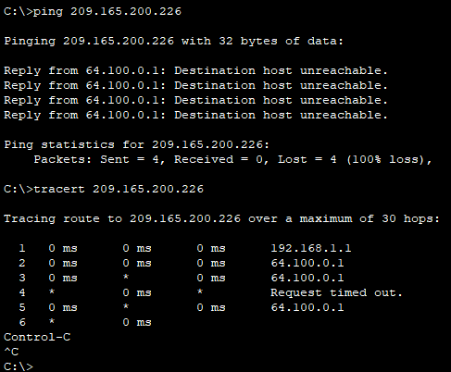

* + - 1. PC-A can reach the ISP router. Based on the successful ping results from PC-A to the ISP router, the network connectivity issue is with 209.165.200.224/24 network. Ping the default gateway to External, which is the GigabitEthernet 0/0/1 interface of the ISP router.

PC-A cannot reach the GigabitEthernet 0/0/1 interface of the ISP router, as displayed by the results from the **ping** command.

The tracert and ping results conclude that PC-A can reach the R1 and ISP routers, but not the External or default gateway for External.

Close command prompt

* + - 1. Use the **show** commands to examine the running configurations for the ISP router.

Open configuration window

The outputs of the **show run** and **show ip interface brief** commands indicate that the GigabitEthernet 0/0/1 interface is up/up, but was configured with an incorrect IP address.

* + - 1. Correct the found issues.

Close configuration window

* + - 1. Verify that PC-A can ping and tracert to EXTERNAL.

Open command prompt

Close command prompt

**Note**: This can also be accomplished using **ping** and **traceroute** commands from the CLI on the ISP router and the S1 switch after verifying that there are no network connectivity issues on the 192.168.1.0/24 network.

* + - 1. Now repeat the process for IPv6 connectivity. **Note**: If you find an incorrect IPv6 address, you will need to remove it because it is not replaced by a new ipv6 address command.

# Reflection Questions

* 1. What could prevent ping or traceroute responses from reaching the originating device beside network connectivity issues?

The computer has problems with the firewall, access list command, routing, broken interface and network delays.

Type your answers here.

* 1. If you ping a non-existent address on the remote network, such as 209.165.200.227, what is the message displayed by the **ping** command? What does this mean? If you ping a valid host address and receive this response, what should you check?

If you receive a message about the expiration of a timeout or a period (.), when checking a valid host address, you should consider several possible reasons. You should check the functionality of the router, the destination node, the return route to your device and make sure that the response delay does not exceed the preset time period.

* 1. If you ping an address that does not exist in any network in your topology, such as 192.168.5.3, from a Windows-based PC, what is the message displayed by the **ping** command? What does this message indicate?

The lack of access to the destination node indicates that there is no route to the destination location, since the network is not registered in the routing table.

* 1. What is the IPv4 TTL value set on the Windows host? What is the IPv4 TTL value set on a Cisco device?

In the Windows operating system, TTL is set to 128, whereas in Cisco devices it is set to 255.

Type your answers here.

* 1. What is the IPv6 Hop Limit value set on the Windows host? What is the IPv6 Hop Limit value set on a Cisco device?

The TTL value set in the Windows operating system is 128, which corresponds to the TTL value for IPv4. However, Cisco devices set the TTL value to 64.

Type your answers here.

# Router Interface Summary Table

| Router Model | Ethernet Interface #1 | Ethernet Interface #2 | Serial Interface #1 | Serial Interface #2 |
| --- | --- | --- | --- | --- |
| 1800 | Fast Ethernet 0/0 (F0/0) | Fast Ethernet 0/1 (F0/1) | Serial 0/0/0 (S0/0/0) | Serial 0/0/1 (S0/0/1) |
| 1900 | Gigabit Ethernet 0/0 (G0/0) | Gigabit Ethernet 0/1 (G0/1) | Serial 0/0/0 (S0/0/0) | Serial 0/0/1 (S0/0/1) |
| 2801 | Fast Ethernet 0/0 (F0/0) | Fast Ethernet 0/1 (F0/1) | Serial 0/1/0 (S0/1/0) | Serial 0/1/1 (S0/1/1) |
| 2811 | Fast Ethernet 0/0 (F0/0) | Fast Ethernet 0/1 (F0/1) | Serial 0/0/0 (S0/0/0) | Serial 0/0/1 (S0/0/1) |
| 2900 | Gigabit Ethernet 0/0 (G0/0) | Gigabit Ethernet 0/1 (G0/1) | Serial 0/0/0 (S0/0/0) | Serial 0/0/1 (S0/0/1) |
| 4221 | Gigabit Ethernet 0/0/0 (G0/0/0) | Gigabit Ethernet 0/0/1 (G0/0/1) | Serial 0/1/0 (S0/1/0) | Serial 0/1/1 (S0/1/1) |
| 4300 | Gigabit Ethernet 0/0/0 (G0/0/0) | Gigabit Ethernet 0/0/1 (G0/0/1) | Serial 0/1/0 (S0/1/0) | Serial 0/1/1 (S0/1/1) |

**Note**: To find out how the router is configured, look at the interfaces to identify the type of router and how many interfaces the router has. There is no way to effectively list all the combinations of configurations for each router class. This table includes identifiers for the possible combinations of Ethernet and Serial interfaces in the device. The table does not include any other type of interface, even though a specific router may contain one. An example of this might be an ISDN BRI interface. The string in parenthesis is the legal abbreviation that can be used in Cisco IOS commands to represent the interface.

End of document