Lab - Observe DNS Resolution

Objectives

Part 1: Observe the DNS Conversion of a URL to an IP Address

Part 2: Observe DNS Lookup Using the nslookup Command on a Web Site

Part 3: Observe DNS Lookup Using the nslookup Command on Mail Servers

# Background / Scenario

The Domain Name System (DNS) is invoked when you type a Uniform Resource Locator (URL), such as **http://www.cisco.com**, into a web browser. The first part of the URL describes which protocol is used. Common protocols are Hypertext Transfer Protocol (HTTP), Hypertext Transfer Protocol over Secure Socket Layer (HTTPS), and File Transfer Protocol (FTP).

DNS uses the second part of the URL, which in this example is www.cisco.com. DNS translates the domain name (www.cisco.com) to an IP address to allow the source host to reach the destination server. In this lab, you will observe DNS in action and use the **nslookup** (name server lookup) command to obtain additional DNS information.

# Required Resources

1 PC (Windows with internet and command prompt access)

# Instructions

## Observe the DNS Conversion of a URL to an IP Address

Open a Windows command prompt.

* + - 1. At the command prompt, ping the URL for the Internet Corporation for Assigned Names and Numbers (ICANN) at **www.icann.org**. ICANN coordinates the DNS, IP addresses, top-level domain name system management, and root server system management functions. The computer must translate www.icann.org into an IP address to know where to send the Internet Control Message Protocol (ICMP) packets.

The first line of the output displays **www.icann.org** converted to an IP address by DNS. You should be able to see the effect of DNS, even if your institution has a firewall that prevents pinging, or if the destination server has prevented you from pinging its web server.

**Note**: If the domain name is resolved to an IPv6 address, use the command **ping -4 www.icann.org** to translate into an IPv4 address if desired.

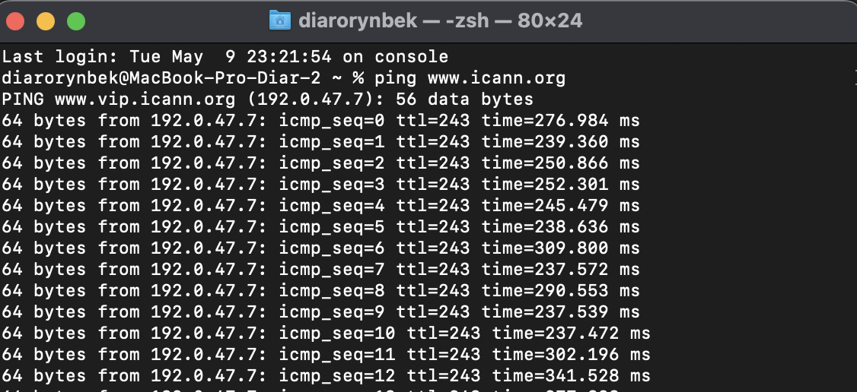

Close the Windows command prompt

* + - 1. Type the IPv4 addresses from step b into a web browser, instead of the URL. Enter **https://192.0.32.7** in the web browser. If your computer has an IPv6 address you can enter the IPv6 address. **https://[2620:0:2d0:200::7]** in the web browser.

* + - 1. Notice that the ICANN home web page is displayed without using DNS.

Most humans find it easier to remember words, rather than numbers. If you tell someone to go to **www.icann.org**, they can probably remember that. If you told them to go to 192.0.32.7, they would have a difficult time remembering an IP address. Computers process in numbers. DNS is the process of translating words into numbers. Additionally, there is a second translation that takes place. Humans think in Base 10 numbers. Computers process in Base 2 numbers. The Base 10 IP address 192.0.32.7 in Base 2 numbers is 11000000.00000000.00100000.00000111. What happens if you cut and paste these Base 2 numbers into a browser?

* + - 1. At a command prompt, **ping www.cisco.com**.

**Note**: If the domain name is resolved to an IPv6 address, use the command **ping -4 www.cisco.com** to translate into an IPv4 address if desired.

## Observe DNS Lookup Using the nslookup Command on a Web Site

* + - 1. At the command prompt, type the **nslookup** command.

Open a windows command prompt

### Question:

What is the default DNS server used?

By default, the nslookup command-line tool uses the DNS stub recognizer, which is based on your ISP's DNS servers, unless you have made changes. However, now nslookup will use Google's DNS server running at IP address 8.8.

Type your answers here.

* + - 1. Notice how the command prompt changed to a greater than (>) symbol. This is the **nslookup** prompt. From this prompt, you can enter commands related to DNS.

At the prompt, type **?** to see a list of all the available commands that you can use in **nslookup** mode.

* + - 1. At the nslookup prompt, type **www.cisco.com**.

**Note**: The IP address from your location will most likely be different because Cisco uses mirrored servers in various locations around the world.

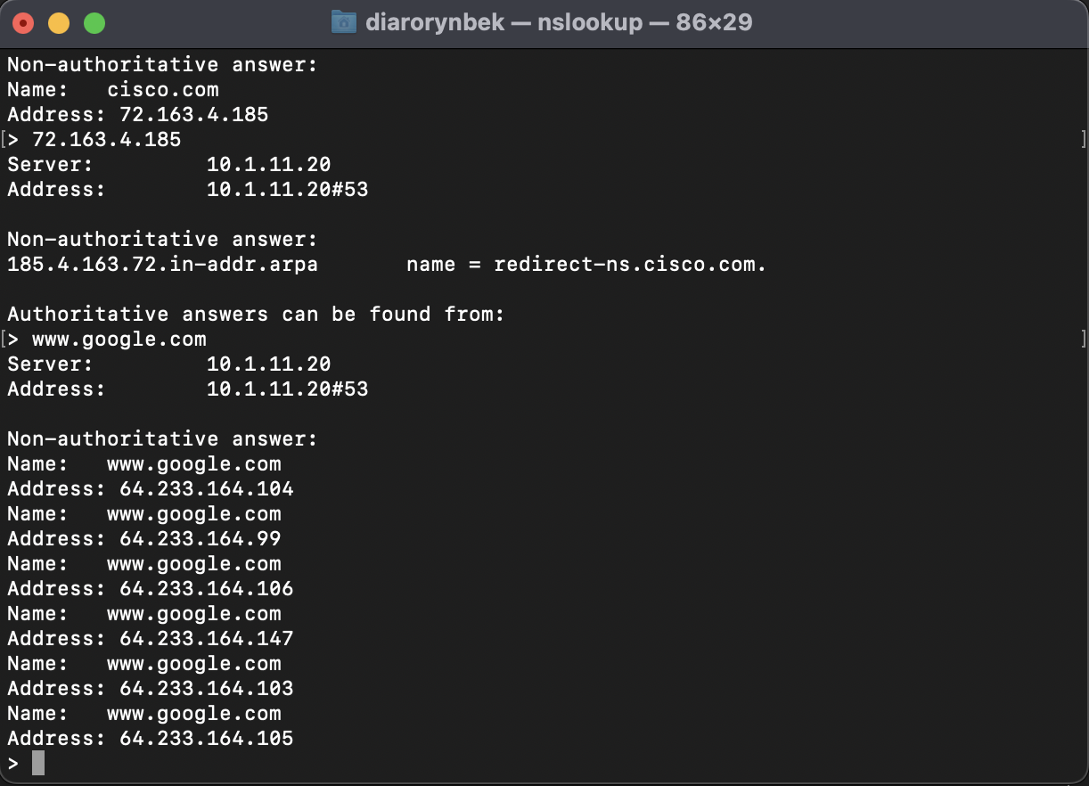

* + - 1. At the nslookup prompt, type the IP address of the Cisco web server that you just found. You can use **nslookup** to get the domain name of an IP address if you do not know the URL.

You can use the **nslookup** tool to translate domain names into IP addresses. You can also use it to translate IP addresses into domain names.

### Question:

Using the **nslookup** tool, record the IP addresses associated with [**www.google.com**](http://www.google.com).

Type your answers here.

## Observe DNS Lookup Using the nslookup Command on Mail Servers

# Reflection Question

What is the fundamental purpose of DNS?

DNS performs the task of converting a domain name to the appropriate IP address by searching DNS records for the requested domain.