Lab - View Network Device MAC Addresses

Topology

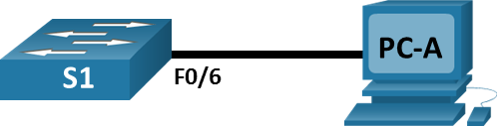

# Addressing Table

| Device | Interface | IP Address | Subnet Mask | Default Gateway |
| --- | --- | --- | --- | --- |
| S1 | VLAN 1 | 192.168.1.2 | 255.255.255.0 | N/A |
| PC-A | NIC | 192.168.1.3 | 255.255.255.0 | 192.168.1.1 |

# Objectives

Part 1: Configure Devices and Verify Connectivity

Part 2: Display, Describe, and Analyze Ethernet MAC Addresses

# Background / Scenario

Every device on an Ethernet LAN is identified by a Layer 2 MAC address. This address is assigned by the manufacturer and stored in the firmware of the NIC. This lab will explore and analyze the components that make up a MAC address, and how you can find this information on a switch and a PC.

You will cable the equipment as shown in the topology. You will configure the switch and PC to match the addressing table. You will verify your configurations by testing for network connectivity.

After the devices have been configured and network connectivity has been verified, you will use various commands to retrieve information from the devices to answer questions about your network equipment.

**Note**: The switches used are Cisco Catalyst 2960s with Cisco IOS Release 15.2(2) (lanbasek9 image). Other switches and Cisco IOS versions can be used. Depending on the model and Cisco IOS version, the commands available and the output produced might vary from what is shown in the labs.

**Note**: Make sure that the switches have been erased and have no startup configurations. If you are unsure, ask your instructor.

# Required Resources

* 1 Switch (Cisco 2960 with Cisco IOS Release 15.2(2) lanbasek9 image or comparable)
* 1 PC (Windows with a terminal emulation program, such as Tera Term)
* Console cable to configure the Cisco switch via the console ports
* Ethernet cables as shown in the topology

# Instructions

## Configure Devices and Verify Connectivity

In this part, you will set up the network topology and configure basic settings, such as the interface IP addresses and device name. For device name and address information, refer to the Topology and Addressing Table.

### Cable the network as shown in the topology.

* + - 1. Attach the devices shown in the topology and cable as necessary.
      2. Power on all the devices in the topology.

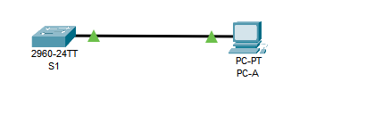

### Configure the IPv4 address for the PC.

* + - 1. Configure the IPv4 address, subnet mask, and default gateway address for PC-A.

* + - 1. From the command prompt on PC-A, ping the switch address.

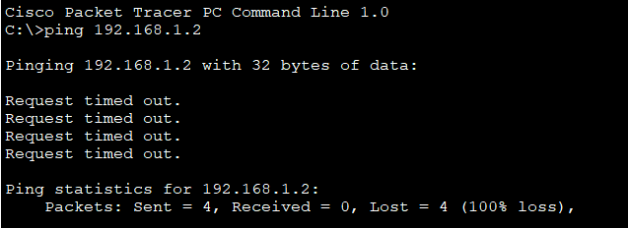

Open a Windows command prompt

#### Question:

Were the pings successful? Explain.

No, because we didn’t configure our switch

### Configure basic settings for the switch.

In this step, you will configure the device name and the IP address, and disable DNS lookup on the switch.

* + - 1. Console into the switch and enter global configuration mode.

Open a configuration window.

Switch> **enable**

Switch# **configure terminal**

Enter configuration commands, one per line. End with CNTL/Z.

Switch(config)#

* + - 1. Assign a hostname to the switch based on the Addressing Table.

Switch(config)# **hostname S1**

* + - 1. Disable DNS lookup.

S1(config)# **no ip domain-lookup**

* + - 1. Configure and enable the SVI interface for VLAN 1.

S1(config)# **interface vlan 1**

S1(config-if)# **ip address 192.168.1.2 255.255.255.0**

S1(config-if)# **no shutdown**

S1(config-if)# **end**

*Mar 1 00:07:59.048: %SYS-5-CONFIG_I: Configured from console by console

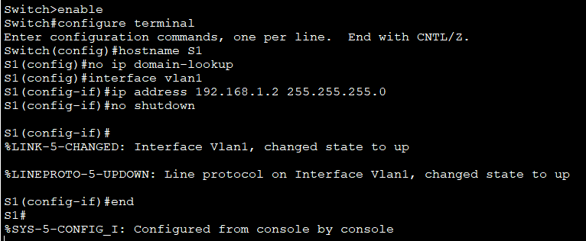

Close a configuration window

### Verify network connectivity.

Open a Windows command prompt.

Ping the switch from PC-A.

#### Question:

Were the pings successful?

Yes

## Display, Describe, and Analyze Ethernet MAC Addresses

Every device on an Ethernet LAN has a MAC address that is assigned by the manufacturer and stored in the firmware of the NIC. Ethernet MAC addresses are 48-bits long. They are displayed using six sets of hexadecimal digits that are usually separated by dashes, colons, or periods. The following example shows the same MAC address using the three different notation methods:

**00-05-9A-3C-78-00 00:05:9A:3C:78:00 0005.9A3C.7800**

**Note**: MAC addresses are also called physical addresses, hardware addresses, or Ethernet hardware addresses.

You will issue commands to display the MAC addresses on a PC and a switch, and analyze the properties of each one.

### Analyze the MAC address for the PC-A NIC.

Before you analyze the MAC address on PC-A, look at an example from a different PC NIC. You can issue the **ipconfig /all** command to view the MAC address of your NIC. An example screen output is shown below. When using the **ipconfig /all** command, notice that MAC addresses are referred to as physical addresses. Reading the MAC address from left to right, the first six hex digits refer to the vendor (manufacturer) of this device. These first six hex digits (3 bytes) are also known as the organizationally unique identifier (OUI). This 3-byte code is assigned to the vendor by the IEEE organization.

To find the manufacturer, use the keywords ***IEEE OUI standards*** to find an OUI lookup tool on the internet or navigate to <http://standards-oui.ieee.org/oui.txt> to find the registered OUI vendor codes. The last six digits are the NIC serial number assigned by the manufacturer.

* + - 1. Using the output from the **ipconfig /all** command, answer the following questions.

C:\> **ipconfig /all**

<output omitted>

Ethernet adapter Ethernet:

Connection-specific DNS Suffix . :

Description . . . . . . . . . . . : Intel(R) 82577LM Gigabit Network Connection

Physical Address. . . . . . . . . : 5C-26-0A-24-2A-60

DHCP Enabled. . . . . . . . . . . : Yes

Autoconfiguration Enabled . . . . : Yes

Link-local IPv6 Address . . . . . : fe80::b875:731b:3c7b:c0b1%10(Preferred)

IPv4 Address. . . . . . . . . . . : 192.168.1.147(Preferred)

Subnet Mask . . . . . . . . . . . : 255.255.255.0

Lease Obtained. . . . . . . . . . : Friday, September 6, 2019 11:08:36 AM

Lease Expires . . . . . . . . . . : Saturday, September 7, 2019 11:08:36 AM

Default Gateway . . . . . . . . . : 192.168.1.1

<output omitted>

#### Questions:

What is the OUI portion of the MAC address for this device?

5c-26-0A

What is the serial number portion of the MAC address for this device?

24-2A-60

Using the example above, find the name of the vendor that manufactured this NIC.

* + - 1. From the command prompt on PC-A, issue the **ipconfig /all** command and identify the OUI portion of the MAC address for the NIC of PC-A.

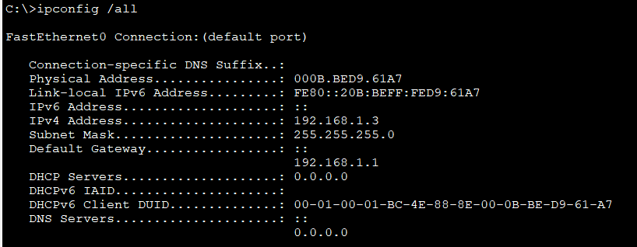

Identify the serial number portion of the MAC address for the NIC of PC-A.

D9-61-A7

Identify the name of the vendor that manufactured the NIC of PC-A.

00-0B-BE

### Analyze the MAC address for the S1 F0/6 interface.

You can use a variety of commands to display MAC addresses on the switch.

* + - 1. Console into S1 and use the **show interfaces vlan 1** command to find the MAC address information. A sample is shown below. Use output generated by your switch to answer the questions.

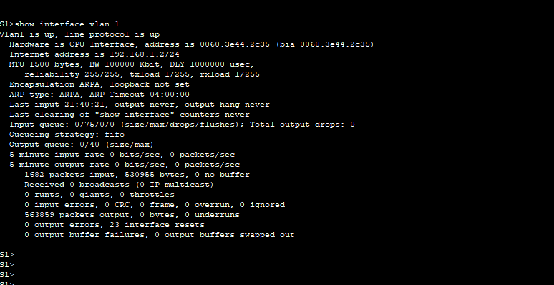

#### Question:

What is the MAC address for VLAN 1 on S1?

0060.3e44.2c35

What is the MAC serial number for VLAN 1?

44.2c35

What is the OUI for VLAN 1?

0060.3e

Based on this OUI, what is the name of the vendor?

Cisco Systems

What does bia stand for?

Burned in address

Why does the output show the same MAC address twice?

The MAC address can be changed via a software command. The actual address will still be there. It is shown in the parenthesis.

* + - 1. Another way to display the MAC address on the switch is to use the **show arp** command. Use the **show arp** command to display MAC address information. This command maps the Layer 2 address to its corresponding Layer 3 address. A sample is shown below. Use output generated by your switch to answer the questions.

What Layer 2 addresses are displayed on S1?

### View the MAC addresses on the switch.

Issue the **show mac address-table** command on S1. A sample is shown below. Use output generated by your switch to answer the questions.

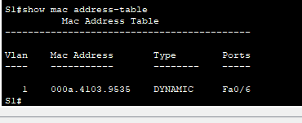

#### Question:

Did the switch display the MAC address of PC-A? If you answered yes, what port was it on?

Yes. Port should be F0/6.

# Reflection Questions

* 1. Can you have broadcasts at the Layer 2 level? If so, what would the MAC address be?
  2. Why would you need to know the MAC address of a device?

End of Document