DATABASE MANAGEMENT CAPSTONE PROJECT REPORT
Flight Reservation System
Submitted in partial fulfilment of the requirement of the degree of
BACHELOR OF TECHNOLOGY in CSE with Specialization Data Science (Section - A)
to

K.R. Mangalam University

by
Aditya Dagar
Roll No: 2501420073
Submission Date: 10 November 2026
Under the supervision of

Dr. Swati Gupta

Department of Computer Science and Engineering, School of Engineering and Technology
K.R. Mangalam University, Gurugram – 122001, Haryana, India

TABLE OF CONTENTS
S.No. | Topic of Content | Section
1 | Abstract | 1.0
2 | Introduction | 2.0
3 | Objectives | 3.0
4 | Problem Statement | 4.0
5 | Database Architecture and Schema Design | 5.0
6 | Tools, Platforms, and Runtime Environment | 6.0
7 | SQL Implementation, Queries, and Execution Evidence | 7.0
8 | Indexing Strategy and Search Optimization (B-Tree vs FULLTEXT) | 8.0
9 | Analytical Window Functions and Preference Modeling | 9.0
10 | Results and Discussion | 10.0
11 | Conclusion | 11.0
12 | References | 12.0

1. ABSTRACT
The Flight Management System is a database management project developed using MySQL. It is designed to store and manage important airline information, including airports, aircraft, flights, passengers, bookings, and payments. The system allows users to search for flights, check seat availability, maintain booking records, and manage payment details. MySQL Workbench is used to create tables, execute SQL queries, and manage the database. This project demonstrates how a relational database can make airline information management more organized, accurate, and efficient.

2. INTRODUCTION
The Flight Management System is developed to manage flight-related information using a computerized database. It helps organize details of flights, airports, aircraft, passengers, and ticket bookings in one place.
The project uses MySQL as its database management system. Different tables are connected through primary keys and foreign keys to maintain relationships between records. SQL queries are used to perform operations such as adding passenger details, searching for flights, checking available seats, managing bookings, and generating payment reports.
This project provides practical knowledge of database creation, SQL commands, and relational database management.

3. OBJECTIVES
The main objectives of the Flight Management System are:
- To develop a database for managing airline information.
- To store and manage airport and aircraft details.
- To maintain passenger information.
- To manage flight schedules and ticket prices.
- To store and track passenger bookings.
- To check available seats on different flights.
- To maintain payment records and payment status.
- To search for flights between different cities.
- To generate booking and revenue reports.
- To understand the practical implementation of SQL and database relationships.

4. PROBLEM STATEMENT
Managing flight information manually can be difficult and time-consuming. It may result in duplicate records, incorrect booking information, difficulty in finding flight details, and problems maintaining passenger and payment records.
The Flight Management System aims to solve these problems by using a centralized MySQL database. It organizes information into separate but connected tables, making it easier to store, update, search, and retrieve records.
The system also helps track seat availability, passenger bookings, and payment information, improving the overall management of airline data.

5. DATABASE ARCHITECTURE AND SCHEMA DESIGN
The Flight Management System uses a relational database named flight_management. It contains six main tables:
1. Airports: Stores airport name, city, country, and airport code.
2. Aircraft: Stores aircraft names and total seating capacity.
3. Flights: Stores flight numbers, source and destination airports, aircraft details, departure time, arrival time, and ticket prices.
4. Passengers: Stores passenger names, email addresses, phone numbers, and passport numbers.
5. Bookings: Stores passenger booking details, flight IDs, seat numbers, booking dates, and booking status.
6. Payments: Stores booking IDs, payment amounts, payment dates, and payment status.
Primary keys are used to uniquely identify records, while foreign keys connect related tables. This structure helps maintain data consistency and reduce unnecessary duplication.

6. TOOLS, PLATFORMS AND RUNTIME ENVIRONMENT
The following tools and technologies were used to develop this project:
- Operating System: Microsoft Windows 11.
- Database Management System: MySQL Server 8.0.46.
- Database Development Tool: MySQL Workbench.
- Query Language: SQL (Structured Query Language).
- Development Environment: MySQL Workbench SQL Editor.
MySQL Server is used to store and manage the database, while MySQL Workbench provides a graphical interface to create tables, execute queries, insert records, and view query results.
7. SQL IMPLEMENTATION, QUERIES AND EXECUTION EVIDENCE
The project was implemented using different SQL commands in MySQL Workbench.
The following operations were performed:
7.1) Database Creation: Created the flight_management database using the CREATE DATABASE command.
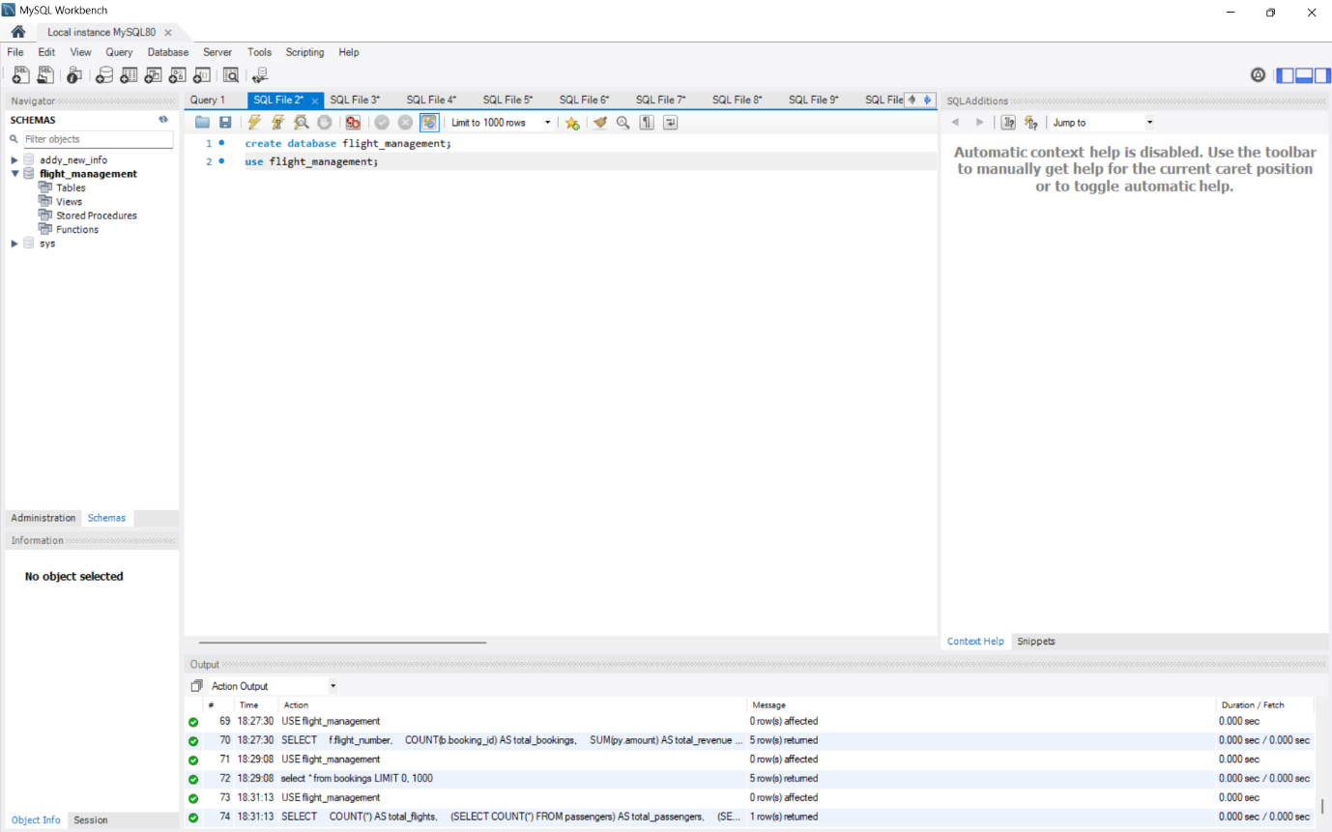

7.2) Table Creation: Created six tables using CREATE TABLE with primary key and foreign key constraint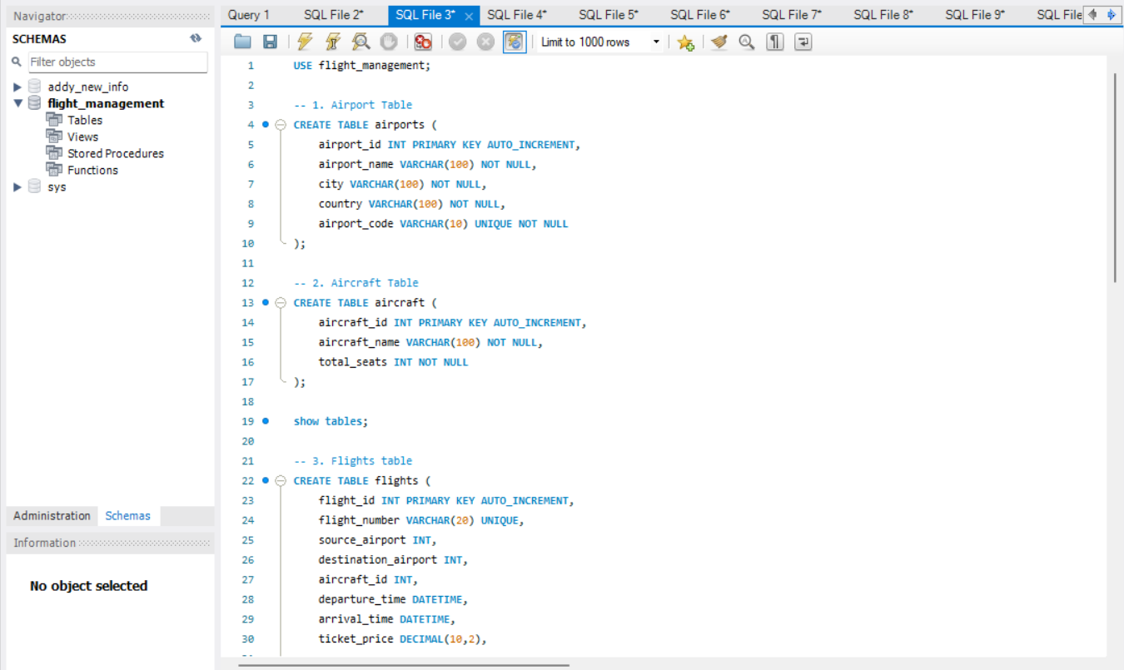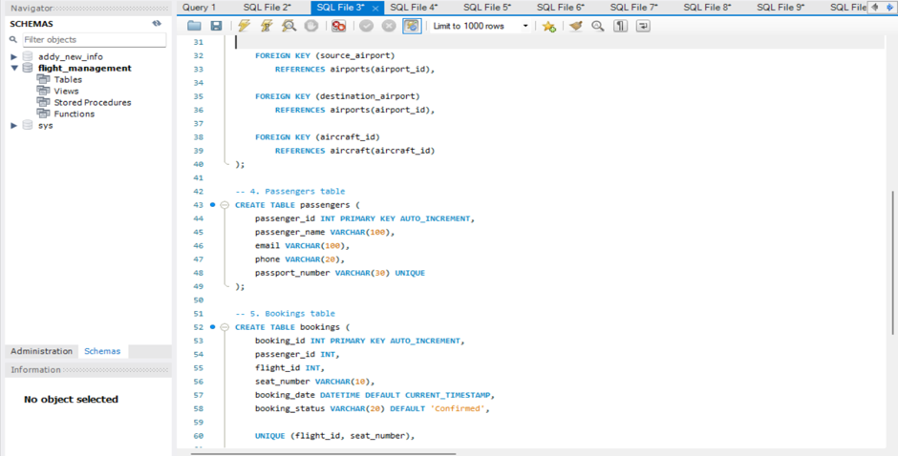 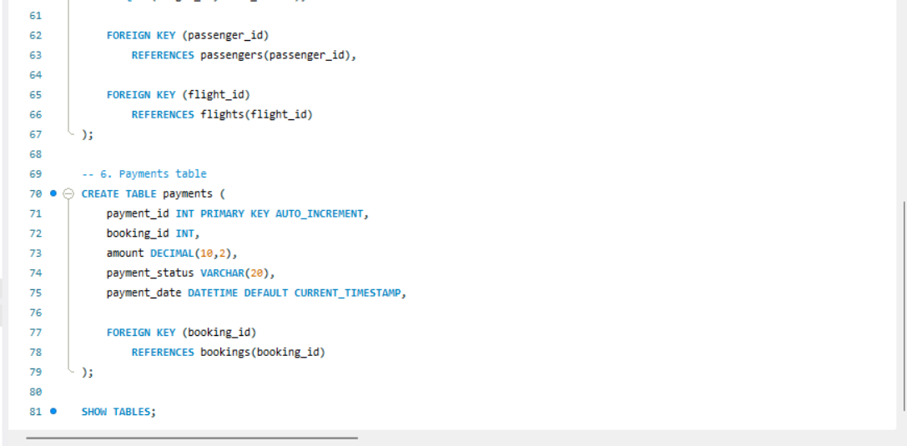

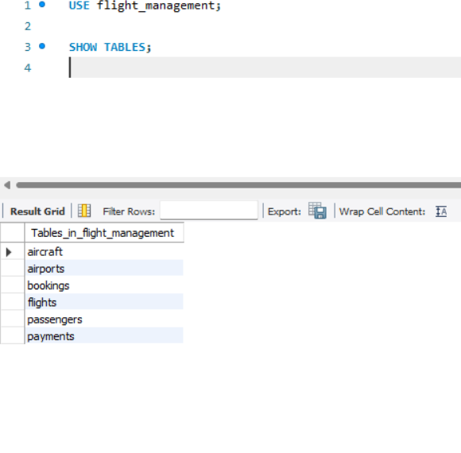

7.3) Data Insertion
The INSERT INTO command was used to insert sample records:
- 5 airport records
- 3 aircraft records
- 5 flight records
- 5 passenger records
- 5 booking records
- 5 payment records
- 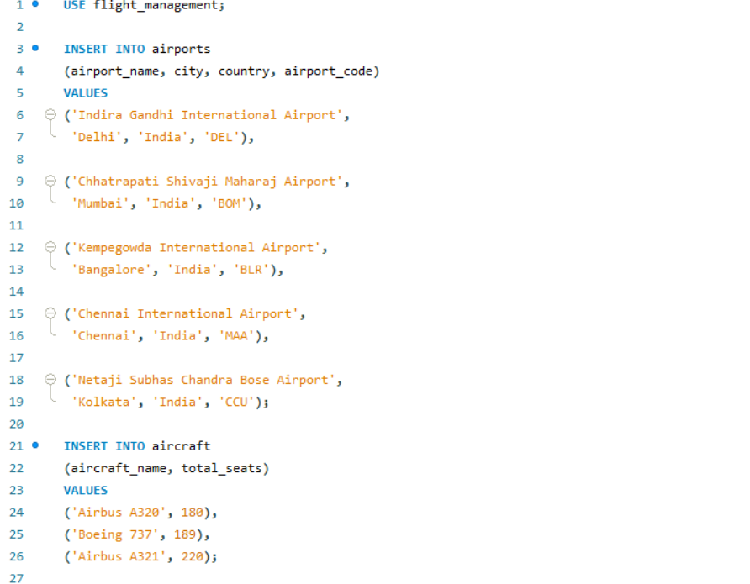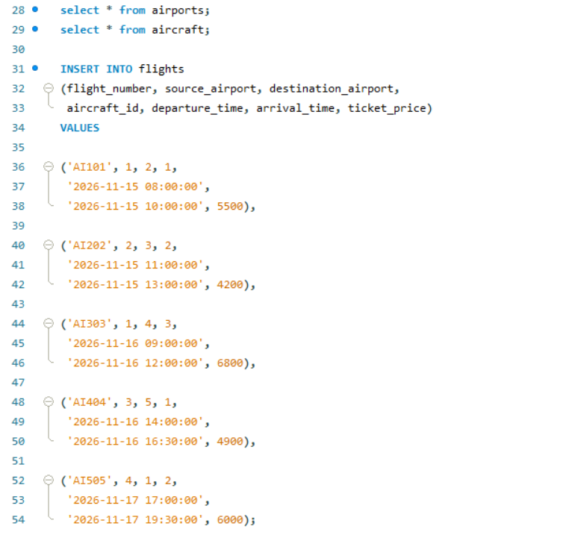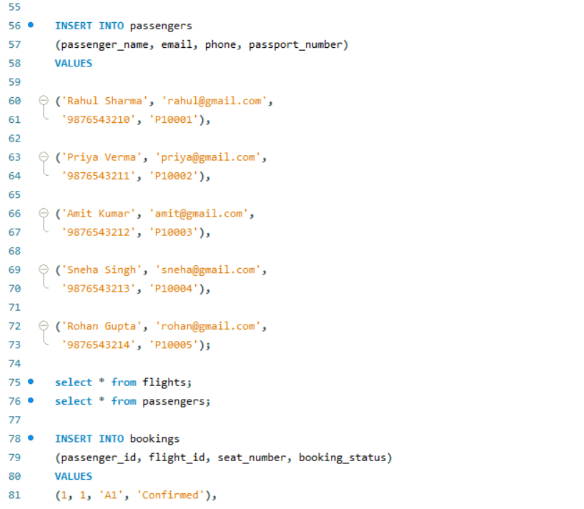
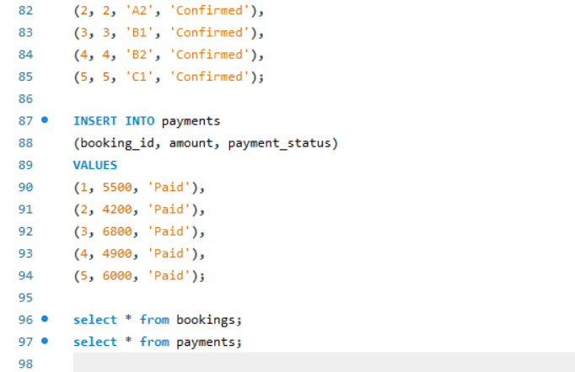
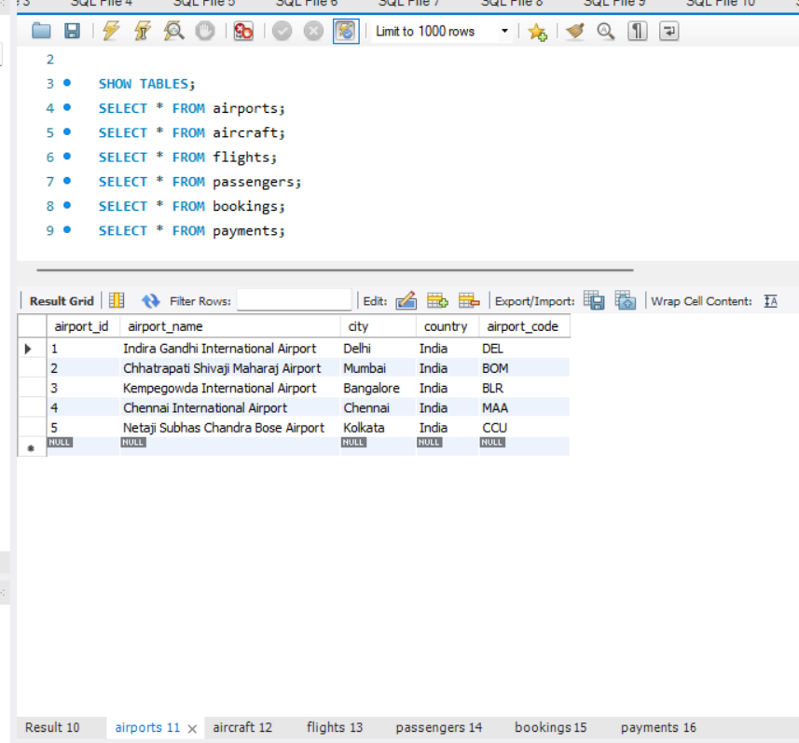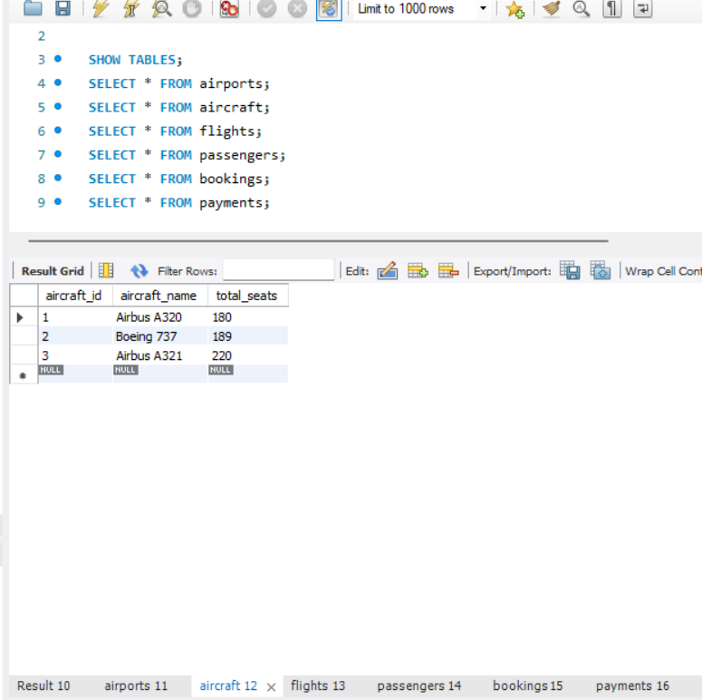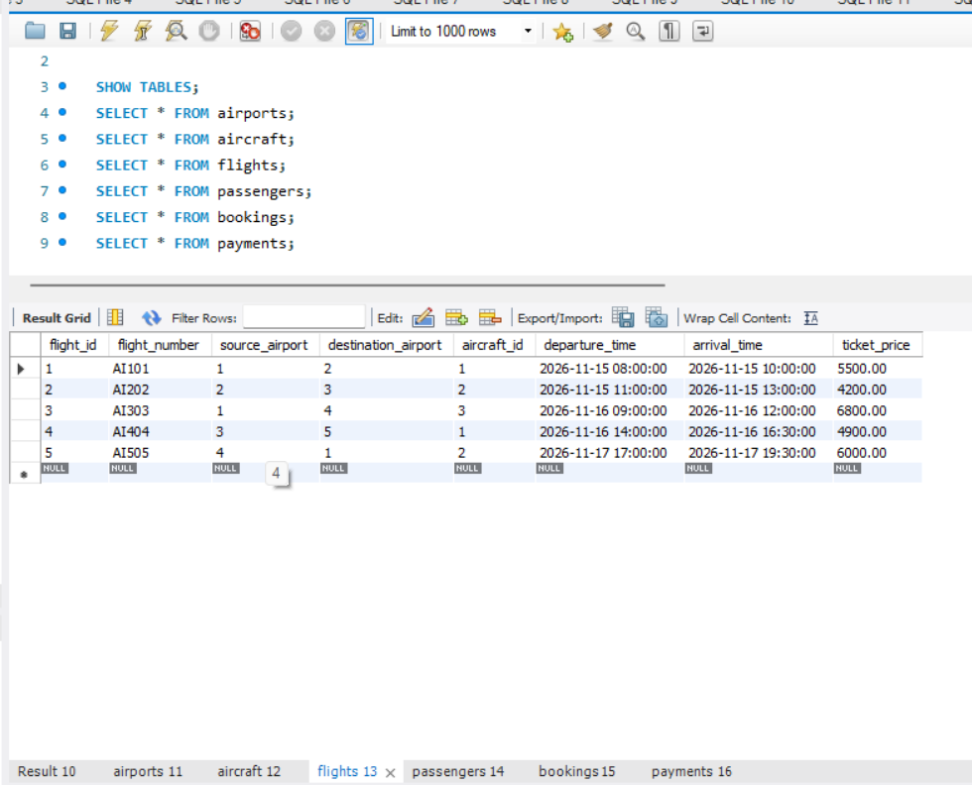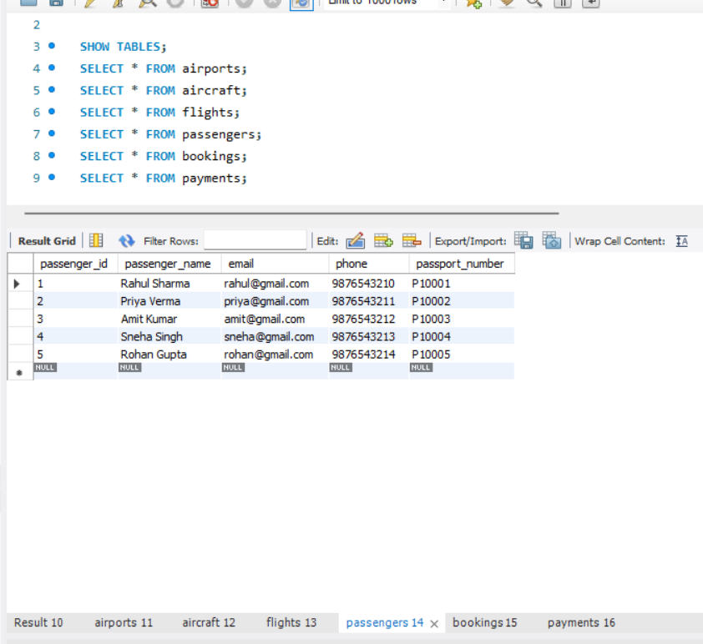

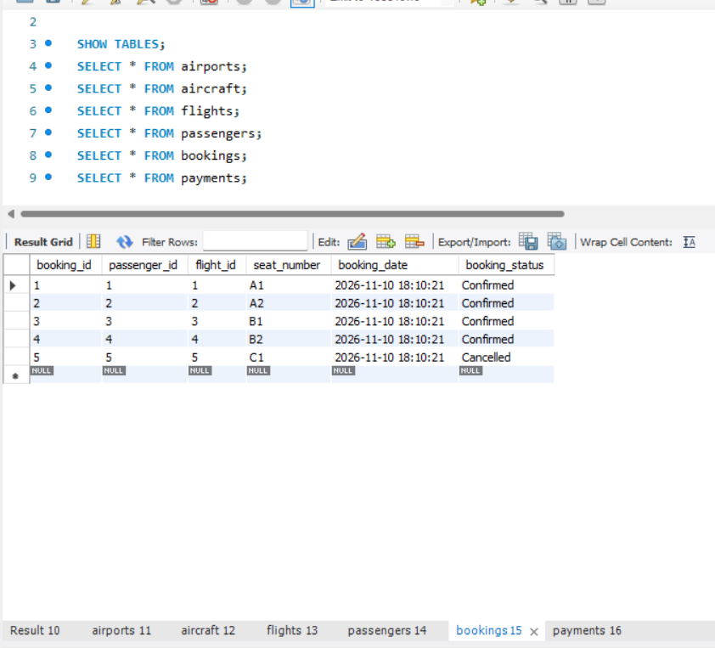

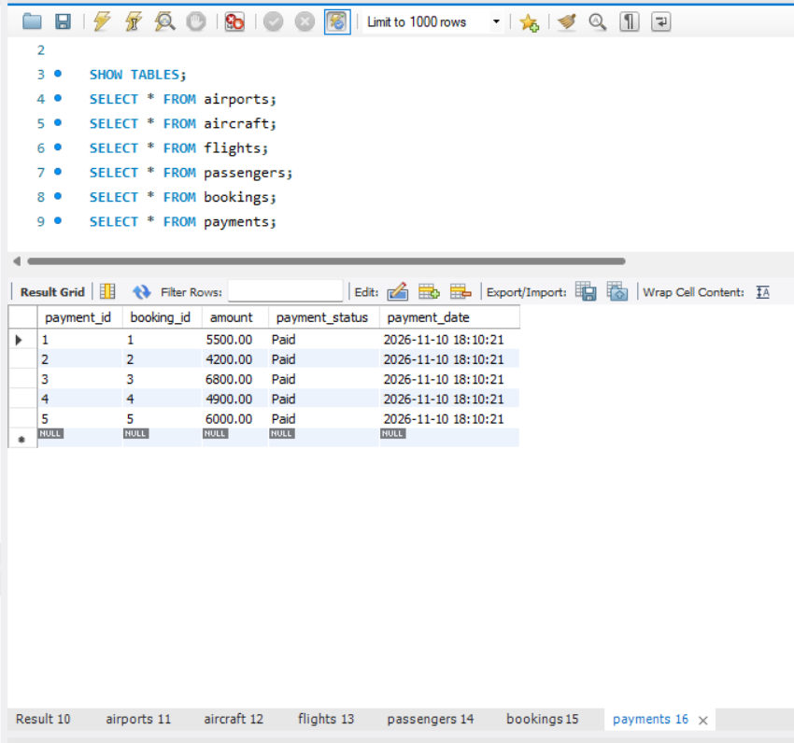
7.4) Flight Search: Used SELECT and JOIN queries to search for flights between cities such as Delhi and Mumbai.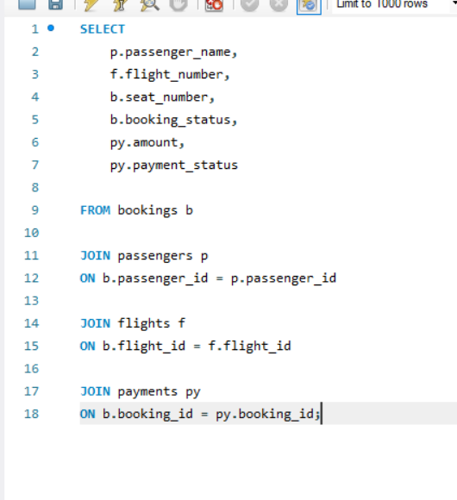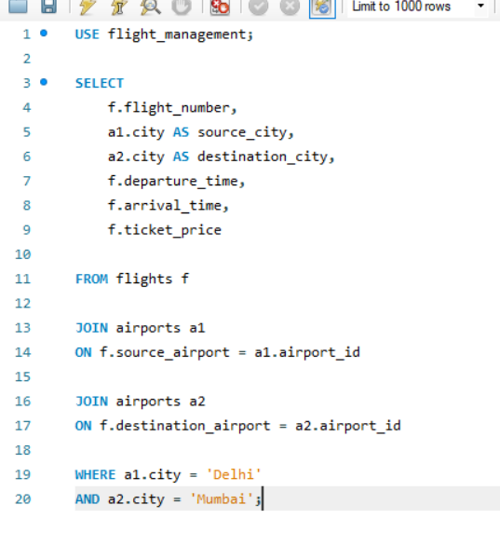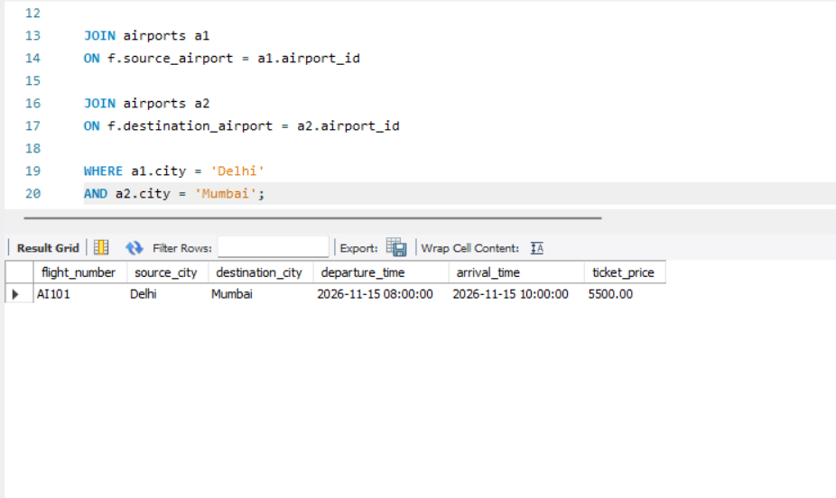

7.5) Seat Availability: Used LEFT JOIN and COUNT functions to calculate booked and available seats for each flight. 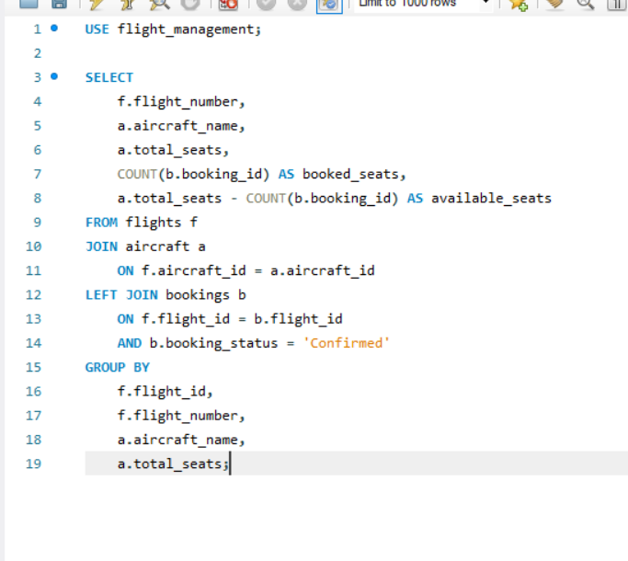 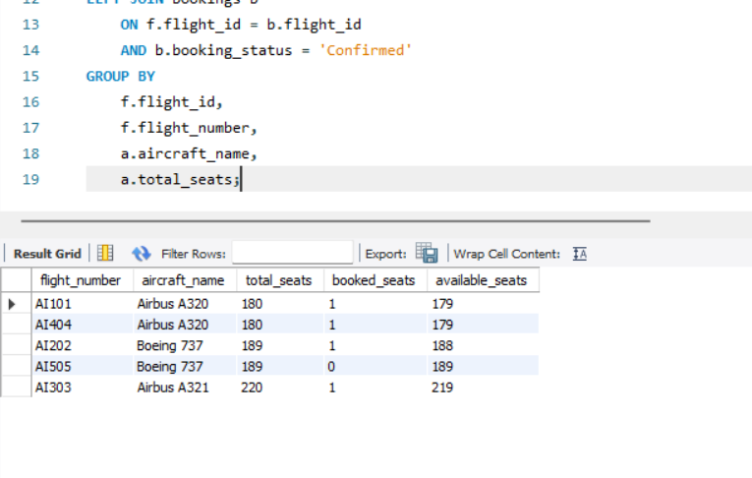
7.6) Search flight by city:
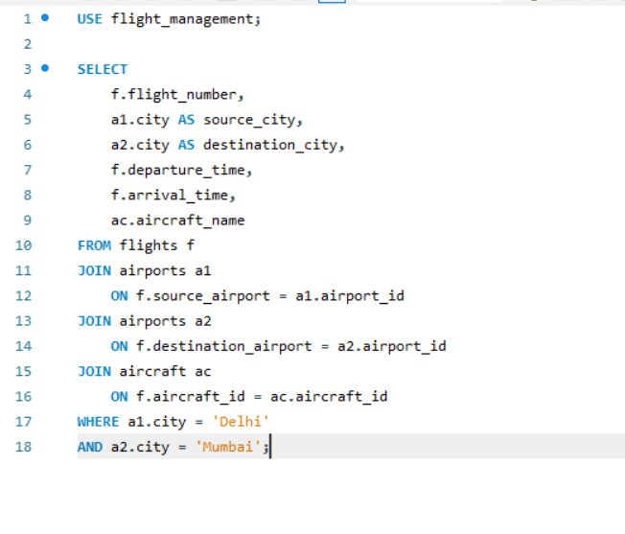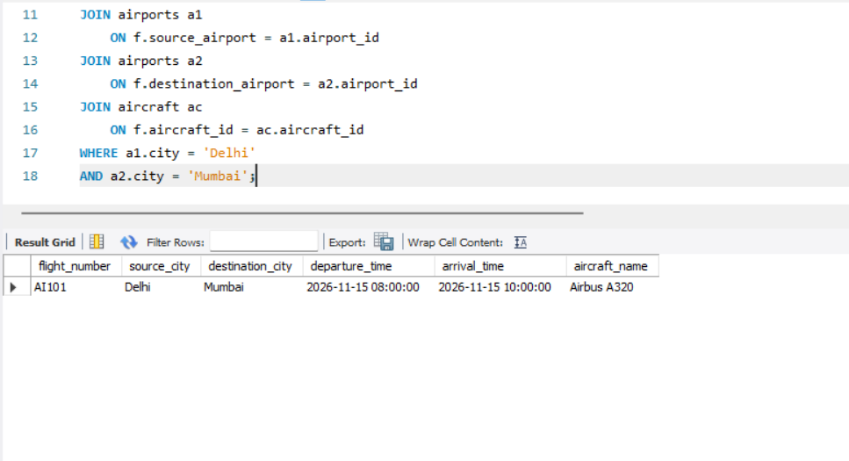

7.7) Passenger Booking Details + Booking Cancellation: Used JOIN queries to display passenger names, flight numbers, seat numbers, booking status with update code for cancellation.
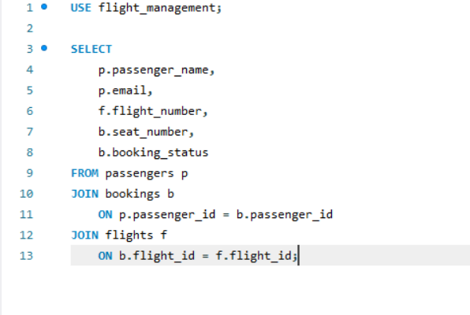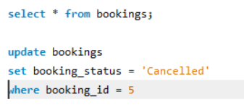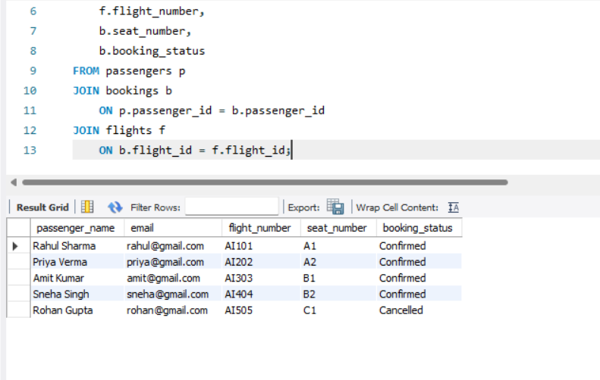
7.8) Payment Management: Retrieved payment details and payment status using SQL queries.

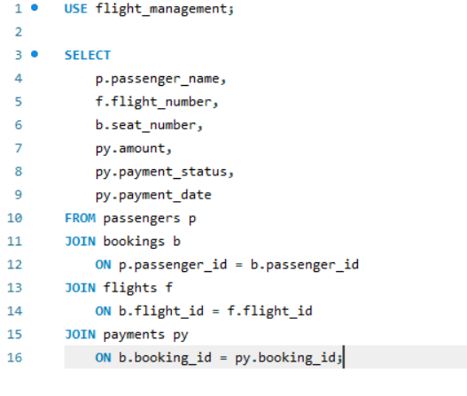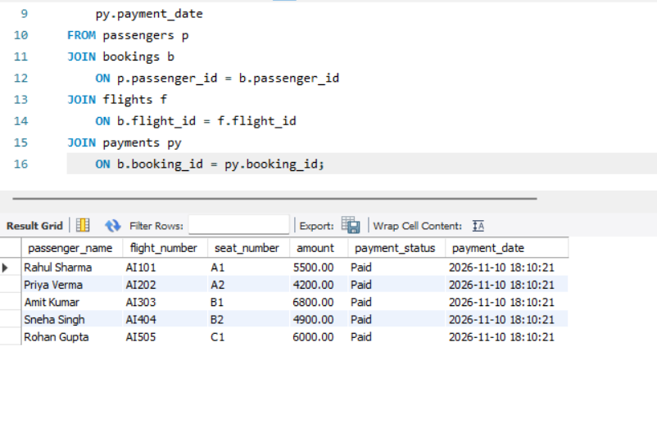

7.9) Revenue Calculation + Revenue Analysis by Flight: Used the SUM() function to calculate total revenue from successful payments.
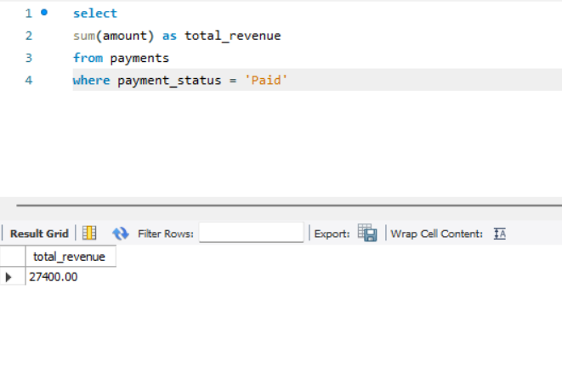

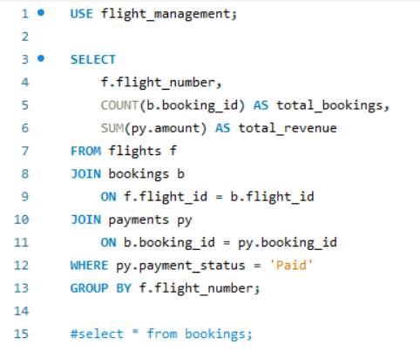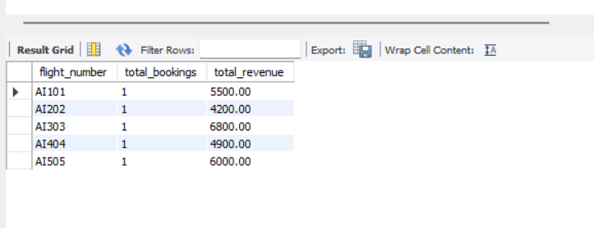
7.10) Dashboard Report: Used COUNT(), SUM(), and subqueries to generate a summary of flights, passengers, bookings, cancellations, and revenue.
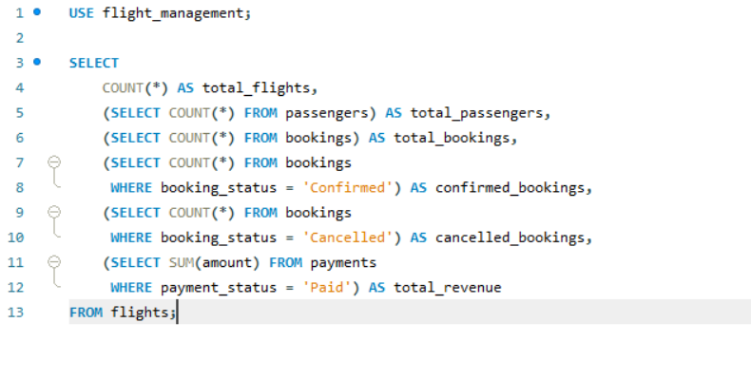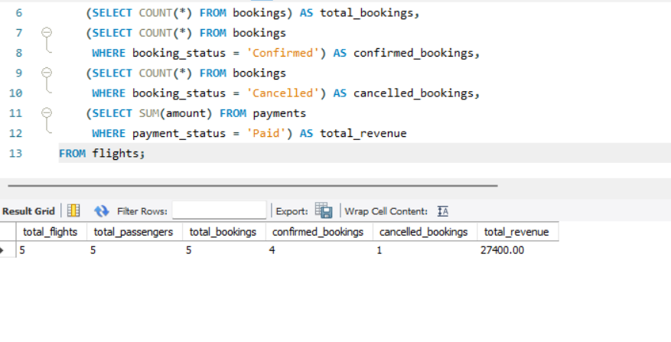

8. Indexing Strategy and Search Optimization (B-Tree vs FULLTEXT)
8.1) Indexing Strategy
Composite indexes are created to improve flight searching and booking lookups.
8.1.1) Before Indexing
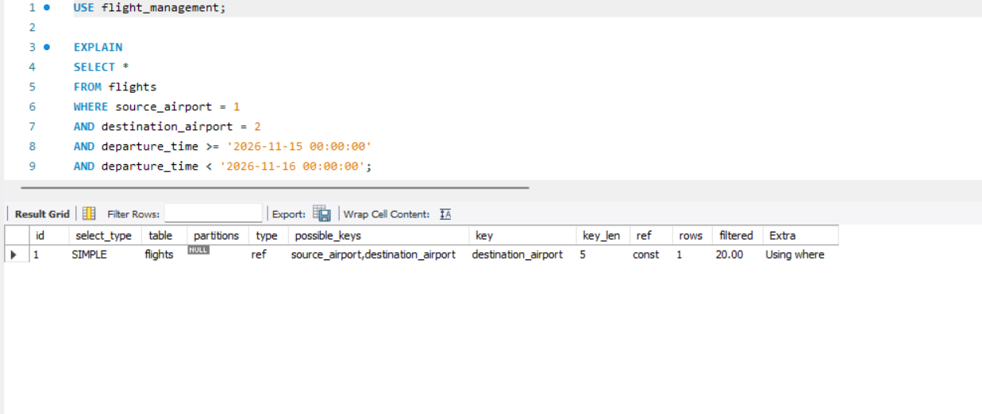

8.1.2) After Indexing
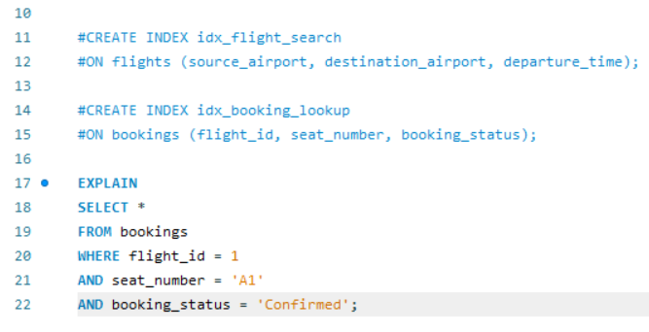
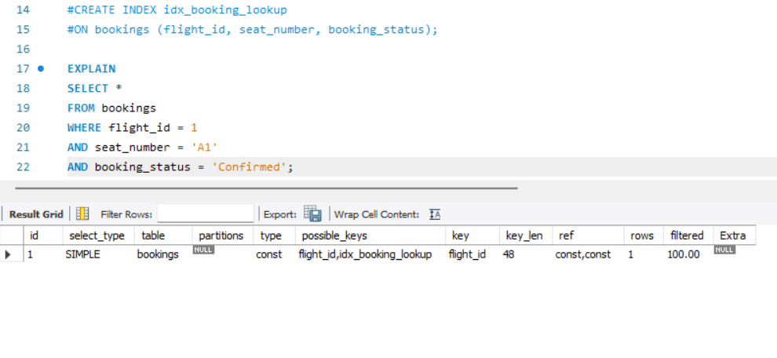
8.2) Why this column order?
- Flight index: source_airport and destination_airport are checked first using equality conditions. departure_time is checked afterward using a date range.
- Booking index: flight_id and seat_number are checked first using equality conditions, followed by booking_status.

8.3) Query where the index may not be used
EXAMPLE:- EXPLAIN
SELECT *
FROM flights
WHERE YEAR(departure_time) = 2026;
The index may not be used efficiently because the YEAR() function is applied to the indexed column.

8.4) Result and Discussion
Composite indexes were created on the flights and bookings tables to improve search performance. The EXPLAIN command was used to compare query execution plans before and after indexing. The column order was selected based on equality and range conditions. Applying functions to indexed columns, such as YEAR(), can prevent efficient index usage.

9). Analytical Window Functions and Preference Modeling
Window functions such as ROW_NUMBER(), RANK(), and SUM() OVER() help analyze flight and booking data. Passenger preferences can be studied using booking history and frequently selected routes.

10). Results and Discussion
The project successfully stores and manages flight, airport, aircraft, passenger, booking, and payment details. SQL queries retrieve flight information, check seat availability, display booking records, and calculate total revenue.

11) Conclusion
The Flight Management System provides an organized way to manage airline information using MySQL. It reduces manual work and makes searching, booking, and managing records easier.

12) References
- MySQL Official Documentation – https://dev.mysql.com/doc/
- MySQL Workbench Documentation – https://dev.mysql.com/doc/workbench/en/
- W3Schools SQL Tutorial – https://www.w3schools.com/sql/
- Class notes and practical lab materials.

