Island Hopper

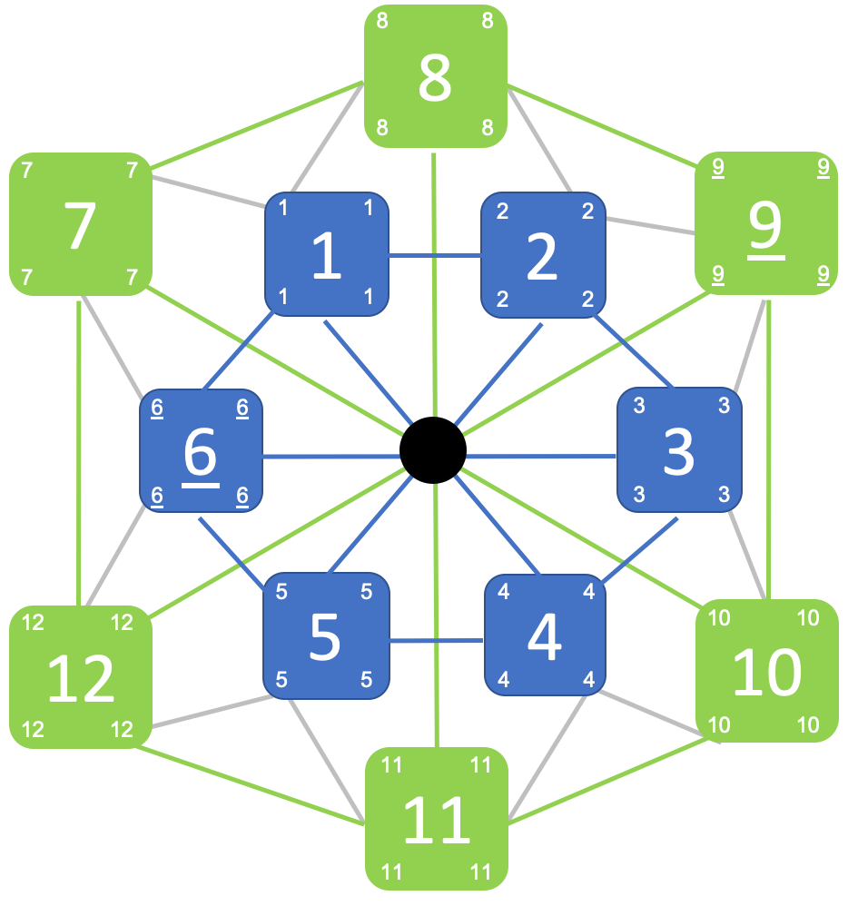

David Garber

GAME 601 Game Design

October 18th, 2020

**Abstract**

Island Hopper is a game of conquest! Outmaneuver your opponent’s Kings through Exploration, Development, and War. Leave behind Garrisons to hold territory as you continue your march towards victory.

**Setup**

* Use the smaller inner board (six islands) for a 2-player game, and the larger board (twelve islands) for a 3 or 4-player game.
* Place the Kings:
  + Islands #1 and #4 for a 2-player game
  + Islands #7, #9 and #11 for a 3-player game
  + Islands #1, #4, #9 and #12 for a 4-player game
* Add Garrisons to each player’s armory:
  + 3 Garrisons each for a 2-player game
  + 4 Garrisons each for a 3 or 4-player game
* Assign each King a starting health score of 3

**Game Rules**

1. Give one player the Start Turn token. Each turn, the player with the token will move first with play continuing clockwise. The Start Turn token passes to the next player (clockwise) at the end of the turn.
2. To begin the turn, all players roll a die simultaneously: use six-sided dice for 2-player games and twelve-sided dice for 3 or 4-player games.
3. **The number rolled determines each player’s course of action**:
   * ***Develop***: if the number rolled is an Island currently occupied by your King or an existing Garrison, increase the health of your King/Garrison by +1. The maximum health of a King or Garrison is 6.
   * ***Explore*:** if the number rolled is an UNOCCUPIED Island adjacent to your King’s current position, move your King to that new Island. Leave behind a Garrison if desired, subtracting the selected health of the Garrison from your King’s health.
   * ***War***: if the number rolled is an OCCUPIED Island adjacent to your King’s current position, go to war! If occupied by a King, reduce the health of both Kings by -1 and do not move (unless the opposing King is reduced to 0 health and removed from play). If occupied by an opposing Garrison, subtract the Garrison’s health from your King’s health and move to the new island, removing the Garrison from play (unless your King is reduced to 0 health and removed from play instead).
   * ***Free move***: If the number rolled is an Island non-adjacent to your King and not occupied by any of your Garrisons, you may choose to ***Develop*** and increase the health of either your King or an existing Garrison by +1. If your King’s health is already at maximum (6), you may alternatively choose to execute a ***Free Move***: your King may ***Explore*** or go to ***War*** with any adjacent Island, or you may instead choose to move the Robber to any Island not occupied by a King (or back to the center of the board).
     1. If placed on an Island with an existing Garrison, the Robber immediately reduces the Garrison’s health by -1, and continues to reduce its health by -1 at the end of each subsequent turn until the Robber is moved to a new location.
     2. You may alternatively use your ***Free Move*** to move your King to the center of the board (as long as the Robber is not there). The center of the board is not an Island and cannot be Garrisoned, however it may be useful in a case where your King becomes trapped by adjacent Garrisons.
4. The Robber functions as an additional King and can never share an Island with another King. Treat as ***War*** any attempt to move onto an Island occupied by the Robber, and thus reduce the health of an attacking King by -1 (even in the case when the Robber is occupying an Island with an existing Garrison on it). While placed in the center of the board, the Robber prevents all movement along the intersecting paths. Treat all such moves as ***War*** resulting in -1 health for the attacking King.
5. A Player whose King is eliminated from the board continues to participate in the game. Have them roll their die at the start of each turn, and obey turn order. They do nothing unless:
   * The number rolled is an Island occupied by one of their remaining Garrisons – ***Develop*** the Garrison by adding +1 health.
   * The number rolled is an Island occupied by the Robber – execute a ***Free Move*** by moving the Robber to a new location.
6. **Victory Conditions.** A Player wins by doing either of the following:

* Placing all of the Garrison’s from their Armory onto the board. The first Player to place them all wins and the game immediately ends!
* Being the last Player left standing – again, the game ends immediately when the second-to-last King is removed.

**Gameplay Example**

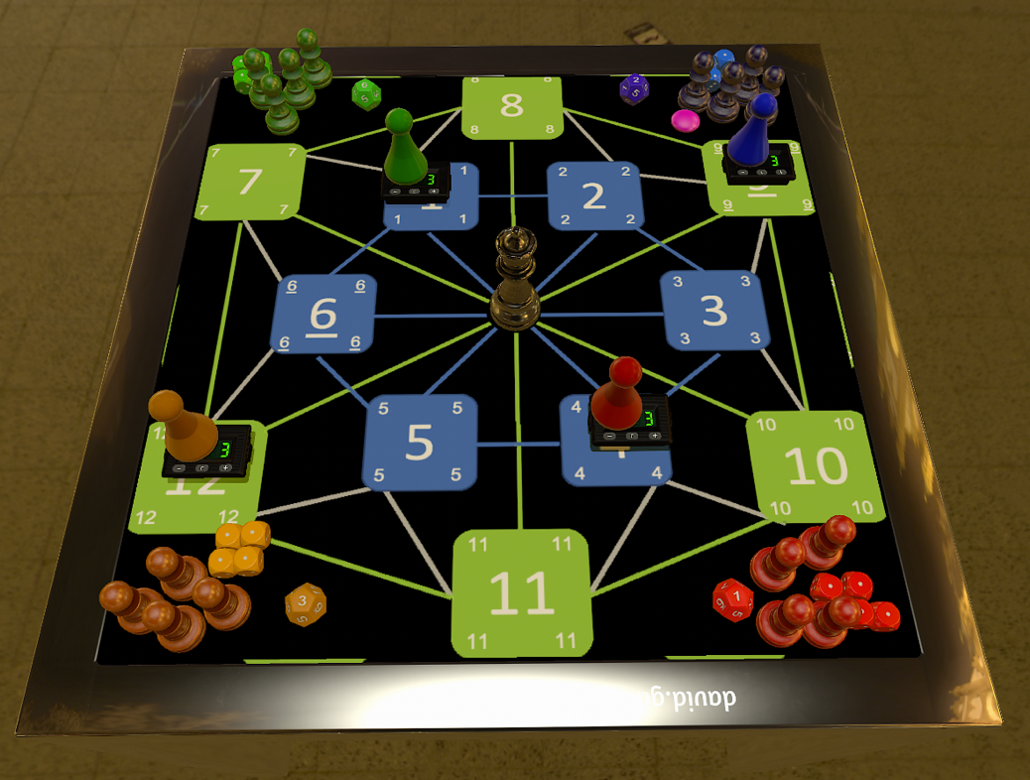

The example above is shown at the start of the first turn of a 4-player game, just after the dice have been rolled.

1. The Blue player has the Start Turn (round pink) token and goes first. Their roll of 2 means that the King must ***Explore*** and move to the adjacent Island #2. The Blue player may also leave behind a Garrison on Island #9 with a health of either 1 or 2 (subtracting that value from the King’s health).
2. The Red player goes next. Their roll of 1 would normally result in ***War*** with the Green King on Island #1 (and -1 health for both Kings), however the presence of the Robber in the middle of the board means that only the Red King suffers -1 health.
3. The Orange player goes next. Their roll of 3 is for a non-adjacent island, and so they must ***Develop*** either the King or an existing Garrison. Since they have no Garrisons, increase the Orange King’s health by +1.
4. The Green player goes last; their roll of 6 (an adjacent Island) means that the King must ***Explore*** and optionally leave behind a Garrison on Island #1.