Rock-Paper-Scissors-*Gun-Bomb*

*Version 2*

David Garber

GAME 601 Game Design

September 6th, 2020

**Abstract**

The classic game of “Rock-Paper-Scissors” has been upgraded with 2 exciting new additions: “Gun-Bomb”! The two new entries create a myriad of possibilities that will have your mind and heart racing… as you face your opponent and count off, “Rock-Paper-Scissors-Shoot!”

**Game Rules**

1. Two players face one another, each holding a closed fist in front of them.
2. The players count off in unison, “Rock-Paper-Scissors” while striking the closed fist into the open palm of their other hand.
3. One final time, the hand is lowered while shouting, “Shoot!” in unison. Each player “shoots” their chosen symbol by choosing from one of the following:
   * Paper – flat hand
   * Scissors – two fingers (pointer and middle) separated by a gap
   * Rock – closed fist
   * Gun – pointer finger extended, thumb raised
   * Bomb – closed fist with thumb raised
4. The winning symbol is based on the following chart:

|  |  |  |
| --- | --- | --- |
|  | Beats: | Is Beaten By: |
| **Paper** | Rock, Bomb | Scissors, Gun |
| **Scissors** | Paper, Bomb | Rock, Gun |
| **Rock** | Scissors, Gun | Paper, Bomb |
| **Gun** | Paper, Scissors | Rock, Bomb |
| **Bomb** | Rock, Gun | Paper, Scissors |

1. To claim their victory, the winning player should make the corresponding sound effect while acting out the victorious action: Bomb exploding Rock (“boom!”), Gun shooting Paper (“pwew!”), Scissors snipping Bomb (“snip!”), Paper covering Rock (“crunch-crunch!”), Rock smashing Gun (“pow!”), etc.
2. To increase the strategic level of the game, ***a player may not play the same symbol twice in a row.***

**Gameplay Examples**

1. Gun defeats Paper (in Step 4 of Game Rules):

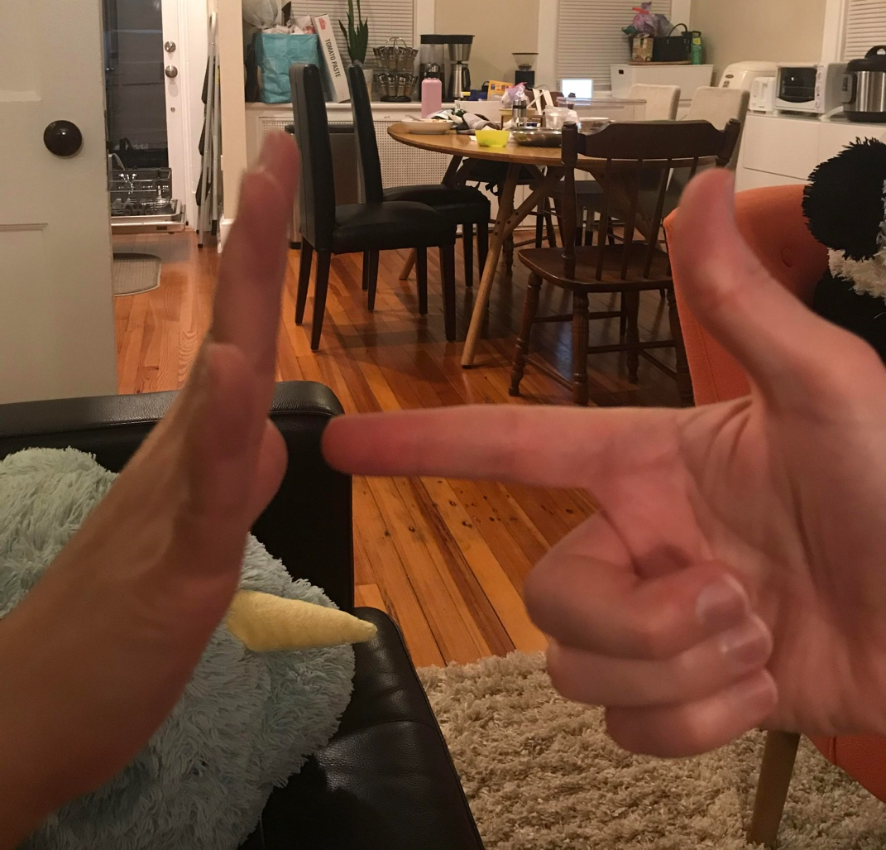

The player on the left may not play Paper for the next round, while the player on the right may not play Gun on the next round.

1. Scissors defeats Bomb (in Step 4 of Game Rules):

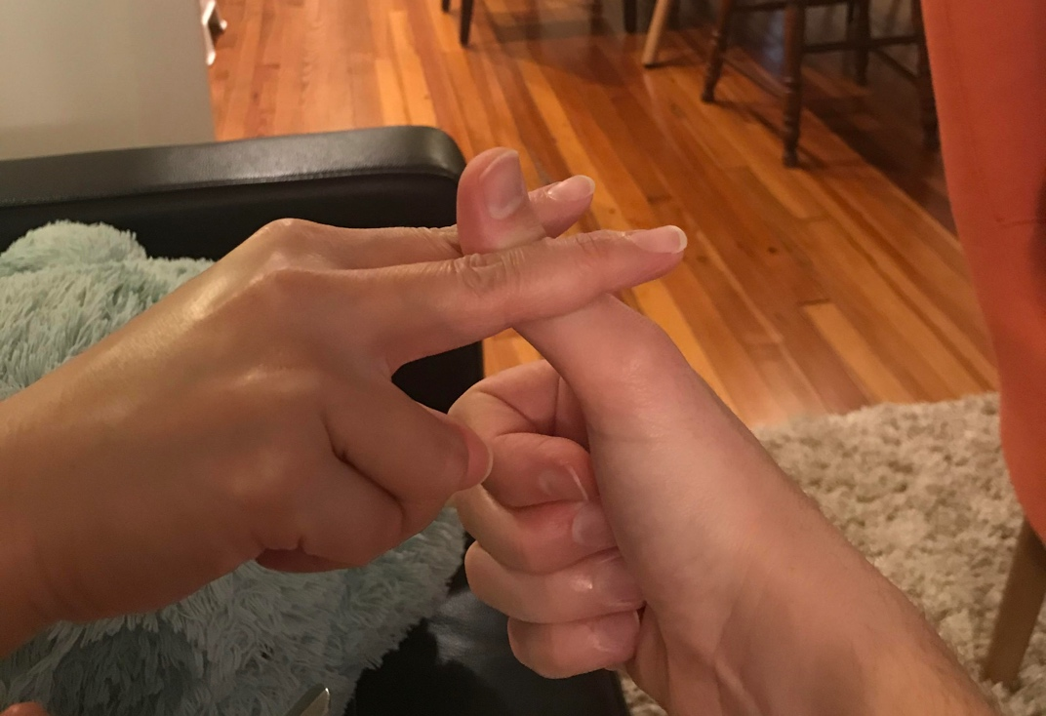

The player on the left may not play Scissors for the next round, while the player on the right may not play Bomb on the next round.

**Tabletop Simulator**

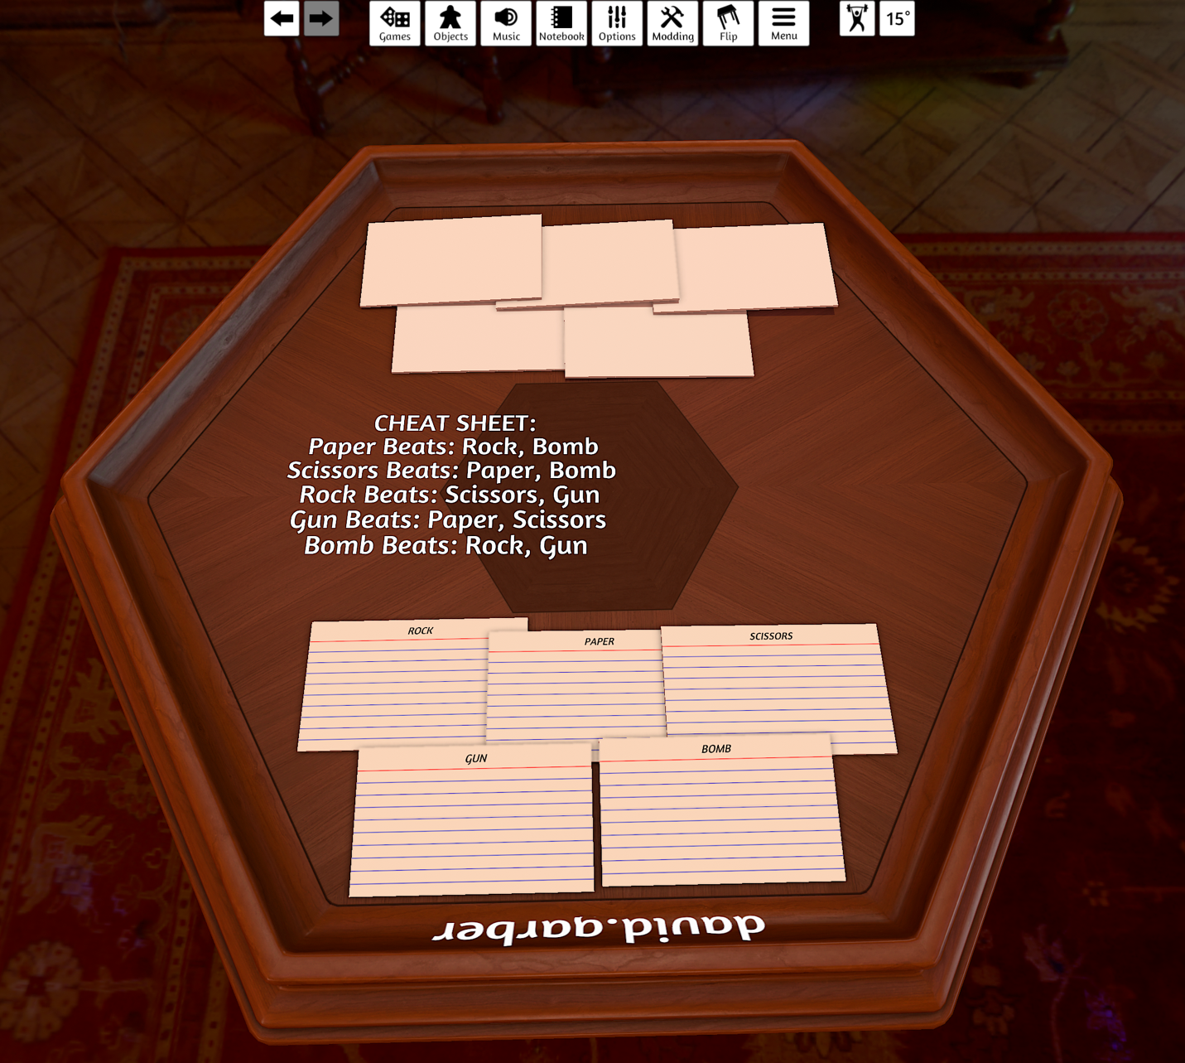

**Game Design Process**

The normal version of Rock-Paper-Scissors involves *blind decisions*, where the player does not have enough information to make a meaningful choice of what symbol to shoot. The only available information is the psycho-analysis that one can make of the other player, rationalizing their thought process as to which symbol they will shoot next based on an established pattern of previous choices.

By carrying-over information from the previous round, the player now has additional information on which to base their decision of the symbol to shoot. This is still not *complete information*, which would ruin the fun of the game and result in a meaningless decision.

The relative value of each symbol is affected in the subsequent round, as represented in the following example.

Example:

**Player1 previous round: Paper**

**Player2 previous round: Rock**

**Player1 next round:**

|  |  |  |
| --- | --- | --- |
|  | Beats: | Is Beaten By: |
| **~~Paper~~** | ~~Rock, Bomb~~ | ~~Scissors, Gun~~ |
| **Scissors** | Paper, Bomb | ~~Rock~~, Gun |
| **Rock** | Scissors, Gun | Paper, Bomb |
| **Gun** | Paper, Scissors | ~~Rock~~, Bomb |
| **Bomb** | Rock, Gun | Paper, Scissors |

**Player2 next round:**

|  |  |  |
| --- | --- | --- |
|  | Beats: | Is Beaten By: |
| **Paper** | Rock, Bomb | Scissors, Gun |
| **Scissors** | Paper, Bomb | Rock, Gun |
| **~~Rock~~** | ~~Scissors, Gun~~ | ~~Paper, Bomb~~ |
| **Gun** | Paper, Scissors | Rock, Bomb |
| **Bomb** | Rock, Gun | ~~Paper~~, Scissors |

Player1 knows that Player2 cannot play Rock, thus the obvious choices to play would be either **Scissors** or **Gun** (which can now each only be defeated by 1 of the remaining choices available to Player2, rather than 2).

Player2 knows that Player1 cannot play Paper, thus the obvious choice to play would be **Bomb** (Rock is not available since it was played by Player2 in the previous round). However, since Player1 may already be motivated to play Scissors due to the elimination of Rock, Player2 may be inclined to make a different choice, perhaps **Gun** (which would defeat Scissors and also be a safe choice against Player1’s other preferred option of Gun)!

**Variations**

If 3 players are present, all 3 may “Shoot” simultaneously. A round is completed when one player defeats both of the other players based on their chosen symbol. In addition, a single player may be eliminated if they are beaten by both of the opposing players, who then “shoot” against one another to determine a winner for the round.