Project Report: Theme Park Simulation

Name: Dayyaan Mohamed

Student Number: 23549654

Date: 18/10/2025

# Overview

This program is a simulation of a theme park containing 4 different types of rides. This program can handle a minimum of 2 and a maximum of 6 rides, and a minimum of 20 and a maximum of 60 patrons. The main file to run this program is “main.py”. There are 2 modes to run this program, an interactive mode and a batch mode. Interactive mode allows the user to put their inputs while the main file is running. Batch mode allows the user to put their inputs in a csv file, and the program would read the csv file and run the simulation.

When the simulation starts patrons would all spawn in the same location and randomly seek out rides. Object collision is also implemented to prevent/minimise patrons going through objects. When a patron reaches their ride, they would all stay in a queue until the ride has reached a certain amount of people. An animation will play when the ride starts and would stop when its end and the patrons would leave the ride and seek out new rides. A day night-cycle exists and the simulation and once it reaches nighttime, patrons would head to an exit position and start de-spawning.

User Guide

**Python Packages Needed**

* NumPy
* Matplotlib.pyplot
* matplotlib.img
* maplotlib.patches
* Csv
* Random
* Sys

**Import files Needed**

* Pirate.py
* HotAirBalloon.py
* Person.py
* FerrisWheel.py
* MerryGoRound.py
* Ride.py

There are 2 modes to run the program:

* Interactive mode – type “python3 main.py -i” in the terminal
* Batch mode – type “python3 main.py -f {name of csv file}” in the terminal

**Interactive mode**

In interactive mode users are asked how many rides they want (2-6) and they would be able to select which rides they want (Pirate Ship, Hot Air Balloon, Ferris Wheel). They can choose what colours they want the ride or their frames to be. For Ferris wheel they can choose the number of cubicles they want (4-8).

**Batch Mode**

In batch mode they must input the number rides for each type they want and the number of people they want to simulate. Colour selection and number of cubicles is not available in batch mode.

Traceability Matrix

|  |  |  |  |  |
| --- | --- | --- | --- | --- |
| Feature | Code Reference | Test Reference | Status | Date Completed |
| 1.0 Ride | | | | |
| 1.01 Initializing Rides | Line 2 – 11 in Ride.py  (Initializing) Inherits in ride related classes. | Tested based on inheritance via test_Ferriswheel.py, test_HotAirBalloon.py | P | 4/10/25 |
| 1.02 Collision | Line 13 – 15 in Ride.py | Tested in test_person.py | P | 11/10/25 |
| 1.03 Insert Person to ride | Line 17-19 In Ride.py | Passed- People get inserted into rides | P | 12/10/25 |
| 1.04 Insert Person to queue | Line 25-31 in Ride.py | Passed – people get inserted into queues | P | 12/10/25 |
| 1.05 Remove Person from queue | Line 32 – 34 in Ride.py | Passed – people get removed from queues | P | 12/10/25 |
| 1.06 Remove Person  From Ride | Line 35 -37 | Passed – people are removed from rides | P | 12/10/25 |
| 1.1 Ferris Wheel | | | | |
| 1.11 Initializing Rides | Line 5 -44 in FerrisWheel.py | Tested in test_FerrisWheel.py | P | 4/10/25 |
| 1.12 Plotting | Line 46 – 66 in FerrisWheel.py | Tested in FerrisWheel.py | P | 4/10/25 |
| 1.13 Step Change | Line 67 – 92 in Ferriswheel.py | Tested in test_FerrisWheel.py | P | 4/10/25 |
| 1.2 Pirate | | | | |
| 1.21 Initializing Rides | Line 6 -32 in Pirate.py | Tested in Test_pirate.py | P | 4/10/25 |
| 1.22 Plotting | Line 34-43 in Pirate.py | Tested in Test_pirate.py | P | 4/10/25 |
| 1.23 Step Change | Line 48-97 in Pirate.py | Tested in Test_pirate.py | P | 4/10/25 |
| 1.3 Hot Air Balloon | | | | |
| 1.31 Initializing Rides | Line 4 – 38 in HotAirBalloon.py | Tested in test_hotairballoon.py | P | 8/10/25 |
| 1.32 Plotting | Line 40-50 in HotAirBalloon.py | Tested in test_hotairballoon.py | P | 8/10/25 |
| 1.33 Step Change | Line 53-68 in HotAirBalloon.py | Tested in test_hotairballoon.py | P | 8/10/25 |
| 1.4 Merry Go Round | | | | |
| 1.41 Initializing Rides | Line 5-42 in MerryGoRound.py | Tested in testMerryGoRound.py | P | 8/10/25 |
| 1.42 Plotting | Line 44 – 61 in MerryGoRound.py | Tested in test_MerryGoRound.py | P | 8/10/25 |
| 1.43 Step Change | Line 64-87 in MerryGoRound.py | Tested in test_MerryGoRound.py | P | 8/10/25 |
| 2.0 People | | | | |
| 2.1 Initializing People | Line 3-12 in person.py | Tested in test_person.py | P | 11/10/25 |
| 2.2 Step Change | Line 14-20 in person.py Collision detection in Class Ride is involved | Tested in test_person.py | P | 11/10/25 |
| 2.3 Go to exit | Line 77 -88 in person.py Collision detection in Class Ride is involved | Passed - people head towards the exit when its nighttime | P | 16/10/25 |
| 3.0 Interactive mode | | | | |
| 3.1 Accepts input from user | Line 80 -117 in main.py | Passed- User inputs are validated | P | 12/10/25 |
| 4.0 Batch mode | | | | |
| 4.1 Accepts inputs from a csv file | Line 134-209 in main.py | Passed – CSV file inputs are validated | P | 13/10/25 |
| 5.0 Plotting terrain | | | | |
| 5.1 Day and night checker | Line 287-290 in main.py | Passed – Day and night simulation exists | P | 17/10/25 |
| 5.2 Plot the terrain | Line 278 – 296 in main.py | Passed – Terrain is plotted | P | 17/10/25 |
| 6.0 Simulation | | | | |
| 6.1 Accept inputs from interactive mode and batch mode, and simulates the theme park and plots the ride and people | Line 269-341 | Passed – Rides and people are simulated and plotted | P | 17/10/25 |

Discussion

Based on the UML diagram, Ride class is a superclass with Ferris Wheel, Pirate Ship and Hot Air Balloon inheriting attributes and methods from it. Rotation Matrix formulae (“How to Rotate Any Graph by Any Angle (Part 2)” n.d.) was used in step change methods in Ferris Wheel and Pirate ship. The pirate ship code was taken from PracTest 3 of this unit (COMP1005, 2025). A person can belong to 0 or 1 ride at an instance and a ride can have 0 or 5 patrons. A Ferris wheel can have 4 or 8 cubicles while a cubicle can belong to 0 or 1 ride.

Person’s movement is done by checking their target destination and distance between the target and their position. Unit/direction vectors would be calculated (Imson 2023); it would then be added to their current position multiplied by their step size (speed).

Collision checking is done by comparing the person’s next position and checks if that position would go inside an object. If it does their y direction unit vector would be reversed and their x position would remain the same. If there is a collision again, the x direct unit vector would be reversed instead, and the y position would remain the same.

A day and night cycle was implemented by adding an overlay. When the simulation reaches halfway, it would be considered afternoon, and a yellow overlay is implemented. When the simulation reaches three quarters of its time, it would be considered nighttime, and a dark overlay is implemented. Once it is nighttime the patrons would start to leave the theme park and de-spawn.

# Showcase

As randomness is used, before the simulation starts, “random.seed(1)” was used in the beginning of the program to ensure reproduceable results.

In Interactive mode 6 rides were plotted.

* 1st Ride - Hot air Balloon (box -black, balloon -red )
* 2nd Ride - Ferris Wheel (Cubicles -8. Frame -yellow)
* 3rd Ride – Pirate Ship (Pirate-blue. Frame- green )
* 4th Ride - Merry Go Round (horses -8)
* 5th Ride - Hot Air Ballon (box – red, balloon - orange)
* 6th Ride - Ferris Wheel (cubicles – 6, Frame - Pink)
* No of People – 55

In batch mode, the given screenshot shows the inputs in the csv for normal, winter and autumn scenario respectively





## Scenario 1: Normal mode

**Interactive Mode**

**Batch Mode**

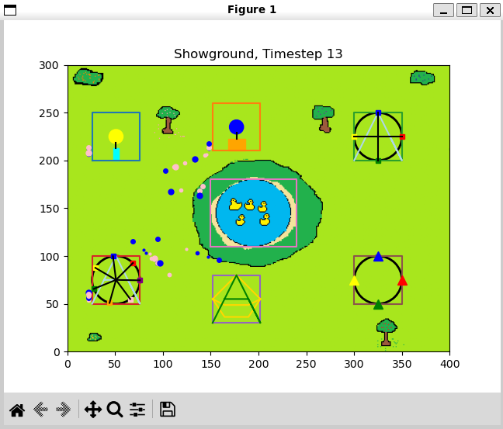

h

## Scenario 2: Winter Mode

**Interactive mode**

**Batch Mode**

## Scenario 3: Autumn Mode

**Interactive Mode**

**Batch Mode**

**Discussion**

For each mode there is different terrain/background. Though in winter mode the simulation last less than the normal or autumn mode. Winter mode also doesn’t have the yellow filter when noon takes place

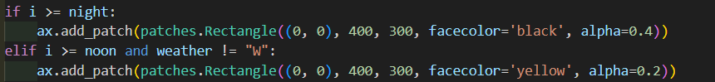

# Conclusion

This program simulates rides and patrons in 3 different scenarios with a day-night cycle. Interactive mode was implemented using user inputs while the program is running while batch mode took the inputs from a csv file. Classes were used to define the rides and the people.

I was able to learn the various functionalities of different python packages such as CSV, sys and matplotlib. This assignment was able to allow me to implement some mathematical knowledge I have learned previously such as calculating rotating figures (rotating pirate ship, Ferriss wheel and merry go round)and vector calculations(person moving towards a ride).

# Future Work

Further work could be to check collisions for people to people as currently there is only collision checking between people-ride therefore patrons can go through each other. A better path finding algorithm could be implemented as patrons may not take the best route to their target. Currently batch mode doesn’t have as much freedom as interactive mode such as choosing colours, this could be taken into consideration for further work.

# References

COMP1005. “Fundamentals of Programming: Practical Test 3.” Accessed October3rd, 2025 via Blackboard

“How to Rotate Any Graph by Any Angle (Part 2).” Accessed October 4, 2025. <https://www.youtube.com/watch?v=_DYYjci2Qpw.>

Imson, Grace. 2023. “How to Find a Unit Vector: Definition, Equation & Examples.” WikiHow. March 31, 2023. <https://www.wikihow.com/Find-Unit-Vector.>

‌

‌