batch.out_stru_ext…

.Control…

.Experimental…

.reaches…

.saccades…

.lat…

.vel…

.(**trial condition**)

.(**raw values and descriptive statistics**)

**Trial condition naming: “type_effector_side_options_hand”**

**type effector side Options Hand**

**t_2 direct e_0 saccade only L left IN instructed RH right hand**

**t_3 memory e_1 free gaze no initial eye fixation (not in use) R right Ch choice LH left hand**

**t_4 delayed e_2 joint (not in use)**

**e_3 dissociated saccades**

**e_4 dissociated reaches**

**e_6 free gaze with initial eye fixation**

Example

batch.out_stru_ext.Control.saccades.lat.**t_4_e_3_L_IN_RH**

**Look in the control group at saccade latencies in the delayed dissociated saccades condition in the left hemi space for instructed trials with the right hand**

**Values**

**mean_of_mean**

**grand mean (across subject means) in this condition**

**raw_of_mean**

**each mean value (1 per subject) in this condition**

**sem_of_mean**

**sem of means (across subject means) in this condition**

**std_of_mean**

**std of means (across subject means) in this condition**

**num_hits_of_mean**

**number of means (across subjects) in this condition**

**mean_of_raw**

**mean across single trials for all subjects in this condition**

**raw_of_raw**

**all values for all subjects in this condition**

**sem_of_raw**

**sem across all trials in this condition (does not make much sense)**

**std_of_raw**

**std across all trials in this condition**

**num_hits_of_raw**

**number of values in this condition**

**mean_of_std**

**mean value of stds per subject**

**raw_of_std**

**all stds one per subject**

**sem_of_std**

**sem of all stds per subject**

**std_of_std**

**no description needed…**

**num_hits_of_std**

**number of stds**

**mean_of_num_hits**

**mean value of hits per subject**

**raw_of_num_hits**

**all number of hits**

**sem_of_num_hits**

**no description needed…**

**…**

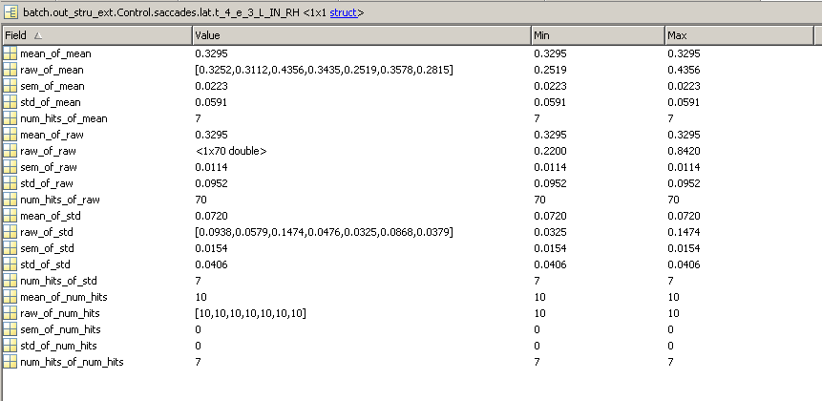

.endpoints_per_position

.tar_pos

.success_raw_x

.success_raw_y

.abort_raw_x

.abort_raw_y