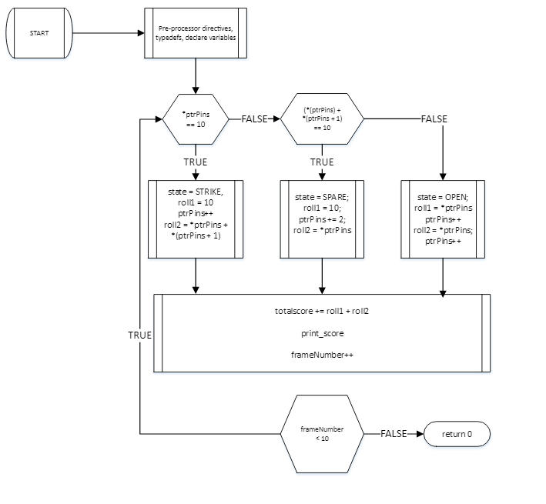

Figure Flowchart for hw01_bowling