DATA AND RESULTS

DATA:

Phosphor material: Gd₂O₂S:Tb
Thickness: 14 mg/cm²
Phosphor surface: 3 x 3 cm²
Monoenergetic x-ray beam, x-ray energy: 12 keV

Assumptions:

Density: 7.34 g/cm³
Light wavelength: 545 nm
Packing density: 50%
Grain size: 5 μm
Intrinsic efficiency: 0.15

RESULTS:

Figure (Pulse height spectrum)
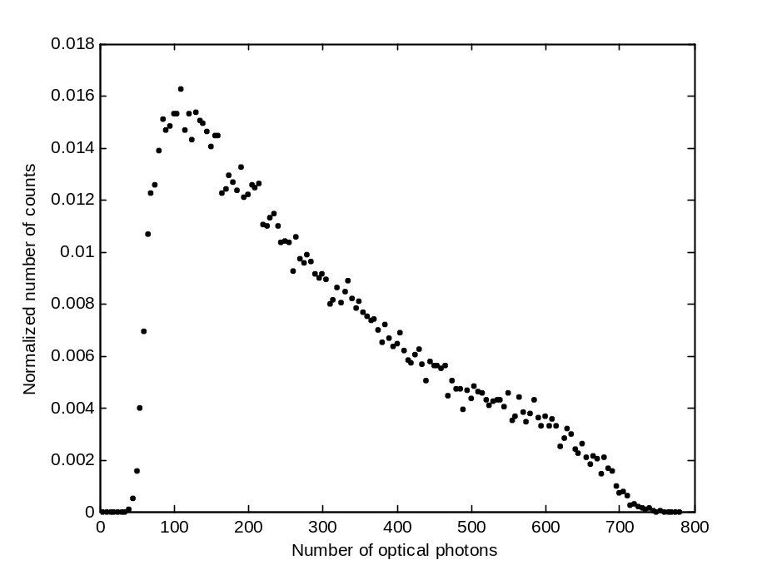
FIG. 1. Pulse-height spectra for x-ray energy 12 keV and phosphor thickness 14 mg/cm². Data provided for the Gd₂O₂S:Tb phosphor screen (transmission mode: non-irradiated surface).

