SIMATS ENGINEERING (SAVEETHA SCHOOL OF ENGINEERING)
Department of Computer Science and Engineering
ASSESSMENT TOOL 2 – TECHNICAL PRESENTATION

Course Code: | CSA16 | Course Title: | Data Warehousing and Data Mining
CO Assessed: | CO1 – Precision (BL2, BL3, BL4) | Assessment: | Assessment Tool 2 – Technical Presentation
Weightage: | 20% of CIA | Total Marks: | 100 (2 Question × 100 Marks)
CO1 Statement: | Design data warehouse architectures with appropriate dimensional models for effective decision support systems. BL1, BL2
Student Name: | D.Deepak | Reg. No.: | 192572095
Section / Batch: |  | Date: | 22/07/26

Instructions to Students
• Answer the given question through a technical presentation. Total Marks: 100.
• Clearly define the problem and explain the concept of algorithm growth functions.
• Present comparative analysis using appropriate representations such as graphs, tables, or charts.
• Use suitable tools (PowerPoint, visualization tools, or software) to support your explanation.
• Ensure technical accuracy, logical flow, and proper interpretation of results.
• Maintain clarity in communication, proper slide organization, and professional delivery.
• Time management, confidence, and audience engagement will be considered during evaluation.

Question Type | Focus Area | Questions | Marks
Technical Presentation | Decision support system, Operational versus Decision support System, Architecture of data warehouse, ETL, OLAP and data cubes, Dimensional data modelling -star snowflake schemas. Query Processing, Open-source Business Intelligence Tools. Develop an application to perform OLAP operations - Introduction to KNIME tool for reporting. | Q1, Q2 | 100
GRAND TOTAL: |  | 100 Marks

SECTION A – Technical Presentation

Topic 1: Decision Support Systems (DSS)
🎯 Focus Areas:
- Definition and need of DSS
- Components (Data, Model, UI)
- Types of DSS
- Real-world applications (banking, healthcare)
- Advantages & limitations

Topic 2: Operational Systems vs DSS
🎯 Focus Areas:
OLTP vs OLAP concepts
Key differences (data, users, purpose)
Performance comparison
Use-case scenarios
Integration between systems

Topic 3: Architecture of Data Warehouse
🎯 Focus Areas:
Data warehouse definition
Three-tier architecture
ETL process
Data marts & metadata
Benefits in decision-making

Topic 4: OLAP and Data Cubes
🎯 Focus Areas:
OLAP concept
Data cube structure
OLAP operations (slice, dice, roll-up, drill-down)
Applications in analytics

Topic 5: Dimensional Data Modeling
🎯 Focus Areas:
Fact and dimension tables
Star schema vs snowflake schema
Schema design process
Real-world example

Topic 6: Query Processing & BI Tools
🎯 Focus Areas:
Query processing stages
Query optimization
BI tools overview
Reporting and visualization
Examples of open-source BI tools

Topic 7: OLAP Application using KNIME
🎯 Focus Areas:
Introduction to KNIME
Workflow components (nodes, connections)
Performing OLAP operations
Sample application/demo
Report generation

Code of Conduct
I __________________________ (Name / Reg No) certify that this submission is my original work and that I have adhered to the guidelines specified for this assessment. I understand that any violation of academic integrity rules will result in disciplinary action.
Signature of the Student: _________________________

RUBRICS FOR CALCULATION
Criteria | Wt. | Level 4 – Exemplary | Level 3 – Proficient | Level 2 – Developing | Level 1 – Beginning
Technical Content Accuracy | 30 | Highly accurate, in-depth, and insightful technical explanation | Technically correct content with adequate depth and clarity | Basic concepts presented with limited accuracy and depth | Content contains major technical errors; concepts poorly understood
Problem Identification | 25 | Problem rigorously analyzed using appropriate and advanced methods | Problem clearly defined with a logical engineering approach | Problem identified but analysis or methodology is weak | Problem statement unclear or incorrect; no logical approach
Use of Tools | 20 | Advanced tools, well-analyzed data, and highly effective visuals | Appropriate tools and data used effectively with clear visuals | Limited use of tools and basic data interpretation | Minimal or incorrect use of tools and data; poor visuals
Communication | 15 | Highly engaging, confident, and audience-focused delivery | Clear, organized, and professional communication | Understandable but lacks clarity, structure, or confidence | Poor organization, unclear speech, ineffective slides
Professionalism | 10 | Exemplary professionalism, leadership, and ethical awareness | Professional conduct with effective team collaboration | Basic professionalism; uneven team participation | Lacks professionalism; minimal contribution or ethical awareness

Marks Evaluation:

Question No. | Technical Content Accuracy (30%) | Problem Identification (25%) | Use of Tools (20%) | Communication (15%) | Professionalism (10%) | Total Marks (100)
Q1
Q2
Overall Total (100)

Faculty In-charge | Course Coordinator | Head of Department
Signature: _______________ | Signature: _______________ | Signature: _______________
Date: ___________________ | Date: ___________________ | Date: ___________________


DATA WAREHOUSE OF ARCHITECTURE:-
A Data Warehouse is a centralized repository that stores integrated, historical, and organized data collected from multiple sources. It is mainly used for reporting, data analysis, and business decision-making. The architecture of a data warehouse defines how data is collected, processed, stored, and accessed by users. A typical data warehouse architecture consists of several important components that work together to provide accurate and reliable information.
The first component is the Data Sources Layer, where data is collected from different internal and external sources. Internal sources include operational databases such as sales, finance, human resources (HR), Customer Relationship Management (CRM), and Enterprise Resource Planning (ERP) systems. External sources may include websites, cloud applications, social media, and third-party data providers. Since the data comes in different formats, it must be processed before being stored in the warehouse.
The next component is the ETL (Extract, Transform, Load) Process. This is one of the most important stages in data warehousing. During the Extract phase, data is collected from various source systems. In the Transform phase, the extracted data is cleaned, validated, standardized, and converted into a common format by removing duplicate records and correcting errors. Finally, in the Load phase, the processed data is stored in the data warehouse. This ensures that only accurate and high-quality data is available for analysis.
After processing, the data is stored in the Data Warehouse, which acts as the central repository. It stores large volumes of historical and subject-oriented data that is optimized for querying and analysis rather than daily transactions. The data is usually organized using schemas such as Star Schema or Snowflake Schema, which improve query performance and make data retrieval faster.
Many organizations also create Data Marts, which are smaller sections of the data warehouse designed for specific departments such as sales, marketing, finance, or human resources. Data marts allow different departments to access only the information they need, improving efficiency and reducing query time.
The OLAP (Online Analytical Processing) layer is used to perform multidimensional analysis on the stored data. OLAP enables users to summarize, filter, compare, and analyze information quickly using operations such as roll-up, drill-down, slice, and dice. This helps managers and analysts identify business trends and make informed decisions.
Finally, users access the data warehouse through Front-End Tools such as reporting software, dashboards, business intelligence (BI) tools, and data visualization applications. These tools help users generate reports, monitor business performance, and gain valuable insights from the stored data.
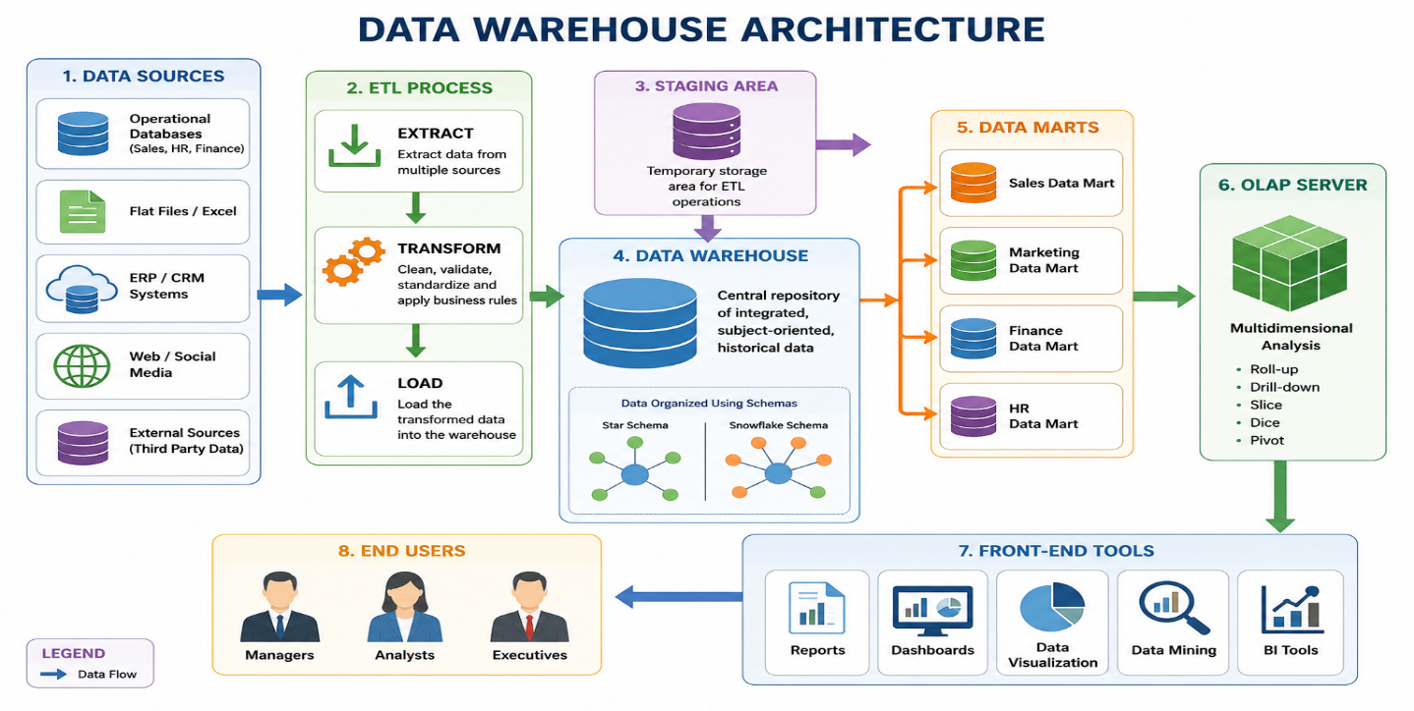
In conclusion, the architecture of a data warehouse provides a structured approach for collecting, processing, storing, and analyzing data. Its major components—data sources, ETL process, data warehouse, data marts, OLAP, and front-end tools—work together to support efficient business intelligence and decision-making. A well-designed data warehouse improves data quality, enhances reporting, and enables organizations to make faster and more informed decisions.

