**A Technical Seminar Report On**

**SMART DUSTBIN FOR WASTE SEGREGATION**

**BACHELOR OF TECHNOLOGY**

**IN**

**COMPUTER SCIENCE AND ENGINEERING**

**Submitted by**

**D.VENKATA HANUMA TEJA**

**(199Y1A0537)**



**DEPARTMENT OF COMPUTER SCIENCE AND ENGINEERING**

**K.S.R.M. COLLEGE OF ENGINEERING**

**(AUTONOMOUS)**

(Approved by AICTE, New Delhi & Affiliated to JNTUA, Anantapuramu)

(Accredited by NAAC,Bangalore)

(An ISO 9901:2000 Certified Institution)

KADAPA – 516003(A.P.)

2022 - 2023



DEPARTMENT OF COMPUTER SCIENCE AND ENGINEERING

VISION:

To produce globally competitive and self- disciplined Computer Engineers with innovative skills, moral values and societal concern by providing education of global standards and research in the field of Computer Science and Engineering.

MISSION:

M1:: To produce globally competent and qualified computer professionals.

M2::To impart high quality professional training with emphasis on basic principles of Computer Science and Engineering and to foster leading edge research in the fast-changing field.

M3:: To facilitate the students to work with recent tools and technologies and train the students by inculcating the spirit of ethical values contributing to societal ethics.

K.S.R.M. COLLEGE OF ENGINEERING

(AUTONOMOUS)

(Approved by AICTE,New Delhi & Affiliated to J.N.T.U.A.,Ananthapuramu)

(Accredited by NAAC,Bangalore)

(An ISO 9001:2015 Certified Institution)



### BONAFIDE CERTIFICATE

## Certified that this is a Bonafide record of the Technical Seminar report entitled,

## “**SMART DUSTBIN FOR WASTE SEGREGATION**”, done by D.VENKATA HANUMA TEJA (199Y1A0537), Submitted to the department of Computer Science and Engineering, in partial fulfilment of the requirements for the Degree of **BACHELOR OF TECHNOLOGY** in **Computer Science and Engineering** from J.N.T.U.A., Anantapuramu during the year of 2022-2023.

Technical Seminar Guide Head of the department :

### **Smt. B.Manorama Devi,M.tech.,(Ph.D) Dr. V. Lokeswara Reddy,M.Tech.,(Ph.D).,**

**Assistant Professor, Professor and HOD,**

**Dept of CSE. Dept of CSE.**

DATE: INTERNAL EXAMINER-1 INTERNAL EXAMINER-2

**CONTENTS** **PAGE NO**

1.Introduction 1

2.Description 2

1. Problem description 3

Proposed system 3

Advantages of proposed system 3

1. Implementation 4 to 5
2. Sensors 6 to 8
3. Flow diagram 9
4. Hardware Requirements

Software Requirements 10

3.Conclusion 11

4.References 12

**1.INTRODUCTION**

As the second most populous country in the world India facing a major problem in waste management. As we now there are traditional waste management systems like periodic and routine clearing by the various civic bodies like the municipal corporation. But even though these routine maintenances is carried out we often come across overflowing garbage bins from which the garbage spills on to the streets. many of us throwing the waste beside of the roads and canals and drainage canals and many other places this will lead to rise many problems like polluting the water bodies and the ground water percentage will be decreased.Due to this we are facings different types of health issues.To over come this problem we came with a “ECONOMIC WASTE MANAGEMENT” which will helpful the both the human beings as well as environment. This is purely based on the IOT(Internet of things),ML(Machine Learning).In this project we used the Arduino UNO Microcontroller, Ultrasonic Sensor ,Moisture sensor ,and Rfid sensor,Load cell sensor ,GSM kit. using image processing, one can measure the waste index of particular dumping ground. In this economic waste management user will dump the waste into dustbin(dry and wet). Firstly the user dump the waste into the dustbin by scaning card through Rfid sensor it will give the details of the user.After dumping waste he will get the credit scores on his or her account .This credit scores will be used for buying or get some discounts for government paybills. This will help us reduce the waste dumping in all areas and it will help the environment very well and the pollution will decrease and the ground water percentage also increase very well.

1

**2.DESCRIPTION**

* In India the traditional waste management system is collecting and clearing garbage regularly and periodically by the municipal corporation or competitive authority.
* This system will be more effective and non-hazardous with the municipal people. when no toxic material will be in contact with them.
* A society will get its waste dispatched properly only if the dustbins are placed and emptied properly.
* If the wastes is not managed properly then there is a mass production of bacteria, insects which finally spread different diseases.
* Thus the normal life of a human being gets affected because of unhealthy environment. Cleanliness is very important and for a smart city.
* we have designed a smart dustbin. In this we have tried to upgrade the trivial but vital component of waste management system.
* The dustbin can be placed in the center of the streets,villages,appartments and where the waste is producing more.
* In this protocal we use the following sensors they are Arduino UNO microcontroller,Ultrasonic sensor,Moisture sensor,Rfid sensor,wifi.

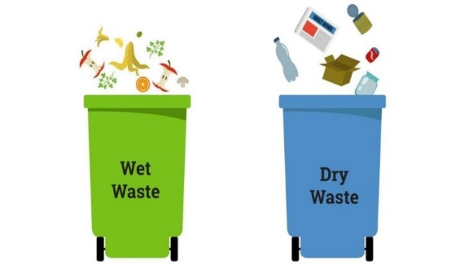

* In the above image process the waste will be dump by the people by identifying the waste dustbin which is wet dustbin and dry dustbin.
* But, In our system the people can dump the waste directly without identifying which is wet waste or dry waste by using the moisture sensor.

2

1. **PROBLEM DESCRIPTION**

As we see around many of the people throwing the waste beside of the roads and canals and drainage canals and many other places this will lead to rise many problems The amount of waste has been increasing due to the increase in human population. In cities, the overflowed bin creates an unhygienic environment which leads to health problems. The proposed system is for the separation of waste into two categories namely wet and dry waste. Each of the wastes are detected by the respective sensors. This system will helpful for both the human beings as well as environment.

**PROPOSED SYSTEM**

The project is purely based on the IOT(Internet of things). The foremost goal of this project is to segregate the wastes, and to perceive the level of the dustbins.With such information, garbage collectors collect the waste from the respective bins where the level of the waste in the bins are reached without going to all the places where the bins are placed. Firstly the user dump the waste into the dustbin, the sensor identifies the type of the waste. If he drops the waste by segregating correctly into the respective bins then he is able to get the credits otherwise not. Moisture sensors are used to detect the waste in the bins,Ultrasonic sensor observes the levels of bin and load sensors are used to calculate the load ,based on the amount of load the credits are awarded to the user.

**ADVANTAGES OF PROPOSED SYSTEM**

* The smart bin ensures collection only when the container is full. It reduces your efforts and time too.
* Truck collection visits enhance traffic and gamming, on the other hand, the smart trash container interrupts traffic and makes the street even cleaner.
* Few smart bins come with a WiFi facility, as a result of, increase in hotspot coverage for the public.
* This smart move improves street hygiene and safety.
* They also encourage recycling and reusability.
* This trashanalysed data of specific areas through waste volumes. This will helps to do better planning to reduce and eliminate wastage from malls, parks, airports and other places.

3

1. **IMLEMENTATION**

* Firstly the Smart dustbins are placed in the one place at the streets , villages , appartments and where the waste is producing more.
* People dumping waste in their home with out segregation after some days the waste will be increased in their homes.
* Before this process the user can give details of the user and they can get the Rfid card
* Every new user can enter their datails to get the rfid card through this rfid card we can open the dustbin door and dump their waste in smart dustbin.
* After getting the Rfid card the user can scan the rfid card and Rfid sensor can scan the datails of the user.
* By scanning the Rfid card the dustbin door will open and user can dump their waste in the smart dustbin.
* After dumping their waste in the dustbin moisture sensor will sensing the waste whether the waste is wet waste or dry waste.
* By sensing the waste it will be dump according to their wet bin and and dry bin.
* After dumped to their respective bins the load cells will show how much wait the waste is poured by the user according to their weight the credits will be scored to their accouts
* Due to this the waste is segregated according to their wet waste or dry waste bacause

of these the pollution will be decreased

4

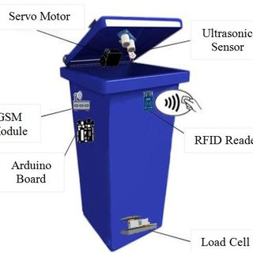

* After few days the dustbin is fill automatically the messege wiil send to the municipal corporation of the receiver vehical through the gsm kit.
* So the municipal corporation vehical can see the messege of the location where the dustbin is fill.
* Then the vehical wil go to their location and they will collect the waste according to their wet waste and dry waste.

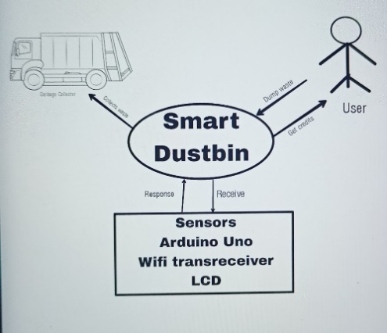

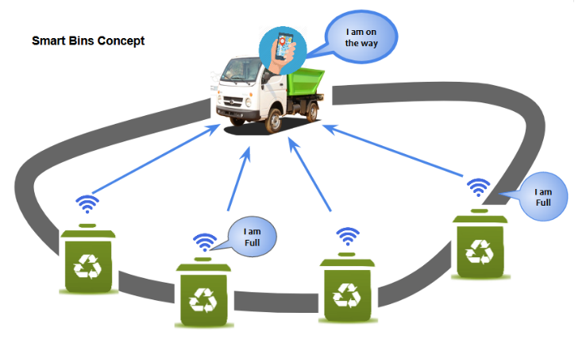

* We can see the above figure the vehical will get messege where the dustbins will full and vehical will collect waste

5

1. **SENSORS**

ULTRASONIC SENSOR:

* The HC-SR04 ultrasonic sensor uses SONAR to determine the distance of an object just like the bats do. It offers excellent non-contact range detection with high accuracy and stable readings in an easy-to-use package from 2 cm to 400 cm or 1” to 13 feet.
* The operation is not affected by sunlight or black material, although acoustically, soft materials like cloth can be difficult to detect. It comes complete with ultrasonic transmitter and receiver module.

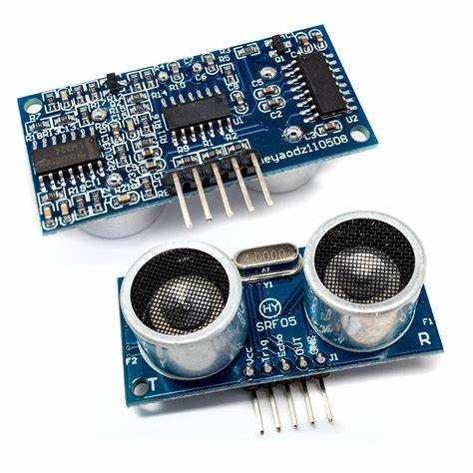

ARDUINO UNO MICROCONTROLLER:

* The Arduino UNO is a standard board of Arduino. Here UNO means 'one' in Italian. It was named as UNO to label the first release of Arduino Software. It was also the first USB board released by Arduino. It is considered as the powerful board used in various projects. Arduino.cc developed the Arduino UNO board.
* Arduino UNO is based on an ATmega328P microcontroller
* . It is easy to use compared to other boards, such as the Arduino Mega board, etc. The board consists of digital and analog Input/Output pins (I/O), shields, and other circuits.
* The Arduino UNO includes 6 analog pin inputs, 14 digital pins,USB.
* connector, a power jack, and an ICSP (In-Circuit Serial Programming) header. It is programmed based on IDE, which stands for Integrated Development Environment. It can run on both online and offline platforms.

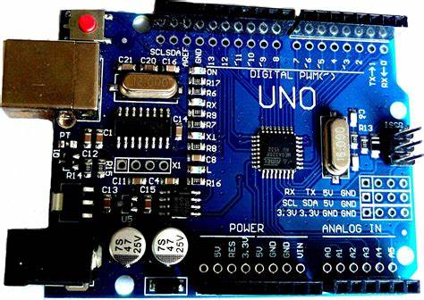

6

LCD DISPLAY:

* The LCD (**Liquid Crystal Display**) is a type of display that uses the liquid crystals for its operation.
* Here, we will accept the serial input from the computer and upload the sketch to the arduino. The characters will be displayed on the LCD.

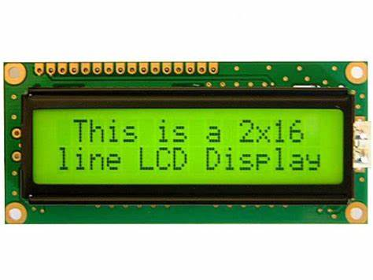

GSM kit:

* 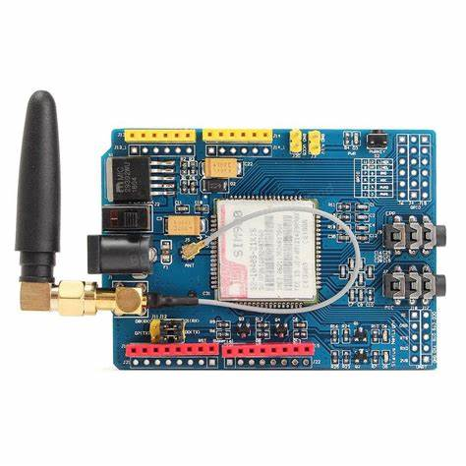At Arduino we have made connecting to a GSM network as easy as getting an LED to blink. You can set or receive calls, send and receive text messages, and access data networks to exchange data with different types of servers. You can even create your own server operating on the GPRS data network

MOISTURE SENSOR:

* On Moisture Sensor, If you want to detect the moisture level in the soil or recognize when you need to water your plants easily, you will use the moisture sensor
* This sensor is consists of mainly two parts, one is Sensing Probs and another one is the Sensor Module. The probes allow the current to pass through the soil and then it gets the resistance value according to moisture value in soil.

7

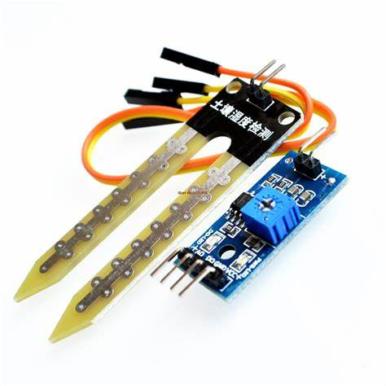

RFID SENSOR:

* RFID tagging is an **ID system** that uses small **radio frequency identification** devices for identification and tracking purposes. An RFID tagging system includes the tag itself, a read/write device, and a host system application for data collection, processing, and transmission.
* In simple words an RFID uses electromagnetic fields to transfer data over short distances. RFID is useful to identify people, to make transactions, etc…

8

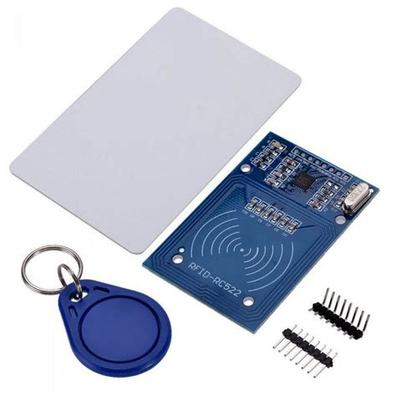

1. **FLOW DIAGRAM**

User Scan card dump

Check

Wet bin

Dry bin

Check weight

credit

If bin is full

Sent msg to vehical

Collects the bin

9

1. HARDWARE REQUIREMENTS:

* Arduino uno microcontroller
* Ultrasonic sensor
* RFID sensor
* GSM kit
* Load sensor
* Moisture sensor

SOFTWARE REQUIREMENTS:

* Arduino IDE
* Wifi

10

**3.CONCLUSION:**

With growing urbanisation and increasing population, effective waste disposal is a major concern. Manual waste segregation is very expensive, time consuming and inefficient. This paper presents a smart and cost effective solution for waste segregation. The proposed SmartBin is an efficient waste segregation system that requires no human intervention to separate dry and wet waste and paves the path for timely collection and disposal. The proposed system can be deployed on a domestic scale in households or on a large scale in public places. This module can be considered to be in conjunction with the Government of India’s Swachh Bharat scheme to reuse and recycle resources and enables scientific waste management methods.

11

4.**REFERENCES:**

1. M.K.Pushpa, Aayushi Gupta, Shariq Mohammed Shaikh, StutiJha, Suchitra V, “Microcontroller based Automatic Waste Segregator”, IJIREEICE, Volume 3, Issue 5, May 2015.
2. Pavithra, “Smart Trash System: An Application using ZigBee”, IJISET, Volume 1, Issue 8, October 2014.
3. Ruveena Singh, Dr.Balwinder Singh, “Design and Development of Smart Waste Sorting System”, IJRECE, Volume 3, Issue 4, OctoberDecember 2015.

12