# REST API

## Registration

**URL: http://localhost:8080/todo/rest/register**

**Header**: Basic Authentication: ([daghan@cba.com](mailto:daghan@cba.com) pass: daghan), Content-Type: application/json

**Method**: POST

**Body**:

{

“firstName”: “[string min 2 max 45 required]”,

“lastName”: “[string min 2 max 45 required]”,

“email”: “[string min 6 max 45 required]”,

“password”: “[string min 6 max 45 required]”

}

**Return**:

Success: Registration object in JSON

Error: String errorString

### Example

Registering someone with

* First name: name
* Last name: last
* Email: [email@g.com](mailto:email@g.com)
* Password: password

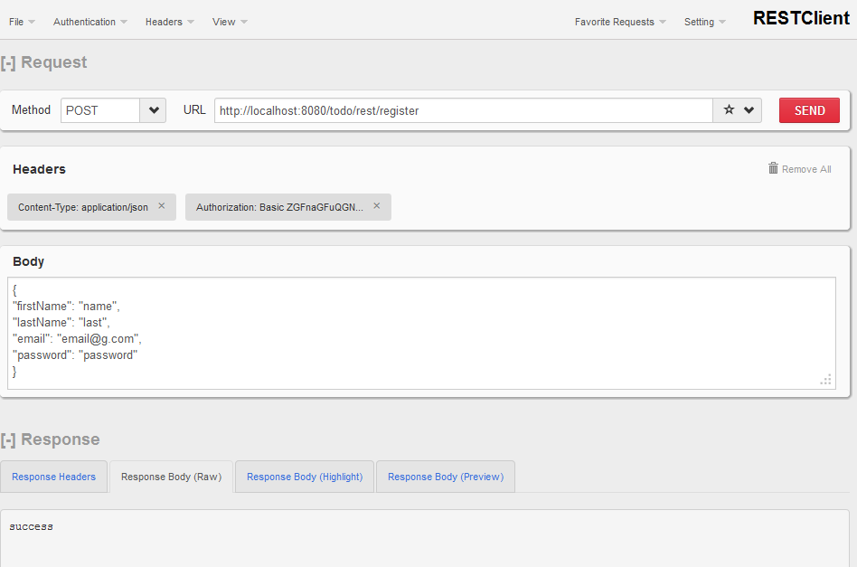

## Todo CRUD

### Get all todo’s

Get all todos for the user

**URL: http://localhost:8080/todo/rest/secure/todos.json**

**Header**: Basic Authentication: ([daghan@cba.com](mailto:daghan@cba.com) pass: daghan), Accept: application/json

**Method**: GET

**Body**:

**Return**:

Success: List of all the todos in JSON syntax

#### Example

Get all todos for the user

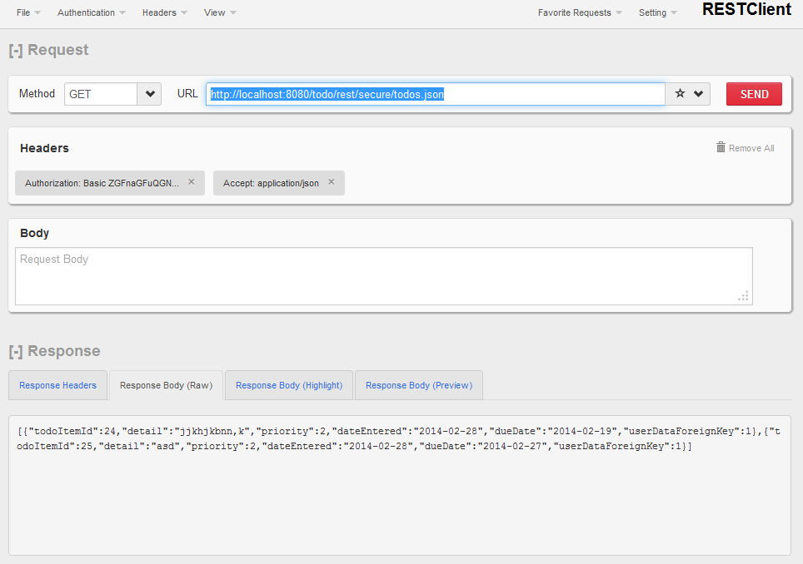

### Get Single Todo

Get single todo for the user

**URL: http://localhost:8080/todo/rest/secure/todos/1.json**

**Header**: Basic Authentication: ([daghan@cba.com](mailto:daghan@cba.com) pass: daghan), Accept: application/json

**Method**: GET

**Body**:

**Return**:

Success: single todo in json syntax

Failure: errorString

#### Example

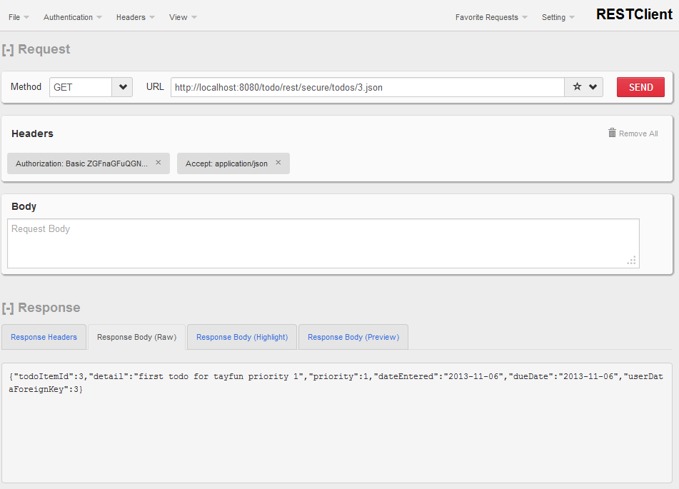

### Add a single Todo

**URL: http://localhost:8080/todo/rest/secure/todos.json**

**Header**: Basic Authentication: ([daghan@cba.com](mailto:daghan@cba.com) pass: daghan), Content-Type: application/json, Accept: application/json

**Method**: POST

**Body**:

{

“detail”: “[string min 2 max 45 required]”,

“priority”: “[integer min 1 max 3 required]”,

“dueDate”: “[date required]”

}

**Return**:

Success: created todo in json syntax

Error: error string

#### Example

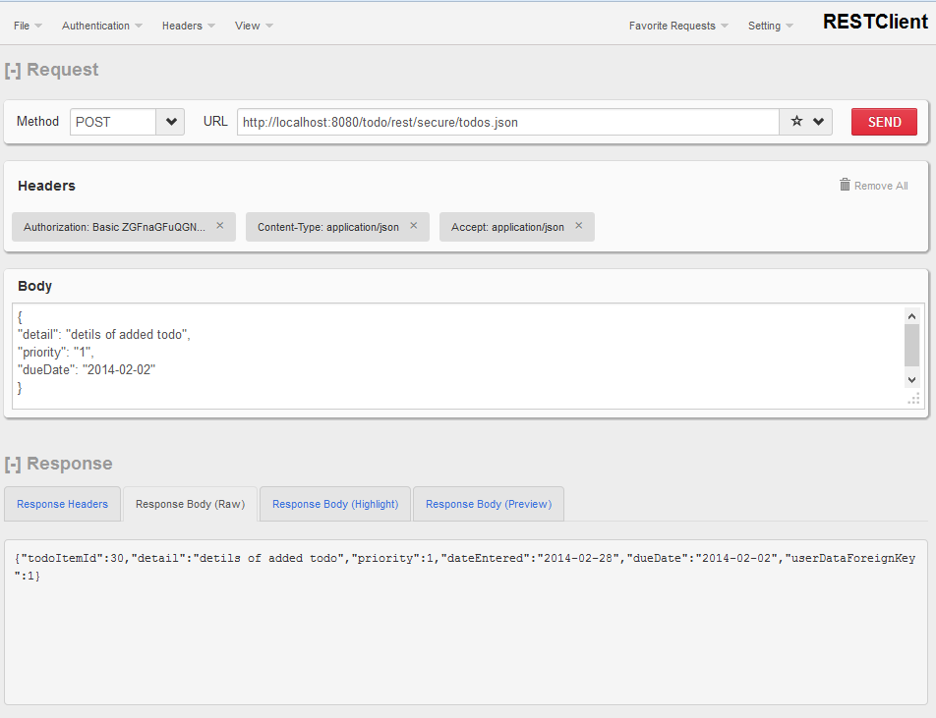

### Update a single todo

**URL: http://localhost:8080/todo/rest/secure/todos/3.json**

**Header**: Basic Authentication: ([daghan@cba.com](mailto:daghan@cba.com) pass: daghan), Content-Type: application/json, Accept: application/json

**Method**: PUT

**Body**:

{

“detail”: “[string min 2 max 45 required]”,

“priority”: “[integer min 1 max 3 required]”,

“dueDate”: “[date required]”

}

**Return**:

Success: updated todo in json syntax

Error: error string

#### Example

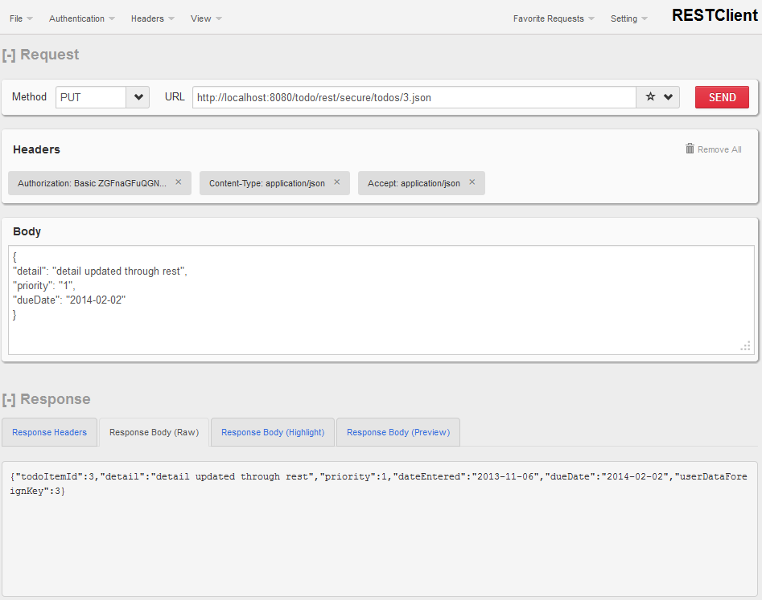

### Delete one todo for the user

**URL: http://localhost:8080/todo/rest/secure/todos/3**

**Header**: Basic Authentication: ([daghan@cba.com](mailto:daghan@cba.com) pass: daghan)

**Method**: DELETE

**Body**:

**Return**:

Success: id of the deleted todo

Error: error string

#### Example

