Molecular Dynamics and Argon Gas

**Nicholas Dagher, Lennie De Roo**

**Computational Physics 480**

Introduction

This project looked at molecular dynamics through computational analysis. We simulated a system of Argon gas based in an FCC (face-centered cubic) lattice structure under a set of initial conditions. Since matter is made up of so many particles we will take a cubic section of this gas made up of numerous FCC lattices and N particles. This section of gas is under periodic conditions in order to effectively simulate that relative to the size of the particles the gas extends to infinity in all directions.

The motions of the particles are treated classically and are governed by the Lennard-Jones potential.

] (1)

The force of the potential is calculated taking the –gradient of equation (1).

We randomly initialize the momentum of these particles using a Maxwell-Boltzmann distribution, and follow the motion of these particles over time calculating pressure and specific heat

**(2)**

(3)

Where P is pressure and p is the pressure due to the force of the potential. We will show that momentum and energy are conserved over time. A thermostat was created in order to keep the temperature constant. We would like to see how our simulation of argon gas compares under different initial conditions of temperature.

Looking at the code

In order to effectively code this project we split it up into different files molecularmainOOP.py, molecularfunctionsOOP.py, molecularPhysicalQuantities.py, F90force/f90pot/f90press and JosPlot.py

MolecularmainOOP.py:

This is where we set the global constants and where we can easily alter the code in order to see the gas evolve under different conditions. The file essentially calls the initial conditions based on the global constants chosen and then runs the simulation returning graphs of energy, momentum, temperature, pressure, specific heat over time. As well as an animation of the gas particles in the box over time.

MolecularfunctionsOOP.py:

Functions that created and updated conditions such as position and momentum where placed here. As well as the functions needed in order to check conservation of momentum and energy.

MolecularPhysicalQuantities.py:

This file contains calculations for average momentum, temperature, pressure, and specific heat. This file also contained the thermostat function, the velocity correction functions, error calculation functions and plotting functions.

JosPlotPy.Py

This is the file that contains the class needed to animate the particle movement.

F90force/f90pot/f90press

These are the files used to calculate fore, potential, and pressure in FORTRAN in order to improve efficiency. The files need to be compiled into the correct format to be used in the python code, those files end with “.so”.

Analysis

At a temperature of .9 in our simulation our total energy, kinetic energy and momentum where all conserved, by looking at graph (1) you can see that the kinetic, potential, and total energy oscillate about a constant energy. The momentum was also conserved in all directions as can be shown on graph (2), also shown is the temperature oscillating the target temperature with an uncertainty of about +/.02 which shows that our thermostat is working. The pressure oscillates over time about a pressure of about 1.6 but peaks of oscillation reach +/1.0, with a small error shown on graph (3). The specific heat also oscillates over time at a specific heat of about .3 with oscillations reaching peaks of +/-.1, the error doesn’t seem to be large either which can be seen on graph (4). When looking at the animation you can see that the lattice structure has already started to shift quickly at this temperature, this can be seen on figure (1).

At a high temperatures Energy, and momentum are all conserved and the temperature behaves the similar to that at .9, but the error in the energy is larger which can bee seen on graph (5+6). Regarding pressure, the pressure seems to decrease from oscillating about ~17 to ~7, the error also seems a little larger shown on graph(7) . The specific heat of the gas also increases to ~160.0 with low uncertainty, the behavior of the graph is similar to how it behaved at a temperature of .9 as seen in graph (8). The figuration of the particles in the cube is more chaotic then before with little similarity to the FCC lattice which can be shown in figure (2)

At low temperatures, we used a temperature of .1, potential, kinetic, and total energy are all conserved and do not have to large of error, the behaviors of the graph resemble the previous conditions as seen on graph(9). Momentum also behaves similarly before as shown in graph (10). Pressure oscillates at ~5.4 but seems much cleaner of an oscillation then in previous conditions as shown in graph (11). The specific heat oscillates at ~ 181 and has little error as before in graph (12). The animation shows the FCC lattice staying in intact as time goes on and the formation can be seen in figure (3)

If the temperature remains at .9 but we increase density to about 1.2 we see that the lattice also maintains its shape better as seen in figure (4).

Conclusions:

We found that all of our energies, momentum and temperatures were conserved as time evolved. The clearest difference as temperature increases is the disturbance in the FCC lattice. At low temperatures you can see the lattice stay together but as we raised the temperature we can see the lattice begin to break down. We could also see that the pressure increased and became less consistent as the temperature rose. The specific heat increased but remained constant as time evolved as we increased temperature.

Graphs and Figures

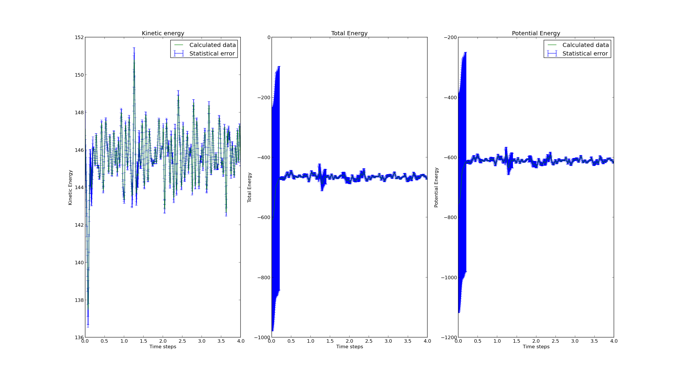

graph

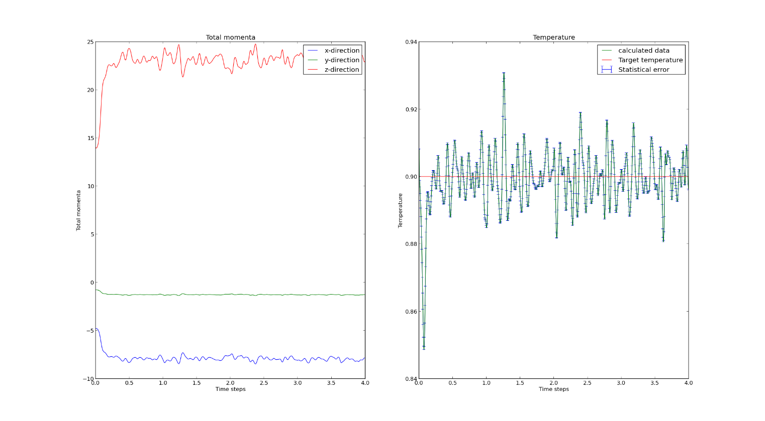

graph

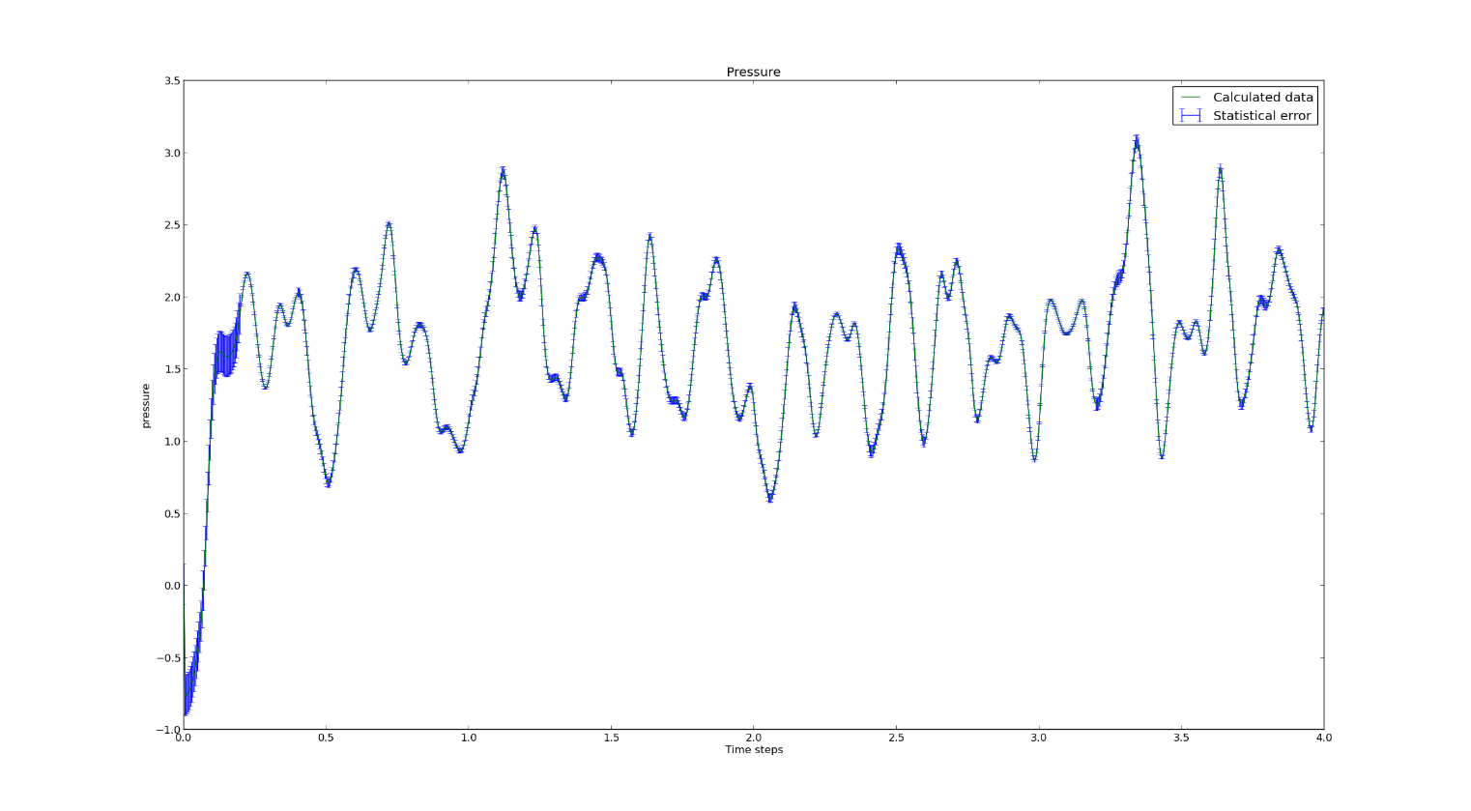

graph 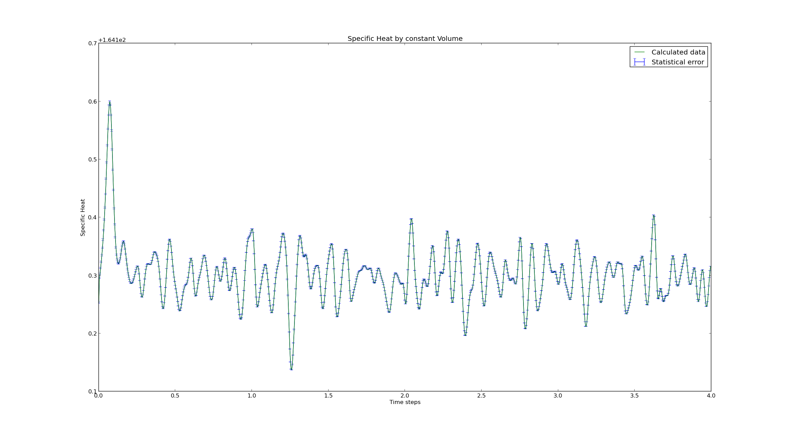

graph

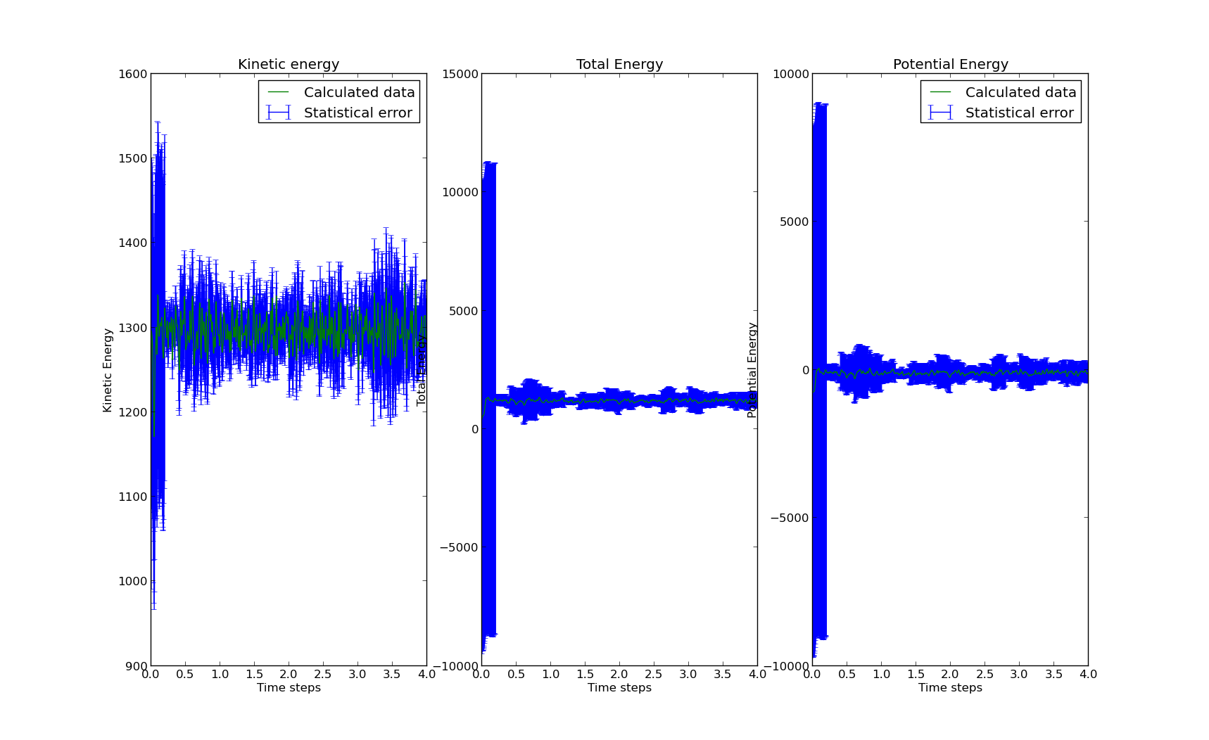

graph

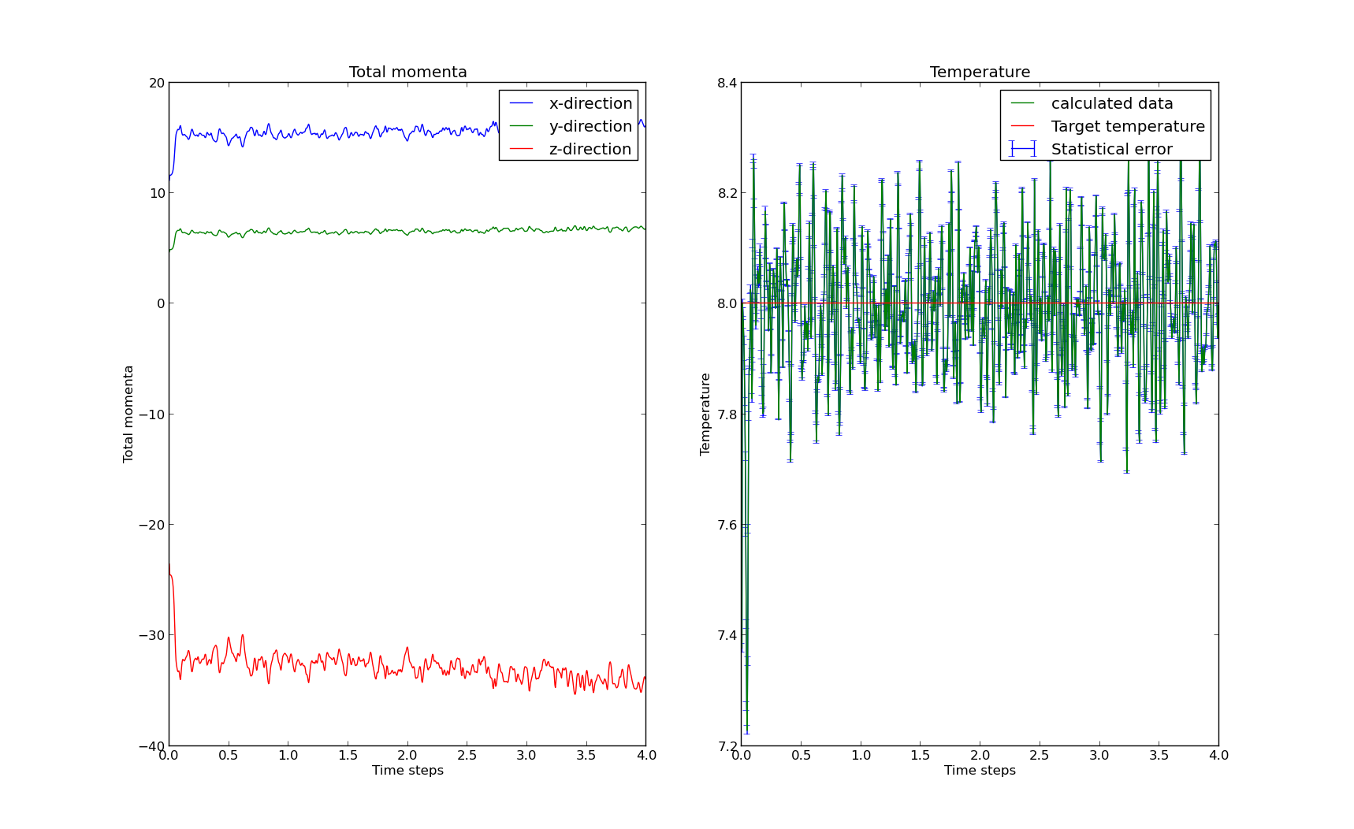

graph

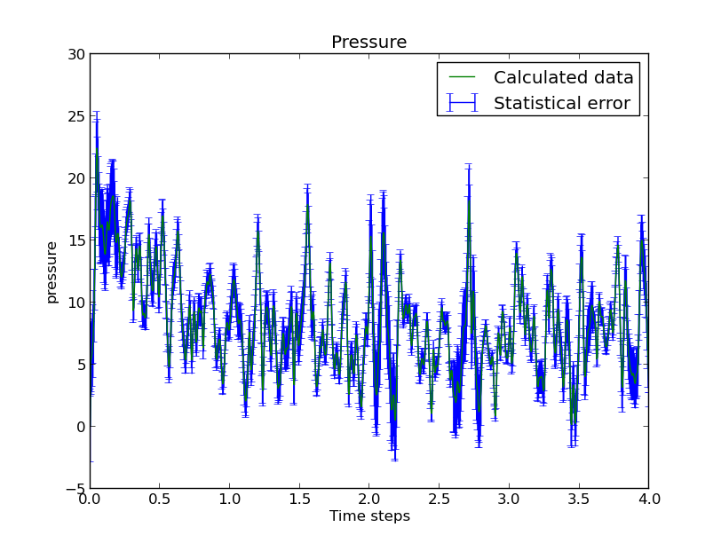

graph

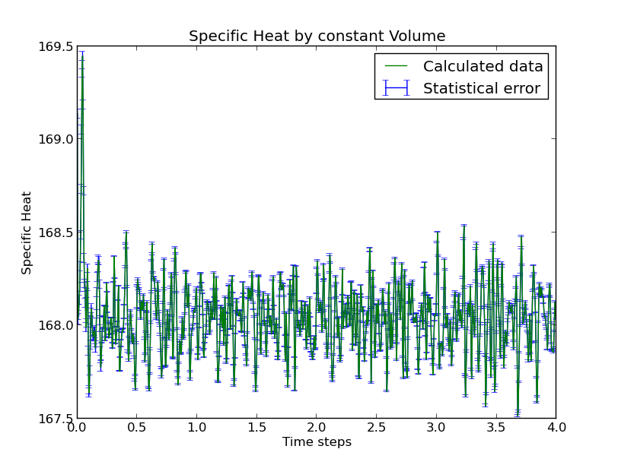graph 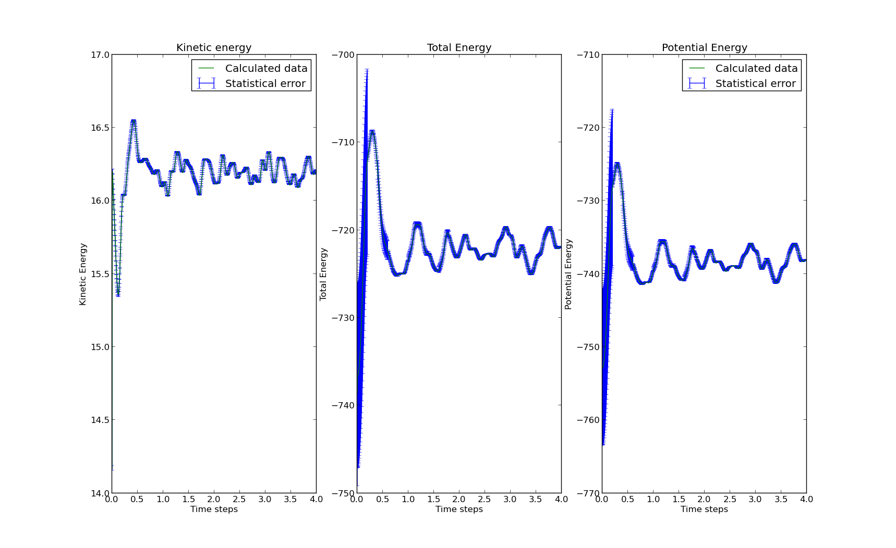

graph

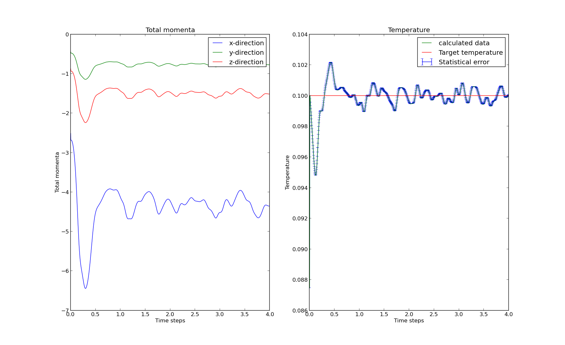

graph

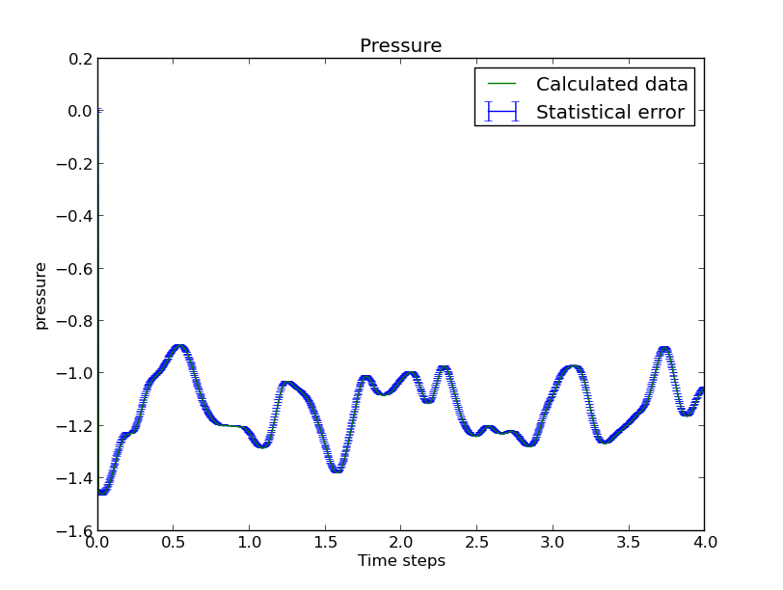

graph

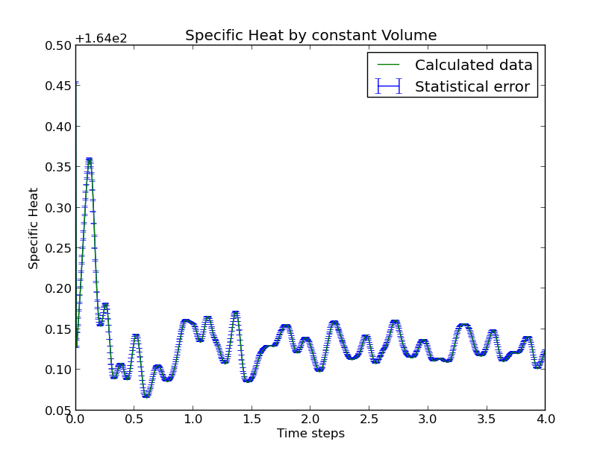

graph

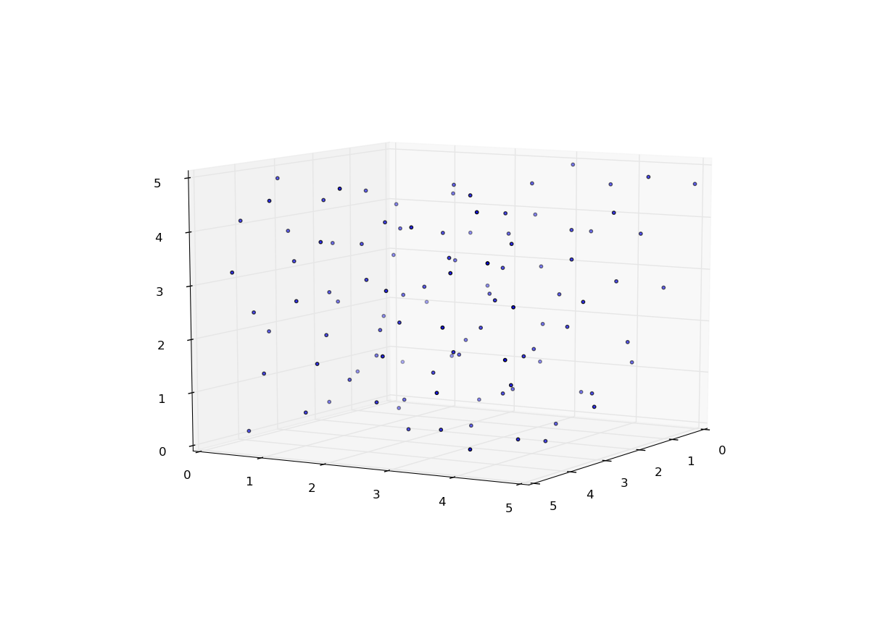

Figure

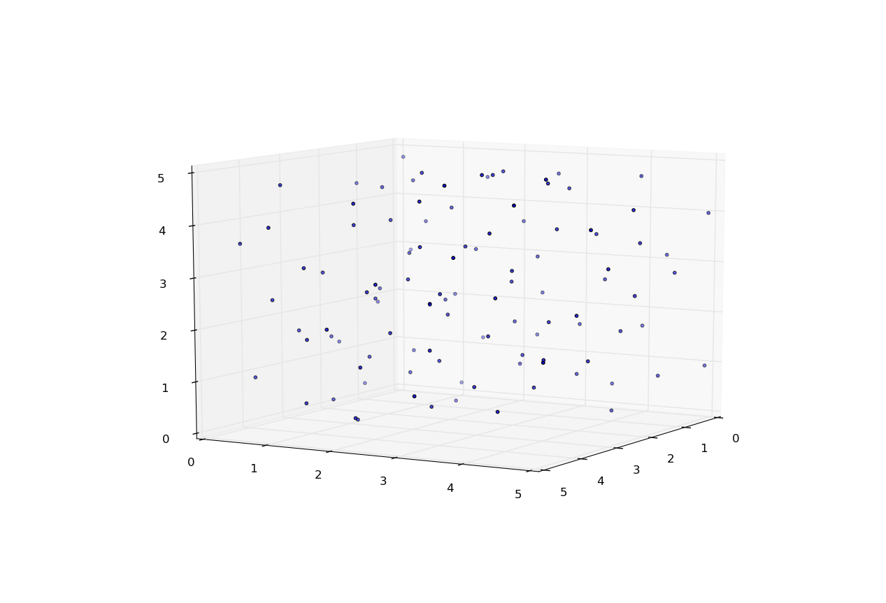Figure 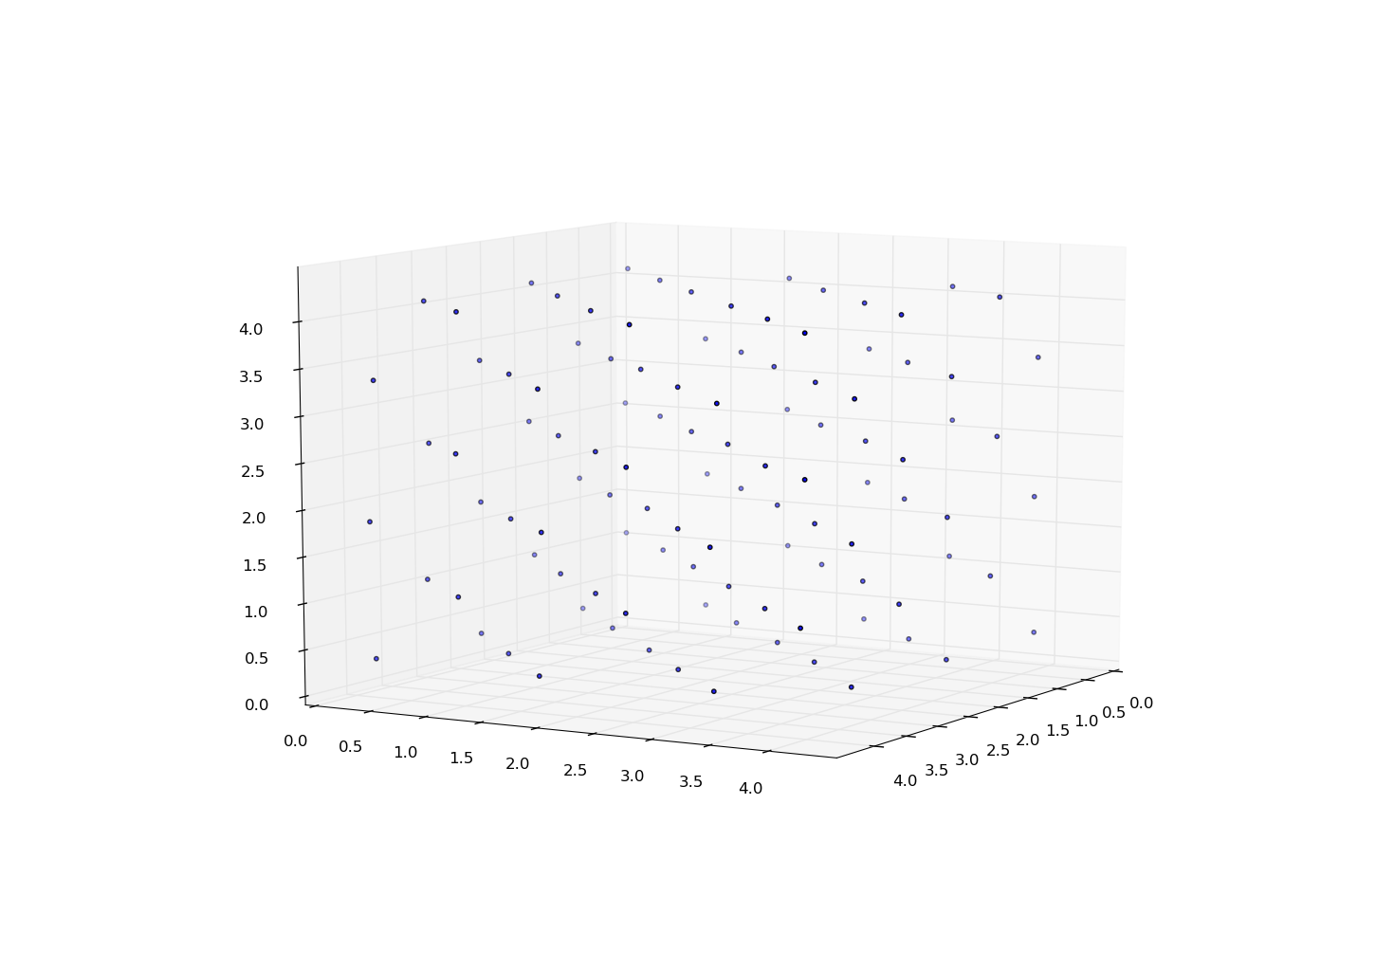Figure 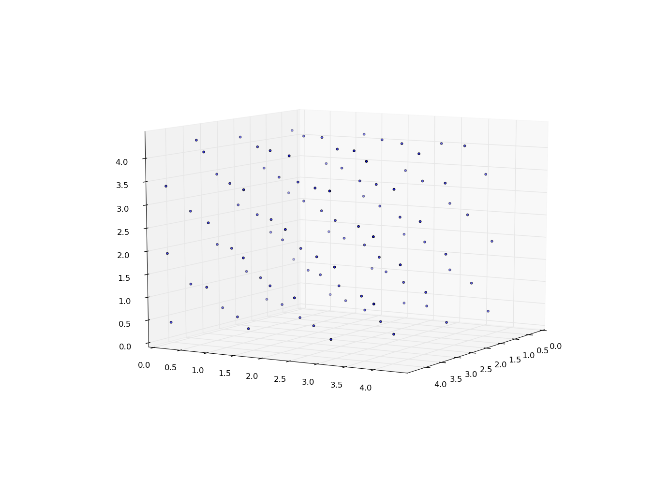

Figure