

**OMO Bank**

**Business Application**

**Development Team**

**Software Project Documentation**

**Title: OMO Bank Recruitment Site**

**Table of Contents**

**1.** **INTRODUCTION** 1

**1.1.** **Scope of and Limitation of the Project** 1

**1.1.1.** **Scope of the Project** 1

**1.1.2.** **Limitation of the Project** 1

**1.2.** **Methodology of the Project** 1

**1.2.1.** **Data Collection Tools/Techniques** 1

**1.2.2.** **System Development Model** 2

**1.2.3.** **Development Tools and Technologies** 2

**2.** **DESCRIPTION OF THE EXISTING SYSTEM** 3

**2.1.** **Major Functions of the Existing System** 3

**2.2.** **Drawbacks of the Existing System** 3

**3.** **PROPOSED SYSTEM** 5

**3.1.** **Functional Requirements** 5

**3.2.** **Non-functional Requirements** 5

**3.3.** **Security Issues** 5

**4.** **SYSTEM ANALYSIS** 6

**4.1.** **System Model** 6

**4.1.1.** **Use Case Model** 6

**4.2.** **Object Model** 7

**4.2.1.** **Class Diagram** 8

**5.** **SYSTEM DESIGN** 9

**5.1.** **User Interface Design** 9

**6.** **CONCLUSION AND RECOMMENDATION** 13

**6.1.** **Conclusion** 13

**6.2.** **Recommendation** 13

**Table of Figures**

Figure 1: Landing page section 1 screenshot 9

Figure 2: Landing page section 2 screenshot 10

Figure 3: Login page screenshot 10

Figure 4: Registration page screenshot 1 11

Figure 5: Registration page screenshot 2 11

Figure 6: Recruiter's home page section 2 screenshot 12

Figure 7: Recruiter's home page section 1 screenshot 12

**CHAPTER ONE**

# **INTRODUCTION**

* 1. **Scope of and Limitation of the Project**
     1. **Scope of the Project**

This proposed system suggests a solution to automate the manual recruitment process. The scope of this proposed system will focus on the job seekers and client companies who will use this system. This recruitment site has several modules to facilitate the recruitment process. Using the client management module, client companies can register and add vacancy details. Also, using the online test module, admin can handle the selection test for job seekers. Furthermore, this system has a feature of scheduling interviews and selection tests dates. Communication between the applicant and company did by the automated emails. Also, this system can generate the reports for decision management process. The proposed system has a backup facility. Using the proposed system company can reach an effective and efficient recruitment process.

* + 1. **Limitation of the Project**

The proposed system has developed based on the following assumptions. The user should have a stable Internet connection, the user should understand the English language and the user should have computer literacy.

* 1. **Methodology of the Project**
     1. **Data Collection Tools/Techniques**

The data collection process for this project is done through the following techniques:-

**Observations**

The data gathering process involves viewing from universally adopted procedures of a vacancy posting and recruitment processes of different companies like Ethiopian commercial bank and other huge firms.

**Interviews**

The data gathering process involves interviewing HR personnel and the clients about questions we have on the recruitment process that are necessary for the development of the module.

**Document analysis**

Analyzing the current process using the company’s usual vacancy postings to understand the client's current situation. Reviewing the available company documentation, charts, recruitment analysis statistics and past recruitment patterns and get an idea about the requirements of the new system.

* + 1. **System Development Model**

The Rad development approach is the first choice of development model, given the short period of time to develop the site. However, incorporating the RAD model to the Incremental development model proved to be the better option. This is achieved by using component-based development for each increment in the development process as much as possible. In other words, for each increment in the development of the site, we try to outsource functionalities rather than developing every feature from scratch.

* + 1. **Development Tools and Technologies**
       1. **Frontend Technologies**

For the Front-End development, we use **React** frame work. Which allows us a much-needed flexibility.

* + - 1. **Backend Technologies**

Our Back-End is built using **Django** python Frame work. Which helps us automate the fundamental systems.

* + - 1. **Documentation and Modeling Tools**

For documentation we use **MS Word** and for modeling we are use **Adobe XD** which we found better suited for offline use.

* + - 1. **Deployment Environment**

This module is developed with an intention that it be part of the already existing website of the bank. Hence, the site makes efficient use of the hosting servers already in use by the bank’s official website.

**CHAPTER TWO**

1. **DESCRIPTION OF THE EXISTING SYSTEM**
   1. **Major Functions of the Existing System**

The company recruits employees for definite or indefinite period of time through the following process:

1. Requirement unit shall receive requisition from any departments of the company through hiring manager.

2. Recruitment unit prepare job description and person specification.

3. Recruitment Unit shall announce vacancies to the public through radio, television, newspapers and etc.

4. Recruitment Unit shall register applicants and receive their educational and other relevant documents after checking against their originals.

5. Recruitment unit will do Short-listing and identifying the prospective employee with required characteristics and conduct interview with the selected candidate.

6. Hiring manager make decision on the selected candidates and shall prepare minutes and recommend for approval.

7. Recruitment Unit ensures that the successful candidate is medically fit and free from any criminals and finally result will be posted on the organization notice board.

8. The selected candidate who are certified and fit for the job shall fill in application forms for employment.

9. Recruitment Unit prepares Personnel Action (PA) after collecting all documents necessary for the personal file of the employees. The PA shall describe Employee name, identification No, position/grade and salary, job code, cost center, location, work Unit/department, division, section, remarks and effective date.

* 1. **Drawbacks of the Existing System**

As the current process is not automated the company needs to cope up with the following set of problems.

* Poor time management: Often paper work is slow, which results delay on client’s services and for the personnel processes of the company.
* Redundant information: Personnel information about employees stored in many places.
* Data is captured redundantly: Personnel information has to be captured again and again when activities related to a particular employee is performed.
* Data is not securely stored as the result; personal information of employees is exposed to unauthorized agents.
* Due to the large number of manual files, data organization is difficult and is not easy to meet new information needs from stored data.
* Manual handling of data is expensive as compared to automated system.
* Delay in announcing notice for vacant positions.

**CHAPTER THREE**

1. **PROPOSED SYSTEM**
   1. **Functional Requirements**

* Allow recruiters to post vacancies and display them to applicants.
* Receive applications from recruits and display it to recruiters in an organized fashion.
* Allow recruiters to schedule selection test and an appointment for job interview
* Allow recruiters to Send email notifications
  1. **Non-functional Requirements**
* Put a limit to the size of the files uploaded by applicants.
* Expired or filled vacancies will not be completely removed from the site.
* Simple and easy to use interface.
* A module that can easily integrate to a bigger system
  1. **Security Issues**

The security issues with the system is that the user may upload malware or unwanted file types and also the user might upload very large files which will overwhelm the database or cause the system to crush. The other security issue is the user using simple passwords that can be accessed using brute force attack or any other social engineering methods.

So to tackle these problems we have proposed restricting the uploaded files to a specific type and size standard in which these specifications are trespassed the system will block access and also setting guidelines.

**CHAPTER FOUR**

1. **SYSTEM ANALYSIS**
   1. **System Model**
      1. **Use Case Model**

The use case model of these project contains three actors which are directly involved with the software being developed.

These are, namely: -

* The Human Resources
* The Recruit and
* The System

The Human Resources is the one responsible for managing and uploading of vacancies and recruiting the employees. Their role involves vacant position posting, viewing and analyzing the recruit data and also scheduling appointment with the recruits.

The Recruit can upload their credentials, view and edit their profiles and credentials. And the system can also manage every individuals account logs, and sends mail accordingly.

* + - 1. **Use Case Diagram**

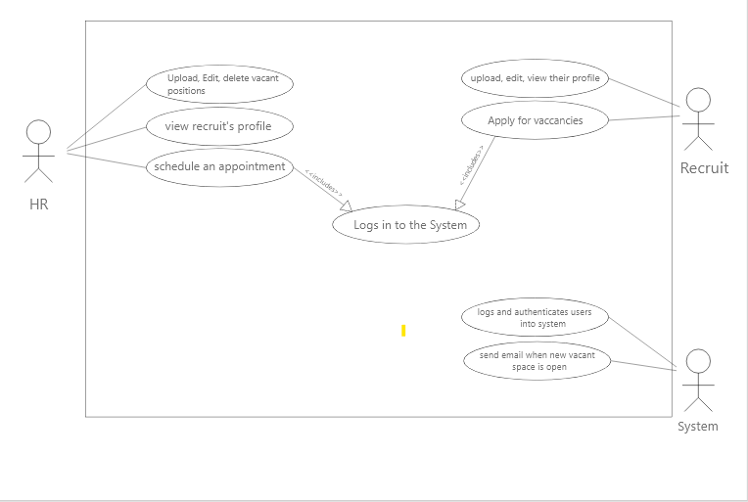

* 1. **Object Model**

The Object Model has six different classes with their own relationships. The Classes are normalized to a degree that befits the project.

The classes are: -

* The user class
* The user Extension class
* The Education class
* The Experience class
* The Vacant Position Class
* The Vacant Requirements Class

The user class has a one to many relationship with the Education and Experience class and a one to one relationship with the userExtension class. And also the Vacant Position class has a one to many relationship with the vacant requirements class.

* + 1. **Class Diagram**

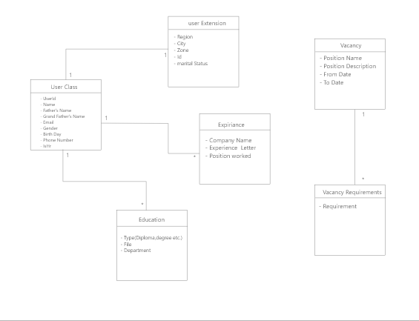

**CHAPTER FIVE**

1. **SYSTEM DESIGN**
   1. **User Interface Design**

The UI/UX has been designed using Adobe XD as mentioned above. In the design, the theme of the existing official website of the bank has been preserved. Below are provided sample screenshots of the designed pages for the site.

1. Landing page

The landing page has two sections, slider section, to give visitors the background of the site and jobs section where available jobs are listed with vague details and users are required to log in for details.

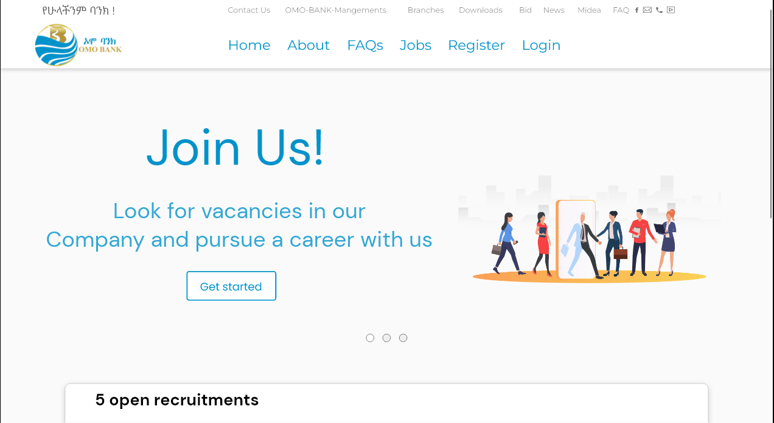

Figure 1: Landing page section 1 screenshot

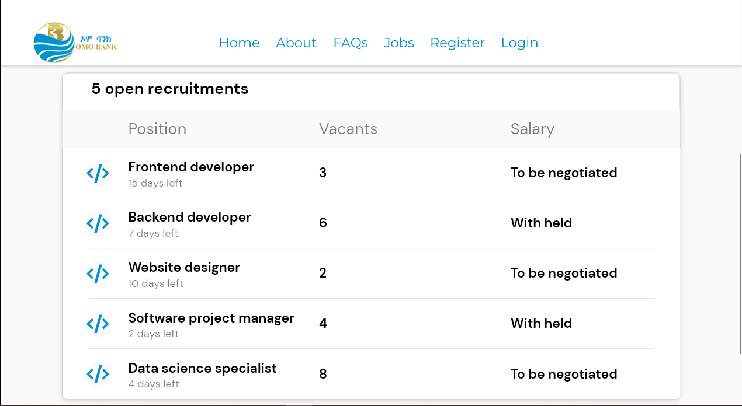

Figure 2: Landing page section 2 screenshot

1. Login page

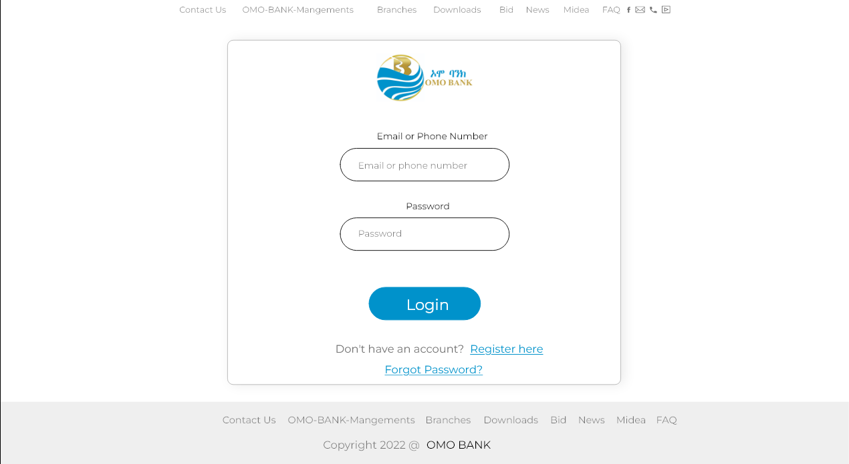

Figure 3: Login page screenshot

1. Registration page

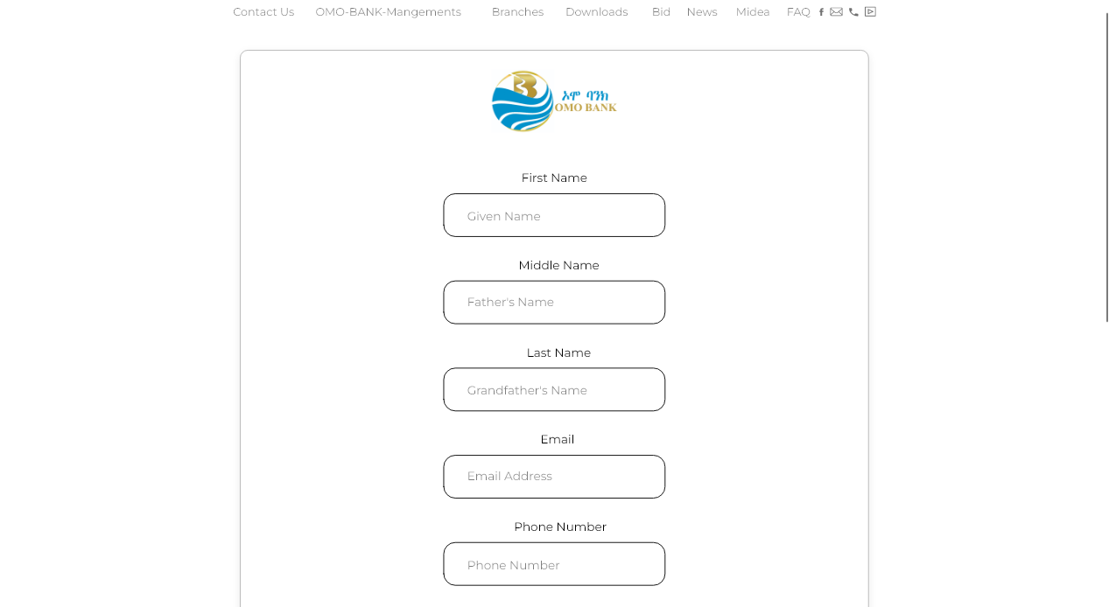

Figure 4: Registration page screenshot 1

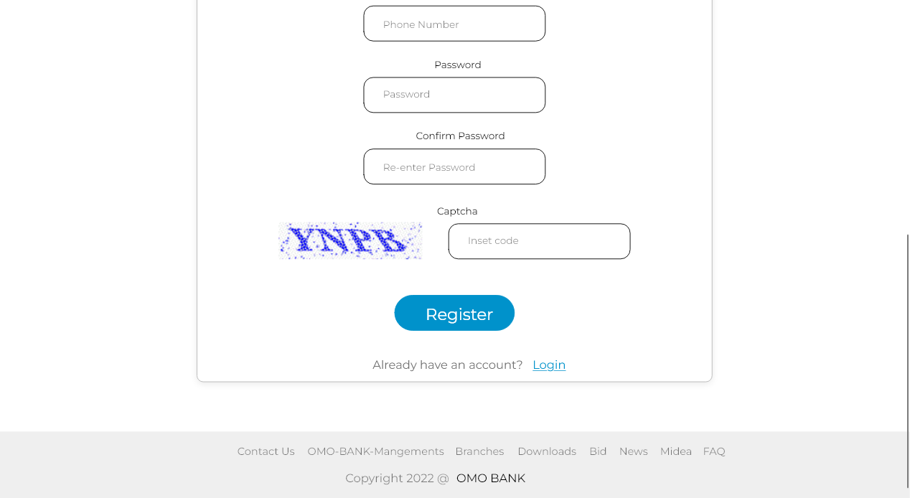

Figure 5: Registration page screenshot 2

1. Recruiter’s home page

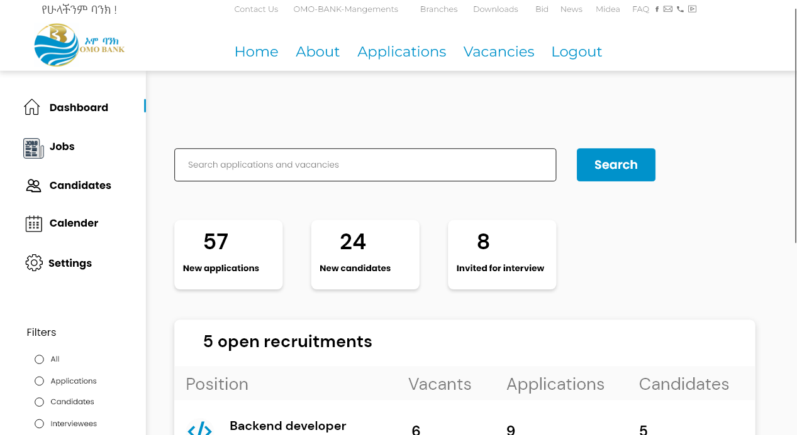

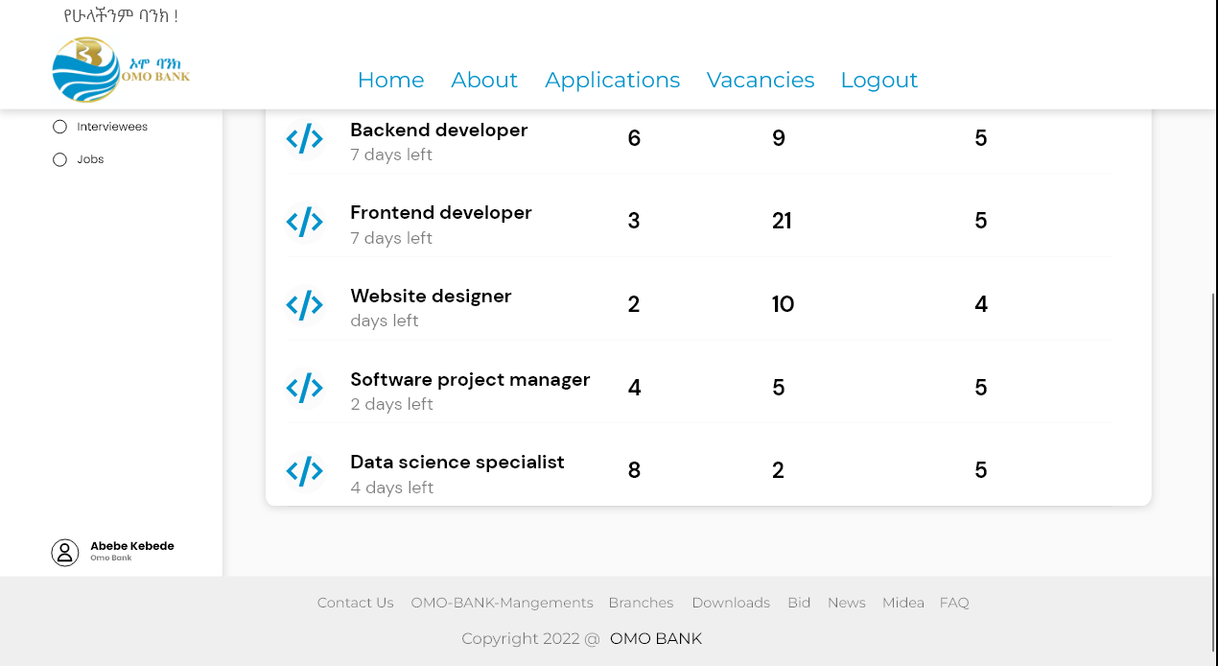Figure 7: Recruiter's home page section 1 screenshot

Figure 6: Recruiter's home page section 2 screenshot

**CHAPTER SIX**

1. **CONCLUSION AND RECOMMENDATION**
   1. **Conclusion**

In General, the system has an improved solution to the presented problem in a way that integrates technology and digital world which makes it open to further improvements and also makes the system more manageable. After completion the project will provide the bank with up-to-Date way of recruiting its employees from all over the country.

* 1. **Recommendation**

However, there are some improvement and future ideas that can be applied to make a fully functional website. Some of them are:

* Intergrade smart interview room by adding Skype facility.
* Intergrade existing notification facility by adding SMS facility.
* Mobile App.
* Add social media plugins to the system to get more publicity for vacancies.
* Integrated existing online test module with a time limit.
* Applicant tracking facility.