Data Quality Control Report

**Report Date:** 2017-05-17

# DATA FILE INFORMATION

**Filename:** QC_ECO66G12_Aw_20130426_20130725.csv

**SiteID:** ECO66G12

**Period of Record, Requested:** 2013-04-26 to 2013-07-25

**Period of Record, Actual:** 2013-04-26 to 2013-07-25

**Recording Interval:** 30 minutes

**Data Type:** Aw

**Parameters Included:** Water.Temp.C, Air.Temp.C, Water.BP.psi, Air.BP.psi, Water.Level.ft, Discrete.Water.Temp.C, Discrete.Air.Temp.C, Discrete.Water.Level.ft,

# DATA SUMMARY, OVERALL

Estimated number of records per day is 48.

Number of records by year and month (with totals).

|  |  |  |  |  |  |
| --- | --- | --- | --- | --- | --- |
|  | 4 | 5 | 6 | 7 | Sum |
| 2013 | 219 | 1488 | 1440 | 1173 | 4320 |
| Sum | 219 | 1488 | 1440 | 1173 | 4320 |

Number of records by day and month (with totals).

|  |  |  |  |  |  |
| --- | --- | --- | --- | --- | --- |
|  | 4 | 5 | 6 | 7 | Sum |
| 1 | 0 | 48 | 48 | 48 | 144 |
| 2 | 0 | 48 | 48 | 48 | 144 |
| 3 | 0 | 48 | 48 | 48 | 144 |
| 4 | 0 | 48 | 48 | 48 | 144 |
| 5 | 0 | 48 | 48 | 48 | 144 |
| 6 | 0 | 48 | 48 | 48 | 144 |
| 7 | 0 | 48 | 48 | 48 | 144 |
| 8 | 0 | 48 | 48 | 48 | 144 |
| 9 | 0 | 48 | 48 | 48 | 144 |
| 10 | 0 | 48 | 48 | 48 | 144 |
| 11 | 0 | 48 | 48 | 48 | 144 |
| 12 | 0 | 48 | 48 | 48 | 144 |
| 13 | 0 | 48 | 48 | 48 | 144 |
| 14 | 0 | 48 | 48 | 48 | 144 |
| 15 | 0 | 48 | 48 | 48 | 144 |
| 16 | 0 | 48 | 48 | 48 | 144 |
| 17 | 0 | 48 | 48 | 48 | 144 |
| 18 | 0 | 48 | 48 | 48 | 144 |
| 19 | 0 | 48 | 48 | 48 | 144 |
| 20 | 0 | 48 | 48 | 48 | 144 |
| 21 | 0 | 48 | 48 | 48 | 144 |
| 22 | 0 | 48 | 48 | 48 | 144 |
| 23 | 0 | 48 | 48 | 48 | 144 |
| 24 | 0 | 48 | 48 | 48 | 144 |
| 25 | 0 | 48 | 48 | 21 | 117 |
| 26 | 27 | 48 | 48 | 0 | 123 |
| 27 | 48 | 48 | 48 | 0 | 144 |
| 28 | 48 | 48 | 48 | 0 | 144 |
| 29 | 48 | 48 | 48 | 0 | 144 |
| 30 | 48 | 48 | 48 | 0 | 144 |
| 31 | 0 | 48 | 0 | 0 | 48 |
| Sum | 219 | 1488 | 1440 | 1173 | 4320 |

Below are the dates with missing data between the min (2013-04-26) and max(2013-07-25 for the provided data. There are 0 records.

[1] ""

# FLAGS, OVERALL, BY PARAMETER

Flags are assigned to each data point (a single measured parameter at a unique point in time) first by each of the QC tests below. Flags are assigned numerical values;

* **P** = Pass,
* **S** = Suspect,
* **F** = Fail,
* **X** = No Data or Not Applicable (NA).

Overall flags are assigned by examining the results of the four tests below.

* **P** = no Fail or Suspect and at least one Pass,
* **S** = no Fail and at least one Suspect,
* **F** = at least one Fail,,
* **X** = all tests were Missing Data.

Overall flags by parameter

## Water.Temp.C

|  |  |  |
| --- | --- | --- |
| P | S | Sum |
| 4297 | 23 | 4320 |

## Air.Temp.C

|  |  |
| --- | --- |
| P | Sum |
| 4320 | 4320 |

## Water.BP.psi

|  |  |  |
| --- | --- | --- |
| P | S | Sum |
| 4318 | 2 | 4320 |

## Air.BP.psi

|  |  |
| --- | --- |
| P | Sum |
| 4320 | 4320 |

## Water.Level.ft

|  |  |  |
| --- | --- | --- |
| P | S | Sum |
| 4302 | 18 | 4320 |

# QC TESTS, BY PARAMETER

* **Gross Range Test (Gross):** Test if data point exceeds sensor or user defined min/max. The values are user defined based on parameter being measured and measuring instrument.
* **Spike Test (Spike):** Test if data point exceeds a user defined threshold relative to the previous data point. The user defined values are based on the parameter being measured.
* **Rate of Change Test (RoC):** Test if a data point exceeds a number of standard deviations from the previous data points over a user defined time period. Default is a 25 hour time period and 3 standard deviations.
* **Flat Line Test (Flat):** Test if a data point is within a user defined threshold from previous data points over a user defined range. Default is 3 previous points for suspect and 5 points for failure. The threshold is user defined and based on the measured parameter and sensitivity of the measuring instrument.

## QC TESTS, Water.Temp.C

### Flags

#### Flag summary, overall number of records.

|  |  |  |
| --- | --- | --- |
| P | S | Sum |
| 4297 | 23 | 4320 |

Estimated number of records per day is 48.

Number of records by year and month (with totals)

|  |  |  |  |  |  |
| --- | --- | --- | --- | --- | --- |
|  | 4 | 5 | 6 | 7 | Sum |
| 2013 | 219 | 1488 | 1440 | 1173 | 4320 |
| Sum | 219 | 1488 | 1440 | 1173 | 4320 |

Number of records by day and month (with totals)

|  |  |  |  |  |  |
| --- | --- | --- | --- | --- | --- |
|  | 4 | 5 | 6 | 7 | Sum |
| 1 | 0 | 48 | 48 | 48 | 144 |
| 2 | 0 | 48 | 48 | 48 | 144 |
| 3 | 0 | 48 | 48 | 48 | 144 |
| 4 | 0 | 48 | 48 | 48 | 144 |
| 5 | 0 | 48 | 48 | 48 | 144 |
| 6 | 0 | 48 | 48 | 48 | 144 |
| 7 | 0 | 48 | 48 | 48 | 144 |
| 8 | 0 | 48 | 48 | 48 | 144 |
| 9 | 0 | 48 | 48 | 48 | 144 |
| 10 | 0 | 48 | 48 | 48 | 144 |
| 11 | 0 | 48 | 48 | 48 | 144 |
| 12 | 0 | 48 | 48 | 48 | 144 |
| 13 | 0 | 48 | 48 | 48 | 144 |
| 14 | 0 | 48 | 48 | 48 | 144 |
| 15 | 0 | 48 | 48 | 48 | 144 |
| 16 | 0 | 48 | 48 | 48 | 144 |
| 17 | 0 | 48 | 48 | 48 | 144 |
| 18 | 0 | 48 | 48 | 48 | 144 |
| 19 | 0 | 48 | 48 | 48 | 144 |
| 20 | 0 | 48 | 48 | 48 | 144 |
| 21 | 0 | 48 | 48 | 48 | 144 |
| 22 | 0 | 48 | 48 | 48 | 144 |
| 23 | 0 | 48 | 48 | 48 | 144 |
| 24 | 0 | 48 | 48 | 48 | 144 |
| 25 | 0 | 48 | 48 | 21 | 117 |
| 26 | 27 | 48 | 48 | 0 | 123 |
| 27 | 48 | 48 | 48 | 0 | 144 |
| 28 | 48 | 48 | 48 | 0 | 144 |
| 29 | 48 | 48 | 48 | 0 | 144 |
| 30 | 48 | 48 | 48 | 0 | 144 |
| 31 | 0 | 48 | 0 | 0 | 48 |
| Sum | 219 | 1488 | 1440 | 1173 | 4320 |

#### Flags by QC Test

##### Flags, Gross

|  |  |
| --- | --- |
| P | Sum |
| 4320 | 4320 |

##### Flags, Spike

|  |  |  |
| --- | --- | --- |
| P | X | Sum |
| 4319 | 1 | 4320 |

##### Flags, RoC

|  |  |  |
| --- | --- | --- |
| P | X | Sum |
| 4319 | 1 | 4320 |

##### Flags, Flat

|  |  |  |
| --- | --- | --- |
| P | S | Sum |
| 4297 | 23 | 4320 |

QC Test Flag fields are saved in the data file so the user can identify data points that have been flagged as suspect or fail.

Test results marked as X (No/Missing Data) if unable to calculate the end point needed for the test. For example, the first record does not have a previous record for comparison for the Gross QC Test. QC Test flags are saved in the data file.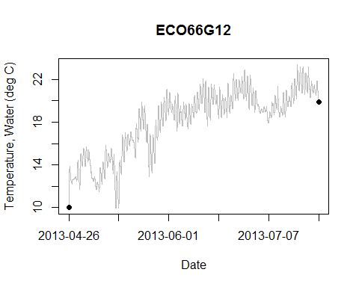

Discrete measurements, if any, show up as points on the plot.

## QC TESTS, Air.Temp.C

### Flags

#### Flag summary, overall number of records.

|  |  |
| --- | --- |
| P | Sum |
| 4320 | 4320 |

Estimated number of records per day is 48.

Number of records by year and month (with totals)

|  |  |  |  |  |  |
| --- | --- | --- | --- | --- | --- |
|  | 4 | 5 | 6 | 7 | Sum |
| 2013 | 219 | 1488 | 1440 | 1173 | 4320 |
| Sum | 219 | 1488 | 1440 | 1173 | 4320 |

Number of records by day and month (with totals)

|  |  |  |  |  |  |
| --- | --- | --- | --- | --- | --- |
|  | 4 | 5 | 6 | 7 | Sum |
| 1 | 0 | 48 | 48 | 48 | 144 |
| 2 | 0 | 48 | 48 | 48 | 144 |
| 3 | 0 | 48 | 48 | 48 | 144 |
| 4 | 0 | 48 | 48 | 48 | 144 |
| 5 | 0 | 48 | 48 | 48 | 144 |
| 6 | 0 | 48 | 48 | 48 | 144 |
| 7 | 0 | 48 | 48 | 48 | 144 |
| 8 | 0 | 48 | 48 | 48 | 144 |
| 9 | 0 | 48 | 48 | 48 | 144 |
| 10 | 0 | 48 | 48 | 48 | 144 |
| 11 | 0 | 48 | 48 | 48 | 144 |
| 12 | 0 | 48 | 48 | 48 | 144 |
| 13 | 0 | 48 | 48 | 48 | 144 |
| 14 | 0 | 48 | 48 | 48 | 144 |
| 15 | 0 | 48 | 48 | 48 | 144 |
| 16 | 0 | 48 | 48 | 48 | 144 |
| 17 | 0 | 48 | 48 | 48 | 144 |
| 18 | 0 | 48 | 48 | 48 | 144 |
| 19 | 0 | 48 | 48 | 48 | 144 |
| 20 | 0 | 48 | 48 | 48 | 144 |
| 21 | 0 | 48 | 48 | 48 | 144 |
| 22 | 0 | 48 | 48 | 48 | 144 |
| 23 | 0 | 48 | 48 | 48 | 144 |
| 24 | 0 | 48 | 48 | 48 | 144 |
| 25 | 0 | 48 | 48 | 21 | 117 |
| 26 | 27 | 48 | 48 | 0 | 123 |
| 27 | 48 | 48 | 48 | 0 | 144 |
| 28 | 48 | 48 | 48 | 0 | 144 |
| 29 | 48 | 48 | 48 | 0 | 144 |
| 30 | 48 | 48 | 48 | 0 | 144 |
| 31 | 0 | 48 | 0 | 0 | 48 |
| Sum | 219 | 1488 | 1440 | 1173 | 4320 |

#### Flags by QC Test

##### Flags, Gross

|  |  |
| --- | --- |
| P | Sum |
| 4320 | 4320 |

##### Flags, Spike

|  |  |  |
| --- | --- | --- |
| P | X | Sum |
| 4319 | 1 | 4320 |

##### Flags, RoC

|  |  |  |
| --- | --- | --- |
| P | X | Sum |
| 4319 | 1 | 4320 |

##### Flags, Flat

|  |  |
| --- | --- |
| P | Sum |
| 4320 | 4320 |

QC Test Flag fields are saved in the data file so the user can identify data points that have been flagged as suspect or fail.

Test results marked as X (No/Missing Data) if unable to calculate the end point needed for the test. For example, the first record does not have a previous record for comparison for the Gross QC Test. QC Test flags are saved in the data file.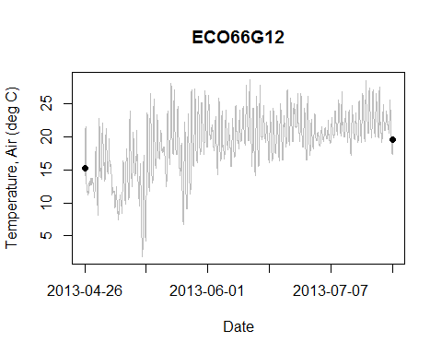

Discrete measurements, if any, show up as points on the plot.

## QC TESTS, Water.BP.psi

### Flags

#### Flag summary, overall number of records.

|  |  |  |
| --- | --- | --- |
| P | S | Sum |
| 4318 | 2 | 4320 |

Estimated number of records per day is 48.

Number of records by year and month (with totals)

|  |  |  |  |  |  |
| --- | --- | --- | --- | --- | --- |
|  | 4 | 5 | 6 | 7 | Sum |
| 2013 | 219 | 1488 | 1440 | 1173 | 4320 |
| Sum | 219 | 1488 | 1440 | 1173 | 4320 |

Number of records by day and month (with totals)

|  |  |  |  |  |  |
| --- | --- | --- | --- | --- | --- |
|  | 4 | 5 | 6 | 7 | Sum |
| 1 | 0 | 48 | 48 | 48 | 144 |
| 2 | 0 | 48 | 48 | 48 | 144 |
| 3 | 0 | 48 | 48 | 48 | 144 |
| 4 | 0 | 48 | 48 | 48 | 144 |
| 5 | 0 | 48 | 48 | 48 | 144 |
| 6 | 0 | 48 | 48 | 48 | 144 |
| 7 | 0 | 48 | 48 | 48 | 144 |
| 8 | 0 | 48 | 48 | 48 | 144 |
| 9 | 0 | 48 | 48 | 48 | 144 |
| 10 | 0 | 48 | 48 | 48 | 144 |
| 11 | 0 | 48 | 48 | 48 | 144 |
| 12 | 0 | 48 | 48 | 48 | 144 |
| 13 | 0 | 48 | 48 | 48 | 144 |
| 14 | 0 | 48 | 48 | 48 | 144 |
| 15 | 0 | 48 | 48 | 48 | 144 |
| 16 | 0 | 48 | 48 | 48 | 144 |
| 17 | 0 | 48 | 48 | 48 | 144 |
| 18 | 0 | 48 | 48 | 48 | 144 |
| 19 | 0 | 48 | 48 | 48 | 144 |
| 20 | 0 | 48 | 48 | 48 | 144 |
| 21 | 0 | 48 | 48 | 48 | 144 |
| 22 | 0 | 48 | 48 | 48 | 144 |
| 23 | 0 | 48 | 48 | 48 | 144 |
| 24 | 0 | 48 | 48 | 48 | 144 |
| 25 | 0 | 48 | 48 | 21 | 117 |
| 26 | 27 | 48 | 48 | 0 | 123 |
| 27 | 48 | 48 | 48 | 0 | 144 |
| 28 | 48 | 48 | 48 | 0 | 144 |
| 29 | 48 | 48 | 48 | 0 | 144 |
| 30 | 48 | 48 | 48 | 0 | 144 |
| 31 | 0 | 48 | 0 | 0 | 48 |
| Sum | 219 | 1488 | 1440 | 1173 | 4320 |

#### Flags by QC Test

##### Flags, Gross

|  |  |
| --- | --- |
| P | Sum |
| 4320 | 4320 |

##### Flags, Spike

|  |  |  |
| --- | --- | --- |
| P | X | Sum |
| 4319 | 1 | 4320 |

##### Flags, RoC

|  |  |  |  |
| --- | --- | --- | --- |
| P | S | X | Sum |
| 4317 | 2 | 1 | 4320 |

##### Flags, Flat

|  |  |
| --- | --- |
| P | Sum |
| 4320 | 4320 |

QC Test Flag fields are saved in the data file so the user can identify data points that have been flagged as suspect or fail.

Test results marked as X (No/Missing Data) if unable to calculate the end point needed for the test. For example, the first record does not have a previous record for comparison for the Gross QC Test. QC Test flags are saved in the data file.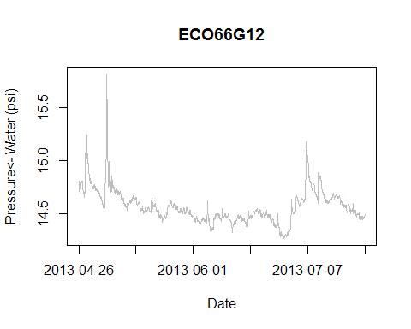

Discrete measurements, if any, show up as points on the plot.

## QC TESTS, Air.BP.psi

### Flags

#### Flag summary, overall number of records.

|  |  |
| --- | --- |
| P | Sum |
| 4320 | 4320 |

Estimated number of records per day is 48.

Number of records by year and month (with totals)

|  |  |  |  |  |  |
| --- | --- | --- | --- | --- | --- |
|  | 4 | 5 | 6 | 7 | Sum |
| 2013 | 219 | 1488 | 1440 | 1173 | 4320 |
| Sum | 219 | 1488 | 1440 | 1173 | 4320 |

Number of records by day and month (with totals)

|  |  |  |  |  |  |
| --- | --- | --- | --- | --- | --- |
|  | 4 | 5 | 6 | 7 | Sum |
| 1 | 0 | 48 | 48 | 48 | 144 |
| 2 | 0 | 48 | 48 | 48 | 144 |
| 3 | 0 | 48 | 48 | 48 | 144 |
| 4 | 0 | 48 | 48 | 48 | 144 |
| 5 | 0 | 48 | 48 | 48 | 144 |
| 6 | 0 | 48 | 48 | 48 | 144 |
| 7 | 0 | 48 | 48 | 48 | 144 |
| 8 | 0 | 48 | 48 | 48 | 144 |
| 9 | 0 | 48 | 48 | 48 | 144 |
| 10 | 0 | 48 | 48 | 48 | 144 |
| 11 | 0 | 48 | 48 | 48 | 144 |
| 12 | 0 | 48 | 48 | 48 | 144 |
| 13 | 0 | 48 | 48 | 48 | 144 |
| 14 | 0 | 48 | 48 | 48 | 144 |
| 15 | 0 | 48 | 48 | 48 | 144 |
| 16 | 0 | 48 | 48 | 48 | 144 |
| 17 | 0 | 48 | 48 | 48 | 144 |
| 18 | 0 | 48 | 48 | 48 | 144 |
| 19 | 0 | 48 | 48 | 48 | 144 |
| 20 | 0 | 48 | 48 | 48 | 144 |
| 21 | 0 | 48 | 48 | 48 | 144 |
| 22 | 0 | 48 | 48 | 48 | 144 |
| 23 | 0 | 48 | 48 | 48 | 144 |
| 24 | 0 | 48 | 48 | 48 | 144 |
| 25 | 0 | 48 | 48 | 21 | 117 |
| 26 | 27 | 48 | 48 | 0 | 123 |
| 27 | 48 | 48 | 48 | 0 | 144 |
| 28 | 48 | 48 | 48 | 0 | 144 |
| 29 | 48 | 48 | 48 | 0 | 144 |
| 30 | 48 | 48 | 48 | 0 | 144 |
| 31 | 0 | 48 | 0 | 0 | 48 |
| Sum | 219 | 1488 | 1440 | 1173 | 4320 |

#### Flags by QC Test

##### Flags, Gross

|  |  |
| --- | --- |
| P | Sum |
| 4320 | 4320 |

##### Flags, Spike

|  |  |  |
| --- | --- | --- |
| P | X | Sum |
| 4319 | 1 | 4320 |

##### Flags, RoC

|  |  |  |
| --- | --- | --- |
| P | X | Sum |
| 4319 | 1 | 4320 |

##### Flags, Flat

|  |  |
| --- | --- |
| P | Sum |
| 4320 | 4320 |

QC Test Flag fields are saved in the data file so the user can identify data points that have been flagged as suspect or fail.

Test results marked as X (No/Missing Data) if unable to calculate the end point needed for the test. For example, the first record does not have a previous record for comparison for the Gross QC Test. QC Test flags are saved in the data file.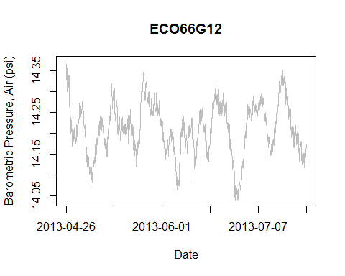

Discrete measurements, if any, show up as points on the plot.

## QC TESTS, Water.Level.ft

### Flags

#### Flag summary, overall number of records.

|  |  |  |
| --- | --- | --- |
| P | S | Sum |
| 4302 | 18 | 4320 |

Estimated number of records per day is 48.

Number of records by year and month (with totals)

|  |  |  |  |  |  |
| --- | --- | --- | --- | --- | --- |
|  | 4 | 5 | 6 | 7 | Sum |
| 2013 | 219 | 1488 | 1440 | 1173 | 4320 |
| Sum | 219 | 1488 | 1440 | 1173 | 4320 |

Number of records by day and month (with totals)

|  |  |  |  |  |  |
| --- | --- | --- | --- | --- | --- |
|  | 4 | 5 | 6 | 7 | Sum |
| 1 | 0 | 48 | 48 | 48 | 144 |
| 2 | 0 | 48 | 48 | 48 | 144 |
| 3 | 0 | 48 | 48 | 48 | 144 |
| 4 | 0 | 48 | 48 | 48 | 144 |
| 5 | 0 | 48 | 48 | 48 | 144 |
| 6 | 0 | 48 | 48 | 48 | 144 |
| 7 | 0 | 48 | 48 | 48 | 144 |
| 8 | 0 | 48 | 48 | 48 | 144 |
| 9 | 0 | 48 | 48 | 48 | 144 |
| 10 | 0 | 48 | 48 | 48 | 144 |
| 11 | 0 | 48 | 48 | 48 | 144 |
| 12 | 0 | 48 | 48 | 48 | 144 |
| 13 | 0 | 48 | 48 | 48 | 144 |
| 14 | 0 | 48 | 48 | 48 | 144 |
| 15 | 0 | 48 | 48 | 48 | 144 |
| 16 | 0 | 48 | 48 | 48 | 144 |
| 17 | 0 | 48 | 48 | 48 | 144 |
| 18 | 0 | 48 | 48 | 48 | 144 |
| 19 | 0 | 48 | 48 | 48 | 144 |
| 20 | 0 | 48 | 48 | 48 | 144 |
| 21 | 0 | 48 | 48 | 48 | 144 |
| 22 | 0 | 48 | 48 | 48 | 144 |
| 23 | 0 | 48 | 48 | 48 | 144 |
| 24 | 0 | 48 | 48 | 48 | 144 |
| 25 | 0 | 48 | 48 | 21 | 117 |
| 26 | 27 | 48 | 48 | 0 | 123 |
| 27 | 48 | 48 | 48 | 0 | 144 |
| 28 | 48 | 48 | 48 | 0 | 144 |
| 29 | 48 | 48 | 48 | 0 | 144 |
| 30 | 48 | 48 | 48 | 0 | 144 |
| 31 | 0 | 48 | 0 | 0 | 48 |
| Sum | 219 | 1488 | 1440 | 1173 | 4320 |

#### Flags by QC Test

##### Flags, Gross

|  |  |
| --- | --- |
| P | Sum |
| 4320 | 4320 |

##### Flags, Spike

|  |  |  |
| --- | --- | --- |
| P | X | Sum |
| 4319 | 1 | 4320 |

##### Flags, RoC

|  |  |  |  |
| --- | --- | --- | --- |
| P | S | X | Sum |
| 4301 | 18 | 1 | 4320 |

##### Flags, Flat

|  |  |
| --- | --- |
| P | Sum |
| 4320 | 4320 |

QC Test Flag fields are saved in the data file so the user can identify data points that have been flagged as suspect or fail.

Test results marked as X (No/Missing Data) if unable to calculate the end point needed for the test. For example, the first record does not have a previous record for comparison for the Gross QC Test. QC Test flags are saved in the data file.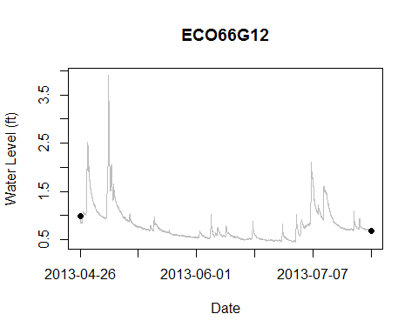

Discrete measurements, if any, show up as points on the plot.

# PLOTS, MULTIPARAMETER

Multiparameter plots if exist in the data.

## PLOT, Temperature (Air vs. Water)

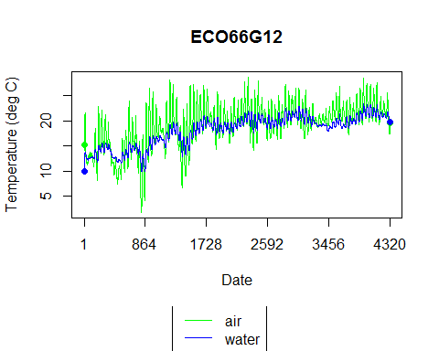

Discrete measurements, if any, show up as points on the plot.

## PLOT, Water Level vs. Water Temperature

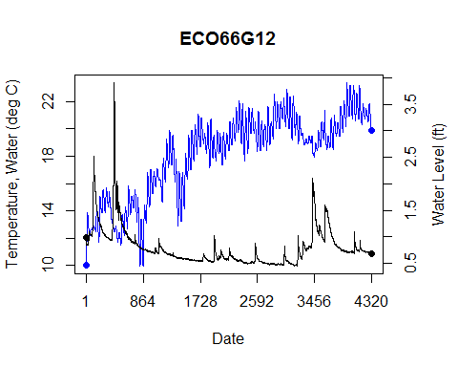

Discrete measurements, if any, show up as points on the plot.