**ADDIS ABABA INSTITUTE OF TECHNOLOGY**

**SCHOOL OF ELECTRICAL AND COMPUTER ENGINEERING**

SENIOR SEMESTER PROJECT PROGRESS REPORT

REALTIME WIRELESS WEATHER STATION (RTWWS)

Prepared by:

Mathias Assefa ---------------------- TCR/2295/02

Tsegaye Atsbeha --------------------- TCR/2690/02

Dagim Feyessa ------------------------- TCR/1892/02

Project Advisor:

Yalew Kidane

February 2014

Addis Ababa, ETHIOPIA

Table of Contents

ACKNOWLEDGEMENT 2

ABSTRACT 3

INTRODUCTION 4

METHODOLOGY 5

ANALYTICAL METHODS AND TECHNIQUES 6

EXPERIMENTAL, SIMULATION RESULTS 7

EVALUATION OF ACCURACY 8

DISCCUSSION OF RESULTS AND SUGGESTIONS FOR FURTHER WORK 9

Results 9

Temperature Data: 9

Light Intensity Data: 9

Pressure Data 9

Suggestion for Further Work 10

CONCLUSION 11

REFERENCE 12

# ACKNOWLEDGEMENT

The gratitude goes to Dagim, Mathias and myself ;) lol

# ABSTRACT

Owing to the fact that weather forecast involves sophisticated equipment, high processing supercomputers and well trained manpower, makes it less available for people with low income and financial problems. Nowadays, with the advent of technology, weather data is available on several devices and various forms. Even though weather data is available on the internet, mobile devices and so on, it is not easy to get access to the real time weather data of a specific location. Real Time Wireless Weather Station, therefore, aims to solve this problem.

The project, being a two semester plan, we have been searching, and surveying for resources, methods and techniques that would help us to achieve our goal and make it reality. Our objective is to design, and prototype real time wireless weather station which provides complete weather data of a specific geographical location (for instance AAiT Campus’ Green Area). So that the user can get access to the data via web-browser or mobile app using internet.

# INTRODUCTION

These days, most of our lives depend not only on the past events and/or the future but also highly on the current ones. It is better understood getting enough data about the current situation would give an insight to the future. This is one of our initiative ideas behind the project choice and motivation that let us work on it. Our daily life is highly influenced by the weather condition surrounding us. Irrespective of what profession people have; farmer, teacher, politician, astronaut, leader, lawyer, and so forth wherever they live, there is an intersection point that makes us all curious about the weather around.

Of course we know that weather data is available, nowadays, more abundantly than ever. But is it sufficient? Do we have accurate and reliable weather data in hand? The answer is obvious, for most of the society in the world, it is not. At least for our country, Ethiopia, not even close. Have you ever wondered when you saw the weather forecast for Addis Ababa that indicates it won’t be raining, and when you go out for shopping you got yourself in trouble? Perhaps, that would not have happened, if you had access to weather data (forecast) of a specific location in real time. And this would make it more reliable if more locations have such weather stations that gather and send data to a central system whereby anyone can simply browse and see what is going on around.

# METHODOLOGY

Throughout the project course, we have been seeking for best ways to accomplish our project. At the beginning we got interested in the problem by observation. In fact, we had more than three topics but at last we settled to do real time wireless weather station. Once we made our mind, we started gathering as much information as possible and kept looking for resources and materials that would facilitate the project development process.

Basically, data is collected with sensors (temperature, pressure, humidity, light intensity, rain, wind etc…). Analog data is collected by the various sensors incorporated which is then processed by hardware (in this case Arduino UNO is used). The analog data is digitized by the Arduino (ADC) and then forwarded to the central station (Raspberry Pi). The raspberry pi provides wireless communication with the central server whereby data is processed for further use and maintenance. The technical details of these system will be discussed in detail later on.

Therefore, from the hardware side the basic functions are raw data collection (analog data), analog to digital conversion (digitizing data), and then send data to central server (wireless communication). From the software side, programs are written to control these activities, process data, and user interface whereby user can see weather data. There should be system management module whereby administrator (authorized personnel) make changes and/or send configuration commands to the weather station(s).

/////////////////////////////////////////////////////////////////////////////////////////////////////

Our system working principle is:

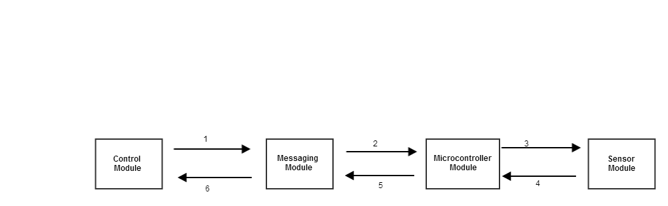

1. The control module sends command (using rabbitmq) to the messaging module (for a specific raspberry pi and Arduino/microcontroller) whenever it requires a certain data. Such as device status, and readings.
2. The messaging broker receives commands from the control module which in turn transfer the command to a specific microcontroller. It main function is for routing messages and/or commands using rabbitmq services.
3. The microcontroller module reads the state/value of the sensor and executes command based on the command received from the messaging module. This is done through serial communication.
4. Sensor module is used to gather weather conditions. Based on the states set by the microcontroller, sensors can be set to state ON or state OFF. Which later on the data is read and processed by the microcontroller.
5. The microcontroller, reads and process data from the sensor module. Since analog data is read by the sensors, it should be digitized for further process and usage (forwarded to the messaging module).
6. Finally, the messaging module receives processed data. These data is then displayed to the end user.

# EXPERIMENTAL AND SIMULATION RESULTS

# DISCCUSSION OF RESULTS AND SUGGESTIONS FOR FURTHER WORK

## Results

According to the project timeline, we believe that the required goal has been achieved. The results and outcomes we found from the testing and experimentation are discussed below.

## Temperature Data:

Analog temperature data has been received from the temperature sensor and were able to log and display data on terminal window from Arduino. The received data was promising and precise. Sample readings are shown below.

## Light Intensity Data:

Analog light intensity data has been received from the light sensor and were able to log and display data on terminal window from Arduino. The received data was promising and precise. Sample readings are shown below.

## Pressure Data

Analog pressure data has been received from the pressure sensor and were able to log and display data on terminal window from Arduino. The received data was promising and precise. Sample readings are shown below.

# Suggestion for Further Work

For the first term of our project, we limited ourselves to do the complete system design; including high level and detail design. And we believe that our project can succeed if the necessary resources and materials are accessible. We understand, however, that our capacity is limited and all we can do is use every resource we have on hand use it effectively. Therefore, we believe prototyping with few sensors that can give an overview on the general weather station system and its working principles.

This being said, we know we have much more to be done by the next term. The weather station has to be complete. Here, the term complete means, it should function as it is needed as of the plan we designed in the beginning. In addition to receiving real time weather data, and displaying to the user, prediction mechanisms, geographical location, web-based user interface, mobile app and additional sensors should be incorporated.

# CONCLUSION

# REFERENCE