Random Taco Cookbook

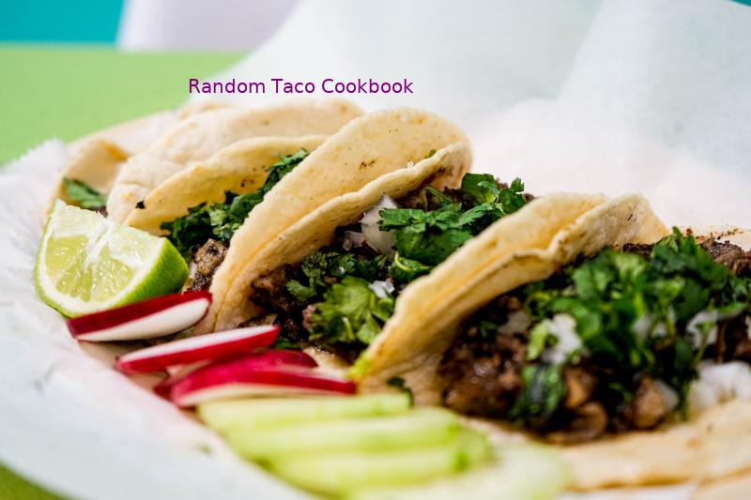

Tai's Captures

https://taco-1150.herokuapp.com/random/?full_taco=true

first last

# Universal Taco Seasoning

Universal Taco Seasoning  
========================  
  
I got tired of buying packets of store-bought taco seasoning, so I experimented with various spices and ratios until I landed on this recipe. I keep a jar of it in the cupboard at all times.  
  
* 6 tbsp chili powder  
* 4 tbsp cumin  
* 4 tbsp corn starch  
* 3 tbsp onion powder  
* 1 tbsp salt  
* 1 tbsp garlic powder  
* 4 tsp oregano (Mexican oregano, if you've got it)  
* 2 tsp crushed red pepper  
  
Combine in Mason jar and shake well to combine.  
  
This mix works well for chicken, pork and beef, destined for the grill, oven, slow cooker or stovetop. You could tweak it a bit to target a specific meat, but I like to have a base, universal mix around. Makes it super easy to turn leftover anything into delicious taco filling: Just chop up whatever it is, toss it into a skillet, sprinkle generously with seasoning, then add a bit of water and simmer to impart flavor.

Mango Lime Salsa  
======================  
  
This fresh mango salsa is sweet, tangy, and simple. It pairs exceedingly well with Garlic Lime Sauce for delicious fish tacos. The recipe is a simplified version of the [mango salsa](http://www.loveandoliveoil.com/2008/04/fish-tacos-with-mango-salsa.html) on Love and Oil.  
  
In a bowl, combine:  
* 2 ripe fresh mangoes, chopped   
* 1/2 cup diced sweet onion  
* 1-2 tablespoons chopped fresh cilantro  
* Juice of 1 fresh lime  
* (optional): 1/2 fresh jalapeno, diced  
  
Stir and serve.

Drunken Green Beans  
===================  
  
Green beans are fine. Green beans cooked in beer are better. Maybe even the best.  
  
* 1 Surly fist full of green beans  
* half a beer  
* quarter cup vegetable broth  
* 2 cloves garlic  
* 1 Tbsp olive oil  
* some salt, whatever  
  
First peel and dice the garlic and sauté it in the olive oil. Before it gets all burned and ruined, add the beer and vegetable broth.   
   
As the liquid comes to a boil, cut the green beans up. Add the green beans and a pinch of salt and let them simmer for about five minutes. If you like your beans on the softer side you can let it go a little longer. But the trick is to pull them right after the color starts to turn and you've just made a delicious addition to any taco.

North Carolina Battered Catfish  
===============================  
  
Do it right and [stick your arm down a catfish hole in the muddy waters of a north carolina pond](http://www.youtube.com/watch?v=zc_huHb4PMc), take that sucker home at serve it up to your friends and family on some corn tortilas  
  
* 1 cup all-purpose flour  
* 1 cup cornmeal  
* 1 tablespoon baking powder  
* 1 tablespoon kosher salt  
* 1/2 teaspoon cayenne pepper  
* 1 (12-ounce) bottle amber beer  
* 4 (6-ounce) catfish fillets  
* 1 tablespoon salt  
* 1 tablespoon cracked black pepper  
* 2 tablespoons granulated garlic  
* 1 lemon, juiced  
  
Preheat a deep-fryer to 350 degrees Fahrenheit.  
  
In a large bowl, add the flour, cornmeal, baking powder, salt and cayenne and whisk to combine. Whisk in the beer, being sure to remove any lumps.  
  
Cut the catfish fillets in half lengthwise to make 2 strips. If desired, cut into bite-sized pieces. In a small bowl add the salt, pepper and granulated garlic. Season the fillets with the salt mixture.  
  
Dip each strip in the beer batter and add to the fryer, a few at a time, moving them around so they don't stick. Fry until brown and crispy, about 3 to 4 minutes. Remove from the fryer to a serving platter. Repeat with the remaining fillets and season the fish with lemon juice. Cut them up into taco size portions and show your friends how amazing your catch tastes.

# Zaatar

Zaatar  
======  
  
_A.k.a. za‘tar, za’atar, zattr, etc._  
  
Zaatar is a thyme-based Middle Eastern seasoning that adapts well to tacos. It has a pleasantly dry, faintly sour/bitter flavor. It goes well on savory bases like squash and lamb, and combines with other sour seasonings like lemon juice and radish.  
  
There are many kinds of zaatar, some quite different; this recipe is representative, not definitive.  
  
* 4 units thyme  
* 2 units oregano  
* 2 units sesame seeds  
* 0–1 unit salt  
* 1 unit sumac (to be found at a Lebanese or Syrian market, or at a yuppie grocery; in a pinch, lemon zest can substitute)  
* Other herbs to taste: fennel pollen, marjoram, cumin, etc.  
* Optional: trace olive oil or lemon juice as a binder (but not if you plan to store it)  
  
Toast the sesame seeds. Grind all ingredients together using any method, stopping when the mixture is not too fine to pick up by pinching.  
  
May be added to meat during cooking, or sprinkled over a finshied taco.  
  
The latest theories have not ruled out the possibility of a zaatar mole.

Phoning it in Pico de Gallo  
===========================  
  
_Super Quick & Easy Pico_  
  
  
* 1 pint grape tomatoes, quartered (make your kids do this part)  
* 3 tablespoons finely chopped white onion  
* Coarse salt  
* Squeeze of lime  
* As many finely chopped red (or green) jalapeños as you want (optional)  
  
Combine the tomatoes, cilantro and onion together in a bowl. Season to taste with salt and lime.  
  
Reserve some of this mixture for kids, and then add as much jalapeño as you like to the remaining mixture for the non wimps.

Potato Hash  
===================  
  
* 6 or so small yukon gold poatoes   
* 4 green onion, chopped  
* 1/2 small can of green chiles  
* olive oil  
* coarse salt  
* 1/4t chili powder  
* dash cumin  
* 1/4t garlic powder  
* Nutrional yeast (optional)  
  
  
Peel and dice potatoes, throw in a pan with a 1/4 or so of water, cover and cook on medium-high until potatoes are soft.  
Once potatoes are soft, lower to medium heat add green onions, chiles, spices and olive oil. Cook until hash-like. BOOM.

Carnitas  
========  
  
This recipe calls for both slow cooking the roast as well as frying before serving.  
  
__Ingredients__  
  
* Pork shoulder roast  
* Onion and Garlic powder  
* Jalapenos  
* Green Onions  
  
  
__Directions__  
  
1. Place a pork shoulder roast in a crock pot, cover roast completely with water.   
2. Sprinkle onion & garlic powder into crock pot.   
3. Cook for 6 to 8 hours on high, or 8 to 10 hours on low.  
4. If frying at a later time, refrigerate roast with some of the cooking water.  
5. When ready to make tacos, shred the meat.  
6. Chop up as much jalapenos and green onions as desired.   
7. In a large frying pan add some oil. When the oil is hot but not burning add the meat and fry.   
8. Add some of the cooking water as needed to fry pan to keep the meat moist.  
9. In the last 5 or so minutes of cooking the meat, add the jalapenos and onions to meat.  
10. Meat should come out crispy but still moist  
11. Serve on tortillas (preferably soft corn tortillas) with choice of condiments (salsa, cheese, onions, etc)

# Sriracha Salt

Sriracha Salt  
=============  
  
I actually received this as a gift, but I found a recipe to make your own.  
  
__Ingredients__  
  
* 1 cup Salt  
* 10 tsp. Sriracha  
  
Mix the two ingredients together in a bowl. Spread it out on a baking sheet lined with foil or parchment paper. Put in a 200-degree oven, then turn the oven off and let it sit overnight inside. It will clump, but place in ziplock bag and attack it with a rolling pin. Tada!  
  
The effect on most food is as awesome as you'd expect but it is especially amazing with eggs. Add it to your breakfast tacos.

Salsa Sauce  
============  
  
From What's Cookin' Cookbook: A Recipe Collection from the Schlaback Family  
  
* 14 c. tomatoes, chopped  
* 2 1/2 c. onions  
* 4 tsp. fresh garlic  
* 2 (4 oz.) canned green chilies  
* 1 tsp. garlic powder  
* 1 tsp. salt  
* 2 tsp. paprika  
* 1/2 tsp. ground cumin  
* 1/4 tsp. oregano  
* 1 tsp. chili powder  
* 1/2 c. vinegar  
* 1 Tbsp. brown sugar  
  
Mix and bring to a boil. Cook down 1 1/2 hours. Cold pack for 20 minutes.

Drunken Green Beans  
===================  
  
Green beans are fine. Green beans cooked in beer are better. Maybe even the best.  
  
* 1 Surly fist full of green beans  
* half a beer  
* quarter cup vegetable broth  
* 2 cloves garlic  
* 1 Tbsp olive oil  
* some salt, whatever  
  
First peel and dice the garlic and sauté it in the olive oil. Before it gets all burned and ruined, add the beer and vegetable broth.   
   
As the liquid comes to a boil, cut the green beans up. Add the green beans and a pinch of salt and let them simmer for about five minutes. If you like your beans on the softer side you can let it go a little longer. But the trick is to pull them right after the color starts to turn and you've just made a delicious addition to any taco.

Chorizo  
=======  
  
_Adapted from [Aredridel's Lightly Seasoned Beef](aredridel_lightly_seasoned_beef.md)_  
  
* 20 oz chorizo  
* 20 g black cumin seed, ground  
* 2 cloves garlic  
* 15 ml white wine  
* 4 g salt if wine is unsalted  
* 1/2 small white onion, diced  
* Oil to coat the pan  
  
__Directions__  
  
1. Heat oil in the pan.  
2. Add in onions, stirring occasionally until onions become translucent.  
3. Toss in the garlic, and the chorizo on top of that.  
4. Add the cumin. Brown the chorizo.  
5. Use the splash of wine to loosen anything stuck to the pan.  
  
Perfect, lightly seasoned taco meat.