Random Taco Cookbook

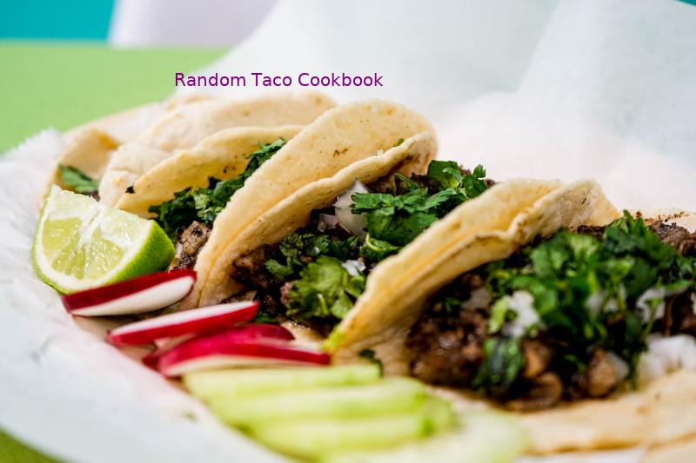

Tai's Captures

first last

https://taco-1150.herokuapp.com/random/?full_taco=true

# Zaatar

Zaatar  
======  
  
_A.k.a. za‘tar, za’atar, zattr, etc._  
  
Zaatar is a thyme-based Middle Eastern seasoning that adapts well to tacos. It has a pleasantly dry, faintly sour/bitter flavor. It goes well on savory bases like squash and lamb, and combines with other sour seasonings like lemon juice and radish.  
  
There are many kinds of zaatar, some quite different; this recipe is representative, not definitive.  
  
* 4 units thyme  
* 2 units oregano  
* 2 units sesame seeds  
* 0–1 unit salt  
* 1 unit sumac (to be found at a Lebanese or Syrian market, or at a yuppie grocery; in a pinch, lemon zest can substitute)  
* Other herbs to taste: fennel pollen, marjoram, cumin, etc.  
* Optional: trace olive oil or lemon juice as a binder (but not if you plan to store it)  
  
Toast the sesame seeds. Grind all ingredients together using any method, stopping when the mixture is not too fine to pick up by pinching.  
  
May be added to meat during cooking, or sprinkled over a finshied taco.  
  
The latest theories have not ruled out the possibility of a zaatar mole.

Mango Lime Salsa  
======================  
  
This fresh mango salsa is sweet, tangy, and simple. It pairs exceedingly well with Garlic Lime Sauce for delicious fish tacos. The recipe is a simplified version of the [mango salsa](http://www.loveandoliveoil.com/2008/04/fish-tacos-with-mango-salsa.html) on Love and Oil.  
  
In a bowl, combine:  
* 2 ripe fresh mangoes, chopped   
* 1/2 cup diced sweet onion  
* 1-2 tablespoons chopped fresh cilantro  
* Juice of 1 fresh lime  
* (optional): 1/2 fresh jalapeno, diced  
  
Stir and serve.

Lettuce (Traditional; US)  
======================  
  
In a traditional American taco, lettuce serves to add extra crunch and coolness. Favor the bulkier lettuces over leafier fare such as Bibb lettuces or mesclun.  
  
* Iceberg Lettuce (shredded)  
* Romaine Lettuce (shredded; maintain the stalks)

Moroccan Lamb  
=============  
  
A Differently Spiced Meat Than Your Usual Taco  
----------------------------------------------  
  
* 500 g ground lamb  
* 20 g Ras al Hanout spice. My mix contains:  
 * Paprika  
 * Cinnamon  
 * Allspice  
 * Clove  
 * Toasted Mustard  
 * Cumin  
 * Caraway  
 * Black Pepper  
* 10 g fresh lemon zest or 10 g finely ground Black Lemon Omani (Moroccoan dried preserved lemon)  
  
Mix together and brown.

# Quick and Dirty Spice Mix

Quick and Dirty Spice Mix  
=========================  
  
I’m not going to make a lot of big assumptions here. You own a skillet of some sort. You have some jars of jankity-ass spices from who-knows-when. You want to eat some tacos within the next, like, fifteen minutes. I got you covered, bachelor(ette).  
  
* 2 Tbsp all-purpose flour  
* 2 1/2 tsp. chili powder  
* 3/4 tsp. onion powder (or 1 1/2 tsp. minced yellow onion)  
* 1 1/4 tsp. salt  
* 1 tsp. paprika  
* 3/4 tsp beef bouillon powder  
* 1/4 tsp. granulated sugar  
* 1/4 tsp. cayenne pepper  
* 1/4 tsp. garlic powder  
* 1 tsp. cumin  
  
Put all this in something with a lid, add 3/4 cup of water, and shake it. Brown a pound of ground beef, then pour the whole situation in there. Stir. Cook it down until it looks like you only put in half a cup of water. You have tacos now.  
  
Vegetarians  
-----------  
  
I’ve made this with that soy protein “ground beef” and it does not _surprisingly_ taste like someone put spices on a stack of cheap bar coasters and ran it all through a blender. (Vegetable) oil the skillet when you’re dealing with that stuff, unless you’re looking for excuses to buy a new one.  
  
If you leave out the bouillon for the sake of doing things vegan-style you’ll probably want to nudge up the salt a little.

Guacamole  
=========  
  
This is pretty canonical stuff right here.  
  
* 1-2 ripe Hass avocados  
* half a lime  
* a clove or two of chopped garlic  
* some chopped white or yellow onion  
* salt  
* pepper  
* dry cayenne or red chile pepper powder  
* a jalapeño, if that's your thing  
* a small chopped tomato  
* a handful of chopped cilantro  
  
Look, here's how this works: First, you squeeze the lime juice into your nice little ceramic bowl. Then you add the garlic, onion, spices, peppers if you're heating it up, and then **walk away**.  
  
Seriously, walk away for a minute. Crack open a nice Negra Modelo and use a wedge of the other half of the lime in it. Back in your bowl, let the strong stuff marinate in that lime juice for a few minutes. It's cooking.  
  
OK, now that you're back, mix in the rest of the non-avocado ingredients. If you have a pestle, now's it's time to shine. If not, use a small wooden spoon, or failing all else, a fork, you miserable lout.   
  
Mash up everything but the avocado. Get it pasty if you can. Squish it all up.  
  
Now you can add your avocado or two, dude. I usually go with about 1.5 avos to condiment tacos or taco-like structures for four humans of varying sizes.  
  
Just in case no one ever taught you how to deal with an avocado correctly, here's a quick lesson:  
* Cut it in half, longways.  
* Smack the pit with the sharp edge of your knife and give it a sensible 90-degree twist.  
* Voila, the avocado pit is on your knife.  
* Dispose of it, unless you're not going to finish all that guac now, in which case, hang onto it and put it in the bowl with the guac before you put it in the fridge.  
* Now that your knife is free, use it to carve long slices into the flesh of your avocado, one half at a time. Cross-hatch that sucker a bit. Don't cut through the flesh.  
* Finally, get your avocado half above your nice bowl full of deliciousness, and use the skin to gently push your nice slices into the spicy soup below. Turn it inside-out, if you must, but know that you can minimize the amount of avocado that gets all over your hands if you do this just right.  
  
To finish up your guacamole, mash your avocado up a bit and gently mix it into the magical citric-spice-tomato concoction. We're done here.  
  
_Thanks to [The Awl](http://www.theawl.com/2010/02/half-baked-guacamole-by-the-ceviche-method) for limited inspiration regarding the limey and drinky parts._

Sweet Potato and Apple Hash  
===========================  
  
Sweet potatoes are my go-to taco punch-up. I was going my normal route of making small (1/4" or so) cubes of sweet potatoes when I thought: Hey, it's fall, I'm going to add an apple in there. Fuck yes.  
  
* 2 Small sweet potatoes (you'd be amazed how little sweet potato you need for tacos)  
* 1 Small apple  
* One can diced green chilis  
* A couple pinches of chili powder  
* A queeze of honey  
* Pat o' butter  
  
Mix this all into a pan, with about 1/4 cup of water, and boil it all up until the water goes away, toss in the butter, and continue to pan-fry until things get a little browned.

Insane Garlic Ground Turkey  
=========================  
  
While not particularly fancy, the insane garlic ground turkey is a crowd pleaser.  
  
Ground Turkey  
-----------  
  
* 2 pounds of ground turkey (preferably thigh meat)  
* Four yellow onions  
* Store-bought Taco Seasoning  
* More garlic than you can imagine (4-5 cloves)  
* Olive Oil  
  
1. Chop several onions into slices.  
2. In a large pan heat olive oil in a saucepan over high heat  
3. Cook onions on high heat until they are almost caramelized. (10 minutes)  
4. Reduce heat to medium.  
5. Add ground turkey making sure to stir meat to ensure adequate turkey / onion mixture.  
6. Cover and let turkey cook for 8 minutes.  
7. Mix taco seasoning using one cup of water for each packet of seasoning  
8. Add several cloves or garlic to pan. When in doubt with garlic always err on the side of too much.  
9. Cook uncovered until taco seasoning is reduced.  
10. Warn guests of impending garlic.  
  
Total cooking time: 30-40 minutes

# Zaatar

Zaatar  
======  
  
_A.k.a. za‘tar, za’atar, zattr, etc._  
  
Zaatar is a thyme-based Middle Eastern seasoning that adapts well to tacos. It has a pleasantly dry, faintly sour/bitter flavor. It goes well on savory bases like squash and lamb, and combines with other sour seasonings like lemon juice and radish.  
  
There are many kinds of zaatar, some quite different; this recipe is representative, not definitive.  
  
* 4 units thyme  
* 2 units oregano  
* 2 units sesame seeds  
* 0–1 unit salt  
* 1 unit sumac (to be found at a Lebanese or Syrian market, or at a yuppie grocery; in a pinch, lemon zest can substitute)  
* Other herbs to taste: fennel pollen, marjoram, cumin, etc.  
* Optional: trace olive oil or lemon juice as a binder (but not if you plan to store it)  
  
Toast the sesame seeds. Grind all ingredients together using any method, stopping when the mixture is not too fine to pick up by pinching.  
  
May be added to meat during cooking, or sprinkled over a finshied taco.  
  
The latest theories have not ruled out the possibility of a zaatar mole.

Phoning it in Pico de Gallo  
===========================  
  
_Super Quick & Easy Pico_  
  
  
* 1 pint grape tomatoes, quartered (make your kids do this part)  
* 3 tablespoons finely chopped white onion  
* Coarse salt  
* Squeeze of lime  
* As many finely chopped red (or green) jalapeños as you want (optional)  
  
Combine the tomatoes, cilantro and onion together in a bowl. Season to taste with salt and lime.  
  
Reserve some of this mixture for kids, and then add as much jalapeño as you like to the remaining mixture for the non wimps.

### Green Chile Cabbage Salad with Seared Corn  
This isn't a tradition, or even particularly traditional -- except in my apartment in Oakland, where I make this for myself ever time I make pork tacos.  
  
#### Ingredients  
* 1 green cabbage  
* 4 limes  
* 2 ears corn, or roughly two cups of corn kernels (adjust to desired corn-y-ness)  
* Dried, Powdered New Mexico Green Chile, to taste  
* Salt, to taste  
* Olive oil  
* Optional: some crumbled cotija or queso Oaxaqueno  
  
#### Directions  
1. If using ears of corn, strip the kernels from them with a sharp knife.  
2. Heat a few tablespoons of oil over high heat. I like to use a Dutch Oven for this, but the main cookware properties you want are heavy-bottomed and wide.  
3. Toss the corn kernels in to the oil, spread them evenly, salt very lightly and let them ride. I _highly_ recommend a splatter guard for this step, but **not** a lid. You want the corn to dry out just a little and get a good sear. It's done when it's starting to get dark, a little chewy, and probably is sticking to the pan.  
4. While the corn is going, core and chop the cabbage in to wide strips.  
5. How's the corn doing?  
6. Juice the limes.  
7. How's the corn doing? If it's not done yet, grab a beer and hang out 'til it is.  
8. The corn is done? Great. Toss it on top of the cabbage. Add a little salt, then a good hit of olive oil, then half-or-so of the lime juice. Toss in a good tablespoon or two of the green chile powder. Start stirring.  
9. You want everything coated nicely, but I don't like the salad too oily, so go easy on that. I add lime until the sour balances the sweet of the corn. I add green chile slowly -- it takes a second to rehydrate and get hot. I might add as much as a half cup of the stuff to a salad for myself or spicy food fans like me; I go easier on the spice-unenthused.  
10. Serve it! If you're in to tossing a little cheese on there, do it -- but I usually just eat it straight. Sometimes this goes on fish or chicken tacos; sometimes it's a side to richer pork tacos. It's always awesome.  
  
**Note on ingredients**: green chile is the gastronomical life blood of New Mexican cuisine, but it's little known in the other 49 states. I like a brand called [_Los Chileros de Nuevo Mexico_](http://www.loschileros.com/), which I can find sometimes in tiendas and other times at Whole Foods (go figure). The trick here is this: just don't accept substitutes. It's not the same. I've also had to accept that fresh chile is just not what this salad needs, so don't do that either (it doesn't distribute well enough across the cabbage). Do have this with cold, crisp beer.

Bulgar Black Bean Filling  
=========================  
  
This is a quick and easy vegetarian substitute for a ground beef-like texture without using a soy substitute.  
  
* 1 cup cooked, strained bulgar  
* 1/3 cup cooked black beans (or canned), rinsed and strained.  
  
Mix bulgar and black beans together. For better texture, slightly mash the black beans. Add your choice of seasonings to taste and serve.