Oxytocin Synthesis
Cell types/tissues: Hypothalamus (magnocellular neurons)
Notes written by us in green

- Translation of OXT gene into preprohormone

From: https://pmc.ncbi.nlm.nih.gov/articles/PMC5374331/ oxytocin is a nine amino acid peptide synthesized in the hypothalamus of the brain and it is stored in the posterior pituitary

Oxytocin biosynthesis starts the transcription of the OXT gene into mRNA into a preprohormone which will be later processed in different cellular compartments. The structure of this polypeptide is as follows:

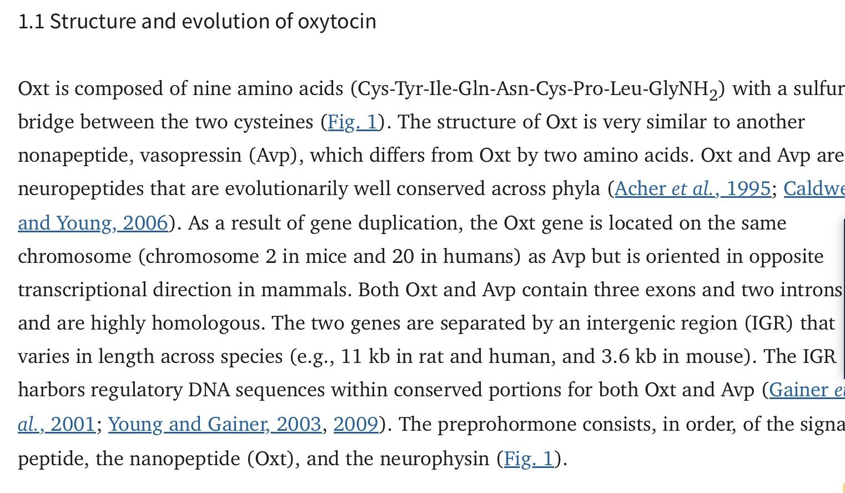
https://pmc.ncbi.nlm.nih.gov/articles/PMC2689929/

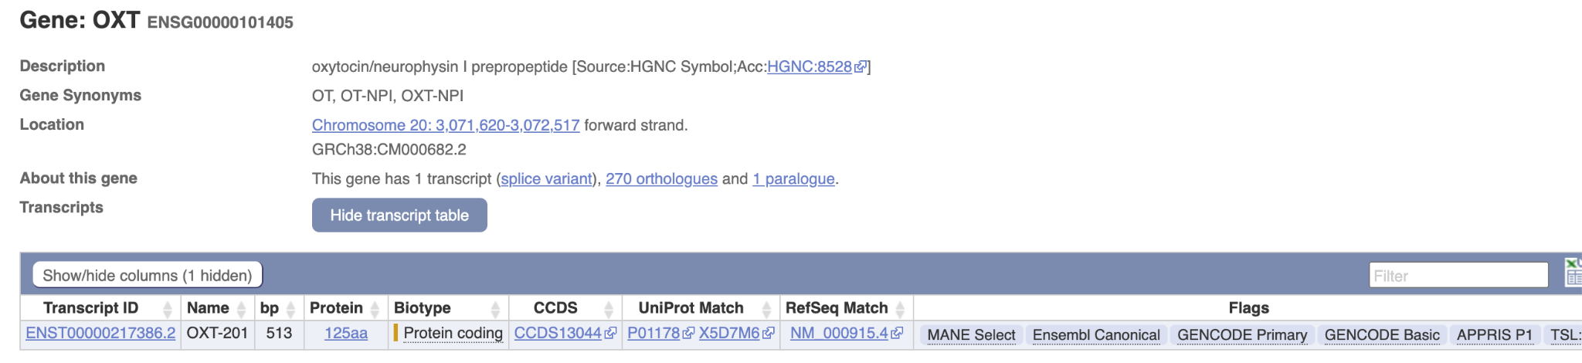

Gene | ENSEMBL id | Main transcript | Link
OXT | ENSG00000101405 | ENST00000217386, ENSP00000217386 | https://www.ensembl.org/Homo_sapiens/Gene/Summary?db=core;g=ENSG00000101405;r=20:3071620-3072517;t=ENST00000217386

This gene encodes a precursor protein that is processed to produce oxytocin and neurophysin I. Oxytocin is a posterior pituitary hormone which is synthesized as an inactive precursor in the hypothalamus along with its carrier protein neurophysin I. Together with neurophysin, it is packaged into neurosecretory vesicles and transported axonally to the nerve endings in the neurohypophysis, where it is either stored or secreted into the bloodstream. The precursor seems to be activated while it is being transported along the axon to the posterior pituitary. https://www.ncbi.nlm.nih.gov/gene/5020

GPR for translation of preprohormone: OXT

Translation:
Reaction: prepro-oxyphysin-1[c] → prepro-oxyphysin-2[c]

GPR: ENSG00000101405

- Translocation to the ER

Prepro-oxytocin is targeted and moved into the ER by the canonical SRP-dependent co-translational translocation pathway used by secretory preprohormones.

First, a ribosome translates a signal sequence that docks it to a signal recognition particle (SRP) on the rough endoplasmic reticulum (RER). Translation continues within the RER, and the growing peptide is cleaved from its signal sequence, forming a large preprohormone, which is cleaved to a prohormone, packaged in a vesicle, and sent to the Golgi apparatus.The posterior pituitary produces two peptide hormones that differ by only two AAs: oxytocin and anti-diuretic hormone (ADH). Both are nonapeptides with a disulfide bridge, which get packaged with carrier proteins called neurophysins. https://www.ncbi.nlm.nih.gov/books/NBK541112/

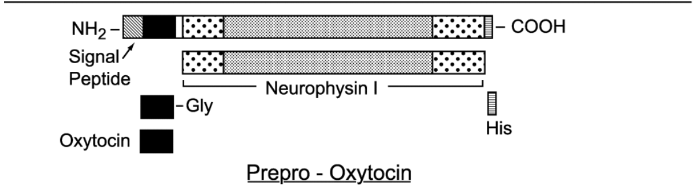
https://www.sciencedirect.com/science/chapter/bookseries/abs/pii/S1054358904500017

2.1 SRP Enzyme
According to: https://pmc.ncbi.nlm.nih.gov/articles/PMC165607/

Signal recognition particle (SRP) is a ubiquitous ribonucleoprotein particle found in all three domains of life, but its complexity has increased considerably during evolution (Walter and Johnson, 1994; Rosenblad et al., 2003) (Figure 1). Mammalian SRP consists of 7SL RNA and six protein subunits: SRP54, SRP19, SRP68, SRP72, SRP14 and SRP9. Mammalian SRP can be divided into two functional domains by micrococcal nuclease: the Alu and S domains (Gundelfinger et al., 1983). The SRP14–SRP9 heterodimer binds to one end of 7SL RNA, forming the Alu domain (Walter and Johnson, 1994; Wild et al., 2002), whereas the forked region of 7SL RNA and the remaining four proteins form the S domain.
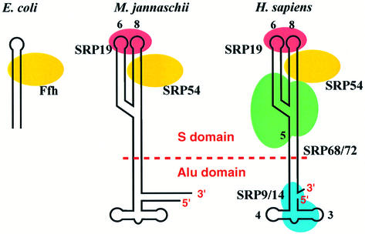
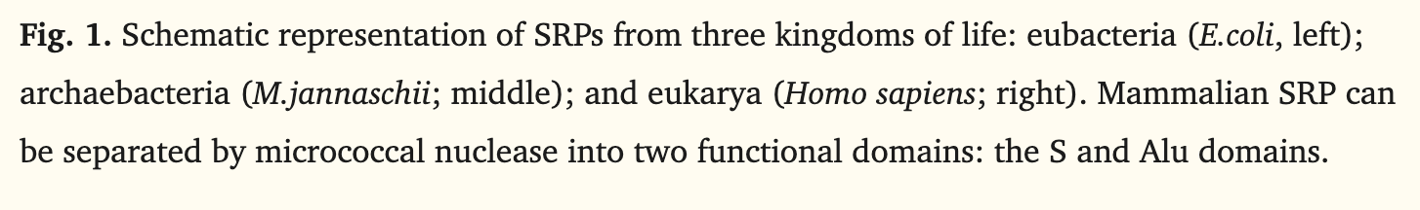

SRP Protein components
SRP GPR: SRP9 AND SRP14 AND SRP19 AND SRP54 AND SRP68 AND SRP72

Gene | ENSEMBL id | Main transcript | Link
SRP9 | ENSG00000143742 | ENST00000304786.12 | https://www.ensembl.org/Homo_sapiens/Gene/Summary?db=core;g=ENSG00000143742;r=1:225777699-225790670
SRP14 | ENSG00000140319 | ENST00000267884.11 | https://www.ensembl.org/Homo_sapiens/Gene/Summary?db=core;g=ENSG00000140319;r=15:40035690-40039181
SRP19 | ENSG00000153037 | ENST00000505459.6 | https://www.ensembl.org/Homo_sapiens/Gene/Summary?db=core;g=ENSG00000153037;r=5:112861188-112898371
SRP54 | ENSG00000100883 | ENST00000216774.11 | https://www.ensembl.org/Homo_sapiens/Gene/Summary?db=core;g=ENSG00000100883;r=14:34981957-35029686
SRP68 | ENSG00000167881 | ENST00000307877.7 | https://www.ensembl.org/Homo_sapiens/Gene/Summary?db=core;g=ENSG00000167881;r=17:76038775-76072517
SRP72 | ENSG00000174780 | ENST00000642900.1 | https://www.ensembl.org/Homo_sapiens/Gene/Summary?db=core;g=ENSG00000174780;r=4:56467595-56503681

SRP enzyme:

Reaction: prepro-oxyphysin-2[c] -> prepro-oxyphysin-2-SRP[c]

GRP: ENSG00000143742 AND ENSG00000140319 AND ENSG00000153037 AND ENSG00000100883 AND ENSG00000167881 AND ENSG00000174780

2.2 SRP receptor
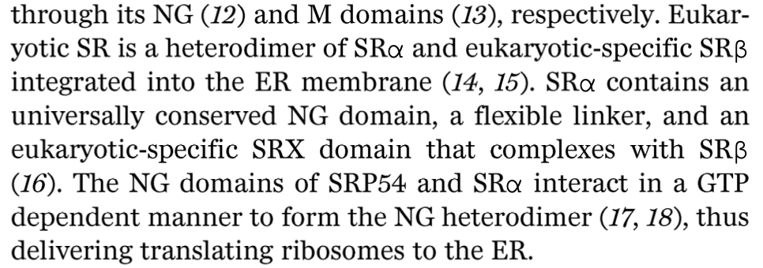
https://www.science.org/doi/10.1126/science.aar7924

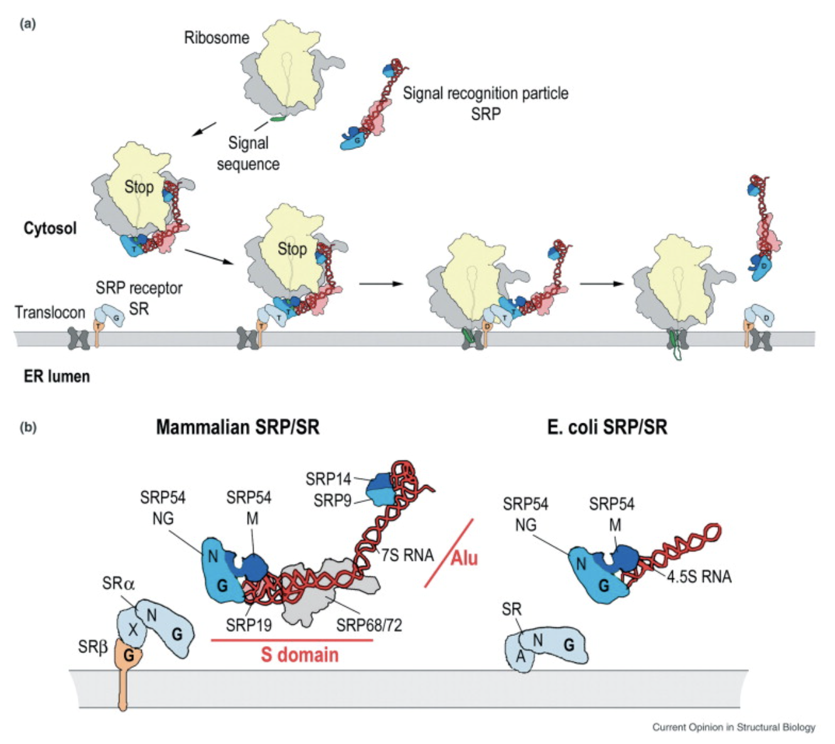
https://www.sciencedirect.com/science/article/pii/S0959440X0500014X?fr=RR-2&ref=pdf_download&rr=9bb4125a9ebd2409

In eukaryotes, SR is a heterodimer formed by the SRα and SRβ subunits. Interestingly, SRα also contains an NG domain, which is structurally and functionally homologous to the NG domain of SRP54. The NG domains of SRP54 and SR interact in the GTP-bound state during the docking step of co-translational targeting. In addition to the NG domain, SRα contains an N-terminal X domain, which interacts with SRβ. SRβ-like subunits appear to exist exclusively in eukaryotes (Figure 1b).
https://www.sciencedirect.com/science/article/pii/S0959440X0500014X?fr=RR-2&ref=pdf_download&rr=9bb4125a9ebd2409

The SRP–RNC complex docks with the membrane via SR primarily through the interaction of their NG domains, with the SRP RNA serving as a catalyst for complex formation [32]. GTP binding to SRP54 and SRα is a prerequisite to complex formation, and GTP hydrolysis leads to complex dissociation.
https://www.sciencedirect.com/science/article/pii/S0959440X0500014X?fr=RR-2&ref=pdf_download&rr=9bb4125a9ebd2409

GPR for SRP-receptor: SRPRA AND SRPRB

Gene | ENSEMBL id | Main transcript | Link
SRPRA | ENSG00000182934 | ENST00000332118.11 | https://www.ensembl.org/Homo_sapiens/Gene/Summary?db=core;g=ENSG00000182934;r=11:126262912-126269144
SRPRB | ENSG00000144867 | ENST00000466490.7 | https://www.ensembl.org/Homo_sapiens/Gene/Summary?db=core;g=ENSG00000144867;r=3:133784023-133825772

SRP receptor:

Reaction: prepro-oxyphysin-2-SRP[c] -> prepro-oxyphysin-2-SRP[r]
Where r is receptor

GRP: ENSG00000182934 AND ENSG00000144867

2.3 Sec61 Translocon

Where does Sec61 translocon fit in?
The endoplasmic reticulum (ER) is a major site for protein synthesis, folding, and maturation in eukaryotic cells, responsible for production of secretory proteins and most integral membrane proteins. The universally conserved protein-conducting channel Sec61 complex mediates core steps in these processes by translocating hydrophilic polypeptide segments of client proteins across the ER membrane and integrating hydrophobic transmembrane segments into the membrane.
https://pmc.ncbi.nlm.nih.gov/articles/PMC9808579/

Architecture of Sec61:
The Sec61 complex is a heterotrimer consisting of subunits α, β, and γ (Fig. 2). The channel is formed by the α subunit (Sec61α in eukaryotes and SecY in prokaryotes), which consists of ten TMs that are arranged in an hourglass shape (Van den Berg et al. 2004). The β and γ subunits are single-spanning membrane proteins that bind to the periphery of the α subunit.
https://pmc.ncbi.nlm.nih.gov/articles/PMC9808579/

Sec 61 translocon GPR: (SEC61A1 OR SEC61A2) AND SEC61B AND
SEC61G

Gene | ENSEMBL id | Main transcript | Link
SEC61A1 | ENSG00000058262 | ENST00000243253.8 | https://www.ensembl.org/Homo_sapiens/Gene/Summary?db=core;g=ENSG00000058262;r=3:128051641-128071705
SEC61A2 | ENSG00000065665 | ENST00000298428.14 | https://www.ensembl.org/Homo_sapiens/Gene/Summary?db=core;g=ENSG00000065665;r=10:12129637-12169961
SEC61B | ENSG00000106803 | ENST00000223641.5 | https://www.ensembl.org/Homo_sapiens/Gene/Summary?g=ENSG00000106803;r=9:99222064-99230615
SEC61G | ENSG00000132432 | ENST00000352861.9 | https://www.ensembl.org/Homo_sapiens/Gene/Summary?db=core;g=ENSG00000132432;r=7:54752180-54759974

SEC61:

Reaction: prepro-oxyphysin-2-SRP[r] -> prepro-oxyphysin-2[t]
Where t is translocon

GRP: ENSG00000058262 AND ENSG00000065665 AND ENSG00000106803 AND ENSG00000132432

Next, it will embed in the ER lumen.
Reaction: prepro-oxyphysin-2[t] -> prepro-oxyphysin-2[er]

3. Cleavage of preprohormone signal peptide catalysed by a peptidase

The hormonal precursor pro-ocytocin-neurophysin is activated by selective cleavage at Arg12-Ala13, producing mature ocytocin and neurophysin. https://pubmed.ncbi.nlm.nih.gov/9862210/

According to: https://www.sciencedirect.com/science/article/pii/S1097276521006006 , it is necessary the help of an accessory protein to cleave the signal peptide and to obtain the pro-oxytocin molecule.
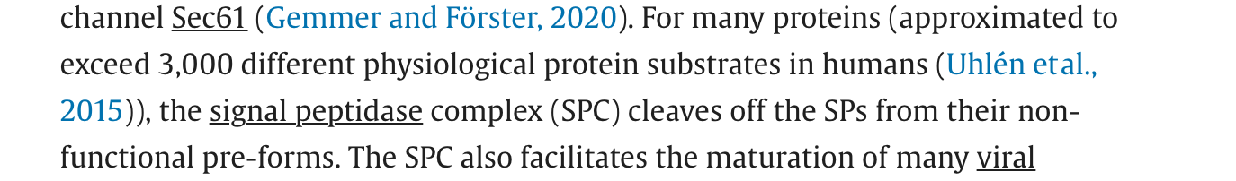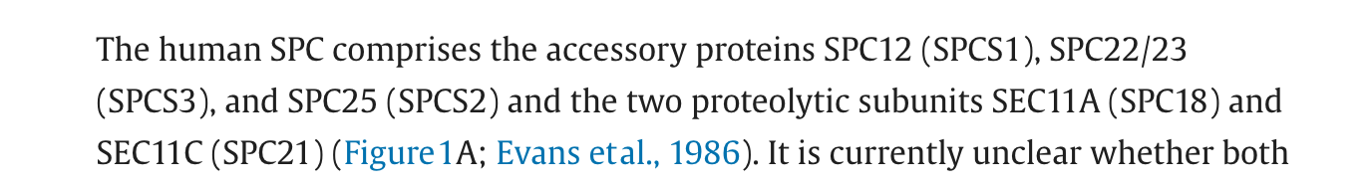
https://www.sciencedirect.com/science/article/pii/S1097276521006006

Sec11A and Sec11C are two paralog genes of the Sec11, that is why the GPR indicates either one or the other and not both at the same time.
- SPC12 AND SPC22/23 AND SPC25 AND (SEC11A OR SEC11B)

Gene | ENSEMBL id | Main transcript | Link
SPCS1 | ENSG00000114902 | ENST00000619898, ENSP00000478310 | Gene: SPCS1 (ENSG00000114902) - Summary - Homo_sapiens - Ensembl genome browser 115
SPCS3 | ENSG00000129128 | ENST00000503362, ENSP00000427463 | https://www.ensembl.org/Homo_sapiens/Gene/Summary?db=core;g=ENSG00000129128;r=4:176319966-176332245
SPCS2 | ENSG00000118363 | ENST00000263672, ENSP00000263672 | Gene: SPCS2 (ENSG00000118363) - Summary - Homo_sapiens - Ensembl genome browser 115
SEC11A | ENSG00000140612 | ENST00000268220, ENSP00000268220 | Gene: SEC11A (ENSG00000140612) - Summary - Homo_sapiens - Ensembl genome browser 115
SEC11C | ENSG00000166562 | ENST00000587834, ENSP00000468633 | Gene: SEC11C (ENSG00000166562) - Summary - Homo_sapiens - Ensembl genome browser 115

Cleavage of pre-pro-oxytocin to pro-oxytocin
Reaction: prepro-oxyphysin-2[er] → pro-oxytocin-neurophysin-I[er] + signal-peptide[er]

GPR: ENSG00000114902 AND ENSG00000129128 AND ENSG00000118363 AND (ENSG00000140612 OR ENSG00000166562)

4. Protein Folding

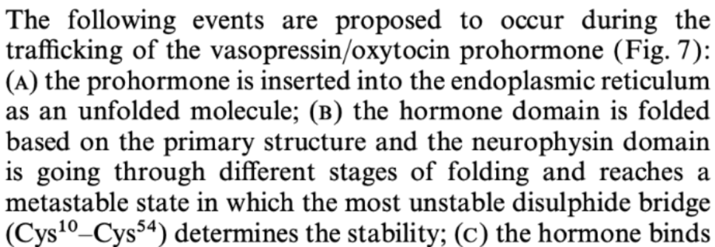

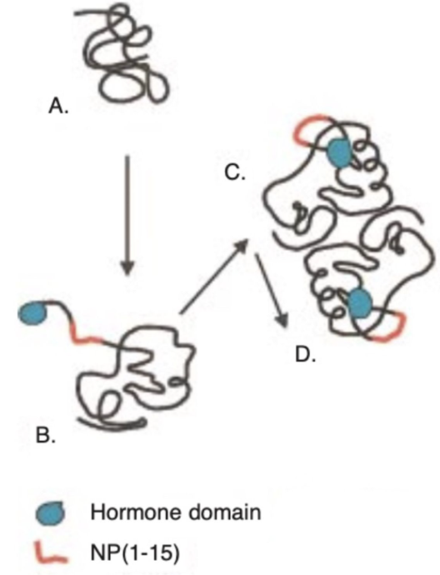

https://doi.org/10.1046/j.1365-2826.2000.00521.x.

HSPA5 (BiP) is an ER molecular chaperone that assists in the folding and quality control of secretory proteins. Its possible involvement in oxytocin biosynthesis is based on its general established role in ER protein folding, rather than direct evidence linking to oxytocin.

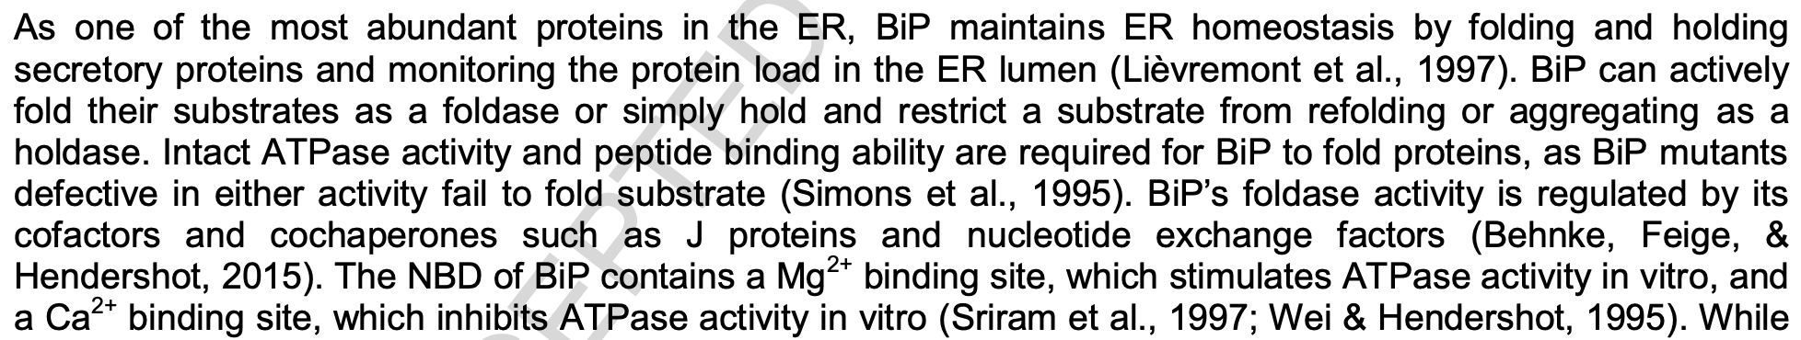

10.1016/j.gene.2017.03.005.

Gene | Ensembl id | Main transcript | Link
HSPA5/BiP | ENSG00000044574 | ENST00000324460.7 | https://www.ensembl.org/Homo_sapiens/Gene/Summary?db=core;g=ENSG00000044574;r=9:125234853-125241382.

Protein Folding
Reaction: pro-oxytocin-neurophysin I, unfolded [er] → pro-oxytocin-neurophysin I, folded [er]

GPR: ENSG00000044574

5. Formation of Disulfide Bonds

According to: https://www.mdpi.com/1422-0067/16/1/1791 & https://www.cell.com/trends/biochemical-sciences/fulltext/S0968-0004%2825%2900063-5

Disulfide bonds are formed in the endoplasmic reticulum for eukaryotic cells and they need the help of a cofactor, in this case PDI-Ero1 and PDI-Erv2 are involved in oxytocin bond formation (they are involved in hormones bond formation but im not sure if they do specifically in oxytocin, it is an assumption)

In a chemical perspective, disulfide bonds are formed between two cysteine residues via the oxidation of the two thiol groups (-SH) which will lose electrons to form sulfur radicals. Then, this sulfur radicals will combine to form the disulfide bridges (S-S)

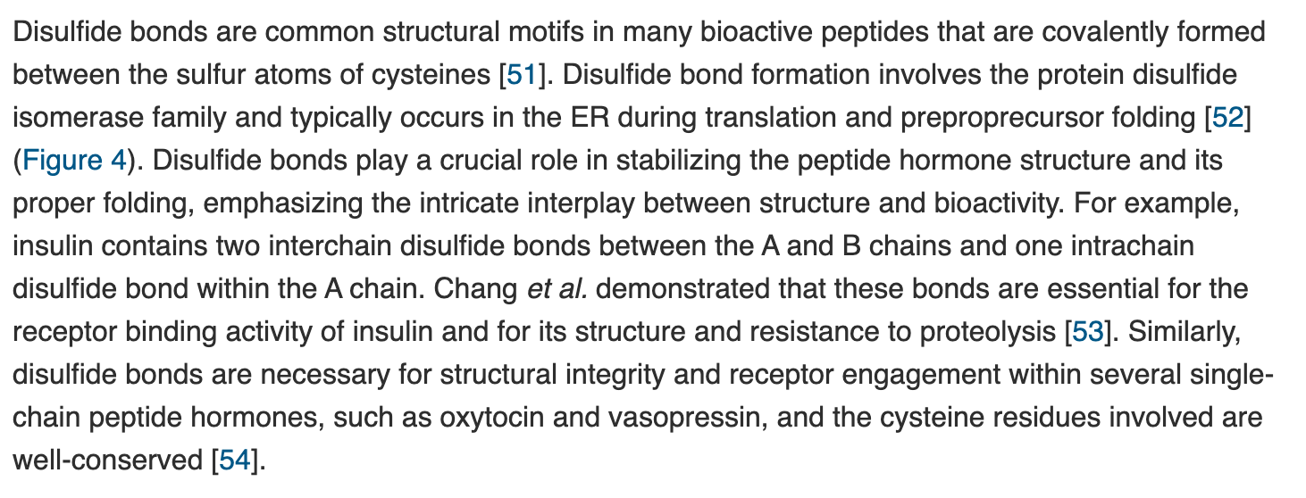

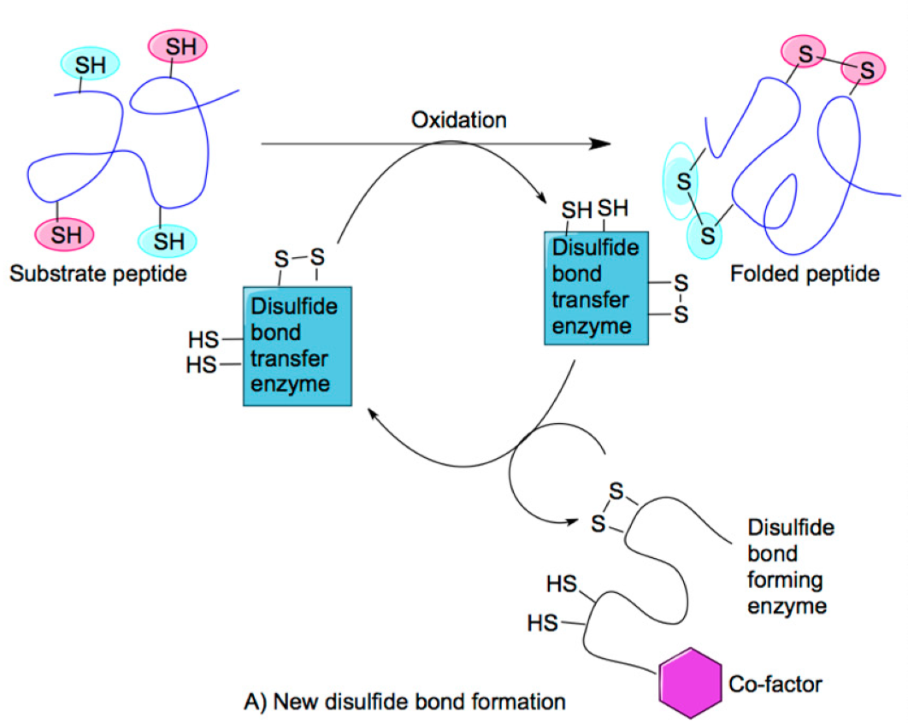

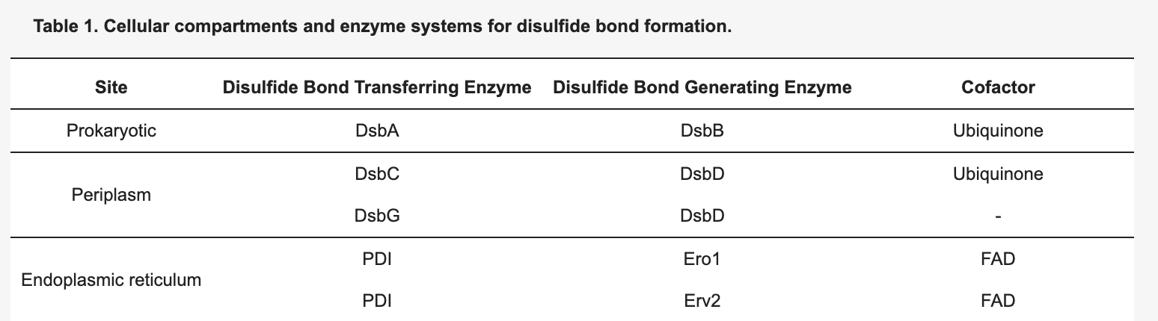

Gene | ENSEMBL id | Main transcript | Link
PDIA1/P4HB | ENSG00000185624 | ENST00000331483, ENSP00000327801 | https://www.ensembl.org/Homo_sapiens/Gene/Summary?db=core;g=ENSG00000185624;r=17:81843159-81860856
ERO1A | ENSG00000197930 | ENST00000395686, ENSP00000379042 | https://www.ensembl.org/Homo_sapiens/Gene/Summary?db=core;g=ENSG00000197930;r=14:52639915-52696025

Redox reactions

- Regeneration of EROI
Reaction: 2 O2[er] + ERO1-4SH[er]→2 H2O2 + ERO1-4S[er]
GPR rules: ERO1A OR ERO1B
- Regeneration of PDIA1
Reaction: PDIA1-4SH[er] + ERO1-4S[er] →PDIA1-4S[er] + ERO1-4SH[er]
GPR rules: (ERO1A OR ERO1B) AND P4HB
- Folding of Oxytocin
Reaction: pro-oxytocin (reduced)[er] + PDIA1-4S[er]→pro-oxytocin (oxidized, folded)[er] + PDIA1-4SH[er]GPR rules: P4HB

Evidence suggests PRDX4 has involvement in oxidative protein folding within the ER, supporting PDI-mediated disulfide bond formation by handling H₂O₂, however no oxytocin-specific role has been proven.

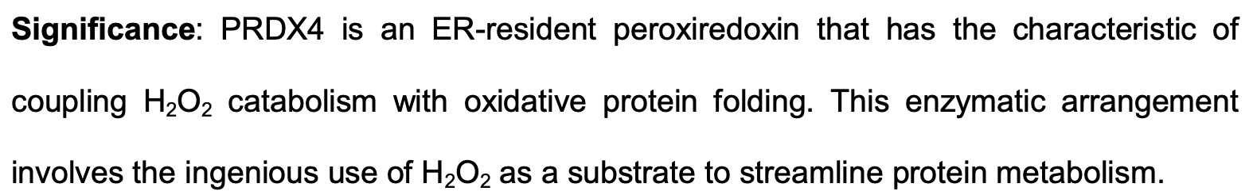

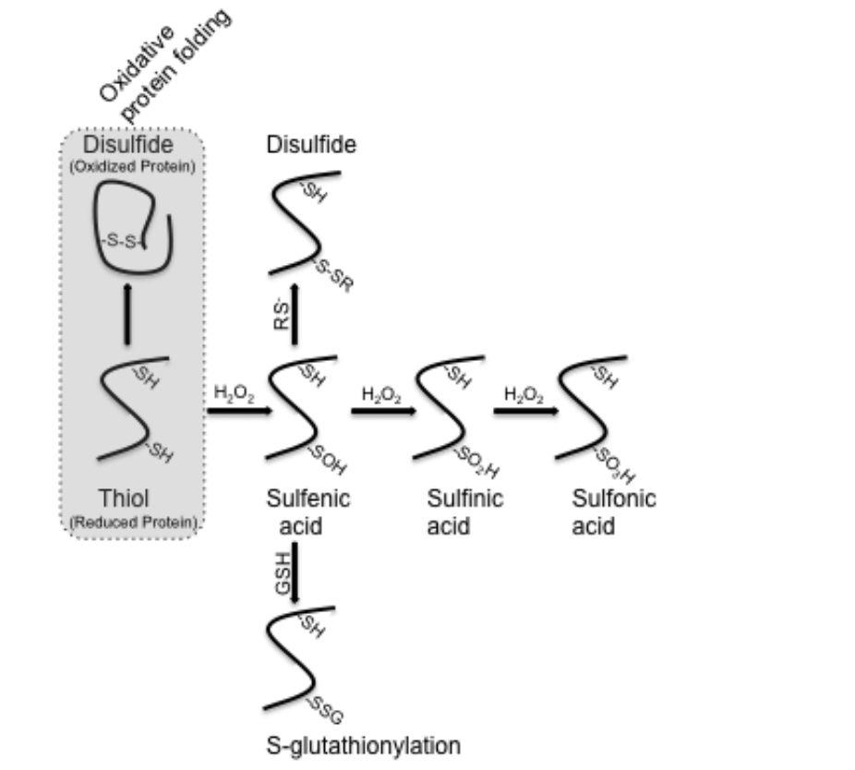

https://doi.org/10.1089/ars.2012.4966.
Gene | ENSEMBLl id | Main transcript | Link
PRDX4 | ENSG00000123131 | ENST00000379341.9 | https://www.ensembl.org/Homo_sapiens/Gene/Summary?db=core;g=ENSG00000123131;r=X:23664262-23686399.

Disulfide bond formation
Reaction: pro-oxytocin-cleaved-Cterm-trimmed[er] → pro-oxytocin-cleaved-Cterm-trimmed-SS-bond[g]

Genes: ENSG00000185624 AND ENSG00000197930

We kept this reaction separate from the PDIA1/ERO1 reaction above but it can be skipped as it is already covered by the PDIA1 oxidation step.

6. Transport into the Golgi apparatus

Following the folding and stabilisation of the oxytocin prohormone in the ER, the molecule undergoes dimerisation and is then transported to the Golgi apparatus. After stabilisation of the neurophysin domain through disulfide bond formation the oxytocin prohormone dimerizes and is subsequently transported from the ER to the Golgi compartment as a part of the regulated secretory pathway.

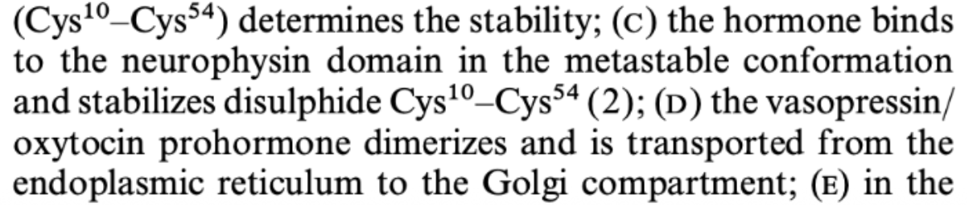

https://doi.org/10.1046/j.1365-2826.2000.00521.x.

6.1 Vesicle Coating

Following folding and stabilisation in the ER, pro-oxytocin-neurophysin I is exported towards the Golgi apparatus with the support of coat protein-dependent vesicular trafficking.

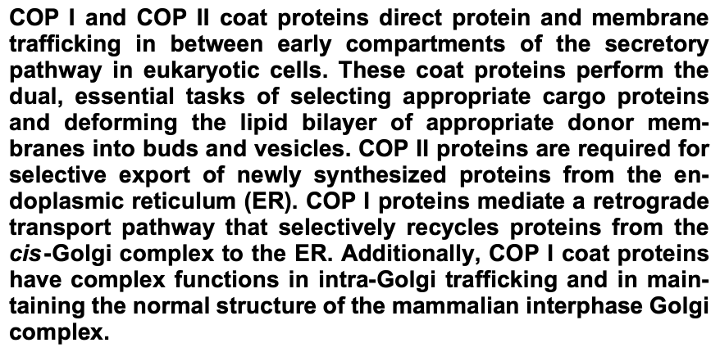

https://doi.org/10.1080/0968768031000122548.

According to this article COPII is essential for the export of newly synthesized peptides. COPII has different important components: GTPase, Sar1p, Sec23/24p and Sec13/31p

Sec12p mediates the exchange of GT`for GDP on Sar1p activating it
Therefore, membrane binding of Sar1p-GTP allows the recruitment of the Sec23/24 complex and subsequently of the Sec13/31p, which induces coat formation and deformation of the membrane into buds and vesicles

Sec16p interacts with: Sar1p, Sar23p, Sar24p and Sar31p

https://pmc.ncbi.nlm.nih.gov/articles/PMC11087783/#:~:text=The%20SAR1A%20and%20SAR1B%20paralogs,CMRD%20(22%2C%2023).

Sar1 has two paralog genes: Sar1A and Sar1B
The text presented below indicates that the knockout of both genes at the same time in order to encounter an alteration in the cell vesicle trafficking and therefore the lead of a disease development
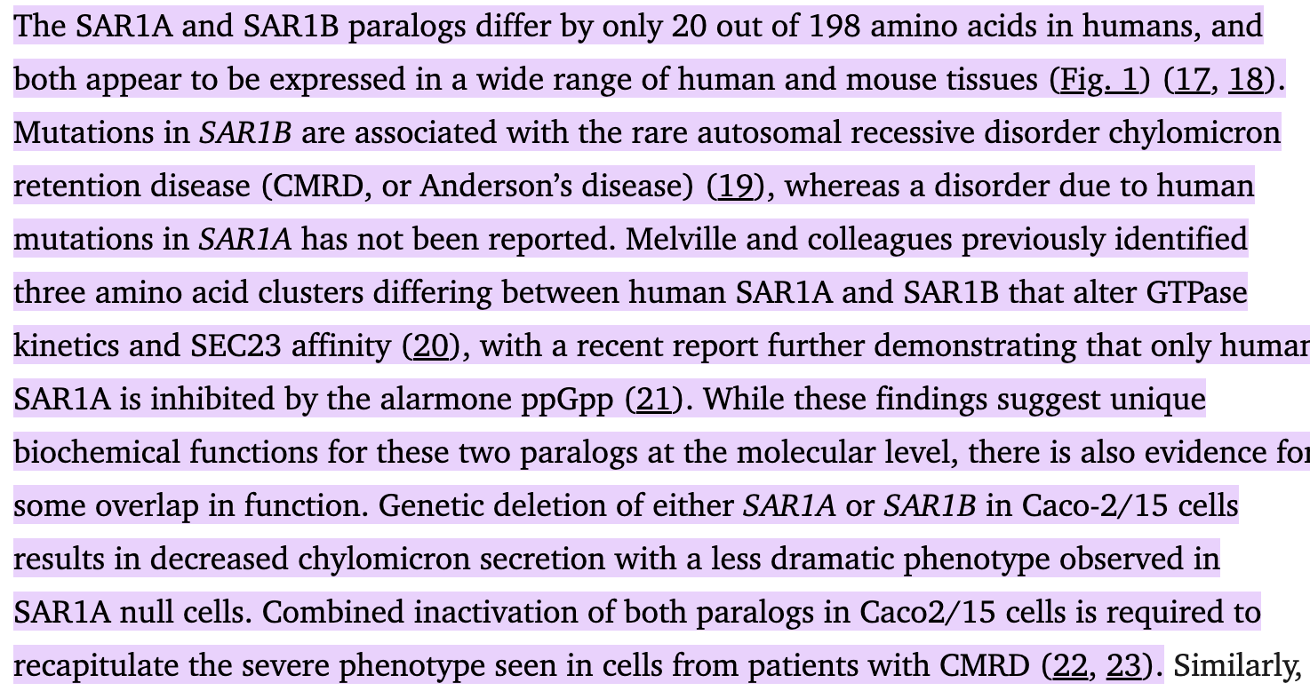
https://pmc.ncbi.nlm.nih.gov/articles/PMC11087783/#:~:text=The%20SAR1A%20and%20SAR1B%20paralogs,CMRD%20(22%2C%2023).

Sec23 has two paralog genes: Sec23a and Sec23b
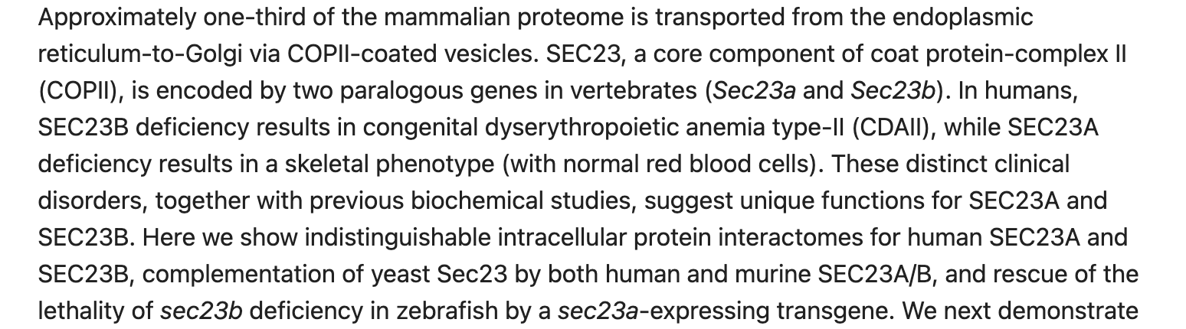
https://pubmed.ncbi.nlm.nih.gov/30065114/

Sec31 has two paralog genes: Sec31A and Sec31B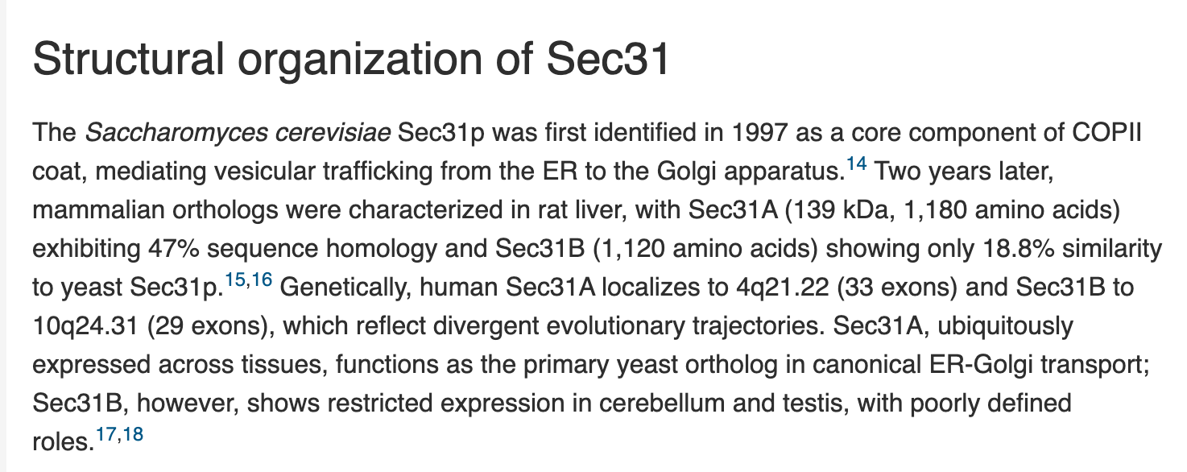

https://www.cell.com/iscience/fulltext/S2589-0042(25)01873-5#:~:text=Declaration%20of%20interests-,Summary,and%20responses%20to%20microbial%20infections.

Sec24 has four paralog genes: Sec24A, Sec24B, Sec24C & Sec24D
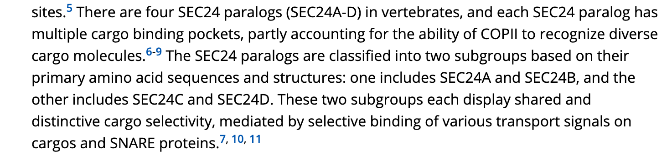
https://onlinelibrary.wiley.com/doi/10.1111/tra.12826

Sec16 has two paralog genes: Sec16A and Sec16B
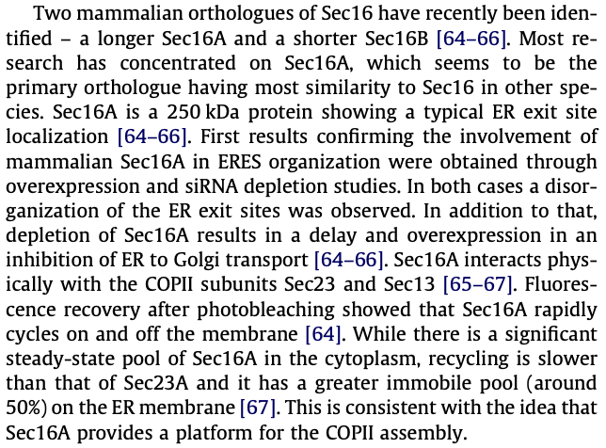
10.1016/j.febslet.2009.10.038
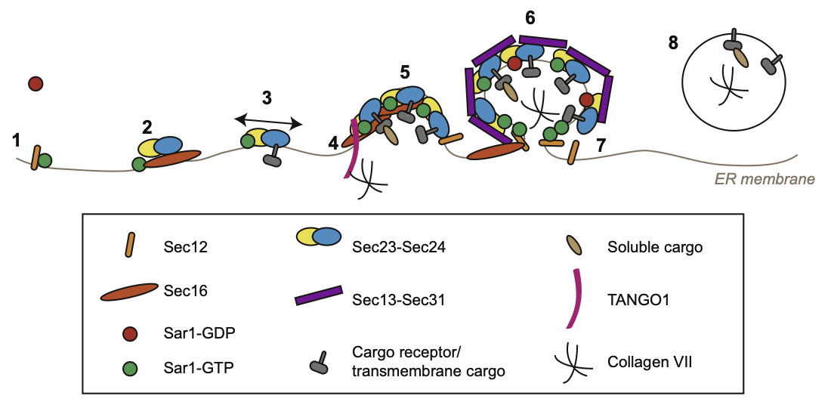
https://doi.org/10.1016/j.febslet.2009.10.038.

GPR: Sar1A OR Sar1B AND Sec12 (PREB) AND Sec16

Gene | ENSEMBL id | Main transcript | Link
SAR1A | ENSG00000079332 | ENST00000373241, ENSP00000362338 | Gene: SAR1A (ENSG00000079332) - Summary - Homo_sapiens - Ensembl genome browser 115
SAR1B | ENSG00000152700 | ENST00000402673, ENSP00000385432 | Gene: SAR1B (ENSG00000152700) - Summary - Homo_sapiens - Ensembl genome browser 115
SEC16A | ENSG00000148396 | ENST00000684901, ENSP00000508822 | Gene: SEC16A (ENSG00000148396) - Summary - Homo_sapiens - Ensembl genome browser 115
SEC16B | ENSG00000120341 | ENST00000308284, ENSP00000308339 | Gene: SEC16B (ENSG00000120341) - Summary - Homo_sapiens - Ensembl genome browser 115
SEC23A | ENSG00000100934 | ENST00000307712, ENSP00000306881 | Gene: SEC23A (ENSG00000100934) - Summary - Homo_sapiens - Ensembl genome browser 115
SEC23B | ENSG00000101310 | ENST00000650089, ENSP00000497473 | Gene: SEC23B (ENSG00000101310) - Summary - Homo_sapiens - Ensembl genome browser 115
SEC24A | ENSG00000113615 | ENST00000398844, ENSP00000381823 | https://www.ensembl.org/Homo_sapiens/Gene/Summary?db=core;g=ENSG00000113615;r=5:134648588-134727909
SEC24B | ENSG00000138802 | ENST00000265175, ENSP00000265175 | Gene: SEC24B (ENSG00000138802) - Summary - Homo_sapiens - Ensembl genome browser 115
SEC24C | ENSG00000176986 | ENST00000345254, ENSP00000321845 | Gene: SEC24C (ENSG00000176986) - Summary - Homo_sapiens - Ensembl genome browser 115
SEC24D | ENSG00000150961 | ENST00000280551, ENSP00000280551 | Gene: SEC24D (ENSG00000150961) - Summary - Homo_sapiens - Ensembl genome browser 115
SEC12/PREB | ENSG00000138073 | ENST00000260643, ENSP00000260643 | https://www.ensembl.org/Homo_sapiens/Gene/Summary?db=core;g=ENSG00000138073;r=2:27130752-27134671

Transport of pro-oxytocin-neurophysin I to Golgi apparatus:

Reaction: pro-oxytocin-neurophysin I, folded [er] → pro-oxytocin-neurophysin I, folded[g]

GPR: ENSG00000079332 OR ENSG00000152700 AND ENSG00000138073 AND ENSG00000148396 AND ENSG00000100934 AND ENSG00000113615

7. Peptide modifications in the Golgi apparatus
According to: https://www.sciencedirect.com/science/article/pii/S0968000425000635
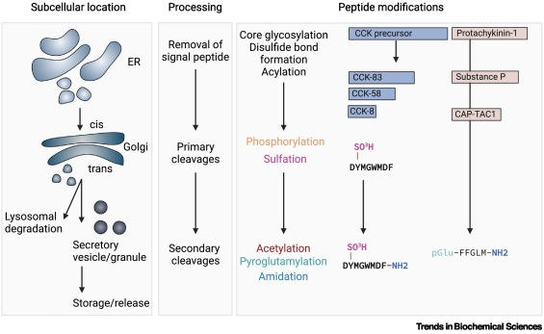
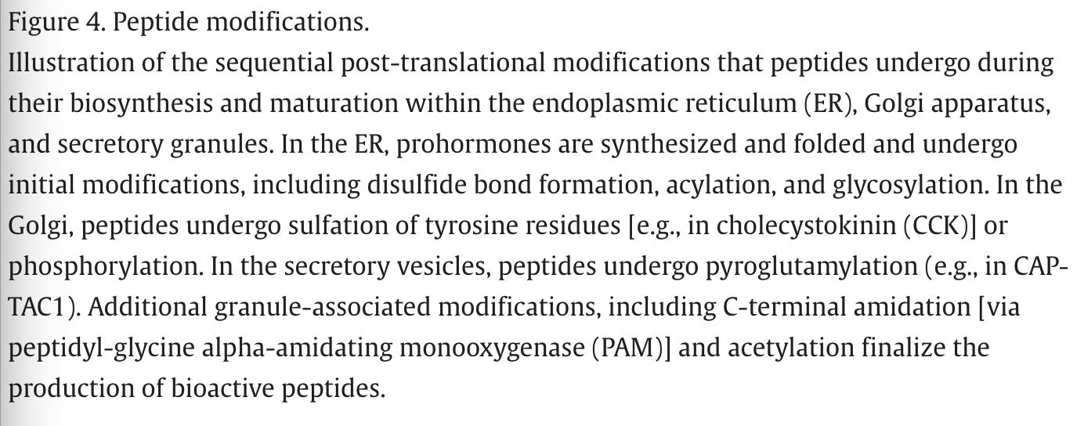

7.1 Proteolytic cleavage by prohormone convertase (PC1/3, PC2)

According to: https://api.repository.cam.ac.uk/server/api/core/bitstreams/e16f70f0-b519-451e-b177-b53dc14576fa/content

PC1/3 is highly expressed in the hypothalamus, where our peptide of interest is biosynthesized. Furthermore, PC2 is also involved in the cleavage of the neurophysin I but in different sites.
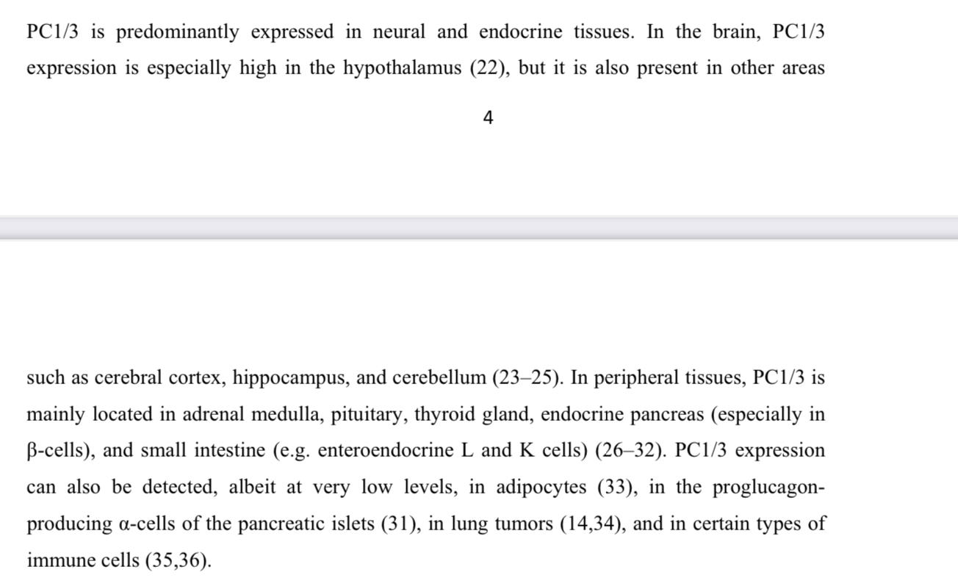

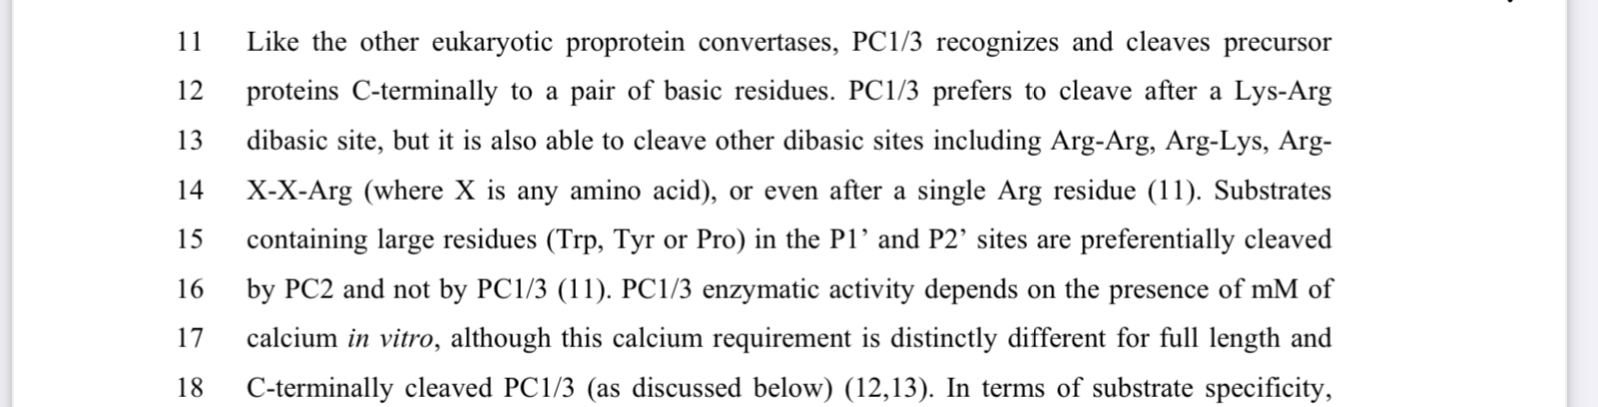

Gene | ENSEMBL id | Main transcript | Link
PC1/ (PCSK1) | ENSG00000175426 | ENST00000311106, ENSP00000308024 | https://www.ensembl.org/Homo_sapiens/Gene/Summary?db=core;g=ENSG00000175426;r=5:96390333-96434143
PC2 (PCSK2) | ENSG00000125851 | ENST00000262545, ENSP00000262545 | https://www.ensembl.org/Homo_sapiens/Gene/Summary?db=core;g=ENSG00000125851;r=20:17226107-17484578

Proteolytic cleavage:
Reaction: pro-oxytocin-neurophysin I, folded [g] → oxytocin-Gly-Lys-Arg (pro-oxytocin-cleaved) [g] + neurophysin I [g] + additional peptides

GRP: ENSG00000175426 AND ENSG00000125851

7.2 Trimming of C-terminal by carboxypeptidase E

According to: https://www.frontiersin.org/journals/neuroscience/articles/10.3389/fnins.2019.00243/full

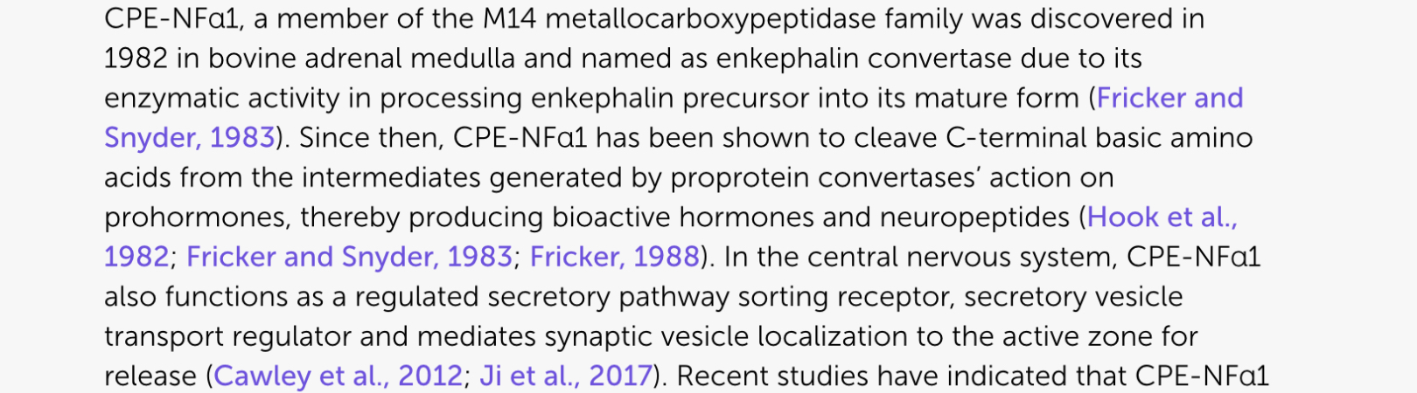

Gene | ENSEMBL id | Main transcript | Link
CPE | ENSG00000109472 | ENST00000402744, ENSP00000386104 | https://www.ensembl.org/Homo_sapiens/Gene/Summary?db=core;g=ENSG00000109472;r=4:165361194-165498547

C-terminal trimming
Reaction: pro-oxytocin-cleaved [g] → pro-oxytocin-cleaved-Cterm-trimmed [g]

GRP: ENSG00000109472

7.3 C-terminal amidation by peptidylglycine α-amidating monooxygenase (PAM)

According to: https://febs.onlinelibrary.wiley.com/doi/10.1111/febs.16049
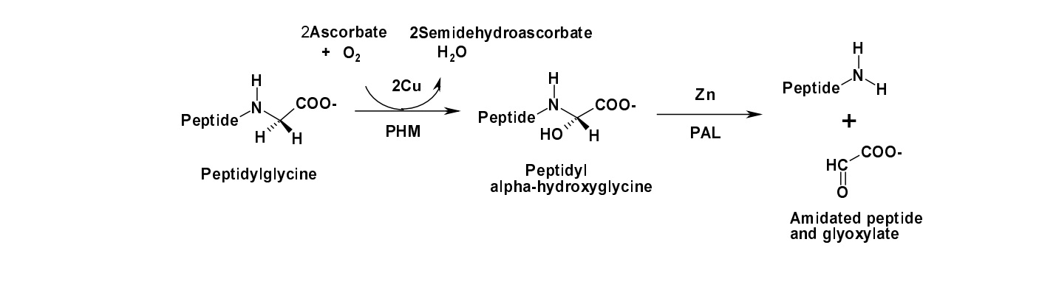
https://link.springer.com/article/10.1007/BF02931985#:~:text=Abstract,industrial%20production%20of%20peptide%20hormones https://academic-oup-com.mu.idm.oclc.org/endo/article/164/9/bqad121/7238035?login=true&token=eyJhbGciOiJub25lIn0.eyJleHAiOjE3NzA1NTU5NTUsImp0aSI6IjQ2YTQ5NTI0LTIxMjYtNGFkYi04MWM4LWEzMmE5MDMwNzRiMyJ9.#415187067

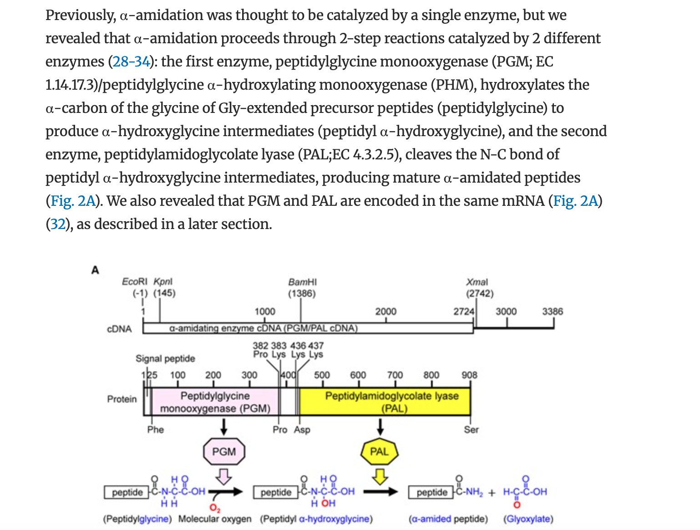

Gene | ENSEMBL id | Main transcript | Link
PAM | ENSG00000145730 | ENST00000438793, ENSP00000396493 | https://www.ensembl.org/Homo_sapiens/Gene/Summary?db=core;g=ENSG00000145730;r=5:102753981-103031149

C-terminal amidation

Reaction:
- peptide-Glycine [g] + O2+ 2H + ascorbate → peptide-𝛼-hydroxyglycine intermediate [g] + H2O + dehydroascorbate
- peptide-𝛼-hydroxyglycine intermediate [g] → peptide-amide [g] + glyoxylate
- pro-oxytocin-cleaved-Cterm-trimmed [g] → pro-oxytocin-cleaved-Cterm-trimmed-amidated [g]

Rename metabolite: pro-oxytocin-cleaved-Cterm-trimmed-amidated = oxytocin (amidated)

GRP: ENSG00000145730 (PAM)

Summary of peptide modifications in the Golgi apparatus before storage and secretion:
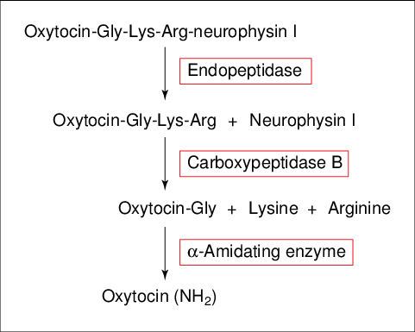

Translation products from mRNA encoding oxytocin. The initial product contains oxytocin and neurophysin I linked covalently by the tripeptide Gly-Lys-Arg. The initial product is cleaved to yield neurophysin I and carboxy-extended prohormones of oxytocin which eventually are converted into mature, amidated oxytocin.
https://www.researchgate.net/figure/Translation-products-from-mRNA-encoding-oxytocin-The-initial-product-contains-oxytocin_fig2_13600370

8. Vesicle trafficking to the posterior pituitary

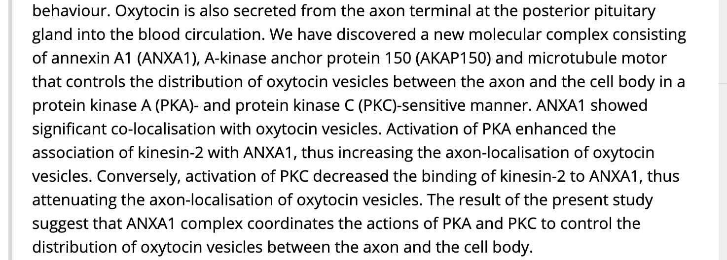
https://onlinelibrary.wiley.com/doi/10.1111/jne.12112
According to this scientific paper,

Protein kinase A has two subunits: the catalytic and the regulatory subunit. Each of them is composed of more than one gene (as seen in the chart below:)
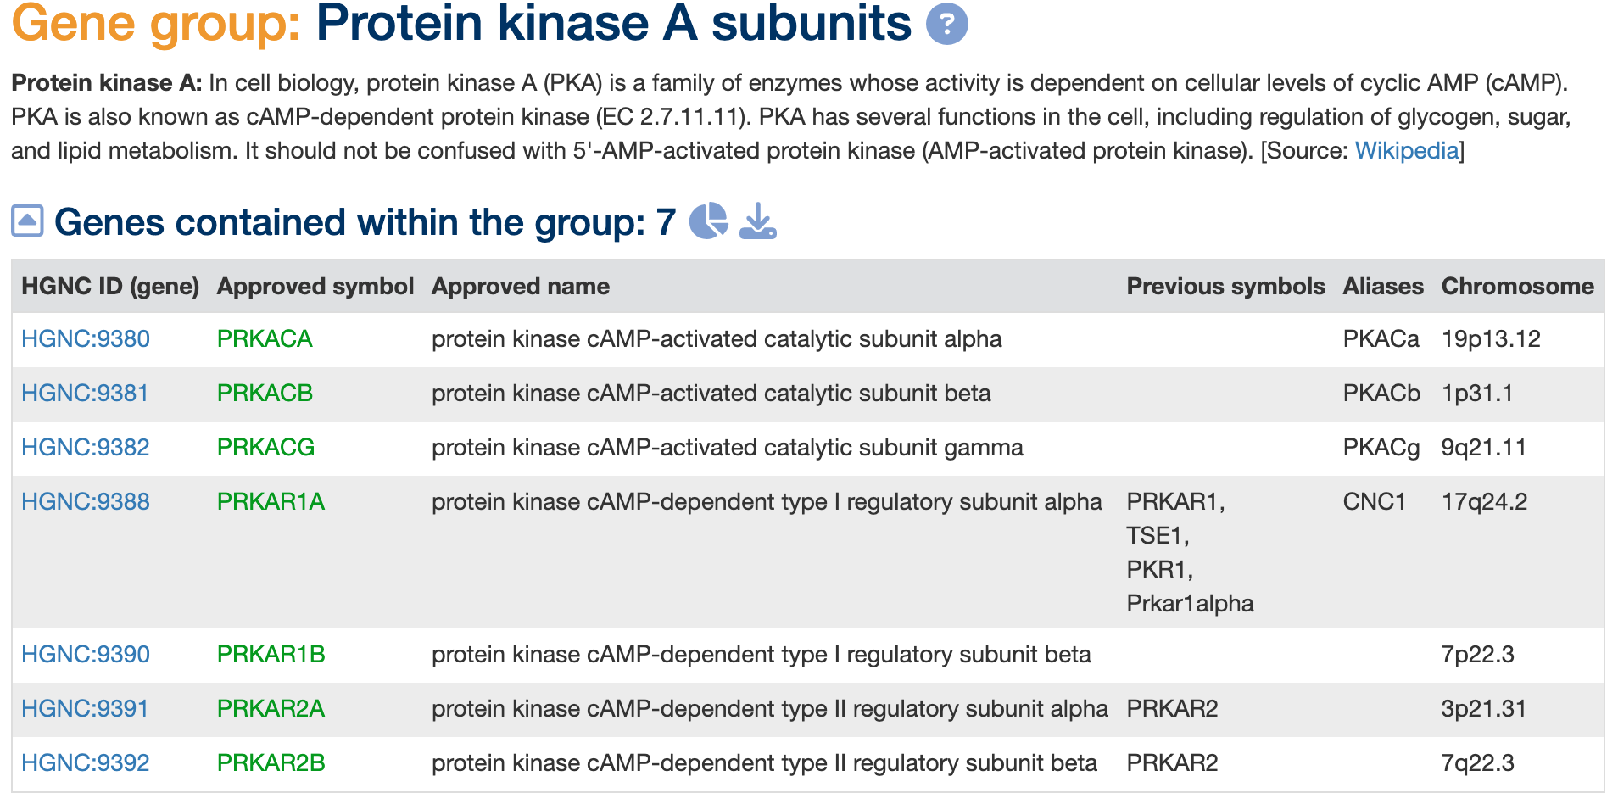
https://www.genenames.org/data/genegroup/#!/group/2144

As discussed in this article, kinesin-2 also involves more than one gene
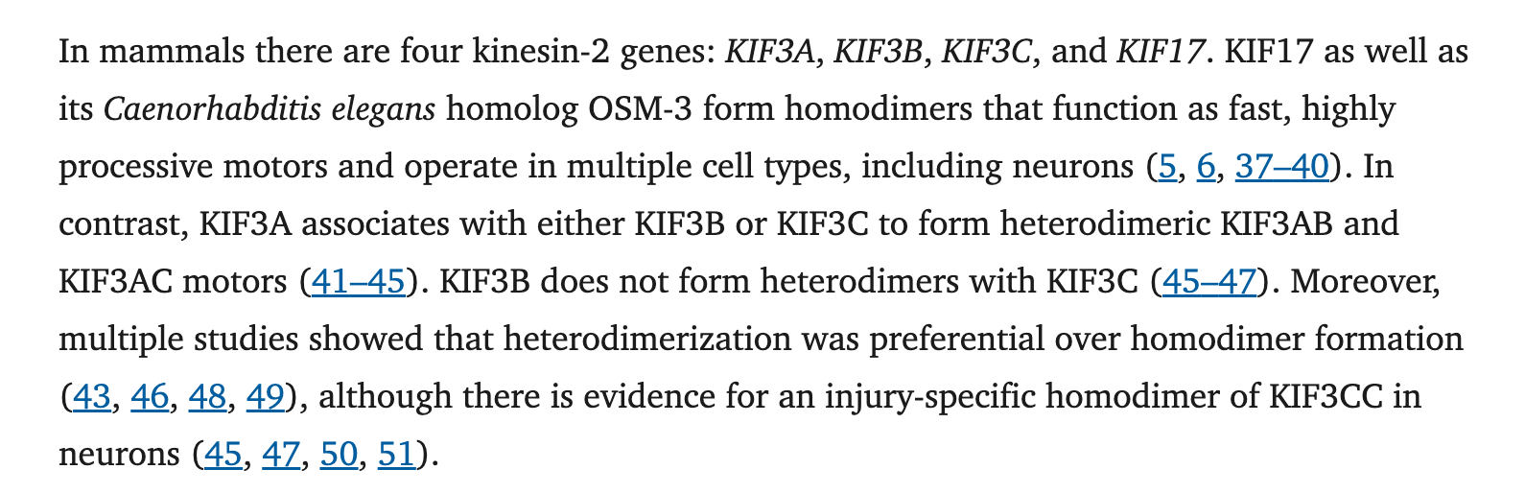
https://pmc.ncbi.nlm.nih.gov/articles/PMC5868254/

Gathering this information we can suggest the list of genes involved in the table below;

Since Annexin A is involved in the transport of oxytocin and PKA is responsible for enhancing the interactions between kinesin and annexin which controls the distribution of the vesicles containing oxytocin.

Gene | ENSEMBL id | Main transcript | Link
ANXA1 | ENSG00000135046 | ENST00000257497, ENSP00000257497 | https://www.ensembl.org/Homo_sapiens/Gene/Summary?db=core;g=ENSG00000135046;r=9:73148874-73170629
KIF3A | ENSG00000131437 | ENST00000403231, ENSP00000385808 | Gene: KIF3A (ENSG00000131437) - Summary - Homo_sapiens - Ensembl genome browser 115
KIF3B | ENSG00000131437 | ENST00000375712, ENSP00000364864 | Gene: KIF3B (ENSG00000101350) - Summary - Homo_sapiens - Ensembl genome browser 115
KIF3C | ENSG00000131437 | ENST00000264712, ENSP00000264712 | Gene: KIF3C (ENSG00000084731) - Summary - Homo_sapiens - Ensembl genome browser 115
KIF17 | ENSG00000117245 | ENST00000400463, ENSP00000383311 | Gene: KIF17 (ENSG00000117245) - Summary - Homo_sapiens - Ensembl genome browser 115
PRKACA | ENSG00000072062 | ENST00000308677, ENSP00000309591 | Gene: PRKACA (ENSG00000072062) - Summary - Homo_sapiens - Ensembl genome browser 115
PRKACB | ENSG00000142875 | ENST00000370685, ENSP00000359719 | Gene: PRKACB (ENSG00000142875) - Summary - Homo_sapiens - Ensembl genome browser 115
PRKACG | ENSG00000165059 | ENST00000377276, ENSP00000366488 | Gene: PRKACG (ENSG00000165059) - Summary - Homo_sapiens - Ensembl genome browser 115
PRKAR1A | ENSG00000108946 | ENST00000589228, ENSP00000464977 | Gene: PRKAR1A (ENSG00000108946) - Summary - Homo_sapiens - Ensembl genome browser 115
PRKAR1B | ENSG00000188191 | ENST00000537384, ENSP00000440449 | Gene: PRKAR1B (ENSG00000188191) - Summary - Homo_sapiens - Ensembl genome browser 115
PRKAR2A | ENSG00000114302 | ENST00000265563, ENSP00000265563 | Gene: PRKAR2A (ENSG00000114302) - Summary - Homo_sapiens - Ensembl genome browser 115
PRKAR2B | ENSG00000114302 | ENST00000265717, ENSP00000265717 | Gene: PRKAR2B (ENSG00000005249) - Summary - Homo_sapiens - Ensembl genome browser 115

Vesicle trafficking

Reaction: pro-oxytocin-cleaved-Cterm-trimmed-amidated [g] → pro-oxytocin-cleaved-Cterm-trimmed-amidated[extracellular] + transported
Rename metabolite: pro-oxytocin-cleaved-Cterm-trimmed-amidated = oxytocin (amidated)

Reaction: oxytocin(amidated)[g] → oxytocin (amidated)[e]

GRP: ENSG00000135046 AND ENSG00000131437 AND (ENSG00000131437 AND ENSG00000117245) AND (ENSG00000072062 AND ENSG00000142875 AND ENSG00000165059 AND ENSG00000108946 AND ENSG00000188191 AND ENSG00000114302 AND ENSG00000114302)

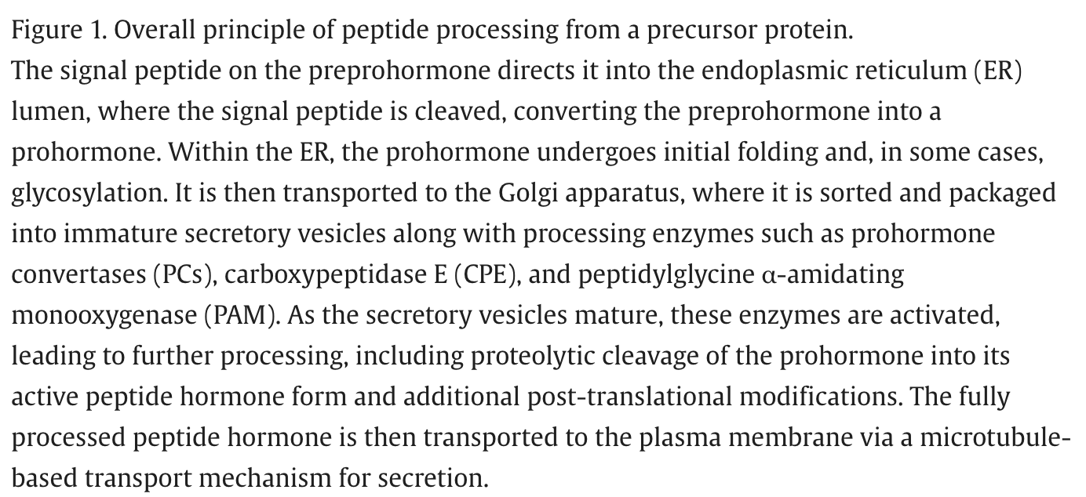

https://www.sciencedirect.com/science/article/pii/S0968000425000635
