Synthesis of ACTH

Cell types: corticotroph and melanotroph cells

Translation of mRNA to pro-opiomelanocortin (POMC)
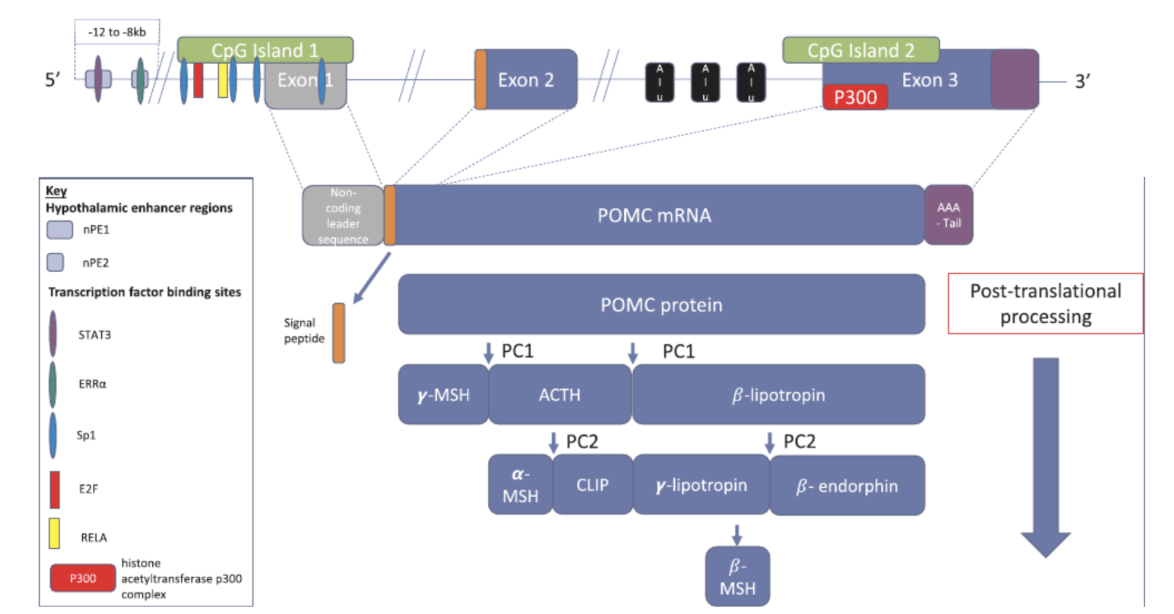
The biosynthesis of ACTH starts with the translation of pre-pro-opiomelanocortin mRNA into pre-POMC protein. This protein, like mostly every peptide hormone, contains a signal peptide that directs it to the ER, where signal peptidase will cleave this signal upon entry, giving rise to POMC.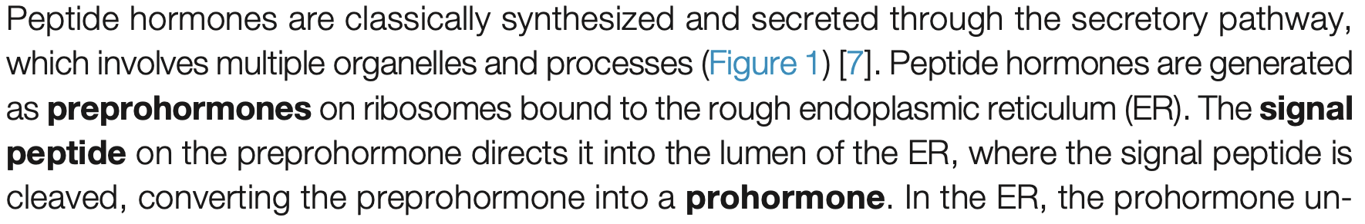
From: https://www.cell.com/action/showPdf?pii=S0968-0004%2825%2900063-5

Gene | ENSEMBL id |  | Main transcript |  | Link
POMC | ENSG00000115138 | ENST00000395826, ENSP00000379170 |  | https://www.ensembl.org/Homo_sapiens/Gene/Summary?db=core;g=ENSG00000115138;r=2:25160853-25168903

Translation of mRNA:
Fake reaction: pre-pro-opiomelanocortin 1 [c] → pre-pro-opiomelanocortin 2 [c]
GPR: POMC

Translocation to the ER

SRP
Although it is not directly stated that POMC is translocated to the ER through the Signal Recognition Particle (SRP) interaction with the SRP receptor, literature suggests that translocation to the ER is universally applicable to all secretory and membrane proteins.
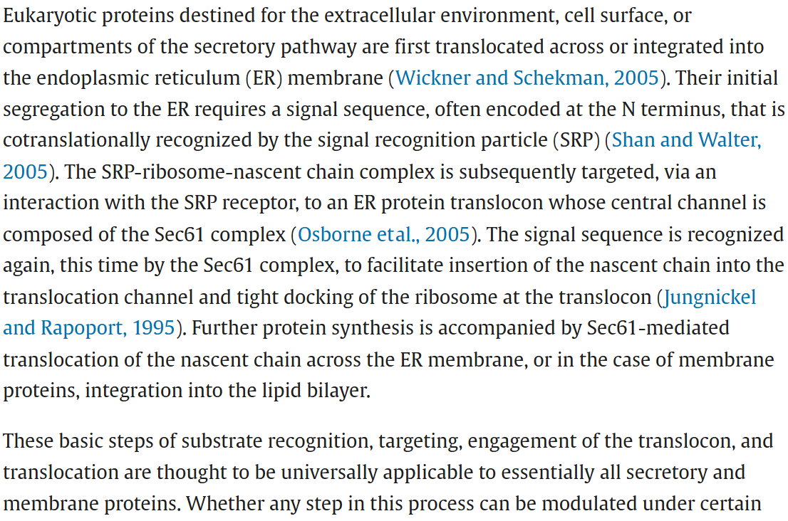
From: Substrate-Specific Translocational Attenuation during ER Stress Defines a Pre-Emptive Quality Control Pathway - ScienceDirect

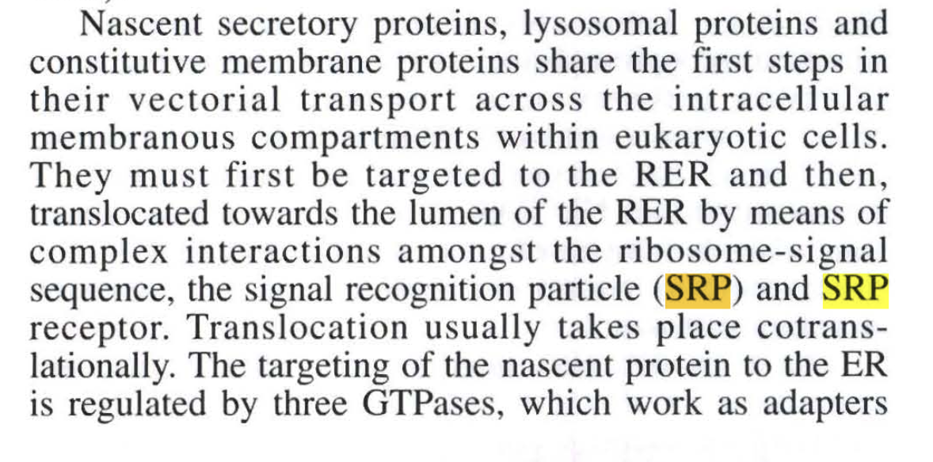
From: Prohormone and proneuropeptide.pdf
Looking those up we get an SRP recognition step, and to quantify both the receptor and SRP steps, we make that 2 reactions: i. SRP enzyme:ii. SRP receptor

SRP enzyme
The SRP enzyme consists of 7SL RNA and six protein subunits.
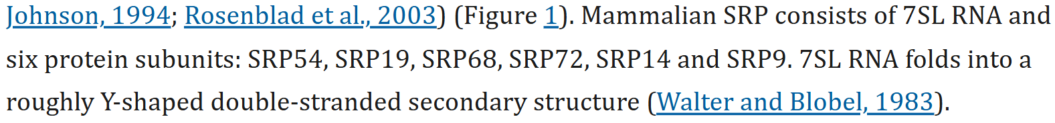
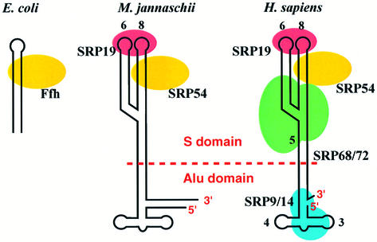
From: NEW EMBO MEMBER’S REVIEW: Structure, function and evolution of the signal recognition particle - PMC

SRP enzyme GPR: SRP9 AND SRP14 AND SRP19 AND SRP54 AND SRP68 AND SRP72
Gene name |  | ENSEMBL id |  | Main transcript |  | Link
SRP9 | ENSG00000143742 |  | ENST00000304786.12 |  | https://www.ensembl.org/Homo_sapiens/Gene/Summary?db=core;g=ENSG00000143742;r=1:225777699-225790670
SRP14 | ENSG00000140319 |  | ENST00000267884.11 |  | https://www.ensembl.org/Homo_sapiens/Gene/Summary?db=core;g=ENSG00000140319;r=15:40035690-40039181
SRP19 | ENSG00000153037 |  | ENST00000505459.6 |  | https://www.ensembl.org/Homo_sapiens/Gene/Summary?db=core;g=ENSG00000153037;r=5:112861188-112898371
SRP54 | ENSG00000100883 |  | ENST00000216774.11 |  | https://www.ensembl.org/Homo_sapiens/Gene/Summary?db=core;g=ENSG00000100883;r=14:34981957-35029686
SPR68 | ENSG00000167881 |  | ENST00000307877.7 |  | https://www.ensembl.org/Homo_sapiens/Gene/Summary?db=core;g=ENSG00000167881;r=17:76038775-76072517
SPR72 | ENSG00000174780 |  | ENST00000642900.1 |  | https://www.ensembl.org/Homo_sapiens/Gene/Summary?db=core;g=ENSG00000174780;r=4:56467595-56503681

SRP enzyme:
Reaction: pre-pro-opiomelanocortin-2 [c] -> pre-pro-opiomelanocortin-2-SRP [c]
GPR: SRP9 AND SRP14 AND SRP19 AND SRP54 AND SPR68 AND SPR72

SRP receptor
Once the pre-pro-opiomelanocortin 2 is bound to the SRP enzyme, it binds to the SRP receptor on the membrane of the ER, a heterodimer composed of two subunits: SRalpha and SRbeta, which are GTPases. These GTPases allow the transfer of the pre-pro-opiomelanocortin 2 into the Sec61 translocase leading to the release of SRP and its entry to the ER lumen through the Sec61 pore.

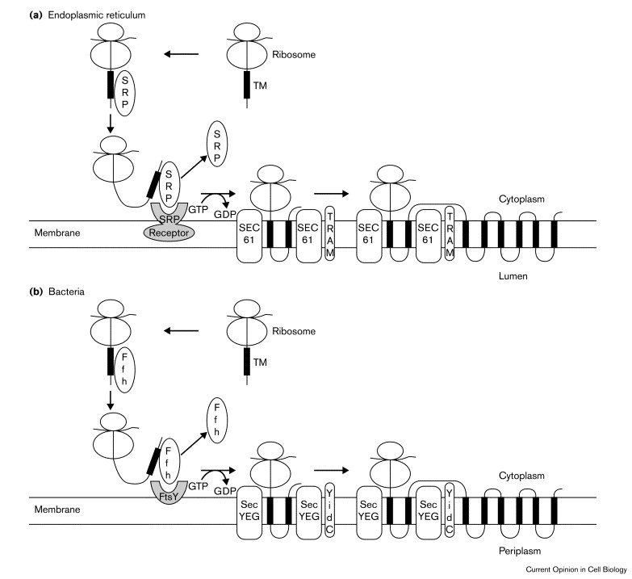
From: https://www.sciencedirect.com/science/article/pii/S0955067400001137
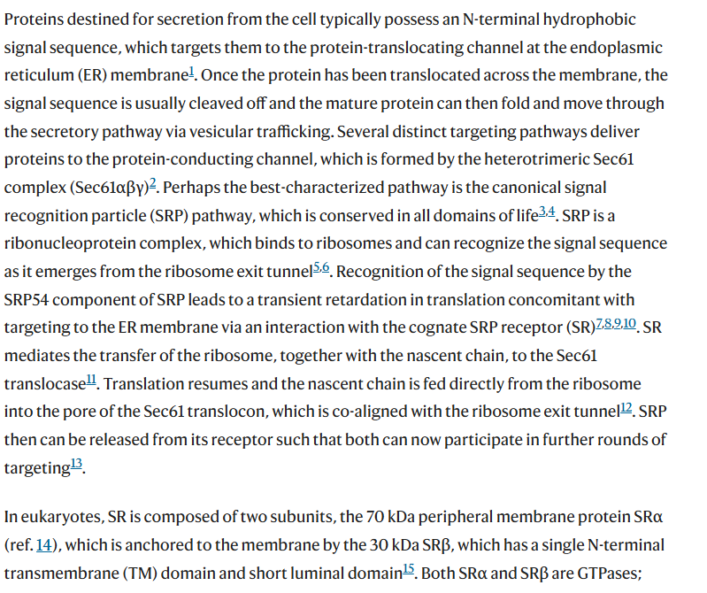
From: Mammalian SRP receptor switches the Sec61 translocase from Sec62 to SRP-dependent translocation | Nature Communications
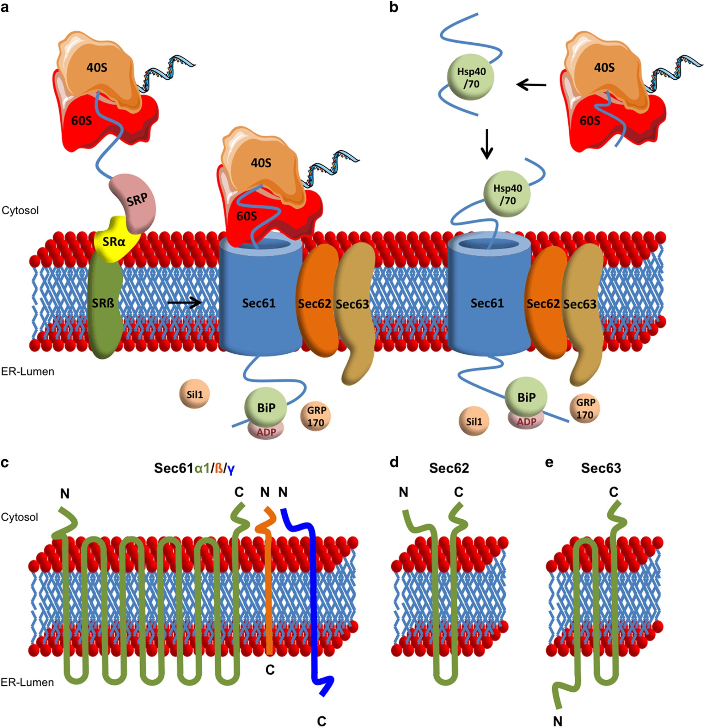
From: Let’s talk about Secs: Sec61, Sec62 and Sec63 in signal transduction, oncology and personalized medicine | Signal Transduction and Targeted Therapy
The Sec61 translocon consists of 3 subunits (α, β, and γ)
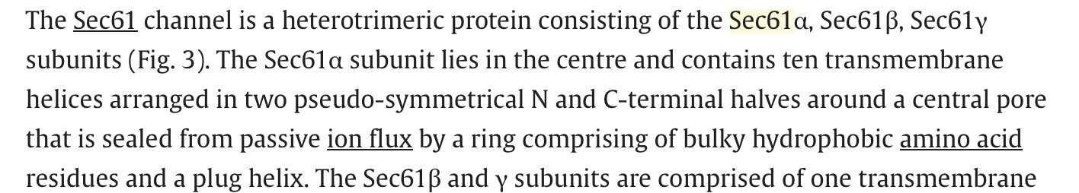
From: https://www.sciencedirect.com/topics/immunology-and-microbiology/sec61

GPR for SEC61: (SEC61A OR SEC61A2) AND SEC61B AND SEC61G

Genes | ENSEMBL id | Main transcript | Links
SRPRA | ENSG00000182934 | ENST00000332118.11 | https://www.ensembl.org/Homo_sapiens/Gene/Summary?db=core;g=ENSG00000182934;r=11:126262912-126269144
SRPRB | ENSG00000144867 | ENST00000466490.7 | https://www.ensembl.org/Homo_sapiens/Gene/Summary?db=core;g=ENSG00000144867;r=3:133784023-133825772
Sec61A | ENSG00000058262 | ENST00000243253.8 | https://www.ensembl.org/Homo_sapiens/Gene/Summary?db=core;g=ENSG00000058262;r=3:128051641-128071705
SEC61A2 | ENSG00000065665 | ENST00000298428.14 | https://www.ensembl.org/Homo_sapiens/Gene/Summary?db=core;g=ENSG00000065665;r=10:12129637-12169961
SEC61B | ENSG00000106803 | ENST00000223641.5 | https://www.ensembl.org/Homo_sapiens/Gene/Summary?g=ENSG00000106803;r=9:99222064-99230615
SEC61G | ENSG00000132432 | ENST00000352861.9 | https://www.ensembl.org/Homo_sapiens/Gene/Summary?db=core;g=ENSG00000132432;r=7:54752180-54759974

SRP receptor and SEC61:
Reaction 1: pre-pro-opiomelanocortin-2-SRP[c] + GTP → pre-pro-opiomelanocortin-2-SRP[t] + GDP
Reaction 2: pre-pro-opiomelanocortin-2-SRP[t] → pre-pro-opiomelanocortin-2-SRP[r]
GPR: (SRPRA AND SRPRB) AND ((Sec61A OR SEC61A2) AND SEC61B AND SEC61G)
[t]= translocon
[r] = Endoplasmic Reticulum

Signal peptide cleavage
Once the pre-pro-opiomelanocortin is in the ER, signal peptidase will cleave the signal peptide giving rise to pro-opiomelanocortin. 
From: https://www.cell.com/action/showPdf?pii=S0968-0004%2825%2900063-5

Human signal peptidase complex (SPC) is composed of accessory proteins and proteolytic subunits.
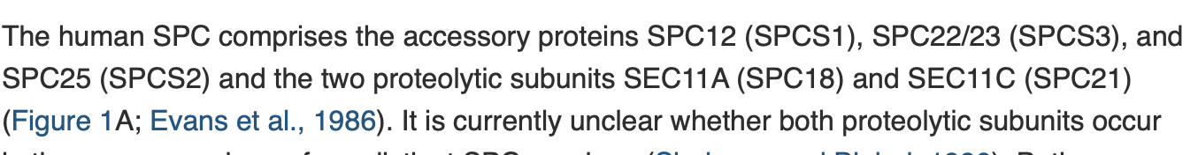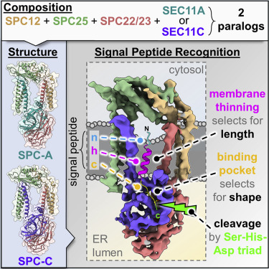
From: https://www.cell.com/molecular-cell/fulltext/S1097-2765(21)00600-6?_returnURL=https%3A%2F%2Flinkinghub.elsevier.com%2Fretrieve%2Fpii%2FS1097276521006006%3Fshowall%3Dtrue

The two enzymatic complexes that catalyze this reaction are:
- SPCS12 AND SPCS22/23 AND SPCS25 AND SEC11A
or
- SPCS12 AND SPCS22/23 AND SPCS25 AND SEC11C
Therefore, the GPR will be SPCS12 AND SPCS22/23 AND SPCS25 AND (SEC11A OR SEC11C)
Gene name |  | ENSEMBL id |  | Main transcript |  | Link
SPSC1 | ENSG00000114902 |  | ENST00000619898.5 |  | https://www.ensembl.org/Homo_sapiens/Gene/Summary?db=core;g=ENSG00000114902;r=3:52704955-52711148
SPCS3 | ENSG00000129128 |  | ENST00000503362.2 |  | https://www.ensembl.org/Homo_sapiens/Gene/Summary?db=core;g=ENSG00000129128;r=4:176319966-176332245
SPCS2 | ENSG00000118363 |  | ENST00000263672.11 |  | https://www.ensembl.org/Homo_sapiens/Gene/Summary?db=core;g=ENSG00000118363;r=11:74949259-74979033
SEC11A | ENSG00000140612 |  | ENST00000268220.12 |  | https://www.ensembl.org/Homo_sapiens/Gene/Summary?db=core;g=ENSG00000140612;r=15:84669529-84716460
SEC11C | ENSG00000166562 |  | ENST00000587834.6 |  | https://www.ensembl.org/Homo_sapiens/Gene/Summary?db=core;g=ENSG00000166562;r=18:59139475-59158837

Cleavage of pre-proopiomelanocortin to proopiomelanocortin
Reaction: pre-pro-opiomelanocortin-2-SRP[r] -> pro-opiomelanocortin-2-SRP[r] + signal-peptide[r]
GPR: SPSC1 AND SPCS3 AND SPCS2 AND (SEC11A OR SEC11C)

Disulfide processing

After the signal peptide on the NH2 terminal of POMC has been cleaved in the ER, it undergoes disulfide processing. Here, two disulfide bonds are formed in cysteine residues.
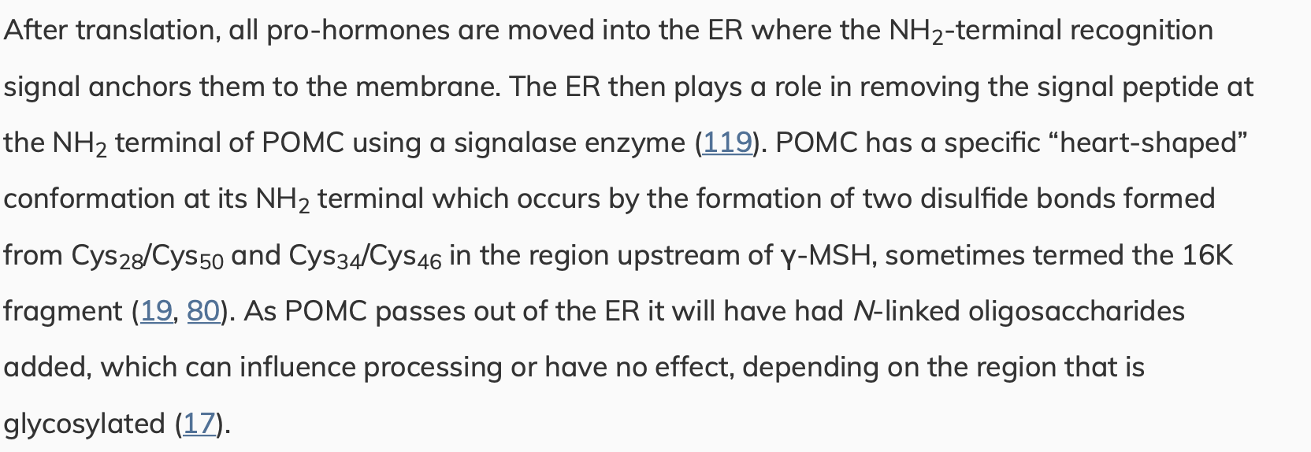
From: https://journals.physiology.org/doi/full/10.1152/physrev.00024.2017#core-B17

From: PDI-Regulated Disulfide Bond Formation in Protein Folding and Biomolecular Assembly

Enzyme responsible for disulfide processing:
Disulfide bond formation in the ER is generally mediated by PDIs which also ensure correct protein folding. The enzyme is composed of thioredoxin-like domains.
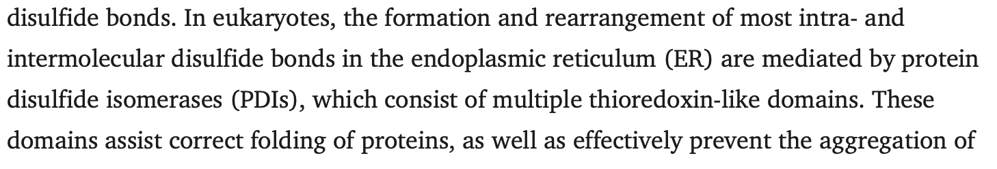
From: https://pmc.ncbi.nlm.nih.gov/articles/PMC7794689/

Protein folding:
The process of protein folding relies on PDIs and ERO1 through a series of redox reactions.
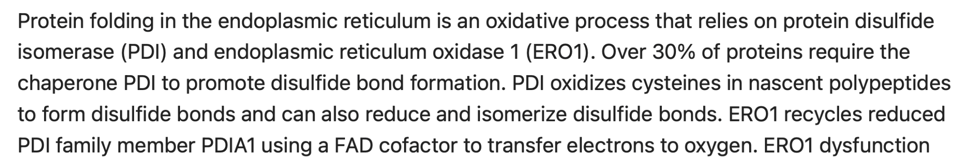
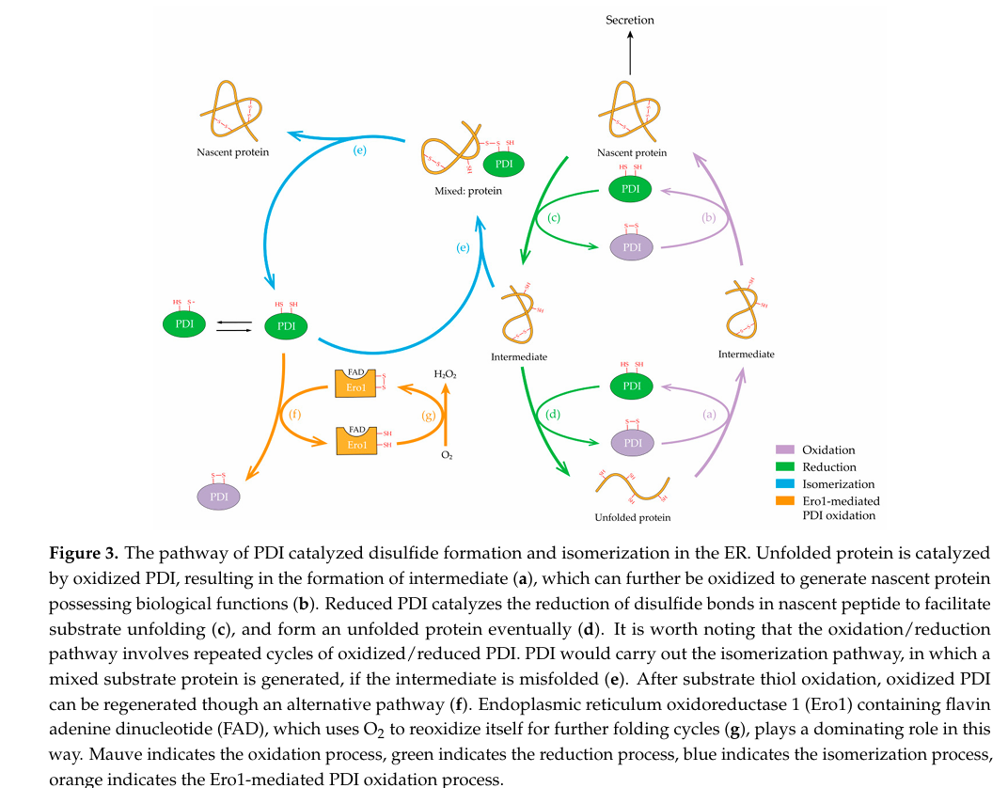

Gene name |  | ENSEMBL id |  | Main transcript |  | Link
P4HB | ENSG00000185624 |  | ENST00000331483.9 |  | https://www.ensembl.org/Homo_sapiens/Gene/Summary?db=core;g=ENSG00000185624;r=17:81843159-81860856
ERO1A | ENSG00000197930 |  | ENST00000395686.8 |  | https://www.ensembl.org/Homo_sapiens/Gene/Summary?db=core;g=ENSG00000197930;r=14:52639915-52696025
ERO1B | ENSG00000086619 |  | ENST00000354619.10 |  | https://www.ensembl.org/Homo_sapiens/Gene/Summary?db=core;g=ENSG00000086619;r=1:236214681-236282019

GRP PDI: PH4B
Regeneration of EROI:
2 O2[r] + ERO1-4SH[r] -> 2 H2O2 + ERO1-4S[r]
GPR: ERO1A OR ERO1B
Regeneration of PDIA1:
Reaction: PDIA1-4SH[r] + ERO1-4S[r] -> PDIA1-4S[r] + ERO1-4SH[r]
GPR: (ERO1A OR ERO1B) AND P4HB
Folding of proopiomelanocortin (POMC):
Reaction: proopiomelanocortin-2-SRP[r] + PDIA1-4S[r] -> proopiomelanocortin-2-SRP-oxidized-folded[r] + PDIA1-4SH[r]
GPR: P4HB

3. Export of POMC from ER to Golgi

a. COPII
i. COPII inner coat
After POMC has been processed in the ER it is exported to the Golgi apparatus through COPII, which is composed of 5 proteins that form 2 layers (inner and outer coat). The inner coat consists of SAR1 and the Sec23/24 complex.
Mammals have 2 paralogs SAR1A and SAR1B, as well as Sec23 (Sec13A, Sec23B) and Sec24 (Sec24A, Sec24B, Sec24C and Sec24D)

ER export is mediated by the coat protein complex II (COPII), which minimally comprises five cytosolic proteins that form two concentric layers on the ER membrane—the inner and outer coat. The inner coat layer consists of the small GTPase Sar1 and the heterodimeric Sec23/24 complex, whilst the outer coat layer comprises the rod-shaped heterotetramer Sec13/31. COPII dynamically assembles and disassembles at ER exit sites, imparting enough force to bend the membrane into unfavourable conformations while at the same time maintaining a range of membrane curvatures. It remains unclear how the COPII coat achieves the required balance of strength and flexibility, and how this balance is regulated to form vesicles of different sizes and shapes, essential to transport a diverse range of cargo molecules.

The inner coat is made of 3 elements: i) Sar1, ii) Sec23, and iii) Sec24.
From: https://www.nature.com/articles/s41467-021-22110-6
From: The small GTPase Sar1, control centre of COPII trafficking - Van der Verren - 2023 - FEBS Letters - Wiley Online Library
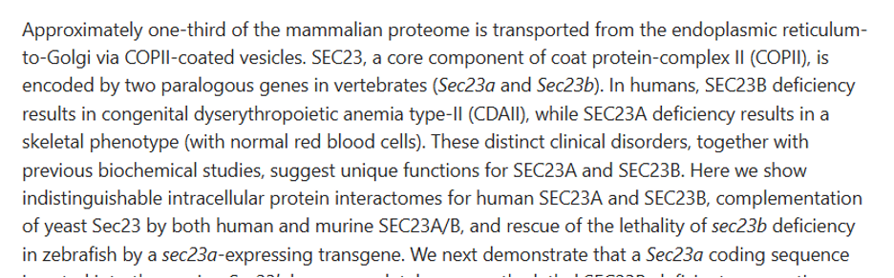
From: https://pubmed.ncbi.nlm.nih.gov/30065114/

Structurally, the core COPII complex is an icosidodecahedral coat consisting of an inner, Sar1-Sec23-Sec24 lattice and outer layer of Sec13-Sec31 heterotetramers.1 The GTPase Sar1, activated by Sec12, is recruited at the ER membrane, which is followed by binding of Sec23-Sec24 heterodimer. Sec23-Sec24 acts as cargo selection platform and forms the pre-budding complex. Sec13-Sec31 joins the complex after cargo capture. Sec23 stimulates Sar1-GTP hydrolysis leading to vesicle fission. The fact that there is a highly diverse repertoire of cargo needed to maintain both steady-state and tissue-specific demand, as well as cater to changing cellular requirements, has likely propelled the need for different paralogs of COPII subunits. While mammals encode two paralogs each for Sec23, Sar1, Sec31 and four for Sec24, and yeast only one for all except three for Sec24, the genome of the Arabidopsis thaliana encodes several isoforms of all COPII components (five Sar1, seven Sec23, three Sec24 and two Sec13 and Sec31).
From: https://onlinelibrary.wiley.com/doi/10.1111/tra.12817

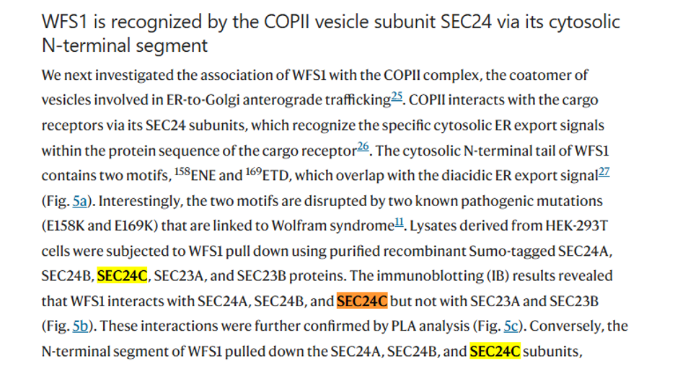
From: https://www.nature.com/articles/s41467-021-27344-y

SEC24 GPR: (SEC24A OR SEC24B OR SEC24C OR SEC24D)

Moreover, Sec12 is also involved in the recruitment and activation of Sar1B to the Golgi and the initiation of the vesicle formation by COPII. Sec16and SURF4 are other proteins required for COPII vesicle formation.
Sec12 was first identified by a complementation assay with a temperature-sensitive secretory mutant isolated by genetic screening (Novick et al., 1980; Nakano et al., 1988). Sec12 is a type II transmembrane protein with a WD40 motif and is required for Sar1 membrane localization (D’enfert et al., 1991a,b; Chardin and Callebaut, 2002). Further characterization revealed that Sec12 acts as a GEF for Sar1 and is required for membrane budding from synthetic liposomes (Barlowe and Schekman, 1993; Futai et al., 2004).
Sec16, another peripheral membrane protein required for COPII vesicle formation in vivo, is conserved from yeast to human (Kaiser and Schekman, 1990; Connerly et al., 2005; Watson et al., 2006; Iinuma et al., 2007; Ivan et al., 2008). Sec16 interacts with several COPII proteins (Gimeno et al., 1996; Shaywitz et al., 1997; Bhattacharyya and Glick, 2007; Hughes et al., 2009; Whittle and Schwartz, 2010; Montegna et al., 2012), indicating that it organizes and acts as a scaffold for COPII assembly (Sprangers and Rabouille, 2015).
From: https://www.frontiersin.org/journals/cell-and-developmental-biology/articles/10.3389/fcell.2017.00075/full

The COPII shell protein complex consists of five core proteins (that is, SAR1B and the shell proteins SEC23, SEC24, SEC13 and SEC31). Among them, SAR1B is the most important component of the COPII shell protein complex (6). Initially, the selection of cargoes transported in the ER is performed by the SAR1B-SEC23-SEC24 complex. Subsequently, SAR1B is recruited to the ER exit site by SEC12, which is activated by SEC12 and binds to the ER membrane to initiate COPII shell assembly. SEC12 is a unique activator of SAR1B, an integral membrane glycoprotein localized to the ER that serves as a GEF, and a fragment of which was previously named as the transcription factor prolactin regulatory element binding protein. It has been shown that knockdown of SEC12 using small interfering RNA results in diminished SAR1B activation signaling at the ER exit (7). Activated SAR1B sequentially recruits the SEC23-SEC24 complex and the SEC13-SEC31 complex to complete the assembly of the inner and outer layers of the COPII coat, respectively (8). SEC23 and SEC31 acting as a GAP to dephosphorylate SAR1B. After cargo recruitment and concentration in the ER lumen mediated by SEC24, SAR1B recruits SEC13 and SEC31 to form the outer coating.
From: https://pmc.ncbi.nlm.nih.gov/articles/PMC12598545/

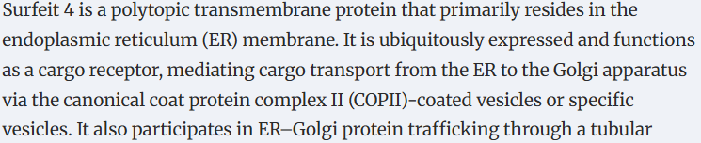
From: Surf4, cargo trafficking, lipid metabolism, and therapeutic implications | Journal of Molecular Cell Biology | Oxford Academic

Sar1/Sec12/Sec16/SURF14 GPR: (SAR1A OR SAR1B) AND PREB[Sec12] AND SEC16A AND SURF4

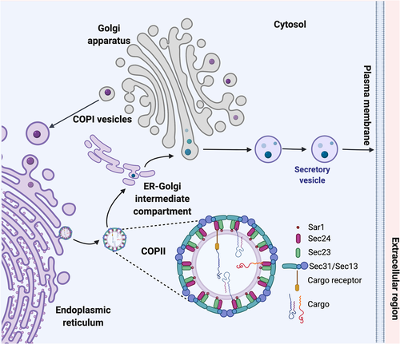
From: https://onlinelibrary.wiley.com/doi/10.1111/tra.12817

We combine the GPR for the 3 elements of the inner coat to get: ((SAR1A OR SAR1B ) AND PREB[Sec12] AND SEC16A AND SURF4) AND (SEC23A OR SEC23B) AND ((SEC24A OR SEC24B OR SEC24C OR SEC24D)
Gene name | ENSEMBL id | Main transcript | Link
SAR1A | ENSG00000079332 | ENST00000373241.9 | https://www.ensembl.org/Homo_sapiens/Gene/Summary?db=core;g=ENSG00000079332;r=10:70147289-70170905
SEC23B | ENSG00000101310 | ENST00000650089.1 | https://www.ensembl.org/Homo_sapiens/Gene/Summary?db=core;g=ENSG00000101310;r=20:18507520-18561415
SEC23A | ENSG00000100934 | ENST00000307712.11 | https://www.ensembl.org/Homo_sapiens/Gene/Summary?db=core;g=ENSG00000100934;r=14:39031918-39109646
SAR1B | ENSG00000152700 | ENST00000402673.7 | https://www.ensembl.org/Homo_sapiens/Gene/Summary?db=core;g=ENSG00000152700;r=5:134601149-134649271
PREB/SEC12 | ENSG00000138073 | ENST00000260643.7 | https://www.ensembl.org/Homo_sapiens/Gene/Summary?db=core;g=ENSG00000138073;r=2:27130752-27134671
SEC16A | ENSG00000148396 | ENST00000684901.1 | https://www.ensembl.org/Homo_sapiens/Gene/Summary?db=core;g=ENSG00000148396;r=9:136440096-136483843
SURF4 | ENSG00000148248 | ENST00000371989.8 | https://www.ensembl.org/Homo_sapiens/Gene/Summary?db=core;g=ENSG00000148248;r=9:133361450-133376166
SEC24D | ENSG00000150961 | ENST00000280551.11 | https://www.ensembl.org/Homo_sapiens/Gene/Summary?db=core;g=ENSG00000150961;r=4:118722822-118838683
SEC24B | ENSG00000138802 | ENST00000265175.5 | https://www.ensembl.org/Homo_sapiens/Gene/Summary?db=core;g=ENSG00000138802;r=4:109433602-109540896
SEC24C | ENSG00000176986 | ENST00000345254.9 | https://www.ensembl.org/Homo_sapiens/Gene/Summary?db=core;g=ENSG00000176986;r=10:73744366-73772173
SEC24A | ENSG00000113615 | ENST00000398844.7 | https://www.ensembl.org/Homo_sapiens/Gene/Summary?db=core;g=ENSG00000113615;r=5:134648588-134727909

ii. COPII outer coat
The Sar1-Sec23-Sec24 complex recruits Sec31/13. The outer coat of COPII consists of Sec31 (which has two paralogs) and Sec13. 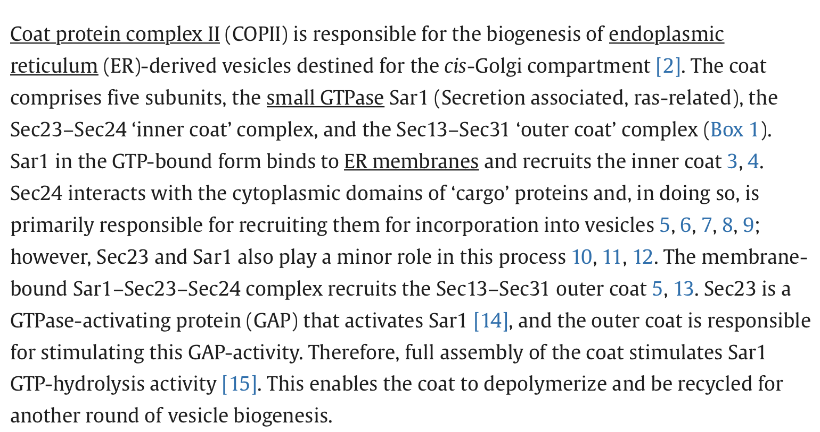
From: https://www.sciencedirect.com/science/article/pii/S0962892408001384?ref=cra_js_challenge&fr=RR-1
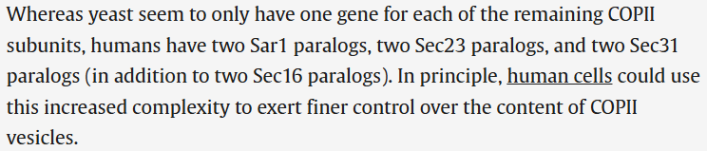
From: Coordination of COPII vesicle trafficking by Sec23 - ScienceDirect
COPII outer coat GPR rule: (SEC31A OR SEC31B) AND SEC13
Gene name | ENSEMBL id | Main transcript | Link
SEC31B | ENSG00000075826 | ENST00000370345.8 | https://www.ensembl.org/Homo_sapiens/Gene/Summary?db=core;g=ENSG00000075826;r=10:100486639-100519864
SEC31A | ENSG00000138674 | ENST00000395310.7 | https://www.ensembl.org/Homo_sapiens/Gene/Summary?db=core;g=ENSG00000138674;r=4:82818081-82901166
SEC13 | ENSG00000157020 | ENST00000350697.8 | https://www.ensembl.org/Homo_sapiens/Gene/Summary?db=core;g=ENSG00000157020;r=3:10293131-10321123

Transport to Golgi
Reaction: proopiomelanocortin-2-SRP-oxidized-folded[r] -> proopiomelanocortin-2-oxidized-folded[g]
GPR: (SEC24B OR SEC24C OR SEC24A OR SEC24D) AND SURF4 AND SEC16A AND SEC12 AND (SAR1B OR SAR1A) AND (SEC31A OR SEC31B) AND SEC13 AND AND (SEC23A OR SEC23B)

4. From Golgi to granules
After the PTMs in the TGN, POMC is sorted into the Regulated Secretory Pathway by binding to a sorting receptor (CPE). In these pathway, POMC is sorted into immature dense core granules where it undergoes acidification by the DCG membrane-spanning proton pump which will lead to the activation of prohormone convertases that will be later used for the cleavage of POMC into pro-ACTH and ACTH.

Regulated Secretory Pathway (RSP)
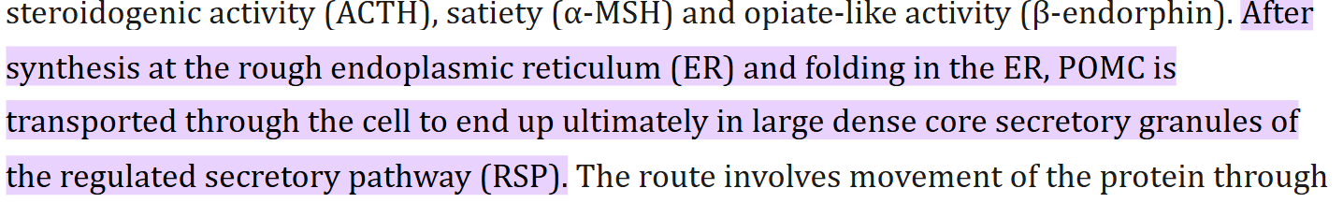
From: Biosynthesis, Trafficking and Secretion of Pro-opiomelanocortin-derived peptides - PMC

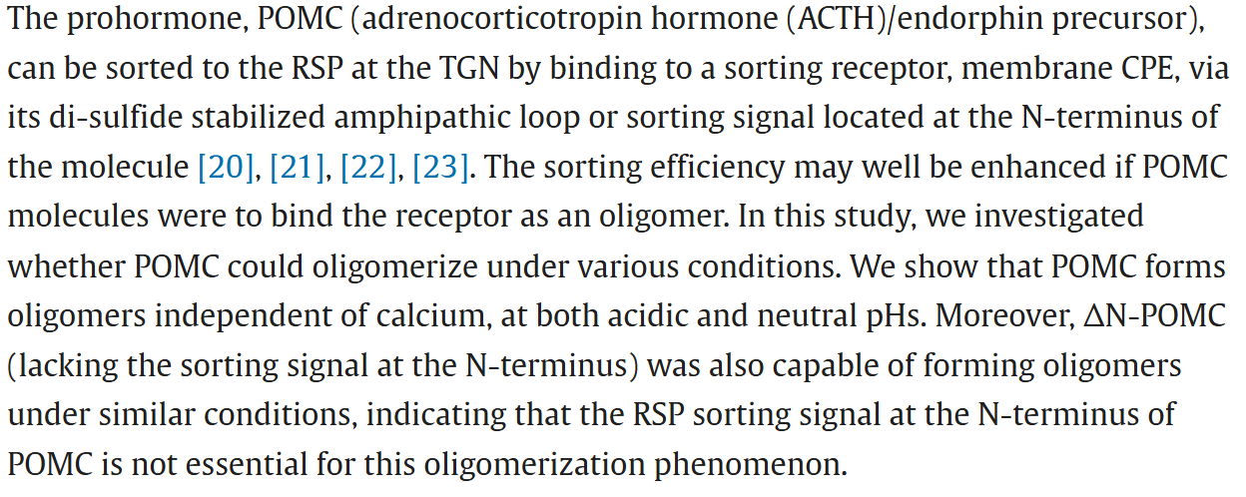From: Oligomerization of pro-opiomelanocortin is independent of pH, calcium and the sorting signal for the regulated secretory pathway - ScienceDirect
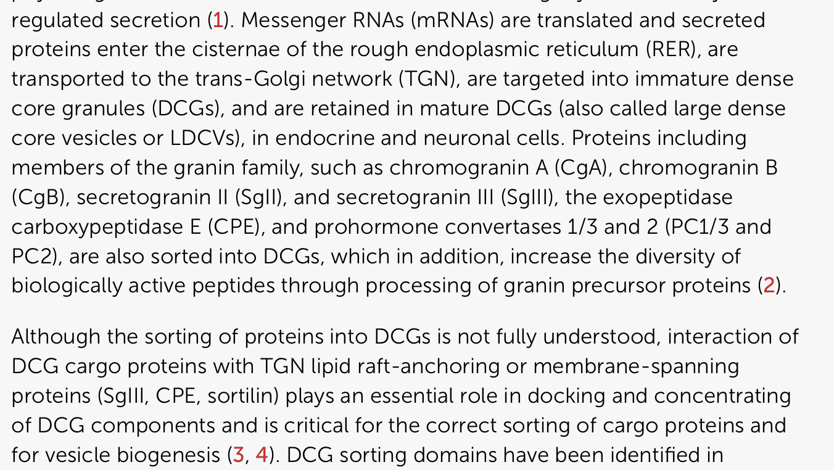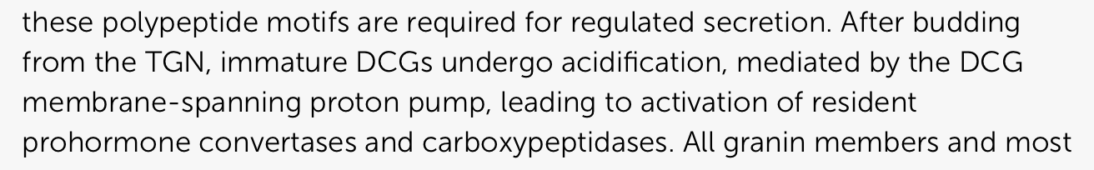
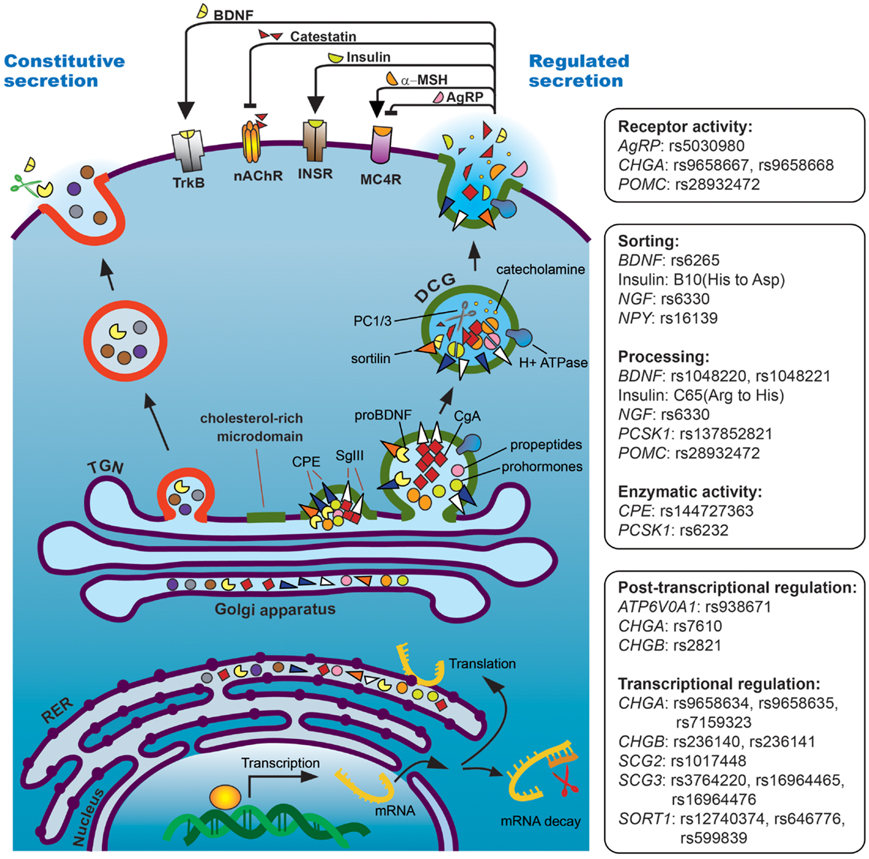
From: https://www.frontiersin.org/journals/endocrinology/articles/10.3389/fendo.2013.00096/full
After the PTMs in the TGN, POMC is sorted into the Regulated Secretory Pathway:
1. Aggregation of POMC
For this, POMC has to be first aggregated by granins in a pH and calcium dependent manner to exclude constitutive secretory proteins from entering the vesicle.

Formation of POMC aggregates:
Reaction: proopiomelanocortin-2 -oxidized-folded[g]+ secretogranin II → proopiomelanocortin-2 -oxidized-folded aggregates [g] (pH=6,0-6,5 and 1-10 mM Ca2+)
GRP: secretogranin II

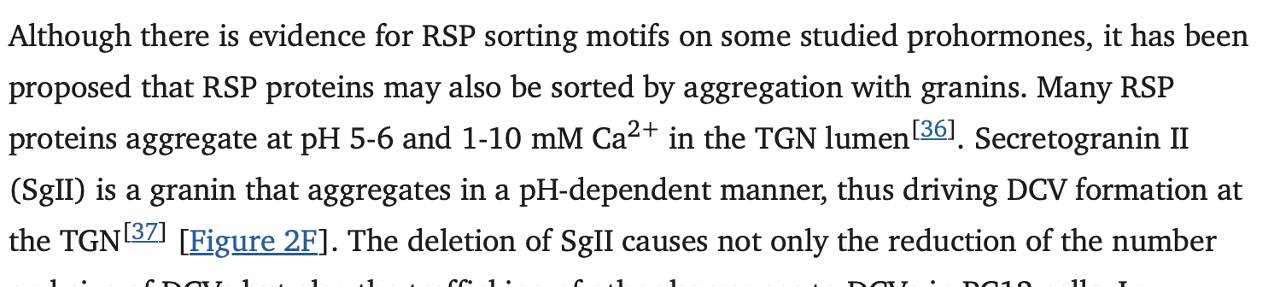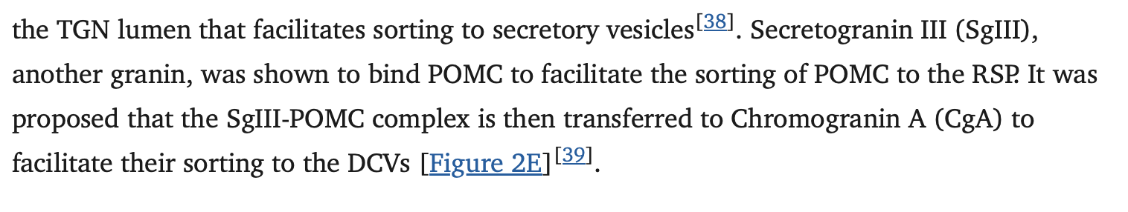
From: https://pmc.ncbi.nlm.nih.gov/articles/PMC10906782/

2. Formation of membrane bound aggregates (binding to CPE)
Then, aggregated POMC will bind to the TGN membrane via binding to a sorting receptor (CPE) in the membrane. In this step, it has been shown that Secretogranin III binds to POMC facilitating the sorting of POMC to secretory vesicles.
The POMC aggregate must be anchored to the TGN membrane to ensure it is packaged into the correct vesicle. Phosphofurin acidic cluster sorting protein-1 (PACS-1) will bind to CPE in the outer part of the Golgi membrane and will act as a binding site for AP-1/3 which will be involved in the next step.
The literature also mentions that Vesicle-associated Membrane Protein 4 (VAMP4) is somehow added to the DCG. It is mentioned that VAMP4 is located in the TGN so we assume that it will bind either to the CPE or POMC aggregates.

Formation of membrane bound aggregates:
Reaction: proopiomelanocortin-2 -oxidized-folded [g] aggregates → proopiomelanocortin-2 -oxidized-folded membrane bound aggregates [g]
GPR rules: CPE AND SGIII AND PACS-1 AND VAMP4

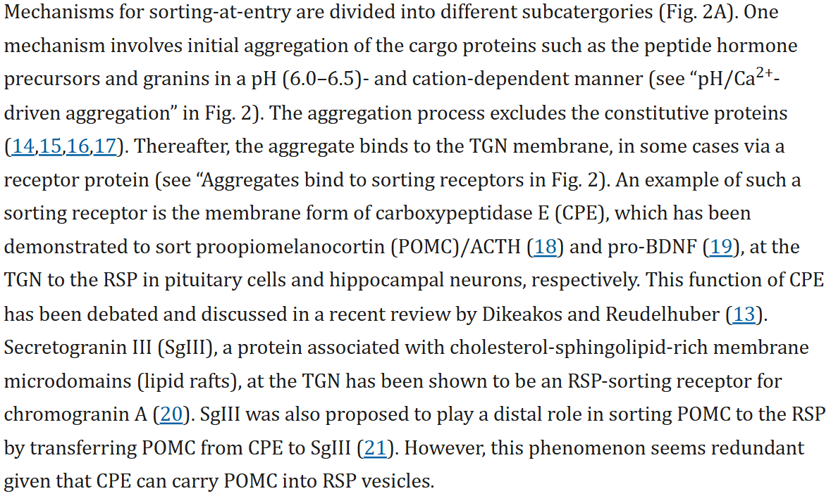
From: Minireview: How Peptide Hormone Vesicles Are Transported to the Secretion Site for Exocytosis - PMC

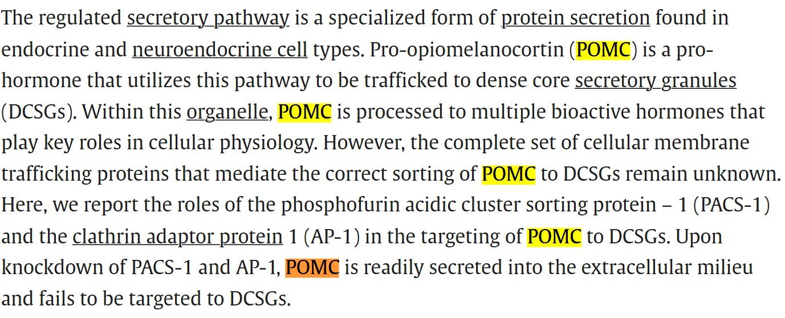
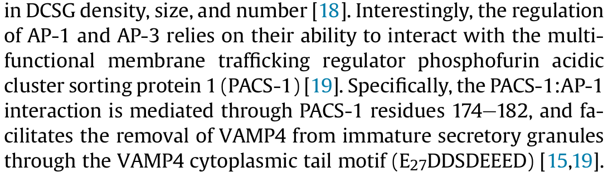
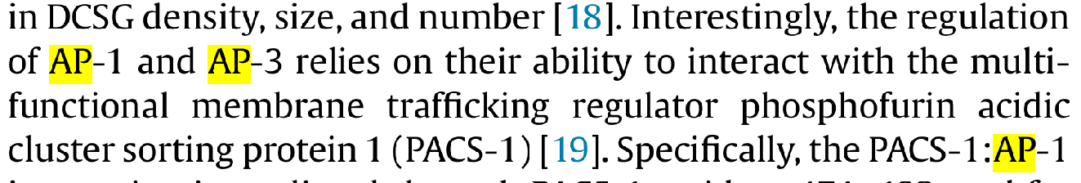
From: PACS-1 and adaptor protein-1 mediate ACTH trafficking to the regulated secretory pathway - PubMed
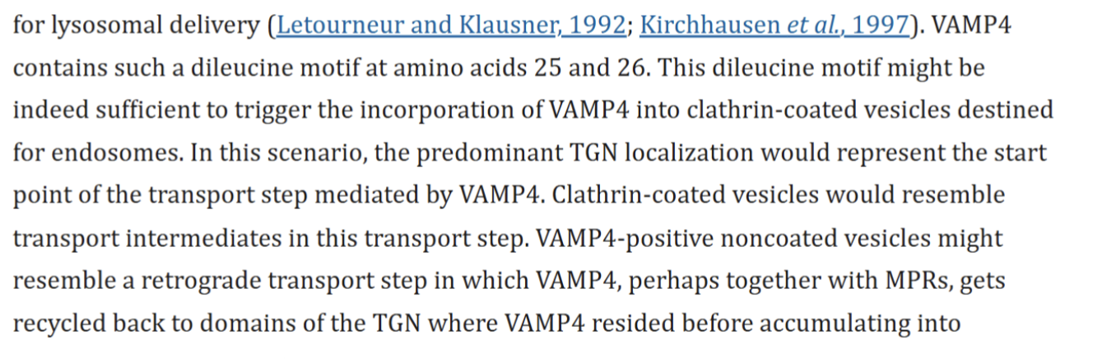
From: mk069901957p

3. Formation and coating of immature granules
After this, POMC is sorted into vesicles from the TGN by clathrin, AP-1 (Adaptor-protein 1) or (Adaptor-protein 3) and GGA (Golgi- localized, γ-ear-containing ADP-ribosylation factor binding protein)
AP-1 and AP-3 are made of different subunits
AP1 GPR: AP1M1 AND AP1G1 AND AP1B1 AND AP1S1
AP3 GPR: AP3M1 AND AP3B1 AND AP3S1
GGA has 3 different types: GGA1, GGA 2 and GGA 3. However GGA 3 is not relevant for coating the granules
GGA GPR: GGA1 AND GGA2

Formation of immature granules:
Reaction: proopiomelanocortin-2 -oxidized-folded membrane bound aggregates [g] → proopiomelanocortin-2 -oxidized-folded [ig]

GPR rules: ((AP1M1 AND AP1G1 AND AP1B1 AND AP1S1) OR (AP3M1 AND AP3B1 AND AP3S1)) AND (GGA-1 AND GGA-2)
[ig]= immature granule

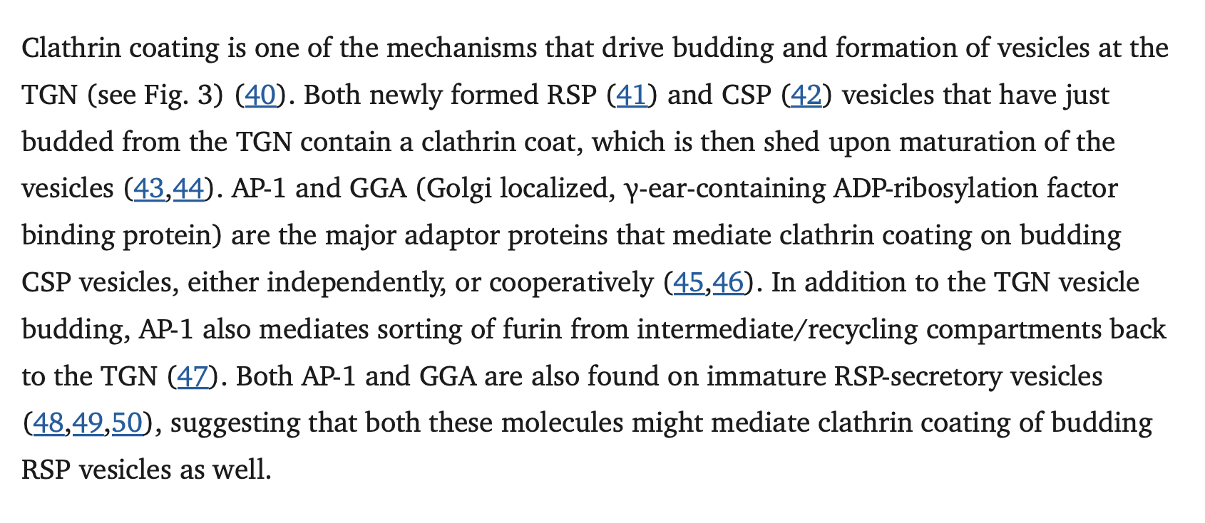
From: https://pmc.ncbi.nlm.nih.gov/articles/PMC2626200/#sec2
From: https://onlinelibrary.wiley.com/doi/10.1111/j.1600-0854.2008.00745.x

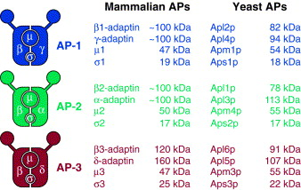
From: The AP-3 complex: a coat of many colours - ScienceDirect
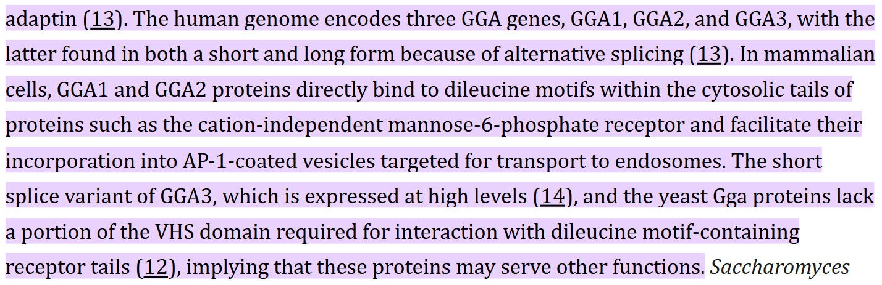
From: The GAT Domains of Clathrin-associated GGA Proteins Have Two Ubiquitin Binding Motifs - PMC

4. Acidification maturation of DCG
Finally, immature dense core granules (DCG) will undergo acidification by the DCG membrane-spanning proton pump which will lead to the activation of prohormone convertases that will be later used for the cleavage of POMC into pro-ACTH and ACTH. For the maturation/acidification of the immature DCG, Rbcm3 complex (composed of DMXL2 and WR7) recruits CAPS1 which aids in acidification. ATP6V0A1 is also involved.

Maturation/Acidification of DCGs :
Reaction: proopiomelanocortin-2 -oxidized-folded membrane bound aggregates [ig]
→ proopiomelanocortin-2 -oxidized-folded membrane bound aggregates [mg]

GPR rules: DMXL2 AND WDR7 AND CAPS1 AND ATP6V0A1
[mg] = mature granule

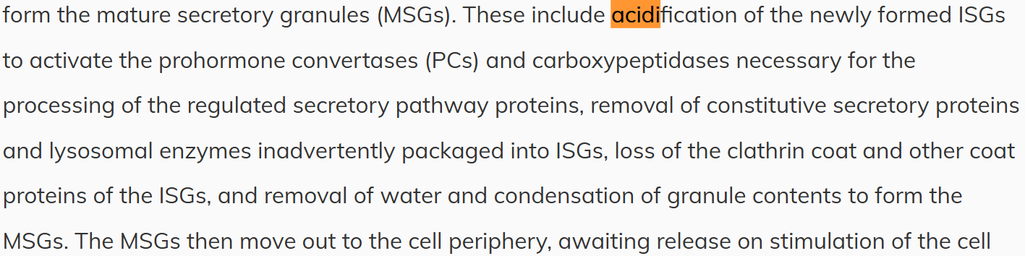
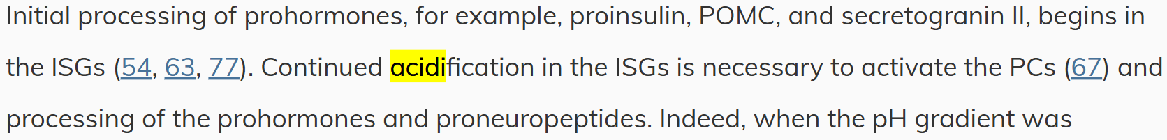
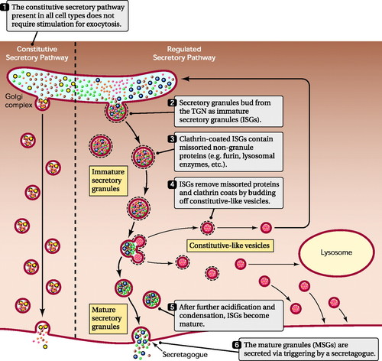
From: Dense-Core Secretory Granule Biogenesis | Physiology | American Physiological Society
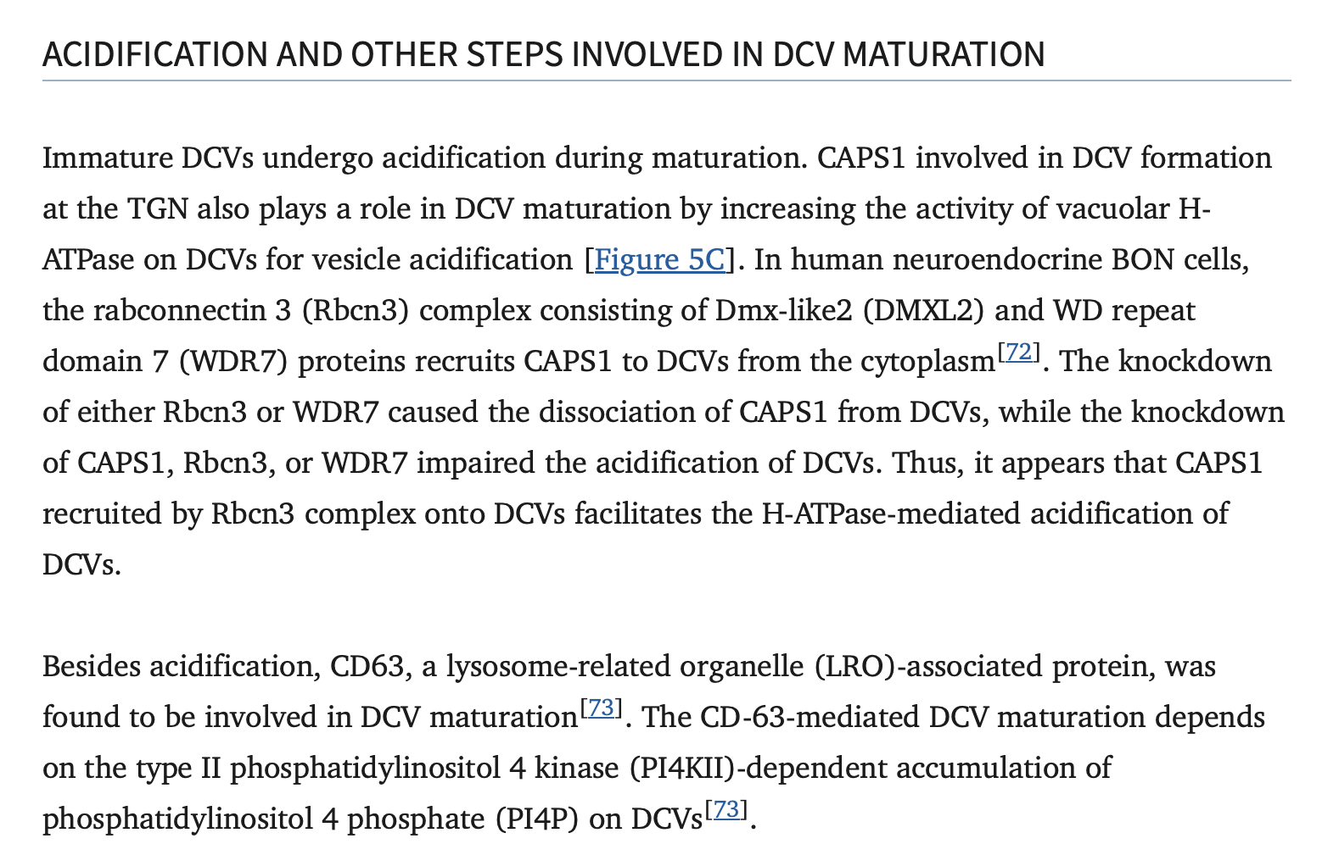
From: https://pmc.ncbi.nlm.nih.gov/articles/PMC10906782/
From: https://www.frontiersin.org/journals/endocrinology/articles/10.3389/fendo.2013.00096/full

Gene | ENSEMBL id |  | Main transcript |  | Link
CPE | ENSG00000109472 | ENST00000402744, ENSP00000386104 |  | https://www.ensembl.org/Homo_sapiens/Gene/Summary?db=core;g=ENSG00000109472;r=4:165361194-165498547
SCG3 (SgIII) | ENSG00000104112 | ENST00000220478, ENSP00000220478 |  | https://www.ensembl.org/Homo_sapiens/Gene/Summary?db=core;g=ENSG00000104112;r=15:51681492-51721026
PACS1 | ENSG00000175115 | ENST00000320580, ENSP00000316454 |  | Gene: PACS1 (ENSG00000175115) - Summary - Homo_sapiens - Ensembl genome browser 115
VAMP4 | ENSG00000117533 | ENST00000236192, ENSP00000236192 |  | https://www.ensembl.org/Homo_sapiens/Gene/Summary?db=core;g=ENSG00000117533;r=1:171700160-171743206
AP1M1 | ENSG00000072958 | ENST00000291439.8 |  | https://www.ensembl.org/Homo_sapiens/Gene/Summary?db=core;g=ENSG00000072958;r=19:16197854-16245906
AP1G1 | ENSG00000166747 | ENST00000299980.9 |  | https://www.ensembl.org/Homo_sapiens/Gene/Summary?db=core;g=ENSG00000166747;r=16:71729000-71809201
AP1B1 | ENSG00000100280 | ENST00000357586.7 |  | https://www.ensembl.org/Homo_sapiens/Transcript/Summary?db=core;g=ENSG00000100280;r=22:29327680-29388612;t=ENST00000357586
AP1S1 | ENSG00000106367 | ENST00000337619.11 |  | https://www.ensembl.org/Homo_sapiens/Gene/Summary?db=core;g=ENSG00000106367;r=7:101154352-101161596
AP3S1 | ENSG00000177879 | ENST00000316788, ENSP00000325369 |  | Gene: AP3S1 (ENSG00000177879) - Summary - Homo_sapiens - Ensembl genome browser 115
AP3D1 | ENSG00000065000 | ENST00000643116, ENSP00000495274 |  | Gene: AP3D1 (ENSG00000065000) - Summary - Homo_sapiens - Ensembl genome browser 115
AP3B1 | ENSG00000132842 | ENST00000255194, ENSP00000255194 |  | Gene: AP3B1 (ENSG00000132842) - Summary - Homo_sapiens - Ensembl genome browser 115
AP3M1 | ENSG00000185009 | ENST00000355264, ENSP00000347408 |  | Gene: AP3M1 (ENSG00000185009) - Summary - Homo_sapiens - Ensembl genome browser 115
GGA-1 | ENSG00000100083 | ENST00000343632, ENSP00000341344 |  | Gene: GGA1 (ENSG00000100083) - Summary - Homo_sapiens - Ensembl genome browser 115
GGA-2 | ENSG00000103365 | ENST00000309859, ENSP00000311962 |  | Gene: GGA2 (ENSG00000103365) - Summary - Homo_sapiens - Ensembl genome browser 115
DMXL2 | ENSG00000104093 | ENST00000560891, ENSP00000453267 |  | https://www.ensembl.org/Homo_sapiens/Gene/Summary?db=core;g=ENSG00000104093;r=15:51447711-51622981
WDR7 | ENSG00000091157 | ENST00000254442, ENSP00000254442 |  | https://www.ensembl.org/Homo_sapiens/Gene/Summary?db=core;g=ENSG00000091157;r=18:56651343-57029811
CADPS (CAPS1) | ENSG00000163618 | ENST00000383710, ENSP00000373215 |  | https://www.ensembl.org/Homo_sapiens/Gene/Summary?db=core;g=ENSG00000163618;r=3:62398346-62875563
SCG II | ENSG00000171951 | ENST00000305409, ENSP00000304133 |  | https://www.ensembl.org/Homo_sapiens/Gene/Summary?db=core;g=ENSG00000171951;r=2:223596940-223602361
ATP6V0A1 | ENSG00000033627 | ENST00000343619, ENSP00000342951 |  | Gene: ATP6V0A1 (ENSG00000033627) - Summary - Homo_sapiens - Ensembl genome browser 115

5. Proteolytic processing (POMC→ACTH)

a. POMC → pro-ACTH
After the maturation of DCGs, POMC inside the granules is cleaved by pro-hormone convertase 1/3 (PC1/3) between the COOH terminal of ACTH and the NH2 terminal of beta-LPH at the site of dibasic amino acids (Lysine-Arginine)
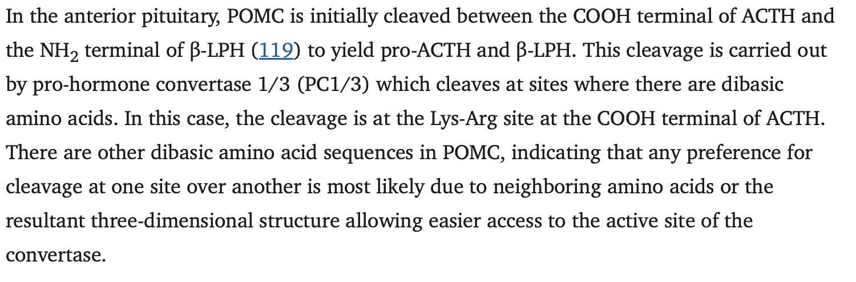
From: https://pmc.ncbi.nlm.nih.gov/articles/PMC6170974/

Gene name | ENSEMBL id | Main transcript | Link
PCSK1 (PC1/3) | ENSG00000175426 | ENST00000311106.8 | https://www.ensembl.org/Homo_sapiens/Gene/Summary?db=core;g=ENSG00000175426;r=5:96390333-96434143

Cleavage of POMC/Formation of pro-ACTH:
Reaction: proopiomelanocortin-2- oxidized-folded [mg] (PC1/3) → pro-ACTH [mg]
GPR: PCSK1

pro-ACTH → ACTH
pro-ACTH is further cleaved by PC1/3 between the COOH terminal of the joining peptide and the NH2 terminal of ACTH. This cleavage will result in ACTH and an NH2 -terminal peptide containing N-POMC (pro-gamma-MSH) 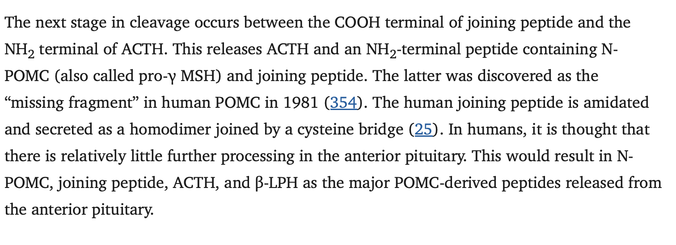
Gene name | ENSEMBL id | Main transcript | Link
PCSK1 (PC1/3) | ENSG00000175426 | ENST00000311106.8 | https://www.ensembl.org/Homo_sapiens/Gene/Summary?db=core;g=ENSG00000175426;r=5:96390333-96434143

Cleavage of pro-ACTH/Formation of ACTH:
Reaction: pro-ACTH [mg](PC1/3) → ACTH [mg]
GPR: PCSK1

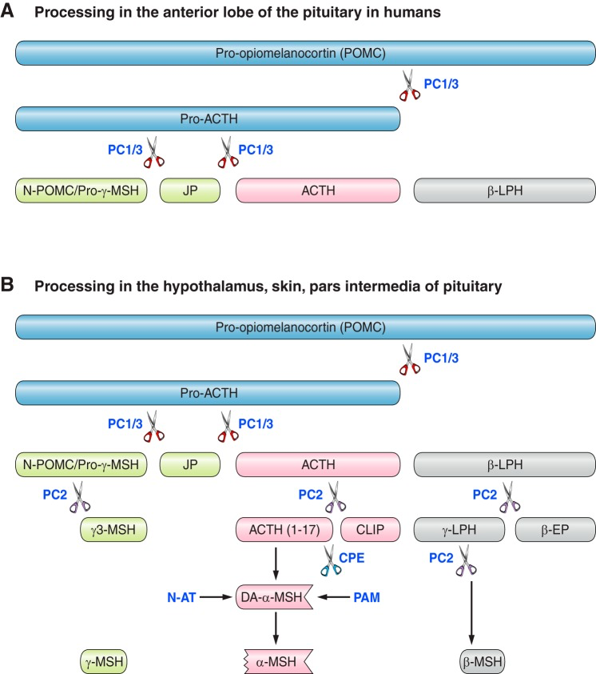

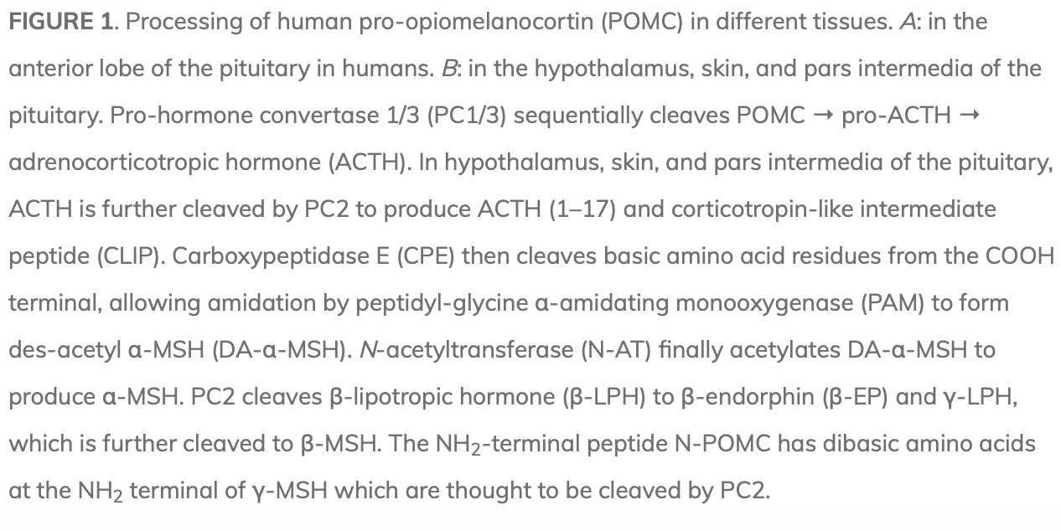
From: https://journals.physiology.org/doi/full/10.1152/physrev.00024.2017

