Peer review- ACTH
Reviewed by: Xena Bezuidenhout, Lauren Buchan, Lucia Campos

- Just state in the start of the document that the comments made by you are written in green, so the reader knows it’s not from a source.

- In this written part, you say “pre-pro-opiomelanocortin mRNA” but mRNA can’t be pre-pro already.

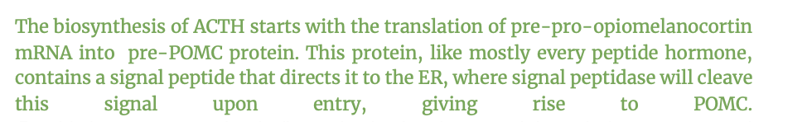

- General comment: the GPR rules should include the gene identifiers

- When the peptide hormone moves to the translocon in the SRP pathway, the “SRP” can be removed from the reaction, and it should also be removed in further reactions, as its only used in the ER translocation.

- https://www.nature.com/articles/s41467-021-27344-y Source is “WFS1 functions in ER export of vesicular cargo proteins in pancreatic β-cells”. WFS1 doesn’t seem to be relevant considering this paper is based on pancreatic β-cells, not ACTH/anterior pituitary

- This is not very specific, Sec12 is involved in the recruitment of Sar1 to the ER membrane, which then initiates COPII vesicle formation for transport to the golgi. not recruited directly to golgi.
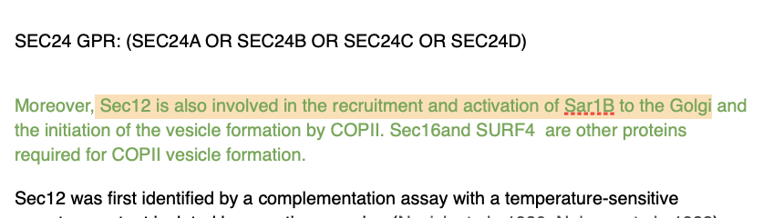

- No evidence to suggest SURF4 is part of ACTH biosynthesis, so maybe use “OR” instead of “AND” in GPR.
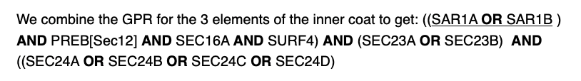

- Be consistent with the main transcripts, they can be chosen from the transcript table provided in the ensembl database or they can also be found in summary, under the MANE category. Why are they mixed ?
