Thyrotropin Synthesis
Cell types/tissues: thyrotropes, anterior pituitary gland

- Translation

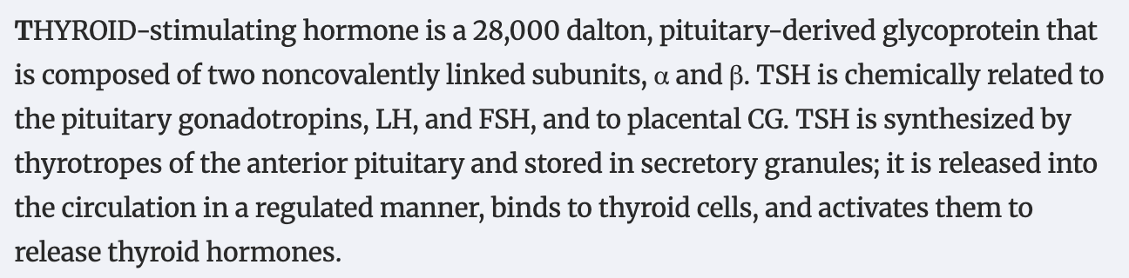
https://academic.oup.com/edrv/article-abstract/11/2/354/2548584?redirectedFrom=fulltext&login=false

According to: https://clinicalgate.com/thyroid-stimulating-hormone-physiology-and-secretion/ Biosynthesis of TSH
The intact TSH molecule is a heterodimeric glycoprotein with a molecular weight of 28 kDa that is composed of the noncovalently linked α and β subunits. The common α subunit contains 92 amino acids, and the specific TSHβ subunit has 118 amino acids. TSH biosynthesis and secretion by thyrotrope cells of the anterior pituitary are precisely regulated events.

According to: https://clinicalgate.com/thyroid-stimulating-hormone-physiology-and-secretion/ Translation of TSH Subunits
The next steps in TSH biosynthesis are summarized in Fig. 2-3.38 The mRNAs for the TSHβ and α subunits are independently translated by ribosomes in the cytoplasm. The first peptide sequences consist of “signal” peptides of 20 amino acids for TSHβ and 24 amino acids for α.39 These signal peptides are hydrophobic, allowing insertion through the lipid bilayer of the membrane of the rough endoplasmic reticulum. Translation into TSHβ and α pre-subunits continues into the lumen of the rough endoplasmic reticulum, and cleavage of the signal peptide occurs before translation is completed. This results in the formation of a 118 amino acid TSHβ subunit40 and a 92 amino acid α subunit. Cleavage of TSHβ to a protein of 112 amino acids appears to be an artifact of purification. Synthesis of recombinant TSHβ subunit has resulted in two products of 112 and 118 amino acids, both of which are similarly active in vitro.41

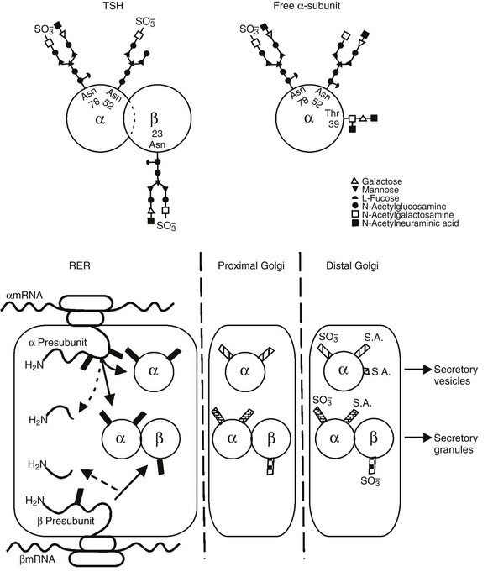
FIGURE 2-3 Top panel, Oligosaccharide chains of thyroid-stimulating hormone (TSH). Shown are typical oligosaccharide chains present on the TSH heterodimer and the free α subunit. Glycosylated asparagine (Asp) and threonine (Thr) residues are indicated. Symbols represent the oligosaccharide chain residues as indicated in the key. Bottom panel, Biosynthesis of thyroid-stimulating hormone (TSH). Schematic shown includes the processes of translation and glycosylation within the rough endoplasmic reticulum (RER) and Golgi apparatus, divided into proximal and distal. Cleavage of the aminoterminal (H2N) signal peptide and early addition of high mannose chains (black boxes), as well as the combination of α and β subunits, occur in the RER. In the proximal Golgi, oligosaccharide chains are modified (shaded boxes), and the final steps of sulfation and sialation occur in the distal Golgi apparatus.
https://clinicalgate.com/thyroid-stimulating-hormone-physiology-and-secretion/

Thyrotropin consists of two subunits, the common alpha-subunit (encoded by CGA gene) and the TSH-specific beta-subunit (encoded by TSHB gene).

Gene | ENSEMBL id | Main transcript | Link
CGA (TSH 𝛼 ) | ENSG00000135346 | ENST00000627148.3 | https://www.ensembl.org/Homo_sapiens/Gene/Summary?db=core;g=ENSG00000135346;r=6:87085498-87095106
TSHB (TSH 𝛽 ) | ENSG00000134200 | ENST00000256592.3 | https://www.ensembl.org/Homo_sapiens/Gene/Summary?db=core;g=ENSG00000134200;r=1:115029826-115034302;t=ENST00000256592

Translation of TSH 𝛼-subunit

Reaction: prepro-TSH-alpha-1[c] → prepro-TSH-alpha-2[c]

GRP: ENSG00000135346

Translation of TSH 𝛽-subunit

Reaction: prepro-TSH-beta-1[c] → prepro-TSH-beta-2[c]

GPR: ENSG00000134200

1.2 Glycosylation of TSH
According to:
https://clinicalgate.com/thyroid-stimulating-hormone-physiology-and-secretion/
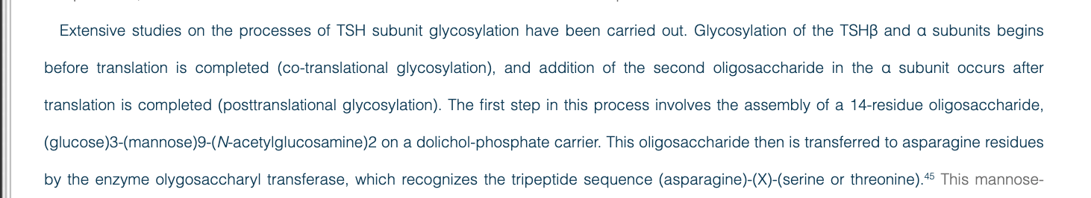

Glycosylation of TSH has a significant impact on its biological activity.42 The TSHβ subunit has a single glycosylation site, the asparagine residue at position 23, whereas the α subunit is glycosylated in two sites, the asparagine residues at positions 52 and 7843 (see Fig. 2-3). Excess free α subunit is glycosylated at an additional site, the threonine residue at position 39.44 This residue is located in a region believed to be important for combination with the TSHβ subunit. It is not known whether glycosylation at this residue is a regulated step that inhibits combination with the TSHβ subunit, or whether it occurs in excess free α subunits because this site is exposed.
Glycosylation of the TSHβ and α subunits begins before translation is completed (co-translational glycosylation), and addition of the second oligosaccharide in the α subunit occurs after translation is completed (posttranslational glycosylation). The first step in this process involves the assembly of a 14-residue oligosaccharide, (glucose)3-(mannose)9-(N-acetylglucosamine)2 on a dolichol-phosphate carrier. This oligosaccharide then is transferred to asparagine residues by the enzyme olygosaccharyl transferase, which recognizes the tripeptide sequence (asparagine)-(X)-(serine or threonine).45

According to https://pmc.ncbi.nlm.nih.gov/articles/PMC7896355/
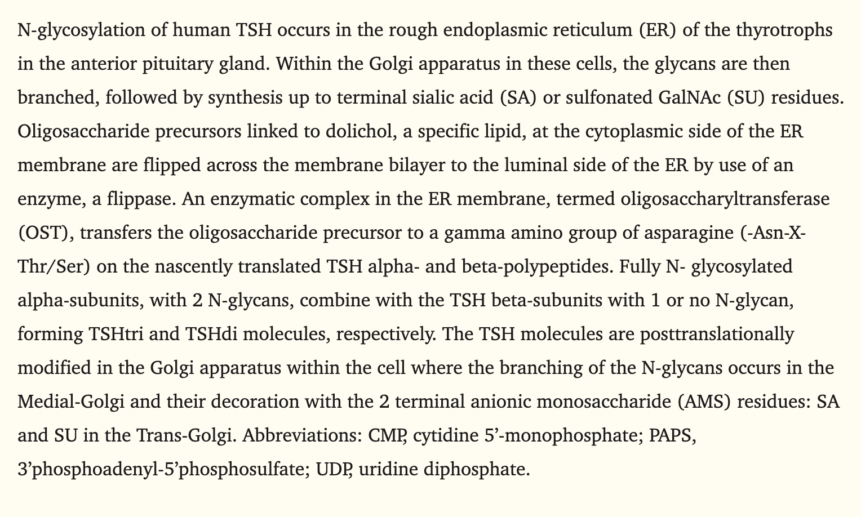
https://www.uniprot.org/uniprotkb/P39656/entry
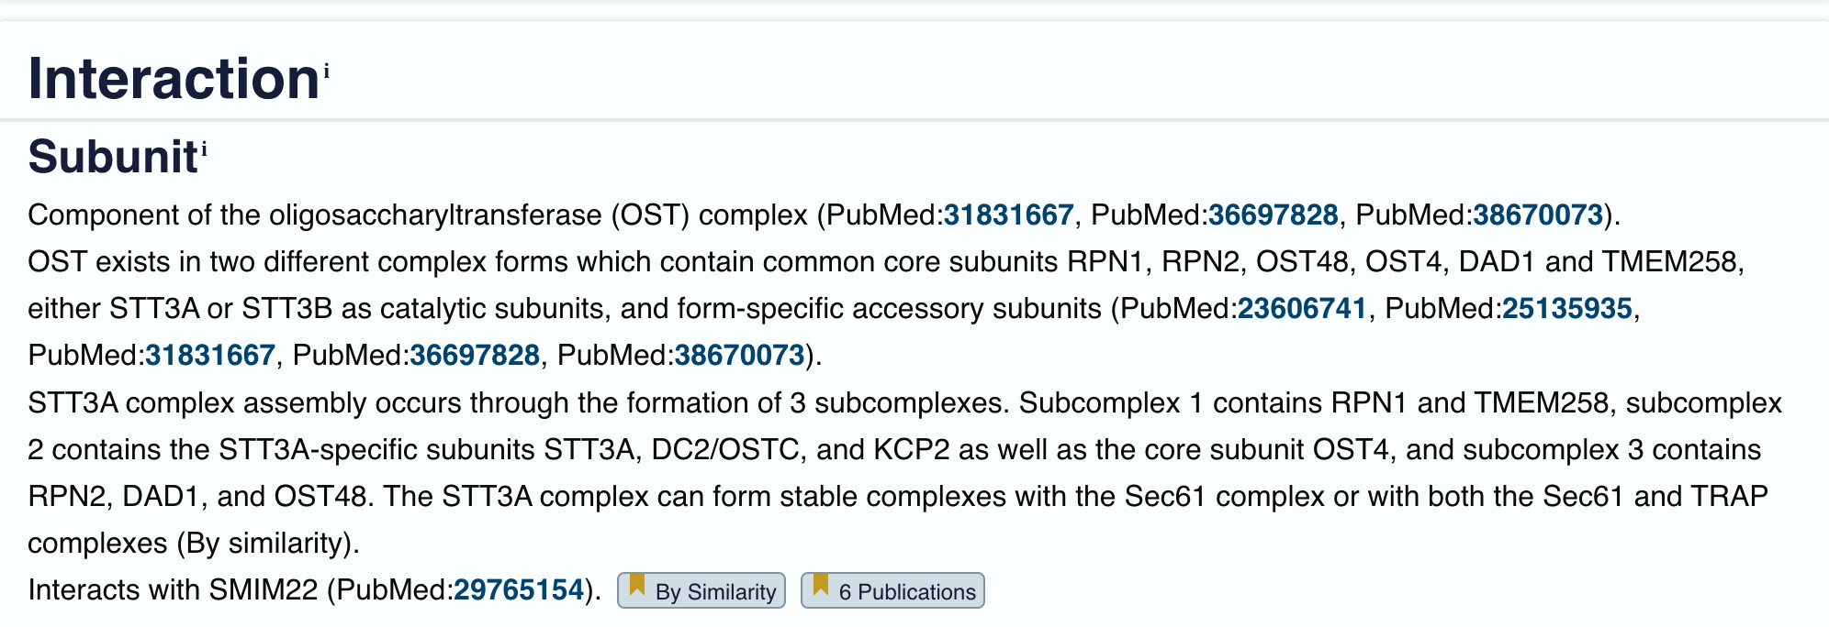

According to: https://pubmed.ncbi.nlm.nih.gov/21614585/

Gene | ENSEMBL id | Main transcript | Link
STT3A | ENSG00000134910 | ENST00000392708.9 | https://www.ensembl.org/Homo_sapiens/Gene/Summary?db=core;g=ENSG00000134910;r=11:125591712-125625215
STT3B | ENSG00000163527 | ENST00000295770.4 | https://www.ensembl.org/Homo_sapiens/Gene/Summary?db=core;g=ENSG00000163527;r=3:31532521-31638548
RFT1 | ENSG00000163933 | ENST00000296292, ENSP00000296292 | Gene: RFT1 (ENSG00000163933) - Summary - Homo_sapiens - Ensembl genome browser 115
RPN1 | ENSG00000163902 | ENST00000296255, ENSP00000296255 | Gene: RPN1 (ENSG00000163902) - Summary - Homo_sapiens - Ensembl genome browser 115
RPN2 | ENSG00000118705 | ENST00000237530, ENSP00000237530 | Gene: RPN2 (ENSG00000118705) - Summary - Homo_sapiens - Ensembl genome browser 115
OST48/DDOST | ENSG00000244038 | ENST00000602624, ENSP00000473655 | Gene: DDOST (ENSG00000244038) - Summary - Homo_sapiens - Ensembl genome browser 115
OST4 | ENSG00000228474 | ENST00000456793, ENSP00000457935 | Gene: OST4 (ENSG00000228474) - Summary - Homo_sapiens - Ensembl genome browser 115
DAD1 | ENSG00000129562 | ENST00000250498, ENSP00000250498 | Gene: DAD1 (ENSG00000129562) - Summary - Homo_sapiens - Ensembl genome browser 115
TMEM258 | ENSG00000134825 | ENST00000537328, ENSP00000443216 | Gene: TMEM258 (ENSG00000134825) - Summary - Homo_sapiens - Ensembl genome browser 115

Glycosylation of TSH 𝛼-subunit

Reaction: prepro-TSH-alpha-2[c] → prepro-TSH-alpha-2-glycosylated[c]

GRP: ENSG00000134910 OR ENSG00000163527

Glycosylation of TSH 𝛽-subunit

Reaction: prepro-TSH-beta-2[c] → prepro-TSH-beta-2-glycosylated[c]

GPR: ENSG00000134910 OR ENSG00000163527

- ER translocation

2.1 SRP enzyme
According to: https://pmc.ncbi.nlm.nih.gov/articles/PMC165607/
Signal recognition particle (SRP) is a ubiquitous ribonucleoprotein particle found in all three domains of life, but its complexity has increased considerably during evolution (Walter and Johnson, 1994; Rosenblad et al., 2003) (Figure 1). Mammalian SRP consists of 7SL RNA and six protein subunits: SRP54, SRP19, SRP68, SRP72, SRP14 and SRP9. Mammalian SRP can be divided into two functional domains by micrococcal nuclease: the Alu and S domains (Gundelfinger et al., 1983). The SRP14–SRP9 heterodimer binds to one end of 7SL RNA, forming the Alu domain (Walter and Johnson, 1994; Wild et al., 2002), whereas the forked region of 7SL RNA and the remaining four proteins form the S domain.
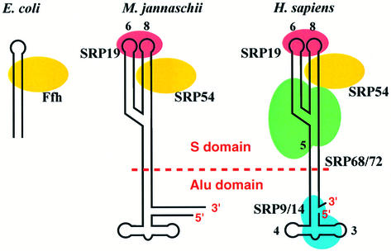
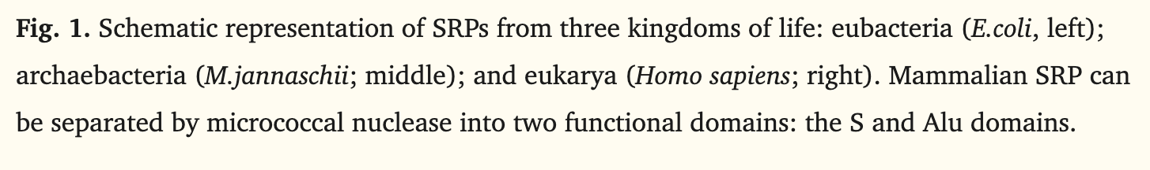
SRP Protein components
SRP GPR: SRP9 AND SRP14 AND SRP19 AND SRP54 AND SRP68 AND SRP72

Gene | ENSEMBL id | Main transcript | Link
SRP9 | ENSG00000143742 | ENST00000304786.12 | https://www.ensembl.org/Homo_sapiens/Gene/Summary?db=core;g=ENSG00000143742;r=1:225777699-225790670
SRP14 | ENSG00000140319 | ENST00000267884.11 | https://www.ensembl.org/Homo_sapiens/Gene/Summary?db=core;g=ENSG00000140319;r=15:40035690-40039181
SRP19 | ENSG00000153037 | ENST00000505459.6 | https://www.ensembl.org/Homo_sapiens/Gene/Summary?db=core;g=ENSG00000153037;r=5:112861188-112898371
SRP54 | ENSG00000100883 | ENST00000216774.11 | https://www.ensembl.org/Homo_sapiens/Gene/Summary?db=core;g=ENSG00000100883;r=14:34981957-35029686
SRP68 | ENSG00000167881 | ENST00000307877.7 | https://www.ensembl.org/Homo_sapiens/Gene/Summary?db=core;g=ENSG00000167881;r=17:76038775-76072517
SRP72 | ENSG00000174780 | ENST00000642900.1 | https://www.ensembl.org/Homo_sapiens/Gene/Summary?db=core;g=ENSG00000174780;r=4:56467595-56503681

SRP enzyme TSH-alpha:

Reaction: prepro-TSH-alpha-2[c] -> prepro-TSH-beta-2-SRP[c]

SRP enzyme TSH-beta:

Reaction: prepro-TSH-beta-2[c] -> prepro-TSH-beta-2-SRP[c]

GRP: ENSG00000143742 AND ENSG00000140319 AND ENSG00000153037 AND ENSG00000100883 AND ENSG00000167881 AND ENSG00000174780

2.2 SRP receptor

According to: https://www.science.org/doi/10.1126/science.aar7924
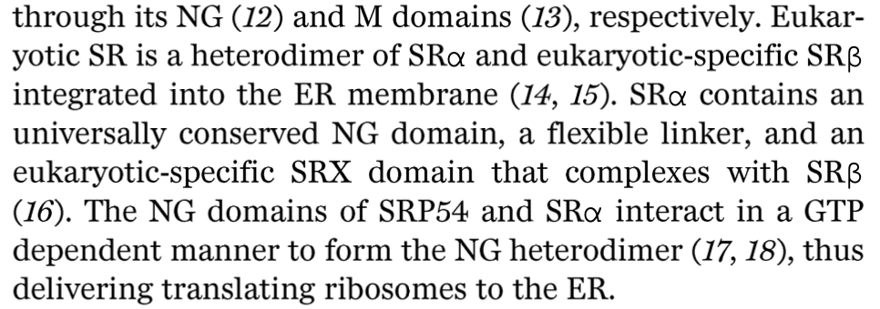
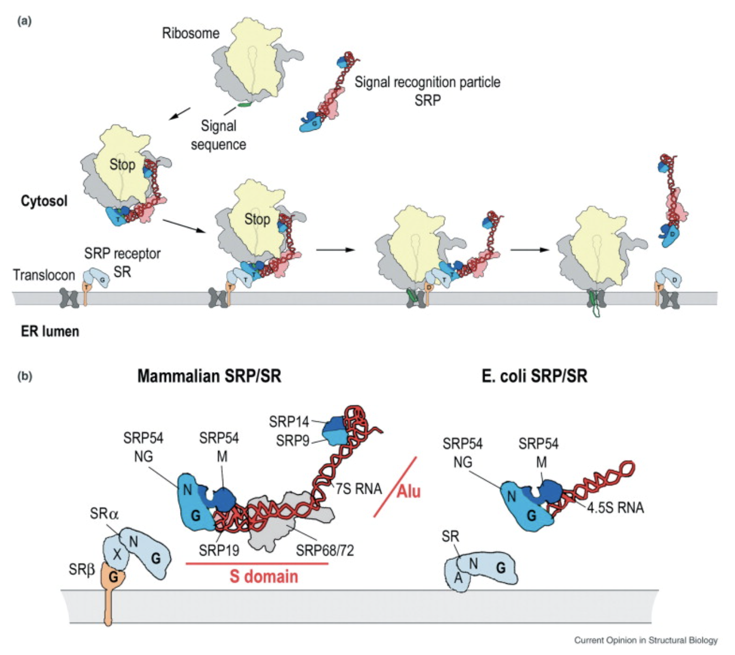
https://www.sciencedirect.com/science/article/pii/S0959440X0500014X?fr=RR-2&ref=pdf_download&rr=9bb4125a9ebd2409

In eukaryotes, SR is a heterodimer formed by the SRα and SRβ subunits. Interestingly, SRα also contains an NG domain, which is structurally and functionally homologous to the NG domain of SRP54. The NG domains of SRP54 and SR interact in the GTP-bound state during the docking step of co-translational targeting. In addition to the NG domain, SRα contains an N-terminal X domain, which interacts with SRβ. SRβ-like subunits appear to exist exclusively in eukaryotes (Figure 1b).
https://www.sciencedirect.com/science/article/pii/S0959440X0500014X?fr=RR-2&ref=pdf_download&rr=9bb4125a9ebd2409

The SRP–RNC complex docks with the membrane via SR primarily through the interaction of their NG domains, with the SRP RNA serving as a catalyst for complex formation [32]. GTP binding to SRP54 and SRα is a prerequisite to complex formation, and GTP hydrolysis leads to complex dissociation.
https://www.sciencedirect.com/science/article/pii/S0959440X0500014X?fr=RR-2&ref=pdf_download&rr=9bb4125a9ebd2409

GPR for SRP-receptor: SRPRA AND SRPRB

Gene | ENSEMBL id | Main transcript | Link
SRPRA | ENSG00000182934 | ENST00000332118.11 | https://www.ensembl.org/Homo_sapiens/Gene/Summary?db=core;g=ENSG00000182934;r=11:126262912-126269144
SRPRB | ENSG00000144867 | ENST00000466490.7 | https://www.ensembl.org/Homo_sapiens/Gene/Summary?db=core;g=ENSG00000144867;r=3:133784023-133825772

SRP receptor TSH-alpha:

Reaction: prepro-TSH-alpha-SRP[c] → prepro-TSH-alpha-SRP[r]

SRP receptor TSH-beta:

Reaction: prepro-TSH-beta-SRP[c] → prepro-TSH-beta-SRP[r]
Where r is receptor

GRP: ENSG00000182934 AND ENSG00000144867

2.3 sec61 (we dont know if it's involved yet??)

Where does Sec61 translocon fit in?
The endoplasmic reticulum (ER) is a major site for protein synthesis, folding, and maturation in eukaryotic cells, responsible for production of secretory proteins and most integral membrane proteins. The universally conserved protein-conducting channel Sec61 complex mediates core steps in these processes by translocating hydrophilic polypeptide segments of client proteins across the ER membrane and integrating hydrophobic transmembrane segments into the membrane.
https://pmc.ncbi.nlm.nih.gov/articles/PMC9808579/

Architecture of Sec61:
The Sec61 complex is a heterotrimer consisting of subunits α, β, and γ (Fig. 2). The channel is formed by the α subunit (Sec61α in eukaryotes and SecY in prokaryotes), which consists of ten TMs that are arranged in an hourglass shape (Van den Berg et al. 2004). The β and γ subunits are single-spanning membrane proteins that bind to the periphery of the α subunit.
https://pmc.ncbi.nlm.nih.gov/articles/PMC9808579/

Sec 61 translocon GPR: (SEC61A1 OR SEC61A2) AND SEC61B AND
SEC61G

Gene | ENSEMBL id | Main transcript | Link
SEC61A1 | ENSG00000058262 | ENST00000243253.8 | https://www.ensembl.org/Homo_sapiens/Gene/Summary?db=core;g=ENSG00000058262;r=3:128051641-128071705
SEC61A2 | ENSG00000065665 | ENST00000298428.14 | https://www.ensembl.org/Homo_sapiens/Gene/Summary?db=core;g=ENSG00000065665;r=10:12129637-12169961
SEC61B | ENSG00000106803 | ENST00000223641.5 | https://www.ensembl.org/Homo_sapiens/Gene/Summary?g=ENSG00000106803;r=9:99222064-99230615
SEC61G | ENSG00000132432 | ENST00000352861.9 | https://www.ensembl.org/Homo_sapiens/Gene/Summary?db=core;g=ENSG00000132432;r=7:54752180-54759974

SEC61 translocon in TSH-alpha:

Reaction: prepro-TSH-alpha-2-SRP[r] → prepro-TSH-alpha-2[t]

SEC61 translocon in TSH-beta:

Reaction: prepro-TSH-beta-2-SRP[r] → prepro-TSH-beta-2[t]
Where t is translocon

GRP: ENSG00000058262 AND ENSG00000065665 AND ENSG00000106803 AND ENSG00000132432

Next, it will embed in the ER lumen.
Reaction TSH-alpha: prepro-TSH-alpha-2[t] → prepro-TSH-alpha-2[er]
Reaction TSH-beta: prepro-TSH-beta-2[t] → prepro-TSH-beta-2[er]

- Cleavage

Cleavage of thyrotropin biosynthesis is restricted to the co-translational removal of N-terminal signal peptides from the alpha and beta subunits during translocation into the ER. No further proteolytic processing of the TSH hormone occurs.

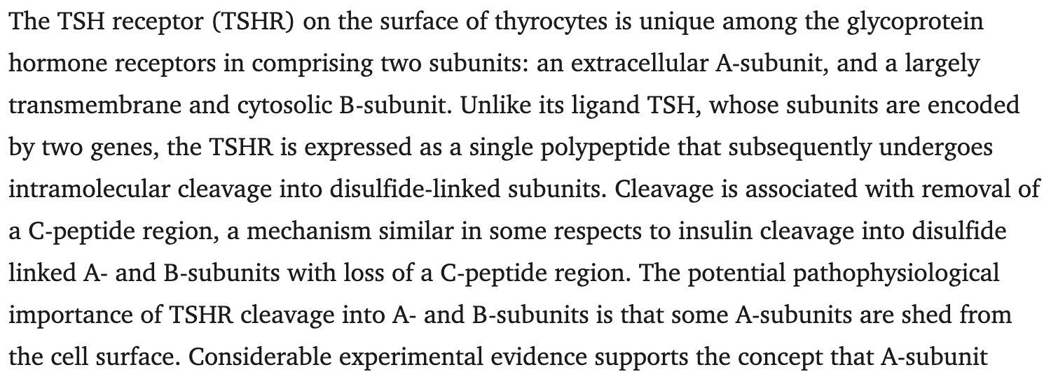

https://doi.org/10.1210/er.2015-1098.

3.1 Cleavage of signal peptide from TSH α-subunit

The TSH preopro-α-subunit is synthesised as a precursor containing an N-terminal hydrophobic signal peptide. The signal peptide is removed during co-translational translocation into the endoplasmic reticulum, enabling entry of the α-subunit into the secretory pathway.

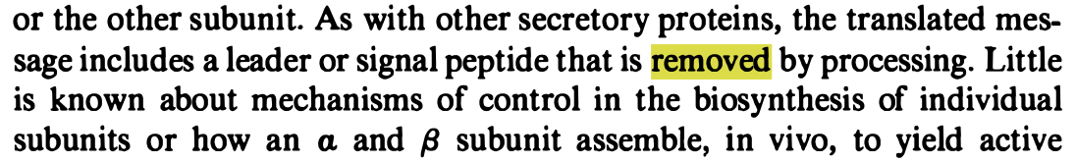

https://doi.org/10.1146/annurev.bi.50.070181.002341.

Gene | Ensembl id | Main transcript | Link
SEC11A | ENSG00000140612 | ENST00000268220.12 | https://www.ensembl.org/Homo_sapiens/Gene/Summary?db=core;g=ENSG00000140612;r=15:84669529-84716460.
SEC11B | ENSG00000226098 | ENST00000518383.1 | https://www.ensembl.org/Homo_sapiens/Gene/Summary?db=core;g=ENSG00000226098;r=8:54522799-54523297;t=ENST00000518383.

Reaction TSH-alpha: prepro-TSH-α[er] → pro-TSH-α[er] + signal-peptide[er]

GPR: ENSG00000140612 OR ENSG00000226098

3.2 Cleavage of signal peptide from TSH β-subunit
During co-translational translocation into the ER, the signal peptide of the prepro-TSH β-subunit is also cleaved, creating the pro-TSH β form. Signal peptide removal occurs early during synthesis and is required for correct and is required for correct ER localisation and subsequent folding.

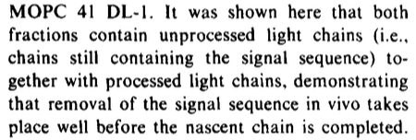

https://doi.org/10.1083/jcb.67.3.835.

Gene | Ensembl id | Main transcript | Link
SEC11A | ENSG00000140612 | ENST00000268220.12 | https://www.ensembl.org/Homo_sapiens/Gene/Summary?db=core;g=ENSG00000140612;r=15:84669529-84716460.
SEC11B | ENSG00000226098 | ENST00000518383.1 | https://www.ensembl.org/Homo_sapiens/Gene/Summary?db=core;g=ENSG00000226098;r=8:54522799-54523297;t=ENST00000518383.

Reaction TSH-beta: prepro-TSH-β[er] → pro-TSH-β[er] + signal-peptide[er]

GPR: ENSG00000140612 OR ENSG00000226098

- Folding and disulfide bond formation

Correct folding and disulfide bond formation are essential for structural integrity and biological activity of glycoprotein hormones. This process occurs in the ER, and is driven by the formation of conserved disulfide bonds within the hormone subunits
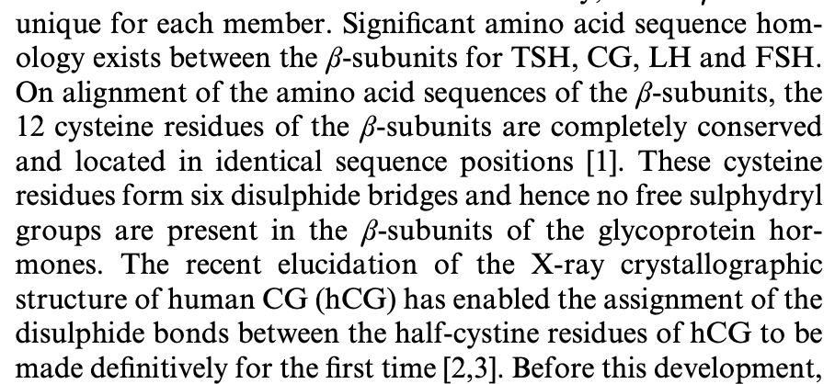

https://doi.org/10.1042/bj3140449.

According to: https://www.mdpi.com/1422-0067/16/1/1791 & https://www.cell.com/trends/biochemical-sciences/fulltext/S0968-0004%2825%2900063-5

Disulfide bonds are formed in the endoplasmic reticulum for eukaryotic cells and they need the help of a cofactor, in this case PDI-Ero1 and PDI-Erv2 are involved in oxytocin bond formation (they are involved in hormones bond formation but im not sure if they do specifically for thyroptropin, it is an assumption)

In a chemical perspective, disulfide bonds are formed between two cysteine residues via the oxidation of the two thiol groups (-SH) which will lose electrons to form sulfur radicals. Then, this sulfur radicals will combine to form the disulfide bridges (S-S)

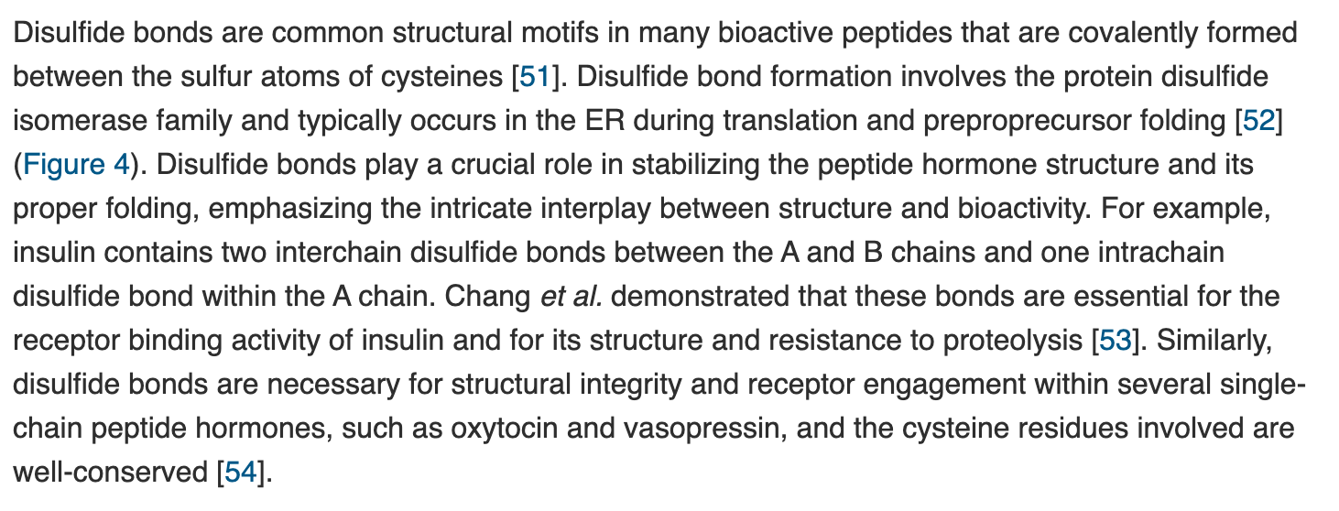
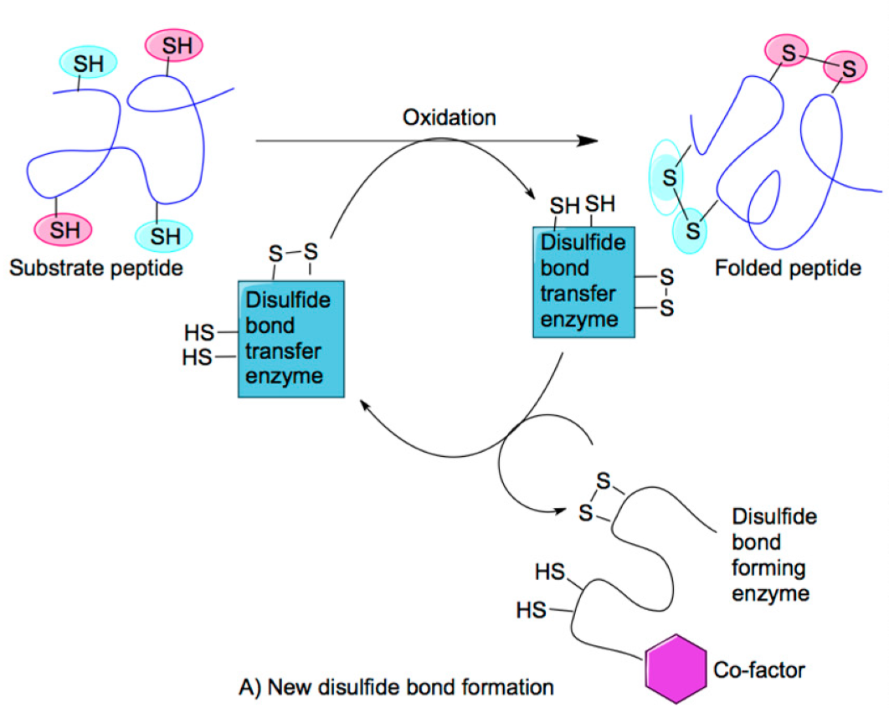

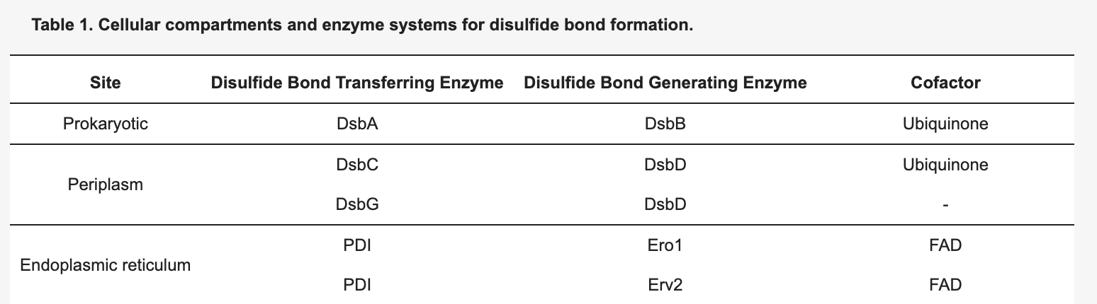

4.1 Folding

Following translocation into the ER, the TSH α and β subunits remain in a reduced, unfolded state and must undergo oxidative folding to achieve their native conformation.

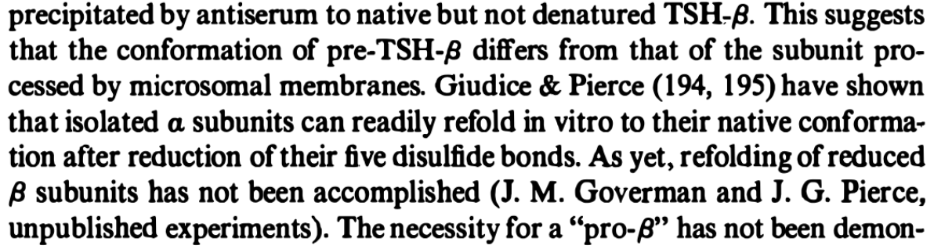

https://doi.org/10.1146/annurev.bi.50.070181.002341.

Gene | ENSEMBL id | Main transcript | Link
PDIA1/P4HB | ENSG00000185624 | ENST00000331483, ENSP00000327801 | https://www.ensembl.org/Homo_sapiens/Gene/Summary?db=core;g=ENSG00000185624;r=17:81843159-81860856
ERO1A | ENSG00000197930 | ENST00000395686, ENSP00000379042 | https://www.ensembl.org/Homo_sapiens/Gene/Summary?db=core;g=ENSG00000197930;r=14:52639915-52696025

Reaction:

pro-TSH-subunits (α/β, reduced) [ER] → pro-TSH-subunits (α/β, oxidised, folded) [ER]

GRP: ENSG00000185624 AND ENSG00000197930

https://doi.org/10.1089/ars.2012.4966.

- Transport to golgi apparatus (lucia)

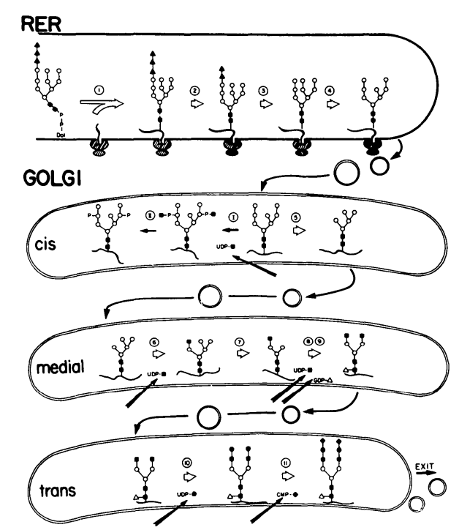
https://academic.oup.com/edrv/article-abstract/11/2/354/2548584?redirectedFrom=fulltext&login=false

5.1 Vesicle coating

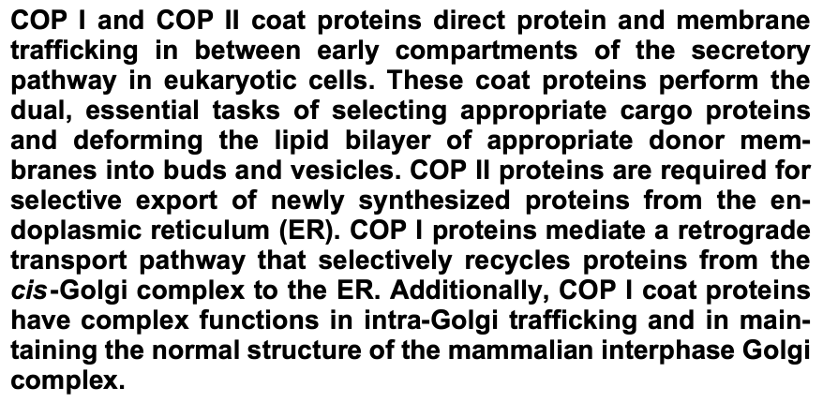
https://doi.org/10.1080/0968768031000122548

According to this article COPII is essential for the export of newly synthesized peptides. COPII has different important components: GTPase, Sar1p, Sec23/24p and Sec13/31p

Sec12p mediates the exchange of GT`for GDP on Sar1p activating it
Therefore, membrane binding of Sar1p-GTP allows the recruitment of the Sec23/24 complex and subsequently of the Sec13/31p, which induces coat formation and deformation of the membrane into buds and vesicles

Sec16p interacts with: Sar1p, Sar23p, Sar24p and Sar31p

https://pmc.ncbi.nlm.nih.gov/articles/PMC11087783/#:~:text=The%20SAR1A%20and%20SAR1B%20paralogs,CMRD%20(22%2C%2023).

Sar1 has two paralog genes: Sar1A and Sar1B
The text presented below indicates that the knockout of both genes at the same time in order to encounter an alteration in the cell vesicle trafficking and therefore the lead of a disease development
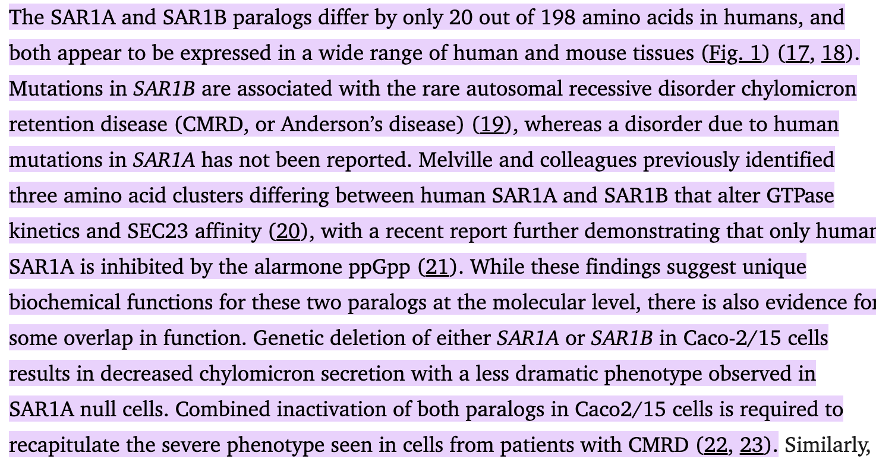
https://pmc.ncbi.nlm.nih.gov/articles/PMC11087783/#:~:text=The%20SAR1A%20and%20SAR1B%20paralogs,CMRD%20(22%2C%2023).

Sec23 has two paralog genes: Sec23a and Sec23b
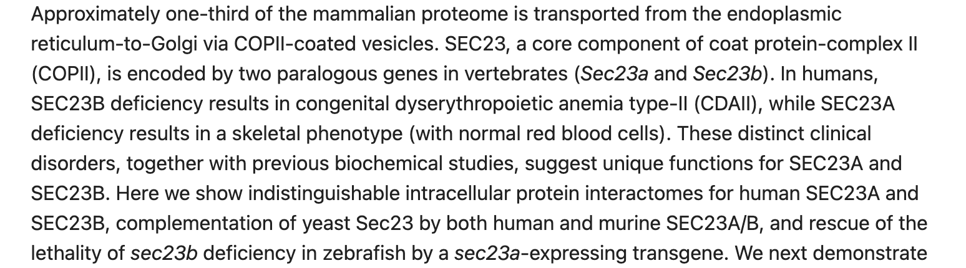

https://pubmed.ncbi.nlm.nih.gov/30065114/

Sec31 has two paralog genes: Sec31A and Sec31B
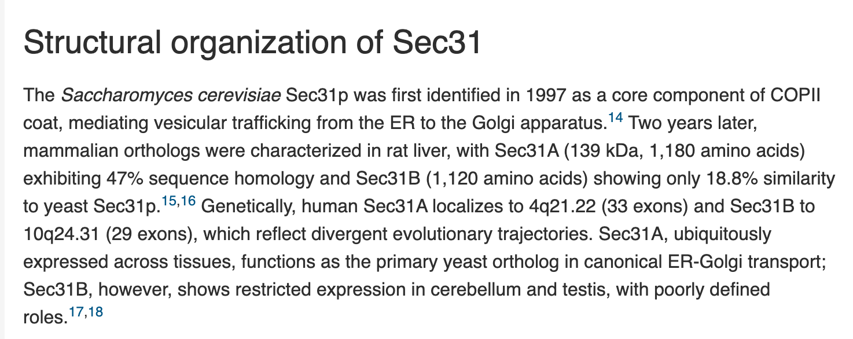

https://www.cell.com/iscience/fulltext/S2589-0042(25)01873-5#:~:text=Declaration%20of%20interests-,Summary,and%20responses%20to%20microbial%20infections.

Sec24 has four paralog genes: Sec24A, Sec24B, Sec24C & Sec24D
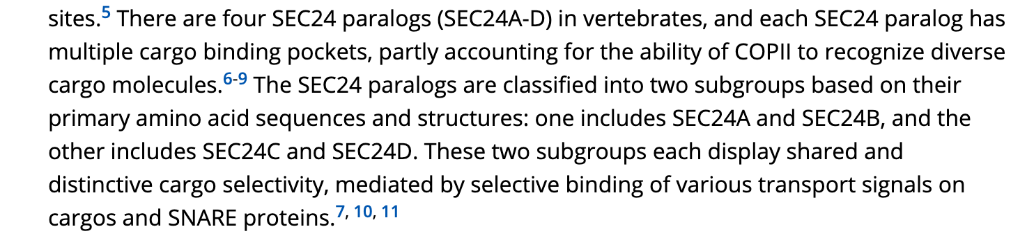
https://onlinelibrary.wiley.com/doi/10.1111/tra.12826

Sec16 has two paralog genes: Sec16A and Sec16B
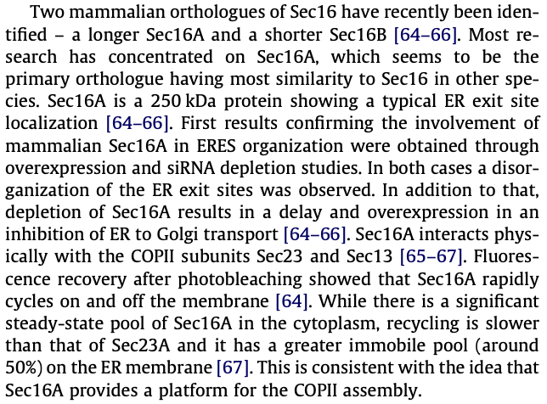
10.1016/j.febslet.2009.10.038

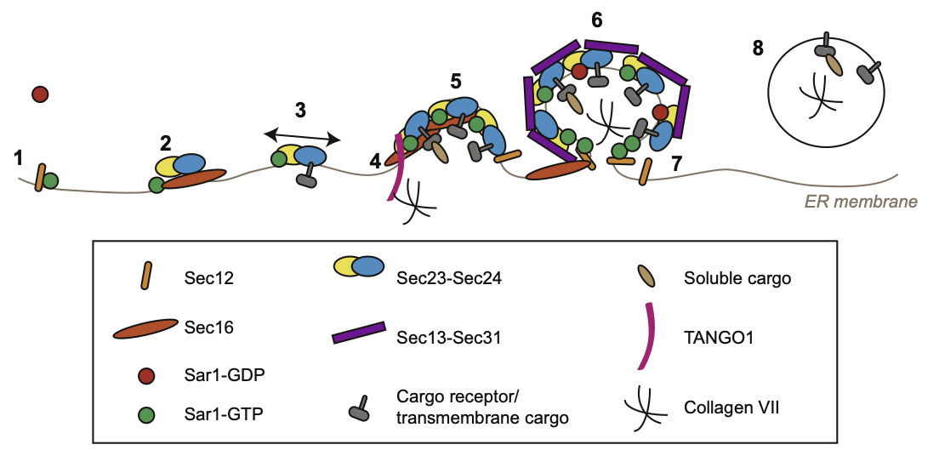
https://doi.org/10.1016/j.febslet.2009.10.038.
GPR: Sar1A OR Sar1B AND Sec12 (PREB) AND Sec16

Gene | ENSEMBL id | Main transcript | Link
SAR1A | ENSG00000079332 | ENST00000373241, ENSP00000362338 | Gene: SAR1A (ENSG00000079332) - Summary - Homo_sapiens - Ensembl genome browser 115
SAR1B | ENSG00000152700 | ENST00000402673, ENSP00000385432 | Gene: SAR1B (ENSG00000152700) - Summary - Homo_sapiens - Ensembl genome browser 115
SEC16A | ENSG00000148396 | ENST00000684901, ENSP00000508822 | Gene: SEC16A (ENSG00000148396) - Summary - Homo_sapiens - Ensembl genome browser 115
SEC16B | ENSG00000120341 | ENST00000308284, ENSP00000308339 | Gene: SEC16B (ENSG00000120341) - Summary - Homo_sapiens - Ensembl genome browser 115
SEC23A | ENSG00000100934 | ENST00000307712, ENSP00000306881 | Gene: SEC23A (ENSG00000100934) - Summary - Homo_sapiens - Ensembl genome browser 115
SEC23B | ENSG00000101310 | ENST00000650089, ENSP00000497473 | Gene: SEC23B (ENSG00000101310) - Summary - Homo_sapiens - Ensembl genome browser 115
SEC24A | ENSG00000113615 | ENST00000398844, ENSP00000381823 | https://www.ensembl.org/Homo_sapiens/Gene/Summary?db=core;g=ENSG00000113615;r=5:134648588-134727909
SEC24B | ENSG00000138802 | ENST00000265175, ENSP00000265175 | Gene: SEC24B (ENSG00000138802) - Summary - Homo_sapiens - Ensembl genome browser 115
SEC24C | ENSG00000176986 | ENST00000345254, ENSP00000321845 | Gene: SEC24C (ENSG00000176986) - Summary - Homo_sapiens - Ensembl genome browser 115
SEC24D | ENSG00000150961 | ENST00000280551, ENSP00000280551 | Gene: SEC24D (ENSG00000150961) - Summary - Homo_sapiens - Ensembl genome browser 115
SEC12/PREB | ENSG00000138073 | ENST00000260643, ENSP00000260643 | https://www.ensembl.org/Homo_sapiens/Gene/Summary?db=core;g=ENSG00000138073;r=2:27130752-27134671
OXER1 | ENSG00000162881 | ENST00000378661, ENSP00000367930 | Gene: OXER1 (ENSG00000162881) - Summary - Homo_sapiens - Ensembl genome browser 115

Vesicle coating involved in transport from ER to Golgi
Reaction: TSH-alpha,beta, folded [er] → TSH-alpha,beta, folded[g]

GRP: ENSG00000079332 OR ENSG00000152700 AND ENSG00000138073 AND ENSG00000148396 AND ENSG00000100934 AND ENSG00000113615 AND ENSG00000162881

https://insight.jci.org/articles/view/191837
https://www.proteinatlas.org/ENSG00000162881-OXER1
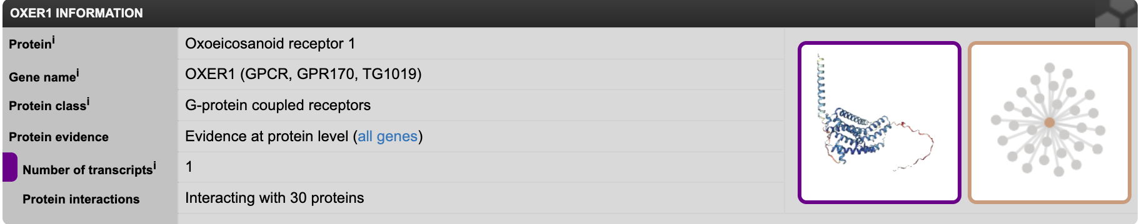
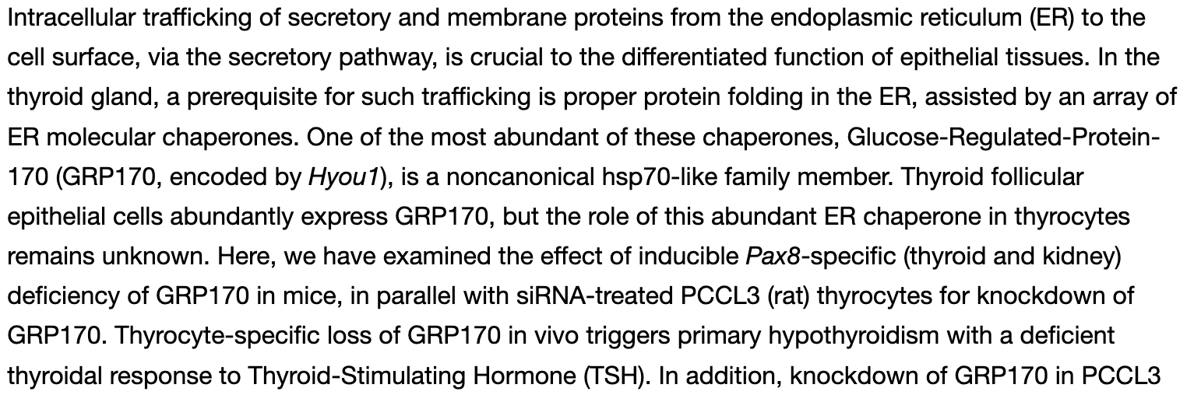

- Post translational peptide modifications

6.1 Sialylation

https://academic.oup.com/jcem/article/104/10/4651/5511540?login=false#. Even though N-glycosylation is the main post translational modification of the TSH molecule, the addition of sialic acid and sulfo residue into the N-glycan is important for their bioactivity.

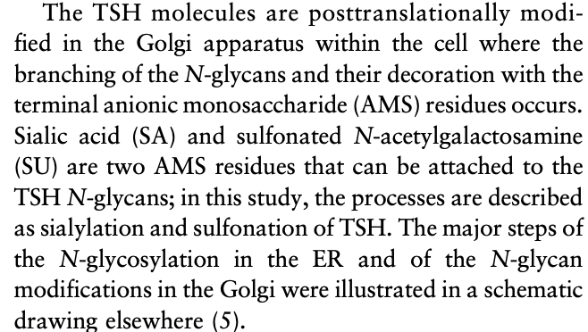

Although the sialylation process has not been yet researched in thyrotropin specifically, according to the scientific article Sialylation of N-glycans: mechanism, cellular compartmentalization and function - PMC this is how it takes place in glycoproteins.

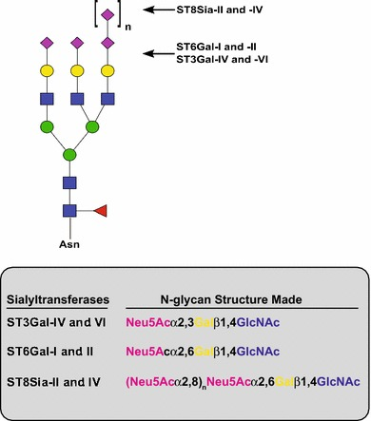

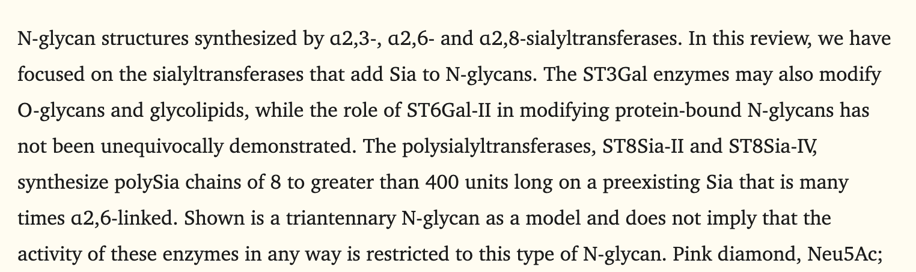

The specific function of each enzyme is not completely understood yet

Gene | ENSEMBL id | Main transcript | Link
ST3Gal-IV | ENSG00000110080 | ENST00000444328, ENSP00000394354 | Gene: ST3GAL4 (ENSG00000110080) - Summary - Homo_sapiens - Ensembl genome browser 115
ST3Gal-VI | ENSG00000064225 | ENST00000483910, ENSP00000417376 | Gene: ST3GAL6 (ENSG00000064225) - Summary - Homo_sapiens - Ensembl genome browser 115
ST6Gal- I | ENSG00000073849 | ENST00000169298, ENSP00000169298 | Gene: ST6GAL1 (ENSG00000073849) - Summary - Homo_sapiens - Ensembl genome browser 115
ST6Gal- II | ENSG00000144057 | ENST00000409382, ENSP00000386942 | Gene: ST6GAL2 (ENSG00000144057) - Summary - Homo_sapiens - Ensembl genome browser 115
ST8Sia-II | ENSG00000140557 | ENST00000268164, ENSP00000268164 | Gene: ST8SIA2 (ENSG00000140557) - Summary - Homo_sapiens - Ensembl genome browser 115
ST8Sia-IV | ENSG00000113532 | ENST00000231461, ENSP00000231461 | Gene: ST8SIA4 (ENSG00000113532) - Summary - Homo_sapiens - Ensembl genome browser 115

N-glycan sialylation
Reaction: TSH-Nglycan + CMP-Neu5Ac [g] → Sialylated TSH [g]

GPR: ENSG00000110080 AND ENSG00000064225 AND ENSG00000073849 AND ENSG00000144057 AND ENSG00000140557 AND ENSG00000113532

6.2 Sulfation
According to https://doi-org.mu.idm.oclc.org/10.1016/bs.mie.2018.03.003

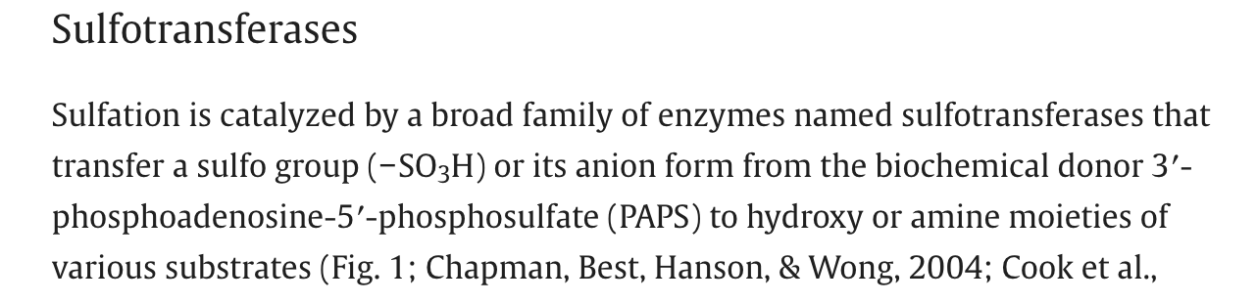

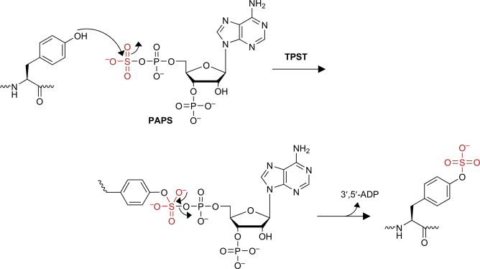

PAPS is the consubstrate which allows the two steps of sulfation to take place. The first step is mediated by PAPS1 and the second step in the process is mediated by PAPS2. https://www.uniprot.org/uniprotkb/O43252/entry

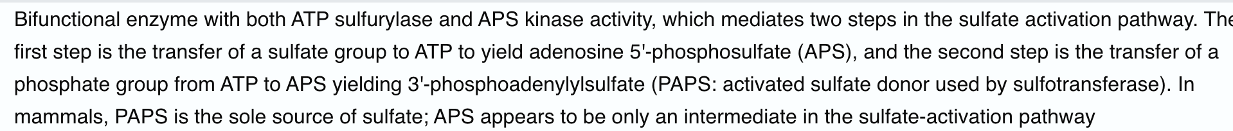

Gene | ENSEMBL id | Main transcript | Link
PAPS1 | ENSG00000138801 | ENST00000265174, ENSP00000265174 | Gene: PAPSS1 (ENSG00000138801) - Summary - Homo_sapiens - Ensembl genome browser 115
PAPS2 | ENSG00000198682 | ENST00000456849, ENSP00000406157 | Gene: PAPSS2 (ENSG00000198682) - Summary - Homo_sapiens - Ensembl genome browser 115
SULT1E1 | ENSG00000109193 | ENST00000226444, ENSP00000226444 | Gene: SULT1E1 (ENSG00000109193) - Summary - Homo_sapiens - Ensembl genome browser 115
SULT1A1 | ENSG00000196502 | ENST00000314752, ENSP00000321988 | Gene: SULT1A1 (ENSG00000196502) - Summary - Homo_sapiens - Ensembl genome browser 115
SULT1A3 | ENSG00000261052 | ENST00000338971, ENSP00000343645 | Gene: SULT1A3 (ENSG00000261052) - Summary - Homo_sapiens - Ensembl genome browser 115

Note: the genes of the enzyme sulfotransferase (SULT1E1) are an assumption made according https://pubmed.ncbi.nlm.nih.gov/10404840/#:~:text=Abstract,metabolism%20needs%20to%20be%20considered, which discusses the sulfation in thyroid hormones. No information was found specifically of the genes involved in thyrotropin.

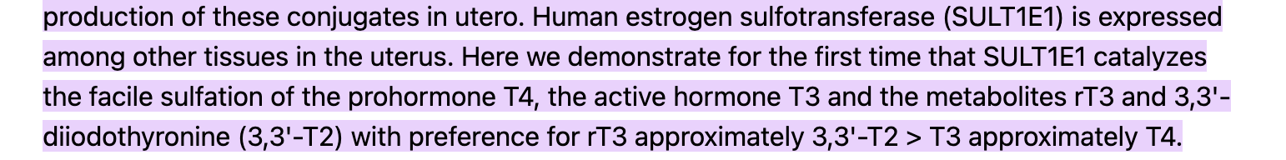

Thyrotropin sulfation
Reaction: TSH-Nglycan + OH (tyrosine reside) + PAPS [g] → sulfonated TSH [g]

GRP: ENSG00000138801 AND ENSG00000198682 AND ENSG00000109193 ( ENSG00000196502 OR ENSG00000261052)

