Adiponectin synthesis and maturation:
https://pmc.ncbi.nlm.nih.gov/articles/PMC8461789/
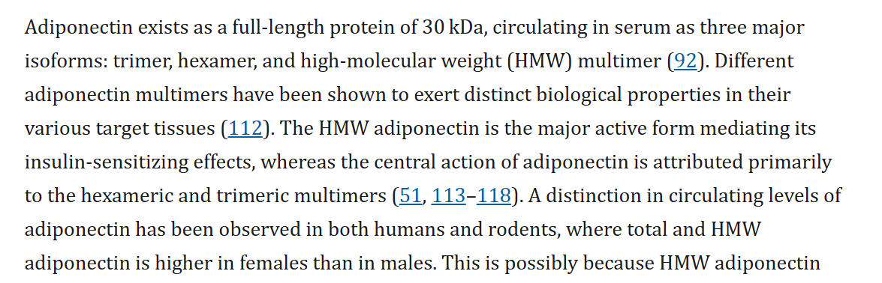
https://pmc.ncbi.nlm.nih.gov/articles/PMC8461789/
Adiponectin-trimer
Adiponectin-hexamer
Adiponectin-multimer
Gene: ENSG00000181092
https://pmc.ncbi.nlm.nih.gov/articles/PMC8461789/
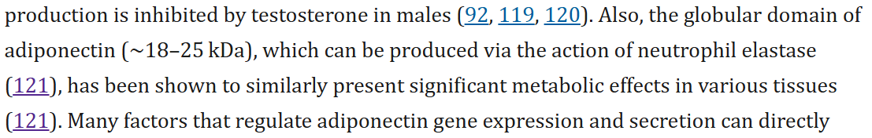
https://academic.oup.com/endo/article/146/2/790/2878536?login=true
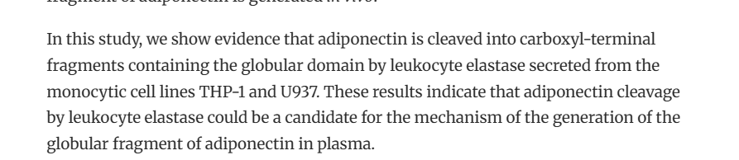
However this cleavage is in the plasma itself, might be a good candidate to for comparing endocrine/paracrine effects if we can correctly predict the neutrophil elastase activity from the blood.

Disulfide bond at Cys36 necessary for multimerization
But Cys36 is also a target of succination, which then blocks the multimerization this might require 2 tasks, and the result to be subtracted from each other
Hydroxylation and subsequent Glycosylation of Lys65, Lys68, Lys77, and Lys101
Both Necessary for intracellular assembly
Then pro71, Pro76, and Pro95 hydroxylation

Multimerization is controlled by ErP44, Ero1A, DsbA-L
https://www.sciencedirect.com/science/article/pii/S0021925820830932?via%3Dihub
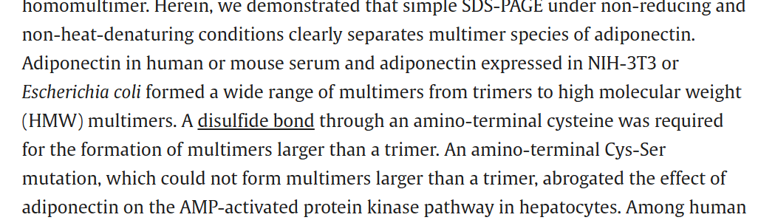
ErP44 inhibits multimierzation (ER-golgi)
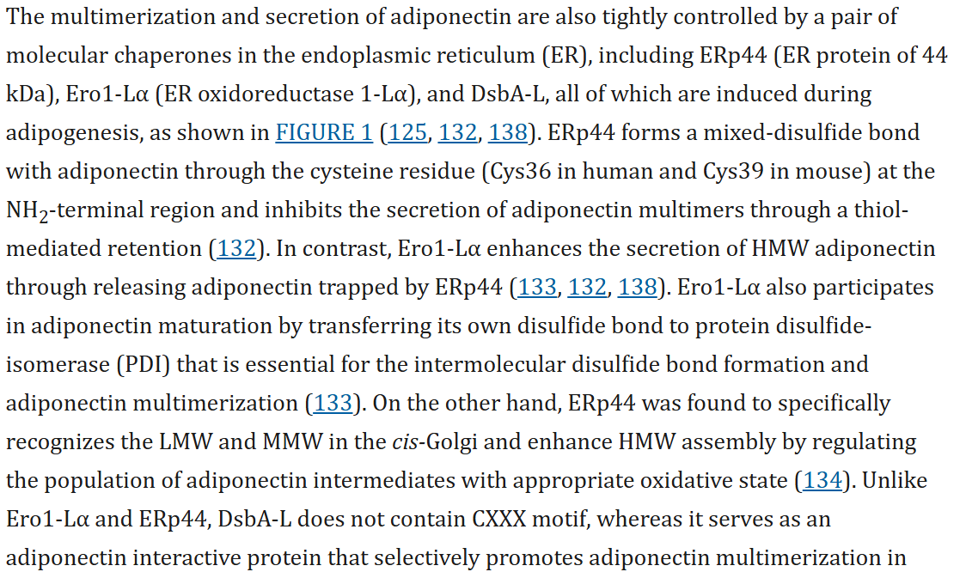
Ero1-1a releases it from ErP44 this again seems to require some type of contrastive interactions, possibly substracting their activities. (in golgi)
Ero1 interacts with PDI which one?? At least PDIA6
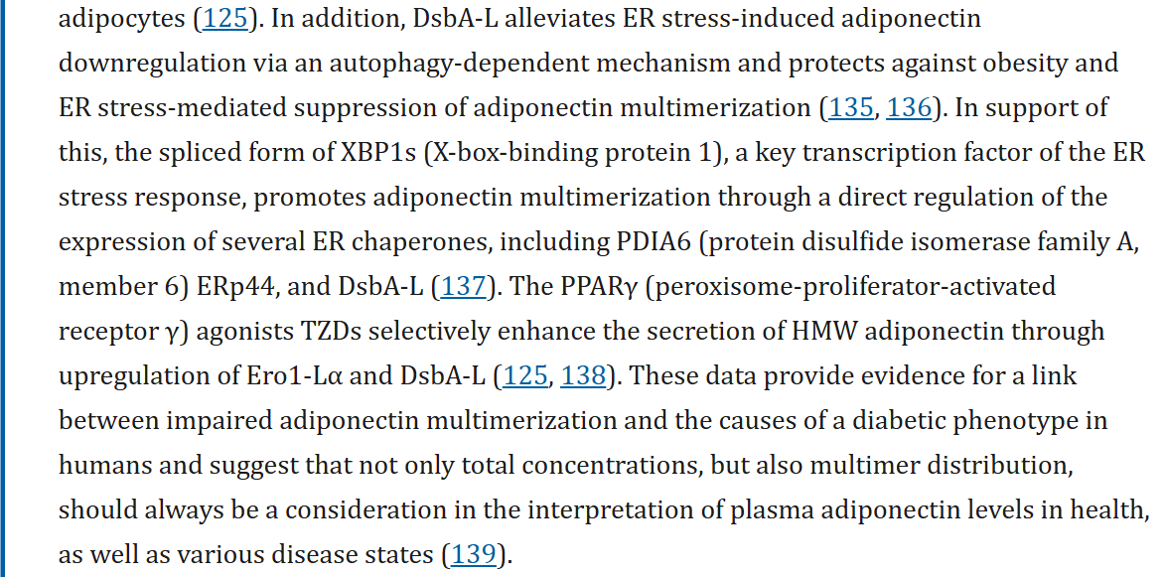
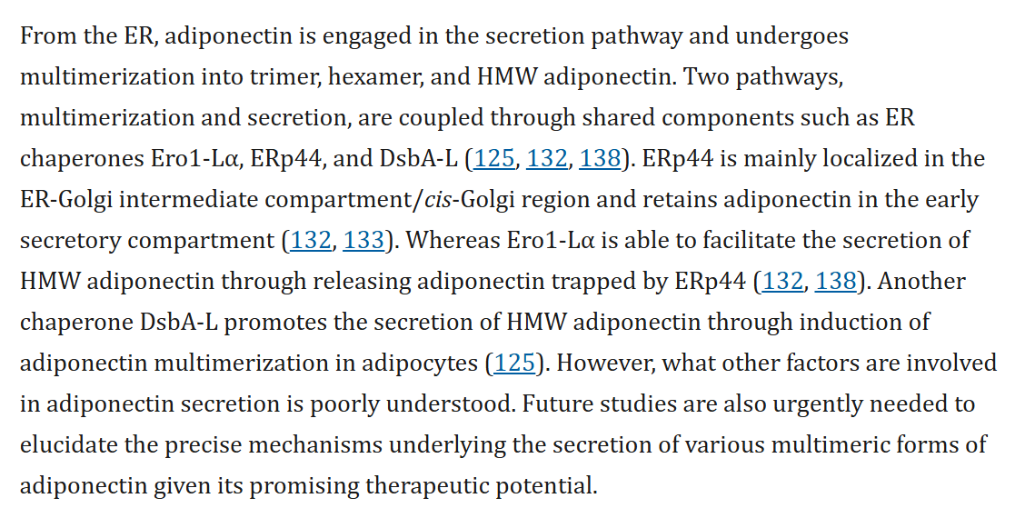
https://portlandpress.com/biochemj/article/409/3/623/42825/Post-translational-modifications-of-adiponectin?guestAccessKey=
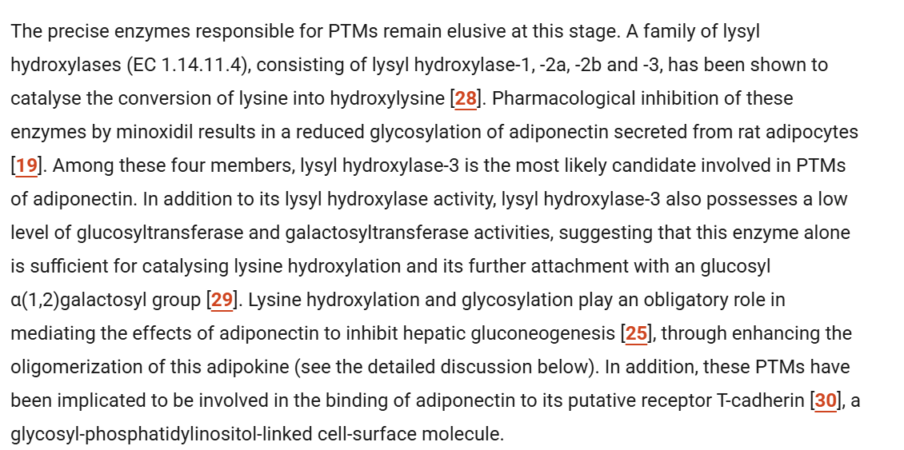
hydroxylisation ->
Similar to https://metabolicatlas.org/explore/Human-GEM/gem-browser/reaction/MAR06983
AKG [c] + O₂ [c] + [protein]-L-lysine [c] ⇒ CO₂ [c] + procollagen-5-hydroxy-L-lysine [c] + succinate [c]
Protein lysine + 2-Oxoglutarate + Oxygen <=> Procollagen 5-hydroxy-L-lysine + Succinate + CO2
https://www.genome.jp/entry/R03376
AKG + O2 + Adiponectin -> CO2 + hydroxylisated-adiponectin + succinate
ENSG00000083444 | ENSG00000152952| ENSG00000106397

Only for HMW:
https://pmc.ncbi.nlm.nih.gov/articles/PMC5434890/
galactosylation through GLT25D1 but not through GLT25D2
ENSG00000130309
UDP-galactose [c] + procollagen-5-hydroxy-L-lysine [c] ⇒ 5-(D-galactosyloxy)-L-lysine-procollagen [c] + H⁺ [c] + UDP [c]
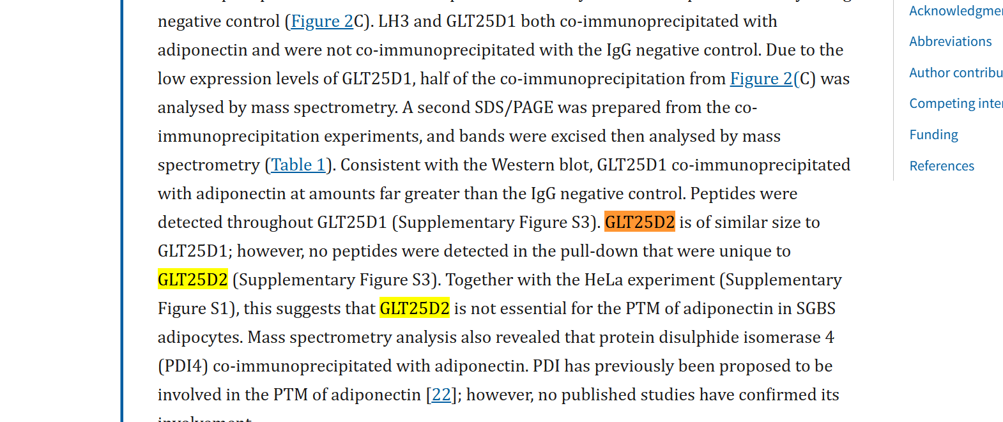
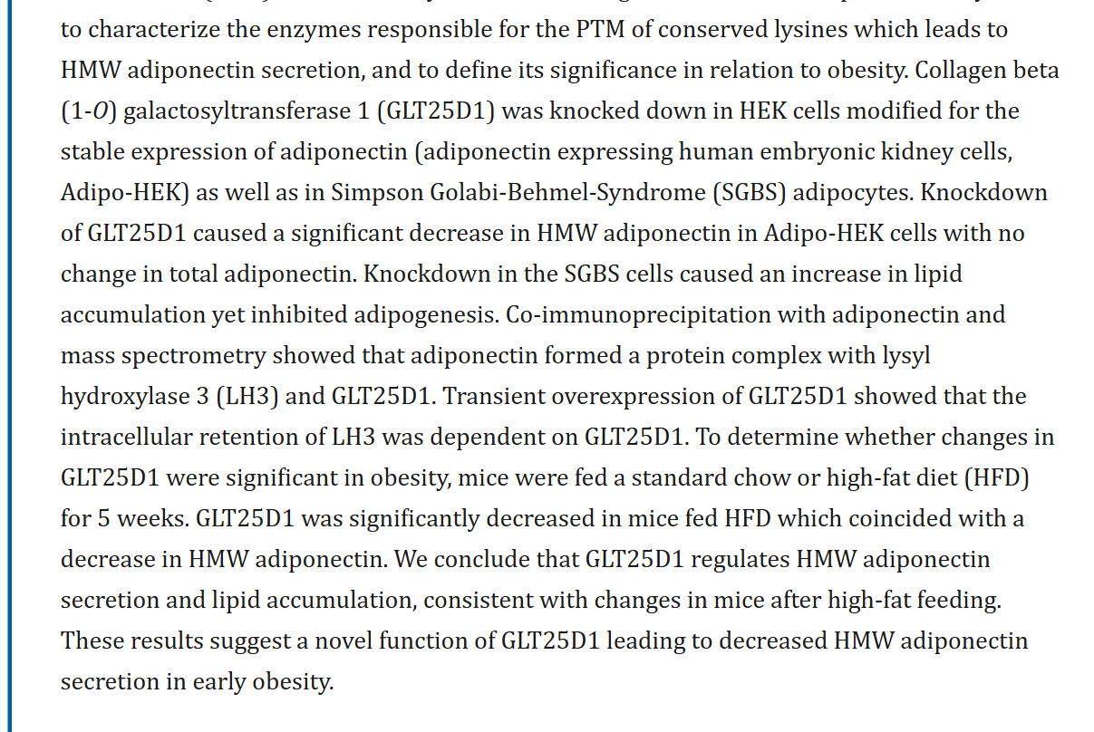

dsbA-L is involved in specific multimers, but how? :

From https://www.frontiersin.org/journals/endocrinology/articles/10.3389/fendo.2011.00062/full :
