https://journals.physiology.org/doi/full/10.1152/ajpendo.90927.2008
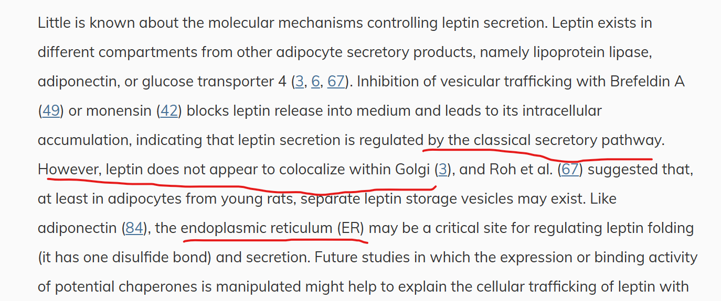
Literally can’t find anything else, it apparently has a signal peptide sequence but even whether that is actually processed by signal peptidase is not confirmed.

