https://docs.google.com/spreadsheets/d/1_SG6BUYSQPkR_8MzOA8YLUAw2p9PgF1CSNdOy6dspm4/edit?usp=sharing
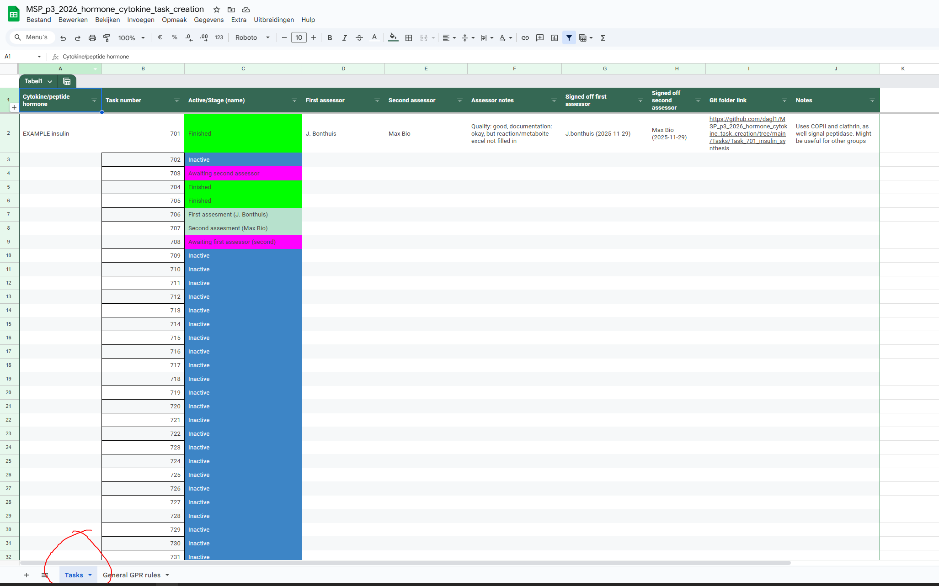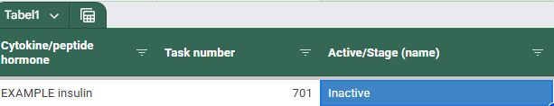
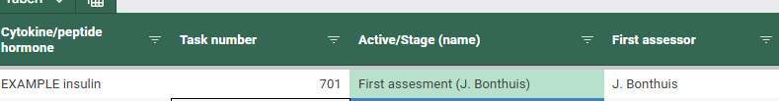
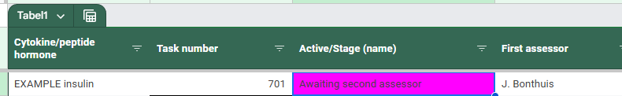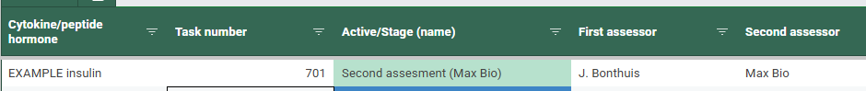
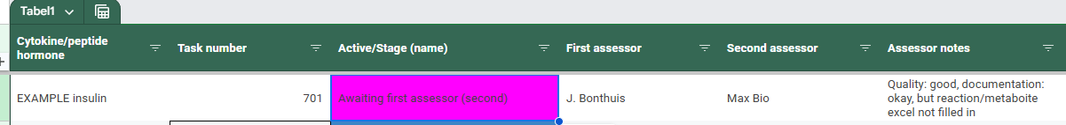
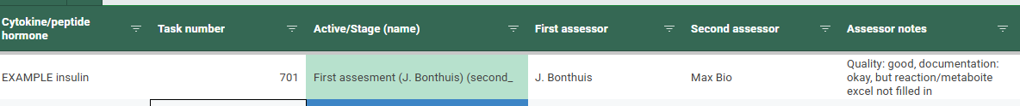
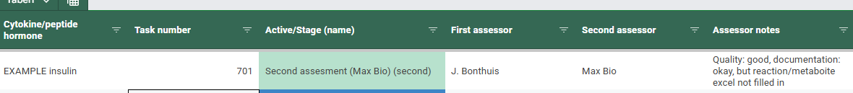

https://www.uniprot.org/uniprotkb/P01308/entry
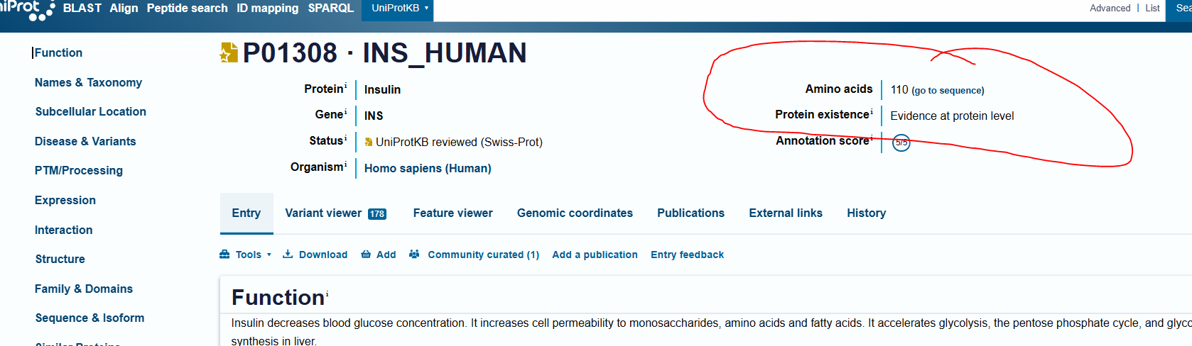
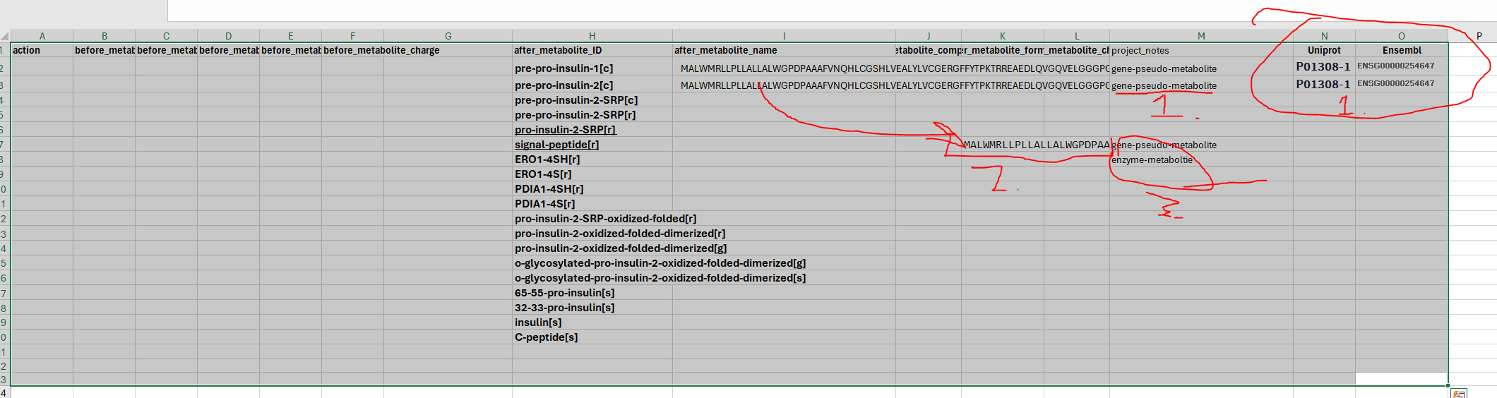
- Gene-pseudo-metabolites are our stand in metabolites for genes, and thus have an AA sequence, and uniport/ensemble IDs
- Because the signal peptide is cleaved from insulin, we take that sequence ; EDIT: in the actual file I called it ins-signal-peptide, as other peptides create other/different signal peptides!
- ERO1-4SH is an enzyme metabolite that is taking up and giving protons, however since this is a protein complex and overall AA sequences and actual atoms don’t match, we therefore leave it empty in the metabolite formula department
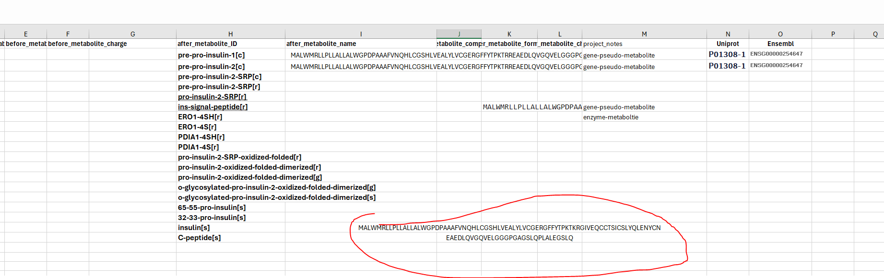
Insulin and C-peptide themselves have sequences we derived from the original sequence, note that this article indicates that CPE cut off two AA’s and so these are not in the final insulin
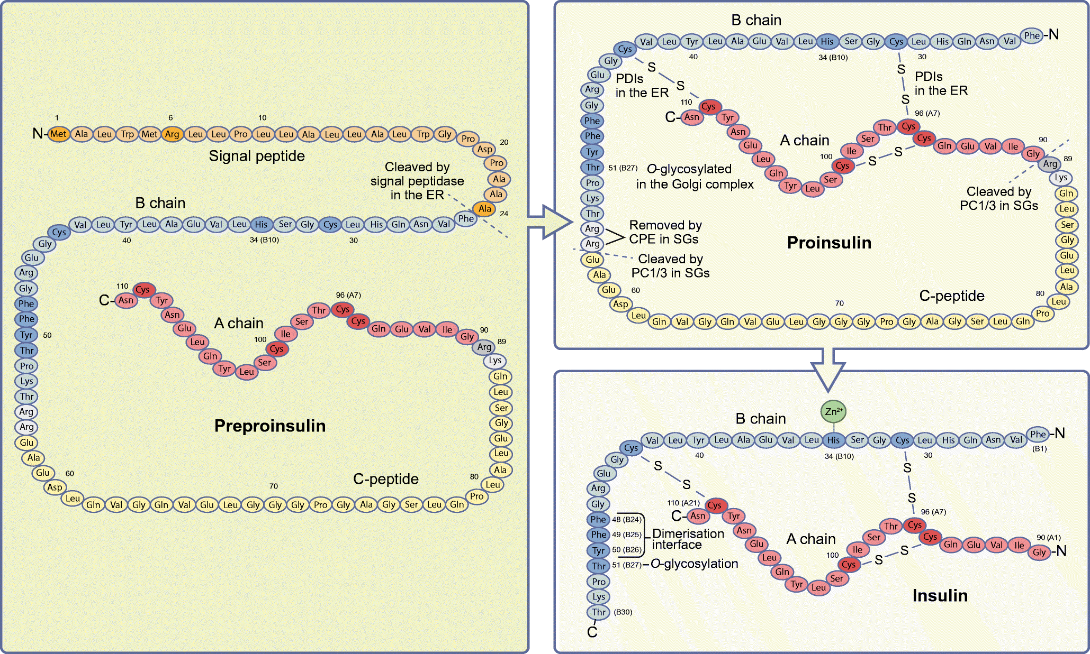 (the two arginine (R) at position 56)
Finishing it up:
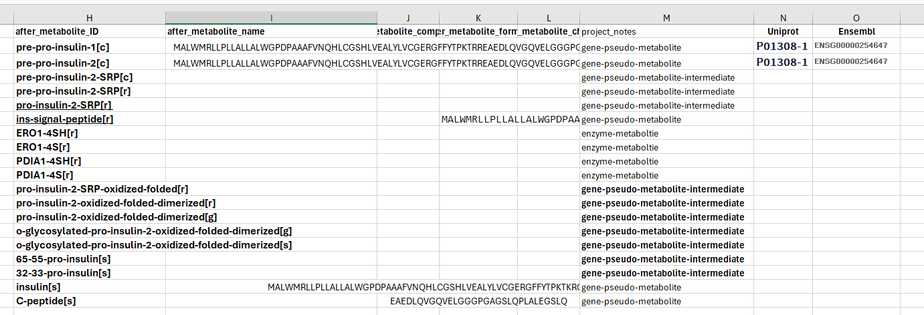
This way, if I ever decide on adding in the metabolite formulas for these other parts, I can easily find them by their type (mentioned in project_notes), if one would have to add anything else, just put a ;
so something like gene-pseudo-metabolite ; “other message”.
Note that if there’s a metabolite such as ATP or water (or anything else that is actually a metabolite and not a peptide), try finding the SMILES on pubchem (and put it in metabolite formula), see this example of ATP:
https://pubchem.ncbi.nlm.nih.gov/compound/5957
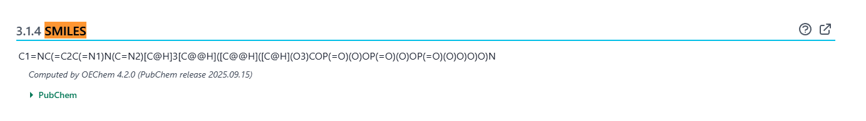
C1=NC(=C2C(=N1)N(C=N2)[C@H]3[C@@H]([C@@H]([C@H](O3)COP(=O)(O)OP(=O)(O)OP(=O)(O)O)O)O)N
In that case, please add the link in the project notes
While not task-specific, since some steps (SRP, SPC, COPII, and Clathrin-mediated transport) will be often used (even if the specific subunits won’t all be used), it is nice to have those GPR rules already put in place and updated when in a GPR spreadsheet that everyone can update/use. Here we can see at a glance what the COPII base coat is, and how the insulin-specific (in this case) coat differs.
Found as the second sheet of https://docs.google.com/spreadsheets/d/1_SG6BUYSQPkR_8MzOA8YLUAw2p9PgF1CSNdOy6dspm4/edit?usp=sharing
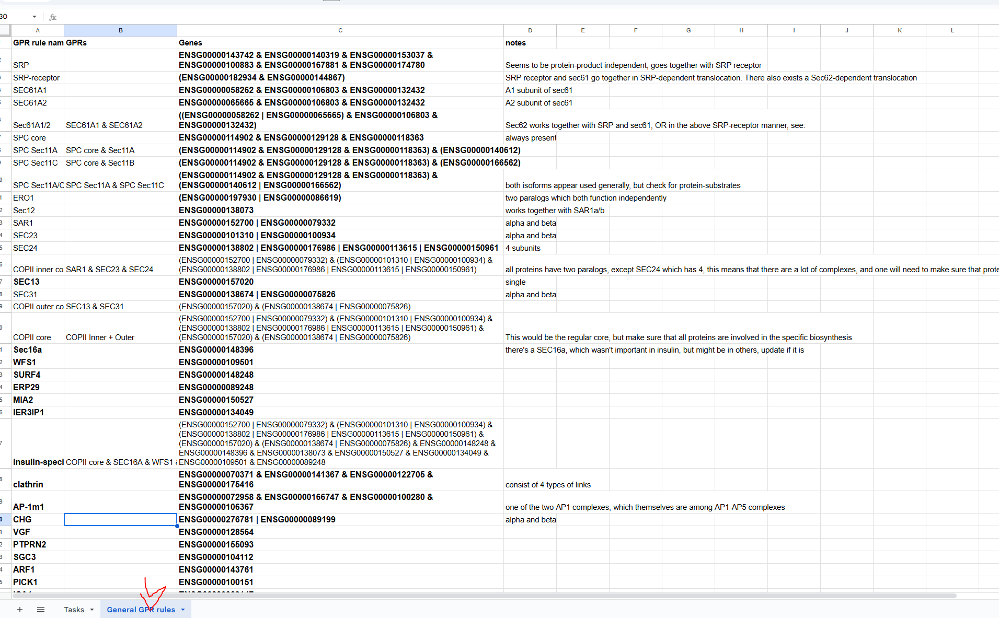
This way we can also easily update the reactions_additions file we add to a task folder (copied from the “current files” folder)
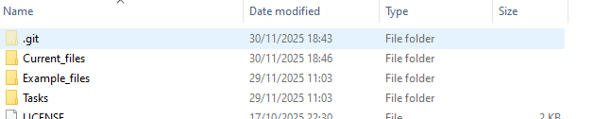
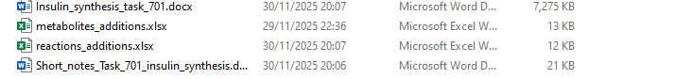
For the reactions we start at task 701, and reactions will have the ID equal to the task number + 00
So MAR70100 is the first reaction added in task 701 (note we start at column G for adding reactions)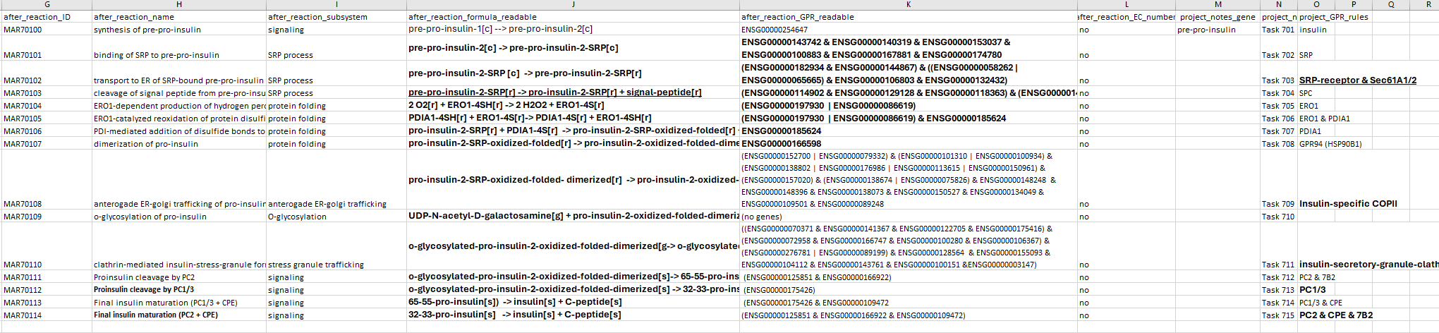
Each reaction has an (unique) ID, a name, a subsystem (try sticking with a few ones consistently, see the example above), a formula (using the specific notation as above, make sure that each substrate/product has a compartment (e.g. insulin[s], or water[r]). The available compartments are as follows:
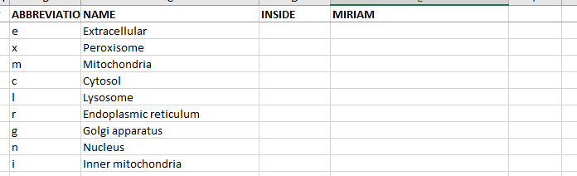
And in the task we added [s] for stress granule.
The reactions should also have the GPR rule written with gene symbols, and all the way at the end the name of the GPR rule (that we can lookup in the larger GPR rule spreadsheet if necessary).
Similarly for the metabolite_additions file, you grab an empty copy and put it in the task folder, then open it and add the metabolties as we did above.
We are then left with a file that should have:
The task documentation (insulin_synthesis_task_701), the metabolites_additions file, the reactions_additions file, and the short_notes (short_notes_task_701_insulin_synthesis). 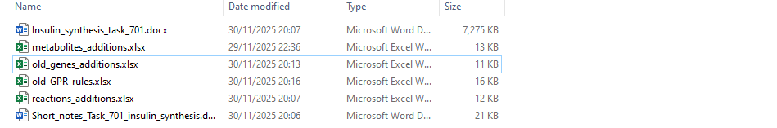
IGNORE the old_genes and old_GPR rules files, they are unnecessary for you at this point (the genes I can automatically create from the reactions, and the GPR rules moved to the online spreadsheet)
The short notes should include all the things we are unsure about, were necessary to note, or might still require further looking into:
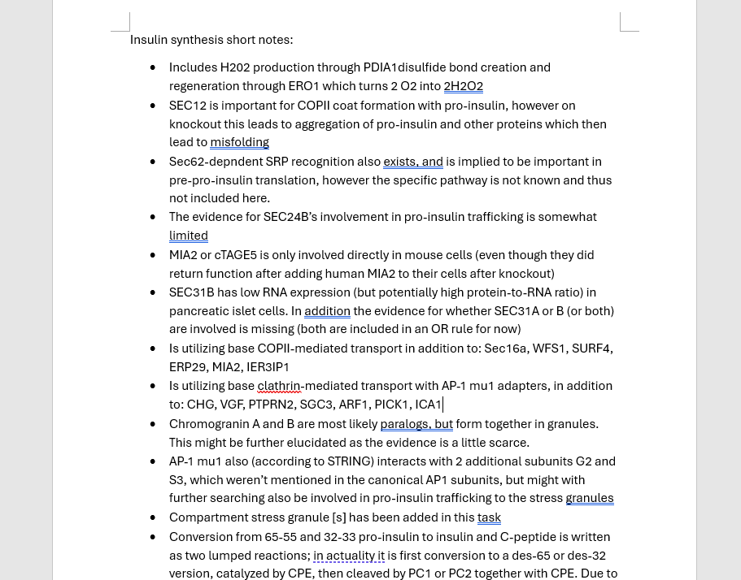
Then we appear to be done, and we let the second assessor check our work. Meanwhile you can take a quick break, or continue with a new task.

