INFUSE & MUSE
Website Content Form
Everything we need from you to replace the placeholder text and images

Please read this first
The website is built and working. Every word and every product photograph on it right now is placeholder material that we wrote or assembled to show you the layout. None of it is final, and none of it should be treated as approved — including the product names, the prices, the tasting notes, and the four artwork titles.
Wherever this form shows you "Placeholder on the site now", that is only there so you can see what sits in that slot and how long it runs. Please replace all of it.

How to fill this in
1. Work straight into the right-hand column of each table. Type over the blank space.
2. Every screenshot shows you exactly where that text appears on the page, so you can picture it.
3. If a section should not exist at all, write REMOVE in the first box for it.
4. Where we suggest a length, it is a guide rather than a rule. Going a little over is fine; going far over will change how the page looks.
5. Send photographs as separate files — see the last section for what we need.

Anything you leave blank stays as the placeholder text, so it is better to fill in everything, even roughly. We can tidy up wording; we cannot invent your product facts.

Part A · The Home Page
The home page is one long scroll made of ten sections. Each one is below, in the order a visitor meets them.

A1 · Opening screen (video + centre panel)
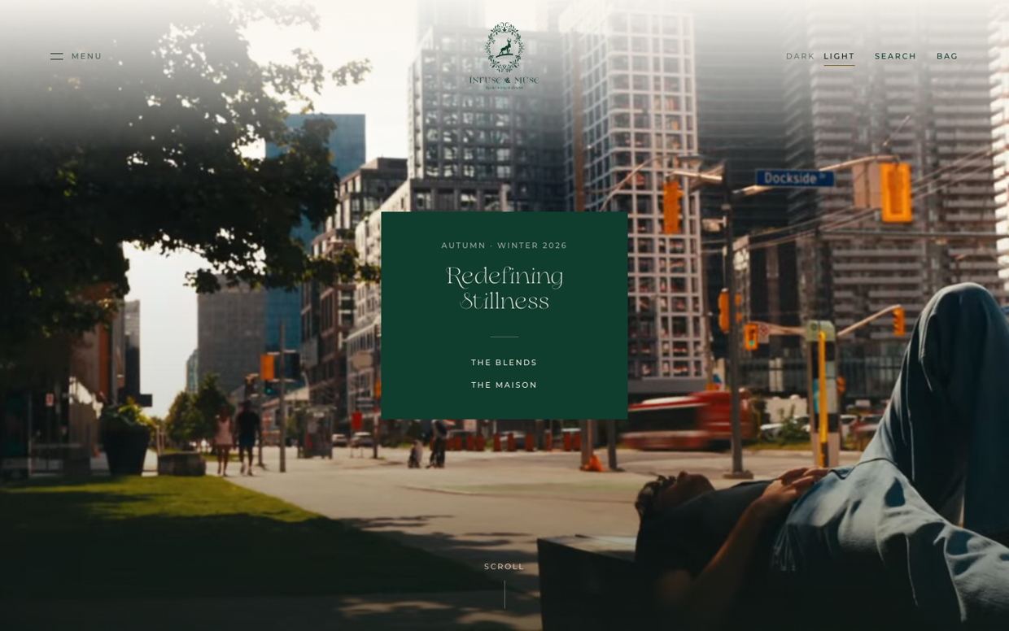
A short film loops behind a small panel. Only the panel carries words.
What | Placeholder on the site now — replace it | Your text
Small line above the title  Around 20–30 characters. A season, a place, or a date. | AUTUMN · WINTER 2026
Main title  Two to four words. This is the first thing anyone reads. | Redefining Stillness
First button  One to three words. | THE BLENDS
Second button  One to three words. | THE MAISON
The film currently playing is the launch clip you sent. Tell us if you would like a different one, or a still photograph instead.

A2 · Opening statement
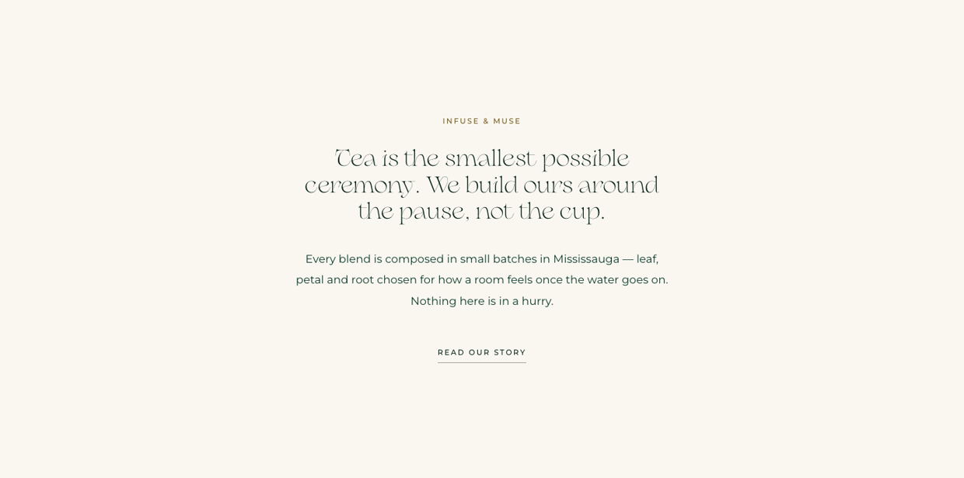
The first words in your own voice. This sets the tone for everything after it.
What | Placeholder on the site now — replace it | Your text
Small label  Around 15–25 characters. | INFUSE & MUSE
Statement  One or two sentences, roughly 90–140 characters. Large type, so shorter is stronger. | Tea is the smallest possible ceremony. We build ours around the pause, not the cup.
Paragraph  Roughly 180–260 characters. Who you are and how you make things. | Every blend is composed in small batches in Mississauga — leaf, petal and root chosen for how a room feels once the water goes on. Nothing here is in a hurry.
Link text  Two to four words. | READ OUR STORY

A3 · Featured blends
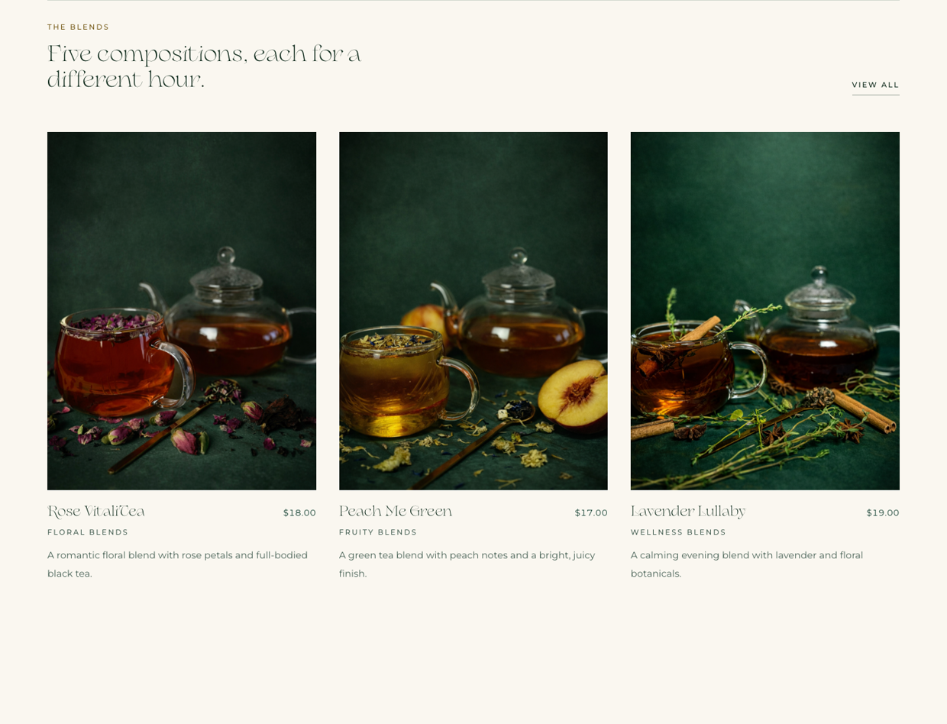
Three products pulled to the front. The products themselves are filled in later, in Part B — here we only need the heading above them.
What | Placeholder on the site now — replace it | Your text
Small label  Around 10–20 characters. | THE BLENDS
Heading  Roughly 40–70 characters. | Five compositions, each for a different hour.
Link text  One to three words. | VIEW ALL
Which three?  Name the three blends you want featured here. | Rose VitaliTea, Peach Me Green, Lavender Lullaby

A4 · The Muses (four artworks)
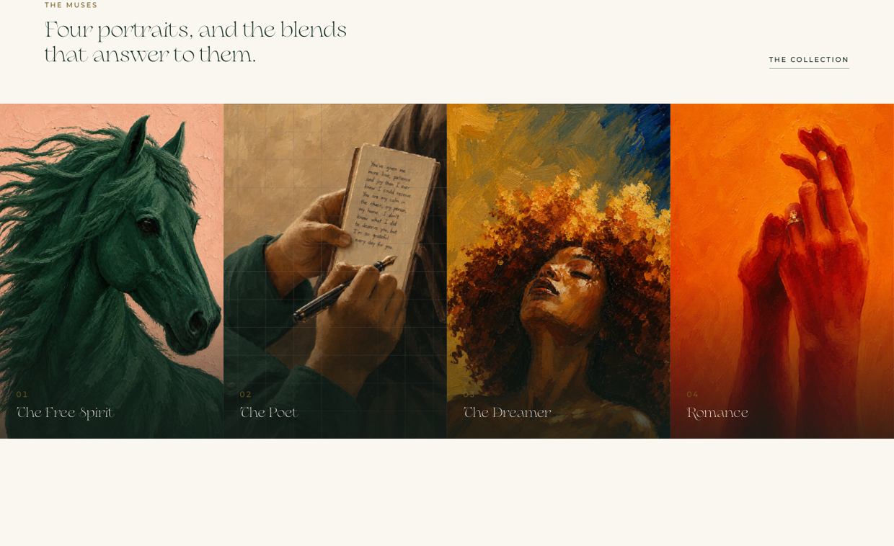
The four paintings run edge to edge. Each has its own page as well — those are in Part D.
What | Placeholder on the site now — replace it | Your text
Small label  Around 8–15 characters. | THE MUSES
Heading  Roughly 40–70 characters. | Four portraits, and the blends that answer to them.
Link text  One to three words. | THE COLLECTION
Important: we invented the wording that connects these paintings to your teas. Please tell us in Part D what they actually mean to the brand.

A5 · Feature panel
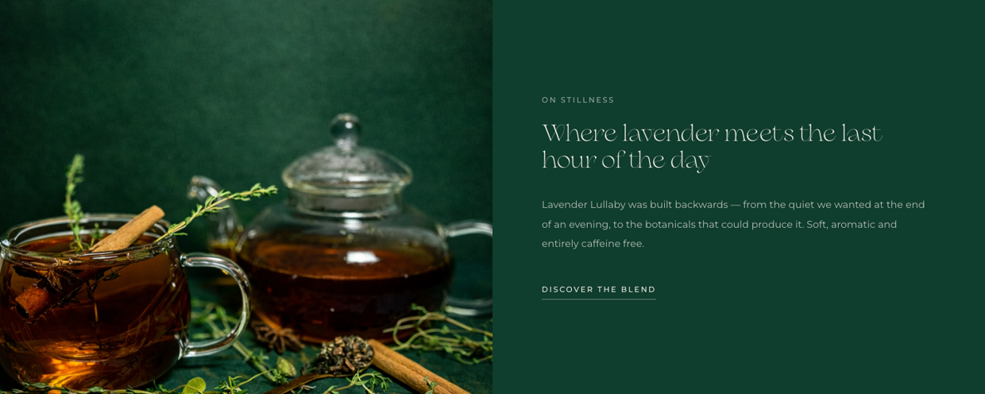
A single blend given a full-width moment, with one photograph beside it.
What | Placeholder on the site now — replace it | Your text
Small label  Around 10–20 characters. | ON STILLNESS
Heading  Roughly 40–60 characters. | Where lavender meets the last hour of the day
Paragraph  Roughly 160–240 characters. | Lavender Lullaby was built backwards — from the quiet we wanted at the end of an evening, to the botanicals that could produce it. Soft, aromatic and entirely caffeine free.
Link text  Two to four words. | DISCOVER THE BLEND
Which blend?  Which product should this panel feature? | Lavender Lullaby

A6 · How to brew
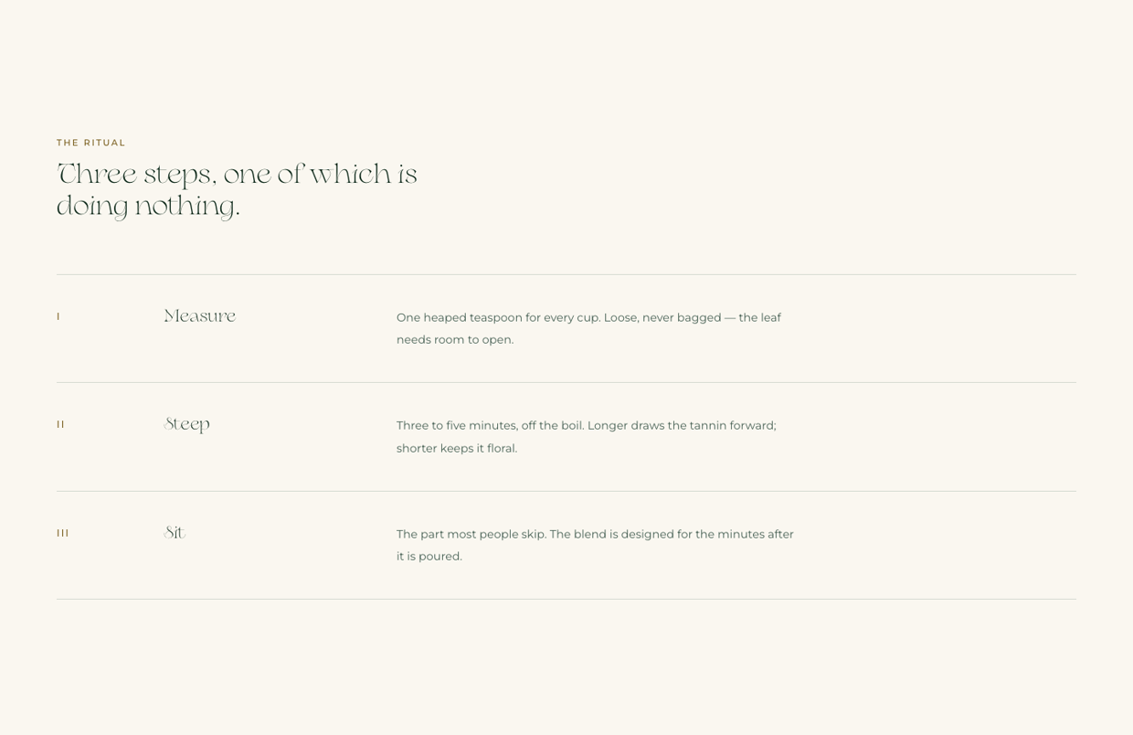
Three numbered steps. Change the wording, or tell us if you would rather have four steps, or two.
What | Placeholder on the site now — replace it | Your text
Small label | THE RITUAL
Heading  Roughly 40–60 characters. | Three steps, one of which is doing nothing.
Step 1 — name  One word if possible. | Measure
Step 1 — text  Roughly 80–140 characters. | One heaped teaspoon for every cup. Loose, never bagged — the leaf needs room to open.
Step 2 — name | Steep
Step 2 — text | Three to five minutes, off the boil. Longer draws the tannin forward; shorter keeps it floral.
Step 3 — name | Sit
Step 3 — text | The part most people skip. The blend is designed for the minutes after it is poured.
Please check the brewing facts carefully — temperatures and steeping times differ by blend, and we guessed.

A7 · Seasonal / limited
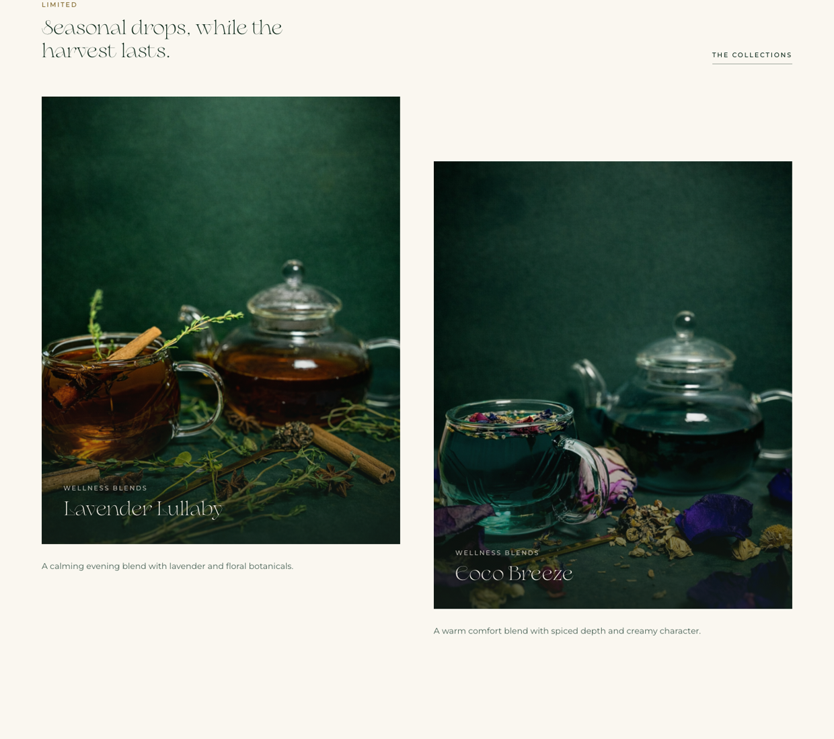
What | Placeholder on the site now — replace it | Your text
Small label | LIMITED
Heading  Roughly 35–60 characters. | Seasonal drops, while the harvest lasts.
Link text | THE COLLECTIONS
Which two?  Name the two blends to show here. | Lavender Lullaby, Coco Breeze

A8 · What you offer
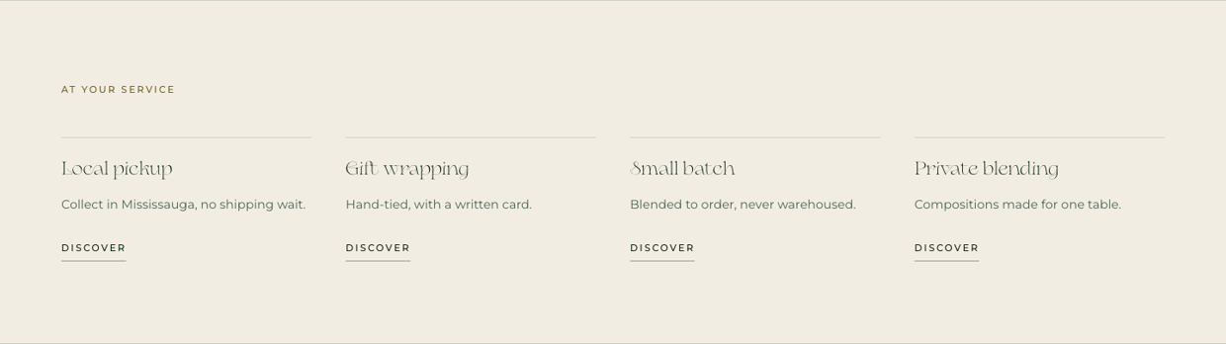
Four short promises. Replace any that are not true of your business.
What | Placeholder on the site now — replace it | Your text
Small label | AT YOUR SERVICE
1 — title  One to three words. | Local pickup
1 — line  Under 60 characters. | Collect in Mississauga, no shipping wait.
2 — title | Gift wrapping
2 — line | Hand-tied, with a written card.
3 — title | Small batch
3 — line | Blended to order, never warehoused.
4 — title | Private blending
4 — line | Compositions made for one table.
Only promise what you can deliver on day one — these are the things customers will hold you to.

A9 · Journal
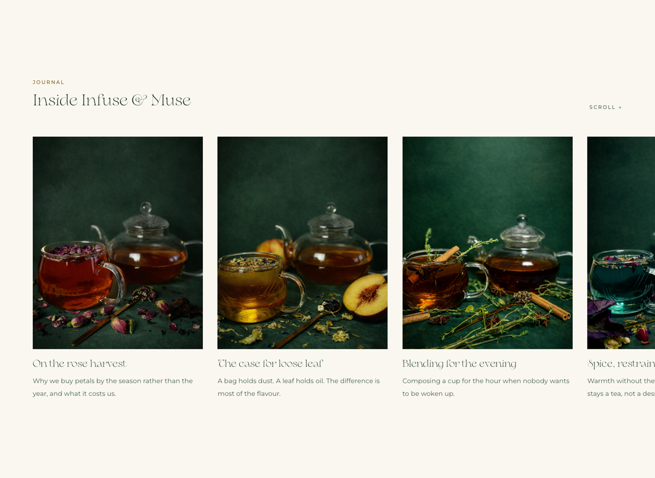
A side-scrolling row of five short pieces. These can be stories, brewing notes, or news. If you would rather not run a journal yet, write REMOVE.
What | Placeholder on the site now — replace it | Your text
Small label | JOURNAL
Heading | Inside Infuse & Muse
Entry 1 — title  Roughly 20–40 characters. | On the rose harvest
Entry 1 — text  Roughly 60–110 characters. | Why we buy petals by the season rather than the year, and what it costs us.
Entry 2 — title | The case for loose leaf
Entry 2 — text | A bag holds dust. A leaf holds oil. The difference is most of the flavour.
Entry 3 — title | Blending for the evening
Entry 3 — text | Composing a cup for the hour when nobody wants to be woken up.
Entry 4 — title | Spice, restrained
Entry 4 — text | Warmth without the syrup — how Coco Breeze stays a tea, not a dessert.
Entry 5 — title | A note on water
Entry 5 — text | The ingredient nobody lists, and the one that decides the cup.

A10 · Mailing list
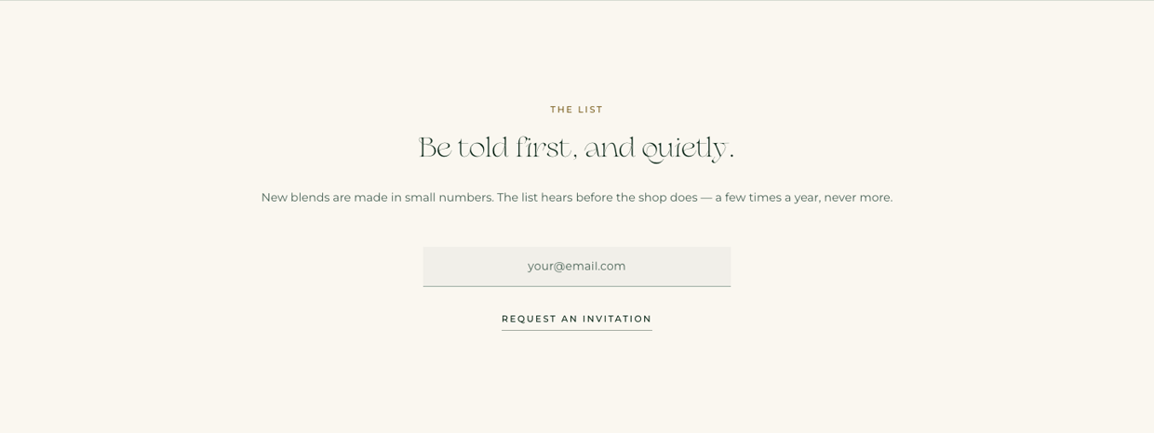
What | Placeholder on the site now — replace it | Your text
Small label | THE LIST
Heading  Roughly 25–45 characters. | Be told first, and quietly.
Paragraph  Roughly 120–180 characters. Say how often you will actually write. | New blends are made in small numbers. The list hears before the shop does — a few times a year, never more.
Button text  Two to four words. | REQUEST AN INVITATION

A11 · Footer
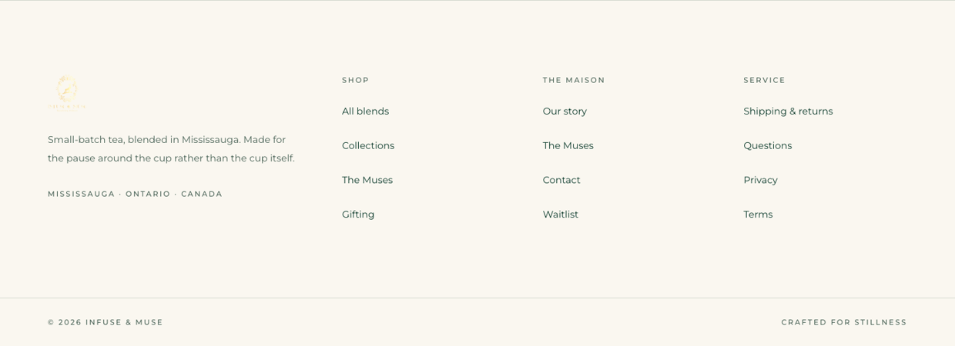
What | Placeholder on the site now — replace it | Your text
Footer paragraph  Roughly 100–160 characters. | Small-batch tea, blended in Mississauga. Made for the pause around the cup rather than the cup itself.
Location line | MISSISSAUGA · ONTARIO · CANADA
Closing line  Three to five words. | CRAFTED FOR STILLNESS

Part B · Your Products
This is the most important part of the form. Every product on the site is placeholder — the five names, the prices, the tasting notes and the descriptions were all written to demonstrate the layout.

Where each field appears
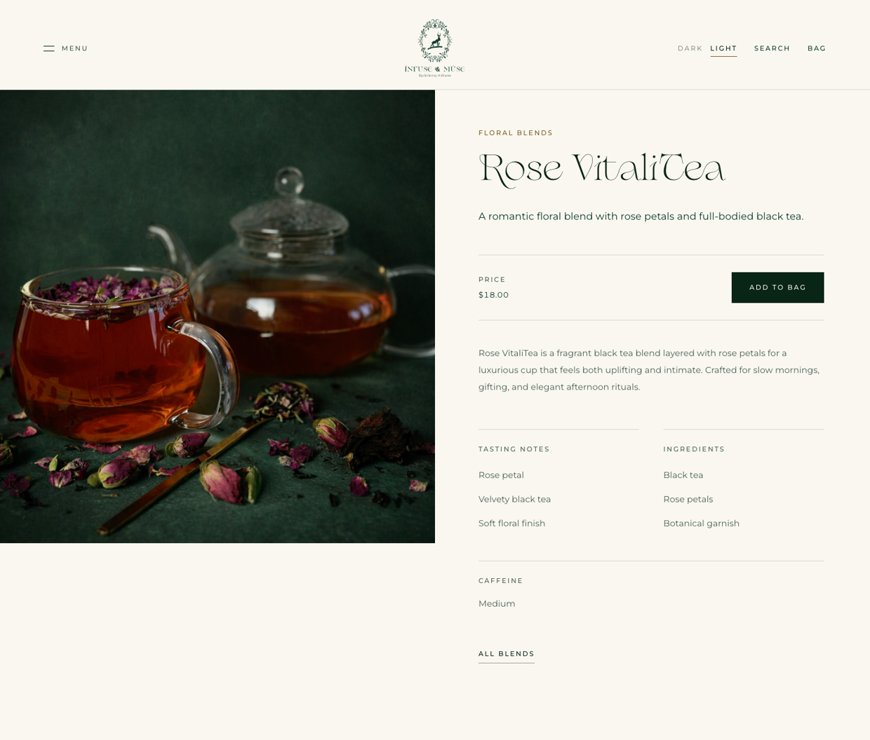
The product page above is built from the fields in the table on the next page. The listing below shows how the same product looks in a grid.
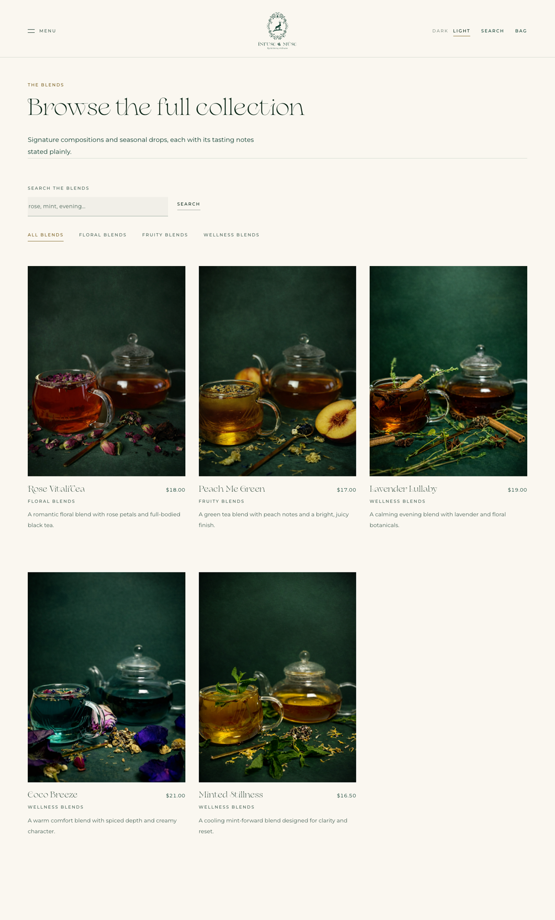

One form per product
Please copy the table below once for every product you sell. There are six blank copies; add more if you need them.
Prices: write the retail price in dollars, e.g. $18.00. Tell us whether tax is included. Also tell us the pouch size or weight — the site does not show one at the moment, and it probably should.

Product 1
Product name
The name customers see. 10–30 characters reads best.
Collection
Which group it belongs to — see Part C.
Price
Include currency. Say if tax is included.
Size / weight
e.g. 50 g pouch, 20 sachets. Currently missing from the site.
Short description
One sentence, roughly 60–110 characters. Used on the grid and in search results.
Full description
Two or three sentences, roughly 250–400 characters. Used on the product page.
Tasting notes
Three short notes, e.g. "Rose petal / Velvety black tea / Soft floral finish".
Ingredients
Full list, in descending order by weight. This is a legal requirement for food.
Caffeine level
e.g. High / Medium / Low / Herbal (none).
Allergen information
Anything present, and anything it may have traces of.
Brewing guidance
Water temperature, steeping time, amount per cup.
Photograph file name
Name the image file you are sending for this product.
Featured on home page?
Yes / No
Seasonal or limited?
Yes / No. If yes, until when?

Product 2
Product name
The name customers see. 10–30 characters reads best.
Collection
Which group it belongs to — see Part C.
Price
Include currency. Say if tax is included.
Size / weight
e.g. 50 g pouch, 20 sachets. Currently missing from the site.
Short description
One sentence, roughly 60–110 characters. Used on the grid and in search results.
Full description
Two or three sentences, roughly 250–400 characters. Used on the product page.
Tasting notes
Three short notes, e.g. "Rose petal / Velvety black tea / Soft floral finish".
Ingredients
Full list, in descending order by weight. This is a legal requirement for food.
Caffeine level
e.g. High / Medium / Low / Herbal (none).
Allergen information
Anything present, and anything it may have traces of.
Brewing guidance
Water temperature, steeping time, amount per cup.
Photograph file name
Name the image file you are sending for this product.
Featured on home page?
Yes / No
Seasonal or limited?
Yes / No. If yes, until when?

Product 3
Product name
The name customers see. 10–30 characters reads best.
Collection
Which group it belongs to — see Part C.
Price
Include currency. Say if tax is included.
Size / weight
e.g. 50 g pouch, 20 sachets. Currently missing from the site.
Short description
One sentence, roughly 60–110 characters. Used on the grid and in search results.
Full description
Two or three sentences, roughly 250–400 characters. Used on the product page.
Tasting notes
Three short notes, e.g. "Rose petal / Velvety black tea / Soft floral finish".
Ingredients
Full list, in descending order by weight. This is a legal requirement for food.
Caffeine level
e.g. High / Medium / Low / Herbal (none).
Allergen information
Anything present, and anything it may have traces of.
Brewing guidance
Water temperature, steeping time, amount per cup.
Photograph file name
Name the image file you are sending for this product.
Featured on home page?
Yes / No
Seasonal or limited?
Yes / No. If yes, until when?

Product 4
Product name
The name customers see. 10–30 characters reads best.
Collection
Which group it belongs to — see Part C.
Price
Include currency. Say if tax is included.
Size / weight
e.g. 50 g pouch, 20 sachets. Currently missing from the site.
Short description
One sentence, roughly 60–110 characters. Used on the grid and in search results.
Full description
Two or three sentences, roughly 250–400 characters. Used on the product page.
Tasting notes
Three short notes, e.g. "Rose petal / Velvety black tea / Soft floral finish".
Ingredients
Full list, in descending order by weight. This is a legal requirement for food.
Caffeine level
e.g. High / Medium / Low / Herbal (none).
Allergen information
Anything present, and anything it may have traces of.
Brewing guidance
Water temperature, steeping time, amount per cup.
Photograph file name
Name the image file you are sending for this product.
Featured on home page?
Yes / No
Seasonal or limited?
Yes / No. If yes, until when?

Product 5
Product name
The name customers see. 10–30 characters reads best.
Collection
Which group it belongs to — see Part C.
Price
Include currency. Say if tax is included.
Size / weight
e.g. 50 g pouch, 20 sachets. Currently missing from the site.
Short description
One sentence, roughly 60–110 characters. Used on the grid and in search results.
Full description
Two or three sentences, roughly 250–400 characters. Used on the product page.
Tasting notes
Three short notes, e.g. "Rose petal / Velvety black tea / Soft floral finish".
Ingredients
Full list, in descending order by weight. This is a legal requirement for food.
Caffeine level
e.g. High / Medium / Low / Herbal (none).
Allergen information
Anything present, and anything it may have traces of.
Brewing guidance
Water temperature, steeping time, amount per cup.
Photograph file name
Name the image file you are sending for this product.
Featured on home page?
Yes / No
Seasonal or limited?
Yes / No. If yes, until when?

Product 6
Product name
The name customers see. 10–30 characters reads best.
Collection
Which group it belongs to — see Part C.
Price
Include currency. Say if tax is included.
Size / weight
e.g. 50 g pouch, 20 sachets. Currently missing from the site.
Short description
One sentence, roughly 60–110 characters. Used on the grid and in search results.
Full description
Two or three sentences, roughly 250–400 characters. Used on the product page.
Tasting notes
Three short notes, e.g. "Rose petal / Velvety black tea / Soft floral finish".
Ingredients
Full list, in descending order by weight. This is a legal requirement for food.
Caffeine level
e.g. High / Medium / Low / Herbal (none).
Allergen information
Anything present, and anything it may have traces of.
Brewing guidance
Water temperature, steeping time, amount per cup.
Photograph file name
Name the image file you are sending for this product.
Featured on home page?
Yes / No
Seasonal or limited?
Yes / No. If yes, until when?

Part C · Collections
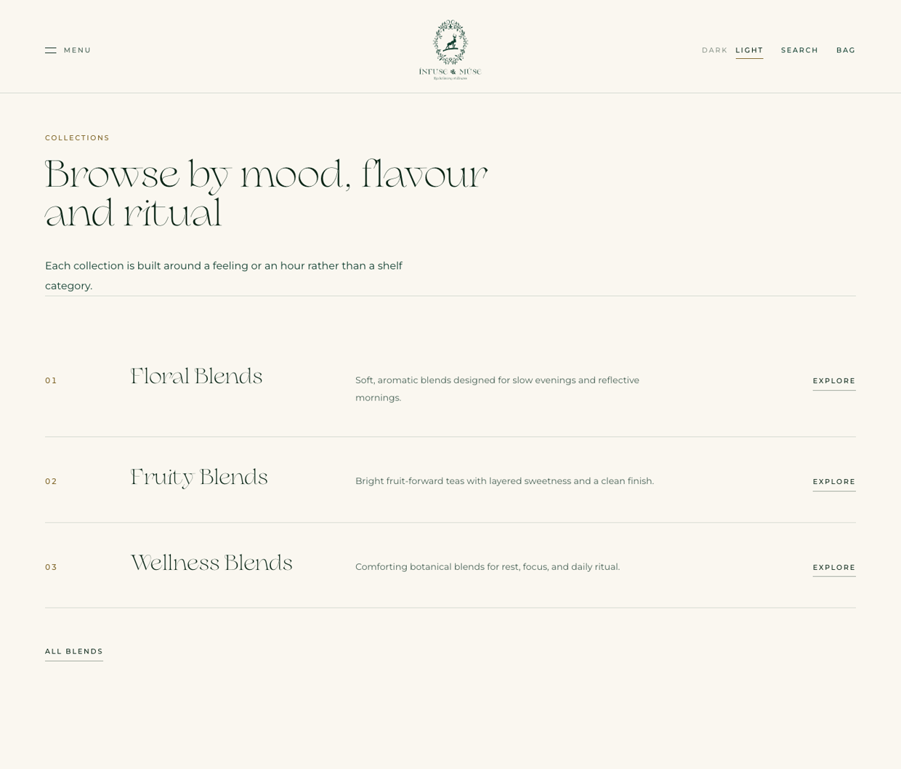
Products are grouped into collections. There are three placeholder groups now; you can have any number.
What | Placeholder on the site now — replace it | Your text
Page heading  Roughly 30–55 characters. | Browse by mood, flavour and ritual
Page introduction  Roughly 80–140 characters. | Each collection is built around a feeling or an hour rather than a shelf category.
Collection 1 — name | Floral Blends
Collection 1 — description  Roughly 70–120 characters. | Soft, aromatic blends designed for slow evenings and reflective mornings.
Collection 2 — name | Fruity Blends
Collection 2 — description | Bright fruit-forward teas with layered sweetness and a clean finish.
Collection 3 — name | Wellness Blends
Collection 3 — description | Comforting botanical blends for rest, focus, and daily ritual.
Any further collections?  Add names and descriptions here. | —

Part D · The Four Artworks
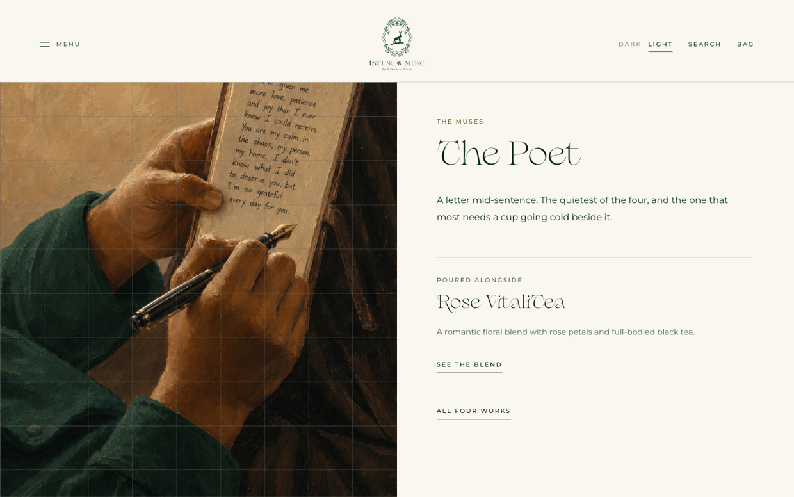
Each of the four paintings has a page like the one above. We wrote the descriptions and we chose which tea sits alongside each painting — all of it is guesswork and needs replacing.

First, the big question
What | Placeholder on the site now — replace it | Your text
What are these four works to the brand?  A few sentences in your own words. Everything else in this section follows from your answer. | We do not know — please tell us.
Should they be shoppable, or purely editorial?  i.e. can someone buy something from these pages, or are they just for atmosphere? | Currently editorial, each linked to one tea.

Then each work
What | Placeholder on the site now — replace it | Your text
1 — Title  Confirm or change. | The Free Spirit
1 — Description  Roughly 120–200 characters. | Movement held still. Painted in the house green against a warm ground, for the part of a morning that refuses to be scheduled.
1 — Paired blend  Which tea belongs with it? | Peach Me Green (our guess)
2 — Title | The Poet
2 — Description | A letter mid-sentence. The quietest of the four, and the one that most needs a cup going cold beside it.
2 — Paired blend | Rose VitaliTea (our guess)
3 — Title | The Dreamer
3 — Description | Head tilted back, eyes closed, hair caught like late light. Painted for the pause rather than the plan.
3 — Paired blend | Lavender Lullaby (our guess)
4 — Title | Romance
4 — Description | Two hands and a single point of gold. The warmest of the set, and the least willing to explain itself.
4 — Paired blend | Coco Breeze (our guess)
Artist credit  Does the artist need naming anywhere? | Not currently shown.

Part E · About the Company
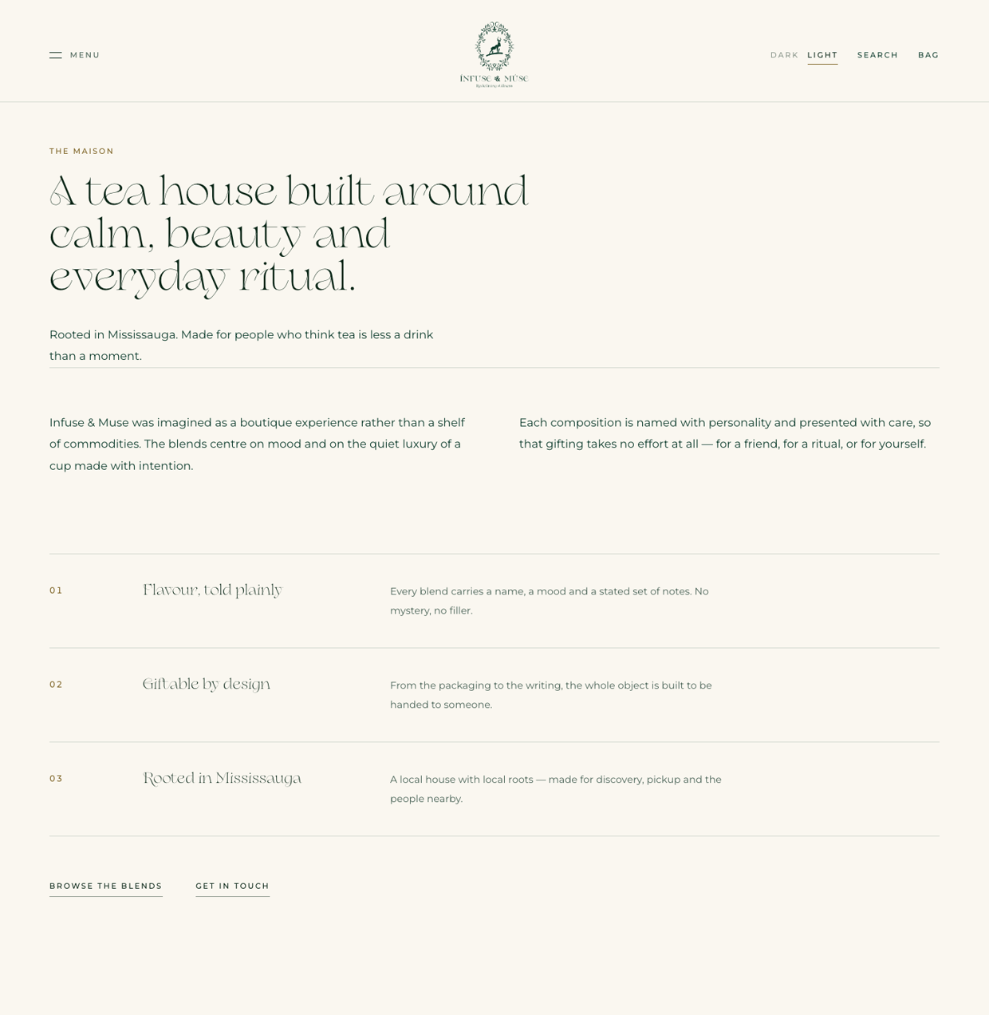
What | Placeholder on the site now — replace it | Your text
Page title  Roughly 45–75 characters. | A tea house built around calm, beauty and everyday ritual.
Introduction  Roughly 70–120 characters. | Rooted in Mississauga. Made for people who think tea is less a drink than a moment.
Paragraph 1  Roughly 180–260 characters. How the company started. | Infuse & Muse was imagined as a boutique experience rather than a shelf of commodities…
Paragraph 2  Roughly 180–260 characters. What you make and for whom. | Each composition is named with personality and presented with care…
Point 1 — title | Flavour, told plainly
Point 1 — text  Roughly 80–140 characters. | Every blend carries a name, a mood and a stated set of notes. No mystery, no filler.
Point 2 — title | Giftable by design
Point 2 — text | From the packaging to the writing, the whole object is built to be handed to someone.
Point 3 — title | Rooted in Mississauga
Point 3 — text | A local house with local roots — made for discovery, pickup and the people nearby.
Founder story?  Would you like a founder name, photograph and short biography added? We can add a section. | Not currently on the site.

Part F · Questions & Answers
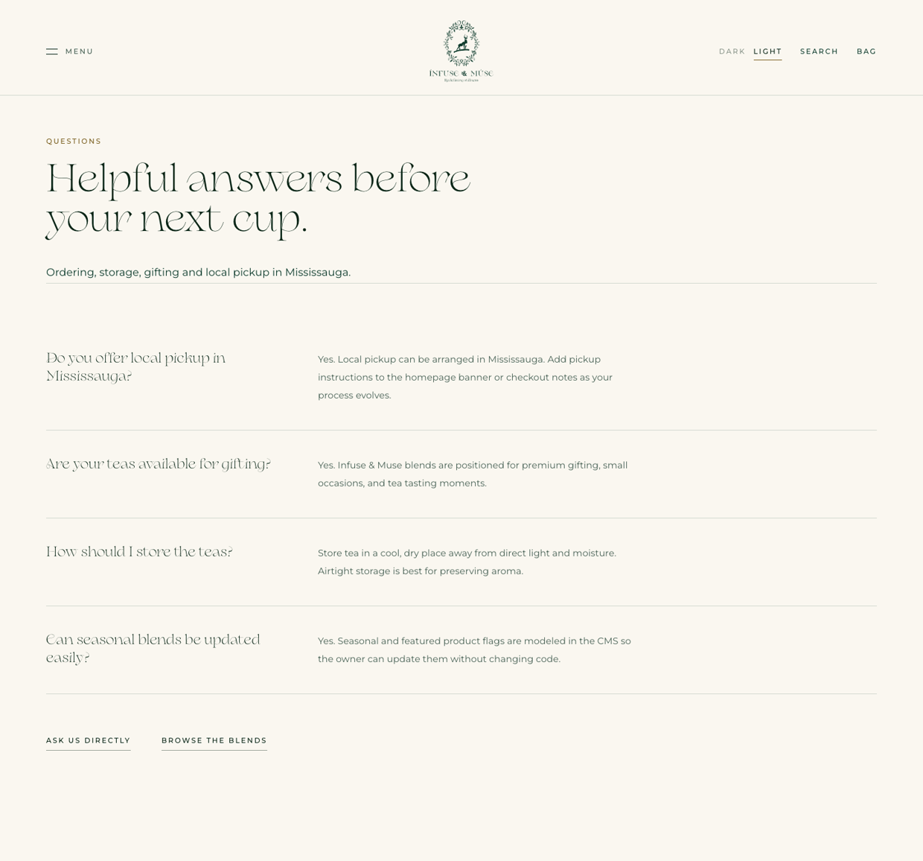
Four placeholder questions are on the site. Replace them with the things customers actually ask you, and add as many as you like — six to ten works well.
What | Placeholder on the site now — replace it | Your text
Page title | Helpful answers before your next cup.
Introduction | Ordering, storage, gifting and local pickup in Mississauga.
Q1 | Do you offer local pickup in Mississauga?
A1 | Yes. Local pickup can be arranged in Mississauga…
Q2 | Are your teas available for gifting?
A2 | Yes. Infuse & Muse blends are positioned for premium gifting…
Q3 | How should I store the teas?
A3 | Store tea in a cool, dry place away from direct light and moisture…
Q4 | Can seasonal blends be updated easily?
A4 | Yes. Seasonal and featured product flags are modelled in the CMS…
Q5  Add your own. | —
A5 | —
Q6  Add your own. | —
A6 | —

Part G · Contact & Business Details
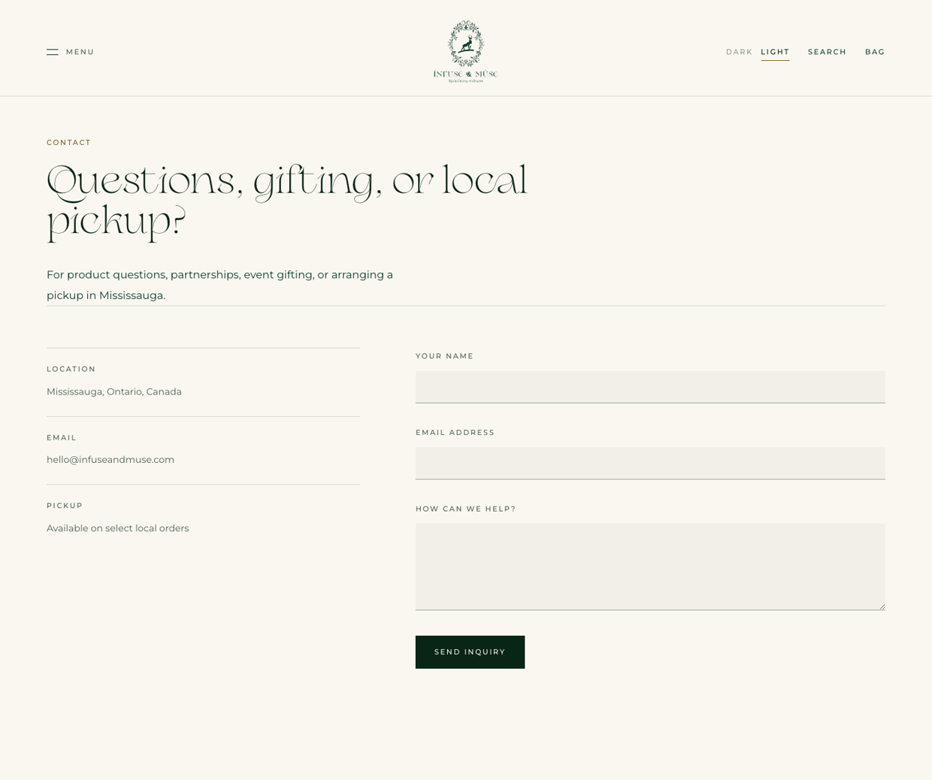
These details also feed the legal pages, the order emails and the footer, so please be exact.
What | Placeholder on the site now — replace it | Your text
Contact email address  Where enquiries should arrive. | hello@infuseandmuse.com
Business address  Full address, or the city if you trade online only. | Mississauga, Ontario, Canada
Telephone  Leave blank if you would rather not publish one. | Not currently shown.
Business legal name  For the terms and privacy pages. | Infuse & Muse
Business number / HST number  If you are registered. | Not currently shown.
Instagram / social handles  Not currently linked anywhere on the site. | —
Contact page title | Questions, gifting, or local pickup?
Contact page introduction | For product questions, partnerships, event gifting, or arranging a pickup in Mississauga.
Pickup arrangements  How does pickup actually work? | Available on select local orders

Policies — please confirm these are correct
We wrote a Privacy Policy, Terms of Service, and a Shipping & Returns policy so the site could go live legally. They contain assumptions. Please check the following in particular, and correct anything wrong.
What | Placeholder on the site now — replace it | Your text
Dispatch time | Orders leave us within two business days.
Delivery — Ontario | 2 to 4 business days.
Delivery — rest of Canada | 4 to 8 business days.
Do you ship outside Canada? | Not currently offered.
Returns window | Unopened pouches within 14 days.
Who pays return postage? | The customer, unless the fault is ours.
Refund processing time | 5 to 10 business days.
Allergen statement  Is this accurate for your kitchen? | Prepared in a kitchen that also handles nuts, dairy and gluten.
Order record retention | Seven years, for Canadian tax purposes.

Part H · Photographs
Please send these as separate image files — not pasted into this document, as that reduces their quality.

What | Placeholder on the site now — replace it | Your text
One photograph per product  Upright (taller than wide), at least 1200 pixels on the short edge. JPEG or PNG. | Five placeholder photographs are in use.
Second angle per product (optional)  The product page can show more than one image if you have them. | Not currently used.
Home page film  Confirm the launch clip is the one you want. If you have a higher-resolution export, please send it. | Your launch clip, currently 720p.
The four artworks  Highest resolution you have. | Supplied — currently in use.
Logo files  If you have the original vector (.ai, .eps, .svg), please send it. | We are using a PNG.
Any lifestyle photography  People, the studio, packaging, the process. | None supplied.

A note on the product photographs: the five in use are all very similar compositions on the same dark background. Once your real range is shot, a little variety between products will make the grid much stronger.

Part I · Anything Else
What | Placeholder on the site now — replace it | Your text
Anything on the site that should be removed
Anything missing that you expected to see
Words or phrases you never want used
Brands whose tone you admire
Helps us match your voice.
Launch date you are working towards | 12 September 2026
Anything else

Thank you. Once this comes back to us, we will replace every placeholder with your words and photographs, and send you a link to review before anything goes public.

