United Planetary Federation's
Second Sathar War
Simulator
User's Guide

Catalog No.
Classification 1A 583B00218S1
United Planetary Federation's
Second Sathar War
Simulator
User's Guide
Table of Contents
Introduction 4
This Document 4
Installation 4
Starting Up the Simulator 4
The Main Window 5
File Menu 6
Show Menu 7
Turn Menu 7
Help Menu 8
Starting a New Game 8
Setting up the UPF 8
The Create Fleet Interface 8
Setting up the Sathar 8
Selecting Sathar retreat conditions 8
Playing the Second Sathar War Strategic Game 8
Viewing a star system 8
Viewing a fleet 8
Splitting a fleet 9
Merging fleets 9
Moving a fleet 9
Normal movement 9
Risk Jumps 9
Adding additional ships 9
Placing Strike Force Nova 9
Ending your turn 9
Combat Resolution 9
Selecting Fleets 9
Selecting the location 10
Entering results by hand 10
Using the tactical combat system 10
Tactical Combat 10
Setting up a new tactical game 11
Setting up a planet 11
Setting up a station 11
Setting up a fleet 12
Moving your ships 13
Selecting weapons 15
Selecting targets 16
Taking the shot 17
Final tactical notes 17

UPF Second Sathar War Simulator User's Guide

Introduction
Welcome to the Second Sathar War Simulator. Originally designed as a training tool for cadets at the Gollwin SpaceFleet Academy, it has now been released to the general public as well for the enjoyment of military enthusiasts and training of the merchant marine. The Second Sathar War Simulator program implements (eventually) the full set of rules for the Second Sathar War strategic game defined in the Knight Hawks Campaign book (pp 55-60). In addition, it contains (again, eventually) a complete implementation of the tactical combat system described in the UPF Tactical Operations Manual (Cat No. 562A11309T9). This combat system will also be contained in the Star Frontiers Tactical Combat Simulator when it becomes available.

This Document
This document contains a guide to the user interface of the Second Sathar War Simulator. It describes the basic layout of the program as well as details on all the displays and dialog boxes that show up during the course of a simulation. In no means is this document designed as a tactical or strategic training guide but simply as an interface guide to the simulator.

Installation
Installing the simulation is quite simple, just unpack the zip file (if on a Windows system) or the gzipped tar file (if on a Unix/Linux system) in the directory where you want the simulation to reside. The unpacking process will create a SSW directory with several subdirectories underneath it (bin, data & icons). No additional setup is required unless you would like a desktop shortcut to the program. In which case move to the bin directory and create a shortcut to the SSW.exe (or just SSW on Unix/Linux systems) and place it on your desktop.

Starting Up the Simulator
Starting up the simulator is quite easy. Simply execute the SSW (or SSW.exe) program in the bin directory where you installed it or click on the desktop icon you created during installation. This will launch the program.
Upon startup the simulator will display the splash screen shown in figure 1 while it initializes the system. The spash screen disappears after about three seconds leaving you with just the main simulation window.
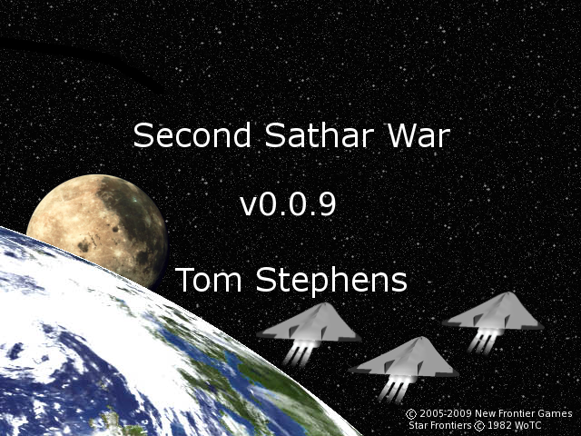Figure 1: The splash screen for the Second Sathar War Simulator displayed at startup.

The Main Window
Once started you will be presented with a mostly empty main window as shown in figure 2. Once a game is underway, the main window will be filled with a strategic map of the Frontier showing all the star systems and jump routes between those systems. However, initially it is blank with only the menu bar at the top and the status bar at the bottom.
The main window contains four top level menus (File, Show, Turn and Help). Each of these menus are described in the subsections below.
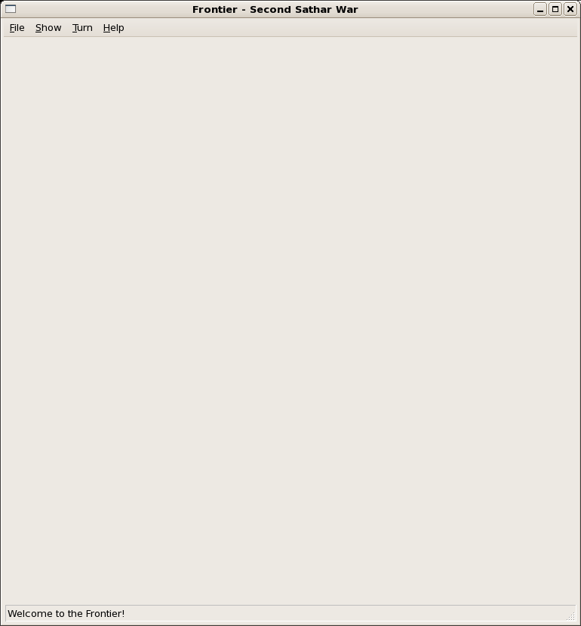Figure 2: Main frame at initial startup with main area blank.

File Menu
The File menu contains five options
- New – Selecting the New option creates a new game and launches a series of dialog boxes allowing you to set up the initial fleet compositions and positions of the simulation. If you select this option while a game is loaded you will be prompted to save the current game first if desired.
- Open – Selecting the Open option bring up the Open File Dialog box allowing you to select a previously saved game and load it into the simulator to pick up where you left off. If you select this option while a game is loaded you will be prompted to save the current game first if desired.
- Save – Selecting the Save option allows you to save the current game to disk for later recall. It opens the Save File Dialog box allowing you to chose a name and location for the save file. This option is not available at startup as no game is loaded.
- Close – Selecting the Close option closes the current game. When selected, it prompts you to save the current game before closes. If you wish to save, it behaves just like selecting the Save option. After the game is saved or the save is declined, the current game is cleared returning you to the blank main screen. This option is not available at startup as no game is loaded.
- Exit – Selecting this option exits the simulation program. If you want to save your game before exiting be sure to select the Close or Save option first as this option immediately terminates the program.

Show Menu
The Show Menu has three available options:
- Players – Selecting this option brings up a dialog box showing the player names. Not very exciting at the moment. In the future it may contain statistics on the player (number of ships, number of ships lost, number of systems controlled, etc).
- Sathar Retreat Conditions – This option is only available to the Sathar player. It is always grayed out for the UPF player. If selected, it shows a dialog box listing what the Sathar player's selected retreat condition is.
- Show Battle Board – This option launches the tactical battle map with a mini combat scenario. Currently the scenario pits a UPF Frigate and 3 Assault Scouts against a Sathar Destroyer and Light Cruiser. It is mainly intended as a test bed as the tactical system is developed but may remain in the game for tutorial purposes. How to interact with the tactical map is described in the Tactical Combat section of this document.

Turn Menu
The turn Menu has four choices that activate various functionality that may be available during your turn:
- End Sathar Turn – This option is active during the Sathar turn and selecting it signifies that the Sathar turn is over. It has the same effect as clicking on the big red “End Sathar Turn” button on the map during play.
- End UPF Turn – This option is active during the UPF turn and selecting it signifies that the UPF turn is over. It has the same effect as clicking on the big red “End UPF Turn” button on the map during play.
- Place Strike Force Nova – This option is active during the UPF turn if Strike Force Nova has not yet been placed on the board. Selecting this option randomly determines the starting location for SF Nova and places the fleet in the appropriate system on the map.
- Add Sathar Ships – This option is active during the Sathar turn if the Sathar player has ships in reserve that have not yet been placed on the board. If selected it brings up a fleet construction dialog similar to the one used during game setup allowing the Sathar Player to place additional ships on the map.

Help Menu
The Help menu currently only contains a single option. Eventually there will be a full on-line help system here.
- About – Selecting this option brings up a small dialog about the program.

Starting a New Game

Setting up the UPF

The Create Fleet Interface

Setting up the Sathar

Selecting Sathar retreat conditions

Playing the Second Sathar War Strategic Game

Viewing a star system

Viewing a fleet

Splitting a fleet

Merging fleets

Moving a fleet

Normal movement

Risk Jumps

Adding additional ships

Placing Strike Force Nova

Ending your turn

Combat Resolution

Selecting Fleets

Selecting the location

Entering results by hand

Using the tactical combat system

Tactical Combat
You get to the tactical combat map either by selection Show Battle Board from the Show Menu on the main screen or during a combat encounter in the strategic game (coming in release v.0.1.0). In either case you are presented with a screen similar to the one shown in figure 3.
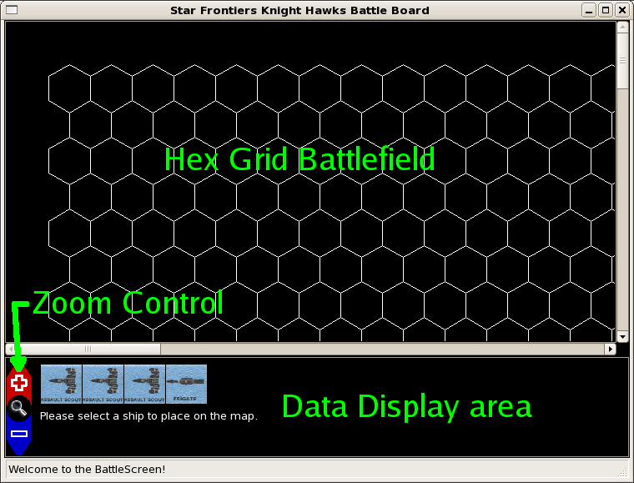Figure 3: Sample initial tactical combat screen. The upper panel is the battle field map and the lower panel is the data display area.
The screen is divided into two sections. The upper section is the battlefield. This portion of the screen is a large scrollable canvas that holds the hex grid map the combat is played out on. It will show all of the ships involved in the combat the planet and station if present and the movement of each ship each turn. In addition it displays the effective range of the currently selected weapon on the currently selected ship during the combat phases of the game.
The bottom window is the data display window. The contents displayed here change throughout the course of the tactical game setup and play depending on the current phase of the game. This display shows the ships to be placed during setup, controls for setting their initial speed, ship status displays for the selected ships and controls for ending the various phases of the tactical combat game.
A permanent feature of the data display panel is the zoom control. This control is always visible and active and allows you to zoom in or out on the battlefield. Clicking on the red “+” arrow zooms in on the hex grid and selecting the blue “-” arrow zooms out.
The entire battle screen window can be resized as desired based on your screen resolution. The data display area always remains a constant height regardless of window size and the battlefield window grows to fill the rest of the space. The initial size of the window is 800x600 pixels in size.

Setting up a new tactical game
When you enter the tactical game, the first thing you have to do is set up the battlefield with the various fleets as well as a possible planet and station. The order of setup is as follows:
- Pick location for planet if one is in the scenario
- Place a station around the planet if there is a station in the scenario
- Place the defending ships on the map
- Place the attacking ships on the map.
Once the ships are placed, the game moves into the combat sequence defined in the Advanced Combat section of the UPF Tactical Manual (will reproduce here eventually).

Setting up a planet

Setting up a station

Setting up a fleet
Setting up a fleet is the same regardless of the side you are playing. Initially, the data display area shows a collection of icons representing your ships as shown in figure 4.
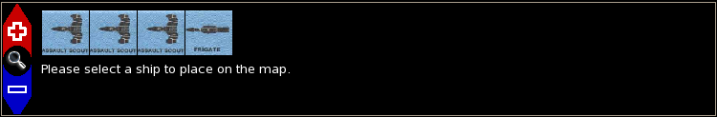Figure 4: Initial data display screen when setting up your fleet. In this case it shows four UPF ships to be placed on the board.
Placing a ship consists of four steps:
- Select the ship you want to place – To pick a ship place a ship on the map, you simply click on the ship icon for that ship.
- Select the ship's location on the hex grid - Once you have selected a ship the display screen changes to the one shown in figure 5. To place the ship, simply click on the hex on the battle map where you want the ship to be located.
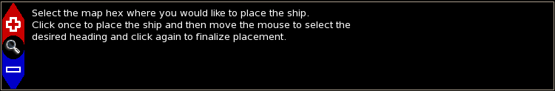Figure 5: Data display screen shown when placing a ship and selecting its initial heading.
- Choose the ship's initial heading – Once you select the hex location, the ship's icon is placed on the map and you have to select its initial heading. Simply move the mouse in the direction you want the ship to face and the ship's nose will follow the mouse. When it is pointed in the direction you want, click the left mouse button to set the heading.
- Set the ship's initial speed – Once the position and heading have been determined, you need to choose the ships initial speed. Set the speed in the input box that appears in the data display (figure 6) area to the desired value and click on the “Set Speed” button. That sets the ship's speed and returns you to step 1.
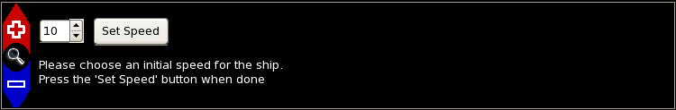Figure 6: Data display area for selecting the ship's inital speed. Use the control to select the speed and click on the "Set Speed" button to save the value.
This cycle continues allowing you to select another ship until the last ship is placed. At that point control either shifts to the other player allowing them to place their ships (if you were the defender) or the combat phases begin with the attacker having the first move.
Note: At the current time all set-up decisions are final. There is no way to go back and move things around or change speeds before passing control onto the next phase.

Moving your ships
On your movement turn, the game provides guidance for your ships' legal moves. To move a ship, simply click on the ship you wish to move. If you have more than one ship in a given hex, clicking multiple times in succession will cycle through all the ship in that hex. When you select a ship the data display area will be updated to show the selected ships vital statistics (Name, HP, ADF, MR, weapons, etc) and the battle grid will be updated to show the possible movement options based on its current speed, heading, ADF, MR and any already selected moves as shown in figure 7.
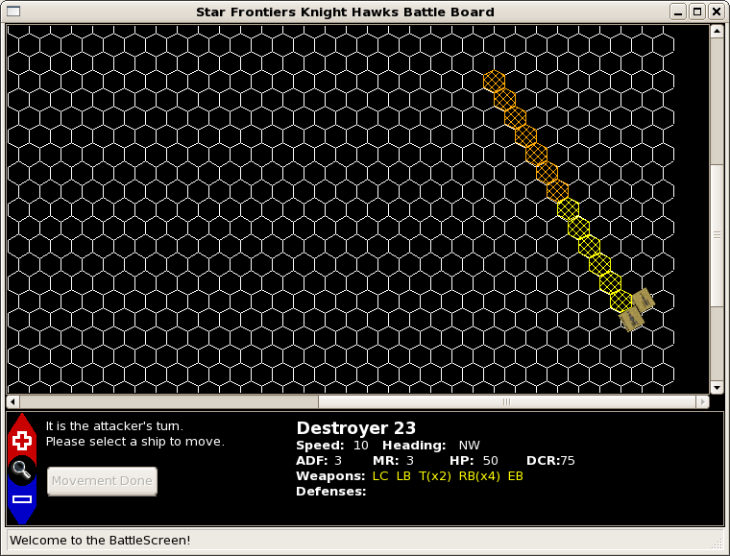Figure 7: Battle screen after selecting a ship to move. The ship statistics are displayed in the data display area and the hexes it can move into based on its current heading and speed are highlighted.
The hexes are highlighted in two different colors. The yellow hexes represent the distance the ship has to travel based on it's ADF and speed from last turn. The orange hexes represent the possible ending hexes, either speeding up or slowing down, based on the ship's ADF and speed. You must eventually end your movement in an orange hex.
To pick the path for your ship simply click on one of the highlighted hexes. When you do so, the hexes between your current ship location and the selected his will be connected by a red line representing the selected move and the hexes on the map will be reshaded based on you possible moves from that point (see figure 8). If you change your mind about your move, simply click in any hex containing the red line and you selected movement will be backed up to that point and the hexes reshaded based on that location.
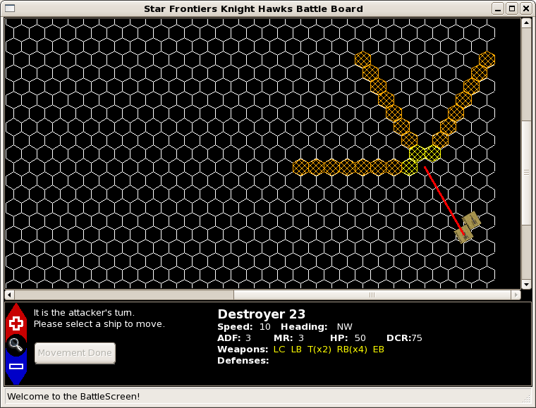Figure 8: Battle screen after picking some inital movement for your ship. The traversed path is marked by the red line and the possible remaining moves (taking a possible turn into account) are highlighted by the shaded hexes.
You do not need to move all of the necessary hexes before moving on to a new ship. You may freely move between all of your ships moving them as little or as much as you like. When you do, the selected path for the ship changes from red to gray. All ships you have moved are so marked so you can see what movement orders you have issued.
However, you must eventually get all of your ships into the orange hex zones to move on. Once you have moved all of your ships into their hex areas marked with orange hexes, the Movement Done button in the data display area illuminates (figure 9). Once you are satisfied with your movement orders, select this button. Your ships will be moved to the ends of the movement lines and it is now time for defensive fire. The movement lines will stay on the board so that the opposing player can see where you traveled during the last turn.
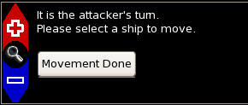Figure 9: Activated 'Movement Done' button after moving all your ships the minimum distance required by their speed and ADF.
Note: There are currently several issues with movement:
- Movement off the map is not supported. If your ships tries to head off the map, it will crash the game. Try to avoid ending your turn with a ship in a position that there is no way for it to move and turn to stay on the map
- Ships can't stop. If you try to not move a ship or have a ship with speed zero, the game may crash. This was discovered by BD_Cerridwen during play-testing and is something I didn't even think to check.

Selecting weapons
To select a weapon, you start by selecting the ship that wants to fire. As always, the information about the selected ship is displayed in the data display area. During your combat phases, the weapon names are color coded and active. The color's have the following meanings:
- white – unable to fire this phase (either out of ammo or MPO during defensive fire)
- yellow – ready to fire, no target assigned
- green – ready to fire, target selected
- red – damaged, unable to fire
To select a weapon, simply click on the weapon in the data display. Doing so highlights the weapon's field of fire. Any hex within range of the target is highlighted in red. If you are firing a Forward Firing weapon, the hexes that fall within the “head on” bonus region are highlighted in blue. If you are the non-moving player this round, it is simply the field of fire based on your current position as shown in figure 10.
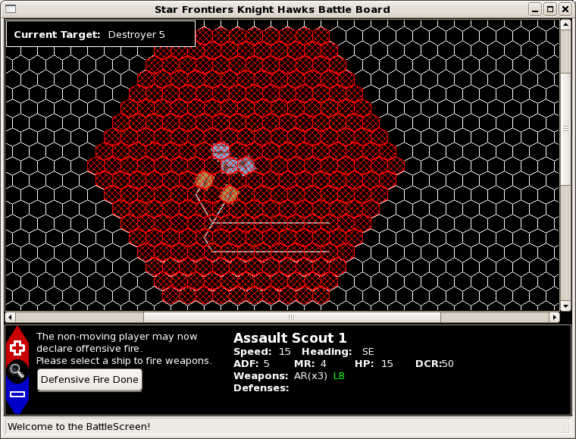Figure 10: Selecting a non-moving player weapon. In this case, the Assault Scout's LB has been selected and all the hexes within its field of fire have been highlighted in red. The selected target (the Sathar Destroyer) is displayed in the box in the upper left.
If you are the moving player, the field of fire is determined based on the weapon's field of fire and the path the ship took. Figure 11 gives an example of the field of fire for a moving weapon.
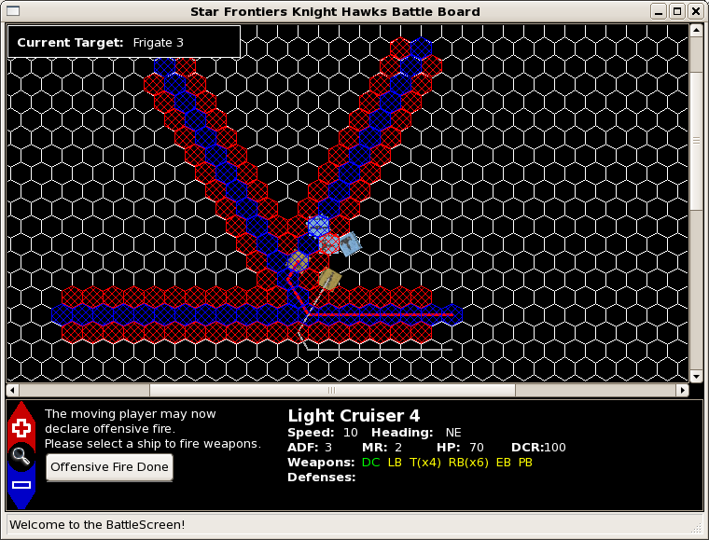Figure 11: Selecting a moving ship's weapon. In this case the Sathar Light Cruiser's DC has been selected and all the hexes that were available as targets as it moved are highlighted. The hexes that qualify for the 'head on shot' bonus are highlighted in blue. Again the selected target is displayed in the upper left and the weapon's name has turned green indicating that it has a selected target.

Selecting targets
Once you've picked your weapon, it's time to pick your target. To select a target simply click on the ship you want to shoot at. If it is not a valid target it will not be selected. If it is, the target vessel's name will be displayed in the target box in the upper left corner and the weapon's color will change to green if it was yellow (see figures 10 & 11). If you want a different target, simply click on a different ship. If there are more than one ship in the selected hex, clicking on the hex multiple times will cycle the target selection through all the ships in that hex.
The criteria for a ship being a valid target is different depending on whether you are the non-moving player or the moving player for that combat phase
- Non-moving player – If you are the non-moving player, a ship is a valid target if during any point of it's move, it passed through the field of fire for your weapon. If the gray movement track does not pass through your field of fire and the ship's counter isn't there either, you can't shoot at it. For example, in figure 10 the Assault Scout can fire its LB at either of the ships as their movement (as shown by the gray lines) passed through its field of fire.
- Moving player – If you are the moving player, then the ship's icon has to fall within the illuminated hexes representing your field of fire for it to be a valid target. If it isn't in one of the marked hexes, you can't shoot at it. In figure 11, the Light cruiser can fire at the Frigate directly ahead of it (as well as the Assault Scout to the lower left of the Frigate) as those ships fall within it's field of fire. The lead Assault Scout, however, is safe as the Light Cruiser's movement never brought it within the DC field of fire.
You don't have to worry about keeping track of “head on” shots for the forward firing weapons. The program automatically checks the target vessel and determines the range to the target so as to give you the best possible chance to hit based on it's location in and out of your “head on” bonus areas.

Taking the shot
You can continue to cycle through all of your ships and weapons selecting and changing targets until you are satisfied with your weapon allocations. Once you are happy with your selections, click on the “Defensive Fire Done” or “Offensive Fire Done” button depending on which phase of the battle you are in. Once you do, hit probabilities are rolled, damage is calculated and applied and any destroyed ships are removed from the game.
The “Offensive Fire Done” and “Defensive Fire Done” buttons are always active when they are displayed. It is perfectly acceptable to end your combat turn without firing all of your weapons so be careful not to click them before you are ready as there is no going back.
Note: Right now the combat system is very basic, implementing the basic rules damage system sans masking screens and ICMs. All the weapons have the basic chance to hit based on firing against a reflective hull on the Advanced Combat Table and all damage is hull damage.

Final tactical notes
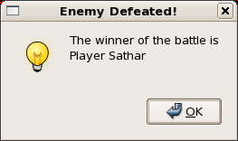
Play alternates back and forth between the two sides until all the ships from one side are destroyed. At which point the game declares the other side the winner and the battle screen exits. If you want to play again, just start it back up and try something different.

