

Course Project Report
Real-time Online Auction System (ROAS)
Subject: SBA301 Version: 1.0

List Members
Full name | Student ID
Châu Viết Doãn | DE190484
Trần Thanh Hưng | DE190481
Nguyễn Tiến Quân | DE190728
Lê Hoàng | DE190435

– Da Nang, July 2026 –
1. Project Introduction 5
1.1. Topic Description 5
1.2. Objectives 5
1.2.1. Technical Objectives 5
1.2.2. Business Objectives 5
1.3. Scope 6
1.3.1. Target User Scope (Actors) 6
1.3.2. Functional Scope (System Scope) 6
2. Task Assignment 6
3. Database Design 8
3.1. ERD Diagram 8
3.2. Description 8
4. API Design 8
4.1. API endpoints 8
4.2. Request/response description 12
4.2.1. Auto-Bid Controller 12
4.2.2. Authentication Controller 14
4.2.3. User Management Controller 19
4.2.4. Auction Session Controller 24
4.2.5. Payment Controller 30
4.2.6. Category Controller 33
4.2.7. Auction Item Controller 36
4.2.8. Bid Controller 42
4.2.9. Bid WebSocket Controller 43
4.2.10. Dispute Controller 44
4.2.11. Analytics Controller 46
4.2.12. Auction Statistic Controller 47
4.2.13. Earning Report Controller 48
4.2.14. Object Storage Controller 51
5. Installation & Execution Guide 52
5.1. Prerequisites 52
5.2. Setup Backend 52
5.3. Setup Frontend 53
5.4. Setup Database 54
6. Execution Results(UI) 54
6.1. Authentication (OTP & JWT) – Execution Result (UI) 54
6.1.1. Execution Steps 54
6.1.2. UI Screenshot 55
6.1.3. Result 55
6.2. Real-Time Bidding (WebSocket/STOMP) – Execution Result (UI) 55
6.2.1. Execution Steps 55
6.2.2. UI Screenshot 56
6.2.3. Result 56
6.3. Auto-Bidding (Proxy Bidding) – Execution Result (UI) 56
6.3.1. Execution Steps 56
6.3.2. UI Screenshot 57
6.3.3. Result 57
6.4. VNPay Payment Integration – Execution Result (UI) 57
6.4.1. Execution Steps 57
6.4.2. UI Screenshot 58
6.4.3. Result 58
6.5. Dispute Management – Execution Result (UI) 58
6.5.1. Execution Steps 58
6.5.2. UI Screenshot 59
6.5.3. Result 59
6.6. Auction Item Management – Execution Result (UI) 59
6.6.1. Execution Steps 59
6.6.2. UI Screenshot 60
6.6.3. Result 60
6.7. Auction Session Scheduling – Execution Result (UI) 60
6.7.1. Execution Steps 60
6.7.2. UI Screenshot 61
6.7.3. Result 61
6.8. User Profile Management – Execution Result (UI) 61
6.8.1. Execution Steps 61
6.8.2. UI Screenshot 62
6.8.3. Result 62
7. Illustrative Code for Each Important Feature 62
7.1. Real-Time Bidding (WebSocket/STOMP) 62
7.1.1. Feature Description 62
7.1.2. Frontend Implementation 63
7.1.3. Backend Implementation 64
7.1.4. API Communication 65
7.1.5. Expected Result 66
7.2. Authentication with OTP & JWT 66
7.2.1. Feature Description 66
7.2.2. Frontend Implementation 67
7.2.3. Backend Implementation 67
7.2.4. API Communication 68
7.2.5. Expected Result 69
7.3. Auto-Bidding (Proxy Bidding) 69
7.3.1. Feature Description 69
7.3.2. Frontend Implementation 69
7.3.3. Backend Implementation 70
7.3.4. API Communication 71
7.3.5. Expected Result 71
7.4. VNPay Payment Integration 71
7.4.1. Feature Description 71
7.4.2. Frontend Implementation 72
7.4.3. Backend Implementation 72
7.4.4. API Communication 73
7.4.5. Expected Result 74
8. Testing 75
8.1. Postman 75
8.2. JUnit 75
9. Project Management 76

Project Introduction

Topic Description
In the era of digital transformation, online shopping models have evolved rapidly, becoming increasingly diverse. Online Auctioning has emerged as an attractive e-commerce model that optimizes asset value through free-market mechanics.
The ROAS (Real-time Online Auction System) project is developed to provide a secure, transparent, and highly interactive online trading floor. The system serves as a bridge between users looking to liquidate or trade assets (Sellers) and buyers looking for high-quality products (Customers), all managed and supervised by a dedicated operations team (Staff/Admin).

Objectives

Technical Objectives
Real-time Performance: Ensure that bidding updates and system notifications are broadcast to all active users in an auction room with ultra-low latency (under 1 second).
Concurrency Handling & Data Integrity: Resolve race conditions at the database layer using advanced locking mechanisms, guaranteeing that only the fastest, valid bid is processed and recorded.
Security & Authorization: Implement secure centralized authentication (OAuth2 via Google/Facebook) and strict Role-Based Access Control (RBAC) to safeguard system resources.

Business Objectives
Seller product submission
Staff moderation
Automated session scheduling
Live customer bidding
Automated checkout and invoice generation
Provide a robust analytics dashboard utilizing data visualization components to help management analyze individual session performance and track trending product categories.

Scope

Target User Scope (Actors)
Customer: Buyers who actively bid in live rooms or delegate maximum spending thresholds to the automated bidding engine.
Auction Manager / Staff: Operators responsible for auditing item contents, setting up and controlling live sessions, and resolving bidding disputes.
System Administrator: Superusers who manage internal user accounts, override global permissions, and configure system-wide thresholds. (Note: To streamline the initial development scope, the Seller's item listing flow is integrated directly into the Staff's inbound content moderation workflow).

Functional Scope (System Scope)
Management of item categories, asset catalogs, and full auction session lifecycles (Draft, Scheduled, Active, Ended).
Live bidirectional WebSocket communication channels and asynchronous background workers for the Auto-Bid engine.
An instant push notification engine handling outbid alerts, session conclusions, and invoice verifications.
Analytical reporting metrics focusing on revenue growth and technical performance (tracking Concurrent Users - CCU peaks).

Task Assignment
Member | Role | Assigned Function | Contribution Level (%)
Châu Viết Doãn | Leader | Live Auction Room Management, Category Management, Realtime Bidding, Auto Bid Configuration, Auction List, Payment FE, User’sAuction Item FE | 32%
Trần Thanh Hưng | Member | User Management, Auction Item Management, Media Upload, Public Layout | 18%
Nguyễn Tiến Quân | Member | Authencation, Analytic Dashboard, Earning Report, Auction Session Management | 22%
Lê Hoàng | Member | Account Setting Management, Live Bid Monitoring and Log, Dispute Resolution, External Payment Gateway | 28%

Database Design

ERD Diagram
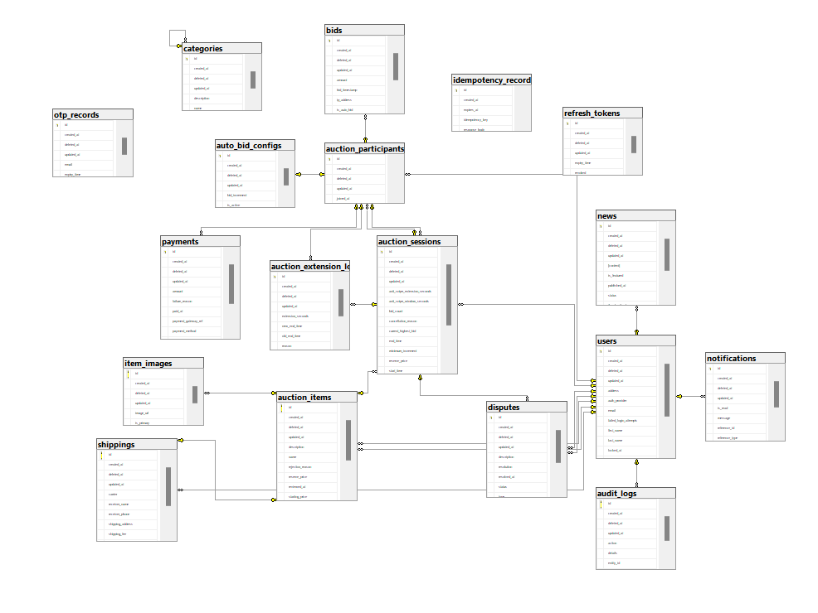
Figure 3-1: ERD Diagram for ROAS

Description

API Design

API endpoints

Method | Endpoint | Description
GET | /api/v1/auction-sessions/{sessionId}/auto-bid | Get the logged in user's active auto-bid configuration for the session.
POST | /api/v1/auction-sessions/{sessionId}/auto-bid | Sets, updates, or toggles the logged in user's automatic bidding setup.
POST | /api/v1/auth/reset-password | Verifies OTP and resets the user's password
POST | /api/v1/auth/resend-otp | Resends an OTP to the user's email
POST | /api/v1/auth/register | Sends an OTP to the user's email for registration
POST | /api/v1/auth/register/verify-otp | Verifies the OTP sent to email and activates the user account
POST | /api/v1/auth/refresh | Refreshes the access token using the refresh token from cookie
POST | /api/v1/auth/logout | Logs out the user and clears tokens and cookies
POST | /api/v1/auth/login | Sends an OTP to the user's email for login
POST | /api/v1/auth/login/verify-otp | Verifies the OTP and returns access token, refresh token (cookie), and CSRF token (cookie)
POST | /api/v1/auth/forgot-password | Sends an OTP to the user's email to reset password
GET | /api/v1/auth/me | Returns the authenticated user's data from the database in real time
GET | /api/v1/users/{id} | Get user by ID
PUT | /api/v1/users/{id} | Update user information
DELETE | /api/v1/users/{id} | Delete user by ID (Admin only)
PUT | /api/v1/users/password | Change password for the authenticated user
GET | /api/v1/users | Get all users
POST | /api/v1/users | Create a new user
PATCH | /api/v1/users/{id}/status | Update user status (Suspend/Activate)
PATCH | /api/v1/users/{id}/role | Assign role to user (Admin only)
GET | /api/v1/auction-sessions/{id} | Returns full details of a single auction session by its ID.
PUT | /api/v1/auction-sessions/{id} | Updates an existing auction session (end time, reserve price, status, etc.).
DELETE | /api/v1/auction-sessions/{id} | Soft-deletes an auction session. Active sessions cannot be deleted.
GET | /api/v1/auction-sessions | Returns a cursor-paginated list of auction sessions with optional search and status filter.
POST | /api/v1/auction-sessions | Creates a new auction session for an approved item.
PATCH | /api/v1/auction-sessions/{id}/restore | Restores a soft-deleted auction session
GET | /api/v1/auction-sessions/{id}/detail | Returns auction session details including item info, current price, winner, and latest 10 bid logs.
GET | /api/v1/auction-sessions/deleted | Soft-deletes an auction session. Active sessions cannot be deleted.
GET | /api/v1/payments/status | Retrieve payment status using gateway transaction reference
GET | /api/v1/payments/session/{sessionId}/my | Retrieve final payment details for the winner of a session
GET | /api/v1/categories/{id} | Fetches details of a specific category using its unique ID.
PUT | /api/v1/categories/{id} | Updates details of an existing category using its ID.
DELETE | /api/v1/categories/{id} | Marks a category as deleted (soft delete) using its ID.
GET | /api/v1/categories | Fetches a list of all active categories in the system.
POST | /api/v1/categories | Creates a category and returns its details. Validates CategoryRequest constraints.
POST | /api/v1/items | Submit a new item (multipart/form-data)
PATCH | /api/v1/items/{id}/update | Admin/Manager updates a pending item
PATCH | /api/v1/items/my-uploaded/{id} | Seller updates and resubmits own item
PATCH | /api/v1/items/{id}/approve | Admin/Manager approves a pending item
PATCH | /api/v1/items/{id}/reject | Admin/Manager rejects a pending item
DELETE | /api/v1/items/{id} | Admin/Manager soft-deletes an item
GET | /api/v1/items | Get list of items with pagination & filters
GET | /api/v1/items/my-uploaded | Get items uploaded by authenticated user
GET | /api/v1/items/my-won | Get items won by authenticated user
GET | /api/v1/bids | Get paginated bid logs (Admin/Manager)
PUT | /api/v1/bids/{id}/cancel | Cancel a suspicious bid (Admin/Manager)
STOMP | /app/auction/{sessionId}/place-bid | Place a bid in real-time via WebSocket
POST | /api/v1/disputes | Create a new dispute for an auction session
GET | /api/v1/disputes | Get paginated disputes with filters (Admin/Manager)
PATCH | /api/v1/disputes/{id}/status | Update dispute status / resolve dispute (Admin/Manager)
GET | /api/v1/admin/analytics/auction-statistics | Get auction statistics by date range (Admin)
GET | /api/v1/analytics/overview | Get dashboard overview (total revenue, sessions, bids, users) (Admin)
GET | /api/v1/analytics/revenue-chart | Get revenue chart data by period (DAILY/WEEKLY/MONTHLY) (Admin)
GET | /api/v1/users/{userId}/earning-report | Get seller earning summary
GET | /api/v1/users/{userId}/earning-statistics | Get earning statistics by time range
GET | /api/v1/users/{userId}/earning-transactions | Get earning transactions with cursor pagination
GET | /api/v1/users/{userId}/earning-transactions/export | Export transactions to Excel or PDF
POST | /api/v1/storage/images/presign | Generate presigned URL for image upload

Request/response description
Base URL: http://localhost:8080
Authentication: Bearer JWT Token (unless otherwise noted)
General Response Wrapper:
json
{
"code": 1000,
"message": "success",
"result": { ... }
}

Auto-Bid Controller
UC-01: Get Auto-Bid Configuration (GET /api/v1/auction-sessions/{sessionId}/auto-bid)
Authorization: Bearer \<JWT_TOKEN\>
A. Request
Path Variable:

Field | Type | Description
sessionId | Long | Auction session ID

B. Response Payloads
Success (HTTP 200 OK):
{
"code": 1000,
"message": "success",
"result": {
"id": 1,
"sessionId": 5,
"userId": 10,
"maxBidAmount": 10000.00,
"bidIncrement": 500.00,
"isActive": true
}
}

UC-02: Configure or Toggle Auto-Bid (POST /api/v1/auction-sessions/{sessionId}/auto-bid)
Content-Type: application/json
Authorization: Bearer \<JWT_TOKEN\>
A. Request
Path Variable:
Field | Type | Description
sessionId | Long | Auction session ID

Request Body (JSON):
{
"maxBidAmount": 10000.00,
"bidIncrement": 500.00,
"isActive": true
}
Field | Type | Description
maxBidAmount | BigDecimal | Maximum bid amount the system will place automatically
bidIncrement | BigDecimal | Amount to increment each automatic bid
isActive | boolean | Enable (true) or disable (false) auto-bidding

B. Response Payloads
Success (HTTP 200 OK):
{
"code": 1000,
"message": "success",
"result": {
"id": 1,
"sessionId": 5,
"userId": 10,
"maxBidAmount": 10000.00,
"bidIncrement": 500.00,
"isActive": true
}
}

Authentication Controller
UC-03: Register (POST /api/v1/auth/register)
Content-Type: application/json
Authorization: None (must NOT be authenticated)
A. Request
Request Body (JSON):
{
"firstName": "John",
"lastName": "Doe",
"email": "johndoe@example.com",
"password": "securePass123",
"phoneNumber": "0901234567"
}
Field | Type | Required | Validation | Description
firstName | String | Yes | @NotBlank, max 100 chars | User's first name
lastName | String | Yes | @NotBlank, max 100 chars | User's last name
email | String | Yes | @NotBlank, @Email | User's email address
password | String | Yes | @NotBlank, min 8 chars | User's password
phoneNumber | String | No | max 20 chars | User's phone number

B. Response Payloads
Success (HTTP 200 OK):
{
"code": 1000,
"message": "OTP sent to your email. Please verify to activate your account!"
}

UC-04: Verify Registration OTP (POST /api/v1/auth/register/verify-otp)
Content-Type: application/json
Authorization: None
A. Request
Request Body (JSON):
{
"email": "johndoe@example.com",
"otp": "482916"
}
Field | Type | Required | Validation | Description
email | String | Yes | @NotBlank, @Email | Registered email address
otp | String | Yes | @NotBlank, exactly 6 digits | OTP received via email

B. Response Payloads
Success (HTTP 200 OK):
{
"code": 1000,
"message": "Account activated successfully! You can now login."
}

UC-05: Login (POST /api/v1/auth/login)
Content-Type: application/json
Authorization: None (must NOT be authenticated)
A. Request
Request Body (JSON):
{
"email": "johndoe@example.com",
"password": "securePass123"
}
Field | Type | Required | Validation | Description
email | String | Yes | @NotBlank, @Email | User's email
password | String | Yes | @NotBlank | User's password

B. Response Payloads
Success (HTTP 200 OK):
{
"code": 1000,
"message": "OTP sent to your email. Please verify to complete login!"
}

UC-06: Verify Login OTP (POST /api/v1/auth/login/verify-otp)
Content-Type: application/json
Authorization: None
A. Request
Request Body (JSON):
{
"email": "johndoe@example.com",
"otp": "482916"
}
Field | Type | Required | Validation | Description
email | String | Yes | @NotBlank, @Email | User's email
otp | String | Yes | @NotBlank, exactly 6 digits | OTP received via email

B. Response Payloads
Success (HTTP 200 OK):
· Body:
{
"code": 1000,
"message": "Login successful!",
"result": {
"accessToken": "eyJhbGciOiJIUzI1NiJ9..."
}
}
· Cookies Set: refresh_token (HttpOnly), XSRF-TOKEN (Csrf token)

UC-07: Refresh Token (POST /api/v1/auth/refresh)
Authorization: Bearer refresh token (cookie) + CSRF token (header)
A. Request
Cookie: refresh_token=<refresh_token_value>
Header: X-CSRF-TOKEN: <csrf_token_value>
No request body required.
B. Response Payloads
Success (HTTP 200 OK):
{
"code": 1000,
"message": "Token refreshed successfully.",
"result": {
"accessToken": "eyJhbGciOiJIUzI1NiJ9..."
}
}

UC-08: Logout (POST /api/v1/auth/logout)
Authorization: Bearer refresh token (cookie) + CSRF token (header)
A. Request
Cookie: refresh_token=<refresh_token_value>
Header: X-CSRF-TOKEN: <csrf_token_value>
No request body required.
B. Response Payloads
Success (HTTP 200 OK):
{
"code": 1000,
"message": "Logged out successfully!"
}
Cookies Cleared: refresh_token, XSRF-TOKEN

UC-09: Forgot Password (POST /api/v1/auth/forgot-password)
Content-Type: application/json
Authorization: None (must NOT be authenticated)
A. Request
Request Body (JSON):
{
"email": "johndoe@example.com"
}
Field | Type | Required | Validation | Description
email | String | Yes | @NotBlank, @Email | Registered email address

B. Response Payloads
Success (HTTP 200 OK):
{
"code": 1000,
"message": "An OTP has been sent to your email to reset your password."
}

UC-10: Reset Password (POST /api/v1/auth/reset-password)
Content-Type: application/json
Authorization: None
A. Request
Request Body (JSON):
{
"email": "johndoe@example.com",
"otp": "482916",
"newPassword": "newSecurePass456"
}
Field | Type | Required | Validation | Description
email | String | Yes | @NotBlank, @Email | User's email
otp | String | Yes | @NotBlank, exactly 6 digits | OTP received via email
newPassword | String | Yes | @NotBlank, min 8 chars | New password

B. Response Payloads
Success (HTTP 200 OK):
{
"code": 1000,
"message": "Your password has been reset successfully."
}

UC-11: Resend OTP (POST /api/v1/auth/resend-otp)
Content-Type: application/json
Authorization: None
A. Request
Request Body (JSON):
{
"email": "johndoe@example.com"
}
Field | Type | Required | Validation | Description
email | String | Yes | @NotBlank, @Email | User's email

B. Response Payloads
Success (HTTP 200 OK):
{
"code": 1000,
"message": "OTP resent successfully."
}

UC-12: Get Current User (GET /api/v1/auth/me)
Authorization: Bearer \<JWT_TOKEN\>
A. Request
No parameters required. User is identified from the JWT token.
B. Response Payloads
Success (HTTP 200 OK):
{
"code": 1000,
"message": "success",
"result": {
"id": 10,
"firstName": "John",
"lastName": "Doe",
"email": "johndoe@example.com",
"phoneNumber": "0901234567",
"address": "123 Main St",
"authProvider": "LOCAL",
"status": "ACTIVE",
"role": "USER",
"createdAt": "2025-07-01T10:00:00",
"updatedAt": "2025-07-15T12:30:00"
}
}

User Management Controller
UC-13: Get All Users (GET /api/v1/users)
Authorization: Bearer \<JWT_TOKEN\> (ADMIN only)
A. Request
No parameters required.
B. Response Payloads
Success (HTTP 200 OK):
{
"code": 1000,
"message": "success",
"result": [
{
"id": 1,
"firstName": "John",
"lastName": "Doe",
"email": "johndoe@example.com",
"phoneNumber": "0901234567",
"address": "123 Main St",
"authProvider": "LOCAL",
"status": "ACTIVE",
"role": "USER",
"createdAt": "2025-07-01T10:00:00",
"updatedAt": "2025-07-15T12:30:00"
}
]
}
UC-14: Create New User (POST /api/v1/users)
Content-Type: application/json
Authorization: Bearer \<JWT_TOKEN\> (ADMIN only)
A. Request
Request Body (JSON):
{
"firstName": "Jane",
"lastName": "Smith",
"email": "janesmith@example.com",
"phoneNumber": "0912345678",
"password": "securePass123",
"address": "456 Oak Ave"
}
Field | Type | Required | Validation | Description
firstName | String | Yes | @NotBlank, max 100 chars | First name
lastName | String | Yes | @NotBlank, max 100 chars | Last name
email | String | Yes | @NotBlank, @Email | Email address
phoneNumber | String | No | max 20 chars | Phone number
password | String | Yes | @NotBlank, min 6 chars | Password
address | String | No | — | Address

B. Response Payloads
Success (HTTP 200 OK):
{
"code": 1000,
"message": "success",
"result": {
"id": 11,
"firstName": "Jane",
"lastName": "Smith",
"email": "janesmith@example.com",
"phoneNumber": "0912345678",
"address": "456 Oak Ave",
"authProvider": "LOCAL",
"status": "ACTIVE",
"role": "USER",
"createdAt": "2025-07-20T08:00:00",
"updatedAt": "2025-07-20T08:00:00"
}
}
UC-15: Get User by ID (GET /api/v1/users/{id})
Authorization: Bearer \<JWT_TOKEN\>
A. Request
Path Variable:
Field | Type | Description
id | Long | User ID

B. Response Payloads
Success (HTTP 200 OK):
{
"code": 1000,
"message": "success",
"result": {
"id": 10,
"firstName": "John",
"lastName": "Doe",
"email": "johndoe@example.com",
"phoneNumber": "0901234567",
"address": "123 Main St",
"authProvider": "LOCAL",
"status": "ACTIVE",
"role": "USER",
"createdAt": "2025-07-01T10:00:00",
"updatedAt": "2025-07-15T12:30:00"
}
}

UC-16: Update User Information (PUT /api/v1/users/{id})
Content-Type: application/json
Authorization: Bearer \<JWT_TOKEN\>
A. Request
Path Variable:
Field | Type | Description
id | Long | User ID

Request Body (JSON):
{
"firstName": "John",
"lastName": "Doe Updated",
"phoneNumber": "0909999999",
"address": "789 New St"
}
Field | Type | Required | Validation | Description
firstName | String | No | max 100 chars | First name
lastName | String | No | max 100 chars | Last name
phoneNumber | String | No | max 20 chars | Phone number
address | String | No | — | Address

B. Response Payloads
Success (HTTP 200 OK):
{
"code": 1000,
"message": "success",
"result": {
"id": 10,
"firstName": "John",
"lastName": "Doe Updated",
"email": "johndoe@example.com",
"phoneNumber": "0909999999",
"address": "789 New St",
"authProvider": "LOCAL",
"status": "ACTIVE",
"role": "USER",
"createdAt": "2025-07-01T10:00:00",
"updatedAt": "2025-07-20T09:00:00"
}
}

UC-17: Delete User (DELETE /api/v1/users/{id})
Authorization: Bearer \<JWT_TOKEN\> (ADMIN only)
A. Request
Path Variable:
Field | Type | Description
id | Long | User ID

B. Response Payloads
Success (HTTP 200 OK):
{
"code": 1000,
"message": "User deleted successfully"
}

UC-18: Change Password (PUT /api/v1/users/password)
Content-Type: application/json
Authorization: Bearer \<JWT_TOKEN\>
A. Request
Request Body (JSON):
{
"oldPassword": "oldSecurePass123",
"newPassword": "newSecurePass456"
}
Field | Type | Required | Validation | Description
oldPassword | String | Yes | @NotBlank | Current password
newPassword | String | Yes | @NotBlank, min 8 chars | New password

B. Response Payloads
Success (HTTP 200 OK):
{
"code": 1000,
"message": "Password changed successfully. A notification email has been sent."
}

UC-19: Update User Status (PATCH /api/v1/users/{id}/status)
Content-Type: application/json
Authorization: Bearer \<JWT_TOKEN\> (ADMIN only)
A. Request
Path Variable:
Field | Type | Description
id | Long | User ID

Request Body (JSON):
{
"status": "SUSPENDED"
}
Field | Type | Required | Description
status | String | Yes | ACTIVE, PENDING, LOCKED, INACTIVE, or SUSPENDED

B. Response Payloads
Success (HTTP 200 OK):
{
"code": 1000,
"message": "success",
"result": {
"id": 10,
"firstName": "John",
"lastName": "Doe",
"email": "johndoe@example.com",
"status": "SUSPENDED",
"role": "USER"
}
}

UC-20: Assign Role to User (PATCH /api/v1/users/{id}/role)
Content-Type: application/json
Authorization: Bearer \<JWT_TOKEN\> (ADMIN only)
A. Request
Path Variable:
Field | Type | Description
id | Long | User ID

Request Body (JSON):
{
"role": "AUCTION_MANAGER"
}
Field | Type | Required | Description
role | String | Yes | USER, AUCTION_MANAGER, or ADMIN

B. Response Payloads
Success (HTTP 200 OK):
{
"code": 1000,
"message": "success",
"result": {
"id": 10,
"firstName": "John",
"lastName": "Doe",
"email": "johndoe@example.com",
"status": "ACTIVE",
"role": "AUCTION_MANAGER"
}
}

Auction Session Controller
UC-21: List Auction Sessions (GET /api/v1/auction-sessions)
Authorization: Bearer \<JWT_TOKEN\>
A. Request
Query Parameters:
Field | Type | Required | Default | Description
cursor | Long | No | — | Cursor for pagination
size | int | No | 10 | Page size
search | String | No | — | Search keyword
status | String | No | — | SCHEDULED, ACTIVE, ENDED, PAID, RESERVE_NOT_MET, CANCELLED, POSTPONED

B. Response Payloads
Success (HTTP 200 OK):
{
"code": 1000,
"message": "success",
"result": {
"content": [
{
"id": 1,
"itemId": 10,
"itemName": "Vintage Guitar",
"itemDescription": "1960s Fender Stratocaster",
"reservePrice": 8000.00,
"currentHighestBid": 9500.00,
"status": "ACTIVE",
"startTime": "2025-07-20T10:00:00",
"endTime": "2025-07-25T18:00:00"
}
],
"nextCursor": 1,
"hasNext": true,
"pageSize": 10
}
}

UC-22: Get Session by ID (GET /api/v1/auction-sessions/{id})
Authorization: Bearer \<JWT_TOKEN\>
A. Request
Path Variable:
Field | Type | Description
id | Long | Session ID

B. Response Payloads
Success (HTTP 200 OK):
{
"code": 1000,
"message": "success",
"result": {
"id": 1,
"itemId": 10,
"itemName": "Vintage Guitar",
"itemDescription": "1960s Fender Stratocaster",
"itemImage": "https://storage.example.com/item/10/main.jpg",
"createdById": 1,
"createdByName": "Admin",
"startTime": "2025-07-20T10:00:00",
"endTime": "2025-07-25T18:00:00",
"reservePrice": 8000.00,
"minimumIncrement": 100.00,
"currentHighestBid": 9500.00,
"currentWinnerName": "John D.",
"status": "ACTIVE",
"antiSnipeWindowSeconds": 30,
"antiSnipeExtensionSeconds": 60,
"bidCount": 15,
"cancellationReason": null,
"createdAt": "2025-07-18T08:00:00",
"updatedAt": "2025-07-20T14:30:00"
}
}

UC-23: Create Auction Session (POST /api/v1/auction-sessions)
Content-Type: application/json
Authorization: Bearer \<JWT_TOKEN\> (ADMIN or AUCTION_MANAGER)
A. Request
Request Body (JSON):
{
"itemId": 10,
"startTime": "2025-08-01T10:00:00",
"endTime": "2025-08-05T18:00:00",
"reservePrice": 8000.00,
"minimumIncrement": 100.00,
"antiSnipeWindowSeconds": 30,
"antiSnipeExtensionSeconds": 60
}
Field | Type | Required | Validation | Description
itemId | Long | Yes | @NotNull | Approved item ID
startTime | LocalDateTime | Yes | @NotNull, at least 5 min from now | Auction start time
endTime | LocalDateTime | Yes | @NotNull | Auction end time
reservePrice | BigDecimal | Yes | @NotNull, min 1 | Minimum acceptable price
minimumIncrement | BigDecimal | Yes | @NotNull, min 1 | Minimum bid increment
antiSnipeWindowSeconds | Integer | No | — | Seconds before end to trigger anti-snipe
antiSnipeExtensionSeconds | Integer | No | — | Seconds to extend on snipe

B. Response Payloads
Success (HTTP 201 Created):
{
"code": 1000,
"message": "success",
"result": {
"id": 6,
"itemId": 10,
"itemName": "Vintage Guitar",
"startTime": "2025-08-01T10:00:00",
"endTime": "2025-08-05T18:00:00",
"reservePrice": 8000.00,
"minimumIncrement": 100.00,
"currentHighestBid": null,
"status": "SCHEDULED",
"antiSnipeWindowSeconds": 30,
"antiSnipeExtensionSeconds": 60,
"bidCount": 0,
"createdAt": "2025-07-20T08:00:00"
}
}

UC-24: Update Auction Session (PUT /api/v1/auction-sessions/{id})
Content-Type: application/json
Authorization: Bearer \<JWT_TOKEN\> (ADMIN or AUCTION_MANAGER)
A. Request
Path Variable:
Field | Type | Description
id | Long | Session ID

Request Body (JSON):
{
"startTime": "2025-08-02T10:00:00",
"endTime": "2025-08-06T18:00:00",
"reservePrice": 9000.00,
"minimumIncrement": 150.00,
"antiSnipeWindowSeconds": 45,
"antiSnipeExtensionSeconds": 90,
"status": "ACTIVE",
"cancellationReason": null
}
Field | Type | Required | Validation | Description
startTime | LocalDateTime | No | @Future | Updated start time
endTime | LocalDateTime | No | @Future | Updated end time
reservePrice | BigDecimal | No | min 1 | Updated reserve price
minimumIncrement | BigDecimal | No | min 1 | Updated minimum increment
antiSnipeWindowSeconds | Integer | No | min 1 | Updated anti-snipe window
antiSnipeExtensionSeconds | Integer | No | min 1 | Updated anti-snipe extension
status | String | No | — | SCHEDULED, ACTIVE, ENDED, CANCELLED, POSTPONED
cancellationReason | String | No | max 500 chars | Reason for cancellation

B. Response Payloads
Success (HTTP 200 OK):
{
"code": 1000,
"message": "success",
"result": {
"id": 1,
"itemId": 10,
"itemName": "Vintage Guitar",
"startTime": "2025-08-02T10:00:00",
"endTime": "2025-08-06T18:00:00",
"reservePrice": 9000.00,
"minimumIncrement": 150.00,
"currentHighestBid": 9500.00,
"status": "ACTIVE",
"antiSnipeWindowSeconds": 45,
"antiSnipeExtensionSeconds": 90,
"bidCount": 15,
"updatedAt": "2025-07-20T09:00:00"
}
}

UC-25: Delete Auction Session (DELETE /api/v1/auction-sessions/{id})
Authorization: Bearer \<JWT_TOKEN\> (ADMIN or AUCTION_MANAGER)
A. Request
Path Variable:
Field | Type | Description
id | Long | Session ID

B. Response Payloads
Success (HTTP 200 OK):
{
"code": 1000,
"message": "success"
}

UC-26: Restore Deleted Session (PATCH /api/v1/auction-sessions/{id}/restore)
Authorization: Bearer \<JWT_TOKEN\> (ADMIN or AUCTION_MANAGER)
A. Request
Path Variable:
Field | Type | Description
id | Long | Session ID

B. Response Payloads
Success (HTTP 200 OK):
{
"code": 1000,
"message": "success"
}

UC-27: Get Auction Session Detail (GET /api/v1/auction-sessions/{id}/detail)
Authorization: Bearer \<JWT_TOKEN\>
A. Request
Path Variable:
Field | Type | Description
id | Long | Session ID

B. Response Payloads
Success (HTTP 200 OK):
{
"code": 1000,
"message": "success",
"result": {
"sessionId": 1,
"itemId": 10,
"itemName": "Vintage Guitar",
"itemImage": "https://storage.example.com/item/10/main.jpg",
"itemDescription": "1960s Fender Stratocaster",
"endTime": "2025-07-25T18:00:00",
"currentPrice": 9500.00,
"currentWinnerName": "John D.",
"winnerId": 10,
"winnerName": "John Doe",
"status": "ACTIVE",
"minimumIncrement": 100.00,
"reservePrice": 8000.00,
"bidLogs": [
{
"bidId": 15,
"sessionId": 1,
"userId": 10,
"bidderName": "John D.",
"amount": 9500.00,
"bidTime": "2025-07-22T14:30:00",
"isSuspicious": false,
"status": "ACTIVE"
}
]
}
}

UC-28: List Deleted Auction Sessions (GET /api/v1/auction-sessions/deleted)
Authorization: Bearer \<JWT_TOKEN\> (ADMIN or AUCTION_MANAGER)
A. Request
No parameters required.
B. Response Payloads
Success (HTTP 200 OK):
{
"code": 1000,
"message": "success",
"result": [
{
"id": 3,
"itemId": 8,
"itemName": "Rare Coin",
"reservePrice": 5000.00,
"status": "CANCELLED",
"startTime": "2025-06-01T10:00:00",
"endTime": "2025-06-05T18:00:00"
}
]
}

Payment Controller
UC-29: Check Payment Status (GET /api/v1/payments/status)
Authorization: Bearer \<JWT_TOKEN\>
A. Request
Query Parameters:
Field | Type | Required | Description
vnp_TransactionNo | String | Yes | Gateway transaction reference

B. Response Payloads
Success (HTTP 200 OK):
{
"code": 1000,
"message": "success",
"result": {
"id": 1,
"participantId": 10,
"type": "FINAL_PAYMENT",
"amount": 9500.00,
"status": "PAID",
"transactionId": "TXN-20250720-001",
"paymentGatewayRef": "12345678",
"paymentMethod": "VNPay",
"paidAt": "2025-07-20T15:30:00",
"failureReason": null,
"createdAt": "2025-07-18T10:00:00",
"updatedAt": "2025-07-20T15:30:00"
}
}

UC-30: Get My Payment for Session (GET /api/v1/payments/session/{sessionId}/my)
Authorization: Bearer \<JWT_TOKEN\>
A. Request
Path Variable:
Field | Type | Description
sessionId | Long | Auction session ID

B. Response Payloads
Success (HTTP 200 OK):
{
"code": 1000,
"message": "success",
"result": {
"id": 1,
"participantId": 10,
"type": "FINAL_PAYMENT",
"amount": 9500.00,
"status": "PENDING",
"transactionId": null,
"paymentGatewayRef": null,
"paymentMethod": null,
"paidAt": null,
"failureReason": null,
"createdAt": "2025-07-18T10:00:00",
"updatedAt": "2025-07-18T10:00:00"
}
}

UC-31: Create VNPay Payment URL (GET /api/v1/payments/vnpay/create-url/{paymentId})
Authorization: Bearer \<JWT_TOKEN\>
A. Request
Path Variable:
Field | Type | Description
paymentId | Long | Payment record ID

B. Response Payloads
Success (HTTP 200 OK):
{
"code": 1000,
"message": "success",
"result": {
"url": "https://sandbox.vnpayment.vn/paymentv2/vpcpay.html?vnp_Amount=950000&vnp_Command=pay&..."
}
}

UC-32: VNPay IPN Webhook (GET /api/v1/payments/vnpay/ipn)
Authorization: None (called by VNPay gateway)
A. Request
Query Parameters (from VNPay):
Field | Type | Description
vnp_TmnCode | String | Merchant code
vnp_HashSecret | String | Hash secret
vnp_Amount | String | Payment amount
vnp_BankCode | String | Bank code
vnp_OrderInfo | String | Order info
vnp_PayDate | String | Payment date
vnp_ResponseCode | String | Response code
vnp_TransactionNo | String | Transaction number
vnp_TransactionStatus | String | Transaction status
vnp_SecureHash | String | Secure hash

B. Response Payloads
Success (HTTP 200 OK):
{
"RspCode": "00",
"Message": "Confirm Success"
}

Category Controller
UC-33: Get All Categories (GET /api/v1/categories)
Authorization: None (Public)
A. Request
No parameters required.
B. Response Payloads
Success (HTTP 200 OK):
{
"code": 1000,
"message": "success",
"result": [
{
"id": 1,
"name": "Art",
"description": "Paintings, sculptures, and prints",
"parentCategoryId": null,
"parentCategoryName": null,
"sortOrder": 1,
"createdAt": "2025-06-01T10:00:00",
"updatedAt": "2025-06-01T10:00:00"
},
{
"id": 2,
"name": "Paintings",
"description": "Oil and acrylic paintings",
"parentCategoryId": 1,
"parentCategoryName": "Art",
"sortOrder": 1,
"createdAt": "2025-06-01T10:05:00",
"updatedAt": "2025-06-01T10:05:00"
}
]
}

UC-34: Get Category by ID (GET /api/v1/categories/{id})
Authorization: None (Public)
A. Request
Path Variable:
Field | Type | Description
id | Long | Category ID

B. Response Payloads
Success (HTTP 200 OK):
{
"code": 1000,
"message": "success",
"result": {
"id": 1,
"name": "Art",
"description": "Paintings, sculptures, and prints",
"parentCategoryId": null,
"parentCategoryName": null,
"sortOrder": 1,
"createdAt": "2025-06-01T10:00:00",
"updatedAt": "2025-06-01T10:00:00"
}
}

UC-35: Create Category (POST /api/v1/categories)
Content-Type: application/json
Authorization: Bearer \<JWT_TOKEN\> (ADMIN or AUCTION_MANAGER)
A. Request
Request Body (JSON):
{
"name": "Jewelry",
"description": "Fine jewelry and watches",
"parentCategoryId": null,
"sortOrder": 3
}
Field | Type | Required | Validation | Description
name | String | Yes | @NotBlank, max 100 chars | Category name
description | String | No | — | Category description
parentCategoryId | Long | No | — | Parent category ID (for subcategories)
sortOrder | int | No | min 0 | Display sort order

B. Response Payloads
Success (HTTP 200 OK):
{
"code": 1000,
"message": "success",
"result": {
"id": 3,
"name": "Jewelry",
"description": "Fine jewelry and watches",
"parentCategoryId": null,
"parentCategoryName": null,
"sortOrder": 3,
"createdAt": "2025-07-20T08:00:00",
"updatedAt": "2025-07-20T08:00:00"
}
}

UC-36: Update Category (PUT /api/v1/categories/{id})
Content-Type: application/json
Authorization: Bearer \<JWT_TOKEN\> (ADMIN or AUCTION_MANAGER)
A. Request
Path Variable:
Field | Type | Description
id | Long | Category ID

Request Body (JSON):
{
"name": "Jewelry & Watches",
"description": "Fine jewelry, gemstones, and luxury watches",
"parentCategoryId": null,
"sortOrder": 2
}
Field | Type | Required | Validation | Description
name | String | Yes | @NotBlank, max 100 chars | Updated category name
description | String | No | — | Updated description
parentCategoryId | Long | No | — | Updated parent category
sortOrder | int | No | min 0 | Updated sort order

B. Response Payloads
Success (HTTP 200 OK):
{
"code": 1000,
"message": "success",
"result": {
"id": 3,
"name": "Jewelry & Watches",
"description": "Fine jewelry, gemstones, and luxury watches",
"parentCategoryId": null,
"parentCategoryName": null,
"sortOrder": 2,
"createdAt": "2025-07-20T08:00:00",
"updatedAt": "2025-07-20T09:00:00"
}
}

UC-37: Delete Category (DELETE /api/v1/categories/{id})
Authorization: Bearer \<JWT_TOKEN\> (ADMIN or AUCTION_MANAGER)
A. Request
Path Variable:
Field | Type | Description
id | Long | Category ID

B. Response Payloads
Success (HTTP 200 OK):
{
"code": 1000,
"message": "Category deleted successfully"
}

Auction Item Controller
UC-38: Submit New Item (POST /api/v1/items)
Content-Type: multipart/form-data
Authorization: Bearer \<JWT_TOKEN\> (Seller)
A. Request
Request Parts:
itemDto (application/json):
{
"itemName": "Vintage Rolex Submariner 1982",
"description": "Excellent condition, original box and papers included.",
"categoryId": 4,
"startingPrice": 5500.00,
"reservePrice": 7000.00,
"condition": "Excellent"
}
Field | Type | Required | Validation | Description
itemName | String | Yes | @NotBlank | Item name
description | String | Yes | @NotBlank | Item description
categoryId | Long | Yes | @NotNull | Category ID
startingPrice | BigDecimal | Yes | > 0.0 | Starting auction price
reservePrice | BigDecimal | Yes | > 0.0 | Minimum acceptable price
condition | String | No | — | Item condition
images | MultipartFile[] | No | — | Image files (PNG/JPEG, max 5MB each)
imageKeys | String[] | No | — | Pre-signed storage keys

B. Response Payloads
Success (HTTP 200 OK):
{
"code": 1000,
"message": "success",
"result": {
"id": 20,
"name": "Vintage Rolex Submariner 1982",
"description": "Excellent condition, original box and papers included.",
"categoryId": 4,
"categoryName": "Watches",
"sellerId": 10,
"sellerName": "John",
"startingPrice": 5500.00,
"reservePrice": 7000.00,
"status": "PENDING",
"createdAt": "2025-07-20T12:00:00"
}
}

UC-39: Update Item by Admin/Manager (PATCH /api/v1/items/{id}/update)
Content-Type: multipart/form-data
Authorization: Bearer \<JWT_TOKEN\> (ADMIN or AUCTION_MANAGER)
A. Request
Path Variable:
Field | Type | Description
id | Long | Item ID

Request Parts (form-data):
Field | Type | Description
name | String | Updated name
description | String | Updated description
categoryId | Long | Updated category
startingPrice | BigDecimal | Updated starting price
reservePrice | BigDecimal | Updated reserve price
status | String | Updated status
imageUrl | String | Updated image URL
image | MultipartFile | Updated image file
imageKey | String | Updated image storage key
startTime | LocalDateTime | Auction start time
endTime | LocalDateTime | Auction end time
artist | String | Artist name
submittedBy | String | Submitter info

B. Response Payloads
Success (HTTP 200 OK):
{
"code": 1000,
"message": "success",
"result": {
"id": 20,
"name": "Vintage Rolex Submariner 1982 - Updated",
"status": "APPROVED",
"startingPrice": 6000.00,
"reservePrice": 7500.00,
"updatedAt": "2025-07-20T13:00:00"
}
}

UC-40: Update Own Item (PATCH /api/v1/items/my-uploaded/{id})
Content-Type: multipart/form-data
Authorization: Bearer \<JWT_TOKEN\> (Owner)
A. Request
Path Variable:
Field | Type | Description
id | Long | Item ID

Request Parts: Same as UC-39
B. Response Payloads
Success (HTTP 200 OK):
{
"code": 1000,
"message": "success",
"result": {
"id": 20,
"name": "Vintage Rolex Submariner 1982",
"status": "PENDING",
"updatedAt": "2025-07-20T14:00:00"
}
}

UC-41: Approve Item (PATCH /api/v1/items/{id}/approve)
Authorization: Bearer \<JWT_TOKEN\> (ADMIN or AUCTION_MANAGER)
A. Request
Path Variable:
Field | Type | Description
id | Long | Item ID

B. Response Payloads
Success (HTTP 200 OK):
{
"code": 1000,
"message": "success",
"result": {
"id": 20,
"name": "Vintage Rolex Submariner 1982",
"status": "APPROVED",
"reviewedById": 1,
"reviewedByName": "Admin",
"reviewedAt": "2025-07-20T15:00:00"
}
}

UC-42: Reject Item (PATCH /api/v1/items/{id}/reject)
Content-Type: application/json
Authorization: Bearer \<JWT_TOKEN\> (ADMIN or AUCTION_MANAGER)
A. Request
Path Variable:
Field | Type | Description
id | Long | Item ID

Request Body (JSON):
{
"rejectionReason": "Item images are blurry and description is insufficient."
}
Field | Type | Required | Validation | Description
rejectionReason | String | Yes | @NotBlank | Reason for rejection

B. Response Payloads
Success (HTTP 200 OK):
{
"code": 1000,
"message": "success",
"result": {
"id": 20,
"name": "Vintage Rolex Submariner 1982",
"status": "REJECTED",
"rejectionReason": "Item images are blurry and description is insufficient.",
"reviewedById": 1,
"reviewedByName": "Admin",
"reviewedAt": "2025-07-20T15:00:00"
}
}

UC-43: Delete Item (DELETE /api/v1/items/{id})
Authorization: Bearer \<JWT_TOKEN\> (ADMIN or AUCTION_MANAGER)
A. Request
Path Variable:
Field | Type | Description
id | Long | Item ID

B. Response Payloads
Success (HTTP 200 OK):
{
"code": 1000,
"message": "Item deleted successfully"
}

UC-44: Get List of Items (GET /api/v1/items)
Authorization: Public (role-based filtering)
A. Request
Query Parameters:
Field | Type | Required | Default | Description
page | int | No | 0 | Page number
size | int | No | 10 | Page size
name | String | No | — | Filter by name
categoryId | Long | No | — | Filter by category
status | String | No | — | PENDING, APPROVED, REJECTED, ACTIVE, SOLD, PAID, SHIPPING, DELIVERED

B. Response Payloads
Success (HTTP 200 OK):
{
"code": 1000,
"message": "success",
"result": {
"content": [
{
"id": 20,
"name": "Vintage Rolex Submariner 1982",
"description": "Excellent condition.",
"categoryId": 4,
"categoryName": "Watches",
"sellerId": 10,
"sellerName": "John",
"startingPrice": 5500.00,
"reservePrice": 7000.00,
"status": "APPROVED",
"imageUrl": "https://storage.example.com/item/20/main.jpg",
"createdAt": "2025-07-20T12:00:00"
}
],
"pageNo": 0,
"pageSize": 10,
"totalElements": 45,
"totalPages": 5,
"last": false
}
}

UC-45: Get My Uploaded Items (GET /api/v1/items/my-uploaded)
Authorization: Bearer \<JWT_TOKEN\>
A. Request
Query Parameters: Same as UC-44
B. Response Payloads
Success (HTTP 200 OK): Same format as UC-44

UC-46: Get My Won Items (GET /api/v1/items/my-won)
Authorization: Bearer \<JWT_TOKEN\>
A. Request
Query Parameters:
Field | Type | Required | Default | Description
page | int | No | 0 | Page number
size | int | No | 10 | Page size
name | String | No | — | Filter by name
categoryId | Long | No | — | Filter by category

B. Response Payloads
Success (HTTP 200 OK):
{
"code": 1000,
"message": "success",
"result": {
"content": [
{
"id": 15,
"name": "Antique Vase",
"status": "SOLD",
"startingPrice": 2000.00,
"reservePrice": 3000.00,
"imageUrl": "https://storage.example.com/item/15/main.jpg",
"paymentId": 5,
"paymentStatus": "PAID"
}
],
"pageNo": 0,
"pageSize": 10,
"totalElements": 3,
"totalPages": 1,
"last": true
}
}

Bid Controller
8.1 UC-47: Get Bid Logs (GET /api/v1/bids)
Authorization: Bearer \<JWT_TOKEN\> (ADMIN or AUCTION_MANAGER)
A. Request
Query Parameters:
Field | Type | Required | Default | Description
page | int | No | 0 | Page number
size | int | No | 10 | Page size
sessionId | Long | No | — | Filter by session
userId | Long | No | — | Filter by bidder

B. Response Payloads
Success (HTTP 200 OK):
{
"code": 1000,
"message": "success",
"result": {
"content": [
{
"bidId": 15,
"sessionId": 1,
"userId": 10,
"bidderName": "John",
"amount": 9500.00,
"bidTime": "2025-07-22T14:30:00",
"isSuspicious": false,
"status": "ACTIVE"
}
],
"pageNo": 0,
"pageSize": 10,
"totalElements": 50,
"totalPages": 5,
"last": false
}
}

UC-48: Cancel a Suspicious Bid (PUT /api/v1/bids/{id}/cancel)
Authorization: Bearer \<JWT_TOKEN\> (ADMIN or AUCTION_MANAGER)
A. Request
Path Variable:
Field | Type | Description
id | Long | Bid ID

B. Response Payloads
Success (HTTP 200 OK):
{
"code": 1000,
"message": "Bid cancelled successfully"
}

Bid WebSocket Controller
UC-49: Place Bid via WebSocket (STOMP /app/auction/{sessionId}/place-bid)
Protocol: STOMP over WebSocket
A. Request
Destination Variable:
Field | Type | Description
sessionId | Long | Auction session ID

Message Payload (JSON):
{
"userId": 10,
"bidAmount": 10000.00
}
Field | Type | Description
userId | Long | ID of the bidding user
bidAmount | BigDecimal | Bid amount

B. Response
Broadcasts updated bid status to all subscribers on topic: /topic/auction/{sessionId}

Dispute Controller
UC-50: Create Dispute (POST /api/v1/disputes)
Content-Type: application/json
Authorization: Bearer \<JWT_TOKEN\> (Any authenticated user)
A. Request
Request Body (JSON):
{
"sessionId": 5,
"type": "NON_PAYMENT",
"description": "Winner has not completed payment within 48 hours."
}
Field | Type | Required | Validation | Description
sessionId | Long | Yes | @NotNull | Auction session ID
type | String | Yes | @NotBlank | Dispute type
description | String | Yes | @NotBlank | Detailed description

B. Response Payloads
Success (HTTP 200 OK):
{
"code": 1000,
"message": "success",
"result": {
"id": 1,
"sessionId": 5,
"raisedById": 10,
"raisedByName": "John",
"type": "NON_PAYMENT",
"description": "Winner has not completed payment within 48 hours.",
"status": "OPEN",
"assignedManagerId": null,
"resolution": null,
"resolvedAt": null,
"createdAt": "2025-07-20T09:00:00"
}
}

UC-51: Get Disputes (GET /api/v1/disputes)
Authorization: Bearer \<JWT_TOKEN\> (ADMIN or AUCTION_MANAGER)
A. Request
Query Parameters:
Field | Type | Required | Default | Description
page | int | No | 0 | Page number
size | int | No | 10 | Page size
sessionId | Long | No | — | Filter by session
raisedById | Long | No | — | Filter by creator

B. Response Payloads
Success (HTTP 200 OK):
{
"code": 1000,
"message": "success",
"result": {
"content": [
{
"id": 1,
"sessionId": 5,
"raisedById": 10,
"raisedByName": "John",
"type": "NON_PAYMENT",
"description": "Winner has not completed payment.",
"status": "OPEN",
"assignedManagerId": 2,
"resolution": null,
"resolvedAt": null,
"createdAt": "2025-07-20T09:00:00"
}
],
"pageNo": 0,
"pageSize": 10,
"totalElements": 8,
"totalPages": 1,
"last": true
}
}

UC-52: Update Dispute Status (PATCH /api/v1/disputes/{id}/status)
Content-Type: application/json
Authorization: Bearer \<JWT_TOKEN\> (ADMIN or AUCTION_MANAGER)
A. Request
Path Variable:
Field | Type | Description
id | Long | Dispute ID

Request Body (JSON):
{
"status": "RESOLVED",
"resolution": "Buyer has been notified and payment deadline extended by 24 hours."
}
Field | Type | Required | Validation | Description
status | String | Yes | @NotNull | OPEN, IN_REVIEW, RESOLVED, REJECTED
resolution | String | Yes | @NotBlank | Resolution note

B. Response Payloads
Success (HTTP 200 OK):
{
"code": 1000,
"message": "success",
"result": {
"id": 1,
"sessionId": 5,
"raisedById": 10,
"raisedByName": "John",
"type": "NON_PAYMENT",
"status": "RESOLVED",
"assignedManagerId": 2,
"resolution": "Buyer has been notified and payment deadline extended by 24 hours.",
"resolvedAt": "2025-07-20T16:00:00",
"createdAt": "2025-07-20T09:00:00"
}
}

Analytics Controller
UC-53: Get Auction Statistics (GET /api/v1/admin/analytics/auction-statistics)
Authorization: Bearer \<JWT_TOKEN\> (ADMIN only)
A. Request
Query Parameters:
Field | Type | Required | Format | Description
`from` | LocalDate | Yes | `yyyy-MM-dd` | Start date
`to` | LocalDate | Yes | `yyyy-MM-dd` | End date

B. Response Payloads
Success (HTTP 200 OK):
{
"code": 1000,
"message": "success",
"result": {
"from": "2025-01-01",
"to": "2025-07-15",
"summary": {
"totalAuctions": 150,
"completedAuctions": 120,
"successRate": 80.0,
"totalRevenue": 250000.00
},
"revenueTrend": [
{ "period": "2025-01", "revenue": 35000.00 },
{ "period": "2025-02", "revenue": 42000.00 }
],
"categorySuccess": [
{ "categoryName": "Art", "successRate": 85.5 },
{ "categoryName": "Jewelry", "successRate": 92.3 }
]
}
}

Auction Statistic Controller
UC-54: Get Overview (GET /api/v1/analytics/overview)
Authorization: Bearer \<JWT_TOKEN\> (ADMIN only)
A. Request
Query Parameters:
Field | Type | Required | Description
`startDate` | String | Yes | Start date (ISO format)
`endDate` | String | Yes | End date (ISO format)

B. Response Payloads
Success (HTTP 200 OK):
{
"code": 1000,
"message": "success",
"result": {
"total_revenue": 250000.00,
"completed_sessions": 120,
"total_bids": 1500,
"new_users": 85
}
}
UC-55: Get Revenue Chart (GET /api/v1/analytics/revenue-chart)
Authorization: Bearer \<JWT_TOKEN\> (ADMIN only)
A. Request
Query Parameters:
Field | Type | Required | Description
`period` | String | Yes | `DAILY`, `WEEKLY`, or `MONTHLY`

B. Response Payloads
Success (HTTP 200 OK):
{
"code": 1000,
"message": "success",
"result": [
{ "period": "2025-07-01", "revenue": 12000.00 },
{ "period": "2025-07-02", "revenue": 8500.00 },
{ "period": "2025-07-03", "revenue": 15200.00 }
]
}

Earning Report Controller
UC-56: Get Earning Summary (GET /api/v1/users/{userId}/earning-report)
Authorization: Bearer \<JWT_TOKEN\> (Owner only: userId == authentication.principal.id)
A. Request
Path Variable:
Field | Type | Description
`userId` | Long | User ID

B. Response Payloads
Success (HTTP 200 OK):
{
"code": 1000,
"message": "success",
"result": {
"totalRevenue": 45000.00,
"successfulProducts": 12,
"pendingAmount": 8500.00
}
}

UC-57: Get Earning Statistics (GET /api/v1/users/{userId}/earning-statistics)
Authorization: Bearer \<JWT_TOKEN\> (Owner only)
A. Request
Path Variable:
Field | Type | Description
`userId` | Long | User ID

Query Parameters:
Field | Type | Required | Default | Description
`range` | String | No | `LAST_6_MONTHS` | `LAST_7_DAYS`, `LAST_30_DAYS`, `LAST_6_MONTHS`, `LAST_12_MONTHS`

B. Response Payloads
Success (HTTP 200 OK):
{
"code": 1000,
"message": "success",
"result": {
"range": "LAST_6_MONTHS",
"revenueByPeriod": [
{ "period": "2025-01", "revenue": 5000.00 },
{ "period": "2025-02", "revenue": 7500.00 }
],
"paidCount": 8,
"pendingCount": 4
}
}

UC-58: Get Earning Transactions (GET /api/v1/users/{userId}/earning-transactions)
Authorization: Bearer \<JWT_TOKEN\> (Owner only)
A. Request
Path Variable:
Field | Type | Description
`userId` | Long | User ID

Query Parameters:
Field | Type | Required | Default | Description
`cursor` | String | No | — | Cursor for next page
`size` | int | No | `10` | Page size
`status` | String | No | — | `SUCCESS` or `PENDING`

B. Response Payloads
Success (HTTP 200 OK):
{
"code": 1000,
"message": "success",
"result": {
"content": [
{
"id": "INV-5",
"productName": "Vintage Guitar",
"sessionEndDate": "2025-07-10T18:00:00",
"finalPrice": 8000.00,
"buyerName": "J*** D***",
"paymentStatus": "SUCCESS",
"rawId": 5
}
],
"nextCursor": 5,
"hasNext": true,
"pageSize": 10
}
}

UC-59: Export Earning Transactions (GET /api/v1/users/{userId}/earning-transactions/export)
Authorization: Bearer \<JWT_TOKEN\> (Owner only)
A. Request
Path Variable:
Field | Type | Description
`userId` | Long | User ID

Query Parameters:
Field | Type | Required | Default | Description
`status` | String | No | — | Filter by status
`format` | String | No | `EXCEL` | `EXCEL` (.xlsx) or `PDF` (.pdf)

B. Response Payloads
Success (HTTP 200 OK):
Binary file download.
Header | Value
`Content-Type` | `application/vnd.openxmlformats-officedocument.spreadsheetml.sheet` (Excel) or `application/pdf` (PDF)
`Content-Disposition` | `attachment; filename="earning-transactions-2025-07-20.xlsx"`

Object Storage Controller
14.1 UC-60: Presign Image Upload (POST /api/v1/storage/images/presign)
Content-Type: application/json
Authorization: Bearer \<JWT_TOKEN\>
A. Request
Request Body (JSON):
{
"fileName": "guitar-photo.jpg",
"contentType": "image/jpeg",
"fileSize": 2048576
}
Field | Type | Required | Validation | Description
`fileName` | String | Yes | `@NotBlank` | Original file name
`contentType` | String | Yes | `@NotBlank` | MIME type (e.g., `image/jpeg`, `image/png`)
`fileSize` | long | Yes | 1 - 5,242,880 (5MB) | File size in bytes

B. Response Payloads
Success (HTTP 200 OK):
{
"code": 1000,
"message": "success",
"result": {
"objectKey": "uploads/10/2025-07-20/abc123.jpg",
"uploadUrl": "https://storage.example.com/uploads/10/2025-07-20/abc123.jpg?X-Amz-Signature=...",
"expiresAt": "2025-07-20T15:00:00Z"
}
}
Field | Type | Description
`objectKey` | String | Storage key to use when creating/updating an item
`uploadUrl` | String | Pre-signed URL to PUT the file directly
`expiresAt` | Instant | URL expiration time

Installation & Execution Guide

Prerequisites

TOOL | VERSION
Java | 21 (JDK 21+)
Node.js | 18.x or later
npm | 9.x or later
SQL Server | 2019 or later
Docker Desktop | (optional, for MinIO storage)

Setup Backend
Stack: Spring Boot 4.0.6, Java 21, Maven
Steps
Navigate to the backend folder:
cd Auction_System_BE

(Optional) Start MinIO (S3-compatible storage) via Docker:
docker compose -f docker-compose.storage.yml up -d
This starts MinIO on ports 9000 (API) and 9001 (Console).
Configure src/main/resources/application.properties if needed (defaults are pre-configured for local
development).
Build and run the application:
.\mvnw.cmd spring-boot:run
Or build the JAR and run:
.\mvnw.cmd clean package -DskipTests
java -jar target\Auction_System_BE-0.0.1-SNAPSHOT.jar
The backend starts at http://localhost:8080
API Documentation
Once running, access the Swagger UI at:
http://localhost:8080/swagger-ui.html
http://localhost:8080/v3/api-docs

Setup Frontend
Stack: React 19, Vite 8, Ant Design 6
Steps
Navigate to the frontend folder:
cd Auction_System_FE
Install dependencies:
npm install
Start the development server:
npm run dev
The frontend starts at http://localhost:5173 .
Build for Production
npm run build
Output is placed in the dist/ folder. Serve with any static file server.

Setup Database
The project uses Microsoft SQL Server with the database name Auction_System_DB .
Steps
Install SQL Server (via SQL Server Developer or Docker).
Start SQL Server on localhost:1433 .
Connect using SQL Server Management Studio (SSMS) or any SQL client with:
Server: localhost,1433
Authentication: SQL Server Authentication
Username: YOUR_NAME
Password: YOUR_PASSWORD
Create the database and tables:
CREATE DATABASE Auction_System_DB;
Note: The tables will be auto-managed by JPA/Hibernate. If you have a .sql init script, run it now against Auction_System_DB .

Execution Results(UI)

Authentication (OTP & JWT) – Execution Result (UI)

Execution Steps
The user navigates to the Login/Register page.
The user enters their credentials (e.g., bidder1@auction.com, password: "password") and clicks "Login".
The system prompts for an OTP. The user checks their email, enters the 6-digit OTP into the verification form, and clicks "Verify".

UI Screenshot
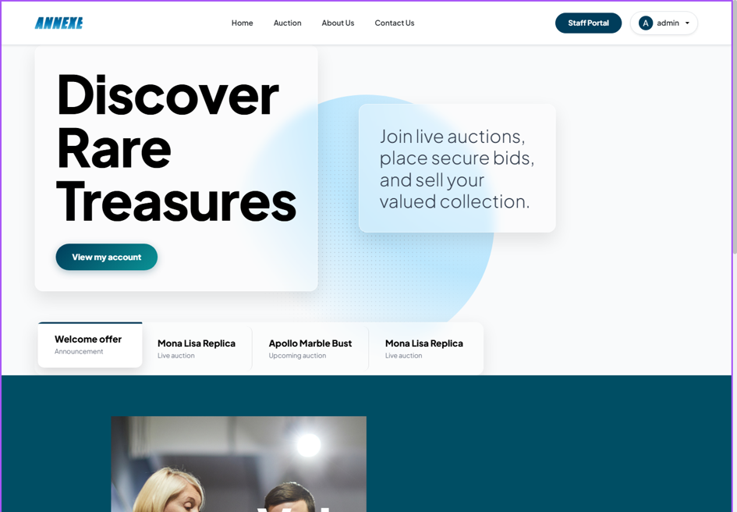

Result
The system successfully processes the request, authenticates the user, generates the JWT Access Token, and redirects the user to the Home dashboard with their authenticated profile loaded.

Real-Time Bidding (WebSocket/STOMP) – Execution Result (UI)

Execution Steps
The user (e.g., bidder1) navigates to the active auction session page (e.g., "Mona Lisa Replica").
The user enters a bid amount higher than the current price (e.g., 200.00) in the bidding input field.
The user clicks the "Place Bid" button.

UI Screenshot
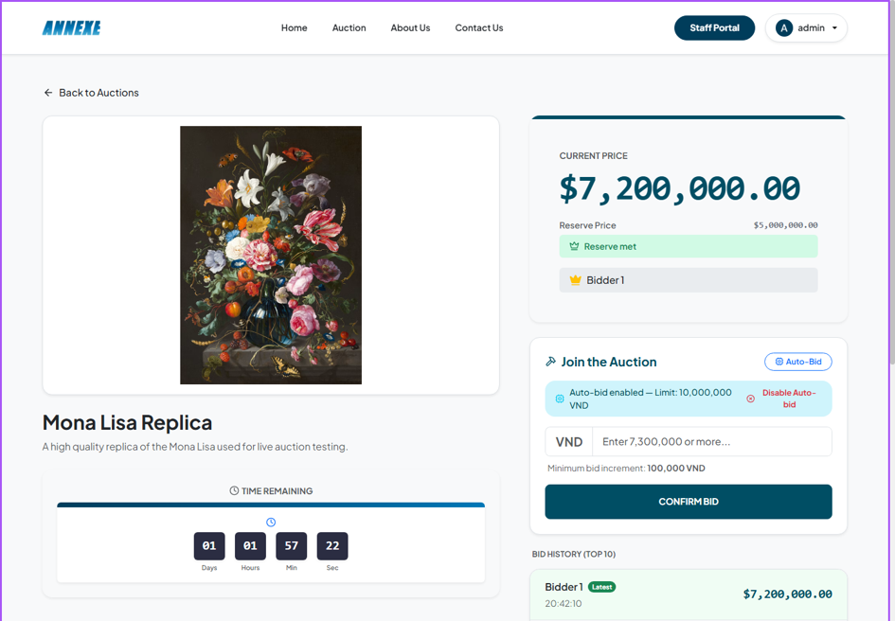

Result
The system successfully processes the request via WebSocket. The bid history instantly updates, and the "Current Highest Bid" dynamically changes for all active users viewing the page without requiring a page refresh.

Auto-Bidding (Proxy Bidding) – Execution Result (UI)

Execution Steps
On the active auction page, the user clicks the "Auto-Bid Settings" button.
The user enables the toggle for Auto-Bid and inputs a maximum bid limit (e.g., 1000.00).
The user clicks "Save Configuration".

UI Screenshot
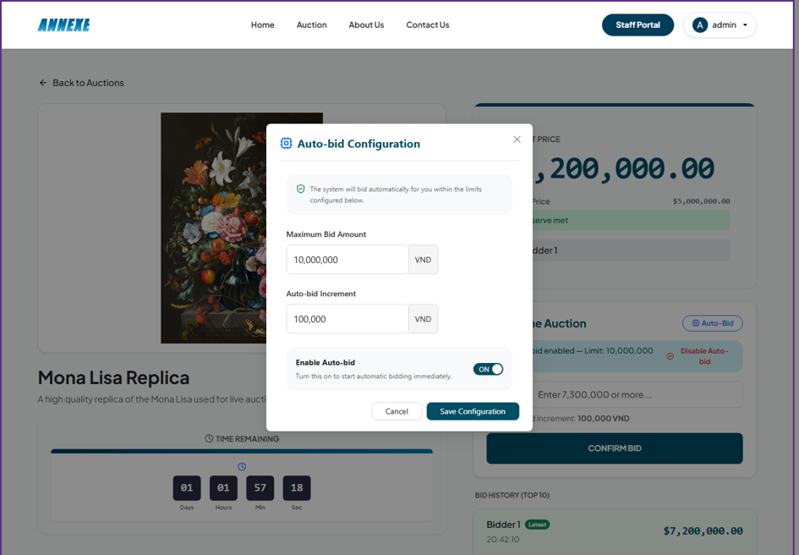

Result
The system successfully processes the request and activates the proxy bidding bot for the user. A confirmation toast message appears, and the system will now automatically counter-bid on the user's behalf up to the specified limit.

VNPay Payment Integration – Execution Result (UI)

Execution Steps
The user navigates to their "Won Auctions" or "Cart" page and selects an unpaid invoice.
The user clicks the "Pay with VNPay" button.
The browser redirects the user to the secure VNPay sandbox gateway, where they enter their test bank card details and confirm the payment.

UI Screenshot
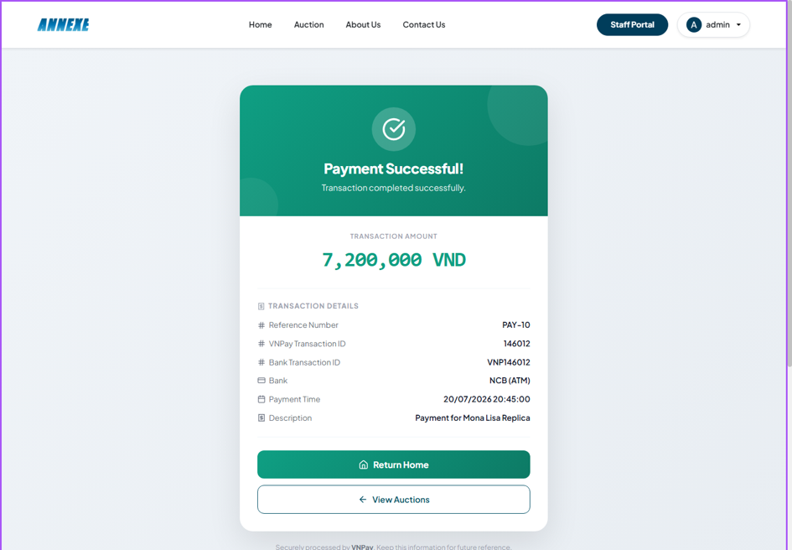

Result
The system successfully processes the request. After completing the payment, VNPay redirects the user back to the application, and the invoice status is automatically updated to "Paid" via the asynchronous IPN webhook.

Dispute Management – Execution Result (UI)

Execution Steps
A buyer (e.g., bidder1) navigates to their "Won Auctions" or "Order Details" page and clicks "Raise Dispute".
The user selects a dispute reason (e.g., "Item Mismatch") and enters a detailed description of the issue.
The user clicks "Submit Dispute". Later, an Admin (e.g., admin@auction.com) reviews and resolves the dispute.

UI Screenshot
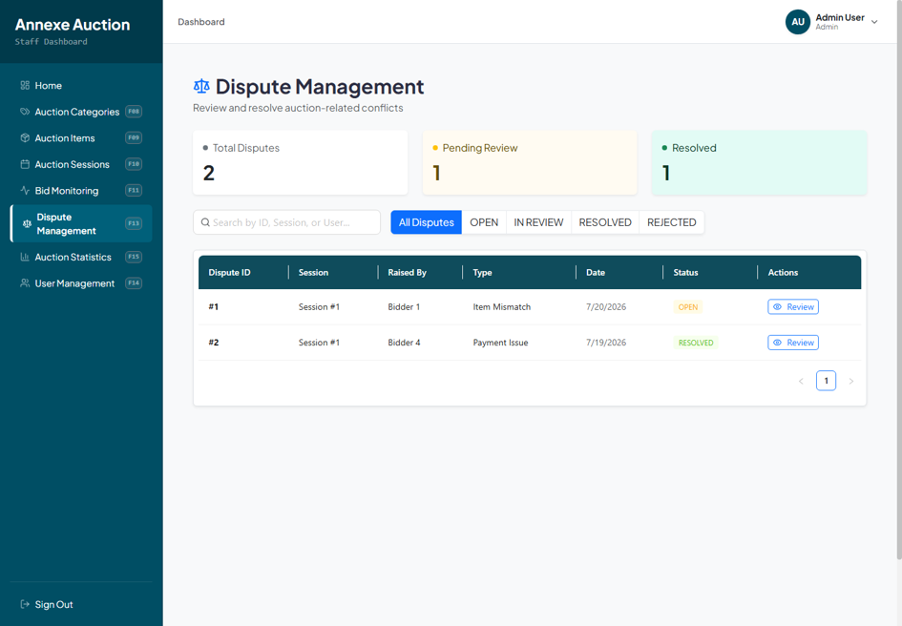

Result
The system successfully processes the request. The dispute status is updated to "OPEN", halting any pending payout to the seller. Once the admin resolves it, the status changes to "RESOLVED" and a resolution note is attached.

Auction Item Management – Execution Result (UI)

Execution Steps
A seller (e.g., seller@auction.com) navigates to the "Create Item" page.
The seller fills out the item details: name (e.g., "Mona Lisa Replica"), category, description, and starting price, then clicks "Submit for Approval".
An Admin logs in, navigates to the "Item Approvals" dashboard, reviews the item, and clicks "Approve".

UI Screenshot
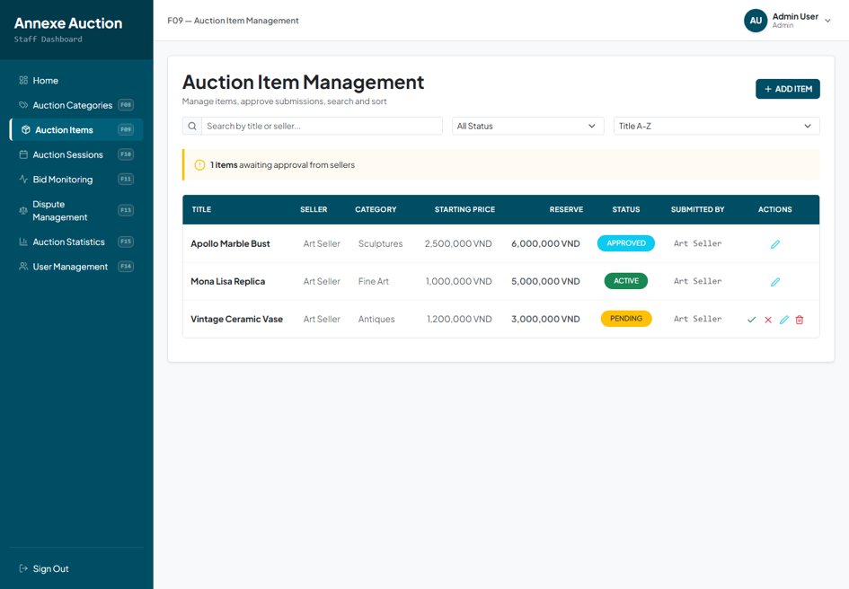

Result
The system successfully processes the request. The item status transitions from "PENDING" to "APPROVED". The item is now available for the Admin to schedule an active Auction Session.

Auction Session Scheduling – Execution Result (UI)

Execution Steps
The Admin navigates to the "Session Management" dashboard and clicks "Create Session".
The Admin selects an approved item, sets the start time, end time, and minimum bid increment, then clicks "Create Session".
Users browse the Homepage and see the newly created session listed under "Upcoming" or "Active" auctions.

UI Screenshot
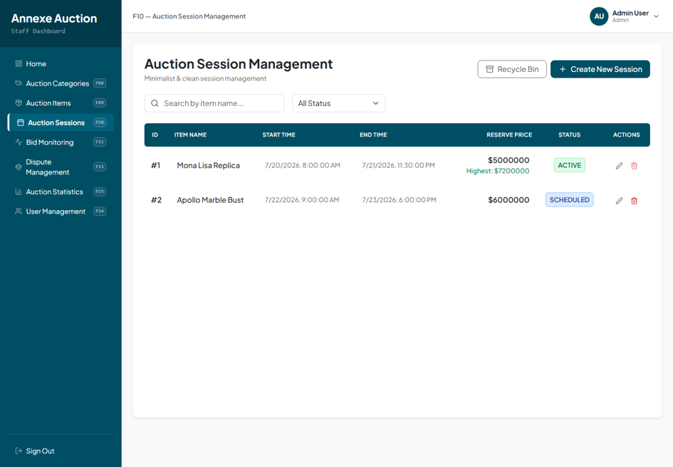

Result
The system successfully processes the request. A new auction session is scheduled and automatically changes its status to "ACTIVE" when the start time is reached, allowing users to start placing bids.

User Profile Management – Execution Result (UI)

Execution Steps
A user navigates to their "My Profile" page from the navigation bar.
The user updates their personal information (e.g., First Name, Last Name, Phone Number) and clicks "Save Changes".
Alternatively, an Admin navigates to the "User Management" dashboard to view and manage user roles (e.g., block/unblock users).

UI Screenshot
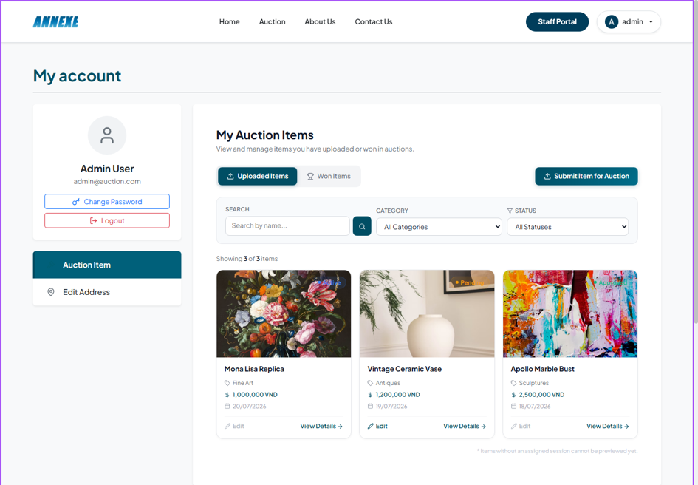

Result
The system successfully processes the request. The user's updated details are immediately reflected across the platform, and admin role adjustments take effect on the targeted user's next login.

Illustrative Code for Each Important Feature

Real-Time Bidding (WebSocket/STOMP)

Feature Description
The Real-Time Bidding (RTB) feature is the core functional pillar of the auction system. It enables users to participate in live auctions by placing bids and instantly seeing updates from other participants without needing to refresh their web browser. This creates a highly interactive and competitive environment crucial for an auction platform.
How users use it:
When a user navigates to an active auction session page, the application automatically establishes a persistent WebSocket connection to the server.
The user inputs their desired bid amount into the bidding form and clicks the "Place Bid" button.
The bid is instantly transmitted to the server via the WebSocket connection.
If the bid is valid (e.g., higher than the current highest bid and meets the minimum increment rules), the server accepts it and immediately broadcasts the updated bid information to all other users currently viewing the same auction session.
Users' screens update automatically in real-time, displaying the new highest bid and the latest bidder's information.

Frontend Implementation
The frontend is responsible for maintaining a stable, real-time connection with the server and seamlessly updating the user interface as new data arrives. It utilizes the @stomp/stompjs library along with sockjs-client to provide a robust WebSocket implementation with a fallback mechanism (SockJS) in case standard WebSockets are restricted by network proxies or older browsers.
// 1. Establishing the connection and STOMP Client
const connectHeaders = { Authorization: `Bearer ${sessionStorage.getItem('accessToken')}` };
const client = new Client({
webSocketFactory: () => new SockJS('http://localhost:8080/ws-auction'),
connectHeaders,
reconnectDelay: 5000,
onConnect: () => {
console.log('STOMP Connected to live auction socket');
}
});
client.activate();
// 2. Subscribing to receive real-time broadcasted bids for a specific session
client.subscribe(`/topic/auction/${sessionId}`, (message) => {
const payload = JSON.parse(message.body);
// This callback updates the React state to reflect the new highest bid instantly
onBidReceived(payload);
});
// 3. Publishing a new bid request to the server
const placeBid = (sessionId, userId, bidAmount) => {
client.publish({
destination: `/app/auction/${sessionId}/place-bid`,
body: JSON.stringify({
userId: parseInt(userId),
bidAmount: parseFloat(bidAmount)
})
});
};
Explanation:
Connection Setup: The SockJS instance provides a cross-browser compatible WebSocket-like connection. The connectHeaders securely pass the user's JWT access token to authenticate the socket connection.
Subscribing (client.subscribe): By subscribing to /topic/auction/{sessionId}, the client actively listens for any messages broadcasted by the server specifically for this auction session. When a message arrives, it parses the JSON payload and triggers a UI re-render through the onBidReceived callback.
Publishing (client.publish): When placing a bid, the data is sent directly over the active socket to the /app/auction/... destination, bypassing traditional HTTP requests for lower latency.

Backend Implementation
The backend leverages Spring WebSocket and the Simple Text Oriented Messaging Protocol (STOMP) as a message broker. It is designed to handle high-frequency incoming bid requests concurrently, validate them against the database, and rapidly dispatch the results to all subscribed clients.
@Controller
@RequiredArgsConstructor
public class BidWebSocketController {
private final AuctionSessionService auctionSessionService;
// 1. Receiving the bid from the WebSocket channel
@MessageMapping("/auction/{sessionId}/place-bid")
public void placeBid(
@DestinationVariable Long sessionId,
@Payload PlaceBidRequest request) {
// 2. Delegating to the service layer for business logic validation and database persistence
auctionSessionService.placeBid(sessionId, request);
}
}
// Inside AuctionSessionService (Illustrative logic)
/*
public void placeBid(Long sessionId, PlaceBidRequest request) {
// 3. Validate bid amount against current highest bid and item step price
// ... validation logic ...
// 4. Save the new successful bid to the database
bidRepository.save(newBid);
// 5. Broadcast the successful bid to all subscribers of this specific session
simpMessagingTemplate.convertAndSend(
"/topic/auction/" + sessionId,
new BidResponseDto(newBid)
);
}
Explanation:
@MessageMapping: This annotation maps incoming STOMP messages directed to /auction/{sessionId}/place-bid to the placeBid method, extracting the sessionId from the destination path and deserializing the message body into a PlaceBidRequest object.
Service Layer Processing: The controller delegates the heavy lifting to the AuctionSessionService. The service ensures that the bid is legal (e.g., the auction is active, the bid is high enough, the user has sufficient funds/permissions).
Broadcasting: After successful validation and database persistence, the SimpMessagingTemplate is used to broadcast the updated bid information to the /topic/auction/{sessionId} destination. Every frontend client currently subscribed to this topic will instantly receive this payload.

API Communication
Endpoint:
[WEBSOCKET CONNECTION] ws://localhost:8080/ws-auction
[PUBLISH DESTINATION] /app/auction/{sessionId}/place-bid
[SUBSCRIBE TOPIC] /topic/auction/{sessionId}
Request (Published by Client):
{
"userId": 42,
"bidAmount": 250000.00
}
Response (Broadcasted by Server to all subscribers):
{
"bidId": 1056,
"sessionId": 12,
"bidAmount": 250000.00,
"bidderName": "JohnDoe99",
"bidTime": "2026-07-20T10:15:30Z",
"isWinning": true
}

Expected Result
Upon successful implementation, the user experience becomes highly dynamic. When a user submits a bid:
1. They immediately see their bid reflected on their own screen.
2. Simultaneously, any other user viewing the exact same auction page will see the current price visually update and the bid history log append the new bid without requiring any manual page refresh.
3. If multiple users bid at the exact same moment, the backend processes them sequentially, ensuring database consistency, and broadcasts the distinct updates in real-time, creating a live, competitive auction atmosphere.

Authentication with OTP & JWT

Feature Description
The Authentication system implements a highly secure, two-step verification process utilizing One-Time Passwords (OTP) delivered via email, combined with JSON Web Tokens (JWT) for session management. This feature ensures that users can safely register and log in while minimizing the risk of unauthorized access or account takeover.
How users use it:
To log in or register, the user enters their email address and clicks "Continue".
The system sends a 6-digit OTP to the user's email.
The user enters the OTP into the application.
Upon successful verification, the user is authenticated and securely logged into the system without needing a traditional password.

Frontend Implementation
The frontend is responsible for collecting user input, orchestrating the two-step API flow, and securely managing the authentication tokens returned by the server. It captures the short-lived Access Token and injects it into the Authorization headers of all subsequent API requests.
// 1. Requesting the server to send an OTP to the provided email
const requestOtp = async (email, password) => {
const loginRes = await axios.post('/api/v1/auth/login', { email, password });
return loginRes.data;
};
// 2. Submitting the received OTP to acquire session tokens
const verifyOtpAndLogin = async (email, otpCode) => {
const verifyRes = await axios.post('/api/v1/auth/login/verify-otp', { email, otpCode });
// Extracting the Access Token from the response body
const accessToken = verifyRes.data.result.accessToken;
// Storing the Access Token securely in sessionStorage
// (Refresh Token is handled automatically via HTTP-Only cookies by the browser)
sessionStorage.setItem('accessToken', accessToken);
};
Explanation:
Two-Step Verification: The process is deliberately split into two distinct API calls to ensure the user physically controls the provided email address.
Token Management: Only the Access Token is handled explicitly by JavaScript. It is stored in sessionStorage to be used as a Bearer token in Axios interceptors.

Backend Implementation
The backend verifies the provided email, generates a secure random OTP, and dispatches it via a JavaMailSender service. Upon OTP verification, it issues a JWT Access Token in the response body and a long-lived Refresh Token embedded securely in an HTTP-Only, Secure cookie.
@PostMapping("/login/verify-otp")
public ResponseEntity<ApiResponse<AuthResponse>> verifyLoginOtp(
@Valid @RequestBody OtpVerifyRequest request,
HttpServletResponse response) {
// 1. Validate the OTP against the database/cache and generate tokens
TokenPair tokenPair = authService.verifyOtp(request);
// 2. Attach the Refresh Token to an HTTP-Only Cookie to prevent XSS attacks
cookieService.addRefreshTokenCookie(response, tokenPair.getRefreshToken());
// 3. Construct the response containing the Access Token
AuthResponse authResponse = AuthResponse.builder()
.accessToken(tokenPair.getAccessToken())
.build();
return ResponseEntity.ok(ApiResponse.success(authResponse, "Login successful!"));
}
Explanation:
OTP Verification: The authService validates the OTP payload and generates a new TokenPair containing both an Access Token and a Refresh Token.
HTTP-Only Cookie Strategy: Adding the Refresh Token as an HTTP-Only cookie (cookieService) is a crucial security best practice. It ensures the token is automatically sent with future requests but remains strictly inaccessible to any client-side JavaScript, effectively neutralizing Cross-Site Scripting (XSS) threats.

API Communication
Endpoint:
[POST] /api/v1/auth/login/verify-otp
Request (Published by Client):
{
"email": "user@example.com",
"otpCode": "123456"
}
Response (Broadcasted by Server to all subscribers):
{
"success": true,
"message": "Login successful!",
"result": {
"accessToken": "eyJhbGciOiJIUzI1NiIsInR5c..."
}
}

Expected Result
The user successfully authenticates and gains access to secured platform features. Subsequent HTTP requests made by the frontend will include the Access Token, allowing the backend to uniquely identify and authorize the user's actions until the session expires or they log out.

Auto-Bidding (Proxy Bidding)

Feature Description
The Auto-Bidding feature allows users to set a maximum limit they are willing to pay for an item. Once configured, the system acts as a proxy, automatically placing incremental bids on the user's behalf whenever they are outbid, ensuring they remain the highest bidder up until their predetermined maximum threshold is reached.
How users use it:
The user opens the auto-bid configuration panel on the auction page.
They toggle the feature "ON" and enter their maximum bid limit (e.g., $5,000).
The user can leave the page. If another participant places a bid of $1,000, the system automatically counter-bids $1,100 (based on the step increment) for the auto-bid user.

Frontend Implementation
The frontend provides an intuitive form to configure the maximum limit and toggle the status. Additionally, it subscribes to a specific, private WebSocket channel to alert the user in real-time if their maximum bid limit has been breached by another competitor.
// 1. Saving the Auto-Bid Configuration via standard REST API
const handleSaveAutoBid = async (sessionId, maxAmount) => {
await axios.post(`/api/v1/auction-sessions/${sessionId}/auto-bid`, {
isActive: true,
maxBidAmount: parseFloat(maxAmount)
});
alert('Auto-bidding has been successfully configured!');
};
// 2. Subscribing to a private user-specific socket queue to receive limit alerts
client.subscribe(`/user/queue/auto-bid/limit-reached`, (message) => {
const alertData = JSON.parse(message.body);
alert(`Warning: Your maximum auto-bid limit of $${alertData.maxLimit} for session ${alertData.sessionId} has been outbid!`);
});
Explanation:
Configuration Payload: Sends the isActive boolean and the maxBidAmount to the server to establish the user's proxy bot constraints.
Private Socket Subscription: Unlike the public /topic channel, /user/queue is a targeted message destination provided by Spring WebSocket, ensuring that limit-reached notifications are delivered exclusively to the affected individual user.

Backend Implementation
The backend stores the user's configuration. The core logic executes implicitly inside the primary bidding service. Every time a new bid is registered, the system scans the database for active auto-bidders, computes the required increments, and automatically recurses the bidding logic on their behalf.
// 1. Controller for configuring the Auto-Bid settings
@PostMapping("/{sessionId}/auto-bid")
public ApiResponse<AutoBidConfigResponse> saveAutoBidConfig(
@PathVariable Long sessionId,
@RequestBody AutoBidConfigRequest request) {
Long userId = securityContextService.getCurrentUserId();
// Saves the maximum limit and active status to the database
AutoBidConfigResponse response = autoBidService.saveAutoBidConfig(sessionId, userId, request);
return ApiResponse.<AutoBidConfigResponse>builder()
.result(response)
.build();
}
Explanation:
· Configuration Management: The AutoBidController solely handles CRUD operations for the proxy settings. The actual intelligence is decoupled and operates reactively inside the bidding service.

API Communication
Endpoint:
[POST] /api/v1/auction-sessions/{sessionId}/auto-bid
Request (Published by Client):
{
"isActive": true,
"maxBidAmount": 5000000.0
}
Response (Broadcasted by Server to all subscribers):
{
"success": true,
"result": {
"configId": 10,
"isActive": true,
"maxBidAmount": 5000000.0
}
}

Expected Result
Once configured, the user's bidding becomes completely hands-off. The system reliably maintains their winning position by automatically outbidding competitors step-by-step. If a competitor places a manual bid that exceeds the user's maximum limit, the auto-bidder halts, and the user receives an immediate push notification alerting them of their lost position.

VNPay Payment Integration

Feature Description
The VNPay integration facilitates a secure and seamless checkout experience, allowing users to pay for won auctions or deposit requirements using domestic bank cards or VNPAY-QR. It abstracts the payment processing to a trusted third-party gateway, ensuring financial security and regulatory compliance.
How users use it:
· The user clicks the "Pay Now" button on their invoice or checkout page.
· They are redirected away from the auction site directly to the official VNPay secure payment portal.
· The user completes the transaction using their banking credentials.
· They are automatically redirected back to the auction site, where their order status reflects the successful payment.

Frontend Implementation
The frontend's role is purely navigational. It requests a uniquely generated payment URL from the backend server and redirects the browser window to that destination. It does not handle any sensitive credit card data directly.
const handleCheckout = async (paymentId) => {
try {
// 1. Request the dynamically generated VNPay redirect URL from the backend
const res = await axios.get(`/api/v1/payments/vnpay/create-url/${paymentId}`);
const vnpayUrl = res.data.result.url;
// 2. Redirect the user's browser to the secure VNPay gateway
window.location.href = vnpayUrl;
} catch (error) {
console.error("Failed to initiate payment", error);
alert("Could not connect to payment gateway.");
}
};
Explanation:
· URL Retrieval: The URL returned by the backend contains complex cryptographic signatures required by VNPay. The frontend must fetch this rather than construct it.
· Browser Redirect (window.location.href): Handing over control entirely to the VNPay domain ensures absolute security for the user's financial input.

Backend Implementation
The backend serves two critical roles: URL generation (applying HMAC SHA512 hashing for security) and handling the asynchronous Instant Payment Notification (IPN) webhook. The IPN ensures that even if the user closes their browser prematurely after paying, the server still receives official confirmation from VNPay to update the database.
// 1. Endpoint to construct the secure payment URL
@GetMapping("/create-url/{paymentId}")
public ApiResponse<Map<String, String>> createPaymentUrl(
@PathVariable Long paymentId,
HttpServletRequest request) {
// Generates the URL containing order info, amount, and the vnp_SecureHash
String url = vnPayService.createVNPayUrl(paymentId, request);
return ApiResponse.<Map<String, String>>builder()
.result(Map.of("url", url))
.build();
}
// 2. Asynchronous Webhook Endpoint (IPN) called server-to-server by VNPay
@GetMapping("/ipn")
public ResponseEntity<Map<String, String>> vnpayIpn(
@RequestParam Map<String, String> params) {
// Validates the cryptographic signature from VNPay and updates the database order status (e.g., SUCCESS/FAILED)
Map<String, String> response = vnPayService.processVNPayIpn(params);
return ResponseEntity.ok(response);
}
Explanation:
· Cryptographic Security: createPaymentUrl leverages the vnPayService to serialize the transaction parameters and sign them with a secret key, preventing tampering.
· IPN Webhook (/ipn): This is the most crucial part of the integration. It acts as a server-to-server callback. It guarantees that the database is only marked as "PAID" when VNPay definitively confirms the transaction, eliminating client-side spoofing.

API Communication
Endpoint:
[GET] /api/v1/payments/vnpay/create-url/{paymentId}
Request (Published by Client):
(No body required. Payment ID is passed as a path variable)
Response (Broadcasted by Server to all subscribers):
{
"success": true,
"result": {
"url": "https://sandbox.vnpayment.vn/paymentv2/vpcpay.html?vnp_Amount=15000000&vnp_Command=pay&vnp_CreateDate=..."
}
}

Expected Result
Clicking "Checkout" transports the user to a standardized, highly trusted payment portal. Upon successful verification of their funds, the system automatically transitions their invoice status to "Paid," unlocks post-auction features (like shipping), and registers the financial transaction securely within the application's ledger.

Testing

Postman

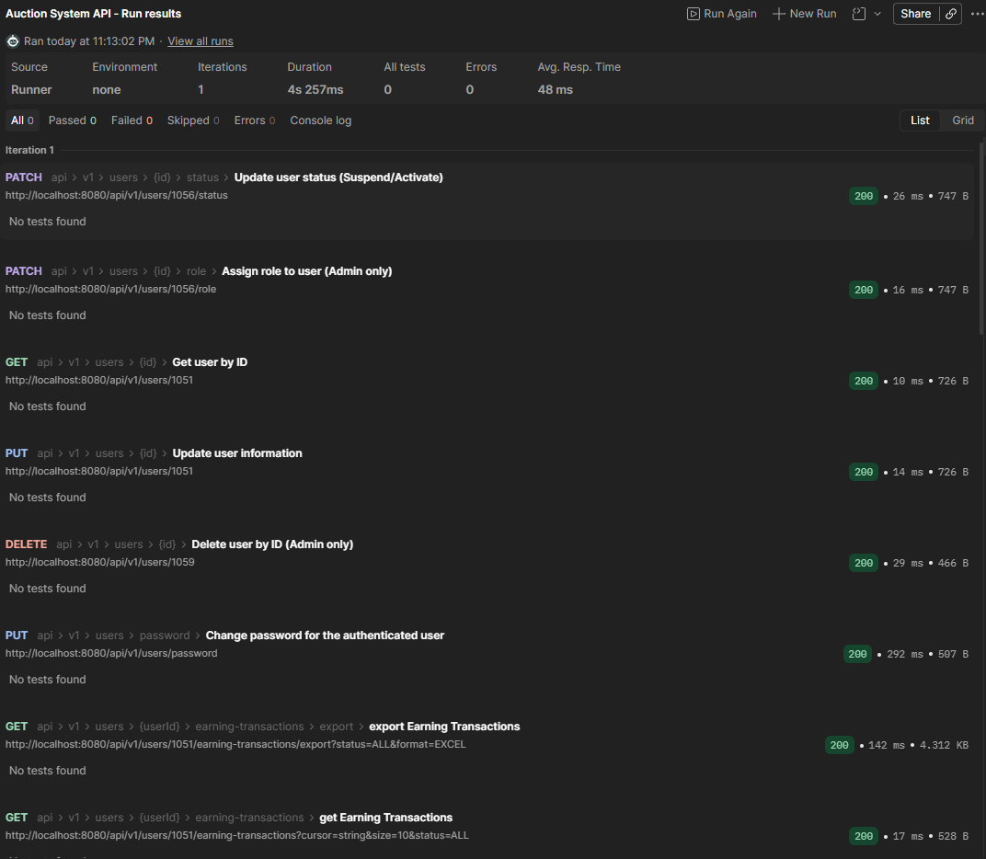

JUnit

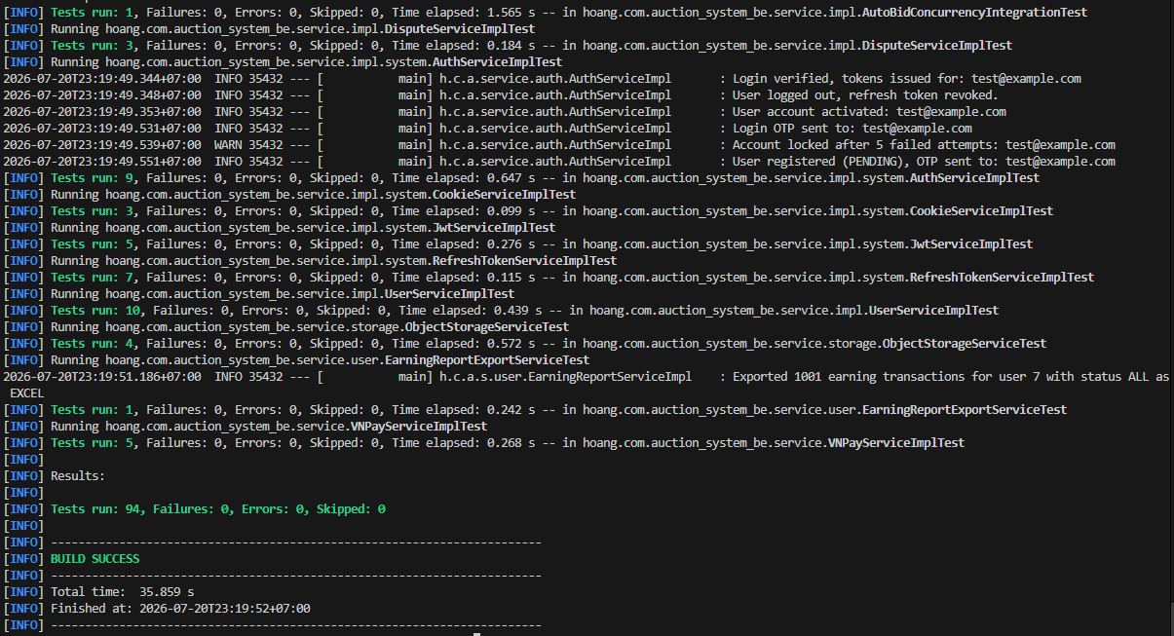

Project Management
Information | Details
Link Jira | https://doanchauviet.atlassian.net/jira/software/projects/SBA3/boards/1
Link GitHub | https://github.com/dagowlol/SBA301_GroupProject

