BUSINESS REQUIREMENTS DOCUMENT
Dashboards for Customer Churn Analysis
E-Commerce Customer Churn — Capstone Project
Business Analytics Programme — Capstone Project
Prepared for: Course Completion Certificate Assessment
Data Source: Simulated dataset modeled on the Kaggle dataset ‘Ecommerce Customer Churn Analysis and Prediction’ (ankitverma2010)

1. Executive Summary
This Business Requirements Document (BRD) defines the business need, scope, stakeholders, and requirements for the “Dashboards for Customer Churn Analysis” capstone project. The project simulates a real e-commerce company's customer base and builds an Excel-based dashboard that identifies which customers are likely to churn, why they churn, and which segments the retention team should prioritize.
The dashboard is built on a simulated dataset of 1,500 customer records structured to match the schema of the public Kaggle dataset “Ecommerce Customer Churn Analysis and Prediction,” as permitted and expected by the capstone brief (“create a suitable simulated dataset”). The workbook applies Excel database design principles, lookup functions, conditional formulas, and pivot-style summary tables to produce a set of interactive charts and KPI cards.
The overall churn rate in the simulated dataset is 14.3%, with churn concentrated among customers who have filed complaints, report low satisfaction scores, have not ordered recently, or fall into Tier 1 metro cities with high competitive alternatives. These findings directly inform the retention workflow mapped in Section 6 (UML Activity Diagram).

2. Business Problem & Objectives

2.1 Business Problem Statement
The e-commerce company is losing customers to churn but currently has no systematic way to identify which customers are at risk, what is driving their disengagement, or which segments deserve retention investment. Marketing and retention spend is therefore allocated reactively rather than proactively, and revenue lost to preventable churn is not being measured.

2.2 Objectives
- Quantify overall and segment-level churn rates across tenure, geography, device, payment mode, order category, and satisfaction.
- Identify the strongest measurable drivers of churn (complaints, satisfaction score, recency of last order, cashback/incentive levels).
- Classify customers into risk segments (High / Medium / Low) using a transparent, auditable rule set.
- Deliver a self-service Excel dashboard that the retention and marketing teams can use without needing a data analyst.
- Establish a repeatable process (mapped as a UML Activity Diagram) connecting data refresh → risk flagging → retention action → outcome logging.

3. Scope

3.1 In Scope
- A simulated e-commerce customer dataset (1,500 records, 20 source attributes) modeled on the Kaggle schema.
- Data cleaning and imputation logic for missing values (Excel formulas).
- Derived analytical fields: Risk Segment, Tenure Bucket, City Tier Label.
- Segment-level churn analysis across 9 dimensions (city tier, order category, payment mode, login device, marital status, satisfaction score, risk segment, tenure bucket, complaint status).
- An interactive Excel dashboard with KPI cards and charts.
- A UML Activity Diagram of the churn-monitoring and retention business process.

3.2 Out of Scope
- Real-time / live data integration with production e-commerce systems.
- Predictive machine learning models (classification/regression) for churn probability scoring — this project uses descriptive/diagnostic analytics and rule-based risk segmentation, not ML.
- Automated email/SMS retention campaign execution (the dashboard informs the decision; execution is manual/operational).
- Financial ROI modeling of retention campaigns beyond directional cost/benefit discussion.

4. Stakeholder Analysis
Stakeholders were identified by mapping every group that (a) supplies data or requirements to the dashboard, (b) consumes its output, or (c) is affected by the retention decisions it drives.
Stakeholder | Interest / Need | Constraint | Influence
CMO / Marketing Head | Reduce churn; run targeted, cost-efficient campaigns | Fixed/limited campaign budget per quarter | High
Customer Success / Retention Team | Prioritize outreach to the customers most likely to churn | Limited headcount — cannot contact every customer manually | High
Finance | Understand revenue at risk from churn; approve retention spend | Requires clear cost-benefit justification, not raw data | Medium
Product / App Team | Improve satisfaction drivers (app experience, complaint resolution) | Development capacity is constrained; changes take release cycles | Medium
IT / Data Team | Maintain a reliable, refreshable data pipeline into the workbook | Data quality and refresh frequency depend on source systems | Medium
Senior Management | Overall visibility into customer retention health | Wants a summary view, not operational detail | High

4.1 Constraints & Trade-offs
- Broad, low-cost retention offers to all at-risk customers vs. targeted, higher-cost, higher-precision outreach to only the highest-risk segment — the Risk Segment formula (Section 7) exists specifically to support the second approach within a limited budget.
- Real-time dashboard refresh (technically possible but costly to maintain) vs. a weekly/batch refresh cycle (cheaper, adequate for a retention motion that already operates on a multi-day cycle).
- Simplicity/transparency of a rule-based Risk Segment (auditable by non-technical stakeholders) vs. the higher predictive accuracy but lower explainability of a machine-learning churn model (explicitly out of scope for this reason, per Section 3.2).
- Data completeness vs. speed: rather than delaying analysis until every missing field is manually corrected, the workbook imputes missing values with column averages (Section 7.2), trading a small amount of precision for a dashboard that stays usable on the day data is refreshed.

5. Business Requirements

5.1 Functional Requirements
ID | Requirement | Priority
FR-1 | The workbook must calculate an overall churn rate and churned-customer count from the customer dataset. | Must have
FR-2 | The dashboard must show churn rate broken down by City Tier, Preferred Order Category, Preferred Payment Mode, Login Device, and Marital Status. | Must have
FR-3 | The workbook must classify every customer into a Risk Segment (High / Medium / Low) using satisfaction score, complaint status, and recency of last order. | Must have
FR-4 | The dashboard must display churn rate by Risk Segment and by Tenure Bucket. | Must have
FR-5 | The workbook must compare average tenure, satisfaction, cashback, order count, and coupon usage between churned and retained customers. | Must have
FR-6 | Missing values in the raw data must be handled automatically via formulas (no manual data entry required to “fix” gaps). | Must have
FR-7 | All dashboard figures must recalculate automatically when the Raw Data sheet is edited (formula-driven, not hardcoded). | Must have
FR-8 | The workbook must flag the count of high-risk customers as a headline KPI. | Should have
FR-9 | The workbook should support filtering/segmenting via Excel Tables for further ad hoc analysis. | Should have

5.2 Non-Functional Requirements
ID | Requirement | Category
NFR-1 | The workbook must open and recalculate in standard Excel (2016+) without errors. | Compatibility
NFR-2 | Formulas must use widely-supported Excel functions (COUNTIFS, AVERAGEIFS, INDEX/MATCH, nested IF) so the file works across Excel versions. | Compatibility
NFR-3 | All source data, lookup tables, and formulas must be visible and editable — no hidden/locked logic — so students and instructors can audit the work. | Transparency
NFR-4 | The dashboard must be understandable by a non-technical retention manager within 2–3 minutes of opening it. | Usability
NFR-5 | Customer-level data contains no real personal information (fully simulated), avoiding any data privacy exposure. | Privacy

6. Business Process Mapping
The current-state process is informal: churn is only noticed anecdotally (e.g. a customer complains or stops ordering) and retention action, if any, happens ad hoc. The proposed process below formalizes churn monitoring into a repeatable cycle across three swimlanes — the Data Team, the Dashboard System, and the Retention Team — so that risk flagging and retention outreach happen on a predictable schedule with logged outcomes.

6.1 UML Activity Diagram — Proposed Process
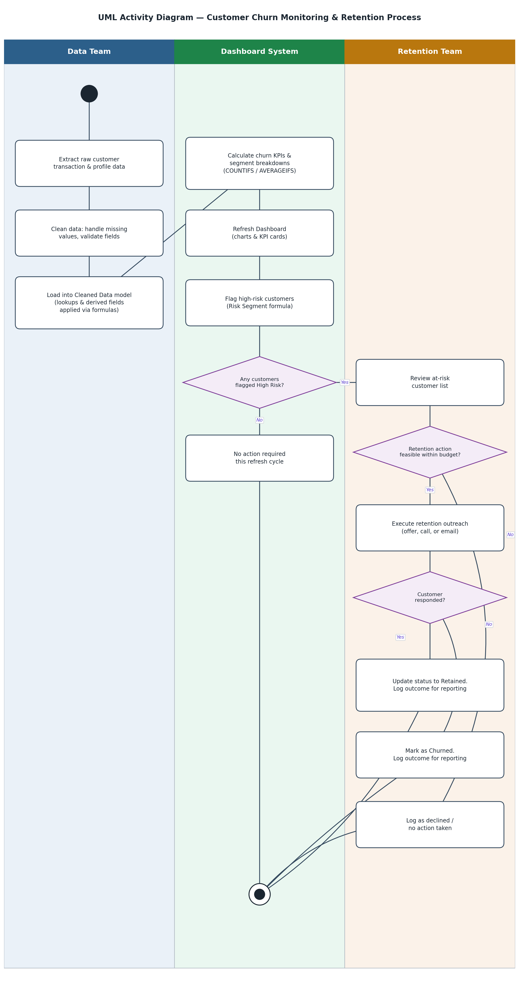

6.2 Process Narrative
- Data Team: extracts the raw customer data, cleans and validates it, and loads it into the Cleaned Data model where lookup and derived-field formulas run automatically.
- Dashboard System: recalculates churn KPIs and segment breakdowns, refreshes the dashboard's charts and KPI cards, and flags high-risk customers using the Risk Segment rule.
- Decision point: if no customers are newly flagged high-risk, no action is required until the next refresh cycle.
- Retention Team: reviews the at-risk list, checks whether a retention offer is feasible within budget, executes outreach where feasible, and logs the outcome (retained, churned, or declined/no action) for reporting back into the next cycle.

7. Data Requirements & Measurable Variables

7.1 Data Source
Data Requirement: a customer-level extract with demographic, engagement, and transaction attributes, refreshed on a recurring (e.g. weekly) cycle from the e-commerce platform's CRM/order systems. For this capstone, a simulated dataset (1,500 rows, 20 columns) was generated to match the field structure of the Kaggle dataset ‘Ecommerce Customer Churn Analysis and Prediction,’ with realistic distributions and an injected 3% missing-value rate per numeric field to mimic real extract quality.

7.2 Data Dictionary
Field | Type | Description / Role in Analysis
CustomerID | Identifier | Unique customer reference number.
Churn | Target (0/1) | 1 = customer churned, 0 = retained. The dependent variable for all analysis.
Tenure | Numeric (months) | How long the customer has been active. Strong inverse relationship with churn.
PreferredLoginDevice | Categorical | Mobile Phone / Computer / Phone — used for device-based segmentation.
CityTier | Categorical (1–3) | Tier 1 = metro, 2 = urban, 3 = semi-urban/rural. Proxy for market competitiveness.
WarehouseToHome | Numeric (km) | Delivery distance; imputed where missing using the column average.
PreferredPaymentMode | Categorical | Debit Card / Credit Card / E wallet / UPI / Cash on Delivery.
Gender | Categorical | Male / Female.
HourSpendOnApp | Numeric (hrs) | Engagement proxy; imputed where missing.
NumberOfDeviceRegistered | Numeric | Devices linked to the account.
PreferedOrderCat | Categorical | Primary category purchased — used for category-level churn analysis.
SatisfactionScore | Numeric (1–5) | Self-reported satisfaction; a core Risk Segment input.
MaritalStatus | Categorical | Single / Married / Divorced.
NumberOfAddress | Numeric | Number of saved addresses.
Complain | Binary (0/1) | Whether the customer filed a complaint; a core Risk Segment input.
OrderAmountHikeFromlastYear | Numeric (%) | Year-on-year order value change; imputed where missing.
CouponUsed | Numeric | Coupons redeemed; imputed where missing.
OrderCount | Numeric | Total orders placed.
DaySinceLastOrder | Numeric (days) | Recency; a core Risk Segment input. Imputed where missing.
CashbackAmount | Numeric (currency) | Cashback earned — proxy for value received from the platform.

7.3 Derived / Measurable Variables
- City Tier Label — INDEX/MATCH lookup translating the numeric CityTier into a readable label.
- Tenure Bucket — nested-IF classification into 0–6, 7–12, 13–24, and 25+ month bands.
- Risk Segment — nested-IF rule: High Risk = Complaint filed AND Satisfaction ≤ 2; Medium Risk = Satisfaction = 3 OR Days Since Last Order > 15; Low Risk = all others.
- Churn Rate by segment — COUNTIFS(churned, segment) / COUNTIFS(segment), computed for every breakdown table.

8. Success Metrics
Metric | Definition / Target
Dashboard adoption | Retention team references the dashboard at the start of every outreach cycle (qualitative check during viva/demo).
Segment visibility | Churn rate is visible for all 9 required segment breakdowns without manual pivoting.
High-risk identification | 100% of customers are assigned a Risk Segment with no formula errors (validated via recalculation).
Data integrity | Dashboard KPI totals reconcile exactly with Raw Data row counts and SUM(Churn) after any data refresh.
Turnaround time (simulated) | From data refresh to updated dashboard: same working day, given the workbook is formula-driven rather than manually rebuilt.

9. Assumptions, Constraints & Risks

9.1 Assumptions
- The simulated dataset's distributions (churn rate, satisfaction, tenure, etc.) are representative enough of a real e-commerce customer base to demonstrate the analytical approach; a production rollout would validate thresholds (e.g. the 15-day recency cutoff in the Risk Segment rule) against real churn outcomes.
- Retention budget and headcount are limited, which is why the process (Section 6) includes a budget-feasibility decision point rather than assuming unlimited outreach capacity.
- Data refresh cadence is weekly/batch, not real-time.

9.2 Constraints
- Deliverable must be built and demonstrated in Microsoft Excel using formulas taught in the programme (lookup functions, conditional aggregation) — no external BI tool or ML library.
- Capstone submission deadline and single in-person viva date leave no room for iterative stakeholder sign-off cycles that a real BRD would normally go through.

9.3 Risks
- Risk: Imputing missing values with column averages can understate variance for customers with genuinely unusual (not just missing) values. Mitigation: imputation is formula-based and clearly documented, so it can be swapped for a different rule without rebuilding the workbook.
- Risk: A static rule-based Risk Segment may misclassify customers relative to a trained predictive model. Mitigation: thresholds are stored transparently in the Lookup Tables sheet so they can be tuned as real outcome data accumulates.
- Risk: Stakeholders may expect real-time dashboards once they see the concept working. Mitigation: refresh cadence and its cost trade-off are documented explicitly in Section 4.1.

