Howard University
College of Engineering and Architecture
Department of Electrical Engineering & Computer Science

Large Scale Programming
Fall 2024

Midterm Exam – Part I
October 17, 2024

Part I: 50 pts. (essay questions)

Instructions:
- Submit completed exam to your github repository under package org.howard.edu.lsp.midterm

Verify that the commit(s) completed successfully

- OPEN BOOK, OPEN NOTES. THERE IS NO COLLABORATION ON THIS EXAM
- Site any and ALL references for anything obtained off the internet.

Question 1. (10 pts.)

You are reviewing the following class in a Fitness Tracking System. The class is intended to manage various aspects of a user’s fitness activities.

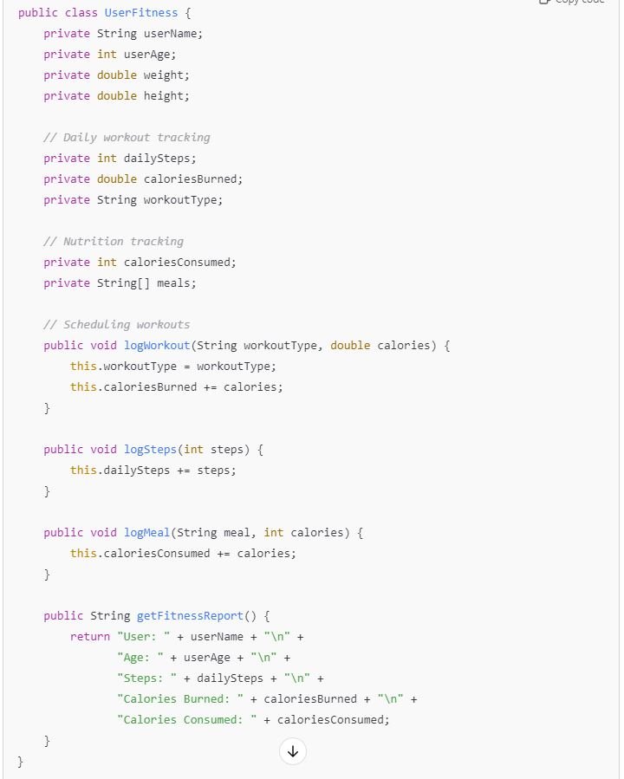

Tasks:
- Analyze the UserFitness class. Explain why this class has low cohesion. (5 pts.)
The UserFitness class has low cohesion since it handles multiple distinct responsibilities - tracking workouts, managing nutrition data, and storing user details. Good software design principles suggest that a class should have a single, focused purpose. Instead of bundling these separate concerns together, the class would be more maintainable and better structured if its functionality was divided into specialized classes that each handle one specific aspect of fitness tracking.

- Describe, in general, how you would split the UserFitness class into more cohesive classes. Your answer should not be a complete design. (5 pts.)
To enhance cohesion, I would break down this class into several more specialized components. A UserProfile class could handle all personal information, while a dedicated WorkoutTracker class could manage exercise-related functionality. Similarly, a separate NutritionTracker class could focus solely on dietary monitoring and calorie tracking. This restructuring aligns with the Single Responsibility Principle, where each class has one clear purpose, resulting in a more maintainable and well-organized system architecture.

Question 2. (5 pts.)
Given the following, answer the below questions.

A university manages its students using a program that has a class Student with subclasses FirstYear, SecondYear, and ThirdYear for year-specific state and behaviors. The program has a List that contains all Students.

Should Student be a class, an abstract class or an interface? Explain your answer.

Student should be an abstract class because it can provide shared implementation for common student attributes and behaviors, while forcing year-specific subclasses to implement unique methods. Unlike an interface, it prevents code duplication across subclasses, and unlike a concrete class, it prevents instantiation of a generic "Student" - every student must be a specific year. This design supports polymorphism while storing all students in a single List.

- At the end of each year, the third-year students graduate and must be removed. This is done by passing the list to the following method:

void removeThirdYears(List<Students> students) {
for (Student student : students) {
try {
ThirdYear = (ThirdYear) student;
students.remove(thirdyear);
}
}
}

Why is the above method flawed? Hint: Another Arthur Riel heuristic (5 pts.)

The method is flawed because it modifies the list while iterating through it (concurrent modification), which can cause elements to be skipped or lead to unpredictable behavior.
Additionally, the type casting approach is poor design - it violates the “tell, don't ask" principle by checking object types explicitly. A better approach would use polymorphism or implement a method in the Student class to identify year level.

Question 3. (5 pts.)
Given the following, answer the below questions.

public class BankAccount {
public String accountHolderName;
public String accountNumber;
public double balance;
public double interestRate;

public BankAccount(
String accountHolderName,
String accountNumber,
double initialDeposit,
double interestRate) {
this.accountHolderName = accountHolderName;
this.accountNumber = accountNumber;
this.balance = initialDeposit;
this.interestRate = interestRate;
}

// Exposed implementation for adding interest
public void addInterest() {
double interest = balance * (interestRate / 100);
balance += interest;
}

// Exposed implementation for deposits
public void deposit(double amount) {
balance += amount;
}

// Exposed implementation for withdrawals
public void withdraw(double amount) {
balance -= amount;
}
}

- Is BankAccount well-encapsulated? Why or why not? If so, describe what changes you would make to the class. Otherwise, state nothing. (5 pts.)

The BankAccount class is not well-encapsulated because all attributes are public and directly accessible from outside the class. This violates data hiding principles and allows external code to modify sensitive account data without validation or control.
To improve encapsulation, I would make all attributes private, add input validation in methods, provide getters for read-only access where needed, and add overdraft checks for withdrawals.

Question 4. (10 pts.)
Given the following, answer the below questions.

Given:
A car manufacturer uses Java software to track current vehicles being built. The UML diagram below shows an excerpt of the current software structure. You should assume the presence of other appropriate fields and methods

Car
getTrimLevel()
Engine
accelerate()
getFuelLevel()
Base
Sports
Luxury
Electric
Petrol

Each car can be built to one of three trim levels: Base, Luxury or Sport. They can also be configured with an electric or petrol engine. At various points in the manufacturing process the customer can choose to change the trim level.

Task:
- Explain in detail why the current structure does not support this. (5 pts.)
The current design represents car trim levels through inheritance, where Base, Sports, and Luxury are subclasses of Car. This creates inflexibility since an object's type cannot change after creation: a Base model car cannot be converted to Sports or Luxury without recreating the entire object. This rigid structure violates the Open/Closed Principle and makes it difficult to modify trim levels during manufacturing, suggesting a need for a more flexible design pattern that would allow dynamic trim level changes.

- Describe how to refactor the structure to allow trim-level change for a car to dynamically change. Hint: How would you modify Car to use composition to solve the problem? (5 pts.)
A better approach would use composition instead of inheritance by creating a separate TrimLevel interface. The Car class would contain a reference to a TrimLevel object, which could be implemented as BaseTrim, SportsTrim, or LuxuryTrim. This allows trim levels to be changed dynamically during manufacturing by simply updating the car's trim level reference, rather than recreating the entire object. This design is more flexible and maintainable, adhering to the Open/Closed Principle while supporting runtime modifications.

Question 5. (5 pts.)
Suppose you are about to code a particular class and find that you have written another class with nearly the functionality that you now are developing. This means that the two classes in large parts contain the same code, but in smaller parts have different code. Explain in detail why this may be a problem and how to solve it. Give your answer in terms of Arthur Riel’s design heuristics.

Having nearly identical classes with small variations violates Riel's "duplicate code" heuristic and creates maintenance problems. When code exists in multiple places, changes must be made in multiple places, increasing the risk of inconsistencies and bugs.
The solution is to use inheritance. Create a parent class containing the shared functionality, then create child classes that inherit this common code and implement only their unique behaviors. This follows Riel's heuristic of "pushing common code up the inheritance hierarchy" and ensures changes to shared code only need to be made once.

Question 6. (5 pts.)
Suppose we need to store instances of the classes Car and BankAccount in a database. To obtain low coupling it may seem as if the functionality to save an instance should be in precisely those classes, since they have the information that shall be saved. Why is it unwise to place the database calls there?

Placing database calls directly in Car and BankAccount classes violates the Single Responsibility Principle: these classes should focus on their core business logic, not data persistence. This creates tight coupling between business objects and the database implementation, making it difficult to change database technology or add different storage methods.

Question 7. (5 pts.)
Given a set of requirements, what conditions must be met to make it appropriate to create a new class hierarchy using inheritance? Neither superclass nor subclass exist before, the question is about designing a new class hierarchy.

A new class hierarchy using inheritance is appropriate when the following conditions are satisfied:
- Multiple classes share significant common attributes and behaviors that can be meaningfully abstracted into a parent class (satisfying "is-a" relationship).
- The potential subclasses represent specializations of the parent concept, with some unique attributes or behaviors beyond the common ones.
- The inheritance relationship would remain stable over time (subclasses will always be types of the parent class).

Question 8. (2.5 pts.)
Describe the difference between inheritance and composition why would you choose one over the other.

Inheritance and composition are two methods for code reuse in object-oriented programming. Inheritance creates an "is-a" relationship, allowing subclasses to inherit from parent classes, useful for shared behavior and polymorphism. Composition establishes a "has-a" relationship, building classes by including other objects as members, offering more flexibility and looser coupling. The choice between them depends on design needs: inheritance for clear hierarchies, composition for complex object construction and modularity. While "favoring composition over inheritance" is a common principle due to its flexibility, both have their place in good design. The best approach often combines inheritance and composition based on specific system requirements.

Question 9. (2.5 pts.)
Explain the meaning of cohesion and describe whether low or high cohesion is better.

Cohesion refers to the degree to which elements within a module or class work together to perform a single, well-defined purpose. High cohesion is generally considered better in software design. It means that a module or class has a clear, focused responsibility and its components are strongly related. High cohesion leads to more maintainable, reusable, and understandable code. It reduces complexity, improves modularity, and makes the system easier to modify and debug. Low cohesion, on the other hand, indicates that a module or class is trying to do too many unrelated things, which can lead to code that is harder to understand, maintain, and reuse.

