Pre-electoral coalitions in parliamentary democracies: a new dataset

Abstract

Keywords

# Introduction

# Defining and measuring pre-electoral coalitions

# Illustration of the data

## Comparison to existing datasets

Our data extend the coverage and increase the granularity of prior collection efforts. First, Sona Golder’s (2006, 15) seminal study covered 364 legislative elections in 23 parliamentary democracies. For the period from 1946 to 2002 Golder coded 240 pre-electoral coalitions. A related study on voter turnout in parliamentary elections between 1970 and 2011 modifies Golder’s data to include information on 223 legislative elections in 19 democracies (Tillman 2015). In extension of these pioneering efforts, our data cover 562 parliamentary elections across 35 EU and OECD democracies. For the period from 1945 to 2015, it identifies 493 pre-electoral coalitions. Second, for each pre-electoral coalition, our data reports information on its type, the existence of a joint program, and incumbency status.[1] It was already possible to study the formation of pre-electoral coalitions at the party-dyad level (Golder 2006b). However, using our data scholars will be able to pose new questions such as when do incumbent government (not) form pre-electoral coalitions or why pre-electoral coalitions put forward joint programs and to what effect?

Table 1 about here

As Table 1 shows, countries differ markedly on their experience with pre-electoral coalitions. countries differ markedly on their experience with pre-electoral coalitions. In some instances, e.g., Australia, Germany, and France, the number of PECs outranks the number of elections held since 1945. Pre-Electoral coalitions competed in all post-1945 German and Australian parliamentary elections and on average they accounted for 48 to 64 percent of the vote. In contrast, pre-electoral coalitions never formed in Canada, Malta, and Switzerland. Pre-electoral coalitions in Central and Eastern Europe which our data cover for the first time rank anywhere in between these extremes. For example, PECs formed in 80 percent of all Bulgarian elections and accounted for 54 percent of the popular vote on average whereas these figures drop to 38 and 10 percent in the Czech Republic. Moreover, our data show considerable variation in both, the probability to which incumbent governments form pre-electoral coalitions and the likelihood of joint programs. On these accounts, the Spanish experience contrasts markedly with the Danish case. In both countries, pre-electoral coalitions competed in about 80 percent of all legislative elections. Remarkably, Spanish governments never formed PECs, but 92 percent of all Spanish PECs agreed on a shared platform. In contrast, about one-third of Danish governments formed a pre-electoral coalition, but PECs almost never compete on the same platform.

Table 1: Descriptive data about pre-electoral coalitions (PECs) by country

| Country | First | Last | # Elections | # PECs | % Elections w/i PECs | PEC ave. vote share | Modal PEC typeb | # Incumbent PECs | # Joint programs | |
| --- | --- | --- | --- | --- | --- | --- | --- | --- | --- | --- |
| Australia | 1946 | 2013 | 27 | 49 | 1.00 | 0.48 | 1 | 16 | 0 | |
| Germany | 1949 | 2013 | 18 | 36 | 1.00 | 0.64 | 1 | 13 | 19 | |
| Francea | 1945 | 2012 | 19 | 35 | 0.68 | 0.55 | - | 0 | 0 | |
| Denmark | 1945 | 2015 | 27 | 32 | 0.81 | 0.43 | 5 | 8 | 2 | |
| Bulgaria | 1991 | 2014 | 8 | 25 | 0.88 | 0.54 | 2 | 4 | 18 | |
| Israel | 1949 | 2015 | 20 | 21 | 0.65 | 0.21 | 2 | 0 | 9 | |
| Belgium | 1946 | 2014 | 22 | 20 | 0.59 | 0.09 | 6 | 1 | 5 | |
| Latvia | 1990 | 2014 | 9 | 20 | 0.78 | 0.30 | 2 | 3 | 18 | |
| Italy | 1946 | 2013 | 18 | 19 | 0.44 | 0.32 | 5 | 2 | 13 | |
| Portugal | 1975 | 2015 | 15 | 18 | 0.80 | 0.21 | 2 | 1 | 9 | |
| Estonia | 1992 | 2015 | 7 | 16 | 0.43 | 0.27 | 2 | 0 | 11 | |
| Norway | 1945 | 2013 | 18 | 16 | 0.67 | 0.32 | 5 | 5 | 5 | |
| Poland | 1989 | 2015 | 9 | 16 | 0.78 | 0.32 | 2 | 1 | 9 | |
| Sweden | 1948 | 2014 | 21 | 15 | 0.62 | 0.27 | 5 | 4 | 8 | |
| Romania | 1990 | 2012 | 7 | 13 | 0.86 | 0.41 | 2 | 3 | 12 | |
| Spain | 1977 | 2015 | 12 | 13 | 0.83 | 0.15 | 2 | 0 | 12 | |
| Croatia | 2000 | 2015 | 5 | 12 | 0.80 | 0.35 | 2 | 2 | 5 | |
| United Kingdom | 1945 | 2015 | 19 | 11 | 0.58 | 0.19 | 1 | 3 | 9 | |
| Hungary | 1990 | 2014 | 7 | 10 | 0.71 | 0.38 | 2 | 3 | 4 | |
| Lithuania | 1990 | 2012 | 7 | 10 | 0.57 | 0.21 | 2 | 1 | 3 | |
| Austria | 1945 | 2013 | 21 | 9 | 0.43 | 0.31 | 5 | 7 | 1 | |
| Greecea | 1974 | 2015 | 17 | 9 | 0.41 | 0.12 | - | 0 | 0 | |
| Iceland | 1946 | 2013 | 21 | 9 | 0.33 | 0.10 | 2 | 1 | 7 | |
| Japan | 1946 | 2014 | 26 | 9 | 0.27 | 0.14 | 1 | 4 | 0 | |
| Netherlands | 1946 | 2012 | 21 | 9 | 0.33 | 0.16 | 5 | 3 | 6 | |
| Ireland | 1948 | 2011 | 19 | 8 | 0.37 | 0.18 | 5 | 5 | 3 | |
| New Zealand | 1946 | 2014 | 24 | 8 | 0.25 | 0.08 | 2 | 1 | 3 | |
| Slovenia | 1990 | 2014 | 8 | 7 | 0.63 | 0.28 | 2 | 1 | 1 | |
| Slovakia | 1990 | 2012 | 8 | 6 | 0.38 | 0.09 | 2 | 1 | 3 | |
| Finland | 1945 | 2015 | 20 | 5 | 0.20 | 0.06 | 2 | 1 | 1 | |
| Czech Republic | 1990 | 2013 | 8 | 4 | 0.38 | 0.10 | 2 | 0 | 1 | |
| Luxembourg | 1945 | 2013 | 16 | 3 | 0.19 | 0.05 | - | 1 | 0 | |
| Canada | 1945 | 2015 | 23 | 0 |  |  |  |  |  | |
| Malta | 1947 | 2013 | 17 | 0 |  |  |  |  |  | |
| Switzerland | 1947 | 2015 | 18 | 0 |  |  |  |  |  | |
| Notes: a Type information unavailable; b Codes: 1 Nomination agreement2, Joint list, 3 Dual-ballot instructions, 4 Vote transfer instructions, 5 Public commitment, 6 individual | | | | | | | | | |

Table 2: Summary of PEC Properties

|  |  |  |  |  |  |  |
| --- | --- | --- | --- | --- | --- | --- |
|  |  | Frequency | |  |  |  |
|  |  | Abs. | Rel. | DM | Disprop.a | Partiesb |
| Type | Nomination Agreement | 72 | 0.17 | 1.00 | 8.66 | 3.36 |
|  | Joint List | 204 | 0.47 | 9.76 | 5.29 | 4.54 |
|  | Dual-Ballot Instructionsc | 1 | 0.00 | 9.20 | 4.61 | 6.05 |
|  | Vote Transfer Instructions | 24 | 0.06 | 1.00 | 8.45 | 2.80 |
|  | Public Commitment | 119 | 0.27 | 12.50 | 2.62 | 4.52 |
|  | Other | 16 | 0.04 | 7.07 | 2.79 | 7.48 |
| Joint | No | 233 | 0.54 | 10.00 | 4.71 | 4.43 |
| program? | Yes | 197 | 0.46 | 8.90 | 4.32 | 3.63 |
| Incumbent | No | 337 | 0.77 | 9.65 | 4.51 | 4.03 |
| coalition? | Yes | 99 | 0.23 | 10.00 | 4.71 | 4.36 |
| Notes: a Gallagher Index; b Median eff. number of electoral parties; c Romania 1996. | | | | | | |

Figure 1 Annual frequency of PECs by property

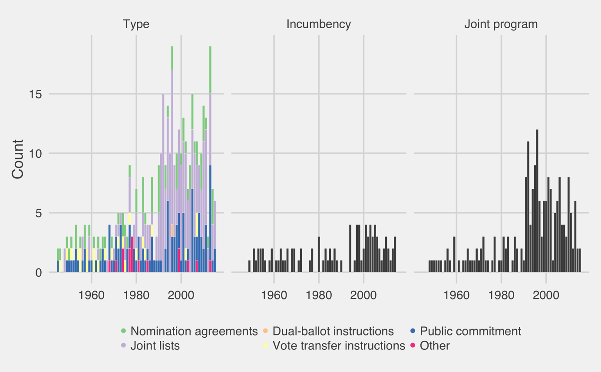

# Conclusion and implications

1. We code pre-electoral coalitions as incumbent if all members of the coalition enjoyed cabinet rank in the government immediately preceding the elections.