Replication Results

Dag Tanneberg

1 April 2019

## Introduction

Tillman argues that pre-electoral coalition increase the identifiability of possible governments and thereby augment electoral decisiveness. In effect, turnout should increase whenever pre-electoral coalitions form. To support his claim, Tillman reports fixed-effects panel regressions which predict turnout from various specifications of the existence and strength of pre-electoral coalitions. In the following, I reanalyze his contribution from several angles. In doing so, I concentrate on Tillman’s primary predictors: the presence of a pre-electoral coalition and the voting percentage a pre-electoral coalition achieved. My brief assessment exposes major flaws in Tillman’s modeling strategy.

## Can the data support any causal effect at all?

Generally speaking, fixed-effects panel regression models estimate the causal effect of some treatment by comparing the outcome on the same observation unit at different points in time. Consequently, a certain amount of (co-)variation within the units is required to estimate any causal effect. The figure below shows how within-differences in turnout and PECs align for every country in the data, and it gives reason to doubt Tillman’s analysis.

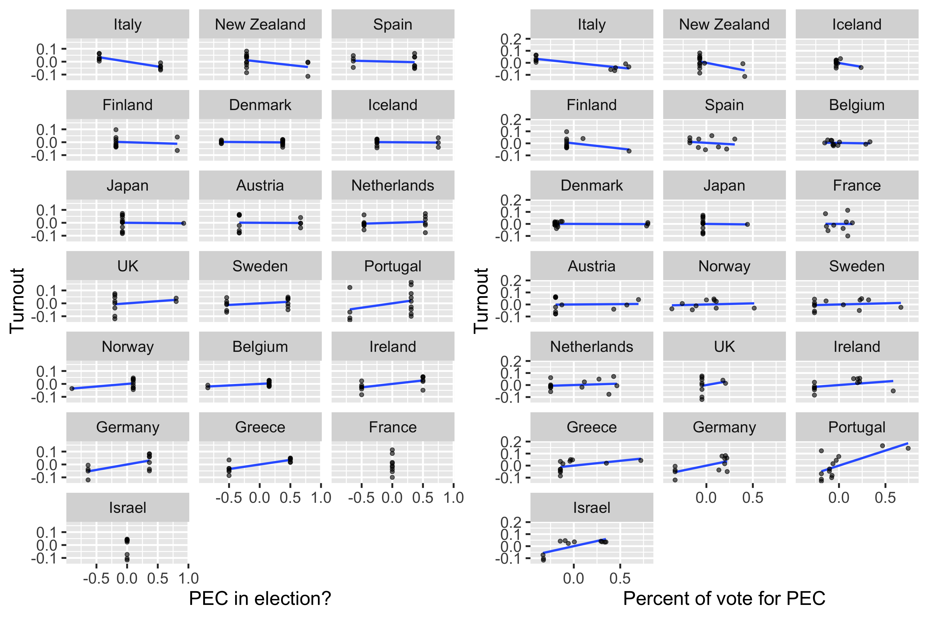

1. The correlation between turnout and PECs varies substantially across countries, ranging from indirect (e.g. Italy and New Zealand) to null (e.g. Denmark and Japan) to direct (e.g., Germany and Greece). It should thus be questioned how representative of the data Tillman’s reported mean effect is.
2. On many occasions the correlation depends on outliers. For instance, the figure implies a direct association between the formation of PECs and turnout in the UK. However, the implication turns entirely on the 1983 and 1987 elections. Likewise, a strong association between turnout and the result for PECs is implied for Portugal. Again, the implication depends entirely on just two elections: 1979 and 1980.
3. Not all countries contribute equally Tillman’s results. Frist, pre-electoral coalitions formed in every French and Israelian election. In other words, the treatment is constant and these countries drop out of the analysis. Moreover, the association between treatment and response is weak or non-existent in almost half of all countries. Hence, Tillman’s results may be driven by strong positive outliers such as Greece respectively Portugal. Jackknife resampling supports that impression, even though it does not invalidate Tillman’s conclusions.

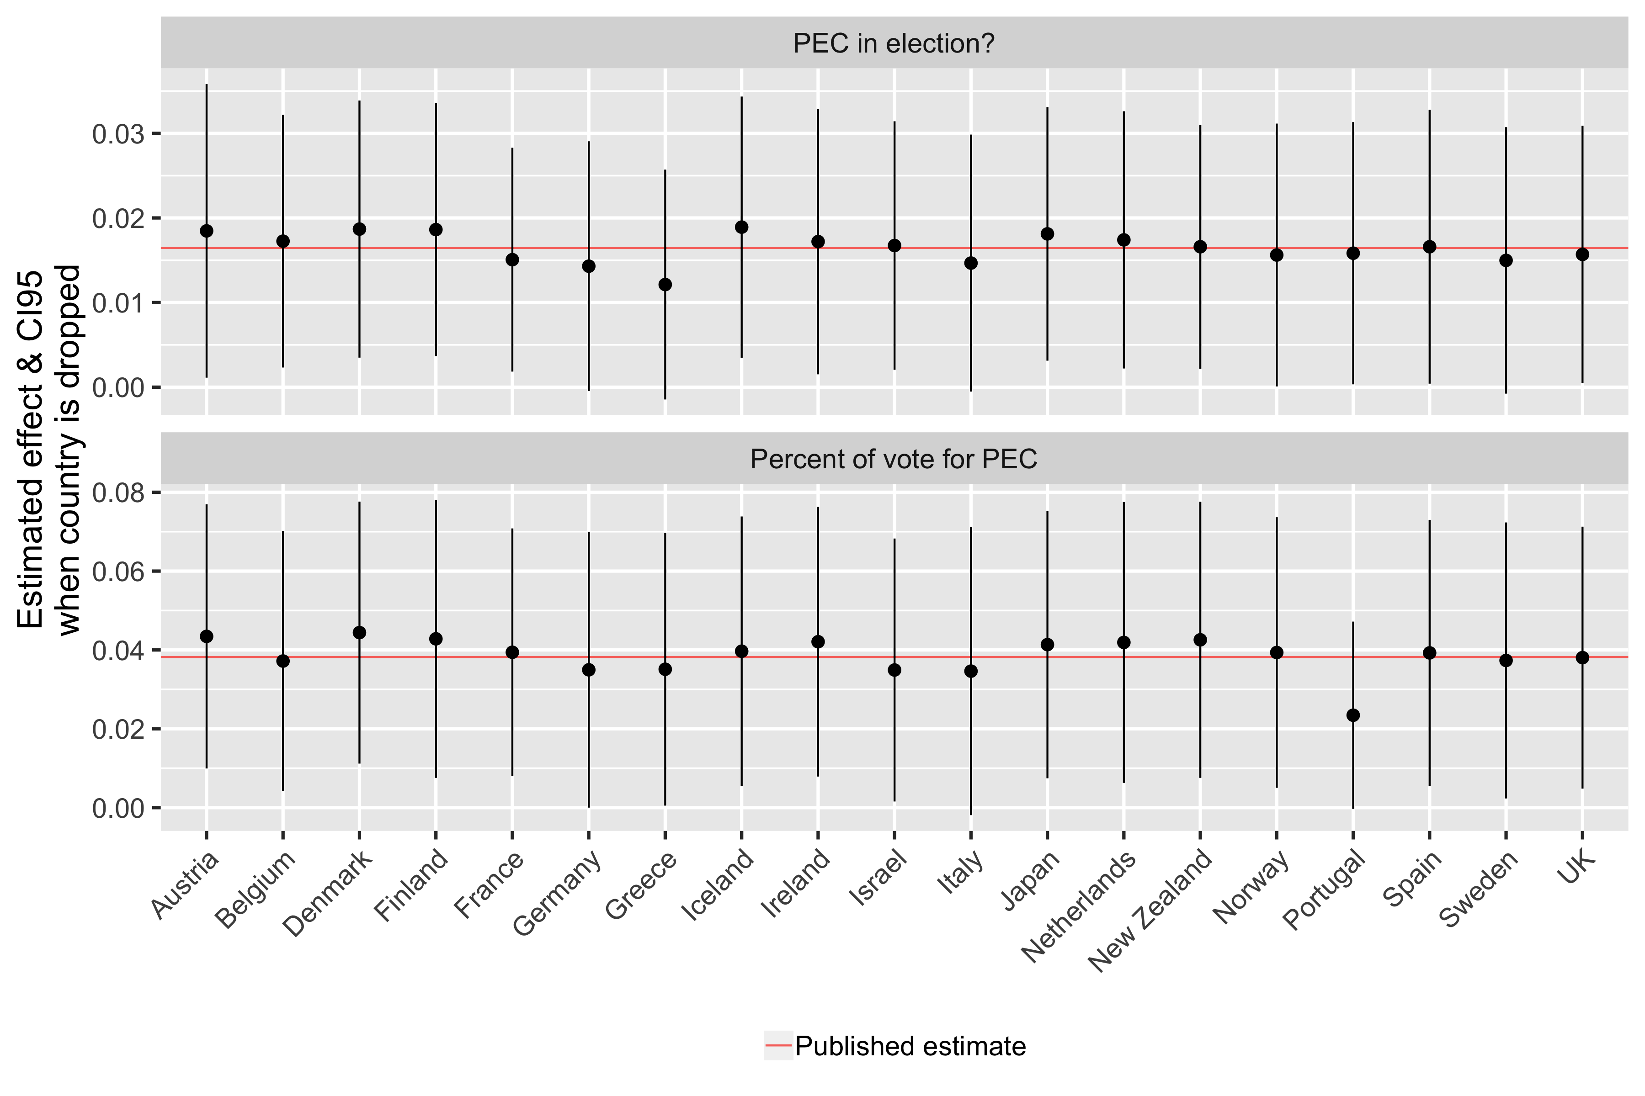

## The model systematically misfits several countries

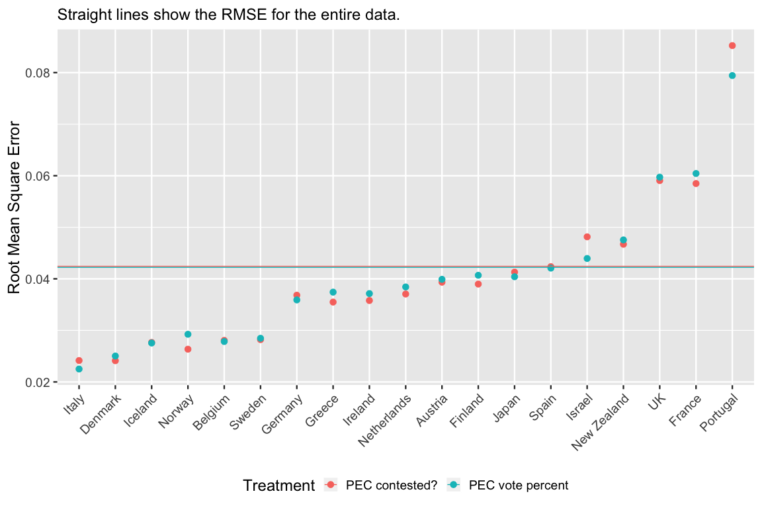

Tillman’s analyses produce training RMSEs[1] of 0.042 and 0.042 for the existence of PECs respectively their vote. Compared to the standard deviation of the demeaned dependent variable (0.050) the average amount of error is reduced by about fourteen per cent. Once again, a country based analysis adds nucance. The figure below plots the RMSE for each country and treamtent, horizontal lines denote the sample based equivalents. The graph demonstrates:

1. Model fit does not noticably depend on the predictor of theoretical interest.
2. There is a group of countries (Italy to Sweden) which fits the model suspiciously well. We should theorize what these countries have in common.
3. There is a second group of countries which does not to fit the model at all. On the one hand, misfit is expected for Israel and France because they do not inform the model (see above). On the other hand, Portugal’s poor performance gives reason for concern because this country is also highly influential.

## The effect of PECs is spurious

Fixed effects analyses should routinely safeguard against mistaking such trends in the outcome for treatment effects. More precisely, turnout has been declining for decades in practically every established democracy. Despite that well known fact, Tillman does not include time dummies in his analysis. Yet, as can be seen from Models 2 and 5 in Table 1 the association between PECs and turnout becomes indistinguishable from zero once year fixed-effects are included.

Moreover, treatment effects may vary over time. In other words, the return from PECs to turnout may change over the observation period. Models 3 and 6 in the table follow up on this possibility and interact the treatment with the year fixed-effects. However, since the interaction terms are collectively indistinguishable from 0, the statistical evidence does not support changing returns from PECs.

1. The Root Mean Square Error is defined as $\frac{1}{N}\sum_{i=1}^{N}{(}y_{i}−{\overset{^}{y}}_{i})^{2}$. Loosely speaking, it states the average error of the model.