The Simple Logical Regulatory Graph
The example was taken from the current SBML Qual Specification document, Version 1 Release 1, 17th May 2013, Section 4.1, page 16.

Building the model
- The model was rebuild in GinSim (exported as PNG, SBMLQual, GINML)
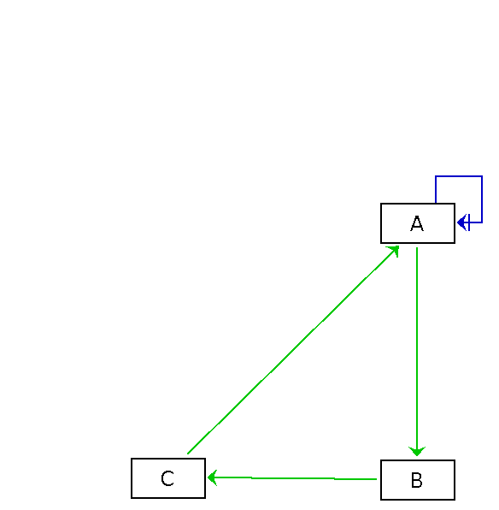

Running the model
The model was then run using GinSim.
Experiment 1: State transition graph
- perturbations: None
- reduction: false
- construction strategy: STG
    - breadth first / depth first
    - max number of states: none defined
- priority class: all species
- update method: Asynchronous
- parameter: none defined
- initial states: none defined
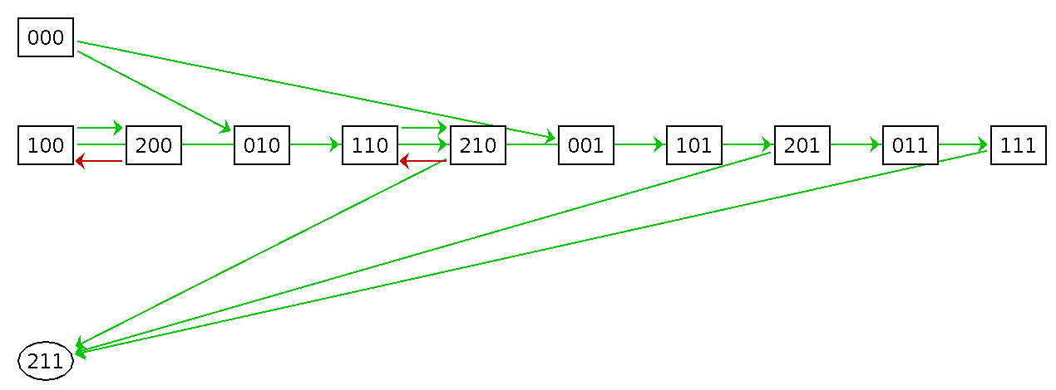

Experiment 2: State transition graph with initial state
- perturbations: None
- reduction: false
- construction strategy: STG
    - breadth first / depth first
    - max number of states: none defined
- priority class: all species
- update method: Asynchronous
- parameter: none defined
- initial states: A=0, B=0, C=0
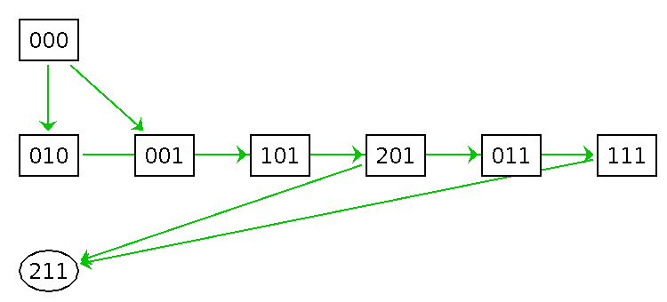

Experiment 3: State transition graph with synchronous update
- perturbations: None
- reduction: false
- construction strategy: STG
    - breadth first / depth first
    - max number of states: none defined
- priority class: all species
- update method: Synchronous
- parameter: none defined
- initial states: none
