Project Planning Phase
Project Planning Template (Product Backlog, Sprint Planning, Stories, Story points)
Date | 4 July 2026
Team ID
Project Name | Rising Waters
Maximum Marks | 5 Marks

Product Backlog, Sprint Schedule, and Estimation (4 Marks)
Use the below template to create product backlog and sprint schedule
Sprint | Functional Requirement (Epic) | User Story Number | User Story / Task | Story Points | Priority | Team Members
Sprint-1 | Registration | USN-1 | As a field officer, I can register for the application by entering my name, email, region and password. | 2 | High | Akshay
 |  | USN-2 | As a field officer, I will receive a confirmation email once I have registered for the application. | 1 | High | Akshay
 |  | USN-3 | As a field officer, I can register for the application through Gmail. | 2 | Medium | Mohammed
Sprint-1 | Login | USN-4 | As a field officer, I can log into the application by entering email & password. | 1 | High | Mohammed
Sprint-1 | Weather Data Input | USN-5 | As a field officer, I can enter current rainfall and cloud visibility readings for my region. | 3 | High | Boppana
Sprint-2 | Weather Data Input | USN-6 | As a field officer, I can upload a CSV of readings for multiple stations at once. | 3 | Medium | Boppana
Sprint-2 | Flood Risk Prediction | USN-7 | As a system, I can preprocess incoming readings and classify flood risk using the trained model. | 5 | High | Eswari
 |  | USN-8 | As a coordinator, I can view flood-risk classification for all monitored regions on one dashboard. | 3 | High | Akshay
Sprint-2 | Alerts & Notifications | USN-9 | As a coordinator, I receive an automatic email/SMS alert when a region is classified as high risk. | 3 | High | Mohammed
Sprint-3 | Dashboard | USN-10 | As a coordinator, I can compare a region's current readings against its historical flood trend. | 3 | Medium | Boppana
Sprint-3 | Model Validation | USN-11 | As an analyst, I can run the model against historical flood records and view its accuracy. | 5 | Medium | Eswari
Sprint-3 | Deployment | USN-12 | As an administrator, I can deploy the trained model and Flask app to IBM Cloud. | 5 | High | Akshay
Sprint-4 | Administration | USN-13 | As an administrator, I can approve or reject new field-officer and coordinator registrations. | 3 | Medium | Mohammed
 |  | USN-14 | As an administrator, I can retrain the model with newly collected data and publish the best version. | 5 | Low | Eswari

Project Tracker, Velocity & Burndown Chart: (4 Marks)
Sprint | Total Story Points | Duration | Sprint Start Date | Sprint End Date (Planned) | Story Points Completed (as on Planned End Date) | Sprint Release Date (Actual)
Sprint-1 | 20 | 6 Days | 6 Jul 2026 | 11 Jul 2026 | 20 | 11 Jul 2026
Sprint-2 | 20 | 6 Days | 13 Jul 2026 | 18 Jul 2026
Sprint-3 | 20 | 6 Days | 20 Jul 2026 | 25 Jul 2026
Sprint-4 | 18 | 6 Days | 27 Jul 2026 | 1 Aug 2026

Velocity:
Imagine we have a 6-day sprint duration, and the velocity of the team is 20 (points per sprint). Let’s calculate the team’s average velocity (AV) per iteration unit (story points per day): AV = 20 ÷ 6 ≈ 3.33 story points per day for the Rising Waters team.
Burndown Chart:
A burn down chart is a graphical representation of work left to do versus time. It is often used in agile software development methodologies such as Scrum. However, burn down charts can be applied to any project containing measurable progress over time.
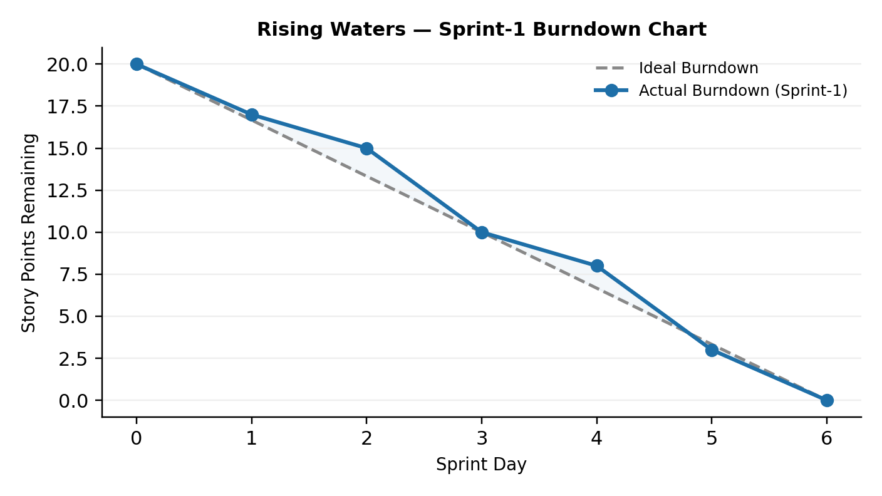
https://www.visual-paradigm.com/scrum/scrum-burndown-chart/
https://www.atlassian.com/agile/tutorials/burndown-charts

Reference:
https://www.atlassian.com/agile/project-management
https://www.atlassian.com/agile/tutorials/how-to-do-scrum-with-jira-software
https://www.atlassian.com/agile/tutorials/epics
https://www.atlassian.com/agile/tutorials/sprints
https://www.atlassian.com/agile/project-management/estimation
https://www.atlassian.com/agile/tutorials/burndown-charts

