**Punto 9**

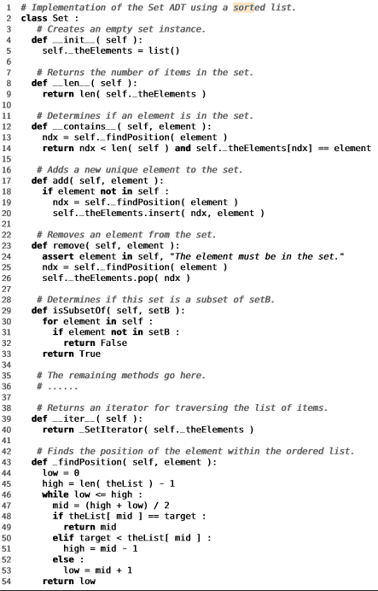

**O(1)**

**O(1)**

**O(n)**

**O(1)**

**O(1)**

**O(1)**

**O(n²)**

**O(1)**

La complejidad del algoritmo = o(n²)