Dahiana Amaro
Computing for Economics
Prof. Jason Barr
05/11/2025

THE EFFECTS OF POPULATION SIZE ON TECHNOLOGICAL INNOVATION
This study investigates how population affects or influences technological innovation. This is a data analysis project developed using data from countries all around the world. The data spans from 1959 to 2000 and was collected from the World Bank Database. The original dataset is called “Innovation and Development Around the World.” I will be using the variables patent (pat) and population total (poptotal) from this dataset. My interest in this topic began when I read the book “The Journey of Humanity: The Origins of Wealth and Inequality” by Oded Galor, in which this topic is discussed. I found it fascinating and questioned why I had never thought about it. In this paper, I will explain the variables, the codes, and my findings. My goal is to show whether the size of population has any effect on innovation using python.
In this analysis, I will be using patents to represent innovation. Patents are a well-known representation of innovation because a patent essentially gives the rights of ownership of an invention to its inventor. In economics, patents are important because they drive economic growth by creating new industries. The creation of new industries creates more jobs as well.
The variable population represents the total number of people in countries around the world. Population is an important variable in economics because it affects the economy in many ways. Generally, a larger population means more workers, which can lead to greater production of goods and, in turn, more economic growth. A higher population also increases demand, which can boost supply and raise GDP. Population is important for forecasting because, in theory, more people can lead to more production, and more production can drive more innovation.
There is empirical data that relates population to technological innovation. A larger population growth rate is associated with more technological input. In an article written by Michael Kremer in 1993, Kremer suggests that bigger populations spur technological change. He claims that throughout most of history, the population growth rate has been proportional to technological innovation. He also argues that even among societies that originally didn’t have an opportunity for technological contact, those societies that started with higher numbers in population were also able to have higher technology levels. In another article, the author found in his study that the population growth rate tends to be associated with higher technological outputs. Higher population growth leads to greater demand for goods and services, which leads to more innovation and economic growth. (Mario Coccia, 2014)
This project was written in Python(Spyder) using the libraries scipy, pandas,numpy, matplotlib.pyplot, statsmodels.api, seaborn, and modules for the graph functions. After getting the dataset from World Bank Data, I deleted all variables but pat (Patent) and poptotal (total population) and saved it with a different name. The variable pat is my y variable, and the variable poptotal is my x variable. To import and read the data, it is important to use the command df = pd.read_excel because my data is in an XLS file format, not CSV. It is also important to clean the data using the command df=df.dropna() because there are a lot of blank spaces in the data. Uncleaned data can lead to difficulties when running correlations and regressions and may result in incorrect results. I use the describe() command, which provides descriptive statistics for all variables. I ran the describe() command for all variables, and then separately for "Patent" and "Population". The correlation function shows how two or more variables are related. In my code, it reveals the correlation between innovation (pat) and population. It tells us if innovation and population change together, and how strongly they are related. The regression function is used to model and analyze the relationship between variables. It shows how the dependent variable changes when the independent variables change. In this analysis, the regression will show how much innovation (pat) changes as the population changes. I used the log of patents and population, and I deleted all countries with patents of 0 or less. In my code. The regression also provides the t-test, which compares the average values of two variables to determine if they are significantly different from each other. In my code, I compared the average values of innovation and population. I used the sns.regplot () command from the seaborn library to graph the regression results. To generate the scatter and line plots, I used modules. I created a separate file containing the graphing functions and then called those functions in the main file using the appropriate import and function call commands.

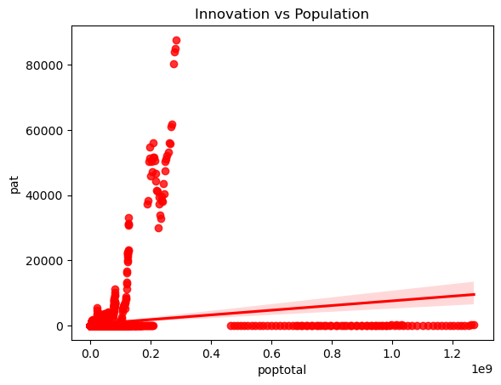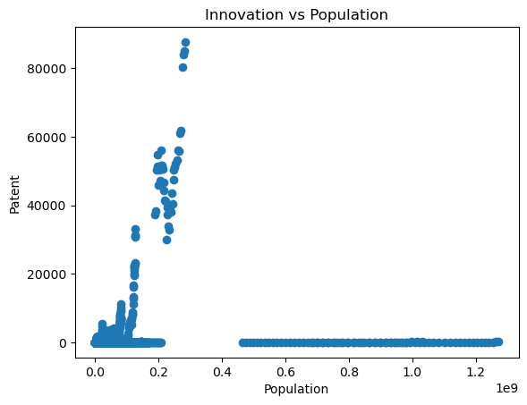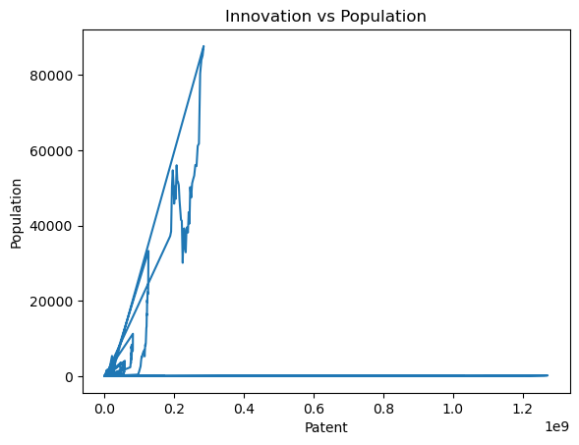
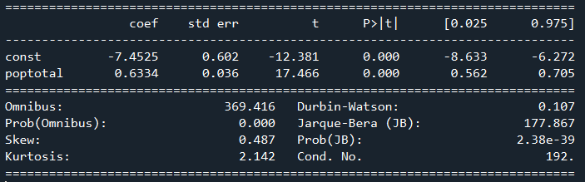
The following section presents the key findings from the analysis of the data. For the variable population, the descriptive command shows that the mean population is 30.8 million people. The smallest population is 500,920, and the maximum is 1.27 billion. For the variable patent (innovation), the mean is 580 patents. The smallest number of patents is 0, and the maximum number of patents a country has is 87,607. The correlation result between patent and population is .169. The correlation shows a positive relationship between patents and population; as population increases, the number of patents increases as well. For the regression, I excluded countries with 0 or fewer patents, and I took the log of my variables. The results from the regression also show a positive relationship between population and patents. As log(population) increases by 1, log(patents) increases by 0.63. According to my data, the p>|t| value indicates that population has a significant effect on innovation because the p>|t| is equal to 0.000. The t-test gave a result of 17.466, which also indicates that the relationship between population and innovation is statistically significant.
In conclusion, this study investigates the relationship between population and technological innovation. My goal was to see if population has any effect on innovation. Previous studies suggest that population size has a positive effect on innovation. My goal was to see if this was correct by running a correlation and regression in Python. The results from both the correlation and the regression suggest that population size does have an effect on innovation. As the population size increases, innovation increases as well.

Work Cited
- Coccia, Mario. “Driving forces of technological change: The relation between population growth and technological innovation: Analysis of the optimal interaction across countries.” ScienceDirect, 5 March 2014, https://www.sciencedirect.com/science/article/pii/S0040162513001261. Accessed 29 April 2024.

- Kremer, Micahel. “Population Growth and Technological Change: One Million B.C. to 1990.” JSTOR, August 1993, https://www.jstor.org/stable/2118405. Accessed 29 April 2024.

