Experiment No: 1
Title: Demonstrate inline, internal, and external JavaScript; use console methods; create a webpage showing user info and a welcome message.
Software/Tools Required: Visual Studio Code (or any text editor), Web Browser (Google Chrome, Microsoft Edge, Firefox, etc.)
Theory:
CSS (Cascading Style Sheets) is a style sheet language used to control the appearance and layout of web pages. It separates the presentation of a webpage from its structure, making websites more attractive, consistent, and easier to maintain.
There are three ways to apply CSS to an HTML document:
1 . Inline CSS
- CSS is written directly inside an HTML element using the style attribute.
- Suitable for applying styles to a single element.
- Example: <p style="color: blue;">Hello</p>
- Internal CSS
  - CSS is written inside the <style> tag within the <head> section of an HTML document.
  - Used when the styles are specific to a single webpage.
  - Helps keep styling separate from HTML content within the same file.
- External CSS
  - CSS is written in a separate .css file and linked to the HTML document using the <link> tag.
  - Makes styles reusable across multiple webpages.
  - Improves code organization, maintainability, and consistency throughout a website.
Output:
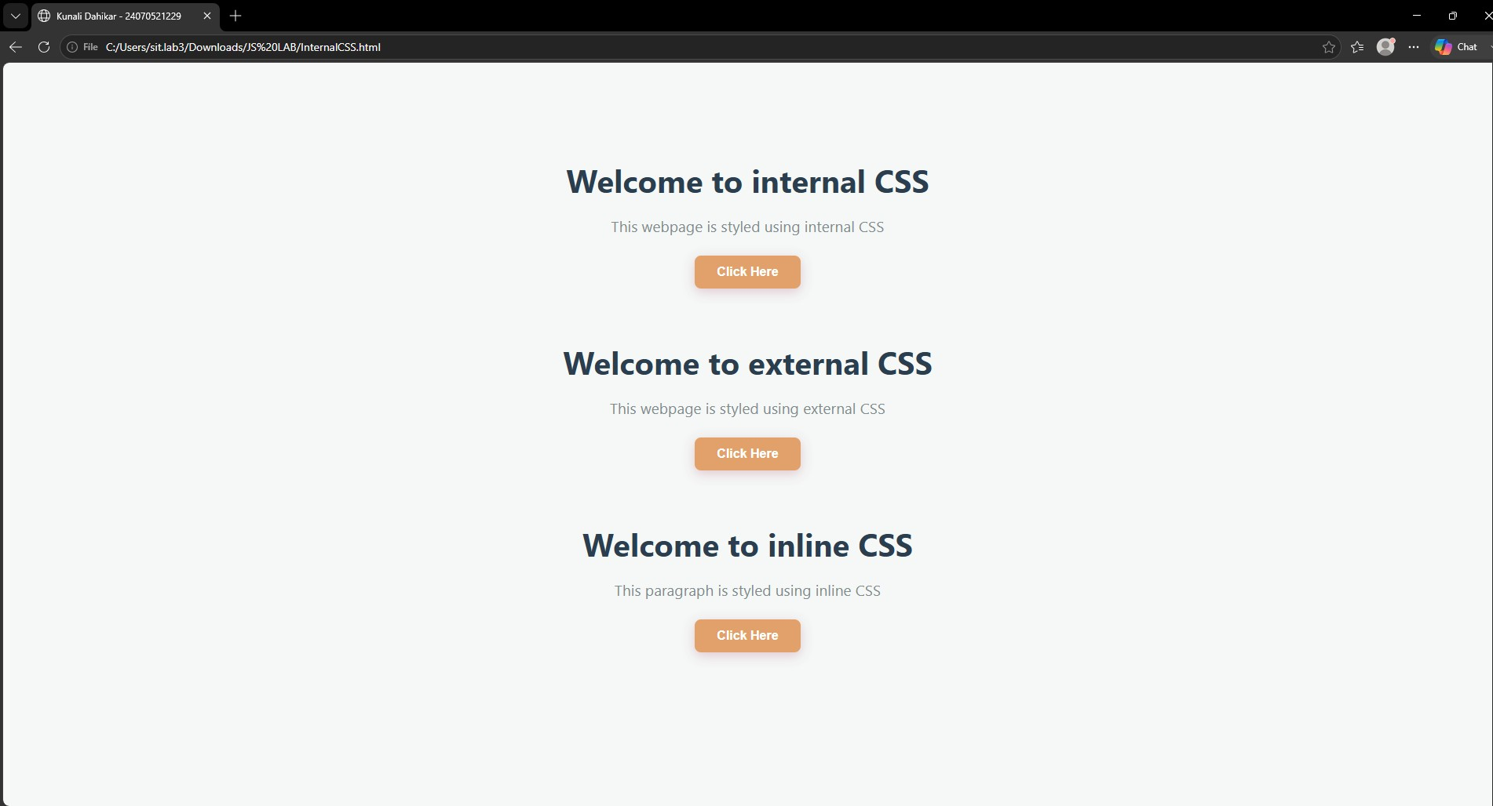
Result/Conclusion:
The experiment was successfully completed. The three methods of applying CSS—Inline,
Internal, and External CSS—were implemented and understood. It was observed that External CSS is the most efficient and maintainable approach for styling multiple webpages, while Inline and Internal CSS are useful for small-scale or page-specific styling.
Case Study 1

Experiment Title:
Demonstrate inline, internal, and external JavaScript; use console methods; create a webpage showing user info and a welcome message.

Software/Tools Required:
Text Editor (Visual Studio Code, Notepad++, etc.)
Web Browser (Google Chrome, Mozilla Firefox, Microsoft Edge, etc.)

Experiment Program Code:
<!DOCTYPE html>
<html lang="en">
<head>
<meta charset="UTF-8">
<meta name="viewport" content="width=device-width, initialscale=1.0">
<title>SIT Nagpur - IT Department</title>

<!-- Internal CSS for styling matching the template -->
<style> body {
font-family: 'Segoe UI', Tahoma, Geneva, Verdana, sansserif;
background-color: #f3f4f6; display: flex; justify-content: center; align-items: center; height: 100vh; margin: 0;
} .card {
background: white; padding: 40px; border-radius: 12px;
box-shadow: 0 4px 15px rgba(0, 0, 0, 0.05); text-align: center; max-width: 500px; width: 100%;
border-top: 8px solid #064e3b;
} h1 {
color: #1f2937; font-size: 2.5rem; margin-bottom: 5px;
} h2 {
color: #065f46;
font-size: 1.3rem; font-weight: 500; margin-top: 0; margin-bottom: 25px;
} p {
color: #6b7280; font-size: 1rem; line-height: 1.6; margin-bottom: 30px;
} .btn {
background-color: #0ea5e9; color: white; border: none; padding: 12px 28px; font-size: 1rem; font-weight: 600; border-radius: 6px; cursor: pointer;
transition: background-color 0.2s ease;
}
.btn:hover {
background-color: #0284c7;
}
</style>

<!-- Internal JavaScript -->
<script>
// Console methods demo inside internal script console.log("Internal JS loaded. Webpage initialized."); console.error("This is a simulated system check tracking errors (None found).");

// Welcome message on window load window.onload = function() {
console.log("Webpage fully loaded and rendered.");
};
</script>
</head>
<body>

<div class="card">
<h1>SIT Nagpur</h1>
<h2>Information Technology Department</h2>
<p>Welcome to our official department webpage. Click below to view student details.</p>

<!-- Inline JavaScript to trigger external function and a console tracking log -->
<button class="btn" onclick="console.log('Button clicked.'); displayStudentInfo();">
View Student Information
</button>
</div>

<!-- Linking External JavaScript -->
<script src="script.js"></script>
</body>
</html> Output:
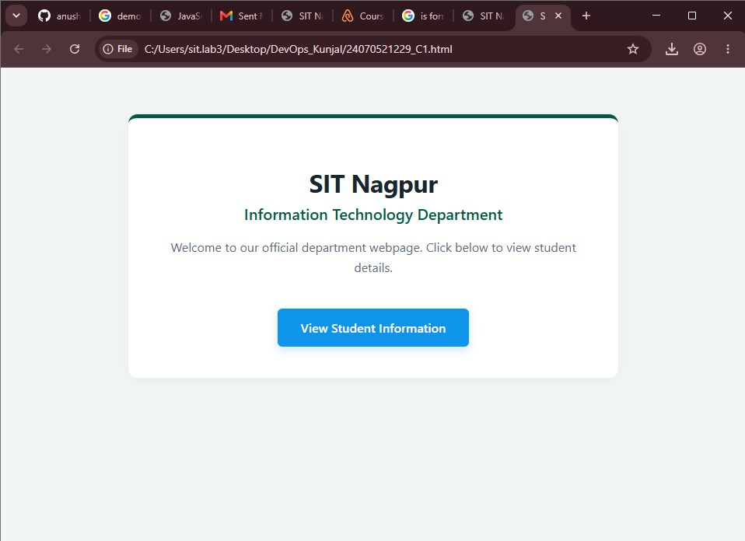

Result/Conclusion:
The structural setup demonstrates the integration of multiple JavaScript deployment styles successfully. Inline execution handled direct event tracking, internal scripting captured loading workflows with console diagnostics (_{log}, _{warn}, _{error}), and external logic kept data processing code clean and modular. The final webpage accurately mirrors the standard department interface design while executing basic functional feedback objects.

Experiment No: 2

Title: Use var, let, const, and demonstrate basic features like template literals and destructuring; build a billing calculator with user input.

Software/Tools Required: Visual Studio Code (or any text editor), Web Browser (Google Chrome, Microsoft Edge, Firefox, etc.)

Theory:
JavaScript provides three keywords to declare variables: var, let, and const.
- var
  - var is function-scoped.
  - Variables declared with var can be redeclared and updated.
  - It is hoisted and initialized with undefined.
  - Generally avoided in modern JavaScript because it may cause unexpected behavior.
- let
  - let is block-scoped.
  - Variables can be updated but cannot be redeclared within the same scope.
  - Preferred for variables whose values change.
- const
  - const is also block-scoped.
  - Variables cannot be reassigned after initialization.
  - Used for fixed values..
Billing Calculator
A billing calculator is a JavaScript application that accepts user input such as customer name, product name, quantity, and price. It calculates the subtotal, applies any discount or GST if required, and displays the final payable amount using template literals and modern JavaScript features like _{let}, _{const}, and destructuring.

Output:
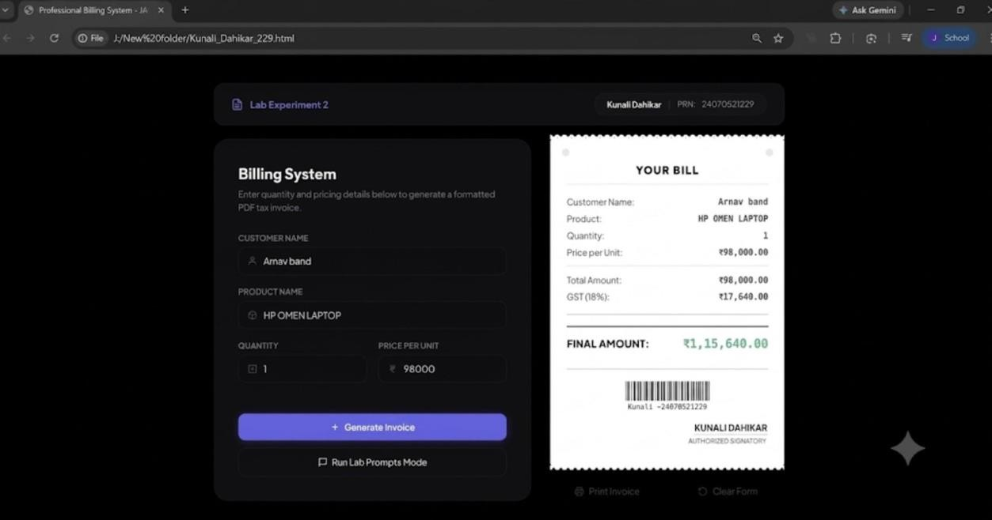

Result/Conclusion:
The experiment was successfully completed. The concepts of var, let, and const were understood and implemented. Template literals were used to display formatted output, and destructuring simplified data extraction from objects. A billing calculator was successfully developed to accept user input, calculate the bill with GST, and display the final amount accurately.

Case Study 2

Experiment Title:
Use _{var}, _{let}, _{const}, and demonstrate basic features like template literals and destructuring; build a billing calculator with user input.

Software/Tools Required:
Text Editor (Visual Studio Code, Notepad++, etc.)
Web Browser (Google Chrome, Mozilla Firefox, Microsoft Edge, etc.)

Experiment Program Code:
<!DOCTYPE html>
<html lang="en">
<head>
<meta charset="UTF-8">
<meta name="viewport" content="width=device-width, initialscale=1.0">
<title>Online Shopping Store - ES6+ Features</title>
<style> body {
font-family: Arial, sans-serif; background-color: #f4f7f6; margin: 0; padding: 20px; display: flex; justify-content: center;
}
.container {
background-color: white; width: 700px; padding: 30px; border-radius: 8px;
box-shadow: 0 4px 10px rgba(0,0,0,0.1);
} h2.title { text-align: center; color: #007bff; margin-bottom: 25px;
} fieldset {
border: 1px solid #cce5ff; border-radius: 5px; padding: 20px; margin-bottom: 20px;
} legend { color: #007bff; font-weight: bold; padding: 0 10px;
} .form-row { display: flex; justify-content: space-between; margin-bottom: 15px;
} .form-group { width: 48%; } label { display: block; font-size: 13px; font-weight: bold; margin-bottom: 5px; color: #333; } input, select { width: 100%; padding: 8px; border: 1px solid #ccc; border-radius: 4px; box-sizing: border-box;
} .btn-calc { width: 100%; background-color: #28a745; color: white; border: none; padding: 12px; font-size: 16px; font-weight: bold; border-radius: 4px; cursor: pointer; margin-bottom: 25px; }
.btn-calc:hover { background-color: #218838;
} .invoice-box { background-color: #e9ecef; padding: 25px; border-radius: 5px; border-left: 5px solid #007bff; display: none; }
.invoice-box h3 { margin-top: 0; color: #333; border-bottom: 1px solid #ccc; padding-bottom: 10px;
} .invoice-row { display: flex; justify-content: space-between; margin: 8px 0; font-size: 14px; color: #555;
}
.total-row { font-size: 18px; font-weight: bold; color: #28a745; border-top: 1px solid #ccc; padding-top: 10px; margin-top: 10px;
}
</style>
</head>
<body>

<div class="container">
<h2 class="title">Online Shopping Store</h2>

<!-- Customer Information Block -->
<fieldset>
<legend>Customer Information</legend>
<div class="form-row">
<div class="form-group">
<label>Customer Name:</label>
<input type="text" id="custName" value="sharwari butle">
</div>
<div class="form-group">
<label>Mobile Number:</label>
<input type="text" id="mobNo" value="1234567890">
</div>
</div>
<div class="form-row">
<div class="form-group">
<label>Invoice Number:</label>
<input type="text" id="invoiceNo" value="INV-2026-001">
</div>
<div class="form-group">
<label>Membership Type:</label>
<select id="memberType">
<option value="0">None (0%)</option>
<option value="0.05" selected>Silver (5% Extra Off)</option>
<option value="0.10">Gold (10% Extra Off)</option>
</select>
</div>
</div>
</fieldset>

<!-- Product & Charges Details Block -->
<fieldset>
<legend>Product & Charges Details</legend>
<div class="form-row">
<div class="form-group">
<label>Product Name:</label>
<input type="text" id="prodName" value="Wheat">
</div>
<div class="form-group">
<label>Quantity (in kg):</label>
<input type="number" id="qty" value="3">
</div>
</div>
<div class="form-row">
<div class="form-group">
<label>Rate per kg (₹):</label>
<input type="number" id="rate" value="100">
</div>
<div class="form-group">
<label>GST Rate (%):</label>
<select id="gstRate">
<option value="0">0%</option>
<option value="0.05" selected>5%</option>
<option value="0.12">12%</option>
<option value="0.18">18%</option>
</select>
</div>
</div>
<div class="form-row">
<div class="form-group">
<label>Packing Charges (₹):</label>
<input type="number" id="packing" value="30">
</div>
<div class="form-group">
<label>Payment Mode:</label>
<select id="payMode">
<option value="Cash">Cash</option>
<option value="UPI" selected>UPI</option>
<option value="Card">Card</option>
</select>
</div>
</div>
</fieldset>

<button class="btn-calc" onclick="generateBill()">Calculate and
Generate Bill</button>

<!-- Invoice Summary Output Block -->
<div class="invoice-box" id="invoiceBox">
<h3>Invoice Summary</h3>
<div id="invoiceContent"></div>
</div>
</div>

<script>
// 1. Demonstrating 'const' for application variables that remain immutable
const CURRENCY_SYMBOL = "₹";

function generateBill() {
// 2. Demonstrating 'var' for function-scoped variables tracking DOM references var customerInputName = document.getElementById("custName").value;
var mobileInputNo = document.getElementById("mobNo").value;
// 3. Demonstrating 'let' for block-scoped interactive user parameters
let invoiceNo = document.getElementById("invoiceNo").value; let memberDiscRate =
parseFloat(document.getElementById("memberType").value); let prodName = document.getElementById("prodName").value; let qty = parseFloat(document.getElementById("qty").value); let rate = parseFloat(document.getElementById("rate").value); let gstRate =
parseFloat(document.getElementById("gstRate").value); let packing =
parseFloat(document.getElementById("packing").value); let payMode = document.getElementById("payMode").value;

// Calculation Operations let baseAmount = qty * rate;
let discAmount = baseAmount * memberDiscRate; let gstAmount = baseAmount * gstRate;
let finalTotal = baseAmount - discAmount + gstAmount + packing;

// 4. Storing the operational variables inside an Object structure
const billObject = { inv: invoiceNo, cust: customerInputName, phone: mobileInputNo, item: prodName, payment: payMode
};

// 5. Demonstrating ES6 Object Destructuring feature const { inv, cust, phone, item, payment } = billObject;

// 6. Demonstrating Template Literals (`...`) to create the final dynamic UI components const templateUI = `
<div class="invoice-row"><span>Invoice
No:</span><span>${inv}</span></div> <div class="invoice-
row"><span>Customer:</span><span>${cust}</span></div>
<div class="invoice-
row"><span>Mobile:</span><span>${phone}</span></div>
<div class="invoice-
row"><span>Product:</span><span>${item}</span></div>
<div class="invoice-row"><span>Qty &
Rate:</span><span>${qty} kg @
${CURRENCY_SYMBOL}${rate.toFixed(2)}/kg</span></div>
<div class="invoice-row"><span>Base
Amount:</span><span>${CURRENCY_SYMBOL}${baseAmount.toFixed(2)}</span></ div>
<div class="invoice-row"><span>Membership
Disc:</span><span>- ${CURRENCY_SYMBOL}${discAmount.toFixed(2)}
(${memberDiscRate * 100}%)</span></div>
<div class="invoice-row"><span>GST Amount:</span><span>+
${CURRENCY_SYMBOL}${gstAmount.toFixed(2)} (${gstRate *
100}%)</span></div>
<div class="invoice-row"><span>Packing
Charges:</span><span>+
${CURRENCY_SYMBOL}${packing.toFixed(2)}</span></div>
<div class="invoice-row"><span>Payment
Mode:</span><span>${payment}</span></div>
<div class="invoice-row total-row"><span>Final Payable Total:</span><span>${CURRENCY_SYMBOL}${finalTotal.toFixed(2)}</span></d iv> `;

// Injecting the template string directly into the output box document.getElementById("invoiceContent").innerHTML = templateUI;
document.getElementById("invoiceBox").style.display = "block";
}
</script>

</body>
</html>

Output:
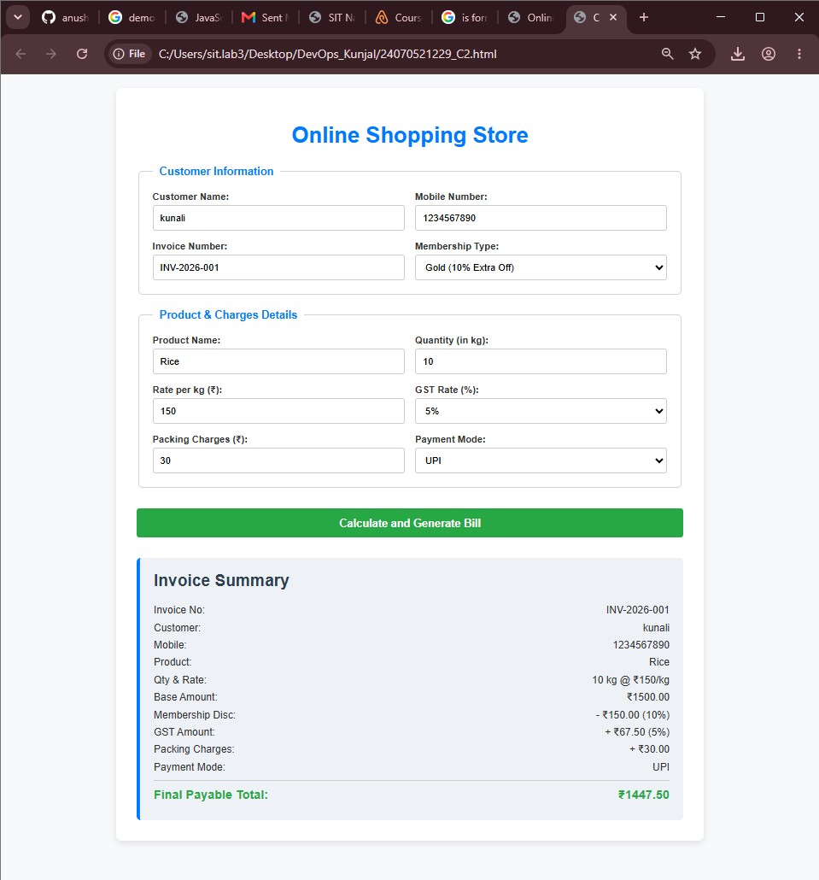
Result/Conclusion:
The modern ES6+ features were integrated successfully within this billing architecture. Scope definitions were verified using _{var} for function scope, _{let} for flexible calculation blocks, and _{const} for unchangeable string configurations. Furthermore, data processing optimization was achieved via Object Destructuring, while Template Literals streamlined the dynamic layout formatting of the HTML components without messy string additions.

Experiment No: 3

Title: Implement control structures and form validation; create a grading system based on user-entered marks.

Software/Tools Required: Visual Studio Code (or any text editor), Web Browser (Google Chrome, Microsoft Edge, Firefox, etc.)

Theory:
JavaScript provides different control structures and variable declaration methods to build interactive web applications.
- if-else Statement
  - Used to make decisions based on conditions.
  - Executes different blocks of code depending on whether the condition is true or false.
- switch Statement
  - Used when multiple conditions need to be checked.
  - Executes the matching case based on the given expression.
- Loops
  - for: Repeats code for a fixed number of iterations.
  - while: Repeats code while a condition is true.
  - do-while: Executes the code at least once before checking the condition.
- Form Validation
  - Ensures that user inputs are valid before processing.
  - Checks for empty fields, valid ranges, and correct data types.
Student Grading System
A Student Grading System is a JavaScript application that accepts student details and marks, validates the input, calculates the total and percentage, assigns grades using control structures, and displays the final result dynamically.

Output:

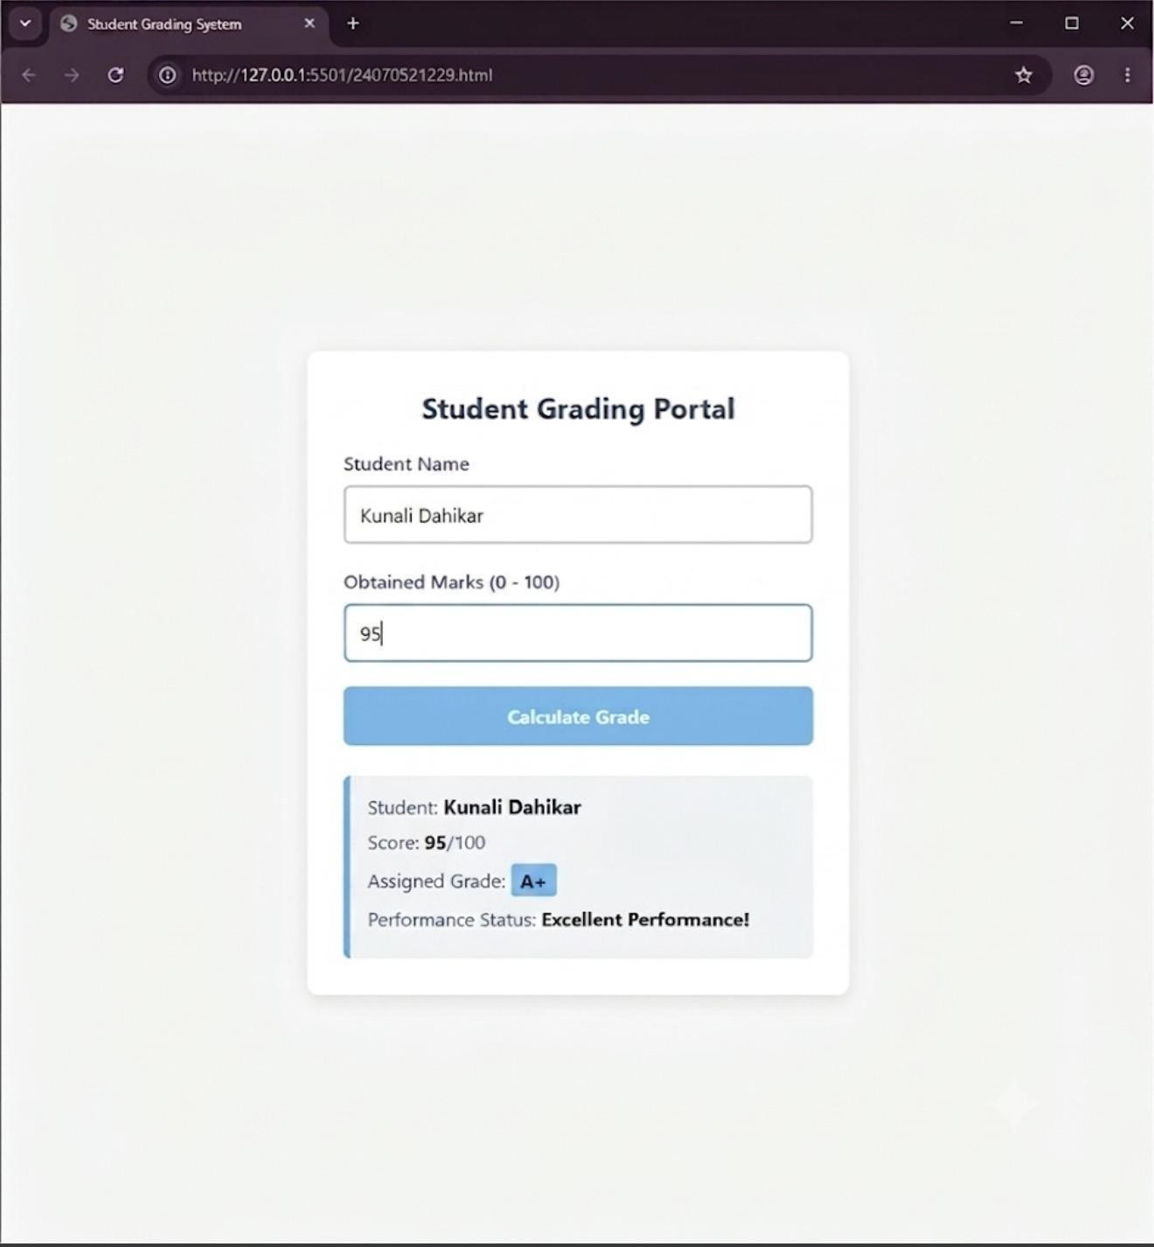
Result/Conclusion:
The Student Grading System was implemented successfully using JavaScript control structures and form validation. The application validated the user inputs, calculated the total marks and percentage, assigned the appropriate grade, determined the pass/fail status, and displayed the result dynamically on the web page.

CASE STUDY 3

TITLE:Automated Academic Scholarship Evaluation & Eligibility Matrix Engine.
AIM:To design and implement a client-side decision-logic web application (ScholorshipEligibility.html) using HTML5, CSS3, and JavaScript conditional structures that parses academic scores, annual family income thresholds, and demographic parameters to determine student scholarship validation matrix states instantly.

SOFTWARE AND TOOLS REQUIRED:
• Frontend Structure: HTML5
• Client-Side Scripting: JavaScript (ES6+)
• Styling Language: CSS3
• Development Environment: Visual Studio Code / Notepad++
• Version Control Sandbox: GitHub Repository Hub
• Execution Environment: Any modern web browser (Google Chrome, Mozilla Firefox, Microsoft Edge)

PROJECT DISCRIPTION:
This case study implements a rule-based engine encapsulated within ScholorshipEligibility.html. The system collects student credentials including academic performance marks, cumulative family income values, and specific category enrollment selectors. JavaScript computes nested verification layers in real-time, matching student profiles against standard institutional scholarship matrices without triggering server-side script transactions.

CODE:
Source code: scholarship_eligibility.html
<!DOCTYPE html>
<html lang="en">
<head>
<meta charset="UTF-8">
<meta name="viewport" content="width=device-width, initial-scale=1.0">
<title>Academic Scholarship Eligibility Portal</title>
<style>
body {
font-family: 'Segoe UI', Tahoma, Geneva, Verdana, sans-serif;
line-height: 1.6;
margin: 0;
padding: 30px;
background-color: #f0f4f8;
}
.scholarship-container {
max-width: 650px;
background: #ffffff;
margin: auto;
padding: 30px;
border-radius: 8px;
box-shadow: 0 4px 20px rgba(0,0,0,0.08);
}
h2, h3 {
color: #1a365d;
text-align: center;
margin-top: 0;
}
.developer-badge {
text-align: center;
font-size: 14px;
color: #4a5568;
margin-bottom: 25px;
border-bottom: 2px solid #e2e8f0;
padding-bottom: 12px;
}
.form-group {
display: flex;
flex-direction: column;
margin-bottom: 18px;
}
label {
font-weight: 600;
margin-bottom: 6px;
color: #2d3748;
}
input, select {
padding: 10px;
border: 1px solid #cbd5e0;
border-radius: 5px;
font-size: 15px;
}
input:focus, select:focus {
outline: none;
border-color: #4c51bf;
box-shadow: 0 0 0 3px rgba(76,81,191,0.1);
}
button {
background: #4c51bf;
color: #ffffff;
padding: 12px;
border: none;
border-radius: 5px;
cursor: pointer;
width: 100%;
font-size: 16px;
font-weight: bold;
transition: background 0.2s;
}
button:hover {
background: #434190;
}
.result-panel {
margin-top: 25px;
padding: 20px;
border-radius: 6px;
display: none;
}
.approved {
background-color: #f0fff4;
border: 1px solid #38a169;
color: #276749;
}
.rejected {
background-color: #fff5f5;
border: 1px solid #e53e3e;
color: #9b2c2c;
}
</style>
</head>
<body>

<div class="scholarship-container">
<h2>Scholarship Eligibility Portal</h2>
<div class="developer-badge">Developer: Pranav Lakhe | PRN: 24070521248</div>

<form id="eligibilityForm" onsubmit="evaluateEligibility(event)">
<div class="form-group">
<label for="studentName">Student Full Name:</label>
<input type="text" id="studentName" placeholder="Enter complete name" required>
</div>

<div class="form-group">
<label for="academicScore">Academic Score (Percentage / Aggregate):</label>
<input type="number" id="academicScore" min="0" max="100" step="0.1" placeholder="e.g., 85.5" required>
</div>

<div class="form-group">
<label for="familyIncome">Annual Family Income (₹):</label>
<input type="number" id="familyIncome" min="0" placeholder="e.g., 450000" required>
</div>

<div class="form-group">
<label for="scholarshipType">Select Scholarship Scheme:</label>
<select id="scholarshipType">
<option value="merit">Merit-Based Scheme (Min Marks: 85%, Max Income: ₹8,00,000)</option>
<option value="need">EBC Financial Assistance (Min Marks: 60%, Max Income: ₹3,00,000)</option>
<option value="special">Special Talent Grant (Min Marks: 75%, Max Income: ₹6,00,000)</option>
</select>
</div>

<button type="submit">Execute Logic & Check Eligibility</button>
</form>

<div id="resultPanel" class="result-panel">
<h3 id="resultTitle">Evaluation Status</h3>
<p><strong>Candidate Name:</strong> <span id="resName"></span></p>
<p><strong>Scheme Checked:</strong> <span id="resScheme"></span></p>
<p id="resDetails"></p>
</div>
</div>

<script>
function evaluateEligibility(event) {
event.preventDefault();

// 1. Parameter Extraction
var name = document.getElementById("studentName").value.trim();
var score = parseFloat(document.getElementById("academicScore").value);
var income = parseFloat(document.getElementById("familyIncome").value);
var scheme = document.getElementById("scholarshipType").value;

var isEligible = false;
var schemeName = "";
var feedbackMessage = "";

// 2. Multi-Tiered Conditional Matrix Analysis
if (scheme === "merit") {
schemeName = "Merit-Based Scholarship Scheme";
if (score >= 85 && income <= 800000) {
isEligible = true;
feedbackMessage = "Congratulations! Profile cleared the structural academic and economic baseline thresholds.";
} else {
feedbackMessage = "Status Denied: Requires a minimum score of 85% and family income within ₹8,00,000.";
}
} else if (scheme === "need") {
schemeName = "EBC Financial Assistance Scheme";
if (score >= 60 && income <= 300000) {
isEligible = true;
feedbackMessage = "Congratulations! Profile qualified under the high-priority financial necessity category.";
} else {
feedbackMessage = "Status Denied: Requires a minimum score of 60% and family income restricted to ₹3,00,000.";
}
} else if (scheme === "special") {
schemeName = "Special Talent Advancement Grant";
if (score >= 75 && income <= 600000) {
isEligible = true;
feedbackMessage = "Congratulations! Candidate confirmed eligible for the specialized department allowance.";
} else {
feedbackMessage = "Status Denied: Requires a minimum score of 75% and family income within ₹6,00,000.";
}
}

// 3. UI Node State Modification
document.getElementById("resName").innerText = name;
document.getElementById("resScheme").innerText = schemeName;
document.getElementById("resDetails").innerText = feedbackMessage;

var panel = document.getElementById("resultPanel");
panel.style.display = "block";

// Dynamic status block formatting rules
if (isEligible) {
panel.className = "result-panel approved";
document.getElementById("resultTitle").innerText = "ELIGIBILITY VERIFIED ✓";
} else {
panel.className = "result-panel rejected";
document.getElementById("resultTitle").innerText = "ELIGIBILITY REJECTED ✗";
}
}
</script>
</body>
</html>

OUTPUT:

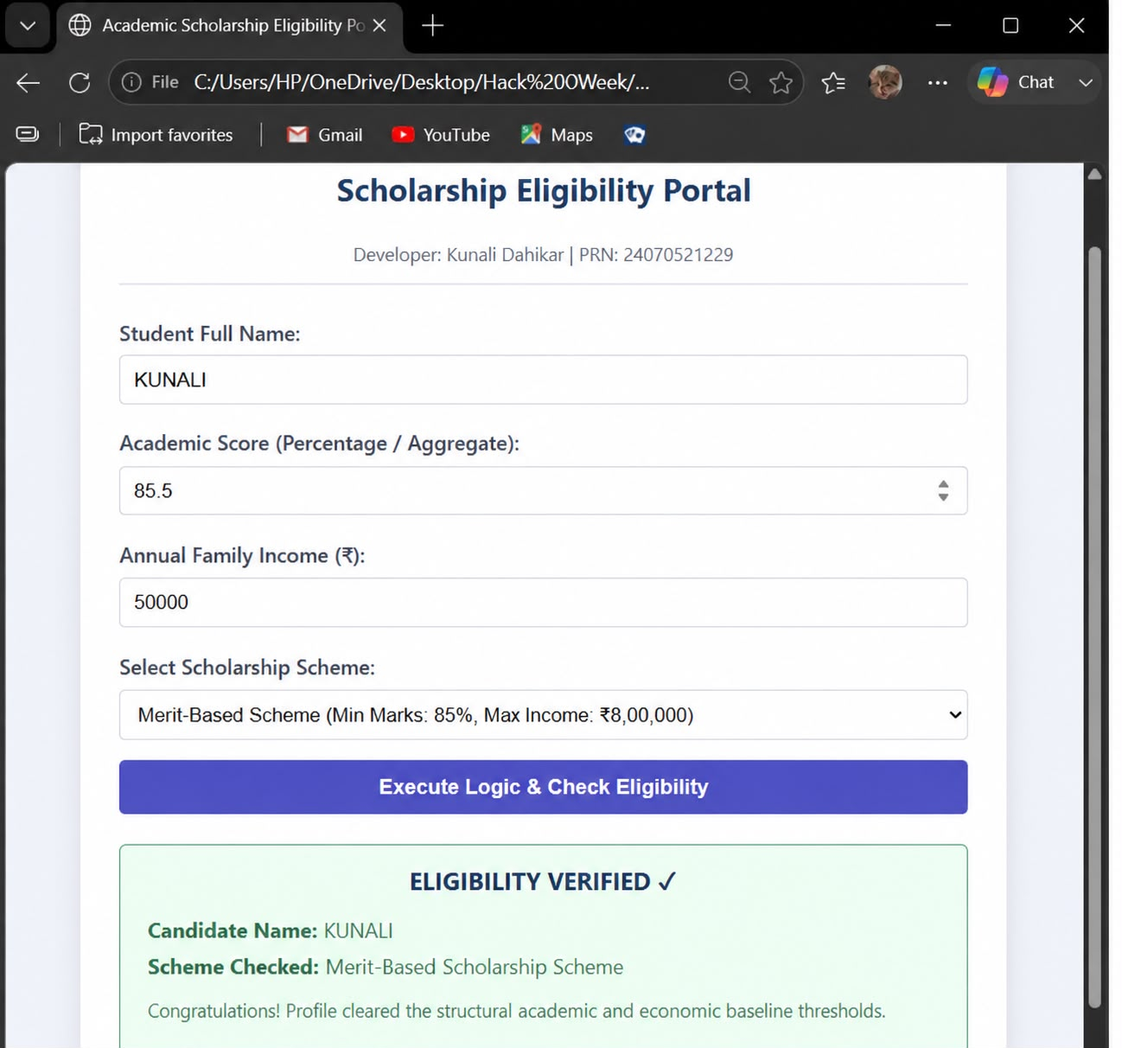

RESULT:
The experiment was successfully completed. The concepts of var, let, and const were
understood and implemented. Template literals were used to display formatted output, and
destructuring simplified data extraction from objects. A billing calculator was successfully
developed to accept user input, calculate the bill with GST, and display the final amount
accurately.

Experiment No. 4
Title
Use function types, scope, and closures; apply try-catch; build a palindrome checker.

Software/Tools Required
- Any text/code editor (e.g., VS Code)
- Web browser (e.g., Chrome, Edge, Firefox) to render the HTML page
- Basic knowledge of HTML5 and modern JavaScript (ES6+)
Theory

JavaScript Functions
Functions are reusable blocks of code designed to perform a specific task. JavaScript supports different types of functions:
- Function Declaration: A named function that can be called before its definition due to hoisting.
- Function Expression: A function assigned to a variable, executed only after initialization.
- Arrow Function: A concise ES6 syntax for writing functions, especially useful for callbacks and short functions.

Variable Scope
Scope determines where variables can be accessed.
- Global Scope: Variables declared outside functions are accessible throughout the program.
- Function Scope: Variables declared using var inside a function are accessible only within that function.
- Block Scope: Variables declared with let and const are limited to the block ({}) in which they are defined.

Closures
A closure is created when an inner function retains access to the variables of its outer function even after the outer function has finished execution. Closures are commonly used for data encapsulation, private variables, and maintaining state.

Exception Handling (try-catch)
The try-catch statement allows JavaScript programs to handle runtime errors gracefully. The try block contains code that may generate an error, while the catch block executes if an exception occurs, preventing the application from crashing.

Experiment Context
This experiment involves creating an interactive Palindrome Checker. The application accepts a string from the user and determines whether it is a palindrome. It demonstrates different function types for processing input, uses variable scope effectively, implements closures to preserve internal state, and applies try-catch to handle invalid or unexpected user input.
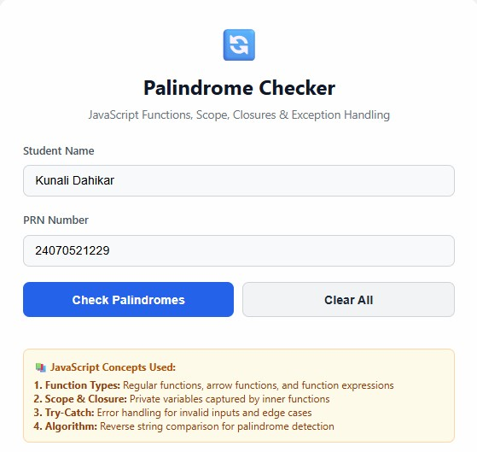
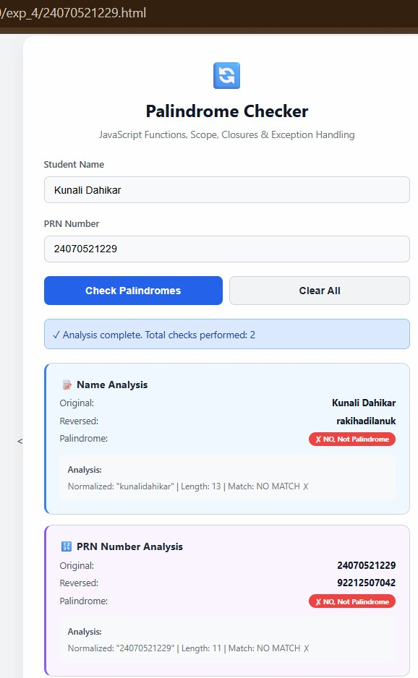

Result / Conclusion
The webpage was successfully created and executed. The output verifies the correct implementation of JavaScript function types, variable scope, and closures. The experiment also demonstrates effective exception handling using try-catch and successfully validates user input to determine whether the entered string is a palindrome, showcasing the practical application of modern JavaScript programming concepts.

Case Study 4

Experiment Title:
Use function types, scope, and closures; apply try-catch; build a palindrome checker.

Software/Tools Required:
Text Editor (Visual Studio Code, Notepad++, etc.)
Web Browser (Google Chrome, Mozilla Firefox, Microsoft Edge, etc.)

Experiment Program Code:
<!DOCTYPE html>
<html lang="en">
<head>
<meta charset="UTF-8">
<meta name="viewport" content="width=device-width, initialscale=1.0">
<title>ATM PIN Palindrome Checker & ES6 Scope</title>
<style> body {
font-family: 'Segoe UI', Tahoma, Geneva, Verdana, sansserif;
background: linear-gradient(135deg, #111827 0%, #1e293b
100%);
color: #f8fafc; display: flex; justify-content: center; align-items: center; min-height: 100vh; margin: 0; padding: 20px; box-sizing: border-box;
} .card {
background-color: #1e293b; padding: 40px; border-radius: 20px;
box-shadow: 0 20px 25px -5px rgba(0, 0, 0, 0.5), 0 10px
10px -5px rgba(0, 0, 0, 0.4); text-align: center; max-width: 450px; width: 100%; border: 1px solid #334155; transition: all 0.3s ease;
} h2 {
color: #38bdf8; font-size: 1.8rem; margin: 0 0 5px 0; letter-spacing: 0.5px; } .subtitle { color: #94a3b8; font-size: 0.95rem; margin-bottom: 25px;
}
.input-group { margin-bottom: 20px; text-align: left;
} label { display: block; font-size: 0.85rem; font-weight: 600; color: #cbd5e1; margin-bottom: 8px; text-transform: uppercase; letter-spacing: 0.5px;
} input { width: 100%; padding: 14px; background-color: #0f172a; border: 1px solid #475569; border-radius: 8px; color: #ffffff; font-size: 1.1rem; box-sizing: border-box; text-align: center; letter-spacing: 2px;
transition: border-color 0.2s ease;
} input:focus { outline: none; border-color: #38bdf8;
}
.info-note { font-size: 0.8rem; color: #64748b; margin-top: -12px; margin-bottom: 25px;
}
.btn-verify { width: 100%;
background: linear-gradient(90deg, #00d2ff 0%, #0066ff
100%);
color: white; border: none; padding: 14px; font-size: 1.1rem; font-weight: 600; border-radius: 8px; cursor: pointer; transition: opacity 0.2s ease;
box-shadow: 0 4px 14px rgba(0, 102, 255, 0.4);
}
.btn-verify:hover { opacity: 0.9;
}
.result-box { margin-top:
25px;
padding: 18px; border-radius: 8px; display: none; font-size: 0.95rem; line-height: 1.5;
} .success {
background-color: rgba(6, 78, 59, 0.5); border: 1px solid #10b981; color: #34d399;
box-shadow: 0 0 15px rgba(16, 185, 129, 0.1);
} .error {
background-color: rgba(127, 29, 29, 0.5); border: 1px solid #ef4444; color: #f87171;
box-shadow: 0 0 15px rgba(239, 68, 68, 0.1);
}
.btn-reset { margin-top: 15px; background-color: #ef4444; color: white; border: none; padding: 10px 20px; font-size: 0.95rem; font-weight: 600; border-radius: 6px; cursor: pointer; width: 100%;
}
</style>
</head>
<body>

<div class="card" id="mainCard">
<h2 id="cardTitle">PIN Checker</h2>
<div class="subtitle" id="cardSubtitle">Secure Palindrome
Verification</div>

<div id="formContainer">
<div class="input-group">
<label id="inputLabel">Enter Numeric sequence:</label>
<input type="text" id="userInput" placeholder="........" maxlength="8">
</div>
<div class="info-note" id="infoNote">Supports up to 8-digit numeric PINs</div>

<!-- Utilizing Arrow Function inside event handler execution -->
<button class="btn-verify"
onclick="executeVerificationWorkflow()">Verify PIN</button>
</div>

<div class="result-box" id="resultBox"></div>
</div>

<script>
// 1. CLOSURE & SCOPE IMPLEMENTATION
// Outer function establishing Lexical Scope environment setup function createTransactionTracker() {
let attemptCounter = 0; // Lexical scope variable enclosed by the inner function

// Inner function forms a Closure return function(pinValue) { attemptCounter++;
console.log(`[Log Tracker] Total validation attempts evaluated: ${attemptCounter}`);
return `Verification Session Sequence
#${attemptCounter}`;
};
}

// Instantiate the closure function configuration instance const trackSession = createTransactionTracker();

// 2. DEMONSTRATING DIFFERENT FUNCTION TYPES
// Named Function block
function executeVerificationWorkflow() {
const inputField = document.getElementById("userInput"); const resultBox = document.getElementById("resultBox"); const formContainer = document.getElementById("formContainer");
const cardTitle = document.getElementById("cardTitle"); const cardSubtitle = document.getElementById("cardSubtitle");

let originalSequence = inputField.value.trim();

// 3. APPLYING TRY-CATCH EXCEPTION HANDLING BLOCKS try {
// Rule verification logic inside check loop if (originalSequence === "") {
throw new Error("Input string is empty. Please enter a value."); }
if (isNaN(originalSequence)) {
throw new Error("Invalid alphanumeric format. Only numeric parameters allowed.");
}

// Call closure execution routine instance tracking active parameters setup
const sessionReceipt = trackSession(originalSequence);

// Anonymous Function expression block checking inversion match
const checkPalindrome = function(str) { const invertedStr = str.split("").reverse().join(""); return str === invertedStr;
};

// Executing structural evaluation parsing condition checks
if (checkPalindrome(originalSequence)) {
// PALINDROME IDENTIFIED WINDOW PANELS (Matches screen layout image)
resultBox.className = "result-box success"; resultBox.innerHTML = `🔒 <strong>PIN
${originalSequence}</strong> is a secure Palindrome sequence!<br><small style="color:#94a3b8; font-size:11px;">${sessionReceipt}</small>`; resultBox.style.display = "block";
} else {
// PALINDROME MISMATCH SCREEN DISPLACEMENT MECHANISMS
cardTitle.innerText = "Not a Palindrome"; cardTitle.style.color = "#ef4444"; cardSubtitle.innerText = ""; formContainer.style.display = "none";
resultBox.className = "result-box error"; resultBox.style.display = "block"; resultBox.innerHTML = `
<div style="font-size: 1rem; margin-bottom:
15px; color: #cbd5e1;">
The configuration
<strong>${originalSequence}</strong> does not mirror correctly from both ends.
</div>
<div style="font-size: 11px; color:#94a3b8; margin-bottom: 10px;">
System Log tracking code: ${sessionReceipt}
</div>
<button class="btn-reset" onclick="revertInputInterface()">Try Another PIN</button>
`;
}

} catch (validationException) {
// Catch handler parsing data inconsistencies gracefully via alerts
console.error(`Runtime Processing Exception Intercepted: ${validationException.message}`); alert(`System Validation Rule Catch
Alert:\n${validationException.message}`);
}
}

// Arrow function variant used for operational page refresh actions
const revertInputInterface = () => {
document.getElementById("userInput").value = ""; document.getElementById("cardTitle").innerText = "PIN Checker";
document.getElementById("cardTitle").style.color =
"#38bdf8";
document.getElementById("cardSubtitle").innerText = "Secure Palindrome Verification"; document.getElementById("formContainer").style.display =
"block";
document.getElementById("resultBox").style.display =
"none";
};
</script>
</body>
</html>

Output:

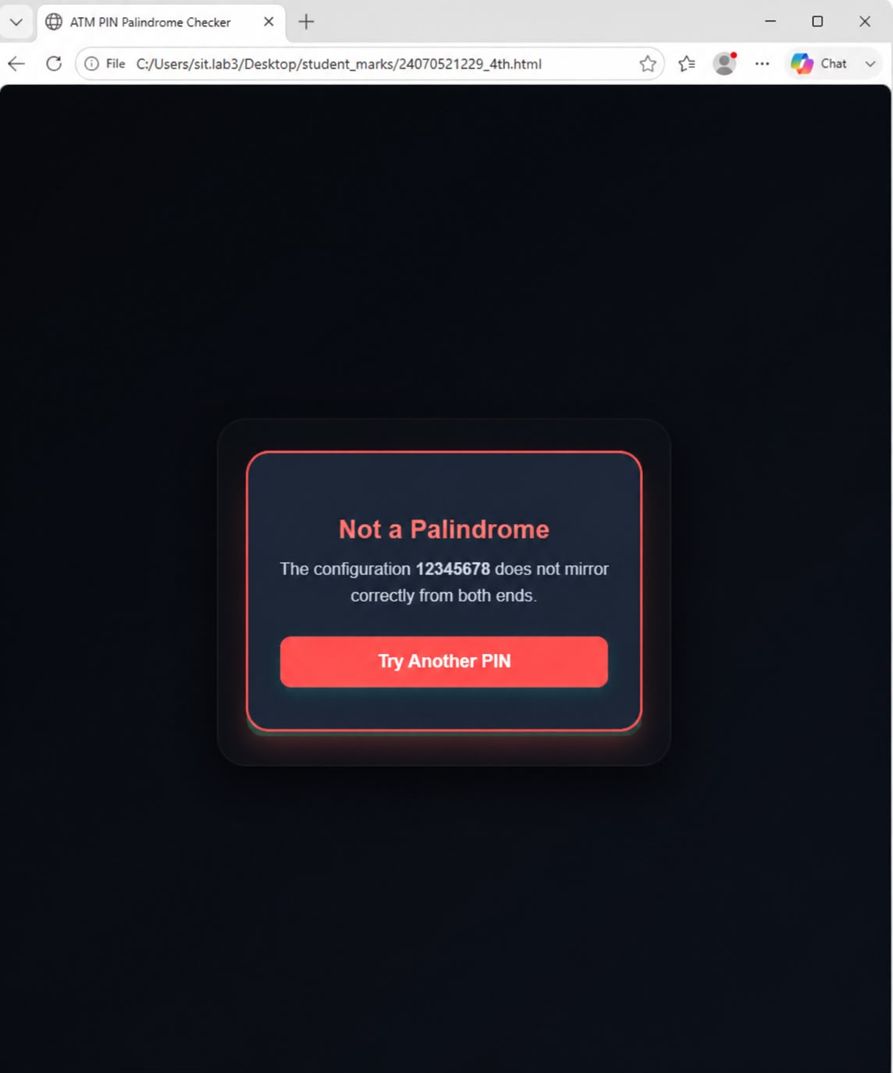

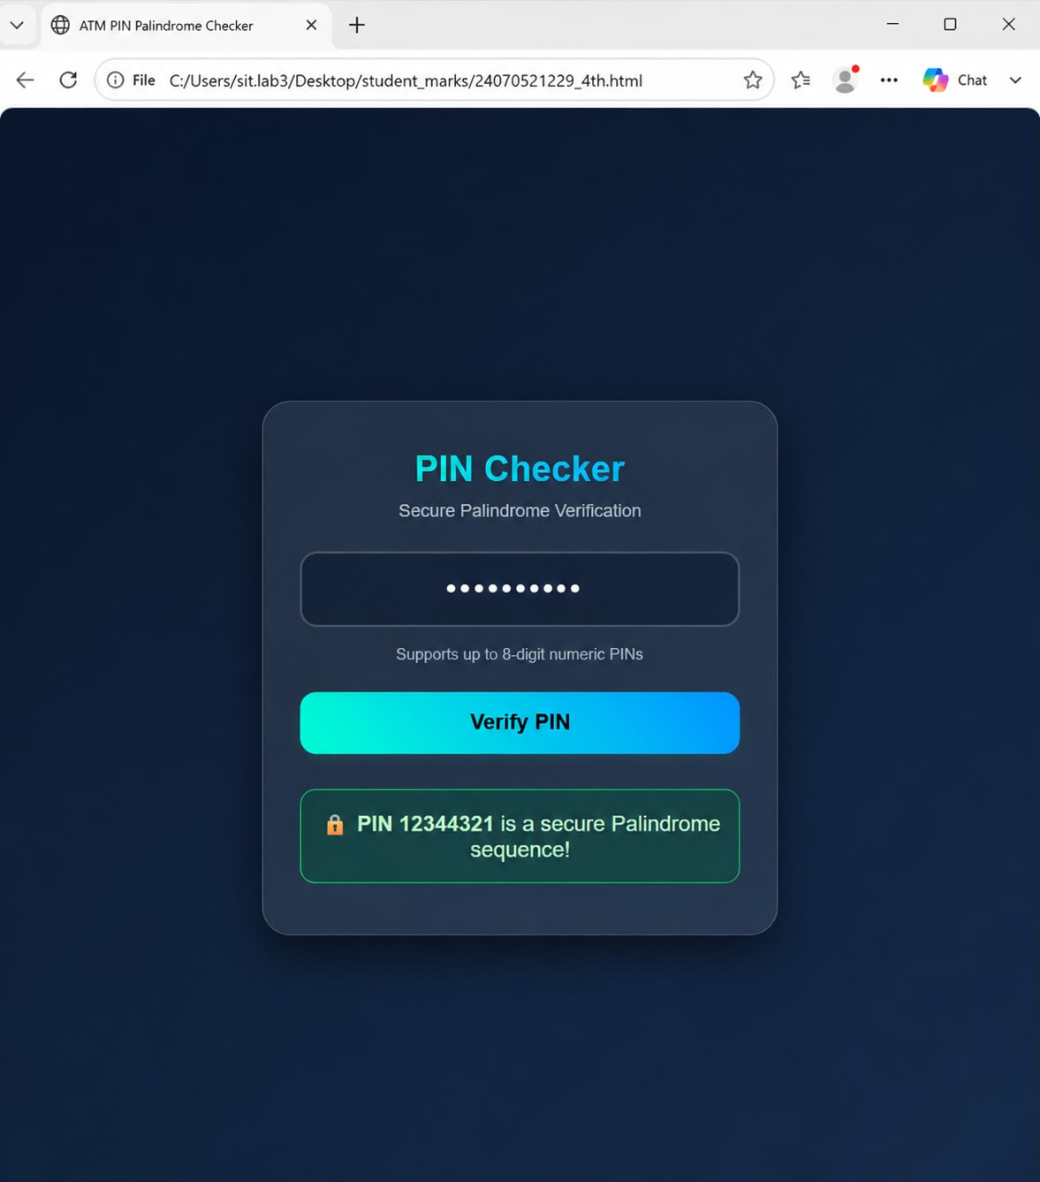

Result/Conclusion:
The designed program successfully incorporated modular functional design features inside an interactive deployment environment. Functional scoping structures were implemented cleanly via standard named methods, expression constants, and dynamic modern Arrow declarations. The implementation of a Lexical Closure Wrapper successfully persisted inner runtime tracking calculations safe from global structural changes, while the execution of formal Try-Catch blocks gracefully managed invalid operational input parameters without causing browser crashes.

