data

Autogenerated data summary from dataReporter

2023-04-20 17:01:24

# Data report overview

The dataset examined has the following dimensions:

| Feature | Result |
| --- | --- |
| Number of observations | 13518 |
| Number of variables | 20 |

### Checks performed

The following variable checks were performed, depending on the data type of each variable:

|  | character | factor | labelled | haven labelled | numeric | integer | logical | Date |
| --- | --- | --- | --- | --- | --- | --- | --- | --- |
| Identify miscoded missing values | × | × | × | × | × | × |  | × |
| Identify prefixed and suffixed whitespace | × | × | × | × |  |  |  |  |
| Identify levels with < 6 obs. | × | × | × | × |  |  |  |  |
| Identify case issues | × | × | × | × |  |  |  |  |
| Identify misclassified numeric or integer variables | × | × | × | × |  |  |  |  |
| Identify outliers |  |  |  |  | × | × |  | × |

Please note that all numerical values in the following have been rounded to 2 decimals.

# Summary table

|  | Variable class | # unique values | Missing observations | Any problems? |
| --- | --- | --- | --- | --- |
| file_name | character | 12 | 0.00 % | × |
| id | character | 12 | 0.00 % |  |
| ptt | numeric | 11 | 0.00 % |  |
| instr | character | 1 | 0.00 % | × |
| date | POSIXct | 13244 | 0.00 % | × |
| type | character | 2 | 0.00 % |  |
| lc | character | 12 | 0.00 % | × |
| lat | numeric | 5410 | 0.00 % | × |
| lon | numeric | 6222 | 0.00 % | × |
| error_radius | numeric | 3475 | 55.67 % | × |
| smaj | numeric | 4930 | 55.78 % | × |
| smin | numeric | 2288 | 55.78 % | × |
| eor | numeric | 181 | 55.78 % | × |
| offset | logical | 1 | 100.00 % | × |
| offset_orientation | logical | 1 | 100.00 % | × |
| gpe_msd | logical | 1 | 100.00 % | × |
| gpe_u | logical | 1 | 100.00 % | × |
| count | logical | 1 | 100.00 % | × |
| comment | logical | 1 | 100.00 % | × |
| age_class | character | 2 | 0.00 % |  |

# Variable list

## file_name

| Feature | Result |
| --- | --- |
| Variable type | character |
| Number of missing obs. | 0 (0 %) |
| Number of unique values | 12 |
| Mode | “./data/original/fur seals//juveniles/232700/232700-1-Locations.csv” |

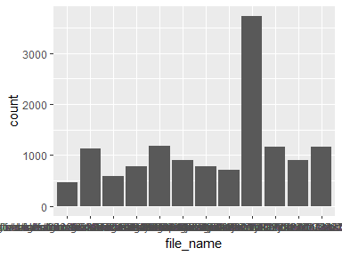

* The following suspected missing value codes enter as regular values: "./data/original/fur seals//females/232699/Aladine-232699-2-Locations.csv", "./data/original/fur seals//females/232702/Eve-232702-1-Locations.csv", "./data/original/fur seals//females/237317/Beyonce-237317-1-Locations.csv", "./data/original/fur seals//females/237319/Neptune-237319-1-Locations.csv", "./data/original/fur seals//females/237321/Daisy-237321-1-Locations.csv", …, "./data/original/fur seals//juveniles/232699/232699-3-Locations.csv", "./data/original/fur seals//juveniles/232700/232700-1-Locations.csv", "./data/original/fur seals//juveniles/232701/232701-1-Locations.csv", "./data/original/fur seals//juveniles/237318/237318-1-Locations.csv", "./data/original/fur seals//juveniles/237323/237323-1-Locations.csv" (2 values omitted).

## id

| Feature | Result |
| --- | --- |
| Variable type | character |
| Number of missing obs. | 0 (0 %) |
| Number of unique values | 12 |
| Mode | “232700” |

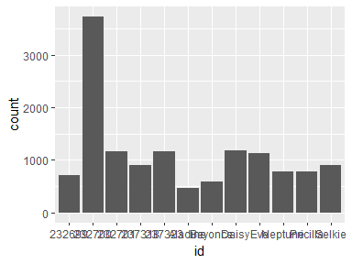

## ptt

| Feature | Result |
| --- | --- |
| Variable type | numeric |
| Number of missing obs. | 0 (0 %) |
| Number of unique values | 11 |
| Median | 232702 |
| 1st and 3rd quartiles | 232700; 237321 |
| Min. and max. | 232699; 237324 |

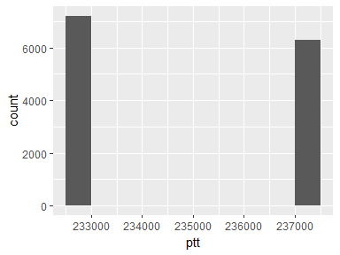

## instr

* The variable only takes one (non-missing) value: "Mk10". The variable contains 0 % missing observations.

## date

* The variable has class POSIXct which is not supported by dataReporter.

## type

| Feature | Result |
| --- | --- |
| Variable type | character |
| Number of missing obs. | 0 (0 %) |
| Number of unique values | 2 |
| Mode | “FastGPS” |

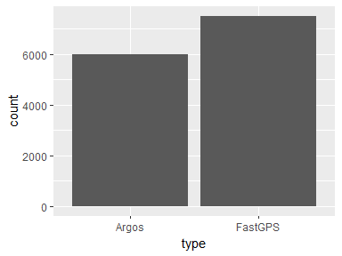

## lc

| Feature | Result |
| --- | --- |
| Variable type | character |
| Number of missing obs. | 0 (0 %) |
| Number of unique values | 12 |
| Mode | “7” |

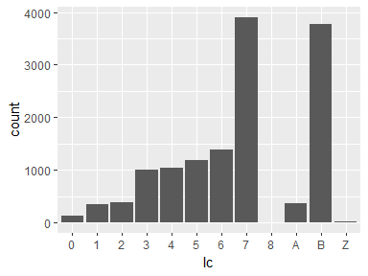

* The following suspected missing value codes enter as regular values: "8".
* Note that the following levels have at most five observations: "8".

## lat

| Feature | Result |
| --- | --- |
| Variable type | numeric |
| Number of missing obs. | 0 (0 %) |
| Number of unique values | 5410 |
| Median | -43.66 |
| 1st and 3rd quartiles | -43.67; -43.55 |
| Min. and max. | -61.14; -27.23 |

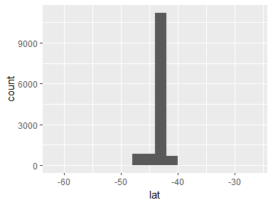

* Note that the following possible outlier values were detected: "-61.14", "-58.17", "-57.25", "-53.98", "-53.52", …, "-33.84", "-31.66", "-28.32", "-27.78", "-27.23" (3150 values omitted).

## lon

| Feature | Result |
| --- | --- |
| Variable type | numeric |
| Number of missing obs. | 0 (0 %) |
| Number of unique values | 6222 |
| Median | 146.06 |
| 1st and 3rd quartiles | 145.5; 146.27 |
| Min. and max. | 123.64; 169.13 |

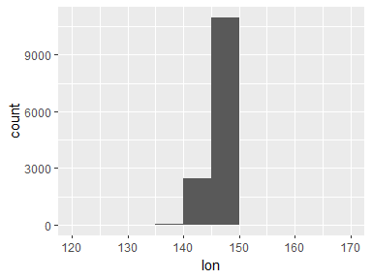

* Note that the following possible outlier values were detected: "123.64", "124.05", "125.8", "127.56", "127.6", …, "158.49", "162.87", "167.65", "168.65", "169.13" (586 values omitted).

## error_radius

| Feature | Result |
| --- | --- |
| Variable type | numeric |
| Number of missing obs. | 7525 (55.67 %) |
| Number of unique values | 3474 |
| Median | 1750 |
| 1st and 3rd quartiles | 415; 3383 |
| Min. and max. | 106; 460765 |

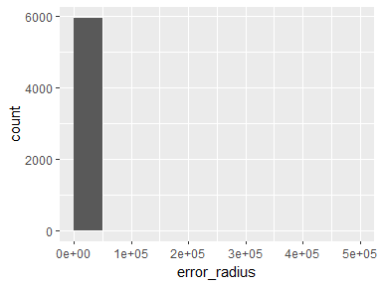

* Note that the following possible outlier values were detected: "12780", "12837", "12868", "12918", "12921", …, "156427", "239514", "289040", "428000", "460765" (198 values omitted).

## smaj

| Feature | Result |
| --- | --- |
| Variable type | numeric |
| Number of missing obs. | 7540 (55.78 %) |
| Number of unique values | 4929 |
| Median | 5153 |
| 1st and 3rd quartiles | 1475.75; 13880 |
| Min. and max. | 132; 945686 |

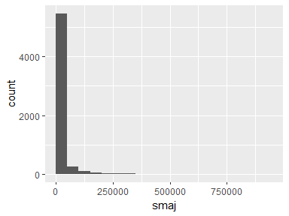

* Note that the following possible outlier values were detected: "103240", "104780", "104792", "105006", "105068", …, "890128", "896612", "943861", "945208", "945686" (241 values omitted).

## smin

| Feature | Result |
| --- | --- |
| Variable type | numeric |
| Number of missing obs. | 7540 (55.78 %) |
| Number of unique values | 2287 |
| Median | 415 |
| 1st and 3rd quartiles | 84; 1327 |
| Min. and max. | 9; 72019 |

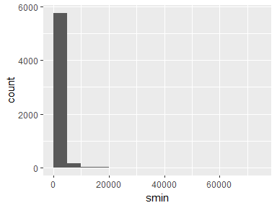

* Note that the following possible outlier values were detected: "10752", "10769", "10793", "10949", "10954", …, "50757", "65311", "67205", "69619", "72019" (55 values omitted).

## eor

| Feature | Result |
| --- | --- |
| Variable type | numeric |
| Number of missing obs. | 7540 (55.78 %) |
| Number of unique values | 180 |
| Median | 92 |
| 1st and 3rd quartiles | 78; 103 |
| Min. and max. | 0; 179 |

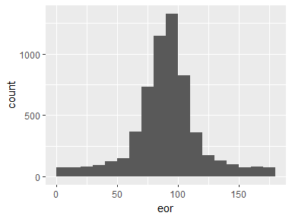

* Note that the following possible outlier values were detected: "0", "1", "2", "3", "4", …, "175", "176", "177", "178", "179" (71 values omitted).

## offset

* The variable only takes one value: "NA".

## offset_orientation

* The variable only takes one value: "NA".

## gpe_msd

* The variable only takes one value: "NA".

## gpe_u

* The variable only takes one value: "NA".

## count

* The variable only takes one value: "NA".

## comment

* The variable only takes one value: "NA".

## age_class

| Feature | Result |
| --- | --- |
| Variable type | character |
| Number of missing obs. | 0 (0 %) |
| Number of unique values | 2 |
| Mode | “juvenile” |

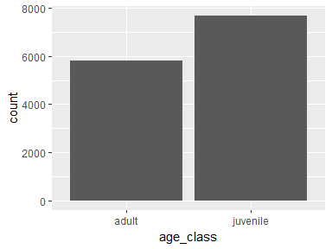

Report generation information:

* Created by: dahliasan (username: xhdfoo).
* Report creation time: Thu Apr 20 2023 17:01:25
* Report was run from directory: C:/Users/xhdfoo/OneDrive - University of Tasmania/Research/TFMP/TFMP Internal Docs/Data Analysis/TFMP R Project
* dataReporter v1.0.2 [Pkg: 2021-11-11 from CRAN (R 4.2.3)]
* R version 4.2.2 (2022-10-31 ucrt).
* Platform: x86_64-w64-mingw32/x64 (64-bit)(Windows 10 x64 (build 22621)).
* Function call: makeDataReport(data = data, output = "test.html")