**Computing outer sphere reorganization energy from molecular dynamics**

**Theory**

**Computing reorganization energy from the electronic energy gap**

The reorganization energy is the energetic displacement experienced by a system when it undergoes a change in its electronic state. In a dielectric environment, this is the result of the rearrangement of surrounding charges to accommodate the change in the electronic state. In a simple solute/solution model, we can split this energy into two components: the inner sphere reorganization energy ($λ_{i}$) and the outer sphere reorganization energy ($λ_{o}$). Then the total reorganization energy is the sum of the inner and outer sphere contributions.

$$\begin{aligned}λ_{tot}=λ_{i}+λ_{o}\#\left(1\right)\end{aligned}$$

Generally, the inner sphere contribution is much less than the outer sphere contribution. This is especially true in a protein environment. Therefore, we will make an approximation that the total reorganization is equal to the outer sphere component:

$$\begin{aligned}λ_{tot}≅λ_{o}\#\left(2\right)\end{aligned}$$

To compute this parameter, all we need to know is the electronic energy difference between the oxidized and reduced states of the redox active species in our simulation. For our work, this is the heme. This can be accomplished by computing the difference in electrostatic energy for each frame of our molecular dynamics simulation as follows:

$$\begin{aligned}δϵ\left(t\right)=\sum_{i}{\sum_{K}{\frac{δz_{i}Z_{K}}{\left|r_{i}\left(t\right)-R_{K}\left(t\right)\right|}}}\#\left(3\right)\end{aligned}$$

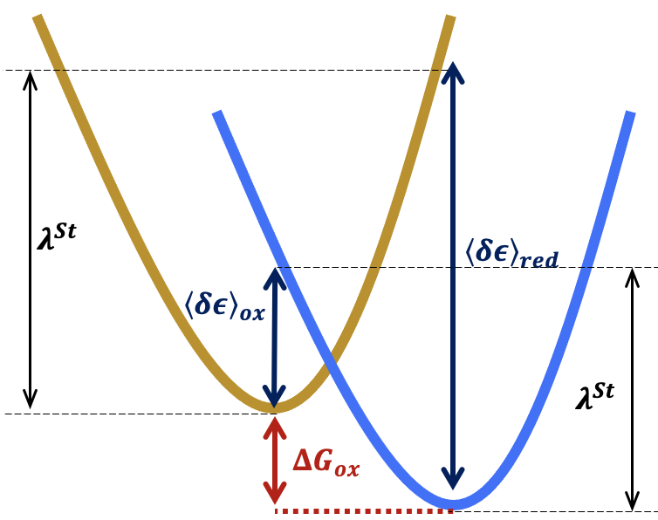Here, $i$ is each solute atom (our heme) and $K$ is each solvent atom (protein environment, water, and ions); $δz_{i}$ is the difference in partial charge between the oxidized and reduced states of solute atom $i$, $Z_{K}$ is the partial charge of each solvent atom K, $r_{i}\left(t\right)$ is the position of solute atom $i$ at time $t$, and $R_{K}\left(t\right)$ is the position of solvent atom $K$ at time $t$. This parameter describes a vertical energetic displacement from the potential energy surface of one charge state to the other.

**Figure 1 | Defining the reorganization energy with the energy gap between oxidized and reduced states.** Both the reorganization energy as well as the free energy of oxidation can be defined using the difference in energy between the oxidized (gold) and reduced (blue) states of the solute molecule (heme). This definition assumes that the free energy landscape is a quadratic. This comes from the Taylor expansion of a Gaussian, truncated after the second term. This truncation results in an approximation known as the linear response approximation (LRA).

Note: $λ^{St}$ should be equal on both sides. Difference shown here is due to sloppy illustration.

We compute this energy gap ($δϵ$) for the simulation when the heme is oxidized ($δϵ_{OX}$) as well as the simulation when the heme is reduced ($δϵ_{RED}$). We can then define what Matushov and coworkers refer to a the Stokes shift reorganization energy:

$$\begin{aligned}λ^{St}=\frac{1}{2}\left({\left\langle δϵ\right\rangle }_{RED}-{\left\langle δϵ\right\rangle }_{OX}\right)\#\left(4\right)\end{aligned}$$

In many instances, this value represents the final outer sphere reorganization energy. However, this is not the case for systems which do not obey Boltzmann thermodynamics. For such systems, we must extend this theory to accommodate extended sampling of the conformational landscape.

**Computing reorganization energy for non-ergodic protein systems**

Since the charges in the interior of a protein are positioned according to the protein’s tertiary structure, the reorganization energy for proteinaceous systems is strongly influenced by the structural fluctuations. Protein structures fluctuate, sampling conformational space according to the free energy landscape dictated by their tertiary structures and their amino acid compositions. For many proteins, this sampling can occur on timescales ranging from 100s of nanoseconds (10-7 s) to several microseconds (10-5 s). Electron transfer reactions occur on timescales ranging from picoseconds (10-12 s) to microseconds (10-6 s). The mismatch of the timescales required for electron transfer and protein structural sampling can result in non-ergodic behavior, or dynamics which do not obey Boltzmann thermodynamics. (*Note: If dynamics do not obey Boltzmann thermodynamics, the distribution of energies will not be gaussian and the LRA will not hold*) This is because electrons can be transferred before the protein scaffold has enough time to rearrange in response to the additional charge.

To address this, Matyushov and coworkers have introduced a variance reorganization energy:

$$\begin{aligned}λ_{RED/OX}^{var}={var\left({δϵ}_{RED/OX}\right)}/{2k_{B}T}\#\left(5\right)\end{aligned}$$

This term accounts for increased variance of the electronic energy gap resulting from non-ergodic dynamics. We then compute the reaction reorganization energy as follows:

$$\begin{aligned}λ^{r}=\frac{{\left(λ^{St}\right)}^{2}}{\frac{1}{2}\left(λ_{RED}^{var}+λ_{OX}^{var}\right)}\#\left(6\right)\end{aligned}$$

This formalism is a generalization of the simple LRA definition. When $λ_{RED}^{var}=λ_{OX}^{var}=λ^{St}$, then $λ^{r}$ is equal to $λ^{St}$ as assumed by the LRA. To quantify non-ergodicity, we can use the following ratio:

$$\begin{aligned}κ_{G}=\frac{λ^{r}}{λ^{St}}\#\left(7\right)\end{aligned}$$

A value of $κ_{G}$ greater than 1 indicates the breaking of ergodicity. For example, Matyushov showed a value of $κ_{G}=2.26$. In contrast, the values of $κ_{G}$ I observed for the hemes in OmcS fell on the range [0.8, 1.34].

**Practical implementation**

**Required software**

* VMD
* NAMD
* Python3

**Required files (scripts and input files)**

* write_deltaQ.tcl
* omcs_pair_interaction_ox.conf
* omcs_pair_interaction_red.conf
* omcs_fully_ox.sb
* omcs_hred.sb
* namddat
* reorg_energy.py

You can download these files from Github: <https://github.com/dahlpete/NAMD_reorg_energy>

Step1: Set up pair interaction files

To compute the electrostatic energy gap we will produce a structure file (.psf) which sets the heme partial charges equal to the difference in partial charges for the oxidized and reduced hemes. We must also write a coordinate file (.pdb) which defines the solute and solvent groups.

This is achieved with the write_deltaQ.tcl script. This script must be updated to specify

1. the heme number (This is for the input and output file names)
2. the base molecule (fully oxidized system)
3. The charged molecule (heme reduced on an oxidized background)
4. The selection text specifying the solute (heme and bound residues)

Run this script with VMD

vmd -dispdev text -e write_deltaQ.tcl

The script will return the following files:

* hemeN_ox_deltaQ.psf
* hemeN_ox_beta.pdb
* hemeN_red_deltaQ.psf
* hemeN_red_beta.pdb

where N is the heme_num parameter you set at the top of the script.

The files labeled *_ox_* are built on the fully oxidized base molecule whereas the *_red_* files are built on the charged molecule. The *_deltaQ.psf files specify the charge difference between the two input systems for the solute molecule, and the *_beta.pdb files specify the solute (1 in beta column) and the solvent (2 in the beta column).

Step 2: Compute the pair interaction energy

Next we perform a pair interaction calculation using NAMD. This is an adaptation of the calculation described in the NAMD electron transfer tutorial (<https://www.ks.uiuc.edu/Training/SumSchool/materials/sources/tutorials/10-electron-transfer/html/node3.html>). This is achieved using the NAMD configuration files. The only adjustable parameters are specified in the top section of the files. Be sure to update the path to the CHARMM parameter files. If you require additional parameters, you will need to add the parameter files in the parameters section.

This script will cycle through each frame of the specified trajectory file, computing the interaction energy between the solute and solvent using the specified force field. This calculation is described by the following equation:

$$\begin{aligned}δϵ=\sum_{j}{Δz_{j}ϕ_{j}^{EW}}\#\left(8\right)\end{aligned}$$

where $Δz_{j}$ is the difference in partial charges for the solute in oxidized and reduced states and $ϕ_{j}^{EW}$ is the Ewald lattice sum electrostatic potential of the solvent or thermal bath.

This calculation is very similar to that which is described by equation (3). However, the sum over the solvent atom charges is replaced with an Ewald sum, which accounts for periodic boundary conditions.

Depending on the length of the trajectory, this can become very computationally expensive. The attached submission scripts will allow for submission of the job to a computing cluster which uses the Slurm scheduler.

This calculation will return a NAMD .log file, where the interaction energies are printed for each frame of the simulation with the format

ETITLE: TS BOND ANGLE DIHED IMPRP ELECT ...

Step 3: Extract the electrostatic energy and compute reorganization energy

To compute the reorganization energy, we need the electrostatic interaction energy. To extract only this energy we use the namddat script. This is a shell script and must be compiled into an executable to run. This can be done with the chmod command:

chmod +x namddat

Then you can execute the script as follows:

./namddat ELECT omcs_pair_interaction_ox.log

This will return a file data.dat. For the calculation performed on the fully oxidized system, rename this file to data_ox.txt. Rename the file for the other simulation to data_red.txt.

Potential error: The energies in these text files should be positive. If they are negative, the base molecule and charged molecule were incorrectly assigned in the write_deltaQ.tcl script. However, since equation (6) uses the square of the Stokes shift reorganization energy, the resulting reaction reorganization energy is unaffected by this mistake.

Put these two text files into a directory with the reorg_energy.py script. The only adjustable parameter in this script is the temperature. By default, the temperature is 310 K. If you ran your simulation at a different temperature, you will need to update this parameter (see variable T under the defined functions).

Run this script with python3:

python3 reorg_energy.py

This will print the Stokes shift reorganization energy, oxidized variance reorganization energy, reduced variance reorganization energy, and the reaction reorganization energy.

The reaction reorganization energy (lambda_r) is the outer sphere reorganization energy.